Advanced Web Development

By: Daniel Davies
Student Number: 1701603
Module: Advanced Web Development
Date: 13/02/2020
User Stories
Allow the user to view a list of all the champions

Allow the user to view the champions within a table through a tier list
Allow the user to use various sorts and searches to find the champs they want

Allow the user to search for champs through a search bar
Allow the user to sort through champions through champion type
Allow the user to sort through champions through champion tier

Allow the user to sign up and sign in

Allow the user to create an account through a form
Allow the user to sign in

Allow the user to log in using the details from the database
Allow the user to enter their log in details
Save the details into a database
Allow the user to enter details of their account

Allow the user to view a list items

Allow the user to view a list of all items
Allow to search for individual items

Allow the user to see the name of the item along with an image of the item
Allow the user to view what the item does
Allow the user to view the cost of the item

Allow the user to view patch notes

Allow the user to view a list of all patch notes

Allow the user to view what patch they are reading about
Allow the user to view a description about the patch

Allow users to navigate through the website

The website should have buttons on some of the webpages to allow the user to navigate
The user should be able to use a navigation bar to navigate through the various pages

The user should be able to access the navigation bar through all the pages
Sssss s s

The website should log certain searches and failed log in attempts

The website should log any failed login attempts to the database
The website should log any searches made to the database

The website should log anything entered within the username and password submitted
The website should log anything searched within the search bar on the item page
The website should log anything searched within the search bar on the champion page

Application
Introduction
Within this section the application is going to be looked at, this will include all the pages and what each pages contains. Along with some of key features all the pages contain.

Pages
The first page is the champion page, this page shows a list of all the champions with different details about them. The user has the option to use different sorts to narrow down the list shown, these searches include a search bar, and different champion details such as champion type and champion tier.
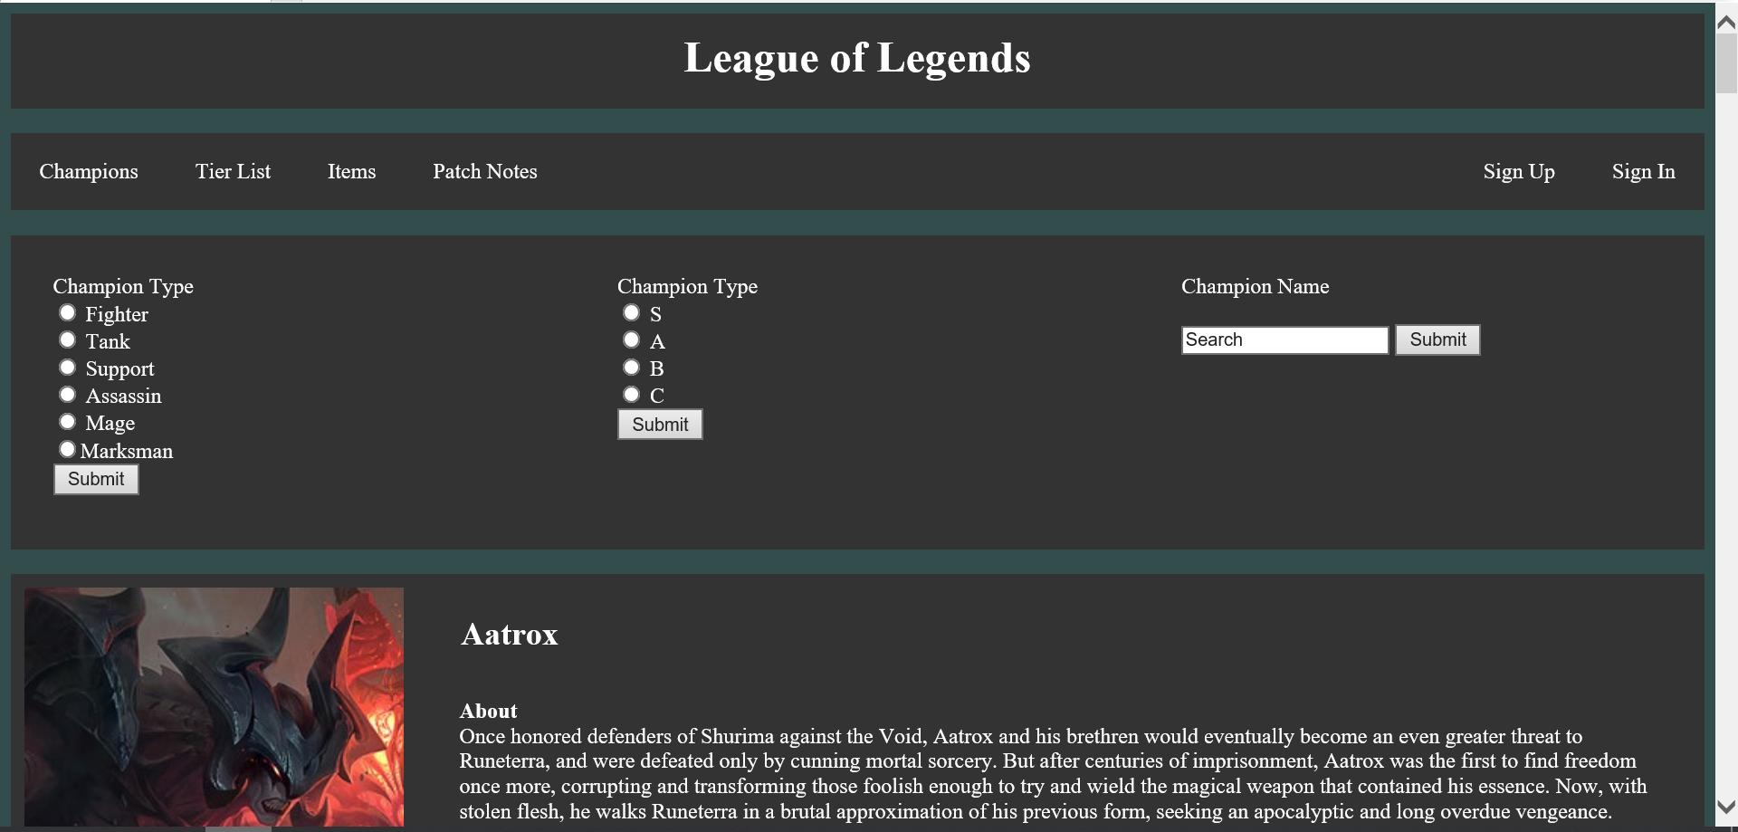
The next page is the tier list page, where the user can few the tier list within a table format.
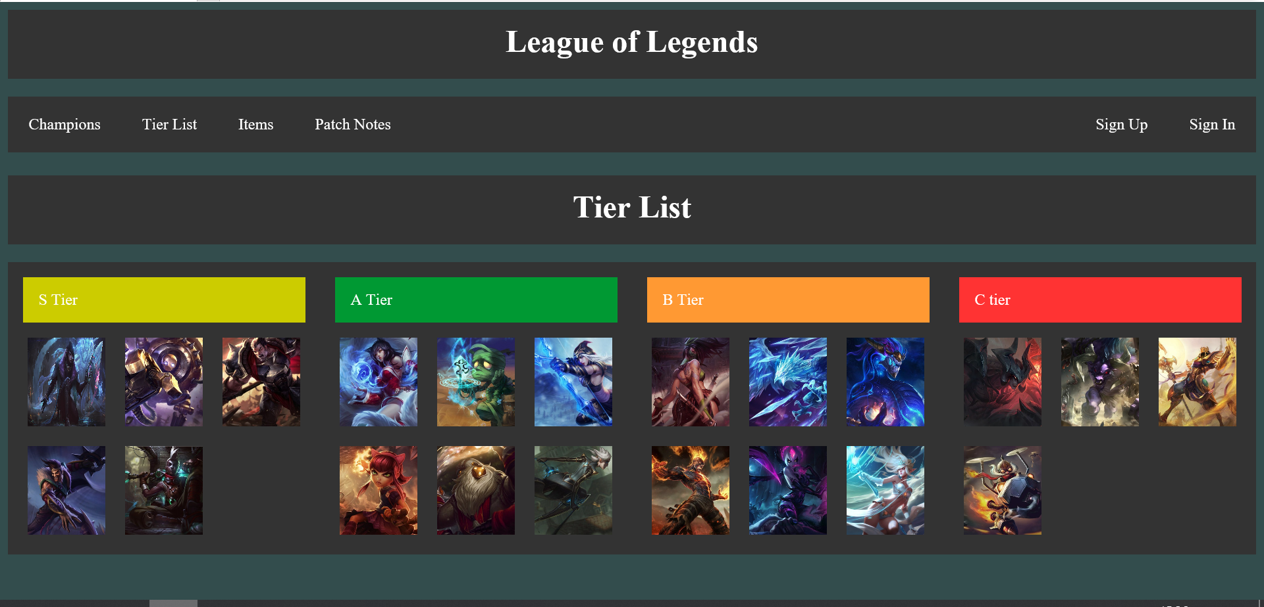
The next page is the item page where the user is able to see a list of all the items. The user has the option to type a item in the search bar which will then bring up more information about the item.
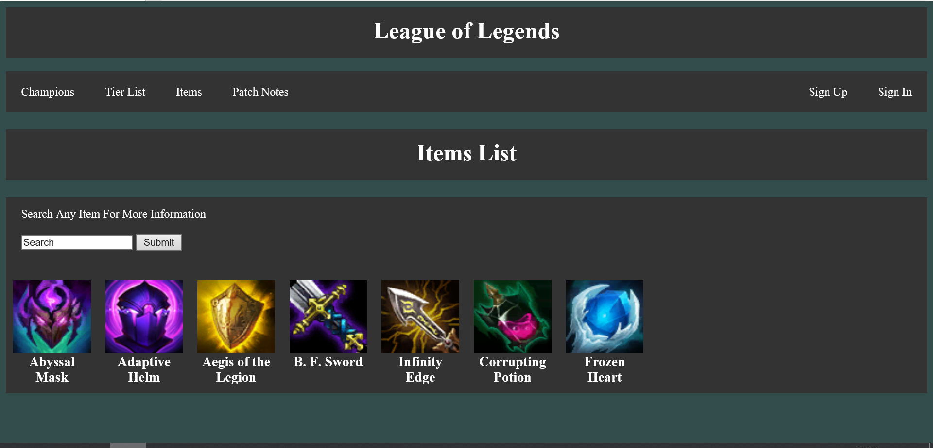
The last page is the patch notes page, in this page it shows a list of all the different patches with details about the patch.
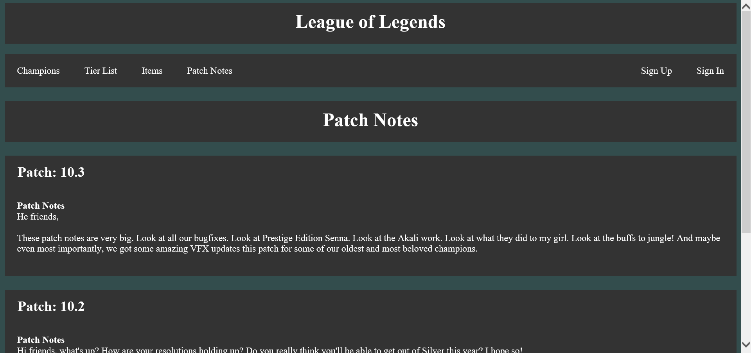

There is also a sign up page and a login page which the user is able to sign up which their details will be saved to the datebase and also will be able to sign in using those details. Any failed attempt in the log in section will result in the failed attempt being logged to the database with the details about the failed attempt.
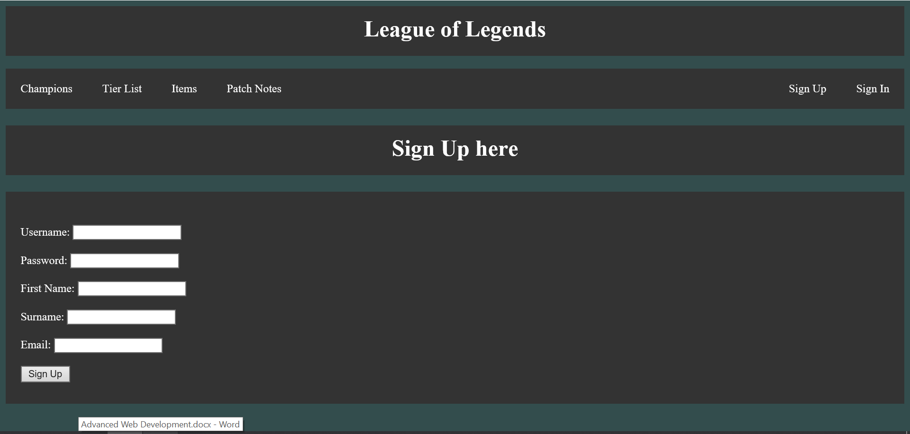

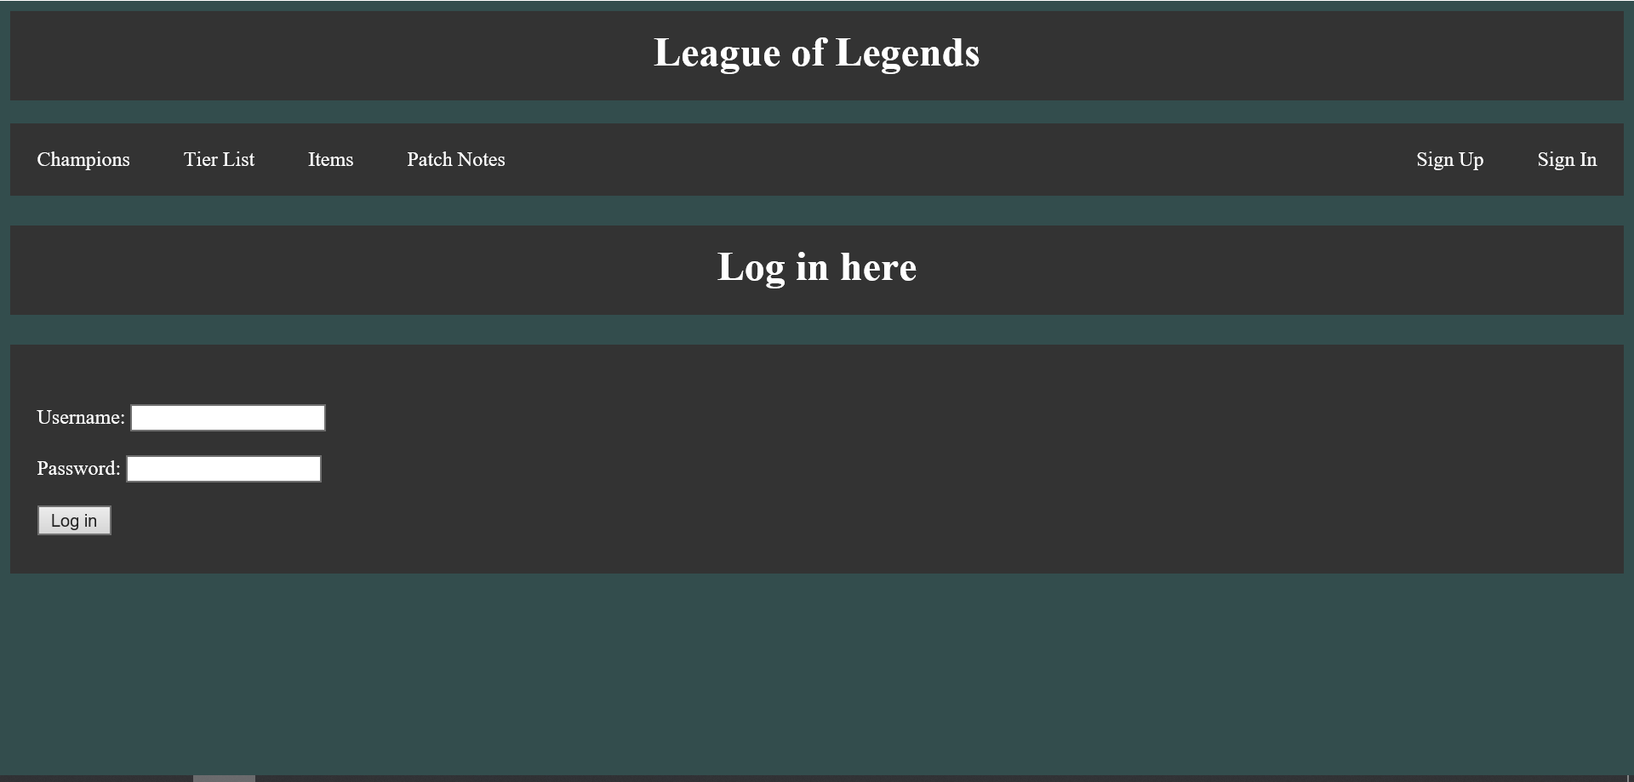

Version Control
Introduction
Within this section of the report version control will be evaluated, this will include what version control is along with why it is important. Also some of the main processes of GIT will be looked at along with some Git commands.

What is Version Control?
Version control is the management of various versions for which a project goes through. The management of every version is very important and every change, which could include adding, editing and removal of files must be tracked. After every change to a file a record of the change must be kept, this can then be used to undo the change. [1]

Why is Version Control Important?
One of the biggest advantages when it comes to version control is when a team is working on the same project. This is because tracking changes made to files becomes very difficult when there is a team working on the same project. However, with version control a team can work on a copy of the project which is called a branch and will only merge the changes to the project when everyone in the team is happy with the changes made. [1]
Another reason why version control is important is because it makes it easier to restore past versions of a file or even the whole project. This then means that if a change is made is not very good or even breaks the whole project then it is very easy to go back to a previous version where everything is working correctly. [2]
Another reason why version control is important is because it makes it easier to track what has been changed and the progress of a project. This is because when a new version of a project is finished and uploaded a description to what has been changed is often required. This will help looking back exactly what was changed throughout each version and helps how a project progresses. [2]

What is Git?
Git is one of the most popular version control system used, this is due to is functionality, security, flexibility and performance on the software. It is used to manage projects and allow multiple people to gain access of the development of the project.

The three stages of Git
- Untracked
The file exists but Git is not tracking the file .
- Staged
Adds the file to the staging area allowing Git to acknowledge the file exists
- Committed
The changes made are committed

Git Commands
The first part of git is creating a local git repository this done by creating a directory, jumping into the directory and executing git init command.
$ cd ~/Desktop
$ mkdir myproject
$ cd myproject/
$ git init

The next step is to create a file in the new repository, the git status command will check current status of files in the directory. As they have not been added to the staged section git is not tracking the two files and has no idea they exist.
$ echo “Hello World” > hello.txt
$ echo “Goodbye” > goodbye.txt
$ git status

The next step is to add the files to the staged state, this is done by:
$ git add your-filename
$ git add .

The final step is to commit
$ git commit -m “description”

Git Hub
GitHub is a web based software development service which uses Git to allow users to develop projects. Throughout the process of development of the web application GitHub was used to keep track of different versions. The following images shows various commits which were committed throughout the development process.
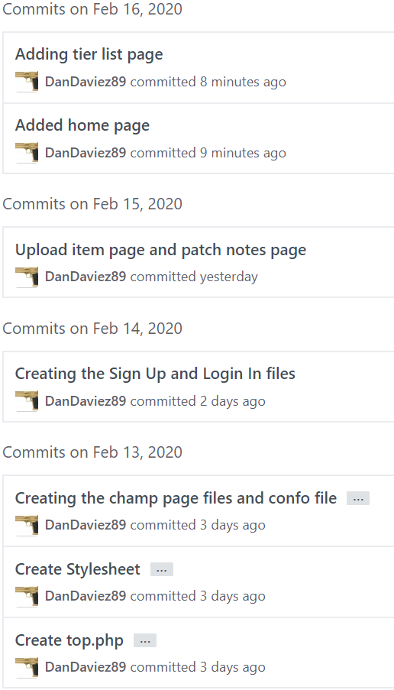

These are all the files which were uploaded to GitHub
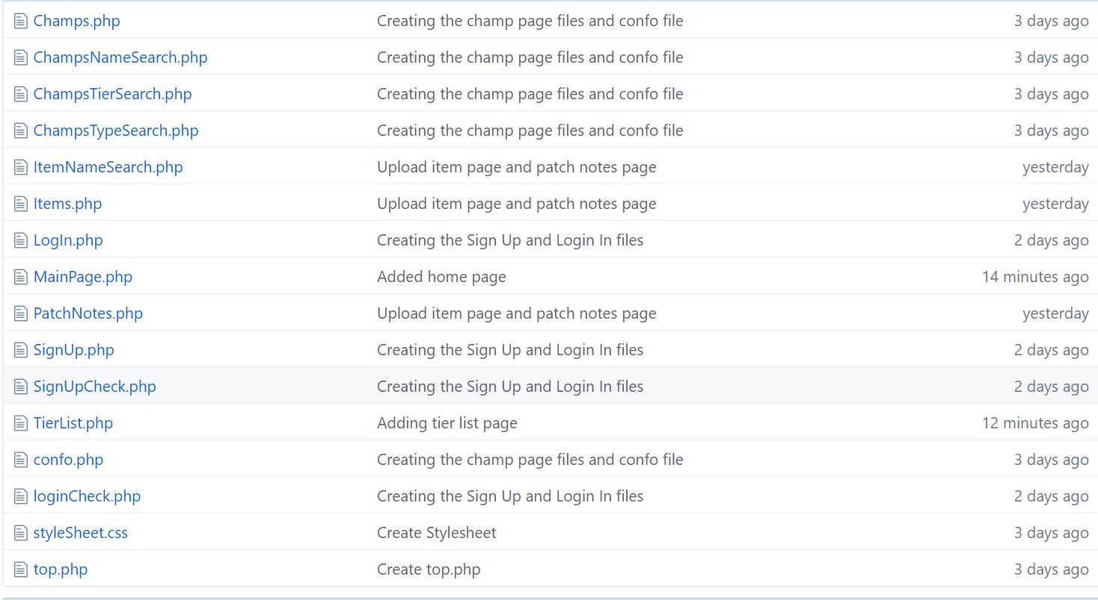

Here is a link to the GitHub web application:
https://github.com/DanDaviez89/DanDaviez89

Bibliography

[1] | M. Tsitoara, "Beginning Git and GitHub," What is Version Control?, p. 3.
[2] | "Learn Version Control with Git," [Online]. Available: https://www.git-tower.com/learn/git/ebook/en/command-line/basics/why-use-version-control. [Accessed 14 02 2020].

