

Programme: Master of Business Administration
Module Name: Marketing Management
Module Code: LCMB7024
Module Lecturer :Taonga Kaonga Sobere-Snithers
“Title:PUMA CIRCULAR+”
Student Name :Nirmal Trivedi
Student Id :2534890

Section | Page
Element 1: Sustainable Brand Extension Poster Presentation | 4
1.1 Company Introduction and Sustainability Imperative | 4
1.2 Purpose of the Brand Extension | 4
1.3 Market Appeal and Persuasive Value Proposition | 4
1.4 Alignment with Sustainability Goals | 5
Element 2: Segmentation, Targeting, Differentiation and Positioning (STDP) Analysis | 5
2.1 Introduction | 6
2.2 Segmentation | 6-7
2.3 Targeting | 8
2.4 Differentiation | 7
2.5 Positioning | 9-10
Element 3: Marketing Mix (7Ps) | 10-11
3.1 Introduction | 11
3.2 Product | 12
3.3 Price | 12-13
3.4 Place | 13-14
3.5 Promotion | 14
3.6 People | 14
3.7 Process | 14-15
3.8 Physical Evidence | 15
Element 4: Reflection | 15
4.1 Introduction | 16
4.2 Experience and Learning | 16
4.3 Skills Developed | 17
4.4 Professional Development | 17
4.5 Areas for Future Development | 17-18
4.6 Conclusion | 18
References | 16

Element 1: Sustainable Brand Extension Poster Presentation
1.1 Company Introduction and Sustainability Imperative

PUMA SE is a German sportswear brand, one of the leading in the world, and is known for its sports activities and innovation in this space, with operations in more than 120 countries. In recent years, sustainability has become an integral, strategic priority in the fashion sector, which has been put under pressure in order to minimise textile waste, carbon emissions and resource usage. PUMA has reacted by fostering circular economy programmes like RE: FIBRE, using recycled and certified materials more widely in PUMA's range, and taking bold measures for environmental goals. Even with these accomplishments, several customers are not familiar with the business's sustainability efforts. As such, it is possible to further enhance the brand image of PUMA and develop a circular service with customer focus, which can turn sustainability into a live consumer experience.
1.2 Purpose of the Brand Extension

PUMA RE: CIRCULAR+ is a sustainable brand extension and a tool to encourage a circular economy, starting with product repair, refurbishment, resale, as well as responsible recycling. This isn't intended to persuade consumers to buy new sports gear when they are already tired or worn out; rather, it is designed to preserve product value and performance through the extension of the product's life. The PUMA stores will accept used PUMA shoes, clothes, and accessories to be professionally recycled, or customers can redeem them for store credit. Products that meet quality standards are resold as certified refurbished products and products that are not of quality are recycled to manufacture new products. This practice can help minimise the waste of textiles, encourage responsible consumption, and add extra value for customers and the company.

1.3 Market Appeal

Environmental consciousness has been having a significant impact on consumer buying habits, especially in the behaviours of Generation Z and Millennials. McKinsey & Company (2024) found that customers are more than willing to support environmentally friendly businesses and hold brands accountable for their sustainability measures. PUMA RE: CIRCULAR+ is available to meet these demands and offers a practical solution: one that is both environmentally responsible and affordable, and one that meets product quality standards. The service is for environmentally aware consumers and value-oriented shoppers, as well as for those who are loyal to PUMA, and generates new revenue opportunities and bolsters customer connections in the long-term.

1.4 To align with sustainability goals.

Alongside PUMA's sustainability strategy, PUMATXT RE: CIRCULAR+ aims to prolong the product life cycle before it is time to recycle. The initiative aligns with the goals of the circular economy, focusing on reuse, refurbishment, and recycling to reduce waste and promote the efficient use of resources. Additionally, the brand extension gives concrete contributions to the United Nations Sustainable Development Goals Number 12 (Resolution Word of Waste, Responsible Consumption and Production), Number 13 (Climate Action) and Number 15 (Life on Land) by reducing textile waste, lowering demand for virgin materials, and reducing manufacturing productiveness's environmental footprint. Puma's aim with this initiative is to reinforce its sustainability goals of innovation and to generate shared value for customers, society and the environment.
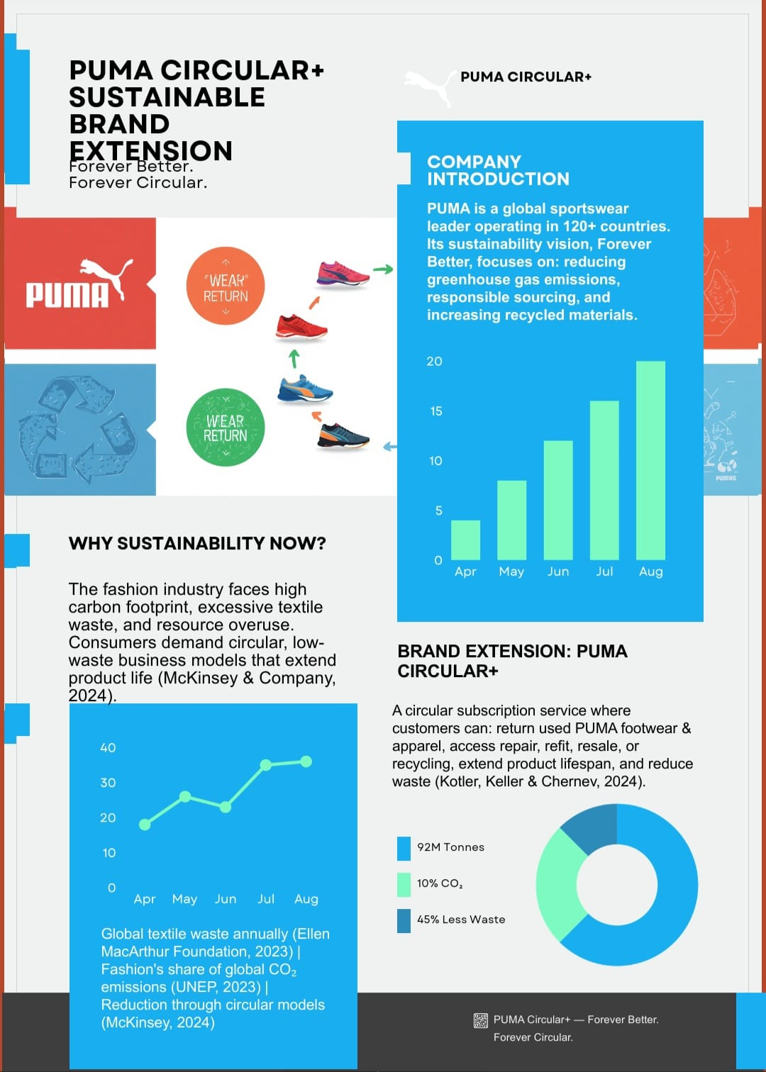

Element 2: Segmentation, Targeting, Differentiation and Positioning (STDP) Analysis
2.1 Introduction

The Segmentation, Targeting, Differentiation and Positioning (STDP) strategy framework is one of the most critical marketing tools in enabling organisations to target favourable market segments and formulate strategies that help to develop competitive advantages (Kotler, Armstrong and Balasubramanian, 2024). For the brand PUMA RE: CIRCULAR+, the framework enables the development of a sustainable brand extension that enables the service to truly address customer expectations, who have become more demanding and interested in environmental responsibility and circular consumption.

2.2 Segmentation

Market segmentation can be defined as a process of dividing the market into segments according to their similarities so that more effective marketing strategies are adopted (Keller and Swaminathan, 2020). PUMA RE: CIRCULAR+: Four segmentation variables.

Sustainability awareness is suppressed, and PUMA is not well represented in the retail sector in other geographies; therefore, that is where the service is not offered. Growth is also observed in terms of acceptance of circular economy initiatives and repaired products in these regions.

With respect to demographics, the main market targets are Generation Z and Millennial consumers aged between 18 and 40 years of age. The study reveals that younger audiences are more eco-conscious and favour brands genuinely seeking to be sustainable (McKinsey & Company, 2024). This group is also actively involved in the digital world, increasing access to them through integrated offline and online services.

According to psychographics, the target group are consumers with values pertaining to sustainability, ethical consumption and product quality. They see buying as an expression of their values and are prepared to champion organisations that minimise environmental effects. The case for sports lovers and lifestyle consumers is especially pertinent as they're keen on working towards their preferred product while opting for a responsible consumption choice.

The service is oriented to loyal customers, who already shop at a PUMA store in the area—whether for its beautiful approach or its commitment to the principles of sustainable development—who will routinely buy sportswear goods from the store. Refurbishment, resale and recycling programmes will ensure ongoing customer relationships with people who are interested in the durability of their product and have high levels of brand loyalty.

2.3 Targeting

PUMA RE: CIRCULAR+ targets an alpha audience; consumers who discard traditional consumerism and are closer to the eco movement in their sports and lifestyle choices. This segment is sensitive towards product performance and takes sustainability into account when purchasing products. Their customers are digital, socially conscious and are growing more sensitive to the notion of corporate social responsibility, as well as brands that have a strong environmental responsibility.

By concentrating on this piece, PUMA can increase customer loyalty and at the same time, appeal to those who are looking for sustainable fashion options as alternatives to fast fashion. In addition, the trend of second-hand and repurposed products plays a positive role in the market in regard to a circular business model. The service addresses current PUMA customers as well as environmentally-minded consumers, thus helping the company grow and get higher customer lifetime value.

2.4 Differentiation

Differentiation helps an organisation make a product that is unique or perculiar to that brand can’t be replicated by competitors (Porter and Kramer, 2019). PUMA RE: CIRCULAR+ is going beyond recycled production to sustainable uses, with its service line that includes repair, refurbishment, resale, and responsible recycling of the product over its life cycle.

The service also offers manufacturer certification and restores with original materials and trained experts, guaranteeing the product's quality and performance. This is better than an independent repair service where repairs may be carried out using substandard materials and quality control. In addition, the extended lifespan of sports gear means that people have a longer duration to connect with the PUMA brand and uphold responsible consumption by keeping the products for longer, through emotional, memorable or personal reasons.

2.5 Positioning

Positioning sets out the unique space in the mind of its consumers over the competitor's products (Kotler et al., 2024). Professional repair, refurbishment, resale and recycling make Puma Re: Circular+ a top-tier circular sports clothing service, offering sustainability and a perfect balance of performance and affordability.

The positioning statement is:

PUMA RE: CIRCULAR+ is the sports and lifestyle product renewal service for environmentally conscious players and consumers - The product is made avaliable for customers with services such as professional repair, refurbishment, resale and recycling of sportswear to eliminate negative environmental impact while ensuring quality and style are maintained.

By taking this stance, it further embodies PUMA's sustainability approach and deepens the brand's distinction by offering circular innovations, with value to the consumers, and a clear commitment to long-term environmental responsibility.
Element 3: Marketing Mix (7Ps)
3.1 Introduction

The Marketing mix can be used as a strategic tool to add value to customers to fulfil the organisation's objectives. As the 7Ps marketing mix highlights service delivery, the customer experience and operational processes (Kotler, Armstrong and Balasubramanian, 2024), it is more suitable to be implemented to the study of PUMA RE:CIRCULAR+, which is a service-based sustainable brand extension than the 4Ps. When sustainability is incorporated into each element, PUMA's competitive position is enhanced, and the sustainability principles of the circular economy are implemented, which results in decreased textile waste (Abdul-Hamid, Ankomah, and Angenu, 2022).

3.2 Product

PUMA RE:CIRCULAR+ is a circular product-service system of prolonging the lifetime of PUMA footwear, clothing and accessories by repairing, refurbishing, selling and recycling. The service does not encourage consuming a product that has reached the end of its useful life, but it encourages customers to use it in the best possible way to keep products in their best condition and performance.

This will involve professional refurbishment, a trade-in scheme where customers can earn store credit, and retail for customer-owned and professionally certified refurbished products. Products that are unsalvageable are managed in PUMA's existing sustainability programs, minimising waste to landfill and promoting the use of resources (Ellen MacArthur Foundation, 2021). This would help build consumer confidence in the PUMA service and drive what sets PUMA apart – a manufacturer-backed service, ensuring quality.

3.3 Price

The new pricing philosophy of PUMA RE: CIRCULAR+ is value-based, as Professional Refurb will be available to customers at a lower price point than for new products. This fee should be used to promote sustainable purchasing practices (Kotler et al., 2024) and to reflect the quality of the service.

The suggested pricing will consist of:

Standard Repair: £20–£35
Premium Restoration: £40–£65
Performance Restoration: £70–£90

The customer gets 20-50% store credit when they use the Trade-In programme. A certified refurbished product will go on sale at between 40 to 60% below the retail price, which gives them an attractive price tag without compromising PUMA's quality branding. This approach is beneficial for both customer retention and will aid in long-term profitability.

3.4 Place

In addition to having physical stores, PUMA RE: CIRCULAR+ has a multi-channel distribution model that also includes the digital side. Customers can avail of the service via certain PUMA flagship stores, authorised retailers, the PUMA website and the mobile applications.

Physical locations offer customers product assessment and collection; digital channels enable repairs to be booked; customers receive estimates for their trade-in; and it is possible to track the progress of the refurbishment. The incorporation of digital channels and physical channels helps to enhance customer interaction and increase participation in circular business models, according to research (Fernandes et al., 2020). This holistic solution creates convenience and promotes sustainable consumption.

3.5 Promotion

Promotional messages should convey sustainability messages and product performance. This campaign, “Keep Great Gear in the Game,” focuses on the environmental and economic advantages of prolonging products' lives instead of replacing them.

The promotion will be through Instagram, TikTok and YouTube, and athlete endorsements, with sustainability influencers and user-generated content following. The use of hashtags by customers will be encouraged, fostering credibility and community participation in the range of pages they create. Consumer confidence in refurbishing will be enhanced by presenting them with clear educational videos on the refurbishing process, thus minimising the misconceptions around refurbished goods. When the apparel is sustainable, consumers highly appreciate transparency and quality assurance, as identified by (Baier, Rausch and Wagner,2020).

3.6 People

Employees play an important role in providing a quality service experience. PUMA needs to educate and train refurbishment specialists, as well as staff and customer service, to ensure customers understand the importance of sustainability and that technical support is provided consistently.

Implement repair solutions and educate customers on the value of trade-in and the environment, and use dedicated online support to provide a smooth shopping experience. Experienced workers improve service quality and consolidate customer trust, promoting customer loyalty for the organisation's brand in the long-term (Vargo and Lusch, 2004).

3.7 Process

The refurbishment is performed in a standardised manner, resulting in efficient operations and a high level of service quality. Every customer sends in products or comes to the store, and trained experts review the condition of the products and give them a quote. Once approved by the customer, the products are cleaned and repaired and then quality inspected and certified prior to return or delivery.

If the products are not appropriate for refurbishment, the material is routed into the PUMA recycling programs, thus minimising waste. Additionally, every customer gets a digital impact report that specifies the environmental impact obtained thanks to refurbishment, and that shows them the benefit of embracing a circular economy.

3.8 Physical Evidence

Physical evidence promotes customer confidence by giving customers a sense of the service quality and sustainability. Refurbished products will include a RE: CIRCULAR+ Certified label and a QR code providing a digital product passport with repair history and sustainability information.

A need for the retail sector is to put recycled material into the products and have separate refurbishment counters, introduce displays teaching sustainability so that PUMA continues their efforts in the field. Products will be returned in recyclable packaging, and it will provide the same brand feel and consumer trust through it and help Puma to be a leader in sustainable sportswear.

Element 4: Reflection :
4.1 Introduction

For this portfolio, PUMA's focus was set on a creative concept for a new product extension based on PUMA's circular economy principles, namely PUMA RE: CIRCULAR+. Extensive work was involved in understanding the application of the marketing theories to build a strategic sustainability marketing mix like STDP and 7Ps. This reflection assesses my experiences of learning, skills acquired and ways to further develop these.

4.2 Experience and Learning

On this assignment, I gained a deeper insight into how sustainability can be implemented in the brand strategy beyond marketing communication. The concept of the circular economy and practises like repair, refurbishment, resale and recycling demonstrated their potential to generate environmental and economic value in a systematic business model.

In a workshop facilitated by the application of STDP, I gained an understanding of how different types of consumer segments are reacting to sustainability initiatives, as well as a deeper understanding of younger audiences (like Gen Z and Millennials). The 7Ps framework helped me understand how marketing strategies based on services should integrate the working of the service processes with the service experience and service communication in order to create value for the customer.

I also learned that tried-and-tested brands like PUMA can open up opportunities to reinforce customer loyalty by moving away from a linear “buy-and-dispose” cycle to an approach with a circular economy and services.

4.3 Skills Developed

This work taught me various important academic and work-related skills. The academic knowledge I can find and use to make marketing decisions was a wonderful learning experience for me. In addition, I developed my thinking skills by connecting the parts of theory to practice regarding sustainability issues.

I also enhanced my logical thinking skills in structuring complex ideas, especially for the presentation of the segmentation, targeting and positioning theory/s. It has also given me more practice at academic writing, which I recognise that there is scope to improve, but is a skill I have become better at.

The quality of and success in professional development and future improvement.

Professionally, it further deepened my concept of sustainability as the leading component of the contemporary marketing process. It also helped me enhance my strategic marketing consultant thinking skills in creating value for customers, profitability, and environmental consideration.

However, I realise that I must enhance my critical analysis by analysing competitor strategies in greater depth, and thoughtfully reviewing potential risks and aspects that the proposed model may have before making a decision. In future, I also hope to work up to a greater depth and variety of academic references.

4.5 Conclusion

Overall, I gained more knowledge about sustainable marketing and circular business with this assignment. It improved my academic and professional competence, and it imparted the knowledge and understanding of how sustainability can be an effective brand development strategy.

Harvard style references:
Baier, D., Rausch, T. and Wagner, T. (2020) ‘Drivers of sustainable fashion consumption’, Journal of Cleaner Production, 274, pp. 1–12.
Ellen MacArthur Foundation (2021) Circular economy in the fashion industry. Available at: https://www.ellenmacarthurfoundation.org/topics/fashion/overview (Accessed: 1 July 2026).
Ellen MacArthur Foundation (2017) A new textiles economy: Redesigning fashion’s future. Available at: https://www.ellenmacarthurfoundation.org/a-new-textiles-economy (Accessed: 1 July 2026).
Ellen MacArthur Foundation (2019) Fashion and the circular economy – deep dive. Available at: https://www.ellenmacarthurfoundation.org/fashion-and-the-circular-economy (Accessed: 1 July 2026).
Ellen MacArthur Foundation (2026) Fashion brands urge governments to fix resale and repair systems. Available at: https://www.ellenmacarthurfoundation.org/press-release-fashion-brands-urge-governments-to-fix-the-economics-of-resale-and-repair (Accessed: 1 July 2026).
Fernandes, T., et al. (2020) ‘Omnichannel retail and customer engagement’, Journal of Retailing and Consumer Services, 54.
Kotler, P., Armstrong, G. and Keller, K. (2024) Marketing Management. Harlow: Pearson.
McKinsey & Company (2024) State of Fashion: Sustainability insights. Available at: https://www.mckinsey.com/industries/retail/our-insights (Accessed: 1 July 2
PUMA SE (2024) Circularity and RE:FIBRE initiative. Available at: https://about.puma.com/en/circularity/refibre (Accessed: 1 July 2026).
PUMA SE (2023) Annual Report 2023 – Sustainability and circularity. Available at: https://annual-report.puma.com/2023/en/sustainability/circularity/index.html (Accessed: 1 July 2026).
Vargo, S.L. and Lusch, R.F. (2004) ‘Evolving to a service-dominant logic’, Journal of Marketing, 68(1), pp. 1–17.

