
Skills for the Workplace
Module Assignment Submission
Student Name: | Ewa Kowalewska
Student Number: | 2017236
Module No: | BMSK4008
Module Title: | Academic and Research Skills

Statement of Confirmation of Authenticity
By the act of making this submission, the student declares that this is the work of the student named above. The work has not, in whole or in part, been knowingly presented elsewhere for assessment, or where assessment has been built on a previous assessment, this has been identified. Where materials have been used from other sources it has been properly acknowledged. If this statement is untrue, the student acknowledges that an assessment offence has been committed.
Attention is drawn to the plagiarism and unfair practice policies of both the University and of ILM.
Permission for ILM to use this script
ILM uses learners’ submissions – on an anonymous basis – for assessment standardisation. By submitting, both the centre and the learner agree that ILM may use this script on condition that identifying information is removed. However, if you are unwilling to allow ILM use this script, please refuse by ticking the box: □

Table of Contents
Managing Remotely: Is it the Way Forward? 3
Part 1 3
1.1 Introduction 3
1.2 Research 3
1.3 Findings 3
1.4 Conclusion 4
Part 2 4
Personal Reflection on Managing Remotely 4
2.1 Description 5
2.2 Feelings 5
2.3 Evaluation 5
2.4 Analysis 5
2.5 Conclusion 6
References 7
Appendix 1 8
Appendix 2 9

Managing Remotely: Is it the Way Forward?

Part 1
During the Assignment of the following topic, managing remotely which need to be researched discussed, and analysed which will lead to the quality and truthful report of positive and negative impact of managing remotely to present the work more objectively it will need to be done through sources that successfully pass C.R.A.A.P test (Currency, Relevance, Authority, Accuracy and Purpose).

1.1 Introduction
This report includes information and research of managing remotely. It will answer the questions if manging remotely is to be the way forward? Also, if it has a positive or negative impact on our lives. It will show how communication organising skills and interpersonal skills have been handled using remote management in all aspect, not only employability or leaders’ skills but also education and life commitment.
“There is no real excellence in all this world which can be separated from right living” (David Starr Jordan)

1.2 Research
To combine this report following research and the findings shown that the Covid 19 pandemic has led to a disastrous effect on the economy which causes them to suffer from the negative influence but also to explore the positives of an entire shut down. World economy during Covid 19 pandemic have divided into two section such as essentials/ non-essential. In the United Kingdom non-essential were for example footwear shops, clothing shops, tobacco shops, travel agents, vehicle showrooms and electronic stores where essentials were food stores, newsagents, off licenses, supermarkets, and garden centres. Others could carry on by doing click and collet service or takeaway service like restaurants. Many companies were suffering from the quarantine rule made by individual county governments to stop the spread of the virus for example costumer service like Virgin Media, BT, society building including banks which on the beginning of the world pandemic stayed open suffer from lack of costumers face to face contact and difficulties from the fear of life threating virus which made them decide to move only on remote working from home and dealing with the customers from the house and over the telephone or any other technology available. With time and the new norm created many of those decision were made that is the way forward for their companies as it is much easier and less cost to operate remotely. The research also shows that working remotely has become more popular and significant in the era of the pandemic. When we look at the research done by Eurostat back in 2018 it visible that only 3.4% were working remotely in Europe but when we compare the same research done in 2019, we can see the difference in percentage which is over 5.6% working remotely. “For many employers this has been a response to increasing interest in work life balance” (Bailyn L, 2001). In the beginning people had many difficulties to adapt to this situation for example adapting they private space into home office, lacking IT skills which were required for good communication skills between the employers. Use of software and Microsoft applications correctly and effectively which included Microsoft Team, Zoom, Google Meeting also time management and life commencement could cause distractions as all individuals have, they own circumstances to be adapted. Which eventually led to the adjustment of a new law with Human Rights. The Equality Act 2010 places a duty on employers to ensure that reasonable adjustments are made to enable an employee to carry out day-to-day duties (Equality and Human Rights Commission (2019)). “If a requirement as at present with the COVID-19 pandemic is to work remotely from home, external work applications should be as accessible as working on a desktop on site, allowing continuity in productivity. Experience has proven this is not always the case as employees have often used their own technology without the desktop applications which they use daily. If a workplace feature or practice, for example, digital applications, puts an employee with a disability at a disadvantage, an employer should look to see what ‘reasonable adjustments’ it can put in place. One such adjustment would be to transfer the desktop workstation from the employer’s workplace to the employee’s home. Once the system is set up, the employee can continue to carry out their duties.” (Barry Ginley Working remotely if you are visually impaired, available at: Working remotely if you are visually impaired - Barry Ginley, 2020 (sagepub.com)). Overall, this research shows that even if many difficulties can come in the way we can overcome them and work remotely with satisfying effect and good productivity by adapting to the new norm created by the world pandemic. “Recent years have seen an increasing number of organisations in the UK offering range of flexible working options to their employees. (Kersley et al., 2006). Not only has working remotely become the new norm during the world pandemic all schools had to close due to the high risk of spreading the virus and they started to operate remotely from home and teachers could carry on passing their knowledge to the students. In the beginning it was quite difficult for everyone to adapt but with time we see much more productivity and the positive impact of studying remotely which causes lower numbers of Covid 19 cases.

1.3 Findings
To create this finding with qualitative and quantitative date following (Appendix 1) questionnaire was made to find out how many people that complete the survey work remotely and what jobs can be reasonably preformed from home. It helps to understand what the responders see as a positive and negative impact of working remotely. Beside the data shows that many people are considering working remotely in the future if they would have the opportunity to do so. Furthermore, the questionnaire answers how difficult or how easy are we able to separate our personal life from work commitments whilst working from home.
The questionnaire has been created in Goole Forms and contains ten questions all those questions were open to any other suggested answers from the responders. The questionnaire was answered by a variety of professionals who worked in face-to-face contact with others before the Covid 19 pandemic, for example teachers, nurses, managers, office workers and factory workers and many more. The responders from the questionnaire were divided by 82% percent that currently work remotely to 18 % who stayed in they workplace during the pandemic. On the other hand, people who filled in the questionnaire answered that 71% would consider working remotely to 29% not willing to even consider the above. The majority of respondents work between 30-40 hours a week (76%), while another group with a high percentage which was 17% work between 16-30 hours a week but only one percent that admitted working remotely more than 40 hours a week. Finding shows the most suitable hours for the responders to work remotely for over 57% are the midday hours (12pm-6pm). The finding also shown that greater part of the respondents which was 65% have someone depending on the during their work hours from home and only 35% had no dependant. The most beneficial answers in the questionnaire which bring a lot of information due to the question being fully open to the responders’ points of view was to list three positives and three negative impacts while working remotely. Most common answers in the positive side of working remotely were saving time on traveling to work and not being on the roads during peak times being able to sleep longer also saving money on petrol or public transport and not being exposed to catching the virus which made them feel safer. The second finding that was very common it was that the responders thought they were more flexible and comfortable in their own space but also able to set their own routines around their family commitments. “Generally flexible workers report lower levels of strain and stress” (Almer and Kaplan, 2002) The answer also shows that people in the category of positive were staying at home and have more time for their loved ones whilst working remotely. On another hand the questionnaire reveals the negative impact of working remotely from the respondent’s point of view most common answer was that people feel less motivated to work and their productivity is much less visible, also that their are lacking face to face contact which was the generally most negative impact of working from home. The respondents mark as negative, lack of IT skills and technical issues, lack of office equipment. The other points that came out from this questionnaire was that people feel like they are taking their work less seriously and spending more time in front of computers or any electronic devices and not having fresh air. Some responders also claim that they have tendency to work much longer hours and they are easily distracted by other members of the household. The last two questions were to show overall satisfaction of the responders in a scale from 1 to 5 where one was not satisfying and five to very satisfying in working remotely and how easy or difficult it was for them to separate the work from personal life where 1 was not easy and 5 very easy to separate. Answers from the fist scale vary from 31% being not satisfying from working remotely to over 46% being very satisfying. The other question reveals that people who respond the questionnaire find difficult to separate their personal life from work while working remotely over 32% claim that it was very difficult to 41% thought it was very easy to be separated. This survey has been published on social media platforms and student access only Team Microsoft. The above surrey has been completed by one hundred responders.

1.4 Conclusion

In conclusion of this report, we need to understand that working remotely become a new norm in 2020 due to the world pandemic. Working remotely becomes more popular and in some way safer for the employees. The world pandemic has been a massive wake-up call towards the potential of working remotely and how business can work around difficulties and positives that come with it. In all this people had to become more open to adapt to the new unknow norms that will stay with us for many years to come. In the beginning of working remotely for many places productivity and lack of preparation lead to losses, and many employers had to adjust to new training and equipment provided to their employees. Managers need to become more open towards individual situations that come across from working remotely for example children or animal noise in the background that can interfere on the meeting that a held remotely but moreover people with time showed that is possible to work and have good results. Overall employees, managers, business owners and many more could possibly see the effect of working remotely, in few years from now will become more beneficial than it does at the moment but on another hand many of them will still feel the consequences of national lock downs and working remotely may have a bad effect on their business and corporation. Furthermore, due to employees working at different stress levels it could lead to loss of business. “Where employees are able to exercise choice over, their working patterns, there is evidence to show a positive impact on job satisfaction (Hill et al., 1998).

Part 2

Personal Reflection on Managing Remotely


Gibbs (1988)

2.1 Description
In this assignment we have been asked to research and conclude our findings on working remotely. Create a report on what positive and negative impact comes with it. We also have to present an academic report on a working remotely topic and construct an academic argument. We also have been asked to create a questionnaire in Google Form to present our capability of basic statistics skills and creating charts and graphs.

2.2 Feelings

As the world is suffering with the global pandemic, the topic was relevant to the current situation we live in. Personally, I found the topic remarkably interesting as I am unemployed, and I have no experience in working or manging remotely in which case I do not have professional experience in time management and work culture in those aspects. While doing the questionnaire I found it quite difficult to objectively see answers given by the respondents as the questionnaire still leaves many unanswered questions from my unemployed perspective.

2.3 Evaluation
In my research I have found many interesting facts about working remotely as being unemployed I have had to base it on the online fact-finding websites and our tutors’ instructions unfortunately I still have not found all the answers to my questions as we still are living in the pandemic, I believe we be able to answer so many more questions in time. My questionnaire helps me to understand people who work remotely points of view. It was a fantastic experience to be part of but on another hand, I still would like to ask many more questions however in my case I was reluctant to potential responders as the questionnaire could take much longer to complete and the questions might become too personal. On our lesson we had an example of one of our colleagues working as a manager remotely where an uncomfortable situation developed with one of her employees which was loud music in the background during their meeting online. Her approach to the situation was incredibly soft in my opinion and very unusual for me from my perspective in all respect she exposed many more employees to not hearing clearly the instructions that were being given only due to one individual. Personally, I have never been in such circumstances so I cannot really say how this matter could be dealt with in other professional way. However, we need to bear in mind that it was not a natural background noise like children playing or animal sound.

2.4 Analysis

This assignment could be beneficial for me in the future if I could work remotely or have a chance to manager people remotely. I have adapted so much knowledge of the professional way of working from home and how to create our working and living space. This experience showed me how many applications are available to produce better quality remote working and how to become more proactive even when working from home. It also shows how much we can expand our horizons in many aspects when working remotely. However, there is much more to it by working remotely we have tendency to work longer hours and have difficulties to separate our family and private time from working hours. We also become less socialised with other people which is especially important for our health also it make us less motivated and in some cases as stated in my questionnaire even depressed. Beside all that impact pandemic showed us that most employers were not prepared for such drastic changes and many of their employees have not had relevant training in years also the was some imperfections in the system used by companies so many of them haven’t updated them for years and had to change them during this difficult time which caused the money losses.

2.5 Conclusion
Overall, I would love to interact and research this study further I would also like to find opportunity to work remotely even volunteer to see all the impact that comes from working in such a way from personal point of view. However, at this stage my opinion towards working remotely in not as positive apart from us having such a huge development of technique and all amenities working remotely have its weak side the biggest one for me is lack of face-to-face contact which is very harming for our mental health and can make us become less motivated depressed and miserable.

References

ADAM HICKMAN, P. A. J. R., 2020. Its working remotly effective?. [Online]
Available at: http://metadataetc.org/gigontology/pdf/Is%20Working%20Remotely%20Effective%20Gallup%20Research%20Says%20Yes.pdf
[Accessed 20. 03. 2021].
Anna Dolot E-mentor, 2020. The influence of COVID-19 pandemic on the remote work - an employee perspective. Economy, Business Economy / Management, 1( Szkoła Główna Handlowa w Warszawie, Fundacja Promocji i Akredytacji Kierunków Ekonomicznych), p. 9.
Almer ED, K. S., 2002. The effects of flexible working arrangements on stressors, burnout, and behavior job outcomes in public accounting. Behavioural Research in Accounting. Volume 14, pp. 1-34.
Bailyn L, R. P. B. D. C. F. a. T. M., 2001. Fleet financial and Radcliffe explore paths of work/life integration.. [Online]
[Accessed 09 03 2021].
Baruch Y., N. N., 1997. Home, sweet work: Requirements for effective home working. Journal of General Management. Volume 23, pp. 15-30.
Eurostat Statistic [Online]
Available at: Home - Eurostat (europa.eu)
[Accessed 10.03.2021]
Equality and Human Rights Commision, 2019. Equality and Human Rights Commision. [Online]
Available at: https://www.equalityhumanrights.com/en
[Accessed 11 03 2021].
Gibbs, G. (1988) Learning by doing; A guide to teaching and learning methods. London: FEU
Ginley, S. J. B., 2020. Working remotely if you are visually impaired. [Online]
Available at: https://journals.sagepub.com/doi/full/10.1177/0264619620925702
[Accessed 10 03 2021].
Google Forms, n.d. Google Forms. [Online]
Available at: https://www.google.co.uk/forms/about/
[Accessed 03 2021].
Kersley BA, F. J. B. A. B. H. D. G. a. O. S., 2006. Inside the Workplace: Findings from the 2004 Workplace Employment Relations Survey.. [Online]
Available at: London: Routledge
[Accessed 08 03 2021].
Y, B., 2000. Teleworking:Benefits and pitfalls as perceived by professionals and managers. New Technology , Work and Employment. [Online]
Available at: googlescholar
[Accessed 20 03 2021].
Zalega, D. T., 2002. Praca zdalna obraz przemian w Polsce i wybranych krajach Unii Eurpejskiej. [Online]
Available at: http://31.186.81.235:8080/api/files/view/1398.pdf
[Accessed 03 2021].

Bibliography

Bailyn L, Rayman P, Bengtsen D, Carre F, and Tierney M (2001) Fleet financial and Radcliffe explore paths of work/life integration. Journal of Organizational Excellence.
Baran, K.W., Ćwietniak M., Dorre-Nowak D., Walczak K. (2009) Prawo pracy. Warszawa: Wolters Kluwer Business. Barlett, C.A., Groshal S. (1993) Beyond the M-from. Towards a Managerial Theory of the Firm. Strategic Management Journal, No. 4.
Bąk, E. (2006) Elastyczne formy zatrudnienia. Warszawa: C.H. Beck Boni, M. (red.) (2008) Raport o kapitale intelektualnym Polski. Warszawa: Publisher, URM.
Baruch Y. , Nicholson N. ( 1997) Home, sweet work: Requirements for effective home working . Journal of General Management 23: 15-30.
Google Scholar | SAGE Journals
Covey, S. R., 2004. 7 The Habits of Highly Effective People. London: Simon & Schuster UK.
Hill EJ, Miller BC, Weiner SP, and Colihan J (1998) Influences of the virtual office on aspects of work and work/life balance. Personnel Psychology 51: 683–67.
Kersley BA, Forth J, Bryson A, Bewley H, Dix G and Oxenbridge S (2006) Inside the Workplace: Findings from the 2004 Workplace Employment Relations Survey. London: Routledge.
Long, J.S. and Freese, J. Regression Models for Categorical Dependent Variables using Stata (2nd Edition). College Station, Texas: Stata Press.
Morgan P., (2017) The Business Student’s Guide to Study and Employablity. SAGE Publications Ltd, London.
Mound A., Schriek M., Tinkler P., K., (2017) Certificate in Higher Education: Skills for the Workplace Student Yearbook. SAGE Publications Ltd, London.

Appendix 1

Belove screen prints presents the questionnaire created by the above name student.
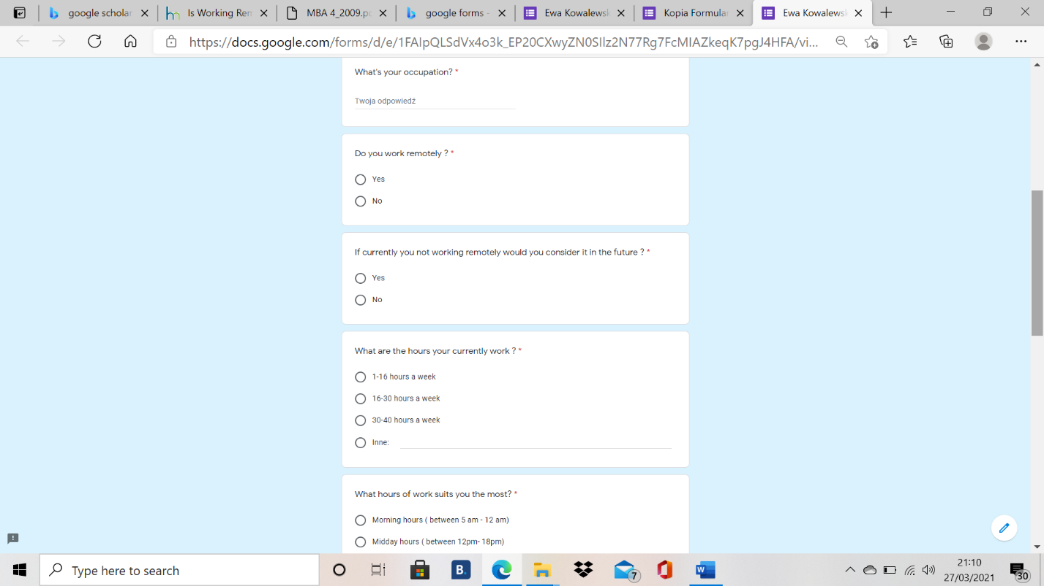

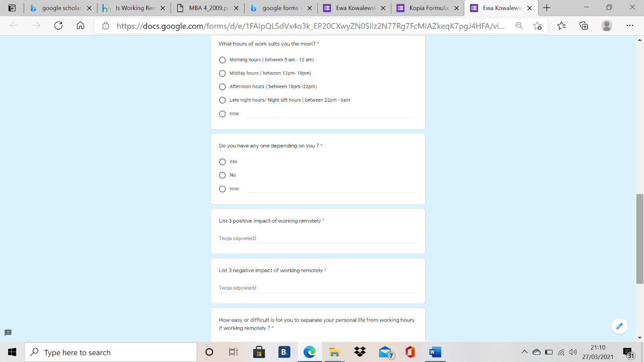
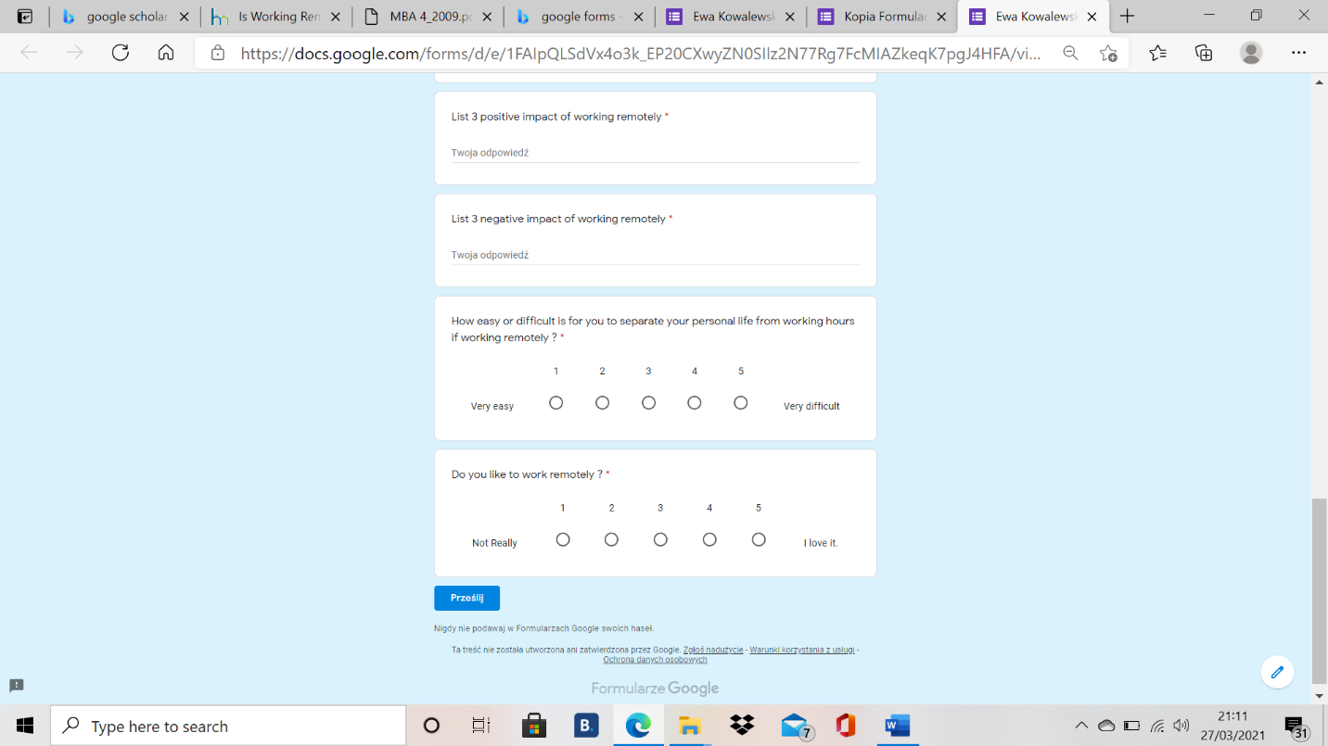

Screen print belove shows the statistics created by Google Forms to answers from respondents to the questionnaire.
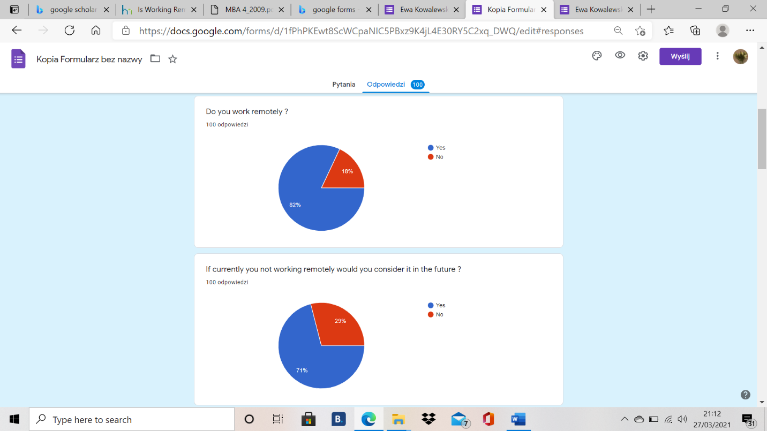

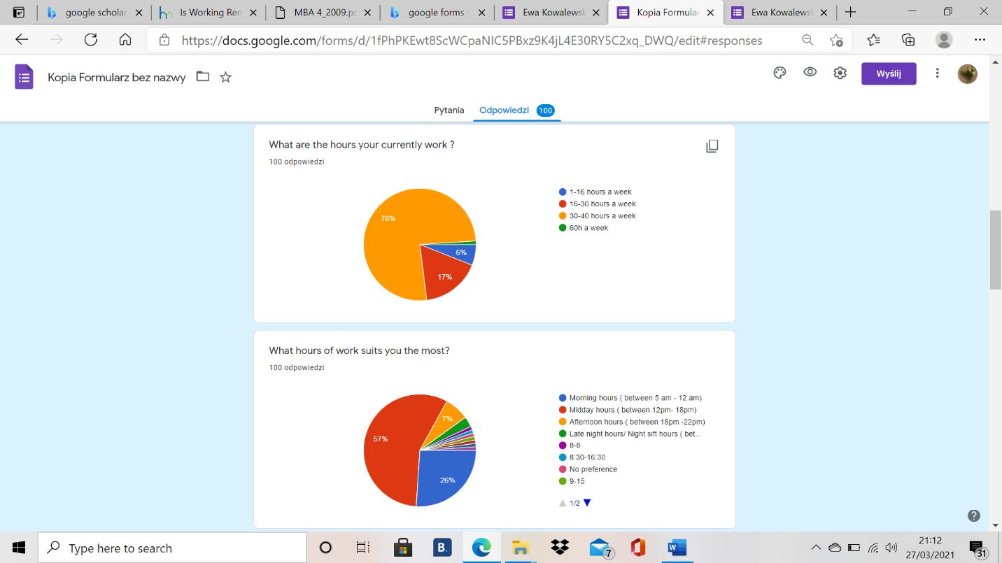

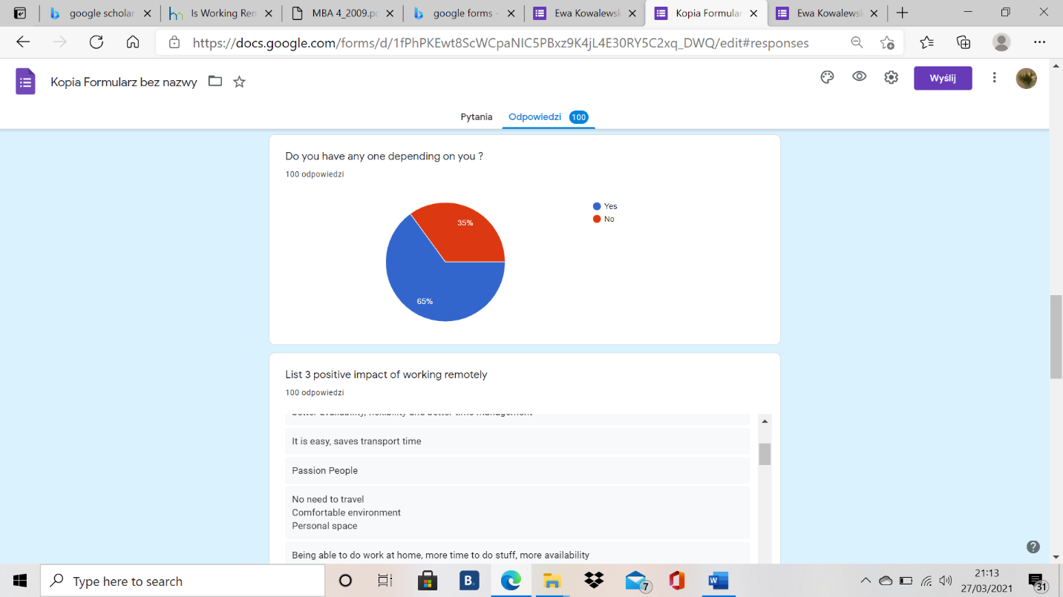

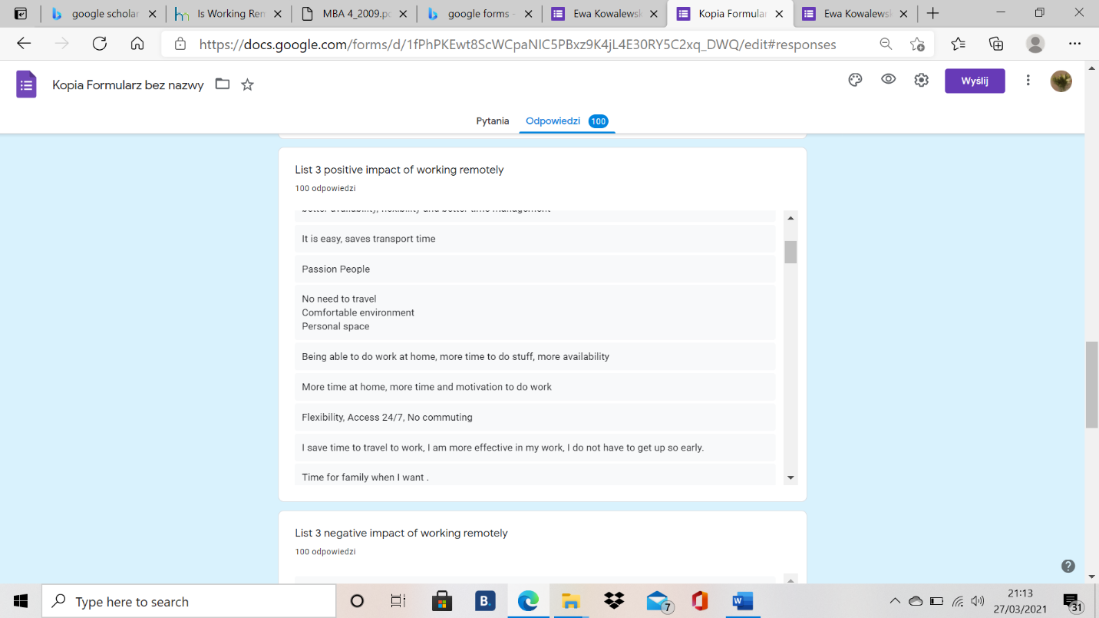

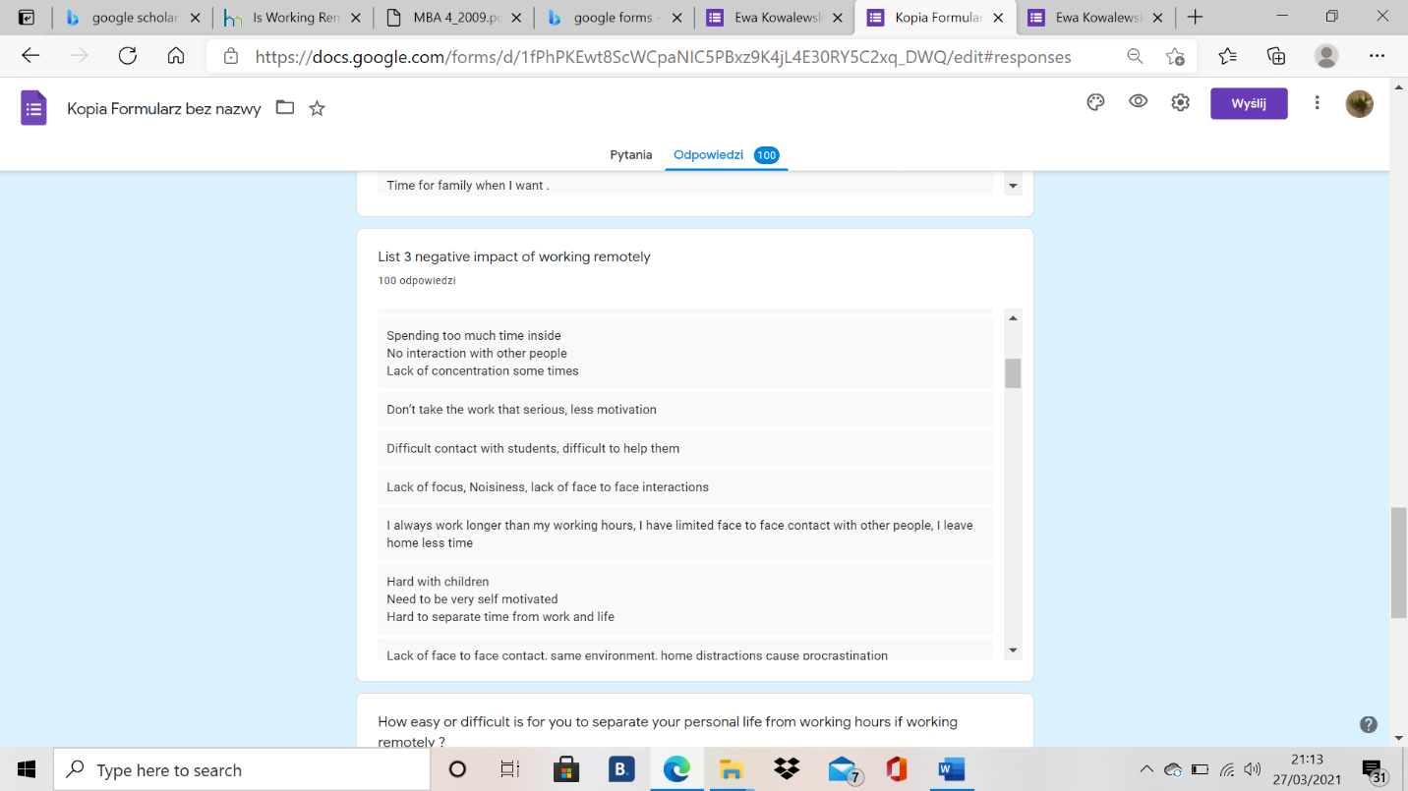

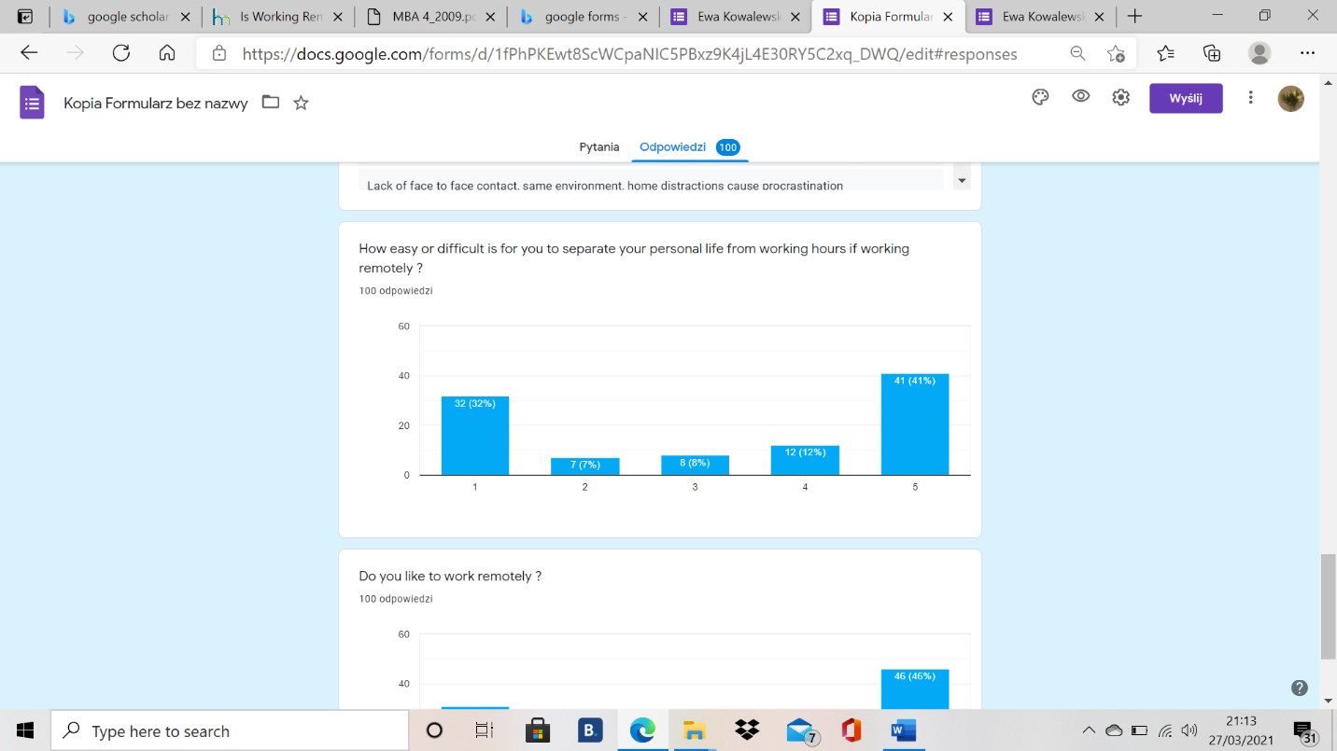

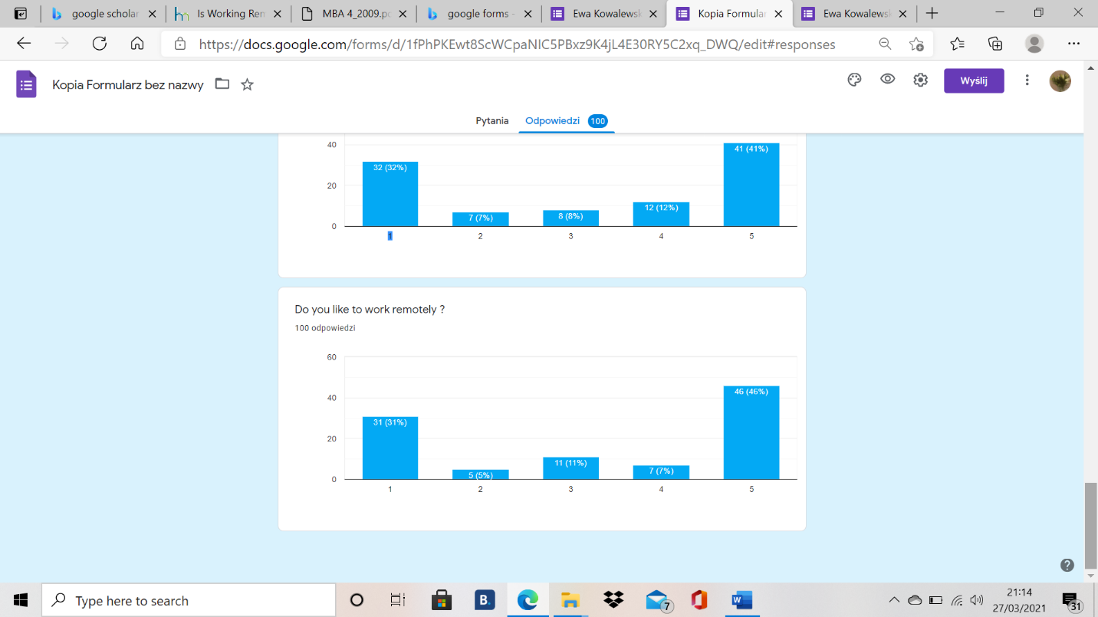

Appendix 2

