

Assignment 2

Student name: Gurleen Kaur

Student id: 2129497

Module code: LCBB5000

Lecturer: Dr. Anupam Mazumdar

Table of Contents

Part 1
Introduction…………………………………………………………………….
Discussion……………………………………………………………………….
Conclusion……………………………………………………………………….

Part 2
Introduction……………………………………………………………………..
Discussion………………………………………………………………………
Conclusion……………………………………………………………………….
References……………………………………………………………………….

Part 1

Introduction
The analysis of sales data allows observing consumer behaviour in the market as well as finding some new trends and opportunities for business growth. By analysing the main factors such as sales trends, customers’ purchasing patterns, and the most successful departments and markets, business owners can come up with the best tactics that can improve their profit and sustainability. This section examines the variables that affect the results which are used in drawing out recommendations that would enhance profit levels as well.

Discussion
Question 1
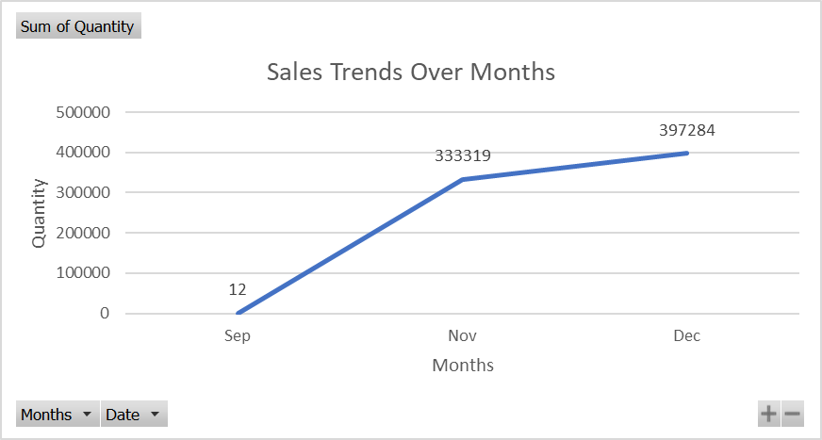
Figure 1.1: Visualization of sales trends over months
The sales pattern for the given period can be concluded from the table represented below, in which the total sum for the number of items sold has been written for each month. The information includes September, November and December, and a total number of 730,615 units of sales. In September, there were 12 units sold figures suggesting a minimal sales activity level possibly due to the beginning of the holiday season not subtly influencing consumer behaviour.
November has the maximum sales as this month registers 333,319 units sold. The sharp rise in sales arises from numerous aspects including black Friday special offers, Cyber Monday deals and a growing green wave during the last period of the year as people progressively intensify their preparations for the most entertaining season in the year. However, the peak sales requirements for December are 397.284 units among the months included in the analysis. Shopping tendencies change quite considerably in December, with Christmas and New Year's Eve purchases forming the peak of the shopping season (Spennemann and Parker, 2021). It is typical for customers to spend more money before the holidays on gifts, decorations, and other festive items purchased, which makes a lot of turnovers go to businesses.

Overall, throughout September to November, there is a steady progressive increase which receives a slight boost in December reflecting the seasonal nature of the business. The February finalization of sales reflects the same retail pattern observed where sales rise constantly towards the end of the year when holidays are in full swing, and the buying habits of consumers are also affected. The line chart in Excel graphically depicts the data, thereby giving a clear picture of the sales trend for each month and emphasising the significant increase in November and the subsequent peak in December. This graphical presentation would inform the stakeholders of the sales peaks of the season and let them make the right decisions about stock management, promotional strategies, and resource allocation.
Question 2
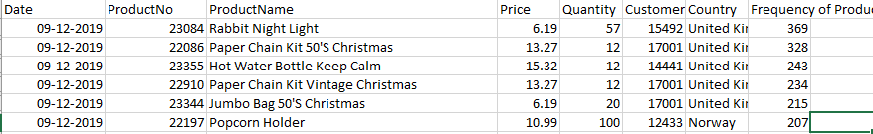
Figure 1.2: Visualization of the most frequently purchased product
The most frequently purchased products based on the total quantity sold are as follows:
- Rabbit Night Light: The Night Light of Rabbit finishes first, having sold 369 units in this quarter. Therefore, the high demand for decorative and functional lighting options is a sign that the market needs innovative designs for children's rooms or kid's room areas.
- Paper Chain Kit 50's Christmas: The Paper Chain Kit 50's Christmas was the second most favourite product on the market. Through 328 units sold in total, it had the majority of sales. This suggests that the demand is seasonal and may be related to its usage as decoration or as a part of usual Christmas celebrations.
- Hot Water Bottle Keep Calm: The Hot Water Bottle Keep Calm is the most frequently purchased item with a total of 243 units sold. This product is clearly in high demand among people interested in homemade projects.
- Paper Chain Kit Vintage Christmas: The Paper Chain Kit Vintage Christmas comes in as the fourth best-selling with only 234 units sold. This suggests a certain trend for vintage-styled house decor items, the popularity for which is likely more for those items with a rustic and antique look.
- Popcorn Holder: With a total of 207 units obtained while being ranked in sixth place for the bestseller Popcorn Holder. This item’s use can be explained by its vitality for serving snacks during parties, film nights, or whenever there is a social gathering.
Their popular products fall into different product categories such as seasonal decor, crafts, home decor, and functional appliances. The customers' explicit choices for different brands demonstrate not only the variable tastes but also the significance of having a large variety of products that fit various tastes and needs.
Question 3
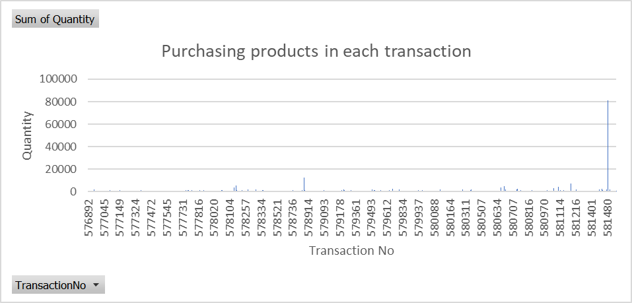
Figure 1.3: Visualization of purchasing products in each transaction
In order to find the number of products purchased per transaction by each customer, it is necessary to observe the "Sum of Quantity" column for the provided table. The term "Sum of Quantity" here quantity is the total number of items purchased in a single purchase. This data will help us to glean customer purchase patterns. In the given dataset, each row responds to different transactions determined by unique Transaction No. The "Sum of Quantity" column denotes the number of products that have been purchased in every transaction. For example, the information revealed by Transaction No 576892 shows that 152 products have been purchased, whereas, transaction No 576893 indicates 35 products have been purchased. Such data allows users to comprehend several items bought in individual transactions.
In addition, a longitudinal study of transactional data will disclose the seasonality, customers' preferences diversity as well as promotions' consequences. Utilizing the longitudinal analysis, manufacturers can make adjustments to their strategies proactivity and stay abreast of the newly emerging market changes (Alghamdi and Agag, 2024). Thus, examination of the transaction information gives the much-needed understanding of the purchase behaviour of the customers. Through the exploration of the total number of products that customers buy per purchase, firms can decide which steps they should take to maximize customers’ satisfaction, operations efficiency, and, ultimately, business growth.
Question 4
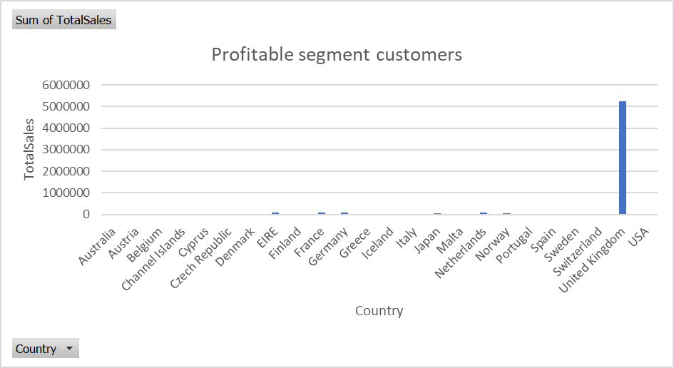
Figure 1.4: Visualization of profitable segment customers
When dissecting the given sales data, clearly it can be seen that the United Kingdom comes first in sales overall. The UK market, however, shows the most significant differences, generating a staggering total of £5,246,778.89 and thus leading competitors with revenues. This could be due to various reasons, such as the scale of the UK market, its strong economy and a probable there is probably a larger consumer base with a powerful purchasing power. Having left the UK in second place, the German, French and Irish markets are also promising for businesses which aim to export there (EIRE). These countries are selling in considerable amounts, especially the Netherlands. Concretely, the Netherlands sold £103,698.20 worth of products. Germany and France already inch at the backs with their sales making up the £89,343.11 and £90,309.10 respectively. They are economic power within the European Union, as indicated by the strong and developed trading followers.
Interestingly, while the UK boasts the highest sales volume UK's total sales, we also find that some countries with smaller populations, like Iceland and Denmark, have incredible figures compared to the overall population size. For example, Iceland with less than 500,000 inhabitants shows total sales of 10,975.14 pounds, thus the market could be relatively profitable too even for so small region. In addition, Norway and Sweden are proved to be good examples of markets which have considerable sales figures, which therefore confirms the strength of the Scandinavian market. Although the revenues of these countries are significantly less as compared to other European nations these still are the key players in the market due to the enormous buying power of their residents as consumers.
Another crucial fact is that outside of Europe, Japan, whose total sales amount up to £43,531.23, comes to the fore as the dominant market. This indicates that the international markets were relevant since they helped firms diversify their revenue streams and also get consumers from different borders. The United States thus provides expansion and growth of the business although it just constitutes a small part of the UK and European market. As a result, the UK leads the European market in terms of total sales, however, countries of the European Union such as the Netherlands, Germany, France, and Ireland are also contributors to the market income. Additionally, national markets such as Iceland, Denmark, Norway, and Sweden, quite small, show strong potential, reminding us of the need to know and cater to different consumer purposes in different regions for viable long-term business growth. Besides, spreading into international markets like Japan and the USA brings about many chances for growth and market diversification.
Question 5
Based on the findings from the analysis of the sales data, several strategies could be recommended to the business to gain more profit:
- Focus on Top Performing Markets: The UK market turns out to be the most profitable one in terms of the total sales volume. Therefore, the company should focus on spending more on assets, marketing, and inventory in the UK market. Adopting a more specific marketing mix based on the UK consumers' demand factors and buying habits may well achieve a higher figure of sales and profitability.
- Expand Presence in High Potential Markets: Additionally, the UK is the best at both in general sales and many other countries of Europe like the Netherlands, Germany, France, and Ireland showed great results. Developing the company`s footprint in those markets through partnerships, localizing marketing strategies, and targeting product offerings might serve as an added traffic stream that leads to profits (Wichmann et al. 2022).
- Tap into Emerging Markets: Small markets such as Iceland, Denmark, Norway and Sweden have yearly sales figures relative to their population size. For the firm to be successful in these markets, it is crucial to invest heavily in market research to understand the consumers' needs and preferences, the socio-cultural nuances of the region, and the purchasing power of the different socio-economic classes.
- Diversify Product Offerings: The data shows that the buyers are attracted to no less than 3 different categories: seasonal decoration, crafts, household decor and functional items for the home. Expanding the product mix by adding new trends and consistently introducing innovative products that appeal to a wider customer segment could boost sales and profitability through increased revenues from both the newer segment and the existing one (Wichmann et al. 2022).
- Optimize Operational Efficiency: Adaptive humanization involves streamlining operations, establishing efficient supply chain management and optimizing the way of stocking inventory based on sales trends and demand forecasts (Hasan et al. 2024). These ultimately reduce costs and enhance the profitability of the company. Integration of enterprise resource planning technology can help in collecting and processing information to make appropriate decisions and apply the best optimal methods for business processes.
- Enhance Customer Experience: Engaging experience creation for customers through personalized shopping, providing quick and responsive customer service correspondence and convenient return policies and exchanges will bring back the customers and earn their trust (Fernandes and Barfknecht, 2020). Forming effective customer relationships using targeted loyalty schemes, special offers, and amusing material will result in growing customer lifetime values and keeping the profit going.

Therefore, by concentrating on star markets, extending to lucrative regions, diversifying the product range, improving operational efficiency, and upgrading the customer experience, the business can propel itself to the podium in the competitive retail arena. Implementing the holistic strategy that will cover the key areas mentioned above will allow the organisation to tap new revenue opportunities, boost customer engagement, and finally, achieve profitability targets.

Conclusion
It can be concluded that the profitability of the company is augmented by the findings of the analysis of the sales data facilitating a comprehensive course of action towards the goal of higher profitability. By focusing on leading marketplaces, expanding the variety of goods, maximising efficiency, and improving the level of clients ‘happiness, businesses can secure long-term success in an unstable commerce environment. Implementing these strategies enables businesses to catch up with the intricate changes the markets impose, uncover new prospects, and succeed in attaining profitability goals.

Part 2

Introduction
The analysis contains several important results drawn from the data on student demographics, lunch qualification status, and academic performance which is reached with the mathematical methods and clustering. Figures include the visualizations for distribution, mean, clustering, and comparison of SPSS with Excel tools for data analysis.

Discussion
Question 1
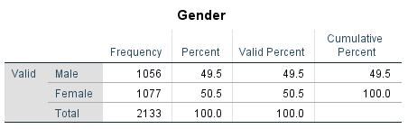
Figure 2.1: Number of male and female students
The survey was conducted among 2133 students where 548 of them were male (49.5%) and 585 were female (50.5%). This distribution shows that the sample not only represents one gender but both equally well. Having an equal number of males and females playing a role is useful in achieving the goal where judgments formulated are based on evidence gathered without any gender bias. brings in nested and proper information concerning the interplay of variables, between such factors as subsidized lunch status and test performance across various genders.
Question 2
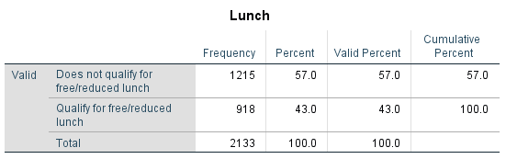
Figure 2.2: Number of students qualifies and does not qualify for reduced/free lunch
Of the total of 2133 students, only 57.0% which is 1215 of them fail to be granted a free or reduced school lunch, whereas 918 (43.0%) qualify and receive it regularly. This factor shows the sizeable part of the school's young people who are beneficiaries of the free lunches or reduced-price program which points out the social-economic gap problems within the school. The distribution of lunch qualification status knowledge is of critical importance for understanding the effects of socioeconomic factors on academic success.
Question 3
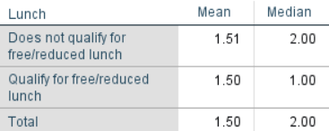
Figure 2.3: Mean and median of students who qualify and do not qualify for reduced/free lunch?

The image of a summary table of lunch intake is presented in the figure showing the mean and the median values. For those who are not eligible for free/reduced lunch the average status of lunch is 1.51, with the approximate median being 2.00. However, the students, who get free/reduced lunch, have the mean value of the lunch status 1.50, with a median of 1.00. As for the sum, both groups share an average lunch status of 1.50, with the median at 2.00. Such an outcome depicts a little gap in lunch status made between to the two groups, with those not qualifying for free/reduced lunch having slightly higher values on average as opposed to those who do qualify.
Question 4
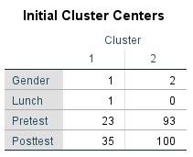
Figure 2.4: Initial cluster for k-means clustering
K-means clustering works by determining the initial cluster centres automatically by some randomizing process or using some predetermined method. This case is portrayed by cluster 1 which has distinctive features like being male, receiving the free or reduced lunch, and having lower pretest and posttest scores. However, cluster 2 is composed of mostly female students, who do not qualify for free or reduced-cost lunches and experience the highest pretest and posttest scores.
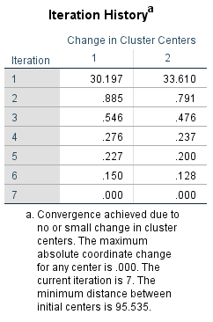
Figure 2.5: Iteration history of k-means clustering
In the 7th iteration, the change in cluster centres comes close to zero, as a maximum absolute coordinate change is observed to be at .000. This suggests that the algorithm has created groups from some points based upon the specifics used, by converging them close to each other. The next information given is about the initial centre distance, which represents the gap between the centres of the first cluster groups.
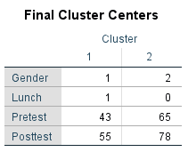
Figure 2.6: Final cluster centers for k-means clustering
In the final cluster centres of K-means clustering, cluster 1 is the only district with only male students who use free or reduced lunch programs and have lower pretest and posttest scores. Contrary to this, cluster two is composed of female students who do not qualify for free reduced lunch, and the scores ascended in the pretest and posttest. These clusters centre on the characteristics of the variation in demographics and academic performances among the students.
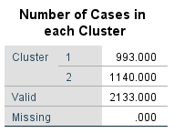
Figure 2.7: Number of cases in each cluster for k-means clustering
On the K-Means clustering results screen cluster 1 contains 993 cases, while cluster 2 contains 1140 cases out of the total 2133 cases. This reveals that the student body of the team is more or less evenly split between the two data points. Each of these separate clusters is made up of an identified subgroup with particular traits, such as student demographic features and academic performance attributes.

Question 5
Criteria | SPSS | Excel
Data Analysis | SPSS is an analysis tool that is explicitly developed for data analysis. It has been equipped with many types of statistical tools and functions for in-depth data analysis. It offers specialized tools for increasingly complicated analyses, regression, Analysis of variance (ANOVA) and factor analysis (Mertler, Vannatta and LaVenia, 2021). | Excel also features some basic statistical functions but has much lower capabilities than SPSS. The software will conduct undemanding tasks like the mean, median, and even simple charts. However, Excel may lack efficiency in examining huge datasets, those that require complex statistical analyses (Islam, 2020).
User Interface | SPSS is a software package for statistical analysis set-up with a user-friendly interface, having menus and dialogue boxes which lead the users through the various procedures (Pekpazar, Coskun and Altin Gumussoy, 2023). It is more user-friendly to users who are conversant with statistical language. | Excel's interface is already recognized among many users and therefore becomes a convenient tool with which to tackle simple data manipulation and analysis (Abbasnasab Sardareh, Brown and Denny, 2021). However, these users may need to have an advanced knowledge of complex formulas and functions for statistical analysis.
Automation | SPSS automation of processes helps perform repetitive tasks via syntax and scripting, as it enables a quick and efficient analysis of the whole dataset (Charalampopoulos, 2020). Data scientists can build scripts for carrying out procedures like data processing, analysis, and report generation, thereby decentralizing operations. | Excel provides only a few features to deal with automation compared to that what SPSS can do (Mirazchiyski, 2021). On the other hand, it supports macros for automation but is not as capable as multifaceted software when used for complicated data analysis tasks.
Visualization | SPSS comes up with a wide range of visualization tools, for example, charts, graphs and plots, to help in data exploration and convey the findings by visual means (Loffing, 2022). It provides an ability to develop the data graphic representations adequately. | Excel provides a diverse array of chart types and the option to customize them to visualize data (Qin et al. 2020). It can be used on the basic level of visualizing data, but it may lack certain features found in the specified data visualization tools such as SPSS.

Conclusion
It can be concluded that the identification of student demographics, economic inequality and academic indicators will help institutions implement precise solutions. Such tools as SPSS make possible an advanced analysis that gives a thorough analysis of data, whereas Excel is at an elementary level of analysis. Balanced representation, class diversity and clustering techniques provide appropriate criteria for building educational strategies that suit all students.

References
Abbasnasab Sardareh, S., Brown, G.T. and Denny, P. (2021). Comparing four contemporary statistical software tools for introductory data science and statistics in the social sciences. Teaching Statistics, 43, pp.S157-S172.
Alghamdi, O. and Agag, G. (2024). Competitive advantage: A longitudinal analysis of the roles of data-driven innovation capabilities, marketing agility, and market turbulence. Journal of Retailing and Consumer Services, 76, p.103547.
Charalampopoulos, I. (2020). The R language as a tool for biometeorological research. Atmosphere, 11(7), p.682.
Fernandes, N. and Barfknecht, C. (2020). Keep customers coming back: Enhancing value and satisfaction in a mobile shopping application context. Cogent Business & Management, 7(1), p.1788874.
Hasan, R., Kamal, M.M., Daowd, A., Eldabi, T., Koliousis, I. and Papadopoulos, T. (2024). Critical analysis of the impact of big data analytics on supply chain operations. Production Planning & Control, 35(1), pp.46-70.
Islam, M. (2020). Data analysis: types, process, methods, techniques and tools. International Journal on Data Science and Technology, 6(1), pp.10-15.
Loffing, F. (2022). Raw data visualization for common factorial designs using SPSS: A syntax collection and tutorial. Frontiers in psychology, 13, p.808469.
Mertler, C.A., Vannatta, R.A. and LaVenia, K.N. (2021). Advanced and multivariate statistical methods: Practical application and interpretation. Routledge.
Mirazchiyski, P.V., 2021. RALSA: the R analyzer for large-scale assessments. Large-Scale Assessments in Education, 9(1), p.21.
Pekpazar, A., Coskun, M.C. and Altin Gumussoy, C. (2023). Conceptualization and Survey Instrument Development for Over-the-Top Platforms’ Usability. Journal of Theoretical and Applied Electronic Commerce Research, 18(4), pp.1764-1796.
Qin, X., Luo, Y., Tang, N. and Li, G. (2020). Making data visualization more efficient and effective: a survey. The VLDB Journal, 29(1), pp.93-117.
Spennemann, D.H. and Parker, M. (2021). The changing face of German Christmas markets: Historic, mercantile, social, and experiential dimensions. Heritage, 4(3), pp.1821-1835.
Wichmann, J.R., Uppal, A., Sharma, A. and Dekimpe, M.G. (2022). A global perspective on the marketing mix across time and space. International Journal of Research in Marketing, 39(2), pp.502-521.
Wichmann, J.R., Uppal, A., Sharma, A. and Dekimpe, M.G. (2022). A global perspective on the marketing mix across time and space. International Journal of Research in Marketing, 39(2), pp.502-521.

