No | Improvement and Development Goals | Success Criteria  (How I will know when I have made this change) | The actions I will take to achieve the goal | Timelines | What will this help me to achieve? | Achievements  (3 monthly review)
1 | Enhance active engagement and note taking in university lectures and within independent study. | When I consistently prepare lecture notes and formulate a few questions or key summaries from each lecture topic to test my understanding. | Complete pre lecture readings and outline key concepts before attending sessions.  Use structured note taking frameworks such as the Cornell method.  Review lecture slides post session to write summaries and note follow up questions for online discussion board/lecturer hours. | Next 4-6 weeks | Help improve information retention and strengthen critical thinking. Improves my foundation of academic knowledge.
2 | Improve knowledge and understanding of observational analyses and child development frameworks. | I will be able to confidently analyse case studies and child observation data, for example narrative logs and accurately link them to early years developmental milestones. | Review lecture materials and academic sources on observational methods.  Explicitly link observed behaviours to Early Years learning framework. | End of academic year. | Deepens my theoretical understanding of child development.
3 | Develop a deeper understanding of inclusive practice (ALN). | Have a deep understanding of ALN legislations and the multi agency referral processes.  Understanding of inclusive practice strategies suitable within Early Years education. | Synthesise key policies and framework guidelines.  Conduct independent reading and research specialising in ALN.  Review case studies on inclusive education. | By the end of the course. | It prepares me to understand diverse learning needs and develop the knowledge and skills necessary to create child-centered and inclusive learning environments in future.

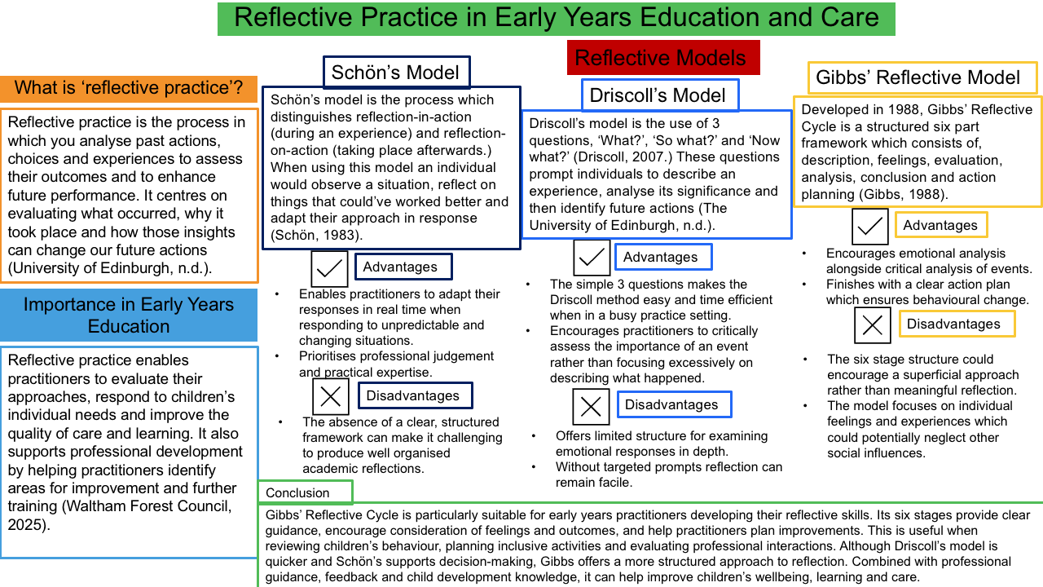
Inclusive practice is necessary in order to promote learning, development, health and the well-being of all children. Every child has his/her unique skills, interests, culture and needs. The Early Years Foundation Stage (EYFS) statutory framework outlines the requirements for children's learning, development, and well-being (Department for Education [DfE], 2026a). Professional values, communication, multi-agency working, observations, planning and compliance with the United Nations Convention on the Rights of the Child (UNCRC) contribute to effective and inclusive practice.
Professional Values
Professional values determine how practitioners behave, make decisions and interact with children, parents, carers and other professionals. Such values are respect, equality, empathy, honesty, confidentiality and safeguarding. According to the EYFS, every child is unique and develops at his/her own pace (DfE, 2026a). Hence, practitioners need to tailor their approaches to individual needs and cannot expect uniform learning from all children.
For example, a practitioner can supply adapted equipment for a physically disabled child or provide the books featuring different cultures and families. The Equality Act 2010 provides protection from discrimination and duties for making reasonable adjustments for people with disability depending on circumstances (Great Britain, 2010). Practitioners should therefore determine the barriers preventing full participation of children.
However, the practice of inclusion does not mean treating all children the same way. A child with communication problems may need visual aids or extra time to join the activities of other children. Professional reflection is important as practitioners' unconscious biases can influence their expectations and decisions. Overcoming such biases will enable practitioners to offer more equal opportunities.

Communication
Communication helps practitioners to learn children's needs, build relationships with their families and exchange information with other professionals. Children communicate differently depending on their age and development, infants can use facial expressions, crying and gestures while older children can use verbal communication. Some children can benefit from signing or picture cards.
By adapting the ways of communicating, practitioners help children to express themselves and take part independently in different activities (Department for Education, 2026a; Ofsted, 2025). The research of signing in early years settings can provide practitioners with information about alternatives for communicating with children. However, the choice of approaches must be based on individual needs.
Communication with parents and carers is also important as they can provide information about the interests, routines, culture and experiences of their children. For example, if a child becomes unusually withdrawn, then it will be helpful to talk with his/her family in order to determine what causes changes in his/her emotional state. Exchanging the information will promote consistency of activities at home and in the setting.
Confidentiality must be maintained while dealing with personal information but it cannot hinder the safeguarding actions. The practitioners have to follow the procedures of information sharing in case of concern (Department for Education, 2026c). Thus, communication contributes to building trustful relationships, early identification of needs and coordinated care of children. The poor communication can result in misunderstanding, exclusion or missed concerns.
Multi-Agency Working
Multi-agency working is a joint effort of professionals to meet children's needs in terms of education, development, health and safeguarding. Professionals involved in multi-agency working can be early years practitioners, special educational needs coordinators (SENCOs), health visitors, speech and language therapists, and social workers.
The Department for Education and the Department of Health (2015) emphasise the importance of early identification of special educational needs and disabilities (SEND) and coordination of appropriate support. Each professional has his/her own specialist knowledge which will help practitioners to know more about children's needs.
For example, if a child has difficulties in communication, then a practitioner can discuss his/her observations with the SENCO and parents of the child. The speech and language therapist can recommend some approaches in case of appropriateness. Then the practitioner can apply these approaches in everyday practice.
Multi-agency working is useful in case of emotional problems and safeguarding concerns. However, the different priorities of professionals, the delays and poor information sharing can impede provision of help to the child. Hence, practitioners have to communicate effectively, understand their roles and follow the procedures. Families have to be involved in case of necessity. Multi-agency working ensures early intervention, continuity of care, and responses considering the whole context of children's lives (Department for Education, 2026).
Observations
Observation helps practitioners to learn more about children's interests, abilities, behaviour, and development. During observation, which takes place in the course of play, routine activities, and social interaction, the information can be gathered. The EYFS framework requires practitioners to support children's learning and development according to their needs (Department for Education, 2026a).
For example, a practitioner can observe that the child likes being in company but rarely talks. Instead of concluding about the development delay, the practitioner has to obtain more information from different contexts and talk about the problem with the parents of the child. This will reduce the risk of the premature conclusion as the behaviour can be caused by personality, confidence, or experience in language.
Observations can also indicate the barriers for inclusion. If the child becomes distressed in noisy environment, he/she may need the quiet area or preparation for transitions. The observations have to be made objectively; that means recording the facts and not applying judgmental descriptions. Observation is more objective when it records the fact that a child did not join a group activity than describing him/her as unfriendly.
Observations have to be purposeful, respectful, and secure. One observation is unlikely to be enough to conclude something about the development. Integration of the information with observations, parents' information, and recommendations from specialists will provide more balanced decisions. Thus, observation is important for discovering strengths, raising concerns, and providing the basis for planning.
Planning
Planning involves the use of observations, assessments, children's interests and information from families in order to organise interesting experiences for children. Good planning should be flexible and inclusive, giving children an opportunity to participate according to their abilities and needs. The EYFS framework suggests that the practitioners have to support the learning and development of children providing appropriate experiences (Department for Education, 2026a).
For example, during storytelling, the practitioners can use picture cards, objects, gestures, and repeating of phrases. The verbally communicative children can retell some parts of the story while the children with communication problems can point to pictures or sign. Thus, all children can access one activity in different ways.
Planning should also include appropriate adjustments. The child with mobility problems will need adapted furniture while the child finding it difficult to go through transitions can benefit from visual timetable. By including books, languages, and materials representing different cultures, the practitioners can promote the identity and belonging. The choices have to be offered to the children in order to influence the activities.
However, the planning cannot become rigid and paperwork-oriented. The interests and needs of children can change, and therefore, practitioners have to reevaluate activities and adapt them. Thus, observations and planning have to form a cycle in which the practitioners observe children, set next steps, create learning opportunities, and assess the outcomes. Planning is important for translating the information about individual needs in practical support of children.
The United Nations Convention on the Rights of the Child (UNCRC)
The UNCRC is the international treaty providing the basic principles regarding the rights of children under 18. They include non-discrimination, protection, participation, and development (United Nations, 1989).
According to Article 2, children should enjoy their rights without discrimination. Practitioners must ensure that children with different abilities, language, culture or family situation can learn and play, which promotes equality and prevents exclusion.
Article 3 stipulates that the best interest of the child should be the primary concern of practitioners when they make the decisions concerning children. Practitioners have to assess the consequences of the decisions on the children's safety, development, and well-being.
Article 12 gives the children the right to express their opinions and to have these opinions considering their age and maturity. Practitioners can help children exercise this right through listening, providing them with choices and reacting to their preferences. Infants and children unable to use verbal communication can use gestures, facial expressions, and behaviour.
Article 23 provides the rights of children with disabilities to live decent life and take part in community. Article 31 provides the rights of children to rest, recreation, play, and cultural activities (United Nations, 1989). Altogether, these articles stress the importance of accessible environments and opportunities for playing.
The UNCRC is important because it shifts the perspective of inclusion from a professional preference to a question of the rights of children. The observance of these rights will promote children's dignity, participation and protection from discrimination.
Conclusion
Professional practice is important for accommodating the needs of children and ensuring their inclusion. Professional values provide the respect and equality necessary. Communication helps practitioners to build relationships with children and their families, multi-agency working integrates the specialised knowledge, observations identify the progress and barriers and planning translates the information in meaningful learning experiences for children. The UNCRC promotes children's rights to participation, protection, and non-discrimination.
These components are interrelated,for example, observations can reveal the communication needs of children, discussions with families can provide additional information and multi-agency working can find appropriate strategies. The practitioners can then adapt the planning and evaluate its outcomes. Thus, professional inclusive practice considers the uniqueness of each child and his/her rights and ensures learning, relationships and belonging for all children.

Reference list
Department for Education (DfE) (2026a) Early years foundation stage (EYFS) statutory framework. Available at: https://www.gov.uk/government/publications/early-years-foundation-stage-framework--2 (Accessed: 24 October 2026).

Department for Education (DfE) (2026c) Information sharing to safeguard children and young people. Available at: https://www.gov.uk/government/publications/information-sharing-to-safeguard-children-and-young-people (Accessed: 24 October 2026).

Department for Education and Department of Health (2015) Special educational needs and disability code of practice: 0 to 25 years. Available at: https://www.gov.uk/government/publications/send-code-of-practice-0-to-25 (Accessed: 24 October 2026).

Driscoll, J. (2007) Practising Clinical Supervision: A Reflective Approach for Healthcare Professionals. 2nd edn. Edinburgh: Baillière Tindall.

Gibbs, G. (1988) Learning by Doing: A Guide to Teaching and Learning Methods. Oxford: Further Education Unit.

Great Britain (2010) Equality Act 2010, c. 15. Available at: https://www.legislation.gov.uk/ukpga/2010/15/contents (Accessed: 24 October 2026).

Schön, D.A. (1983) The Reflective Practitioner: How Professionals Think in Action. New York: Basic Books.

University of Edinburgh (n.d.) ‘Reflecting on experience’. Reflection Toolkit. Available at: https://reflection.ed.ac.uk/reflectors-toolkit/reflecting-on-experience (Accessed: 17 October 2026).

Waltham Forest Council (2025) Reflective Practice Through a Lens: A Managers Guide. Waltham Forest Early Years Guidance. Available at: https://thehub-beta.walthamforest.gov.uk/sites/default/files/2025-09/Reflective_practice_through_a_lens_guidance_2025_0.pdf (Accessed: 17 October 2026).

United Nations (1989) Convention on the Rights of the Child. Available at: https://www.ohchr.org/en/instruments-mechanisms/instruments/convention-rights-child (Accessed: 24 October 2026).

