

Methods and Search Strategy Academic Poster

STUDENTNAME: LUCRESHA LEWIS
STUDENT ID:2315413

MODULE NAME: INDEPENDENT RESEARCH
MODULE CODE: BMHP 6020
LECTURER: JOANNE DAVIES

Early Detection Challenges in Women of Colour: Awareness and Diagnosis of Paget’s Disease of the Breast
01- Introduction and Research Aim  According to Khan et al. (2023), the methodology chapter explains the systematic process applied to locate, gather, evaluate, and analyse the research data. Such a process not only demonstrates how the research was conducted but also justifies the methods to uphold reliability and validity. The poster summarises the methodological approach applied in the study, with a focus on the search strategy, data selection process, research validation, and ethical considerations.  Research Aim:  To critically examine the current literature on Paget’s disease of the breast and explore whether current screening and diagnostic practices sufficiently recognise symptoms in women of colour, with the aim of identifying gaps in awareness, diagnosis and clinical practice. | 02- Search Strategy  A search strategy is an organised combination of keywords, phrases, subject headings, and limiters used to search a database (Bramer et al., 2018). For the current dissertation, a comprehensive search strategy was adopted.  - Key terms included: “Paget’s disease of the breast”, “breast cancer detection”, breast cancer in women of colour”, “misdiagnosis of nipple eczema” “, skin tone and medical diagnosis”  - Boolean operators AND, OR, and NOT were used to refine the searches.  - Truncation to capture variation in key terms, e.g. cancer* → cancer, cancers, cancerous  - Selected approach critical in ensuring all the literature included is relevant, credible and academically sound (Chigbu et al., 2023).
03- Searching for Information  - Identification of Keywords and search terms related to breast cancer and Paget’s disease.  - Database Selection - Academic databases such as Google Scholar, PubMed, and university library resources were searched.  - Filtering results- filters integrated to limit results to peer-reviewed and recent publications.  - Removal of duplicate articles appearing across multiple studies  - Screening of titles and abstracts to ascertain the relevance to the research aim.  - Full-text review of selected articles to establish if they fit the inclusion criteria.  - Select studies that directly address diagnosis, detection, and health disparities for inclusion.  - Critical Appraisal of selected studies using CASP Tool (Long et al., 2020). | 04 Picture - Literature Search and Screening Process  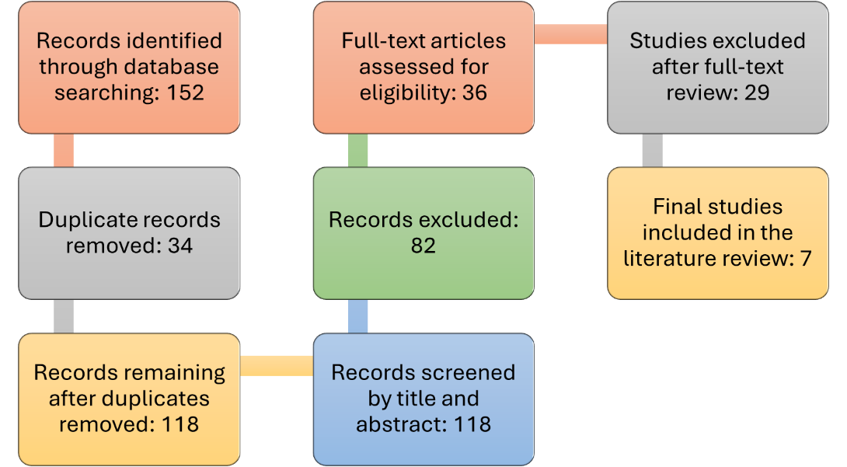
0 Research Validation and Analysis
Nobble and Smith (2025) conceptualise research validation as the process of ensuring the research data and sources are credible, reliable and appropriate for academic use. Protecting the validity is critical because it strengthens the quality of the conclusions emanating from the dissertation. Credibility in the current study was upheld through ensuring that all sources were peer-reviewed and published in reputable journals, and the authors are recognised experts. Each source was also appraised using the Critical Appraisal Skills Programme (CASP) tool for reliability and methodological quality. Even so, secondary research has limitations. Researchers have to depend on existing studies that may contain bias, a limited sample or gaps in diversity or representation (Baldwin et al., 2022). Thematic analysis was adopted, guided by Braun and Clarke's (2006) six-phase approach, to identify the recurring patterns or themes. Identified themes for the current dissertation include misdiagnosis of nipple symptoms as eczema, delayed diagnosis of Paget’s disease of the breast, lack of representation of darker skin tones in medical education and potential inequalities in early detection for women of colour, which are explored in chapter 4.
06 Inclusion Criteria  - Peer-reviewed sources  - Published within the last 10 years  - Studies related to breast cancer diagnosis and Paget’s disease of the breast  - Available in full text and English | 07 Exclusion Criteria  - Studies older than 10 years  - Non-academic or non-peer-reviewed sources  - Articles not directly relevant to the research topic  - Sources without full-text access
08 Ethical Considerations
- In secondary research, Ethics is the responsible use of existing research while upholding academic integrity and fostering intellectual property. Ethical considerations in the study encompassed;

References
Baldwin, J.R., Pingault, J.B., Schoeler, T., Sallis, H.M. and Munafò, M.R., 2022. Protecting against researcher bias in secondary data analysis: challenges and potential solutions. European journal of epidemiology, 37(1), pp.1-10. https://doi.org/10.1007/s10654-021-00839-0
Bramer, W.M., De Jonge, G.B., Rethlefsen, M.L., Mast, F. and Kleijnen, J., 2018. A systematic approach to searching: an efficient and complete method to develop literature searches. Journal of the Medical Library Association: JMLA, 106(4), p.531. https://doi.org/10.5195/jmla.2018.283
Chigbu, U.E., Atiku, S.O. and Du Plessis, C.C., 2023. The science of literature reviews: Searching, identifying, selecting, and synthesising. Publications, 11(1), p.2. https://www.mdpi.com/2304-6775/11/1/2
Khan, J.A., Raman, A.M., Sambamoorthy, N. and Prashanth, K., 2023. Research methodology (methods, approaches and techniques). San International Scientific Publications. https://doi.org/10.59646/rmmethods/040
Long, H.A., French, D.P. and Brooks, J.M., 2020. Optimising the value of the critical appraisal skills programme (CASP) tool for quality appraisal in qualitative evidence synthesis. Research Methods in Medicine & Health Sciences, 1(1), pp.31-42. https://doi.org/10.1177/2632084320947559
Noble, H. and Smith, J., 2025. Ensuring validity and reliability in qualitative research. Evidence-Based Nursing, 28(4), pp.206-208. https://doi.org/10.1136/ebnurs-2024-104232

