Handout 7: Using Files

As well as writing the results of programs to the screen, we can also write results to a text file. This is done using the command fprintf.

1. Writing to a file

To write to the screen, we use printf
To write to a file, we use a similar command: fprintf

For fprintf, we need to tell the program which file we want to write to. We use a pointer for this (below, the pointer is called fp)

FILE *fp creates a pointer that will be used to communicate with the file. This is because the file’s memory location is outside our program, therefore we need to point directly to its memory location.

“w” means “open the file for writing”. However, it’s a little more nuanced than that. If the file myfile.txt does not exist, "w" will create it. If myfile.txt already exists, it will wipe any data contained in it.

#define _CRT_SECURE_NO_WARNINGS
#include <stdio.h>

void main()
{
FILE* fp; //Declare file pointer
int number = 4;
int i;

printf("%d ", number); //Print number on screen

fp = fopen("myfile.txt", "w"); //Open file for writing and point
//to it using fp

fprintf(fp, "%d ", number); //Print variable number to file

fclose(fp); //Close file

}

In the program above, on first run, a text file is created and the contents of number is written to it. On second run, third run etc, the text file already exists, so it doesn't need to be created. Any data previously stored in it is wiped before writing number to it.

Run the program and then open the file to check that variable number (4) has been written to the file. To find it, go to File -> Open -> File

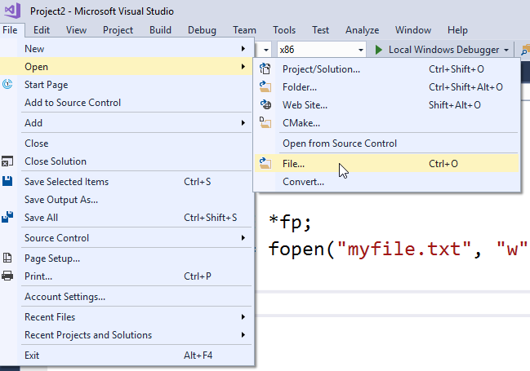



We can open this file so that we can see it in our project, alongside source.cpp

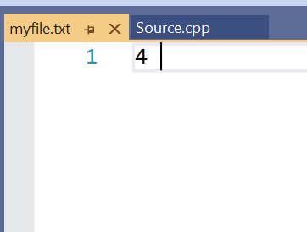

2. Reading from a file

We can also read information into a program from a file. This is done using fscanf which works in a very similar way to scanf.

We must first create a file that we can read from. Create a blank file within Visual Studio by adding an item to source files. Right click on Source Files, then select Utility and Text File.

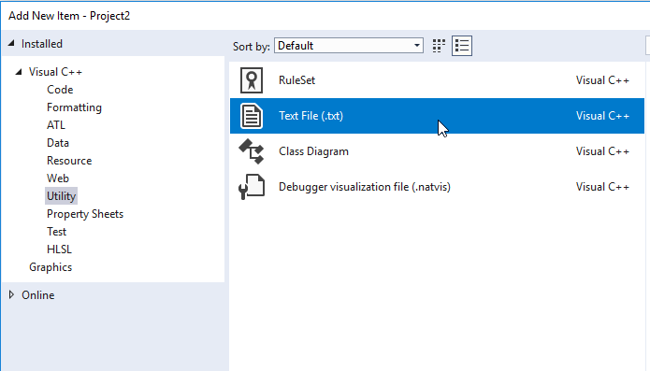

Give it a name, eg readfile.txt and click “Add”



Add some values to your file and save them. Leave a space or a linebreak in between each value. This allows your program to know where one value ends, and the next one begins.

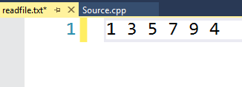

This time we are opening the file for reading (“r”) so that we don’t delete the values.

In the example below, we read the first number from the file into a variable using fscanf:

#define _CRT_SECURE_NO_WARNINGS
#include <stdio.h>

void main()
{
FILE* fp;
int number;
int i;

fp = fopen("readfile.txt", "r"); //Open file for reading

fscanf(fp, "%d", &number); //Read number from file into memory

fclose(fp); //Close file

printf("%d ", number); //Print number on screen
}

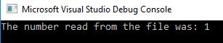

To read another number, I have used a second variable below. Note that the file pointer moves along automatically.

#define _CRT_SECURE_NO_WARNINGS
#include <stdio.h>

void main()
{
FILE* fp;
int number, anothernumber;
int i;

fp = fopen("readfile.txt", "r"); //Open file for reading

fscanf(fp, "%d", &number); //Scan number from file into memory
fscanf(fp, "%d", &anothernumber); //Scan 2nd number from file into memory

fclose(fp); //Close file

printf("The number read from the file was: %d\n", number);
printf("...and the second number was: %d ", anothernumber);

printf("\n\n");
}

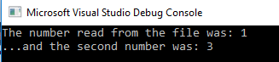
3. Appending data to a file

Sometimes, we do not want to open the file for writing (“w”) because that would delete all the existing data. For example, if we were writing a log file, we would want to append the latest data to the previous data. In this case, we can use “a” for appending.

In the program below, we get the time from the system clock and a temperature reading from the user. This is then appended to a log file (LogFile.txt) each time the program is run. (For a bit of extra fun, I’ve also grabbed the time off the current system clock – marked in yellow below)

#define _CRT_SECURE_NO_WARNINGS
#include<stdio.h>
#include<time.h>

void main()
{
float temperature;
time_t now;
time(&now);
FILE* fp;

printf("Enter temperature reading: ");
scanf("%f", &temperature);

printf("Writing to file...");

fp = fopen("LogFile.txt", "a");
fprintf(fp, "%s%f\n", ctime(&now), temperature);
fclose(fp);

printf("OK.");
}

Here’s an example of LogFile.txt after running the code 3 times and entering 3 different values for temperature:



