Artificial Intelligence & Machine Learning Exam Answers

Name: Ben Kiddie

Student Number: 1800242

Contents
Question 1 3
Part a 3
Part b 6
Question 2 7
Part a 7
Part b 7
Part c 7
Question 3 (DID NOT ANSWER) 12
Question 4 13
Part a 13
Part b 13
Part c 14

Question 1

Part a

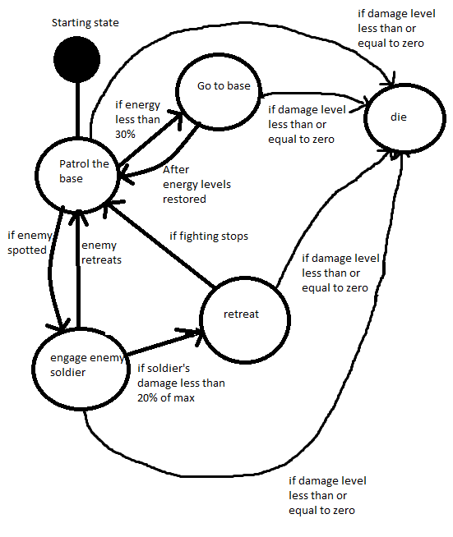
Terminal state

MachineEnter()
{
PatrolEnter();
}

PatrolEnter()
{
isPatrolling = true;
PatrolExecute();
}

PatrolExecute()
{
While(isPatrolling = true)
{
If(enemy in range)
{
PatrolExit();
AttackEnter();
}
If(damageValue <= 0)
{
PatrolExit();
DieEnter();
}
}
}

PatrolExit()
{
isPatrolling = false;
}

AttackEnter()
{
engagedEnemySoldier = true;
AttackExecute();
}

AttackExecute()
{
While(engagedEnemySoldier = true)
{
If(enemyOutOfRange = true)
{
PatrolBaseEnter();
}
If(soldierDamage < (0.2 * maxDamage))
{
RetreatEnter();
}
If(soldierDamage < 0)
{
DieEnter();
}
}
}

AttackExit()
{
engagedEnemySoldier = false;
}

Part b
One form of state machine is known as a Mealy machine. These types of state machine will output data upon each successful state transition depending on the current state and current inputs, making it good for sequential control problems. They are slower, but easy to design.
The tuples involved in this machine include a finite set of states ‘Q’, an initial state ‘q0’, the input alphabet ‘∑’, the output alphabet ‘O’, the transition function which maps Q×∑ → Q, ‘δ’, and the output function which maps Q×∑→ O ‘λ’.

Another form of state machine is a Moore machine, which do not output any symbols based on the input, but rather simply allow the current state to determine the output. These are faster, harder to implement, and have a smaller state number requirement.
The tuples involved in this include all tuples of a Mealy machine, with the exception of ‘λ’, which is instad the output function which maps Q → O (input has no bearing on output).

Question 2

Part a
Fuzzy expert systems is a term describing the grouping of fuzzy sets under one particular characteristic, where each fuzzy set is separated by its own linguistic variable, for example “IF speed is slow, THEN stopping distance is short”, where speed and stopping distance are linguistic variables, and ‘good’, ‘short’ are the linguistic values.
Linguistic values typically lie on the x-axis of a given fuzzy system when graphed, where the x-axis is known as the universe of discourse, i.e., the range of values for which a characteristic is mapped.

Part b
Two methods of defuzzification exist – the Mamdani method, and Sugeno method. For a real time application, Sugeno is more ideal since it is less computationally expensive. This is due to it being highly adaptable for dynamic, non-linear systems.

Part c
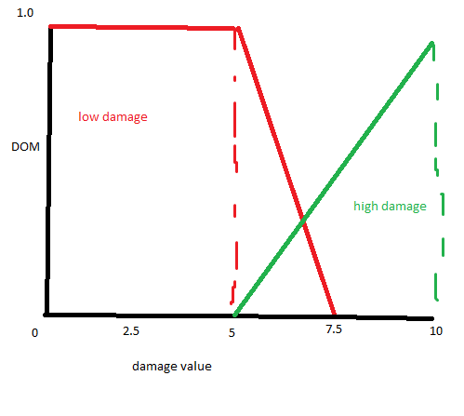
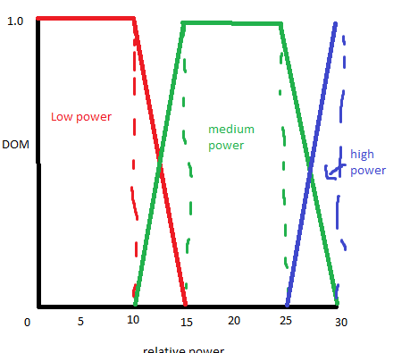

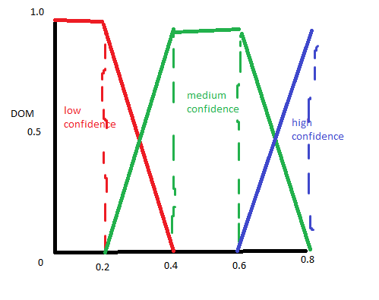

Enemy power = 11 units, damage value (damage level of opponent) = 6 units.
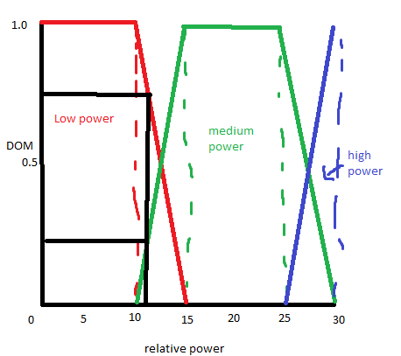
Using the fuzzy system constructed for relative power, it can be seen that the enemy power Degrees of memberships (DOMs) are approximately low = 0.75, medium = 0.25, high = 0.0.

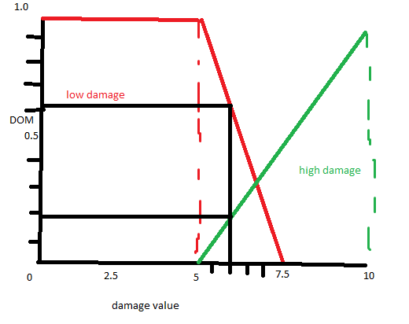
As seen above, the DOMs for damage value of opponent are approximately low = 0.6, high= 0.2.

Considering rule 1, we accept the values high power = 0.0 and low damage value = 0.6 as our antecedent values. The truth antecedent is the maximum DOM, as the conditional statement is an “OR”, therefore we accept 0.6 as our truth antecedent for rule 1. The consequent is to map this DOM to the low confidence fuzzy set, as seen below:
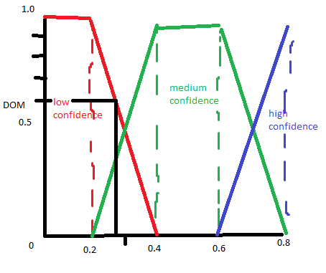
Thus providing a consequent of approximately low confidence = 0.275.

With regards to rule 2, the conditional statement is an “AND”, so we accept the minimum of medium relative power = 0.25, and high damage value = 0.2. Our truth antecedent of 0.2 is mapped to the medium confidence fuzzy set:
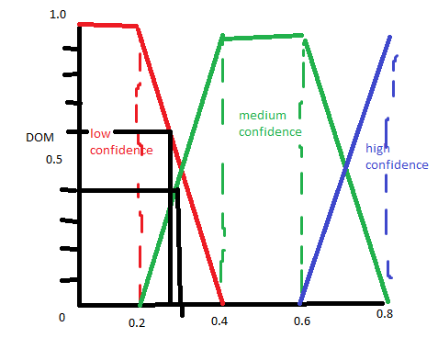
Providing approximately medium confidence = 0.3 as the consequent.

Rule 3, as there is not a conditional statement, is simply mapping the value of our only antecedent (low relative power = 0.75) to our high confidence fuzzy set:
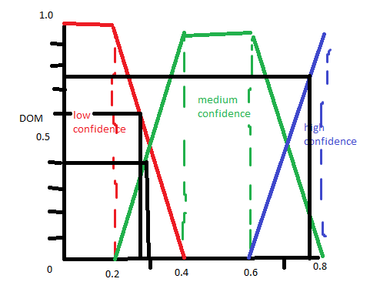
As seen above, rule 3 outputs a consequent of approximately DOM high confidence =0.775.

Aggregating the results gives us:
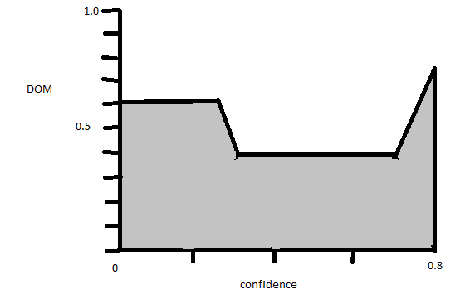
Confidence – low (0.6), medium (0.4), high (0.75).

Using the centroid defuzzification method, and knowing our universe of discourse ranges from 0 to 100%:
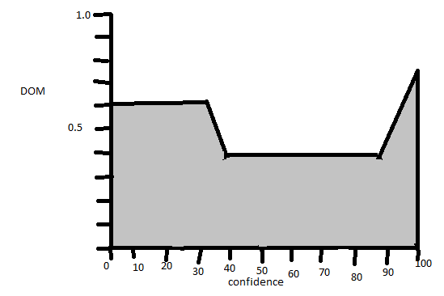
Then perform the below calculation to find our centre of gravity:
$$\frac{\left(0+10+20+30\right)*0.6+\left(40+50+60+70+80\right)*0.4+\left(90+100\right)*0.775}{0.6+0.6+0.6+0.6+0.4+0.4+0.4+0.4+0.4+0.775+0.775}$$
Which equals $50.\dot{9}663$ – the confidence of our AI bot.

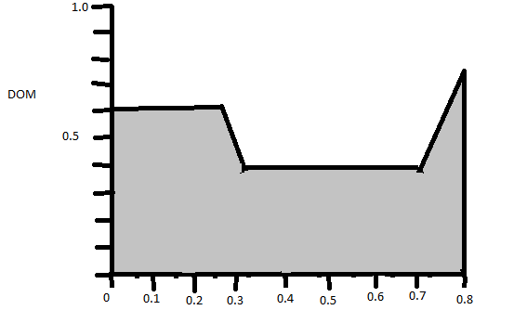
Using the samples along our universe of discourse, and the formula for centre of gravity, we get:
$$\frac{\left(0+0.1+0.2\right)*0.6+\left(0.3+0.4+0.5+0.6+0.7\right)*0.4+\left(0.8\right)*0.775}{0.6+0.6+0.6+0.4+0.4+0.4+0.4+0.775}$$
Giving us our centre of gravity equal to $0.431$.

Question 3 (DID NOT ANSWER)

Question 4

Part a
The purpose of synaptic weights is to increase or decrease the influence a particular input signal has on the output of our activation function. If we deem a particular input signal more important or influential on the output, we increase the weighting using positive synaptic weights. If we deem an input signal less significant or inhibitory, we give it less or negative synaptic weights.

Part b

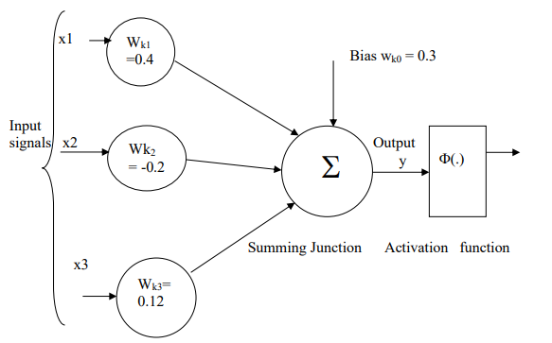
X1 = 0.9, x2 = 0.8, x3 = -0.12, activation function ReLU phi(max(0, y)).
To begin, we apply the synaptic weights to each input signal, giving us $w_{kj}x_{j}=0.36, -0.16, -0.0144$
We then add the bias to the summation of weighted inputs – providing us with an activation function input of 0.4856. This gives us an activation function of phi(max(0,0.4856)), i.e., f(x) = 0 if x <= 0, or x if x > 0. A graph would look something like this:
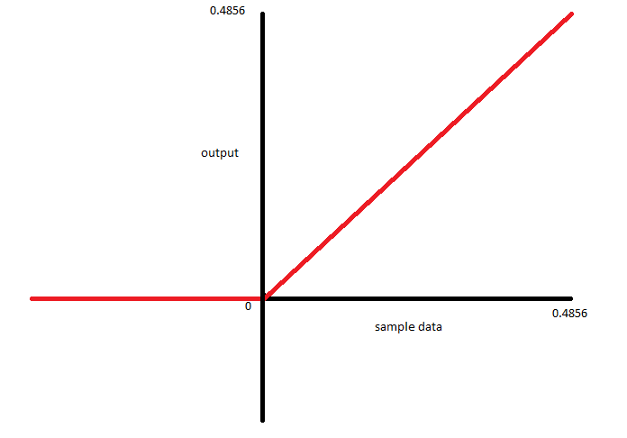
- Sigmoid functions utilise f(x) = 1/(1+$e^{-x}$)

Given the input values, weights and bias are the same as the first part of this question, a graph would look something like this:
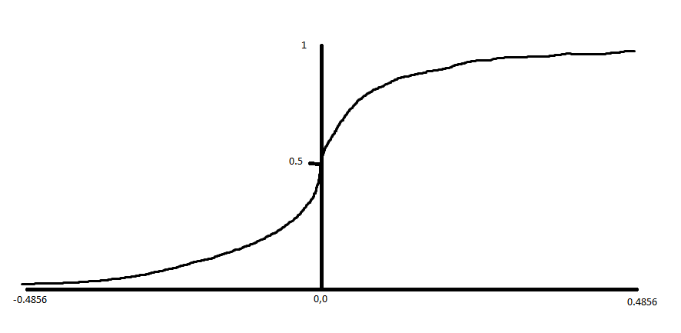

Part c
The dying ReLU problem goes back to how it works – f(x) = 0 if x <= 0, x if x > 0. This means that values of x that are negative will be lost information, which is dangerous as our neural network learns best when there is a greater change in the gradient when we sample along the x-axis. Of course, negative x values would then produce zero gradient change, hence halting the neural network learning process, letting neurons die.
A technique used to cover the dying ReLU problem is the Leaky ReLU solution. What this does it that negative values of x are given a small change in gradient, so that the neuron has the ability to keep adjusting its synaptic weights and pull itself out of the negative range and back into the positive range, where the optimal changes in gradient are. One potential method of implementing Leaky ReLU is to assign negative x values a y value of 0.0001*x.

