Communications skills at the working place and beyond.

Yordan Terziev 1914788
Effective team work and communication
Timothy Hopkins
Date: 01.05.2020.

- Introduction………………………………………………………………………….p.3
- Communication in the workplace………………………………………….p.4-6
  - Communication effectiveness………………………………………p.4
2.2. Management and Employees ……………………………………….p.4-5
2.3. Active Listening........……………………………………………………..p.5-6
- Models of communication…………………………………………………….p.6-9
3.1. Shannon and Weaver…………………………………………………….p.6-7
3.2. Schramm’s.....................................................................p.7-8
3.3. Berlo`s…………………………………………………………………………..p.8-9
- Case study……………………………………………………………………………p.10-12
- Conclusion…………………………………………………………………………..p.12
- List of references…………………………………………………………………p.13
7. Appendices………………………………………………………………………..p.14-15

Introduction
Communication exists when two or more people exchange thoughts, information or ideas through conversation, messages or gestures, understanding one another. The process requires a sender who encodes a thought in the form of words, a picture or a facial expression, and then sends it to the receiver who decodes the information, understandably returns an answer. There are several methods of communication ; Verbal, nonverbal, Written, etc.
Verbal is the most commonly used mean of communication, that is oral by uttering words related in sentences that are perceived by the receiver in the form of a sound. Verbal communication is one of the best in work environments where you need to respond quickly and often to certain work situations.
It is nonverbal communication when you express your thoughts in a conversation with Body language, facial expression, arms crossed, eye contact, etc. This method is very important at job interviews for both the employer and the employee.
Written, a method by which the sender and the receiver communicate through text messages via e-mail, letters or working writing board. It is the most common way of communication between citizens and institutions.The good communication between various units at the workplace is important so that any problems related to the company can be resolved as quickly as possible.This report is about the communication in the workplace and beyond ,
and how important it is in the development of each of us.

Communication in the workplace
Communications are important in every aspect of a person's life, but they also play a big role in the development of a business organization. In order for the communication at work to be as effective as possible, each member of the working group should be aware of how he looks from the perspective of his colleagues. He needs to understand the group's task, to read the signs that his interlocutor is transmitting with his body language, to be sure that he understands the information provided to him. All those involved in the workflow of a task must be qualified to make communication and conversations between individual group members easier. At the same time, it is very important to give feedback between themselves so that everyone is aware that they are going in the right direction to complete the task. There may be disagreements between the members of the group but they must be resolved by team discussion so that everyone is aware that achieving the common goal is paramount. It also helps to form a team spirit that is very important.
Communication between the worker and the Manager is of utmost importance because it can give the manager information about the various problems that exist in the workplace and how they interfere with the work process. In turn the worker may receive the necessary advice or assistance to deal with them.
It is very important to use the right tone of communication as positive, sincere, and definite between management and staff. This helps to communicate freely with each other.
The level of formality between a worker and a manager can be two types; low formality(informal) or high formality(formal).
Low formality worker is concerned about achieving his goals, he does not think about the rules he must follow. These are workers who start a job where they get their freedom to be creative and handle their tasks in their own way,which does not bother them but gives them pleasure. In order to manage with this type of workers you have to give them the greatest possible freedom.Of course every company has its own rules, but the Manager must be able to balance between them and low formality worker.
High formality employee is motivated to do his job without mistakes, without deviating from the rules, without looking to the side for any other way to finish it.
“When you manage a high-formality employee, she’ll want a crystal clear understanding of the rules and regulations. Your job is to make sure that she clearly understands what “right” looks like. This gives her comfort and confidence to move forward. What the high-formality worker needs most is freedom from risk of error. She needs time to develop expertise.” (Poepsel 2017).
Active listening is the method that best ensures (that) you understand what the other person wants to tell you. The first sign by which you can tell if a person is actively listening is the physical posture he is occupying.
As Griffiths(2015) suggests: SOLER is an acronym that describes five specific behaviors for proper listening posture.
Squarely face the person to whom you speak.
Open standing without arms crossed.
Lean slightly to engage in the conversation by showing through verbal and non-verbal signs that you understand the speaker.
Eye contact without looking sideways or down.
Relax. The listener should not interrupt the speaker and remain quiet until he or she has fully understood the information.
If the speaker sees these five behaviors in the listener he will be more comfortable in sharing information.
Paraphrasing is the second sign of active listening. It indicates that the listener has understood the topic and responds by understanding the problem of the conversation.
Probing is the third component of active listening. The listener may ask for additional information to understand the speaker's ideas or opinion. For this purpose, he uses questions of several kinds.
open-ended question are those that stimulate reflective thinking and lead to a deeper understanding of the problem. These types of questions give you the opportunity to understand what the speaker's concerns are because it gives him full control over the answer. Open-ended questions usually start with the words why, how or what .
Hypothetical questions give the listener the ability to understand exactly what the speaker is having a problem with. On the other hand, the speaker understands from the answer that he receives whether his interlocutor has the necessary qualities to assist him in the task he has.
A forced-choice question gives the speaker the opportunity to receive a short and accurate answer that shows the listener's knowledge and preferences on the topic.

Models of communication
Communication models are actually relevant theories that show the schema and the components of the communication.
In 1948, American mathematician Claude Shannon developed a theory to use in telecommunications companies to improve capacity and eliminate noise,
known in the engineering environment as information theory. Later Warren Weaver added that the theory could be used in all types of communication and became known as Shannon and Weaver Model Of Communication.
In this model of communication we have a sender and a receiver. The sender encodes the information and sends it through a technological channel. The receiver, in turn, receives, decodes and understands the message and returns feedback.
The model has advantages because it demonstrates how two-way communication and noise enhancement improve effective communication. Critics note that this theory cannot be used as a model of communication for a large group of people and that the receiver of the information is not equal to the sender (Businesstopia, 2018).

Diagram: 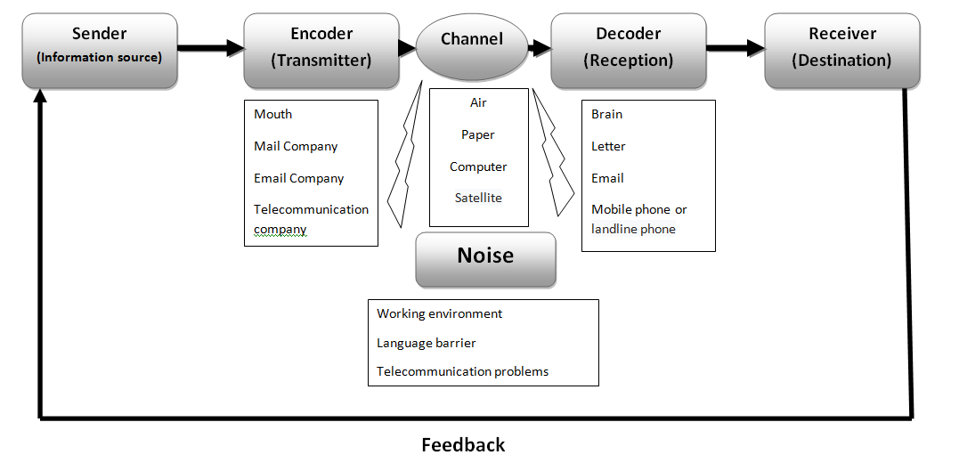
Source: the author

Schramm’s Model of Communication 1954. In this model of communication the sender and receiver are completely equal.Both need to encode, transmit, and decode the information, but for that purpose they must first understand it. Therefore, the most important unit here is the Interpreter. According to Wilber Schramm, if a communication does not show feedback between the sender and the recipient, it is not completed and is not effectively implemented. The disadvantage is that the model does not look at the noise and how it affects the conversation.
Diagram: 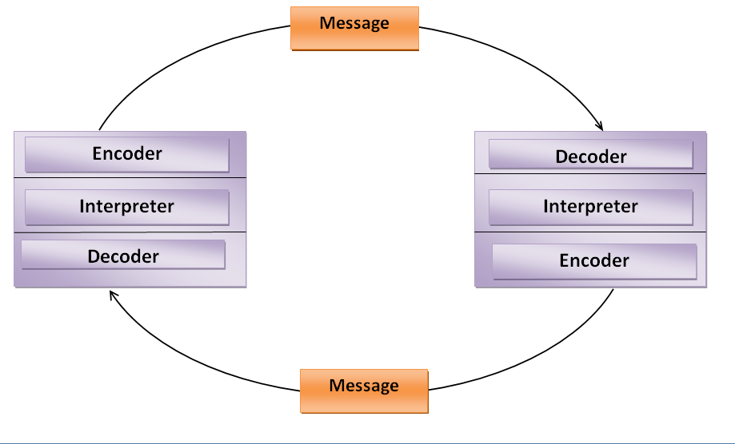
Source: the author

Berlo`s Model of communication

David Berlo wrote his model of communication in 1960. The model shows how communication can be more effective by describing factors which can affect the parts in it. These are the four main parts – sender, message, channel and receiver.
Sender – sends message to the receiver. He can be affected by the following factors:

Communication skills – the ability to communicate effectively – to write, read, speak and listen.
Attitude – the attitude of the sender and the receiver can change the effect of the message.
Knowledge – to know the essence of the message.
Social system – the difference in values, beliefs, religion and other social factors can affect the meaning of the message.
Culture – people with a different culture may not understand the message in the same way.

Message – the information sent from the sender. There are a few factors that can affect the message:

Content – the idea of the sender expressed in the message.
Elements – nonverbal signs, like gestures and language.
Treatment – how the information is sent.
Structure – the arrangement of the message.
Code – form that message can take.

Chanel – medium which sends the message. It can be affected by the five senses of a human being – hearing, seeing, touching, smelling, tasting.

Receiver – must have all the factors as the sender plus active listening to fully understand the information received.

The main disadvantages of the model are that there is no feedback, you cannot understand the outcome of the conversation. And the noise issue is not considered, leading to problems in effective communication.

Diagrama:
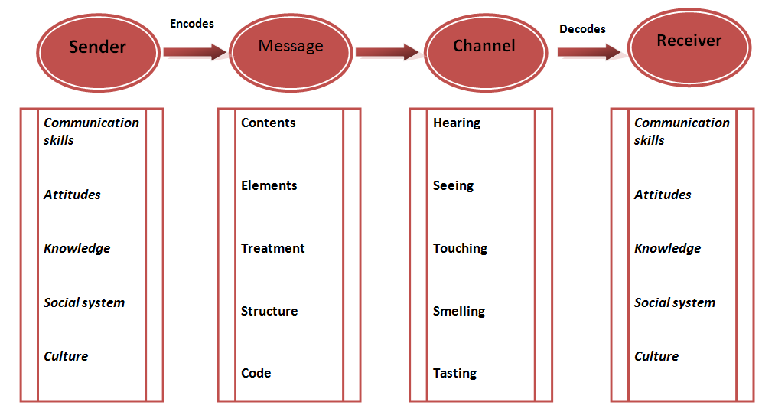
Active listening
Source: the author

Case study
I’m working in “Sainsbury’s” warehouse in Dartford. The main company in the warehouse is “DHL”, which is the supplier of stocks from Europe to all Sainsbury’s shops in the country . On the other side is the Agency “Mach recruitment ltd” for which I’m working a) a picker
The agency is linked to“Sainsbury's” and “DHL” because there is a contract to work with „Sainsbury's” but the workers, and in that number I , do the work that “DHL” have to do - i.e. “Mach recruitment ltd” is subordinate to both companies and has to communicate with them constantly.
This is where the communication problems begin. I have many examples of bad communication in this company but I will write about the last one I can think of and try to explain it as one of the models of bad communication that I learned during this class.
Few months ago I started a course of two weeks for PHD(Private Hire Driver license).In this course I had to go to classes from 8am to 13pm in a college in Northwest London and I didn’t have any problems with that because my working shift started at 14pm and I had time to go to work on time. To secure myself before the course I talked to one of the supervisors in my shift to inform him about the situation and so that he is aware of this If I am late sometimes. On the 3rd day of the course I received the regular message from the agency about my shift which said ; “Hello ,today your shift starts at 13pm because as you already know is really busy time…” I was really surprised from this message and a little bit nervous because I was just getting into the class. On the break I called In the main office of the agency, from where this messages came, and explained them the situation. They told me they hadn’t receive that information about me and that it was not a problem to come at 14pm as usual.
In this case I’m sure that in my communication with the company I used “Shannon” and “Weaver” models because I received a feedback from the supervisor that he understood what I told him .But I think in the “Mach recruitment ltd” they used “Berlo” model because in this model there is no feedback - just sender and receiver.
But maybe there was no active listening somewhere between the two conversations. “Paying attention to posture, paraphrasing what is heard, and probing for deeper meaning are skills that facilitate this type of prespective taking and lead to a more accurate understanding of the messages that are communicated.”(Griffiths and Duneham, 2015)
Communication between the supervisor and agency office , illustrated using the Berlo model.
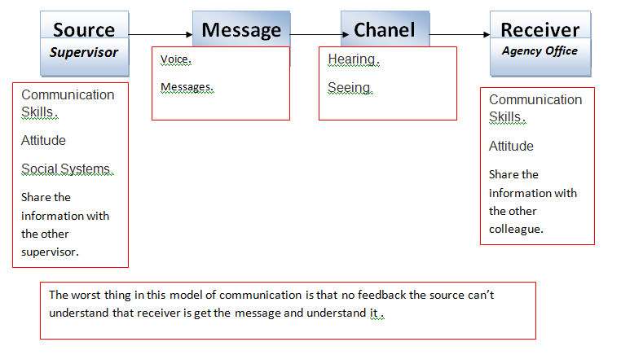
Source: the author

Which communication model they should use, illustrated using the Shannon and Weaver model. 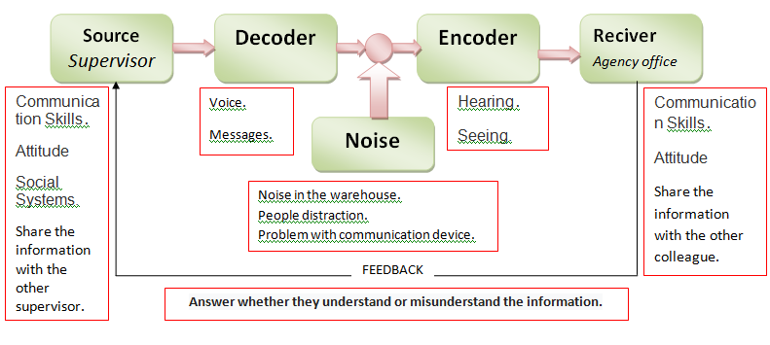
Source: the author

Conclusion
This report shows how workplace communications play a key role in managing companies. And how if you don't use the right models of communication you can put yourself or your colleagues in a bad situation.
The main task of communication is to bring people together, whether at work or outside. The better we know the methods and models of communication, the better we can understand each other. Not all communications will evoke good feelings in us, some conversations can be provocative, others frustrating. But the best conversation will always be the one you fully understand.

References:

- businesstopia, (2018) “ Shannon and Weaver Model Of Communication” in Businesstopia. Available at:
https://www.businesstopia.net/communication/shannon-and-weaver-model-communication (Accessed: 28.04.2020)

- Griffths, B.A. and Dunham, E. B. (2015) “Communication”. In SAGE (ed.) “Certificate in higher education: Skills for the workplace” . Thousand Oaks, California

- Class Textbook

- Poepsel,M. (2017) Levels of formality at work: high vs. low formality behavioral drive, The Predictive Index ,[online] Available at: https://www.predictiveindex.com/blog/the-formality-drive-deconstructed/ [Accessed 22 Apr. 2020]

Appendices


