Alexandre Goncalves Batista

My Screenshots/Photos
- Please add 4–6 screenshots or photos of your digital life.
- You can use your phone or laptop.
- For each screenshot, write one or two sentences explaining what it shows.

Screenshot/Photo 1
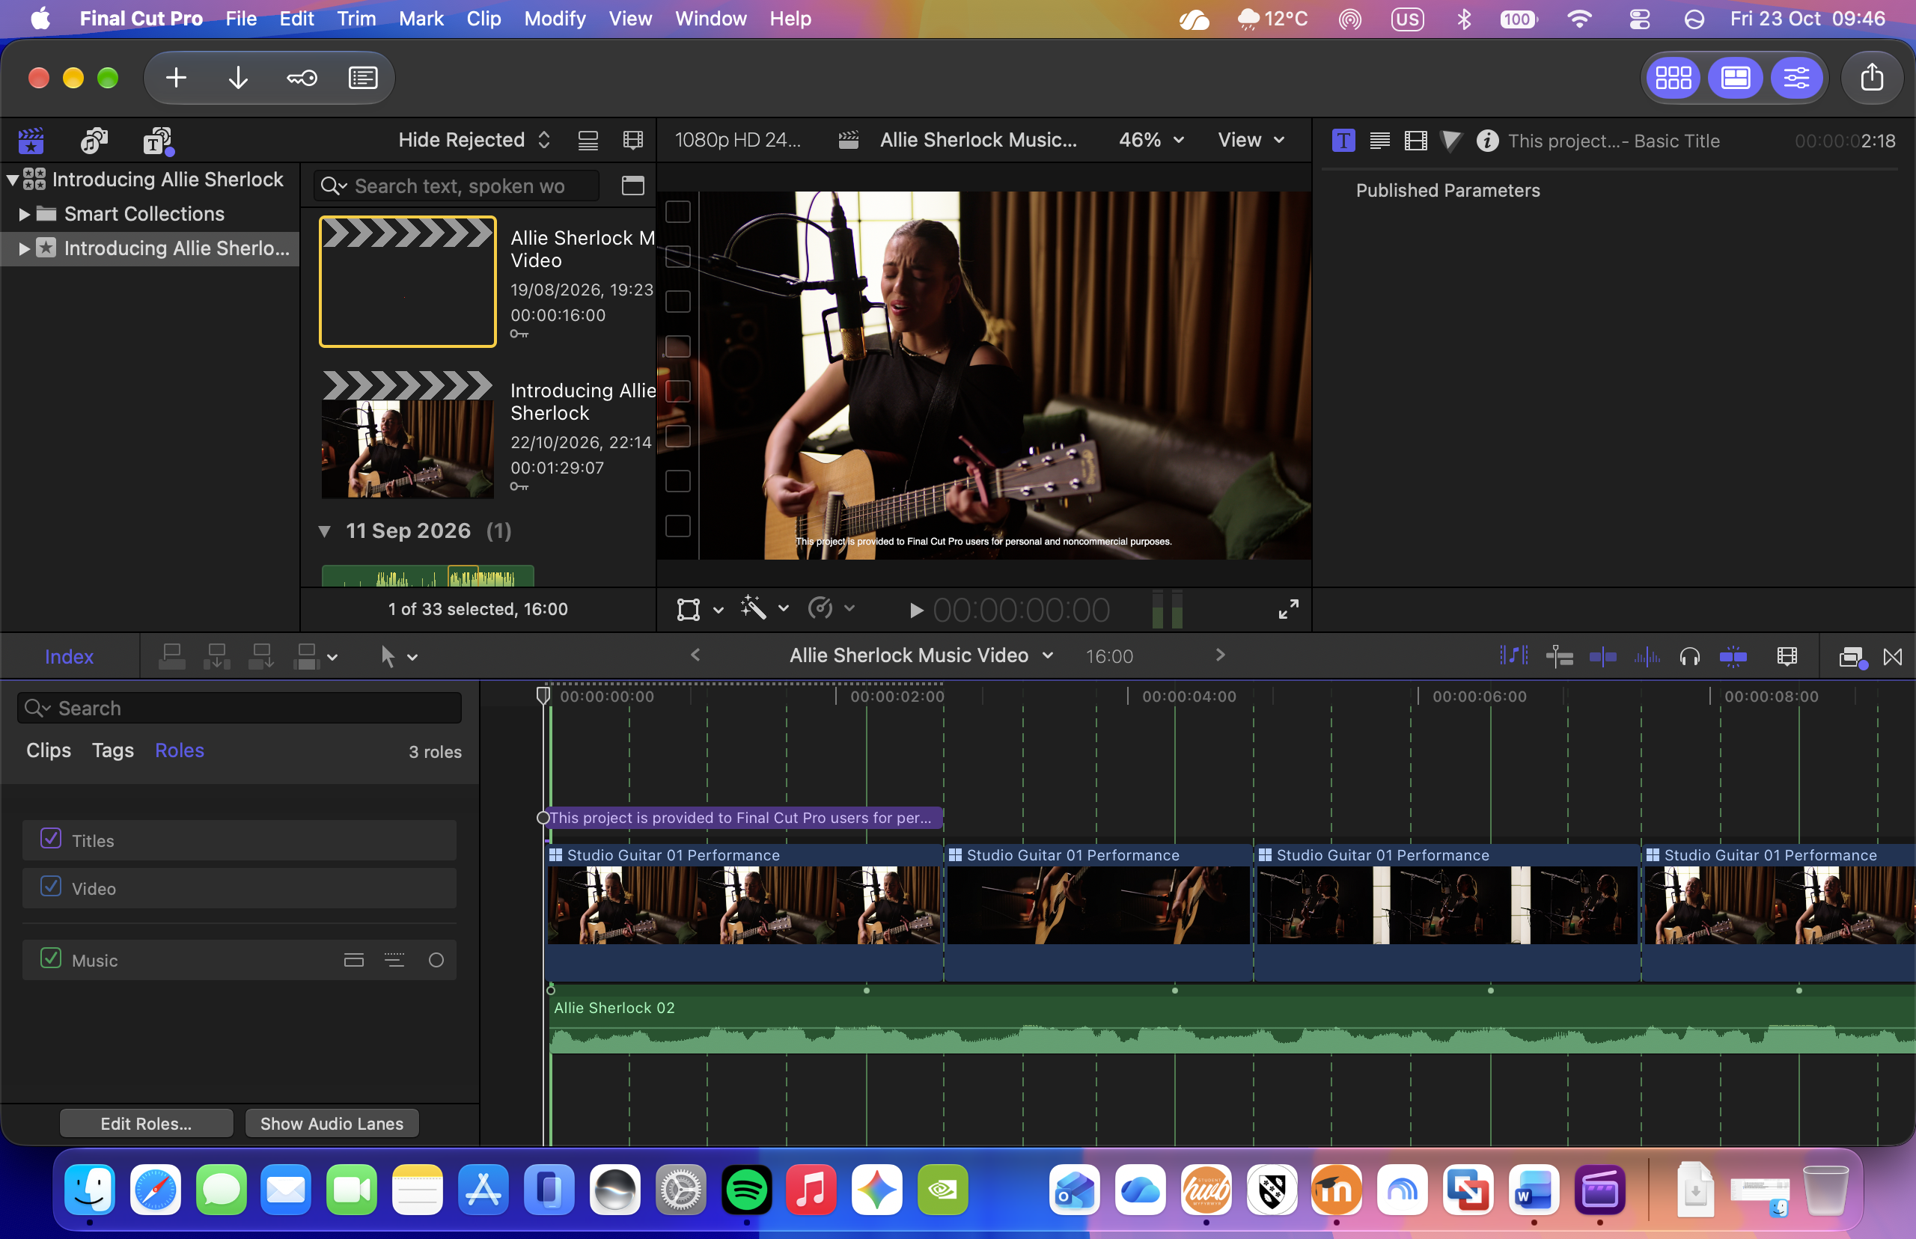
Final Cut Pro is my favourite software to edit my videos.

Screenshot/Photo 2
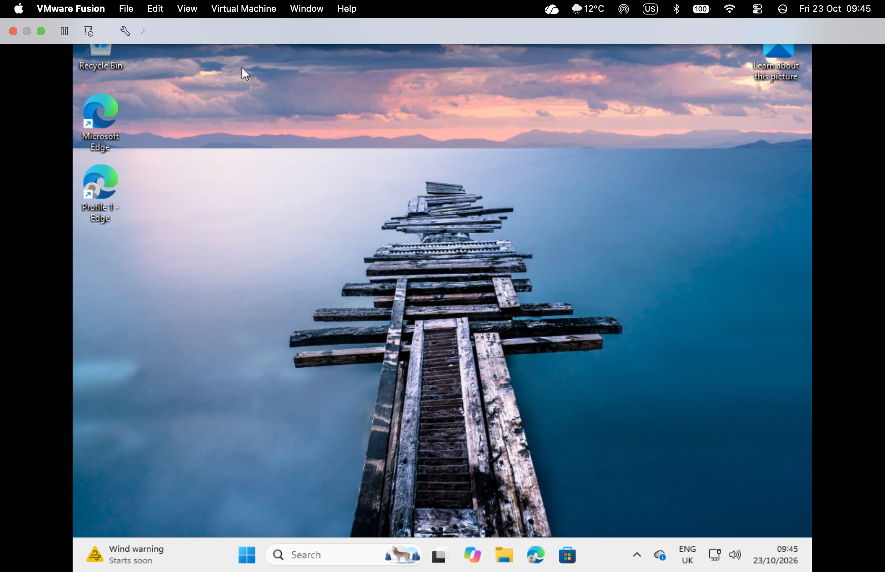
VMware Fusion helps me to use Windows 11 on my mac.

Screenshot/Photo 3
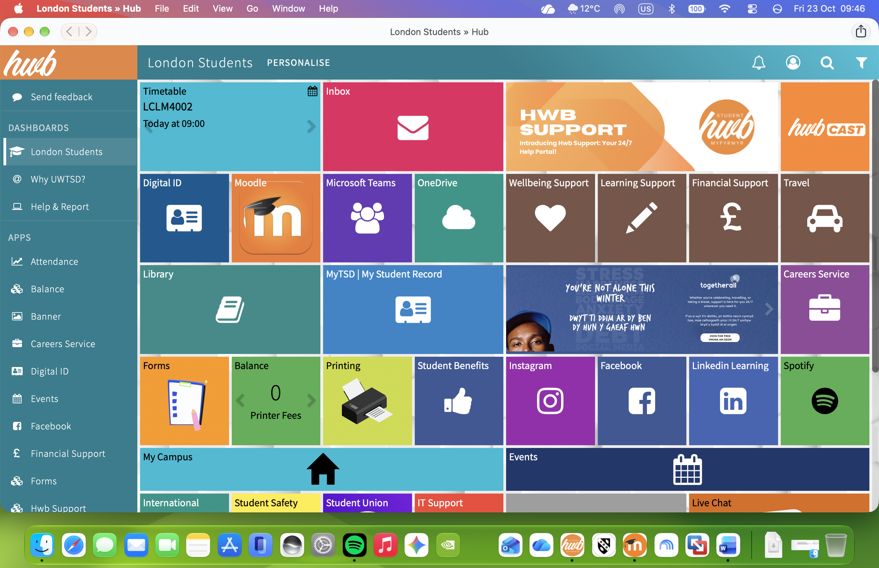
T student hub is essential to manage my student life.

Screenshot/Photo 4
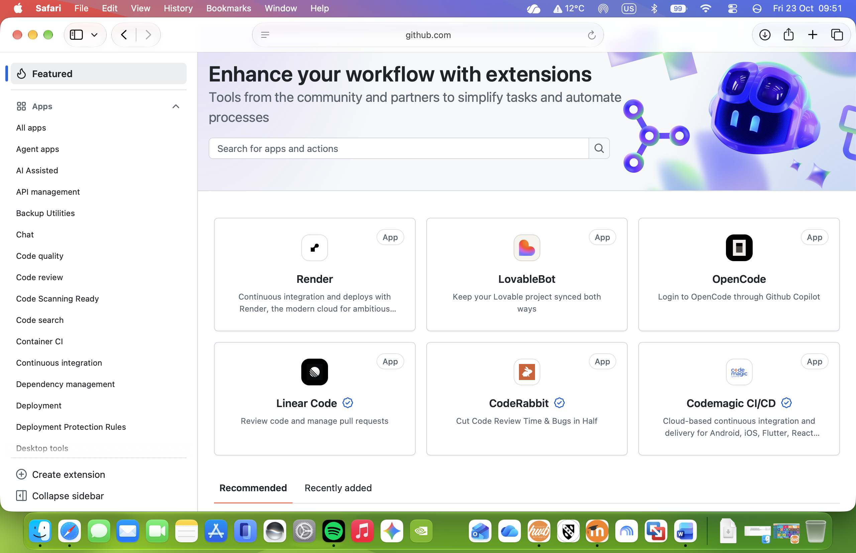
I’m always on github.com to manage and update websites with new tools.

Screenshot/Photo 5
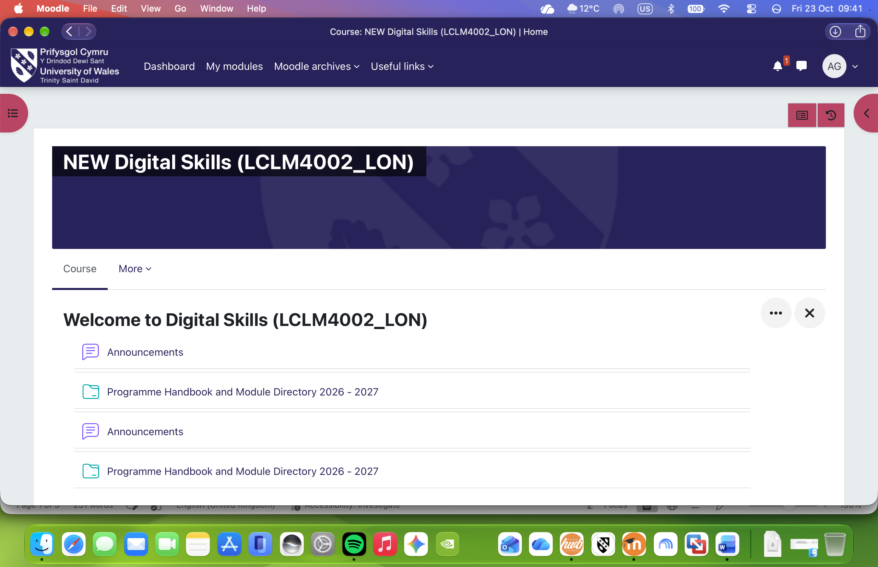
At least 3 times on the week I’m on Moodle to study and follow the university guidelines.

Screenshot/Photo 6
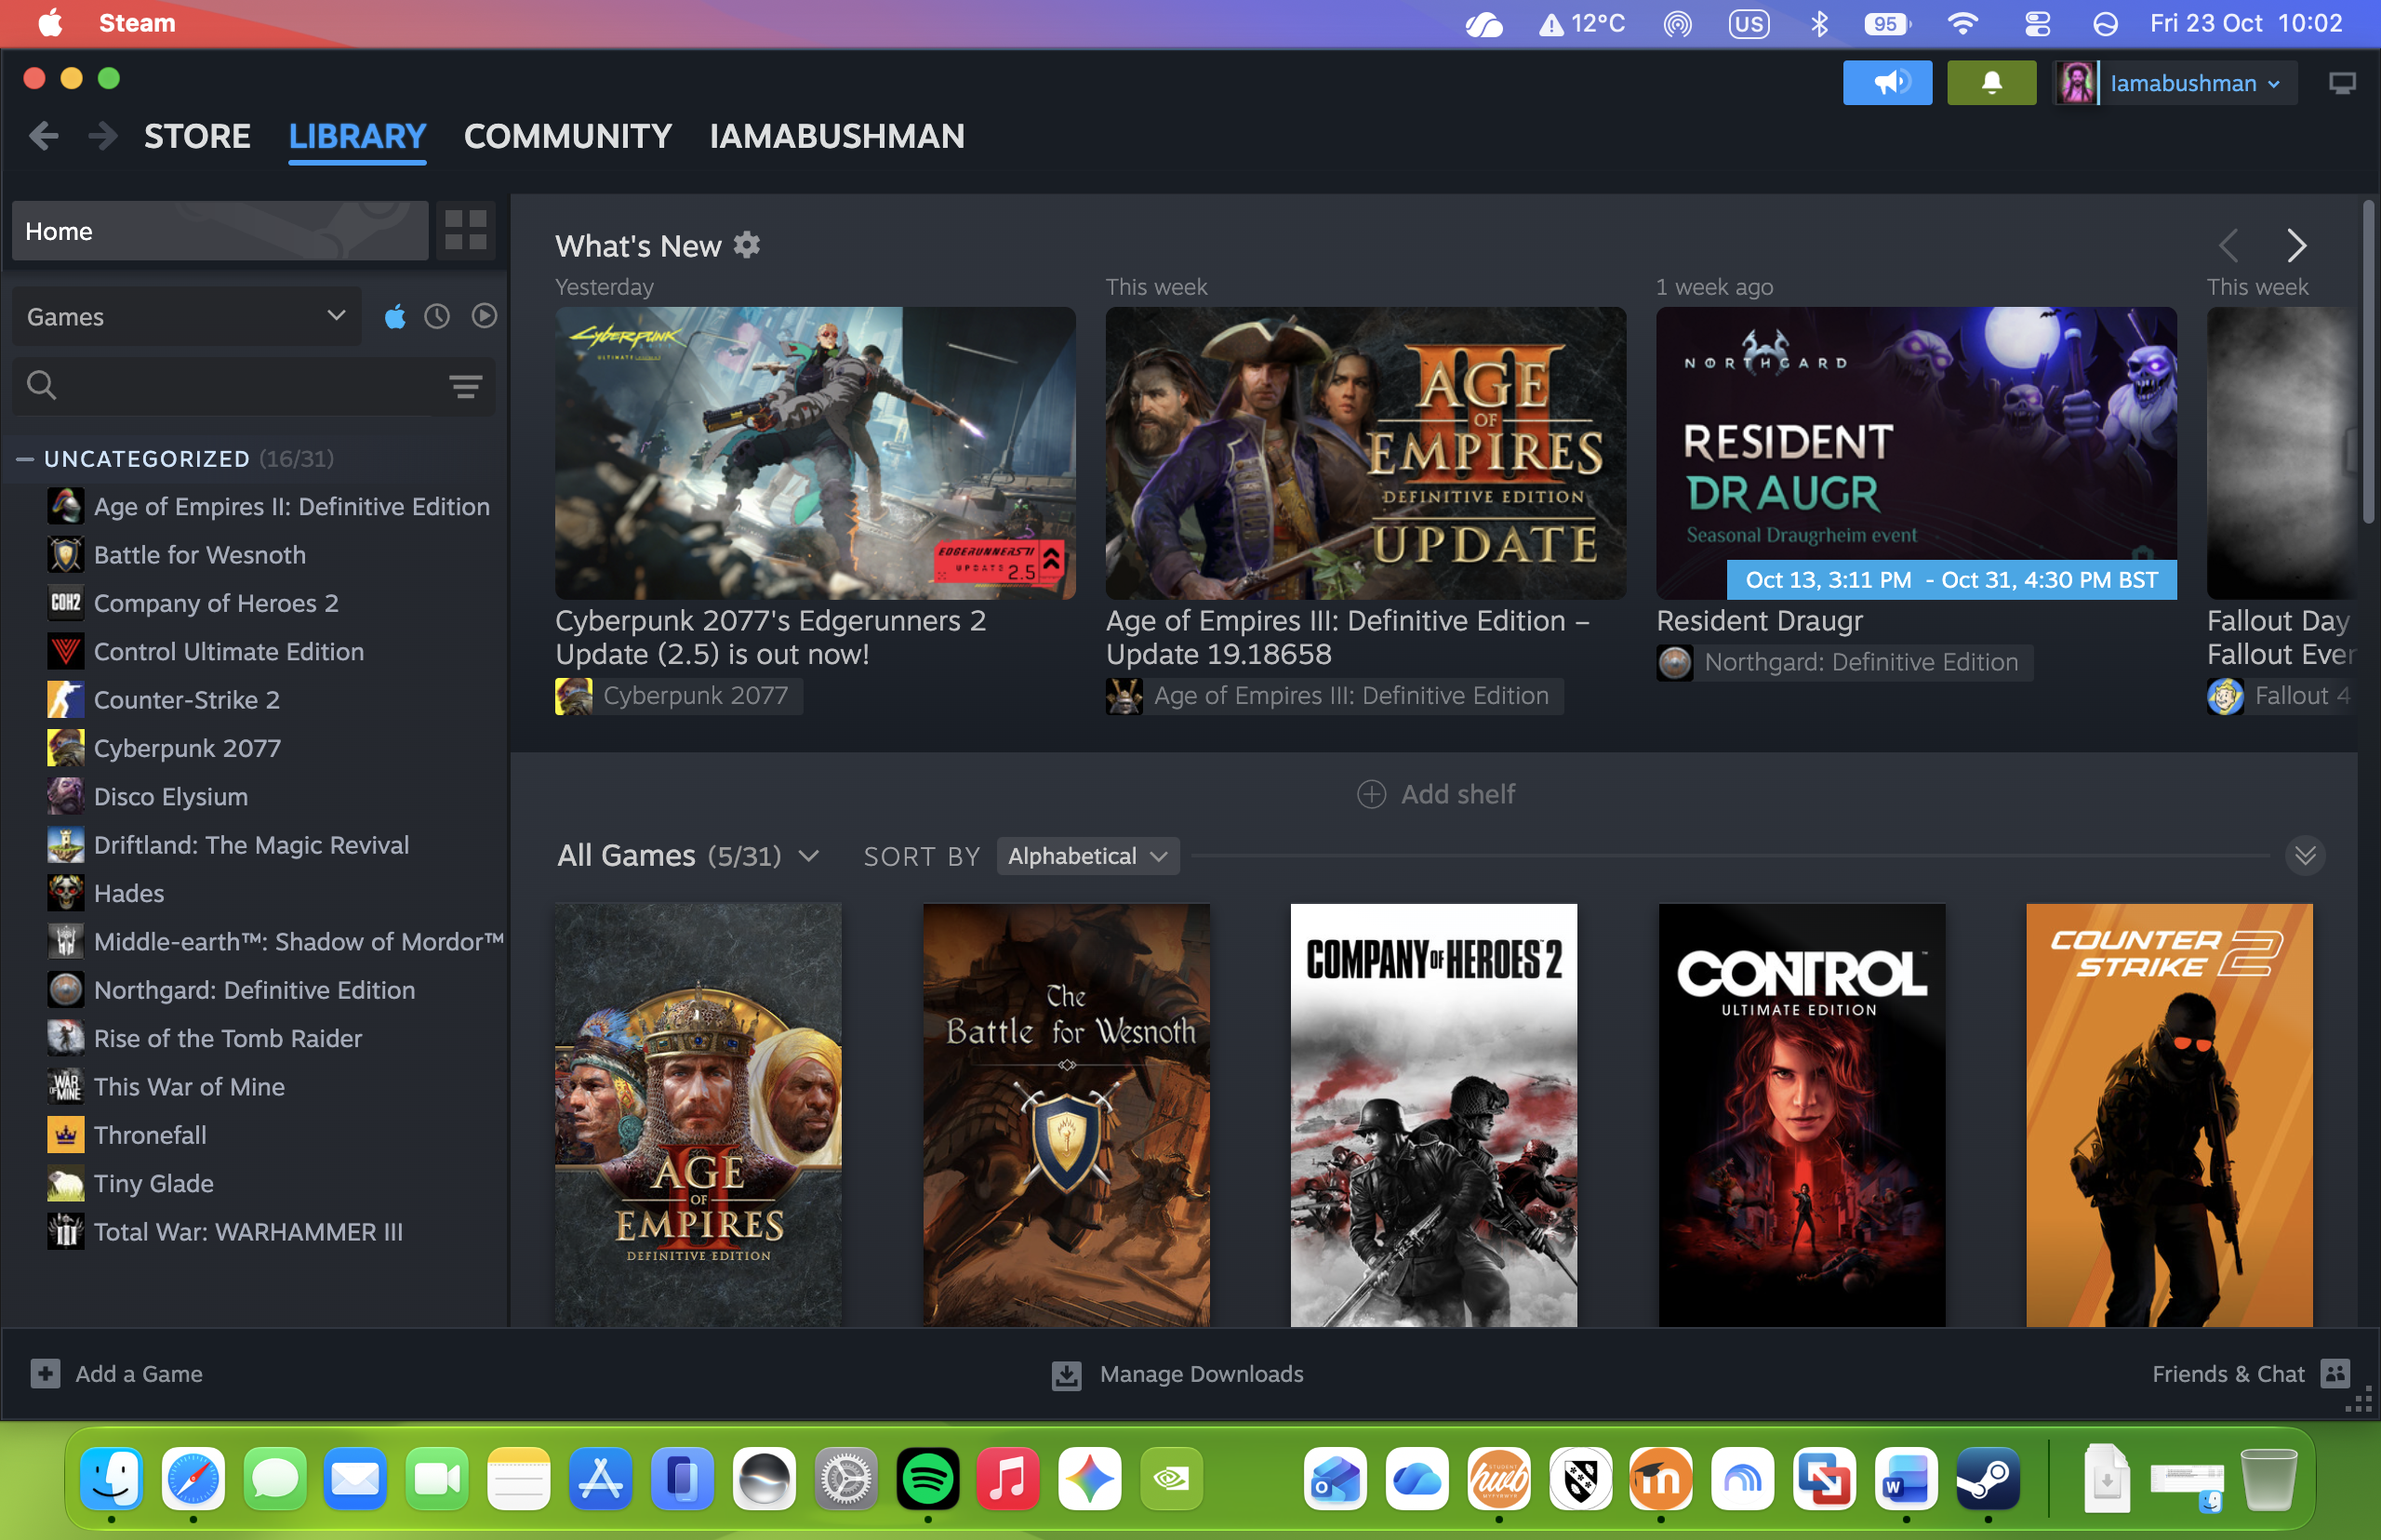
And of course, Steam for gaming and have fun.

My Short Reflection
- Write 5–8 simple sentences about your digital life.
- You can use the sentence starters below if helpful.
I have a digital life since 1998 when I started to use Windows 95.
And since then, digital tools for everything in my life and business.
I feel confident using or learning any software or gadget in my day-by-day basis, and new technologies makes me
Being completely honest I’m not sure if this module will help me with anything but I’m open to it.
My goal is learning Python and getting Microsoft Office certification until the end of 2027 and I’m going for it.

Submission Checklist
Before you submit, please check:
​​​ ☒ I added 4–6 screenshots
☒ I wrote short sentences for each screenshot
☒ I wrote my short reflection
☒ My work is my own
☒ My file opens correctly
​​☒ My file opens correctly

