Assessment 2 market research & website
BMSW4003 Digital Skills & Research Methods
Student Mihaela Fodor
Student number 1905830
University of Wales
Trinity St David

Table of Contents
1. Website login details 1
2. Introduction (86 words) 1
3. Questionnaire design & analysis (949 words) 1
• Importance of Market research 1
• Methods 1
• Survey for Microblading Xtream 2
4. Website design (600 words) 6
5. Conclusion 9
References 10
Appendix 11

Website login details
Email address:1905830@student.uwtsd.ac.uk
Password: Alexia2010

Introduction

This report has been compiled as part of the assessment for the module Digital Skills and Research Methods to present how I have compiled a primary research questionnaire to gather relevant data and information for my business on may target customers and their preferences and, by analyzing it, to decide on how to create a targeted website using this knowledge in order to present my business and products in an efficient and productive way and to align them with the needs and preferences of the customers.

Questionnaire design & analysis

Importance of Market research

Marketing research is a tool used to objectively gather relevant data and information about the customers and competitors and analyze it in order to find solutions and methods make the right decisions with the smallest risk regarding the future strategies of any company and understand the customers’ trends and preferences, find opportunities to maximize profits, predict changes of the economy, gather knowledge about the competition, etc. (Crawford, 1997), (Business Development Bank of Canada, n.d.).
Since 1955, multiple analysts have compiled a hierarchy describing the process of research as a pyramid starting with gathering data and information as the lower levels, filtrating them by relevance and importance gaining the knowledge of the important aspects of the market and finding the wisdom on how to decide the best strategies to follow, most important being in 1987 Milan Zeleny (Zeleny, 1987) and in 1989 Russell Ackoff (Ackoff, 1989) but, as observed by Wallace in 2007 (Wallace, 2007), none of them used this graphical description.

Methods
Market research has the role to gather information about products, price, location and promotion (advertising) and can be done using two methods – gathering information from third parties about markets and trends – secondary research or by developing own research tools personalized and structured for a specific reason like trends, preferences, opinions to gather information directly from the targeted source like potential customers - primary research.
If we compare the two methods, we can find that the primary research is more useful since it is relying on tools conceived to address specific points of interest of a company, provides unique and specific data and information unavailable elsewhere, the results are the property of the company that conducts the research, it targets specific products, market segments and customer groups and provides a better knowledge. (Business Development Bank of Canada, n.d.) (Grant, 2022)
Some of the most used methods of gathering primary research data are survey, observations, interviews and projective methods. From these methods, the surveys are considered one of the accessible to use. The survey steps include the reason of the study, type, investigation setting and sampling, data collection through questionnaires, analysis, reports and recommendations. (Ekinci, 2015).

Survey for Microblading Xtream
For Microblading Xtream, we have done a survey using Microsoft Forms (see appendix 1). To compile this survey, the next steps were followed:

Reason
Assessing the awareness of our products and build a website to promote and attract customers.

Type
Online questionnaire with both open and closed responses to gather qualitative and quantitative data from our respondents regarding their history, awareness, interests in our products, prices, personal opinions regarding the beauty concepts, facilities, additional products they are interested in having in one place.

Questionnaire
The online questionnaire contains 11 questions regarding information about respondents (age, contact details, personal characteristics and history relevant for our products, prices and facilities. The questionnaire was addressed to a group of 10 people. These questions are organized in 3 sections, which analyzed both separated and combined, provide a lot of useful knowledge:
- personal data and information about respondents, which contain questions about age, motifs and preferences
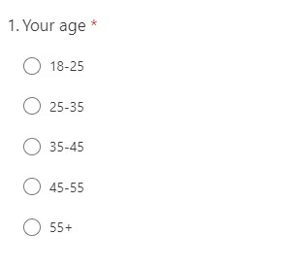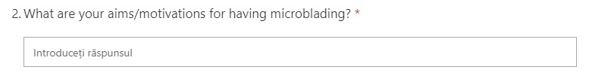

b. knowledge and history in relation to the product,
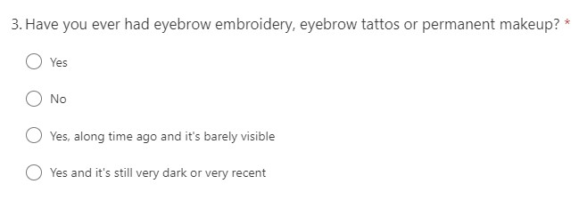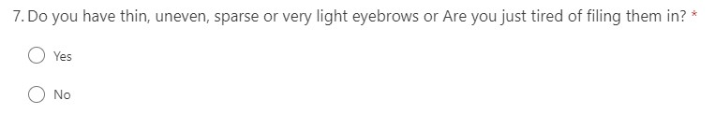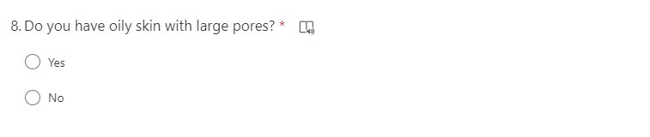

- Price and facilities preferences.
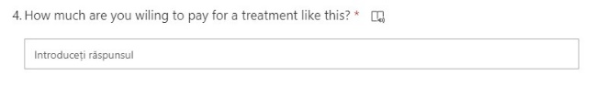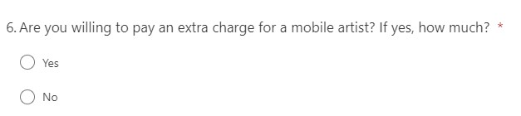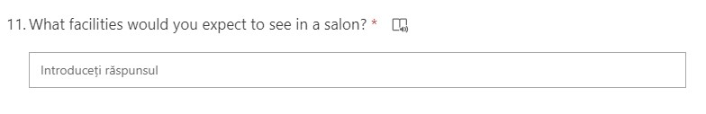

Analysis
- By analyzing the first segment we can find that our group is composed predominantly of women aged 35-45 with 5 respondents (Fig 1). From the Q1 we can find that we could extend the future research for a broader group containing more responders with a diverse range of age and sex, for more reliable data.

Figure 1 Chart for repartition by age and sex
Also, from the responses to Q2, we can notice that most of the respondents would use beauty treatments as microblading to improve their appearance, while only a few are not interested in these type of treatments. (Fig. 2):

Figure 2 Aims and motivation
- If we analyze this information together with the answer from Q3 about history of use, from the second part, we can see that, from our respondents, most of them never used microblading. However, we can notice that all were women. This led us to the conclusion that the service and its benefits are not well known by men.

Figure 3 Usage History by sex
Going further we can see all previous users of the service are in the price range of 35-45 years.

Figure 4 Usage history by age
Overall, this section of the questionnaire advises us that the service is not well known to our group, which leads us to believe that some awareness campaigns and strategies regarding the service would help attract some potential customers.

- The third sections provides us with important information regarding the price range which shows us that most of the respondents would pay between £200 and £300 for a microblading treatment.

Figure 5 Price range
In this section we can also see that, from our group, most of the respondents would prefer to have access to the service at their residence. Even more, the customers would pay extra for this type of service.

Figure 6 Extra charge for mobile artist

Reports and Recommendations
From the data gathered through our questionnaire we can deduct the following
- Campaigns, blog posts to raise awareness especially through male potential customers would have success in bringing new customers
- Diversity of the products and increased flexibility would help customers choose our products.
- Further research on a wider group including more respondents from different ages and sex would help gathering more relevant data in regards to these points of interest. Also more specific and structures questionnaires would provide vital data for the future strategies of our business.

Website design

The questionnaire analysis provided a lot of useful information regarding the awareness about the products and services and about my potential customer’s motivation and preferences regarding prices, products and facilities.

- I have decided to create a section on our website where to explain every procedure in detail, create also links to my videos on the business’s YouTube channel presenting each procedure and underlining the benefits for each category of potential clients (sex, age) and to get in close contact with our potential customers, by allowing them to ask questions and receive information regarding the desired services.

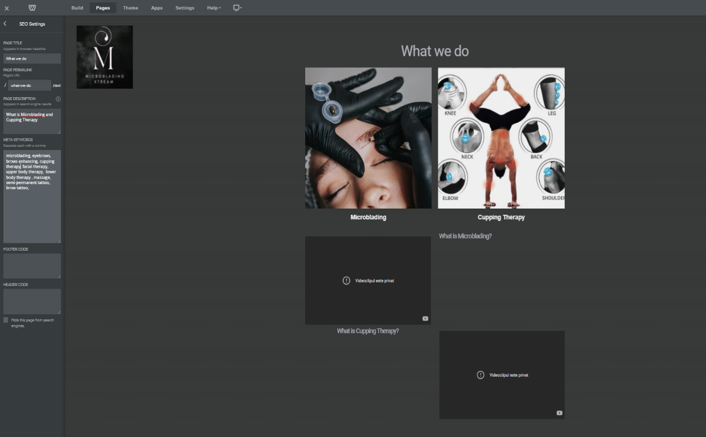
Figure 7 What we do
- Include a number of secondary services available for online booking
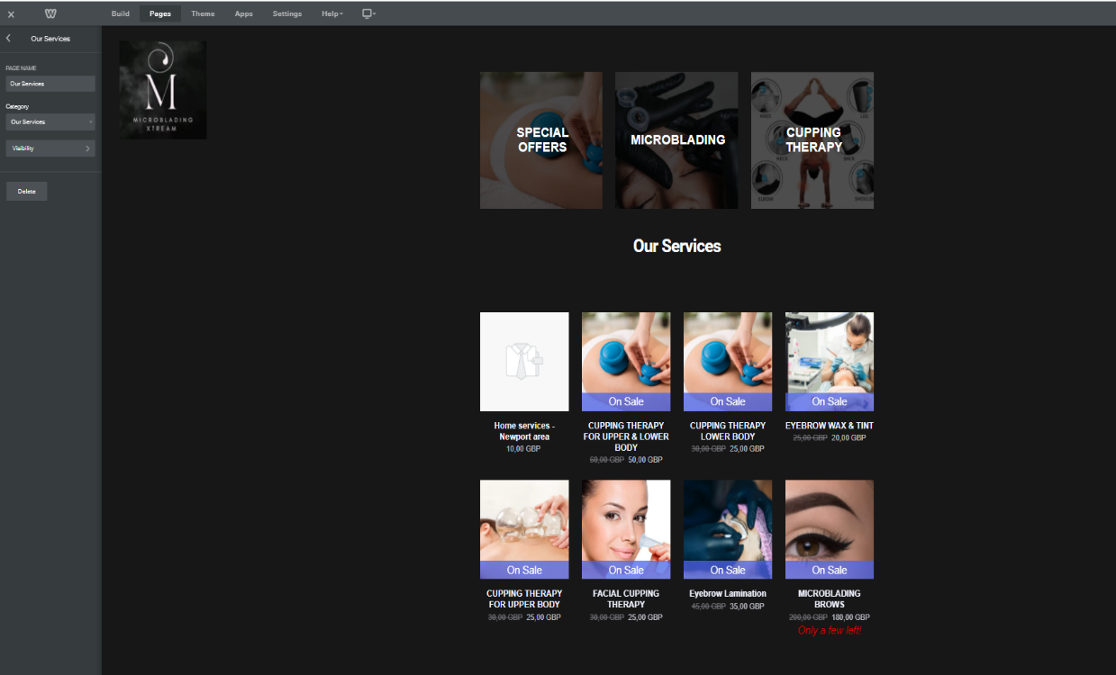
Figure 8 Our services
- Create special offers on service packages like limited time discounts for frequent customers (e.g. 10% discount for a second booking on same service), referrals (recommend a friend and receive 10% discount for your procedure or book 2 procedures and receive a discount of 15%), or different services package (book 1 microblading and 1 cupping therapy session and receive a 10% discount on the cheaper one) with the purpose of attracting customers on all our range of services.
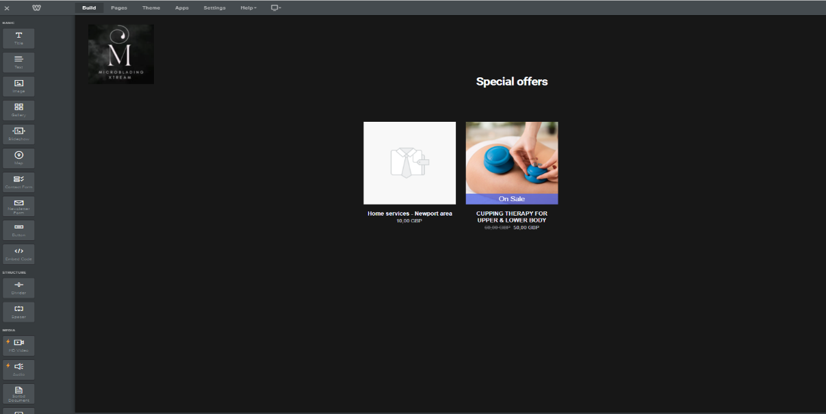
Figure 9 Special Offers
- Include the possibility of location mobility when possible for procedures, with extra charge
- Create a newsletter section where interested customers to receive information regarding the offers, products with the purpose of creating a database of potential customers for future surveys regarding our products.

Figure 10 Newsletter form

For the website I chose a dark background as it suggest professionalism and also provides a good contrast for the text and colored images. I have chosen the images in relation to the information related by the title and text.

In terms of SEO, I have chosen terms and combination of terms in relation with:
- Location – terms that localize my business area (city of Newport Wales and neighboring cities)
- Services – for each item and category created I have used terms and / or combination of terms from the service description and from the questionnaire section about aims and motivation of the customer like “perfect eyebrows” or “perfect brows”.
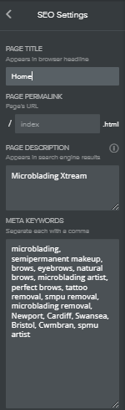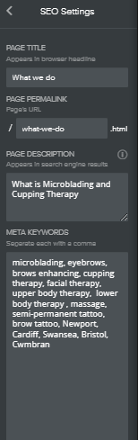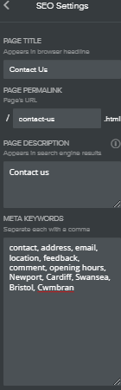
Figure 11 SEO on different pages

Conclusion
It is very important that any decision should be made after gathering relevant data and information and analyzing it to gain the insights and knowledge about the trends and preferences of the potential customers. Attracting these clients can only be made by aligning our strategies to their preferences and trends.
For me, using the survey based on a questionnaire offered good reference points for how should I structure my website to provide exposure for my services, make them unique to improve my marketing strategies and adapt them on my customers’ preferences and trends, increasing my chances of customer conversion.

References
Ackoff, R., 1989. From Data to Wisdom. Journal of Applied Systems Analysis, pp. 3-9.
Business Development Bank of Canada, n.d. The Importance of Market Research. [Online]
Available at: www.antco.ca/downloads/importance-of-market-research.pdf
[Accessed March 2022].
Crawford, I. M., 1997. Marketing Research and Information Systems, Rome: Food and Agriculture Organization of the United Nations.
Ekinci, Y., 2015. Designing Research Questionnaires for Business and Management Students. Online,2020 ed. s.l.:SAGE Publications LTD.
Grant, D., 2022. Primary Market Research: What is it and Why is Important?. [Online]
Available at: www.driveresearch.com/market-research-company-blog/primary-research-wht-is-it-and-why-is-it-important/
[Accessed 2022].
Wallace, D. P., 2007. Knowledge Management: Historical and Cross-Disciplinary Themes. s.l.:Libraries Unlimited.
Zeleny, M., 1987. Management Support Systems: Towards Integrated Knowledge Management. Human Systems Management, pp. 59-70.

Appendix
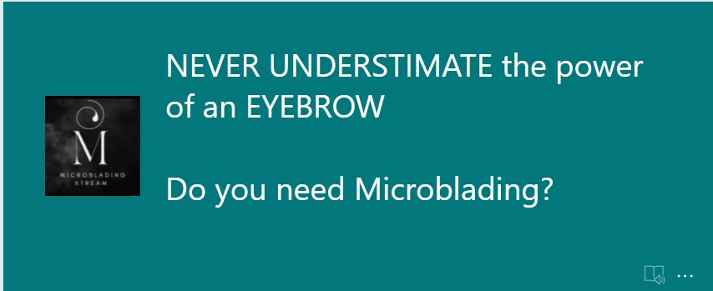
1.

