University of Wales Trinity Saint David

Computer Aided Engineering



Application of Computer Aided Engineering Processes
L5 – Computer Aided Engineering (ACDB5007)

Craig Maclellan

2114212

April 2023

Lecturer: Andrew Noble

Contents
1.0 Introduction 1
1.1 Aims & Objectives 3
2.0 Background Information 4
3.0 Methodology 6
3.1 Explicit Dynamics 7
Engineering Data 7
3.2 Geometry 9
3.3 Solidworks 10
3.4 Model 13
3.5 Setup 14
3.5.1 Mesh 15
3.5.2 Summary 16
3.6 Solution 17
4.0 Validation 18
5.0 Results & Analysis 20
Copper and Brass 20
ABS Plastic and Steel 22
Lead bullet and ABS Plastic Lego target 24
Lead and Aluminium 26
6.0 Conclusion 29
7.0 Reference List 30

Introduction
This assignment will show the capabilities of computational engineering, which includes Computer-Aided Design (CAD), Computer Aided Engineering (CAE), Computer Aided Manufacturing (CAM) and Finite Element Analysis (FEA). The use of these tools/software will be showcased throughout the assignment as well as their limitations.
Various computational engineering software applications will be used to design and simulate a realistic Ordnance, Munition and Explosive inspired scenario where a comparison will be made between results/outcomes. This assignment will also feature some background knowledge of the OME industry.
CAD, CAE, and CAM are used heavily worldwide in many complex engineering projects and are relatively new processes with them only being introduced in the last few decades. CAE has become a vital first stage of the design process of a product. It has had a great effect on the industry and carries lots of benefits as it is able to push the boundaries of design and manufacturing.
Computational engineering improves engineering accuracy​, increases productivity​, allows tracking of workflow​, facilitates the better transfer of knowledge​, allows parts to be easily changed​ and enables information sharing [1]. These are just a few of the benefits computational engineering offers.
Finite Element Analysis (FEA) is a process that simulates the behaviour of a model/assembly under specific given conditions which then simulates physical phenomena [2].
A mesh made up of millions of smaller elements is created and used in line with mathematics to quantify the effect of real-world conditions.
Solidworks, invented by MIT student Jon Hirschtick, is a 2D and 3D modelling software, used by all kinds of engineers, which will be used in this assignment to model the components [3].
Swanson Analysis System Inc, also known as Ansys, is an engineering simulation software with FEA and can get the analysis needed for this assignment. ANSYS is used in many industries including aerospace, defence, biomedical, automotive, and other industrial sectors [4].

CAE’s biggest benefit is the reduction in risk and reduction in cost. There is no risk involved in running a CAE simulation as it is virtual. Before CAE the best way to design a product was through trial and error which required a lot of money and time. Using CAE accelerates the design process because everything can be done on a computer. An example of this is BAE Systems which must invest in the CAE world. BAE are constantly designing munition products. For these products to make it to the shelf they need to be tested. Multiple physical prototypes need to be designed and built and then fired in a real-life environment. This costs money, takes time, and most importantly puts people at risk. It is rare that things are perfect and work for the first time, especially in the OME world. CAE allows for multiple designs to be made costing relatively nothing. All that is needed is a computer system as well as someone who knows how to use it.
This report aims to look at how CAE software can be used to design and simulate an OME product. Multiple simulations will be run, each time will be different to create a comparison in results. The design of both models will be altered to get different results. projectiles design will be changed and so will the target to show a comparison. With each simulation things will change; Material properties will be taken.

1.1 Aims & Objectives
The aim of this assignment is to see how computational engineering can be used to accurately replicate a real-life OME scenario. Below are the results that are expected from the analysis.

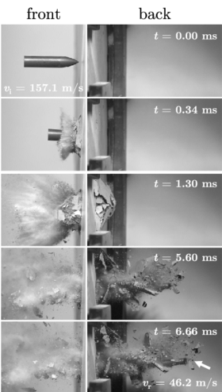
Bullet Effect Example 1

Things like fragmentation from the bullet are expected to be seen in the results as this is what would happen in real life. Fragmentation is parts of an object that separate to make smaller pieces. Most OME products take fragmentation into consideration when designing a product as it can be used to its advantage as the small pieces of material fly through the air at dangerous speeds and can cause serious harm to a human.
Limitations of the software will also be explored in this assignment and compared to the real world.

2.0 Background Information
The projectile that will be designed in Solidworks is a 147-grain M80 FMJ 7.62x39mm. This type of bullet is typically used in small arms amongst NATO countries. First designed in the 1950s, the 7.62x39mm is a rimless, bottlenecked rifle cartridge which the United States (US) brought into service for its M14 rifles and M60 machine guns. Many firearms (marksman rifles/sniper rifles and medium machine guns/general-purpose machine guns) remain in service that uses this type of ammunition.
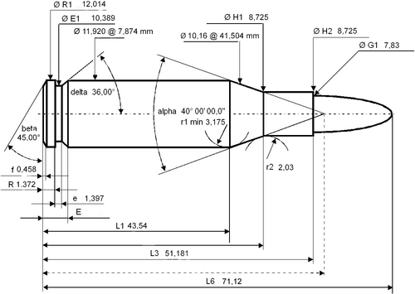
Projectile Dimensions 1
There is also a 7.62x39mm cartridge which is a Soviet rifle cartridge designed in World War II. Shortly after the war, one of the world’s most recognised assault rifles was designed specifically for this cartridge. The replacement for the 7.62x39mm cartridge is the 5.45x39mm which is less powerful but longer range due to its much higher velocity. The change was in response to NATO replacing the 7.62mm cartridge with the 5.45x39mm NATO [5]. The muzzle velocity of this bullet is approximately 850 m/s the same as the 7.62.39mm cartridge. All the bullets used in this assignment have a steel core in real life, but the projectile model will have different materials applied to it to get different results.
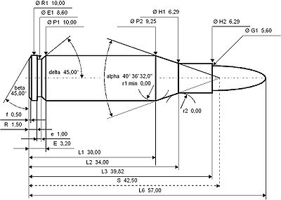
Projectile Dimensions 2
The AK47, also known as the Avtomat Kalashnikova, is a Soviet gas-operated assault rifle. This rifle is chambered for the 7.62x39mm cartridge. The AK47 has been around for decades and has become one of the world’s most renowned assault rifles. 5.45x39mm cartridges are shot by the AK4 which is the new and improved version of the AK47
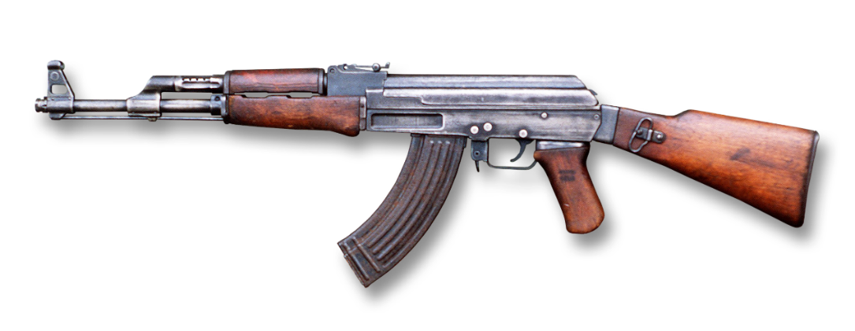

3.0 Methodology
The simulation will show the projectile (bullet) making an impact with the target (plate) using one of the integrated ANSYS analysis systems.
The projectile in the simulation will be in motion then it will penetrate the target so it must have force, mass, momentum, and energy all over time. The problem time magnitude will be very small for this analysis because the projectile will be travelling at the velocity of an an80 FMJ 7.62 round which travels at 850 m/s. Due to the quickly applied loads/impacts, this is a nonlinear dynamic analysis. Coming back to the point about the time step; because it has super small-time increments this will be an explicit analysis.
When it comes to a simulation there are two factors that take the time of the simulation into consideration. This is explicit and implicit; both solve the same thing, but the difference is how they increment time. Implicit is used for slow simulations over a long amount of time so it is of no use for the simulation whereas explicit is used for fast simulations which is why it is being used in this situation [6]. The equilibrium also has a part to play because with explicit, at each time increment the global equilibrium in the model is established which makes it must converge. With explicit, there is no need for converging as there are no iterations (repetition) due to its super small-time increment, so the solver does not establish the global equilibrium it just assumes that it exists. The global equilibrium of forces dictates that the net force on the surface of the body vanishes. If a body is not moving, then the forces acting in all directions are 0.
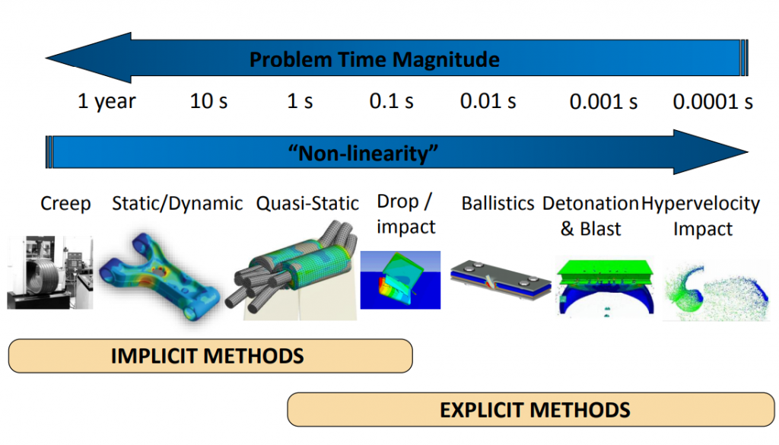

3.1 Explicit Dynamics
The analysis system that will be used to simulate the projectile going into the target is “Explicit Dynamics”. Explicit Dynamics is a time integration method that is used to perform dynamic simulations when speed is important [7]. Explicit dynamics account for quickly changing conditions or discontinuous events, such as free falls, high-speed impacts, and applied loads. Because these “nonlinear dynamics” are integrated into the simulation, explicit dynamics is the preferred choice for simulating highly transient physical phenomena [8].
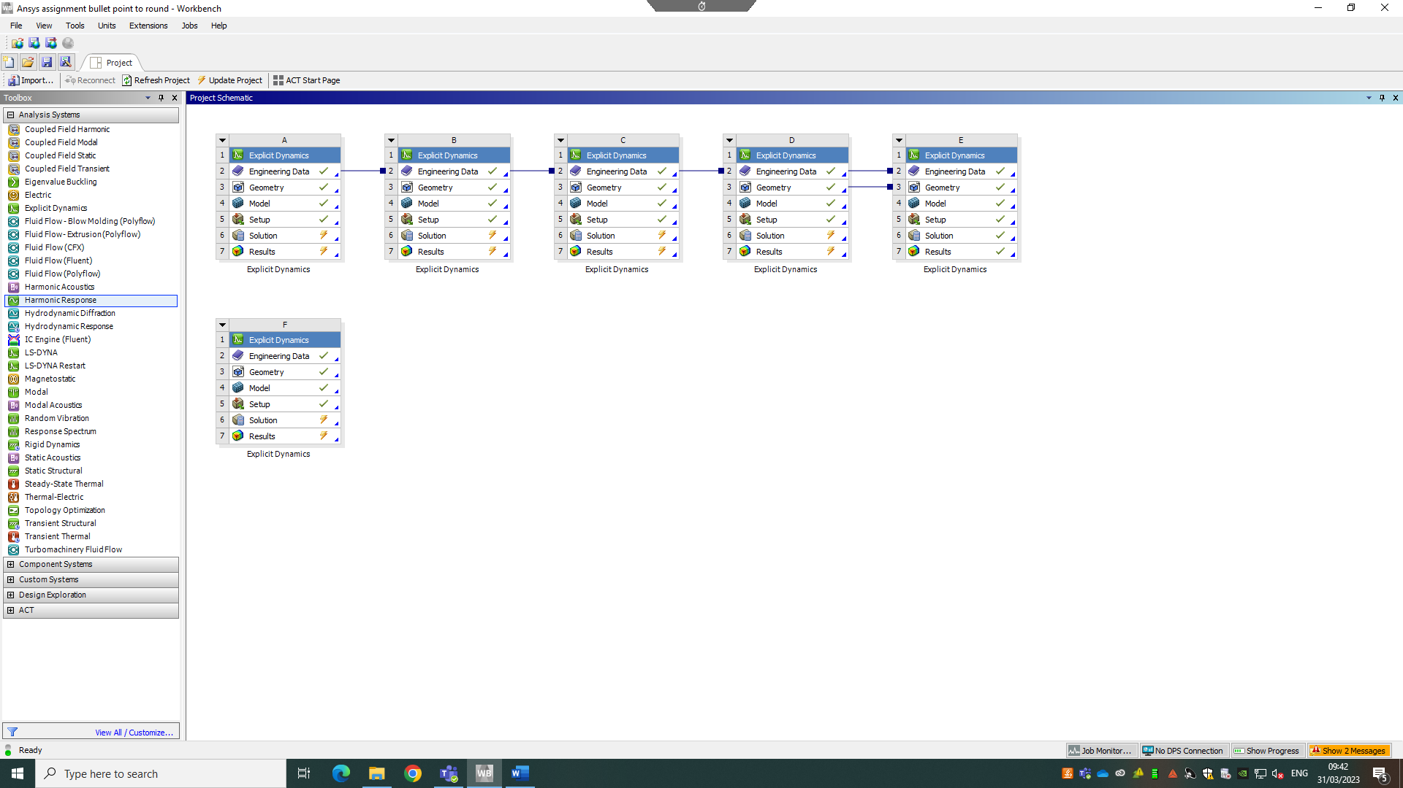
Image of Explicit Dynamics 1

Engineering Data
The Engineering Data tool on Ansys opens a library full of material properties. This library has loads of pre-loaded materials.
Image of Explicit Dynamics 2
The materials required for the simulation are found in the “Explicit Materials” section. Here, the materials can be selected and added to the engineering data.
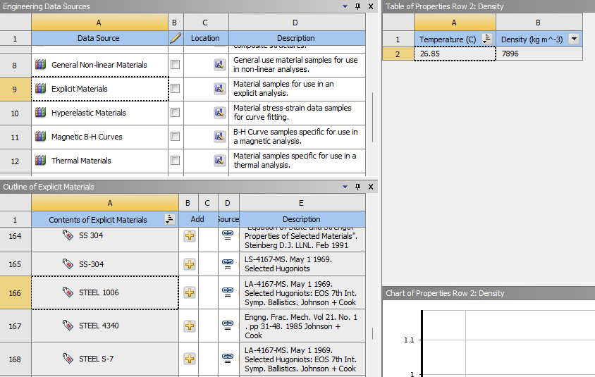
Image of Engineering Data 1
Without Engineering Data, the analysis would not be realistic. Material properties are required because they tell the software stuff like stress and strain figures which helps with the mathematics. The whole point of the simulation is to see how the materials are affected/behave when penetrated by the projectile. A few things to consider are how bendy the material is, how hard it is, and how stretchy it is. This refers to the brittleness and ductility of the material. If the material is ductile then it can be stretched but if the material is brittle, it will break rather than stretch [9].
Some of the most common words that will be found in material science/engineering are Alloy, Ceramic, Composite and Polymer. Alloy is a metallic material that is made of two or more elements such as Aluminium Alloy, Steel Alloy, and Copper, hence the word alloy in the names of these materials. Ceramics is a material which is made by heating inorganic non-metallic components, such as bricks, clay, and glass. Composite is a material made from two materials that have different chemical and physical properties, examples of this are, Wood, Carbon Fibre and Kevlar. Lastly, Polymer is a material that contains large molecules composed of repeating smaller units such as Nylon, Teflon, and Polyethylene. The materials used for this assignment are mostly metals (alloys). Some polymers such as rubber and plastic will be used just to show comparison.

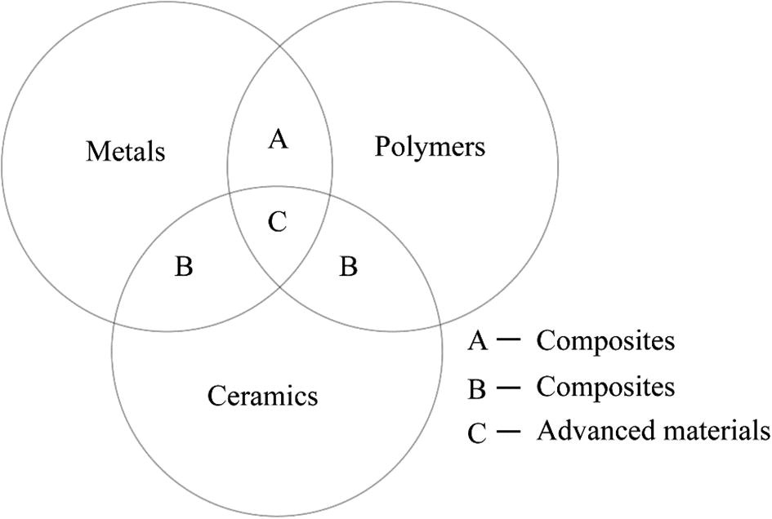

3.2 Geometry
The next step is to select the geometry. This is where the model assemblies from Solidworks will be imported.
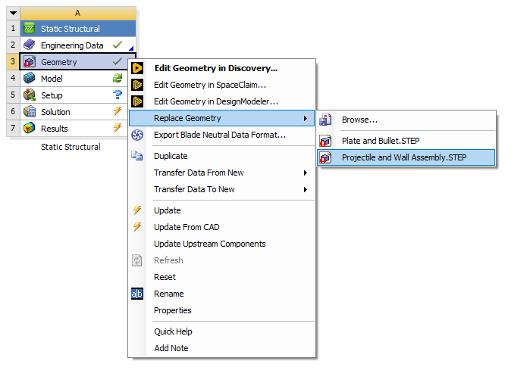
Image of Geometry 1

3.3 Solidworks
For the geometry to work, models must be made in Solidworks then assembled. Below are all the models that have been made for this assignment.
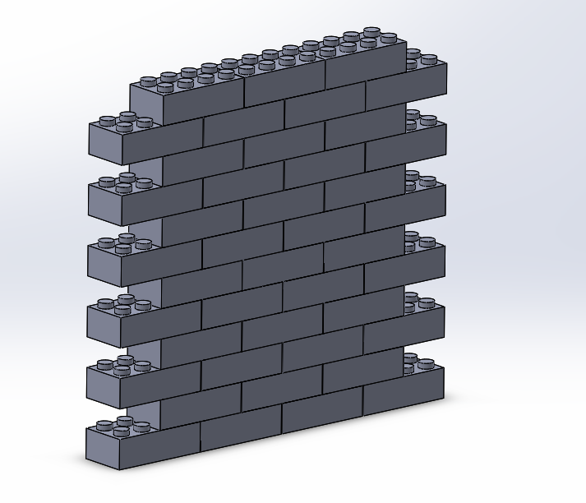
Image of Target 1
Target 1 is made up of 42 Lego bricks which is all connected using multiple constraints. Please see Target 1 Dimensions for dimensions.

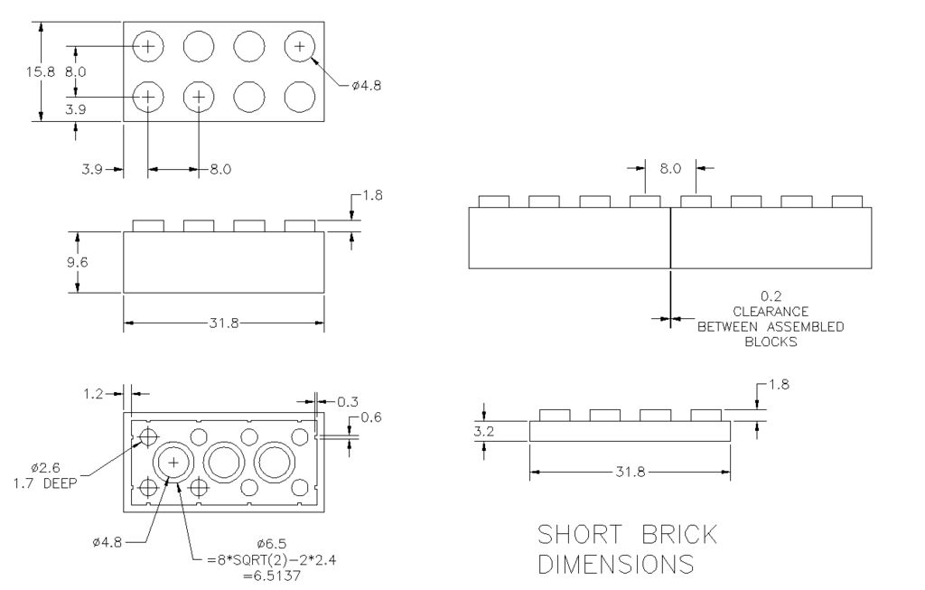
Target 1 Dimensions 1

Target 2 is a cylinder with a diameter of 150Ø and a thickness of 10mm.
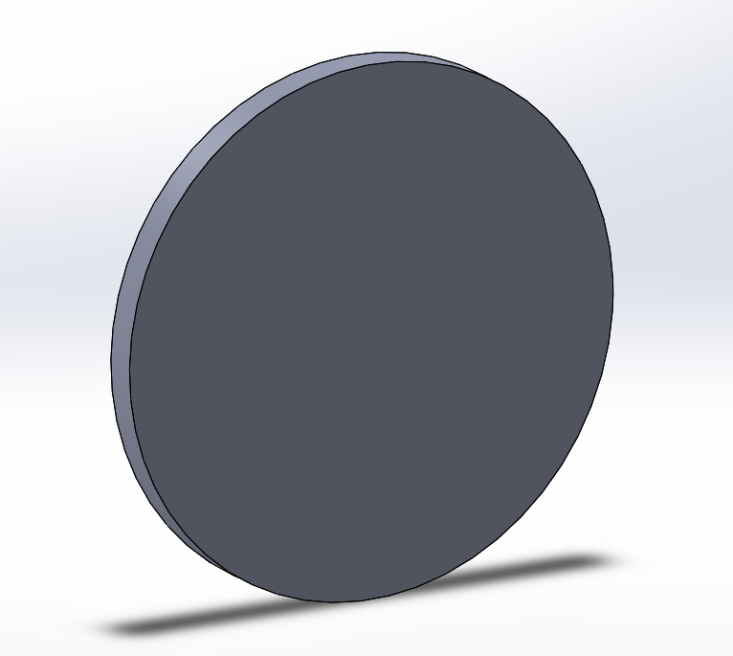
Image of Target 2
Target 3 is a cuboid with dimensions 150mm x 150mm and a thickness of 5mm.
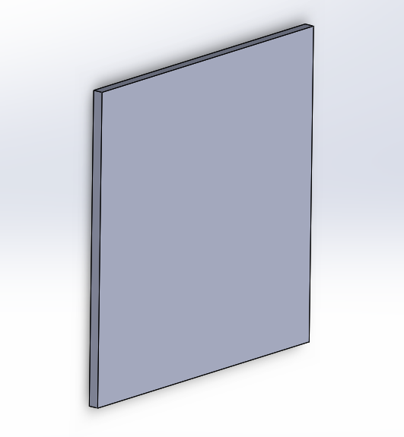
Image of Target 3

Target 4 is the same as target 3 but 3x thicker. A cuboid with dimensions 150mm x 150mm and a thickness of 15mm.
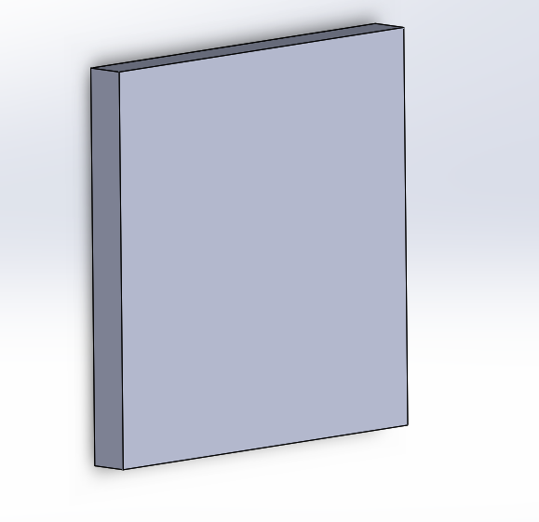
Image of Target 4
This is the 5.45x39mm round normal with a slight rounded but pointed tip.

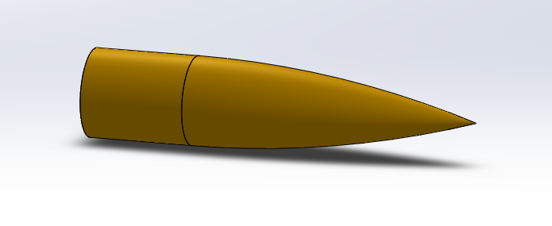
Image of Projectile 1

This is the 5.45x39mm round with a more rounded edge. Similar to the 7.62x39mm round.
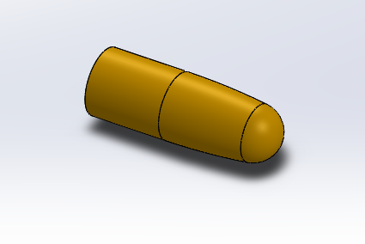
Image of Projectile 2

For compatibility reasons, all models are saved as STEP files. Most CAD programs can read and edit STEP files which enhances the cross-platform design and collaboration. STEP files use mathematical representation of curves, also known as NURBS, which allows the date to be stored accurately [10].

3.4 Model
The model is where the geometry/assembly is loaded into Ansys and can be visualised/interacted with. The image below is the Lego wall assembly with the projectile. It is important to note that the bullet does not have to be at a distance from the target. This is just to help visualise the scenario better. This is because in this simulation the bullet is moving at the same velocity regardless of where it. The setup stage is where things like this is considered.

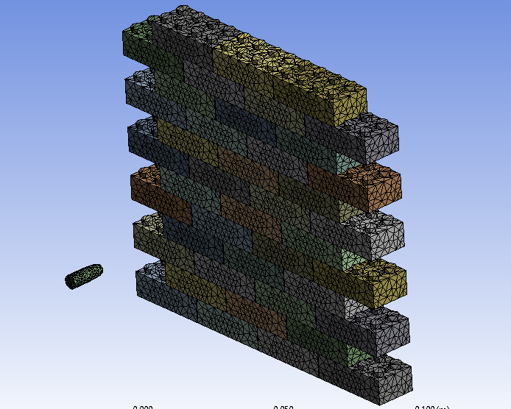
Image of Model in Ansys 1

3.5 Setup
Now that the model has been imported into Ansys, it is time to setup the simulation/scenario. Let it be noted that this can be done in any order and for this assignment below is the way it was done.
Firstly, insert a fixed support boundary condition to the target edges to prevent the entity from moving or deforming.
Apply material from engineering data list to the target and to the projectile.
Under Static Structural, insert a velocity. This will specify a displacement per unit of time. Select the geometry for the velocity, in this case, it is the back of the projectile as it is to mimic being shot from a gun. Make sure the velocity is defined by the component. Figure out which direction and path the bullet must take (X, Z, Y) for it to penetrate the target. Enter The velocity applied to the projectile which is 850 m/s.
Now that the velocity has been applied, the Result Number of Points, found under analysis settings then Output Controls, must be changed from 20 to 100. Because the simulation is explicit by increasing this figure it allows for more visual points in the result so it can be seen clearly step by step what is happening.
For the simulation to run an End Time is required, this can be calculated using simple maths. For example:

Bullet velocity = 850 m/s
Target thickness = 15mm
850 milometers per second = 850,000 (850x10^3)
$$\frac{60}{850000}$$
=0.00007059 x 15
= 0.00105885s
= 0.001s
= 1.e-003s

3.5.1 Mesh
The last part of the setup is to create the mesh. This is an interesting part as this helps the
Explicit Dynamics on ANSYS then import assembly from Solidworks as the geometry.
Meshing takes a complex geometry and converts it into well-defined cells where the solver can then use a governing equation to easily simulate realistic physical behaviour [11]. By creating a high-quality mesh that defines the geometry well, it ensures accuracy and convergence which is needed in high velocity simulations like this one.
In this assignment, three-dimensional (3D) meshing was used. Two-Dimensional (2D) meshing is also available but was not practicable for this type of model/analysis. The most common cell shapes for meshing are triangular and quadrilateral.
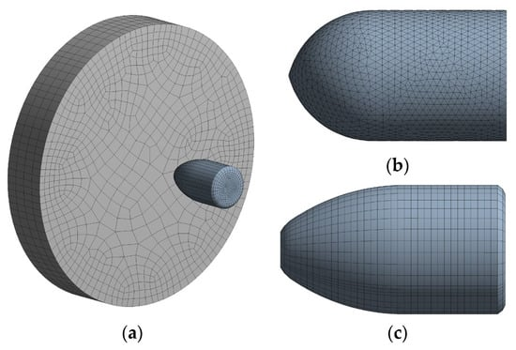
Quadrilateral
Triangular
Image of Meshing Example 1
A 3D meshing has many shapes such as a tetrahedron, quadrilateral pyramid, triangular prism, and hexahedron.
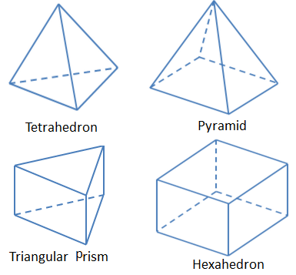
Image of Mesh Shape 1

By using reference points in X, Y and Z axes 3D mesh can define the shape with height, width, and depth. To create a realistic/photorealistic simulation many polygons are required, although relatively simple shapes, they allow for faster processing in comparison to other techniques [12].
Another technique is NURBS which stands for Non-Uniform Rational B-Spline (the B stands for basis). Splines converge curves which results in a continuous and irregular curve. NURBS produce smooth curves and are usually used for unique or unusual geometries [13].
There are different classifications of grids such as structured and unstructured. Structured grids require significantly less memory and can be identified by their regular connectivity. The advantages of structured grid meshing are simplicity and efficiency [14]. Unstructured grids require more space so are highly space inefficient. They are identified by irregular connectivity and have the ability to deal with complex geometries [15].
Ansys has provided a recommended default element size of 5.3092e-003m for the mesh. This is 0.0053092m. The mesh value will change but this is a good basis for the study.
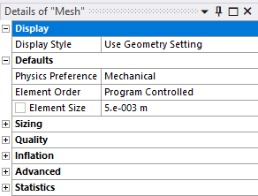
Image of Mesh Details 1
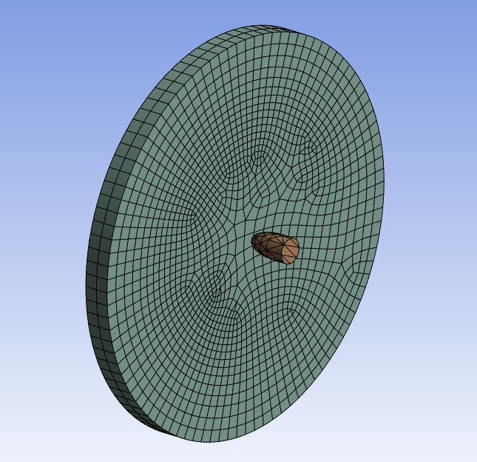
Image of Meshing Example 2

3.5.2 Summary
Fix edges of target
Apply velocity in correct direction = 850 m/s
Number of Points = 100
End Time = 0.001s (1.e-003s)
Generate Mesh = ±0.005m (5e-003m)

3.6 Solution
The final step to get the simulation running is the solution. In the solution section there is a menu drop down called “Analysis”, this application automatically performs all appropriate Workbench Project page configurations.
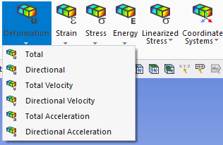
Image of Analysis 1
In this analysis the total deformation was studied. Once it has been selected, the solve handler tool will run the simulation and give results. This process can take some time depending on mesh size and complexity of what it is being asked to do.
Below is the Ansys workbench with multiple results all in the one file which helps to keep things neat and all in one place, so it is easy to access.
Image of Ansys Design Tree 1

4.0 Validation
Validation as well as verification is a formal process to check result accuracy. Prior to running analysis for the OME model, some sanity checks were performed on a cantilever beam to analyse its deformation. A cantilever beam is a long rigid beam that is only fixed/supported at one end as seen in Cantilever beam 1.

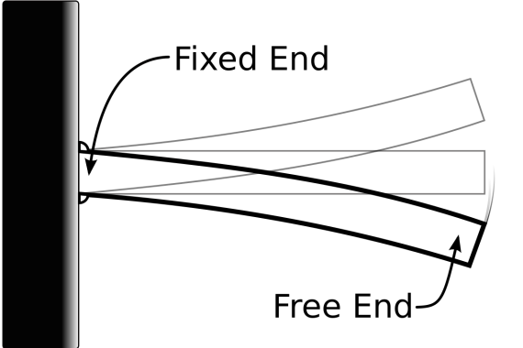
Cantilever Beam 1

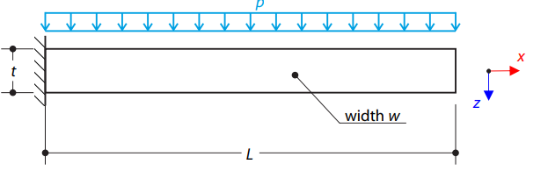
Cantilever Beam 2

The Euler-Bernoulli theory calculates the bending of beams when a load is applied. It is a simplification to linear theory of elasticity. This method determines the load-carrying capacity as well as the deflection characteristics of the beam. This equation is used in this validation to calculate the
In this example, the self-weight is neglected so doesn’t have effect on it, but the small deformations are considered. The aim is to calculate the the maximum deflection ($U_{Z, Max})$ and show that the surface behaves linearly when under bending.

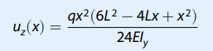
Equation 1
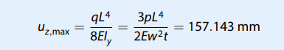
Equation 2

The analytical solution for the maximum deflection is 157.143mm and the maximum deflection that it is being compared against is 157.150mm. The validation was a success as it had a low error percentage and all the result were relatively close.

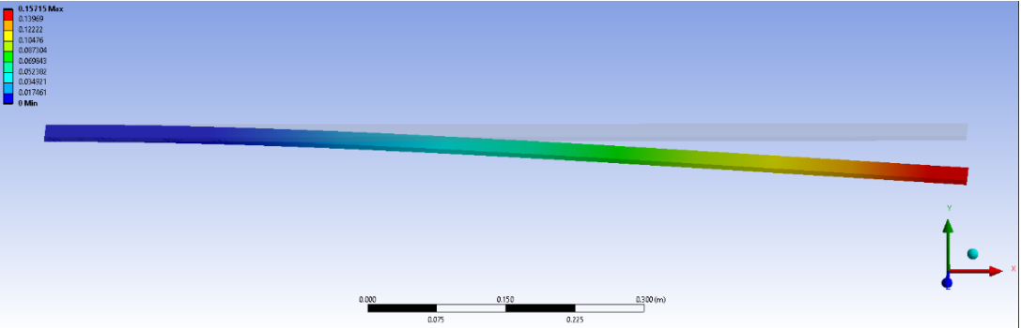
Cantilever Beam 3

5.0 Results & Analysis

Copper and Brass
The first simulation to run was a brass projectile being shot at a copper plate. Both materials have similar material properties so will be interesting to see. The target is 5mm thick and 150mmx150mm. The projectile has a pointier tip with only a slight curve.

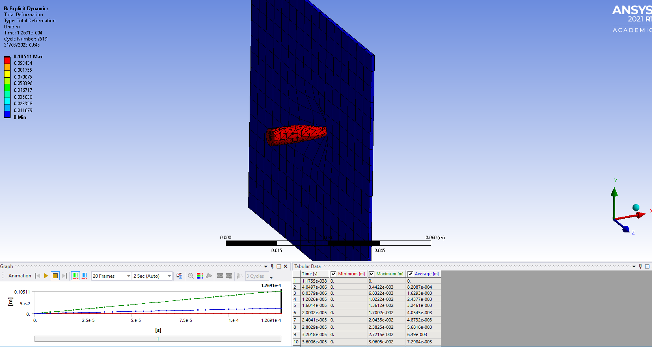
Copper and Brass 1

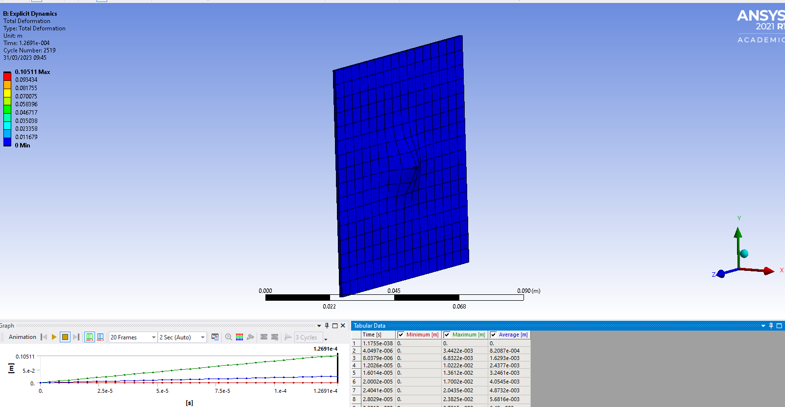
Copper and Brass 2
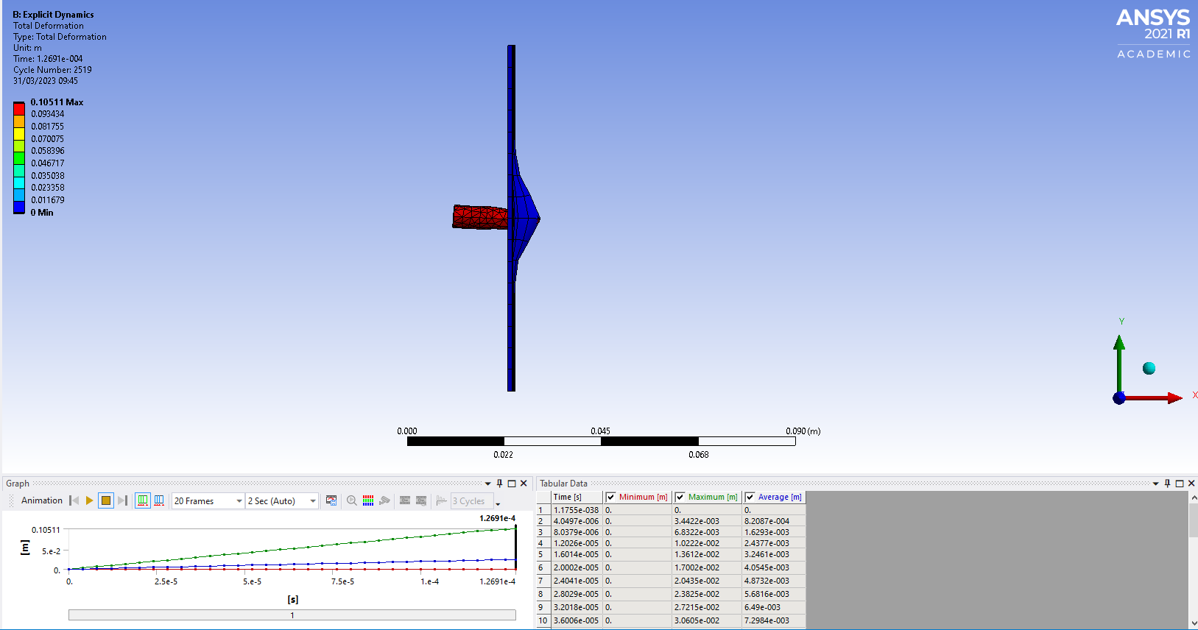
Copper and Brass 3

The brass projectile appears to struggle when trying to penetrate the copper plate. The two materials aren’t identical and have difference, but this difference is relatively small compared to other materials. With the projectile travelling at 850m/s and the target only being 5mm thick the projectile should penetrate/pierce the target more than it did. The bullets trajectory changes at the end and appears to start falling to the surface.
Below is a comparison of the material properties of copper and brass.
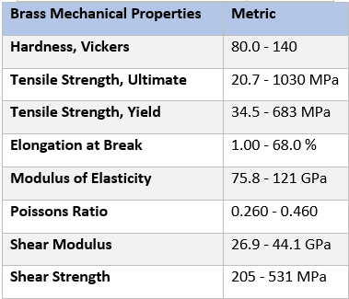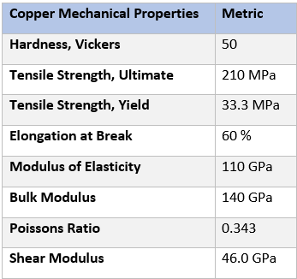
Material Properties 2
Material Properties 1

ABS Plastic and Steel
For this analysis, the target will be ABS plastic and the projectile will be Steel. These are both completely different materials so hope to see better results this time and resolve the issue. The bullet has also been rounded as before the bullet was pointy which can cause problems with the meshing. This is because the impact point is so small and makes the results not accurate.
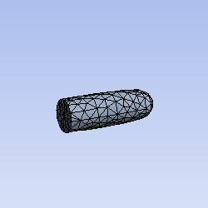
ABS Plastic and Steel 1
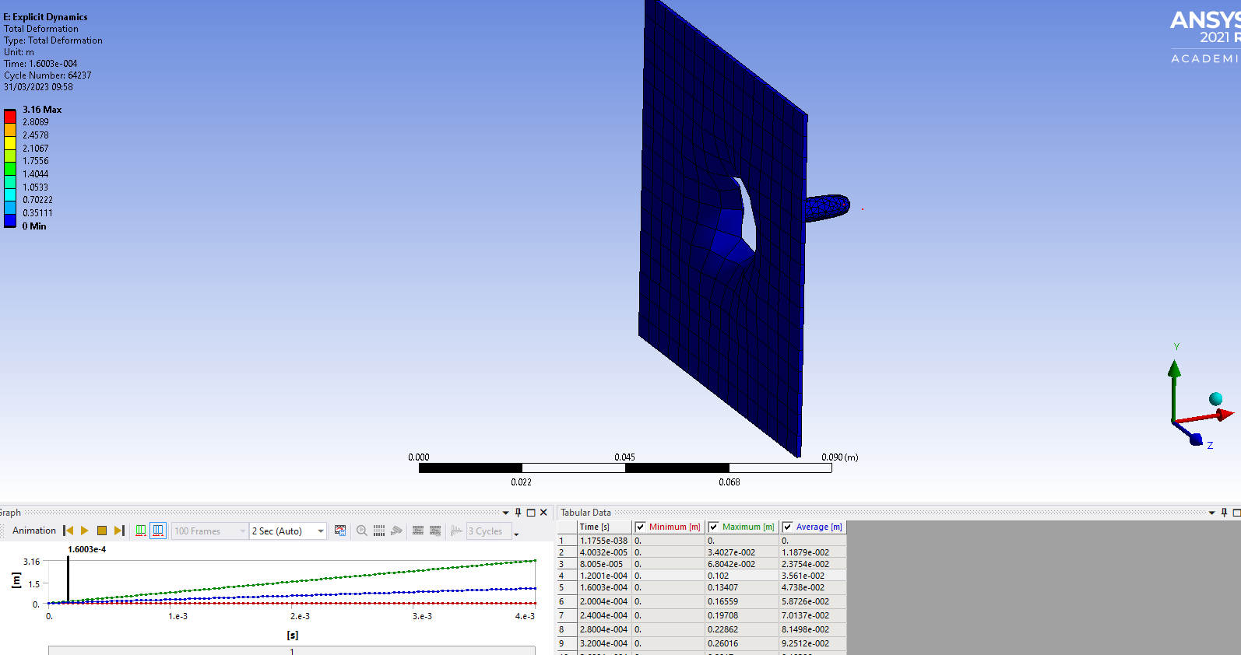
ABS Plastic and Steel 2
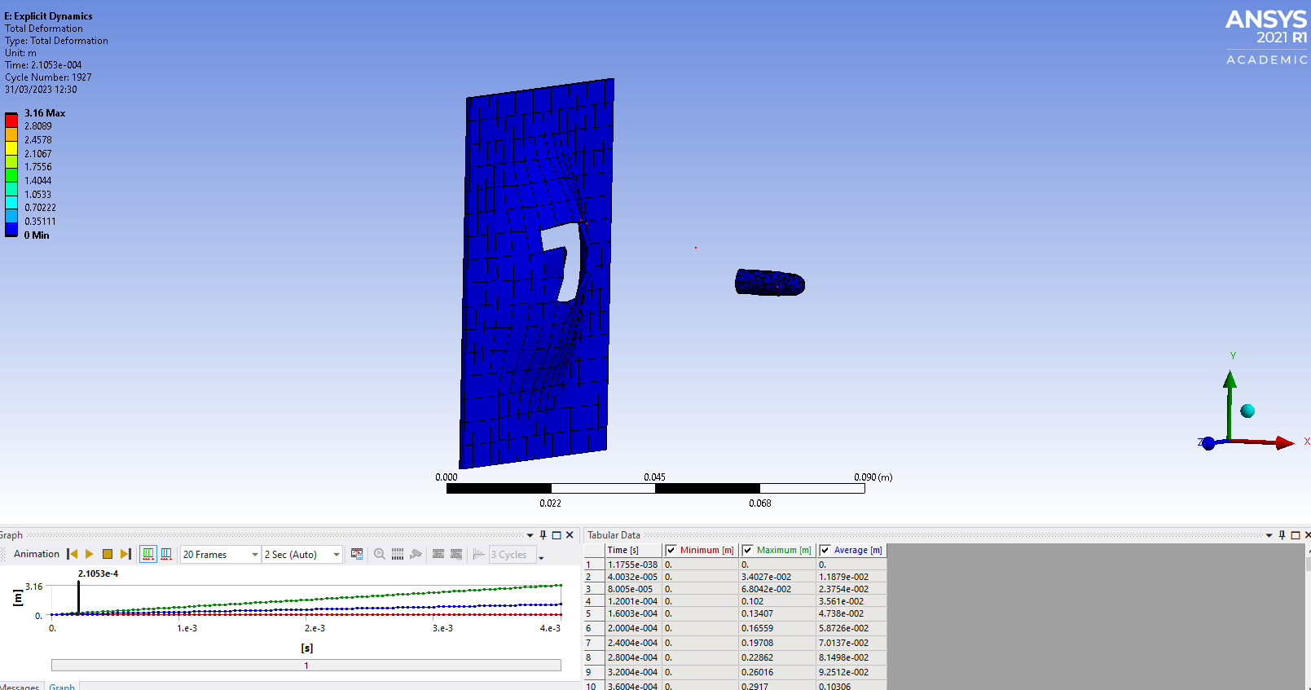
ABS Plastic and Steel 3

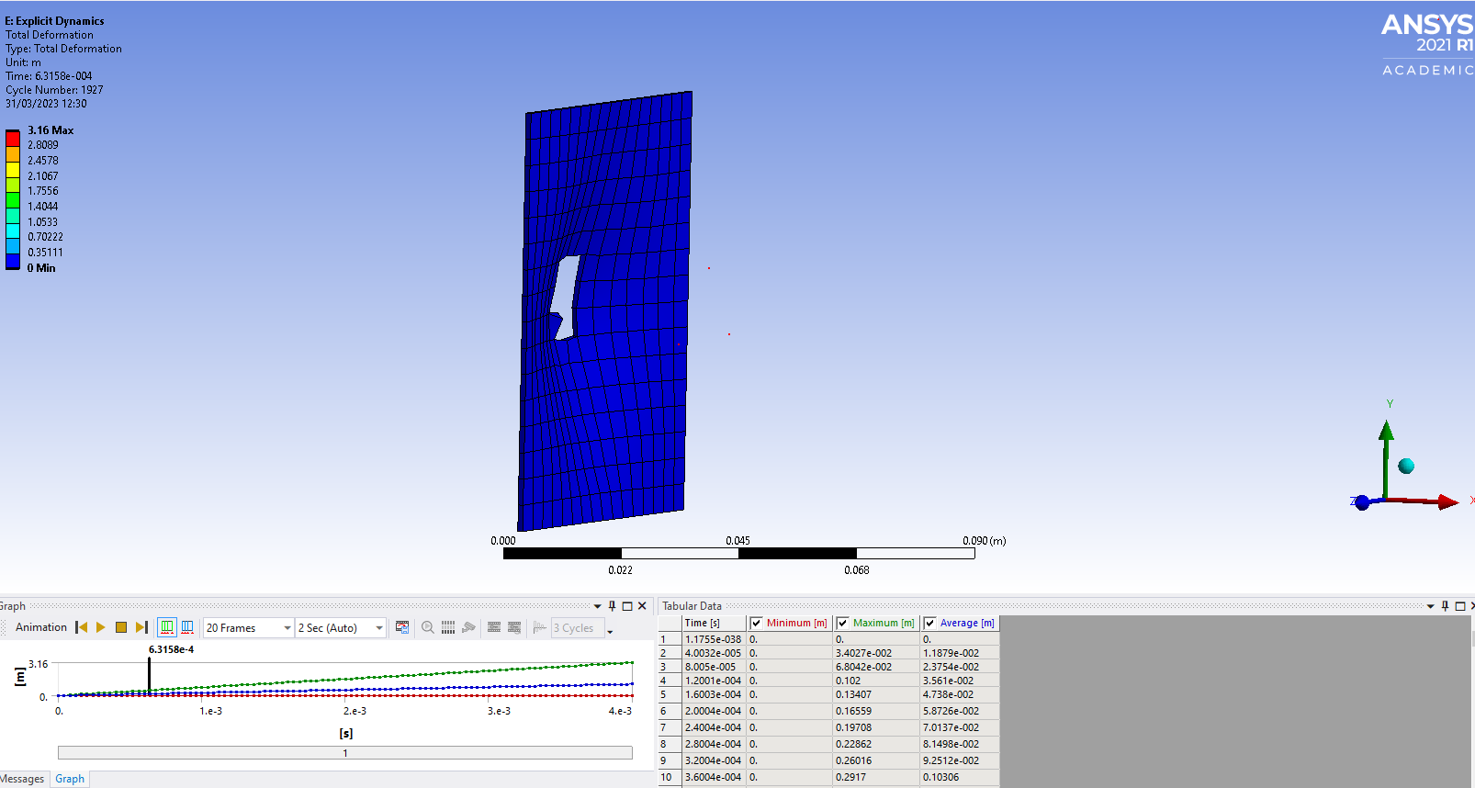
ABS Plastic and Steel 4
There were much better results this time with the projectile piercing through the target as seen below.
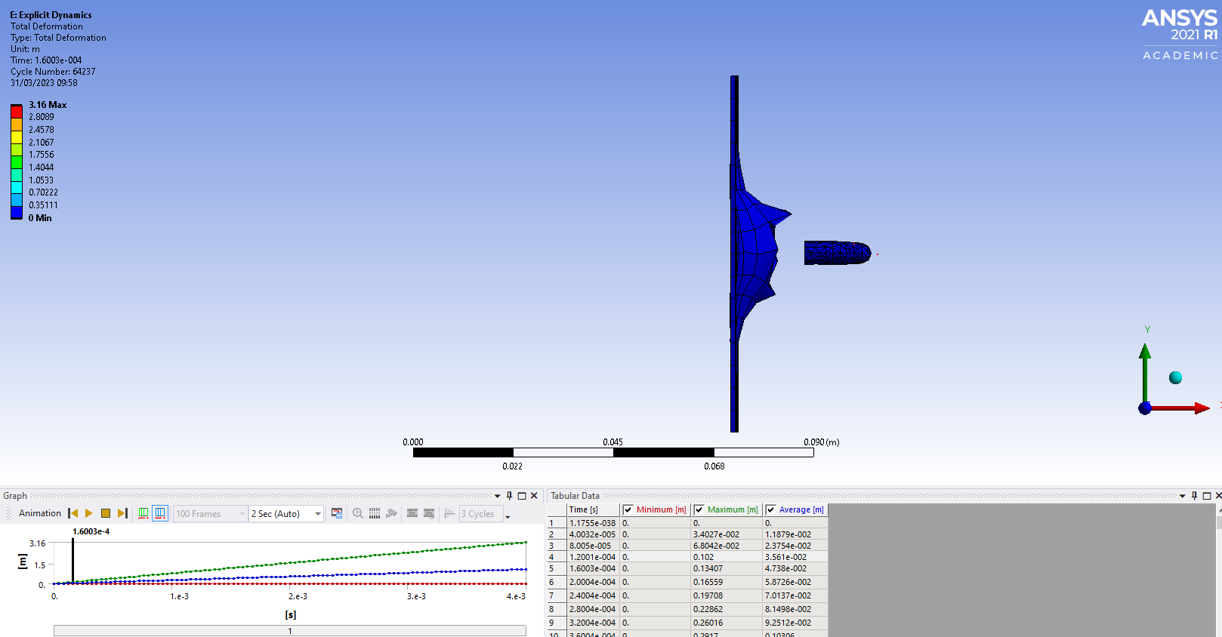
ABS Plastic and Steel 5

This was expected because of the difference in material properties. The meshing was better this time but was quite big and didn’t give the most realistic effect. With smaller meshing there would be visible fragmentation. There was also a recoil effect on the target as seen above where it sprung back and forth.

Lead bullet and ABS Plastic Lego target
With the results from last time being better and working without any errors, this time the meshing was made smaller, but the geometry was more complex. The meshing for this target was very intense on the software as it had to mesh every part but that wasn’t the biggest issue which was the way the Lego bricks were constrained to each other. All the Lego bricks were fixed with about 3 supports so the software found it hard to work around this.

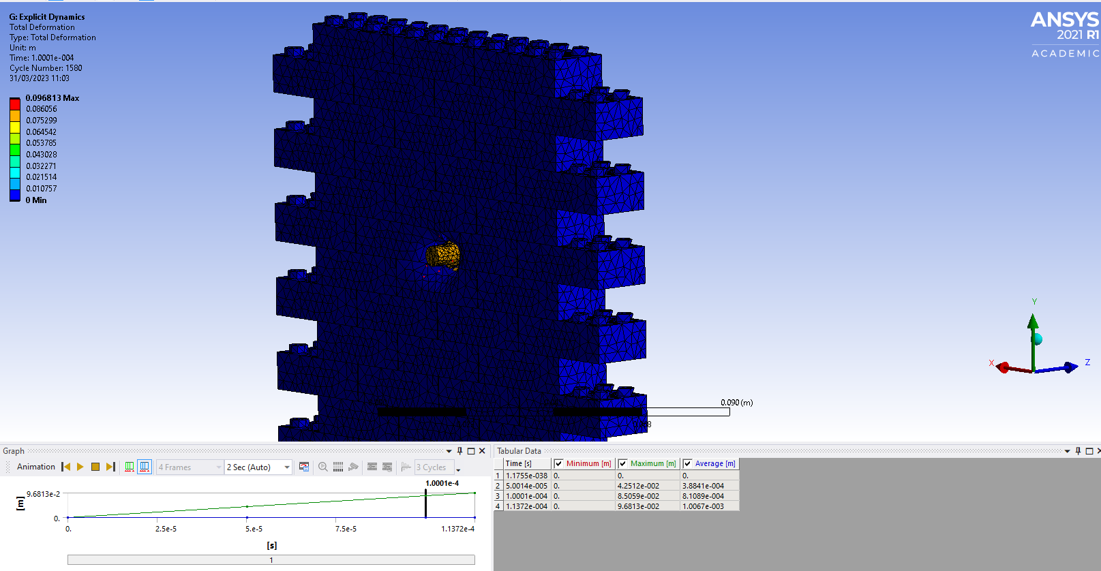
ABS Plastic and Lead 1

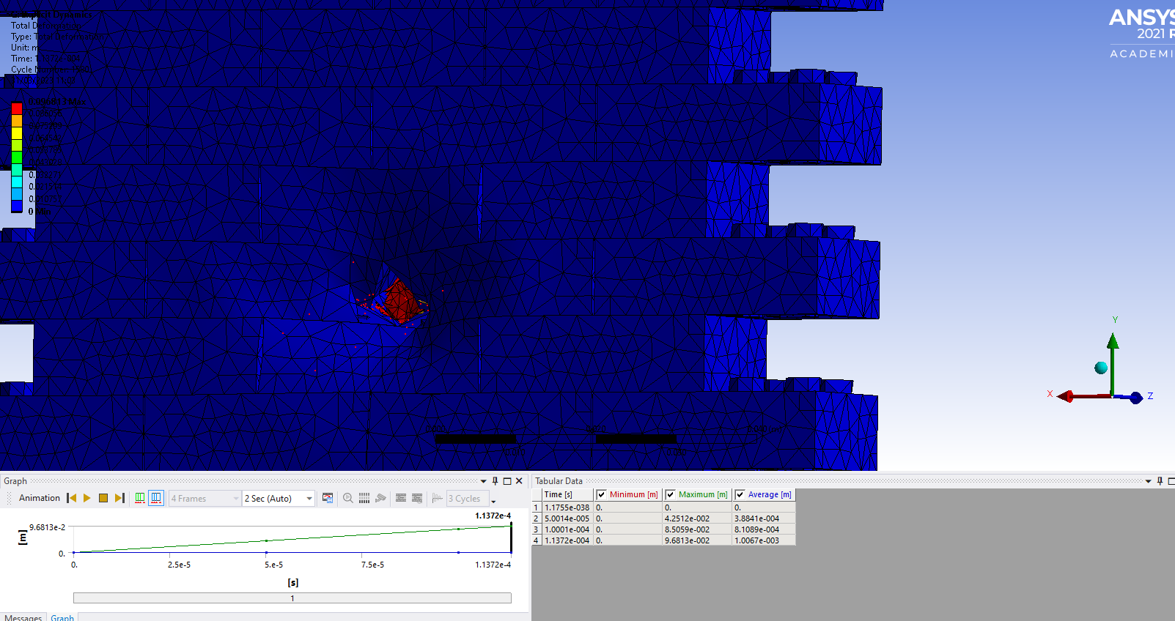
ABS Plastic and Lead 2
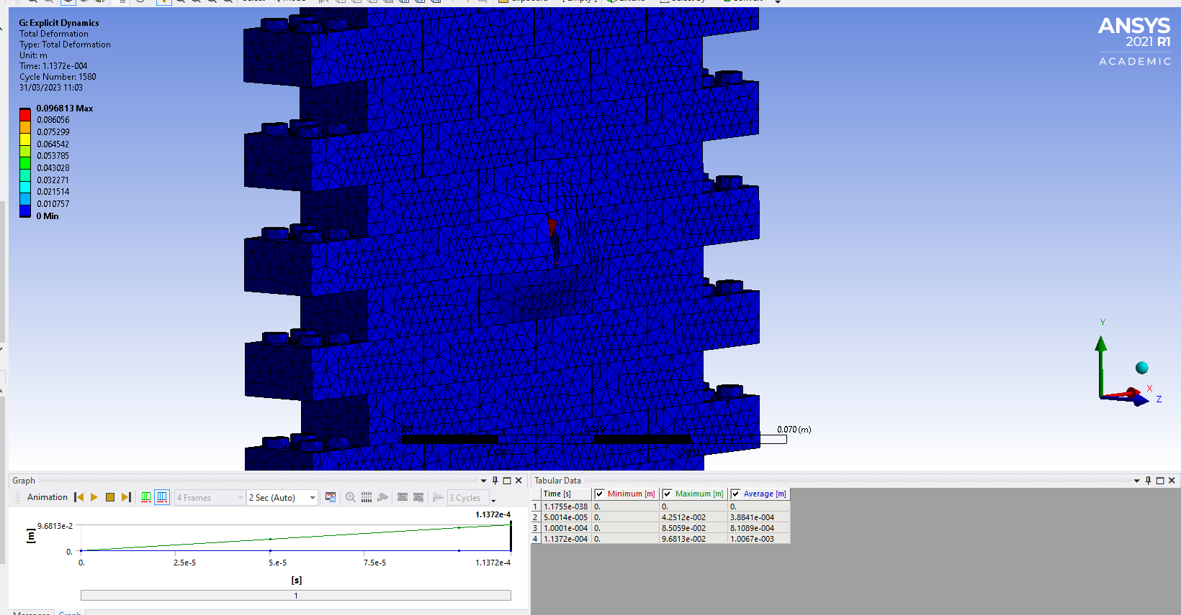
ABS Plastic and Lead 3

This analysis unfortunately didn’t complete the whole way, but a good effort was made. After multiple time of playing around with the mesh and end time it ran for a while but then came up with an error. The projectile goes to penetrate the target but then strangely seems to disintegrate.

Lead and Aluminium
The target in this analysis has a thickness of 15mm so there should be a lot more fragmentation. To make the most of this, the mesh size is relatively smaller than the other meshes.

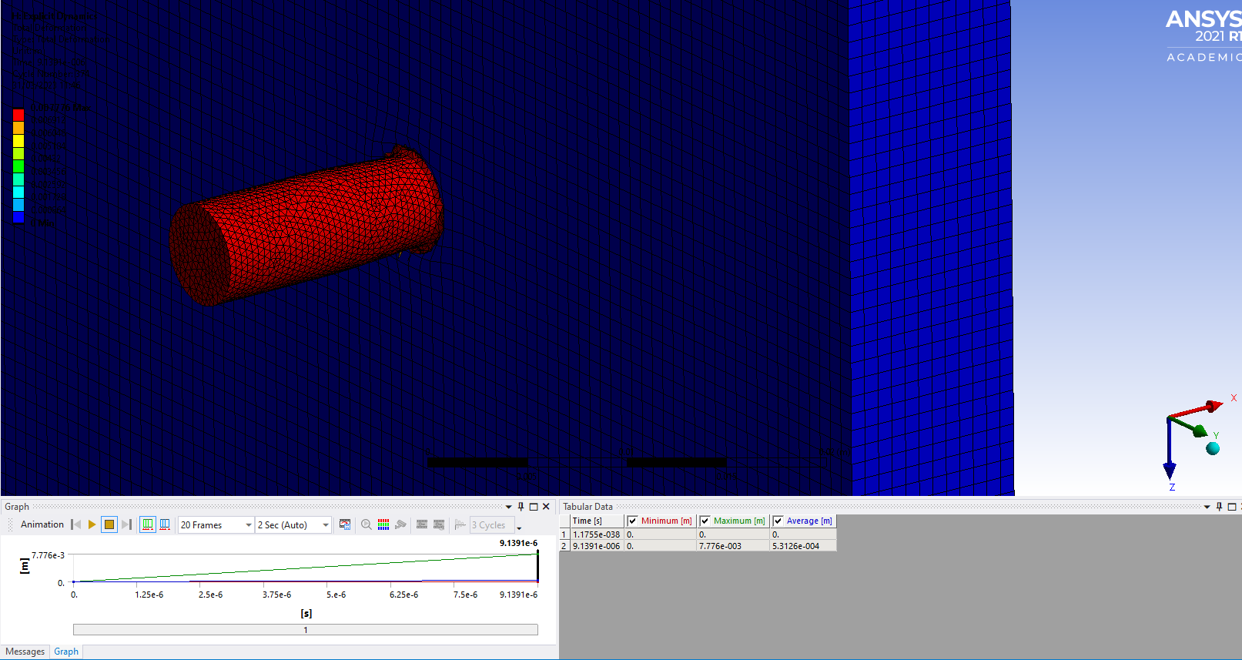
Lead and Aluminium 1

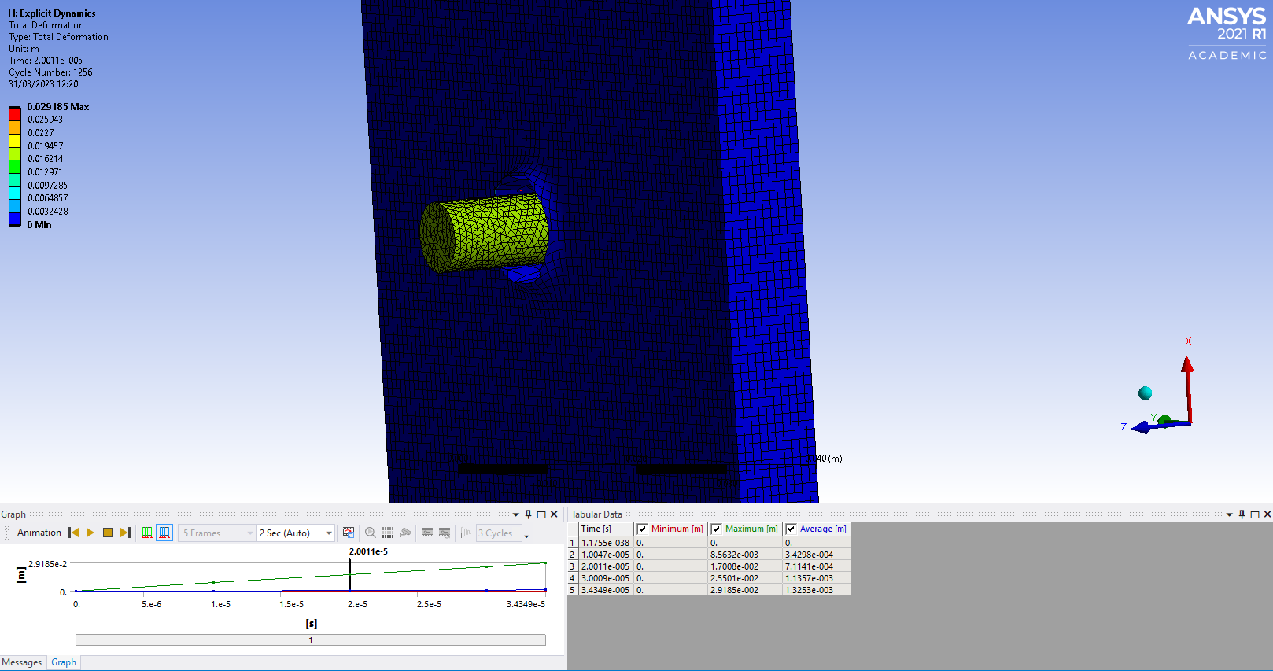
Lead and Aluminium 2

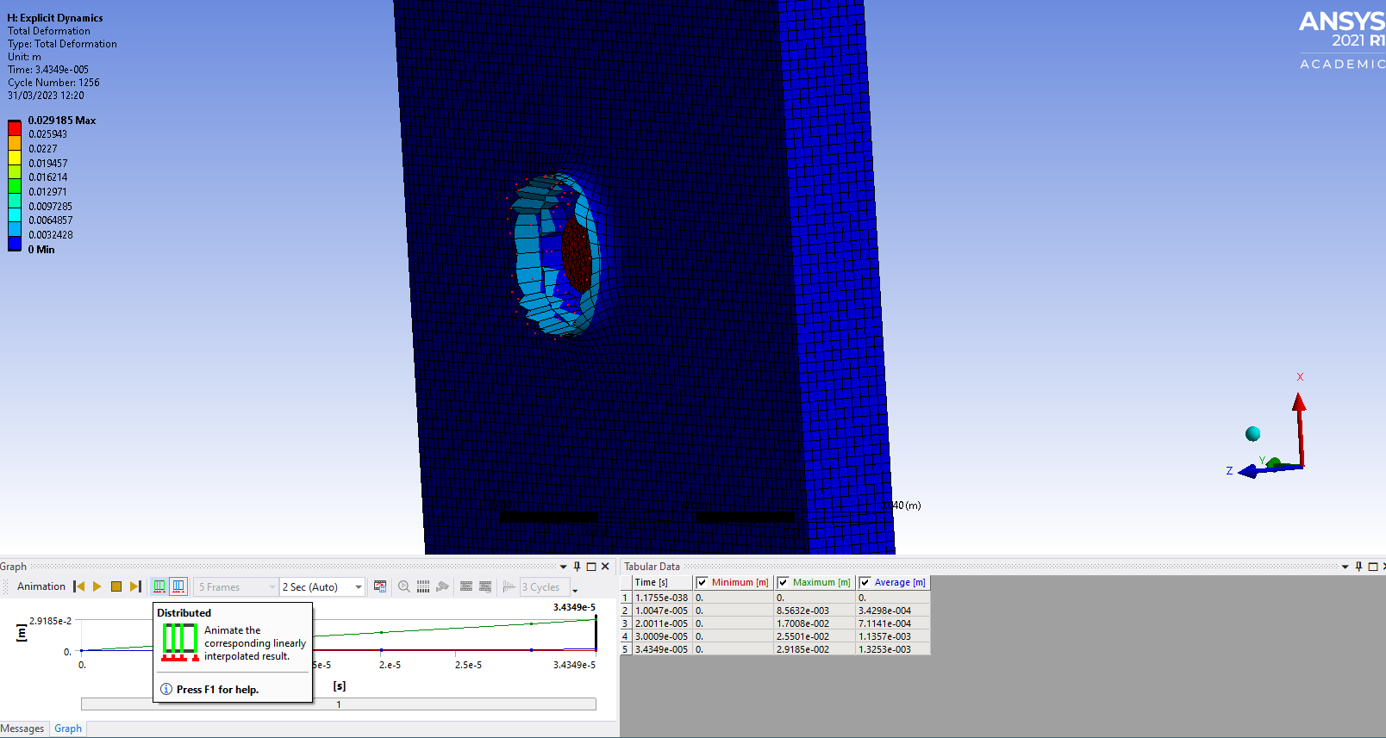
Lead and Aluminium 3

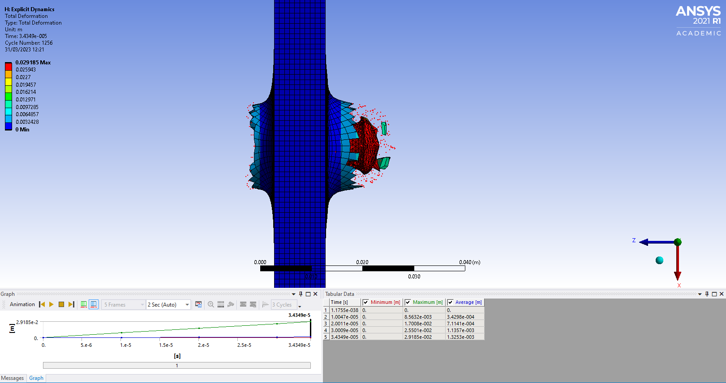
Lead and Aluminium 4

This was a successful analysis because the projectile pierced through the target and showed fragmentation. Also, the stress levels on the projectile where clearly showing by the thermal bar on the left which haven’t been showing properly on any of the other simulations. This shows that the lead bullet had a relatively big amount of stress applied to it when it penetrates the target. Deformation of the bullet tip can also be seen in Lead and Aluminium 4 where it has created a mushroom effect. Below is an image of a real-life bullet hole in metal, the effect the bullet in this simulation has on the target is realistic.

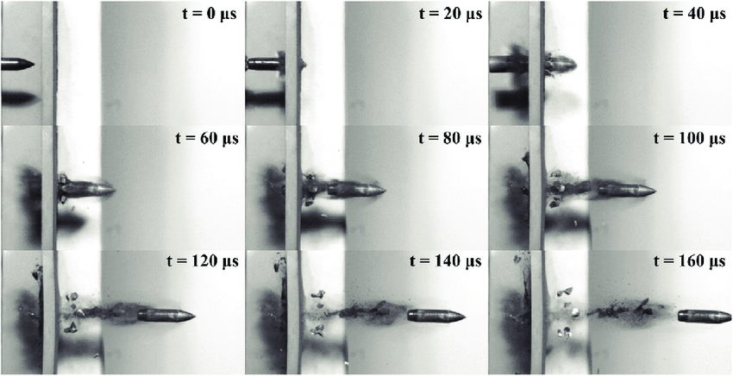
Bullet Effect 1

The bullet can be seen going through and the fragmentation from it. At the back there is a part where the bullet has exerted a force and pops the metal out. This can be seen in Bullet Effect 3.

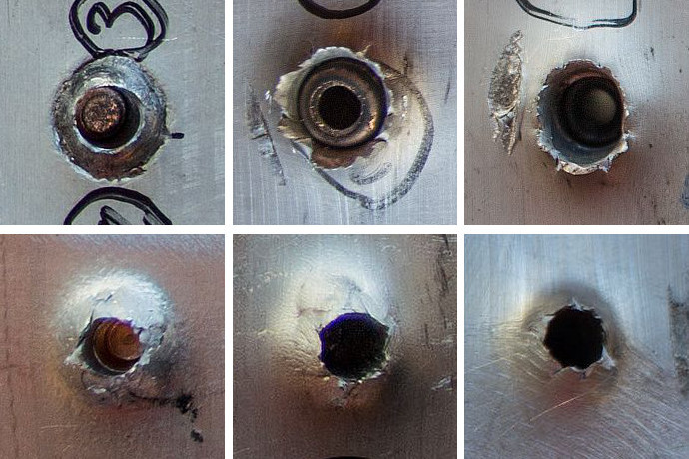
Bullet Effect 2

6.0 Conclusion
The key findings of this assignment were that CAE can be used to recreate real life scenarios accurately, the validation process proved this through mathematics. It requires a lot of trial and error, but the result is worthwhile. Also, material properties have an important part in analysis. This area was bit of a limitation with the Ansys software as it wasn’t as realistic as expected but with more time spent on it and more precise material data, there would probably be an alright outcome.
Time was limited with the software for this assignment, so more time to use the software would have been good as there would have been a better understanding of time steps and meshing. For example, more research into Explicit and Implicit would have been interesting to do as physically working with the processes would give a better understanding of the theory.
The material properties chosen for this assignment weren’t the greatest as it was using data from Ansys, more specific data can be found online on websites like MatWeb which would have given more realistic results again.
Another limitation the software had was when constraining multiple parts together, as seen in the Lego brick wall. The software was confused by this because it was so many parts but a way to resolve this is by building it all as one piece rather than multiple. Also, the 7lego assembly did work a little so curious to whether the materials selected weren’t the greatest, steel maybe would have been a better bullet as it was before how it pierced the plastic.
The ammunition used in this assignment was good but a comparison between a bullet into a target then something bigger like an artillery shell would have been interesting to see and make a good comparison.

7.0 Reference List

[1] | D. university, “Advantages and Disadvantages of CAD,” 03 September 2021. [Online]. Available: https://drexel.edu/cci/stories/advantages-and-disadvantages-of-cad/#:~:text=CAD%20allows%20experts%20to%20create,calculates%20how%20multiple%20materials%20relate..
[2] | TWI, “WHAT IS FINITE ELEMENT ANALYSIS (FEA)?,” [Online]. Available: https://www.twi-global.com/technical-knowledge/faqs/finite-element-analysis.
[3] | CAPITOL, “What is SOLIDWORKS?,” 19 November 2018. [Online]. Available: https://www.captechu.edu/blog/solidworks-mechatronics-design-and-engineering-program.
[4] | Design Tech CAD Academy, “Introduction to Ansys,” 2022. [Online]. Available: https://www.designtechacademy.com/knowldedge-base/ansys-software.
[5] | E. Lawrence, “Practical Guide to the operational Use of the RPD Machine Gun,” 2015.
[6] | enterfea, “enterfea,” 24 October 2019. [Online]. Available: https://enterfea.com/implicit-vs-explicit/.
[7] | ÖZGÜN, “What is Explicit Dynamics in Ansys?,” 09 July 2019. [Online]. Available: https://www.mechead.com/what-is-explicit-dynamics-in-ansys/.
[8] | ANSYS, “What is Explicit Dynamics?,” 27 July 2022. [Online]. Available: https://www.ansys.com/en-gb/blog/what-is-explicit-dynamics#:~:text=Explicit%20dynamics%20is%20a%20time,speed%20impacts%2C%20and%20applied%20loads..
[9] | Futurum, “Living in a material world: the importance of materials science and engineering,” 30 August 2022. [Online]. Available: futurumcareers.com/Living-in-a-material-world-the-importance-of-materials-science-and-engineering.
[10] | Adobe, “Step files,” 2022. [Online]. Available: adobe.com/creativecloud/file-types/image/vector/step-file.
[11] | Cadence CFD, “The Importance of Meshing in CFD and Structural FEA,” 2022. [Online]. Available: https://resources.system-analysis.cadence.com/blog/msa2022-the-importance-of-meshing-in-cfd-and-structural-fea.
[12] | Tech Target Contributor, “3D Mesh,” October 2016. [Online]. Available: https://www.techtarget.com/whatis/definition/3D-mesh#:~:text=A%203D%20mesh%20is%20the,with%20height%2C%20width%20and%20depth..
[13] | E. GAROFALO, “What Are NURBS Curves in 3D Modeling?,” 24 June 2022. [Online]. Available: https://www.makeuseof.com/what-are-nurbs-curves/.
[14] | P. P. Marshall Bern, Handbook of Computational Geometry, 2000.
[15] | A. A. L. Mahsa Ghaffari, Computer Aided Chemical Engineering, 2015.
[16] | MatWeb, “Copper, Cu; Annealed,” [Online]. Available: https://www.matweb.com/search/datasheet.aspx?matguid=9aebe83845c04c1db5126fada6f76f7e&ckck=1.

