BMIH5007
Financial Management for the Hotel Industry
Business Report – Comparison of Shangri-La Hotels and Travelodge Hotels

Flor Yasmin Perez Paula
2226712

Table of Contents
Executive summary 3
Introduction 4
Total revenue analysis 4
Market Position 7
Growth Potential 9
Financial Commitment to CSR 10
Conclusions and recommendations 10
References 11

Figure 1. Travelodge's revenue 5
Figure 2. Shangri-La financial highlights 6

Executive summary
The following business report critically assesses the Shangri-La Hotel Group and Travelodge Hotels in terms of their financial management strategies and practices. The purpose of this study is to evaluate their individual financial management methods, taking into account various critical aspects that influence their financial success and long-term viability. The analysis includes comparing these two corporations in the key areas of total revenue, market position, growth potential, and financial commitment to corporate social responsibility (CSR). The report investigates their revenue sources and trends, the factors that drive their performance growth or decline, their market share, customer demographics, and brand perceptions, an examination of their expansion strategies, market opportunities, and potential barriers to growth, and an assessment of the financial commitment of each organisation to CSR initiatives.
Both companies are leaders in their market segments, and they have reported strong financial performance. Shangri-La is a leader in the luxury hotel market, while Travelodge is a leading brand in the budget segment. Both companies have significant growth opportunities and strong CRS approaches. We recommend continuing to invest in seizing market opportunities and sustainable operations to enhance their market share and financial performance.

Introduction
The following business report critically assesses the Shangri-La Hotel Group and Travelodge Hotels in terms of their financial management strategies and practices. The purpose of this study is to evaluate their individual financial management methods, considering various critical aspects that influence their financial success and long-term viability. The analysis includes comparing these two corporations in the key areas of total revenue, market position, growth potential, and financial commitment to corporate social responsibility (CSR). The report investigates their revenue sources and trends, the factors that drive their performance growth or decline, their market share, customer demographics, and brand perceptions, an examination of their expansion strategies, market opportunities, and potential barriers to growth, and an assessment of the financial commitment of each organisation to CSR initiatives.
The Shangri-La Group (2024a) is one of the world's leading developers, owners, and managers of hotels and investment properties. It also specializes in office buildings, commercial real estate, and serviced flats and residences. The group's other main businesses include the development of real estate for sale and hotel management services. It currently owns and/or manages more than 100 hotels in 76 different countries under the Shangri-La, Kerry, JEN by Shangri-La, and Traders brands. The Group, which holds a prominent position in Asia, has a significant number of upcoming hotel and mixed-use development projects in Australia, China Mainland, Cambodia, Japan, and Australia.
Travelodge Hotels Limited (2024) was founded in 1985 and is Britain's first budget hotel company. Today, it is one of the major budget hotel companies in the UK, with a portfolio of approximately 600 hotels and over 46,000 guestrooms across the UK, Ireland, and Spain. Welcoming approximately 22 million guests annually, the majority of Travelodge hotels are located in major cities, towns, and holiday attractions, as well as alongside airports and vital business hubs. With 90% of its hotels rated 4 dots or above on TripAdvisor, Travelodge offers a good value experience to a varied client base, whether travelling for work or leisure.

Total revenue analysis
Revenue is the complete sum of money that a company or organisation earns from its main activities, such as selling things or providing services. A company generates revenue before subtracting expenditures, taxes, and additional expenses. Revenue is a crucial financial measure that demonstrates the company's capacity to earn income from its primary business activities. The income statement commonly includes revenue, which is crucial in evaluating a firm's financial performance and expansion (Pike and Neale, 2006).
Travelodge Hotels Limited (2024b) reported 13.7% revenue growth to £1,035.2 million, based on a LFL RevPAR(1) increase of 12.4% to £59.14 (2022: £52.62), an occupancy increase of 0.7 pts to 83.4%, and an ADR increase of 3.8% to £69.02. The company forecasts demand drivers such as tourists seeking out good value, positive forward booking patterns, and macroeconomic trends that favour budget accommodation.
According to Travelodge Hotels Limited (2024b), the main financial highlights for the year ended December 31, 2023, include a record performance with revenue surpassing £1 billion for the first time in the company's history, performance driven by strong demand, continued investments in rooms’ design upgrades and brand campaigns, and positive trading patterns. The business saw a 13.7% increase in revenue to £1,035.2 million, as well as a 14.6% increase in underlying earnings (adjusted EBITDA) to £243.9 million. Please see the following figure for an illustration.

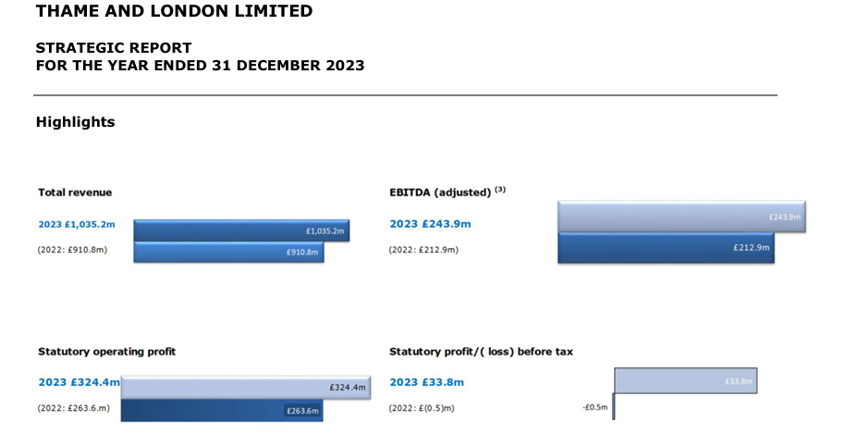
Figure 1. Travelodge's revenue
Source: Travelodge Hotels Limited, 2024b, p. 2
The revenue from rooms for Thame and London Limited in the year ended December 31, 2023, was £971.1 million. This figure includes sales related to accommodation, such as Wi-Fi and car parking (Travelodge Hotels Limited, 2024b).
According to Shangri-La Group's 2023 annual report (2024b), their financial highlights also show an increase in revenue, gross profit, and operating profit, as well as an improvement in EBITDA and profit for the year. There were also increases in the share of associate profits and total comprehensive income. Additionally, there were changes in accounts payable and accruals, expenses by nature, and other gains (net). The company's net asset value and total equity remained stable. Please see the following figure for an illustration.
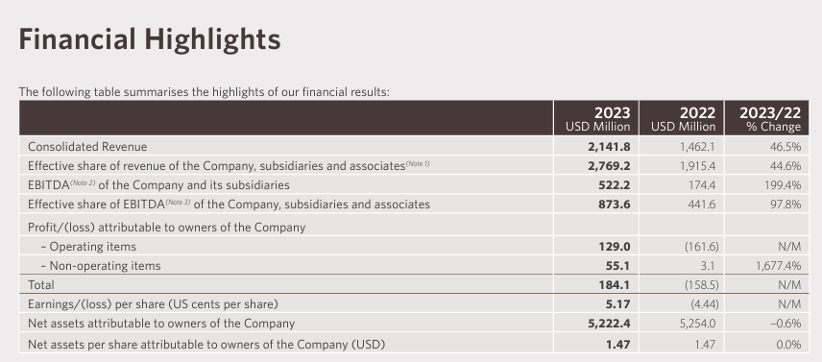
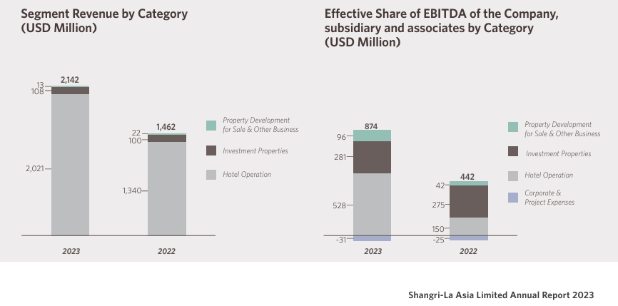
Figure 2. Shangri-La financial highlights
Source: Shangri-La Group, 2024b, p. 3

Shangri-La Group (2024b) reported 2,141.79 million USD (circa £1,713 million) in total consolidate revenue, a 46.5% growth compared to the previous reporting period. The group generates revenue from various sources, including hotel room bookings, food and beverage sales, additional services provided to hotel guests, hotel management services, property development and sale, other business activities, and income from investment properties it owns. The revenue from rooms was 1,041 million USD (approximately £833 million), which was 67.1% more than the previous year. The effective share of revenue for the year ended December 31, 2023, was USD 2,769.2 million, showing a growth of 44.6% compared to USD 1,915.4 million for the year ended December 31, 2022. This indicates a substantial increase in the group's share of revenue from its subsidiaries and associates. Overall, the revenue trends for the group show significant growth in both consolidated revenue and the effective share of revenue. The recovery of the hotel business, especially in Mainland China and Hong Kong, and the strong travel demand in other parts of the world are responsible for this growth. ​
Even though the total revenues of Shangri-La were higher than the revenues of Travelodge (around £1,713 million vs. £1,035.2 million), the second gained more revenue from rooms (£971.1 million vs. £833 million). The performance of Travelodge is based on a significant increase in demand from local leisure clients, primarily due to events, athletic fixtures, and exhibitions, and over 45,000 corporate clients; thus, the demand for business-related services continued to increase throughout the year. They are a cost-effective service provider, offering a high-quality product as a foundation to fulfil customers' travel requirements, both for business and pleasure.

Market Position
Market positioning is the capacity to shape customer perceptions of a brand or product in relation to competitors. According to the Corporate Finance Institute (2024), the primary goal of market positioning is to create a distinct image or identity for a brand or product in order to shape consumers' perception of it in a specific way. The positioning strategies may focus on the product's characteristics and advantages, the price (competitive pricing), the superior quality of the product, product utilization and implementation (a specific purpose), or creating the perception among consumers that a brand or product is superior to that of your competitors.
Travelodge operates within the midrange and budget segments of the hotel industry, positioning itself as a cost-effective provider. It offers standardised and contemporary guest rooms at reasonable pricing, catering to both business and leisure travellers. Travelodge strives to provide guests with an optimal combination of location, pricing, and quality to meet their travel requirements. People widely recognise Travelodge as a brand that provides economical travel, and it currently holds the top position in the thriving UK hotel market segment. Their established presence, extensive geographic coverage, and effective national marketing campaigns contribute to their success.
According to Kunst (2023), 34% of hotel customers preferred Travelodge in 2022, with a brand awareness of 91% in the UK. Overall, 27% of hotel customers in the UK use Travelodge. Therefore, out of the total population who are aware of the brand, 30% actually utilise their products or services (Kunst, 2023). Approximately 22% of hotel customers in the United Kingdom express their inclination to utilise Travelodge’s services once again. Relative to the brand's 27% usage share, this indicates that 81% of their customers demonstrate brand loyalty.
According to Greene (2023), Travelodge is now implementing its hotel refurbishment programme, which is the company's most substantial brand overhaul to date. Travelodge is making progress, with plans to renovate 25% of its hotels to the new design by the end of 2023. The corporation intends to expedite its investment in 2024 to enhance around 50% of its room portfolio by the end of that year. The renovation programme encompasses a redesigned hotel layout that showcases a modern reception area, advanced rooms equipped with bedside charging ports and blackout curtains, and enhanced bar cafés.
According to Mordor Intelligence (2024), Travelodge is one of the five leading brands in the UK hospitality sector, along with Whitbread Group, Intercontinental Hotels Group, Accor SA, and Marriott International, Inc. In the budget market segment, Travelodge ranks second after Whitbread Group (IBISWorld, 2024).
Shangri-La Hotels and Resorts, on the other hand, tailor their product portfolio to cater to the upper echelons of society, emphasizing luxury and premium experiences (Bhasin, 2024). The hotel brands cover various segments within the luxury hotel market, including exclusive clubs, luxury accommodation types, themed accommodation, family accommodation, restaurants, bars, lounges, culinary experiences, facilities for meetings and events, including weddings, additional luxury services, and health and leisure services (Bhasin, 2024). The hotel chain, in line with its luxury brand positioning, implements a premium pricing strategy that includes variable price strategies for each type of accommodation, seasonal discounts, and separate charges for value-added features. Positive evaluations and comments from previous guests act as intangible empirical evidence, bolstering the brand's reputation for exceptional hospitality. The hotel's website and promotional materials frequently highlight these features.

Growth Potential
Travelodge has a well-defined growth plan that includes a multi-channel brand campaign to increase their UK market share, a significant brand transformation through an accelerated refit programme, and expanding their hotel chain in both the UK and Spain (Travelodge Hotels Limited, 2024b). Increased demand for domestic accommodation, particularly due to changing customer trends favouring the budget market segment, represents the main UK market opportunity for the company. Furthermore, the company aims to seize the significant potential of digital marketing to enhance its performance, as well as the potential represented by a sustainable approach to operations to increase brand appeal for environmentally conscious customer segments. The main threats include geopolitical instability, inflation, exchange rate fluctuations, and competition (Travelodge Hotels Limited, 2024b). To address these threats, Travelodge maintains its commitment to enhancing customer appeal and ensuring high quality by consistently investing in revenue management systems, procedures, and analytical power. This enables Travelodge to effectively align room prices with customer demand. The company is also allocating resources to improve its data capabilities and digital platform, which includes implementing advanced search features for clients and enhancing personalisation.
Shangri-La Group's growth strategy (2024b) is based on delivering their unique style of sincere Asian hospitality as they expand the customer base and enhance customer loyalty. Personal recreational excursions, rather than corporate travel, are primarily driving the resurgence of travel after the pandemic. The April 2022 overhaul of the reward program, Shangri-La Circle, has resulted in unprecedented levels of direct involvement and consumer loyalty, establishing stronger connections with their broad consumer base and providing more personalized experiences. Considering this, they aim to continue to advance and allocate resources towards programs and initiatives that improve their offerings and services, with a particular focus on the leisure sector. Their main challenge remains the negative impact of the COVID-19 pandemic on the Asian hospitality market.

Financial Commitment to CSR
According to Moneva et al. (2007), companies that prioritise stakeholder interests and engage in CSR activities may see positive financial outcomes.
Shangri-La is committed to promoting sustainability and implementing ethical business practices that appeal to environmentally conscious consumers and positively impact the brand's reputation and operations. Effectively implementing environmental, social, and governance (ESG) practices aligns with the company's long-term goals and objectives, enabling them to actively support government initiatives, foster strong relationships with existing and prospective employees, and make meaningful contributions to the local communities (Shangri-La Group, 2024c). Implementing sustainable practices not only satisfies visitors' demand for eco-friendly options but also reduces procurement risk by guaranteeing that they collaborate with responsible suppliers. The newly implemented Triple S strategy encompasses Shangri-La core business operations and key areas of focus, ensuring that they address environmental, social, and governance (ESG) concerns across all aspects of the Shangri-La experience. At the core of their operations is their dedication to corporate governance, which entails acting ethically, responsibly, and sustainably. In the last financial reporting period, the company invested USD 3.2 million in project expenses and donations for communities, and over 138,000 people have benefited from it (Shangri-La Group, 2024c).
Based on their Better Future sustainability plan (Travelodge Hotels Limited, 2024d), Travelodge also commits to CSR. Travelodge has made several financial commitments to sustainability and responsible business practices. These commitments include becoming a net-zero business by 2050, reducing electricity consumption, reducing water consumption, improving waste management and recycling, and implementing responsible sourcing and supply chain management practices (Travelodge Hotels Limited, 2024e). These commitments demonstrate Travelodge's dedication to sustainability and reducing their environmental impact.

Conclusions and recommendations
The report has critically assessed Shangri-La Hotel Group and Travelodge Hotels in terms of their financial management strategies and practices. Both companies are leaders in their market segments, and they have reported strong financial performance. Shangri-La is a leader in the luxury hotel market, while Travelodge is a leading brand in the budget segment. Both companies have significant growth opportunities and strong CRS approaches. It is recommended to continue to invest in seizing market opportunities and also in sustainable operations to increase their market share and financial performance.

References
Bhasin, H. (2024) Marketing Mix of Shangri-la Hotels and Resorts and 7Ps (Updated 2024). Available at: https://www.marketing91.com/marketing-mix-of-shangri-la-hotels-and-resorts/ (Accessed 9 May 2024)
Corporate Finance Institute (2024) Market Positioning. Available at: https://corporatefinanceinstitute.com/resources/management/market-positioning/ (Accessed 30 April 2024)
Greene, A. (2023) Travelodge reports record results. Available at: https://www.hospitalityandcateringnews.com/2023/11/travelodge-reports-record-results/ (Accessed 9 May 2024)
IBISWorld (2024) Budget Hotels in the UK - Market Size, Industry Analysis, Trends and Forecasts (2024-2029). Available at: https://www.ibisworld.com/united-kingdom/market-research-reports/budget-hotels-industry/#IndustryStatisticsAndTrends (Accessed 9 May 2024)
Kunst, A. (2023) Travelodge brand profile in the UK 2022. Available at: https://www.statista.com/forecasts/1335657/travelodge-hotels-brand-profile-in-the-uk#:~:text=What%20is%20the%20usage%20share,in%20the%20UK%20use%20Travelodge. (Accessed 9 May 2024)
Moneva, J.M., Rivera‐Lirio, J.M. and Muñoz‐Torres, M.J. (2007) ‘The corporate stakeholder commitment and social and financial performance’. Industrial management & data systems, 107(1), pp. 84-102.
Mordor Intelligence (2024) Hospitality industry in the UK. Available at: https://www.mordorintelligence.com/industry-reports/hospitality-industry-in-the-united-kingdom (Accessed 9 May 2024)
Pike, R. and Neale, B. (2006) Corporate finance and investment: decisions & strategies. 5th edn. London: Pearson Education.
Shangri-La Group (2024a) Pioneers of Asian Hospitality. Available at: https://www.shangri-la.com/group/our-story/ (Accessed 27 April 2024)
Shangri-La Group (2024b) Annual Report 2023. Available at: https://www.shangri-la.com/group/investors/public-disclosures (Accessed 27 April 2024)
Shangri-La Group (2024c) Sustainability Report 2023. Available at: https://www.shangri-la.com/group/sustainability/report (Accessed 9 May 2024)
Travelodge Hotels Limited (2024a) Company overview. Available at: https://www.travelodge.co.uk/our-business/about-us/company-overview/ (Accessed 27 April 2024)
Travelodge Hotels Limited (2024b) Record full year performance with Travelodge well positioned for long-term growth. Available at: https://travelodge.co.uk/our-business/blog/press_release/record-full-year-performance-with-travelodge-well-positioned-for-long-term-growth/ (Accessed 30 April 2024)
Travelodge Hotels Limited (2024c) Group overview. Available at: https://www.travelodge.co.uk/investors/home (Accessed 9 May 2024)
Travelodge Hotels Limited (2024d) Sustainability. Available at: https://travelodge.co.uk/our-business/sustainability/ (Accessed 9 May 2024)
Travelodge Hotels Limited (2024e) Better Future Report. Available at: https://travelodgecorp.wpenginepowered.com/wp-content/uploads/Better-Future-Report-2023.pdf (Accessed 9 May 2024)

