

Module Code: LCHS7003
Module Title: Community Care and Management of Longer-term Conditions
Lecturer’s Name: Dr Aishat Bakre
Assignment Title: Component 1 Information Booklet of Long-term Condition Management
Topic: Chronic Obstructive Pulmonary Disease (COPD) Management
Student Name: Geetha Marimuthu
Student ID: 2528691

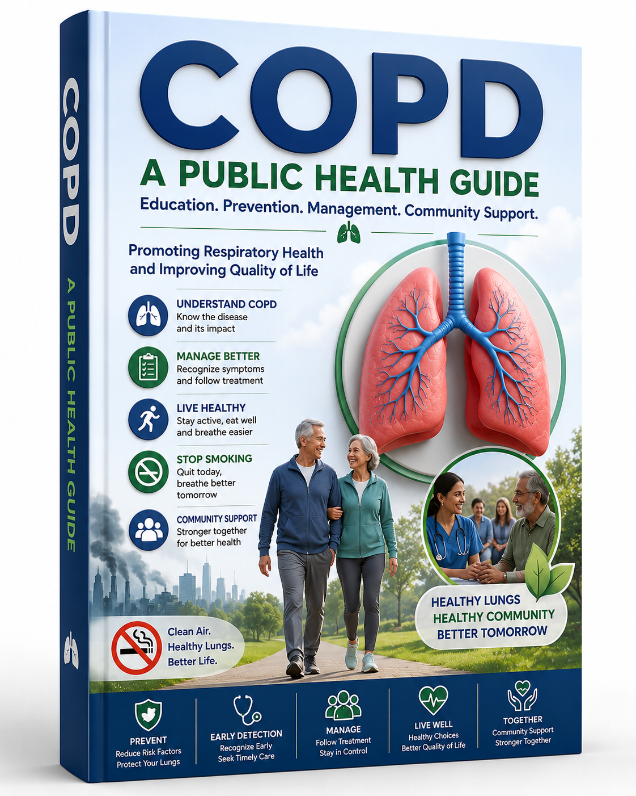

Table of Contents
1 Explanation, Evaluation and Epidemiology of COPD 4
Comprehensive definition and clinical manifestations 4
Global Burden and Prevalence Profile 6
Risk Factors and Aetiology 7
2 Multi-Dimensional Impact of COPD and NHS Treatment Pathways 9
Physical, Psychological and Social Implications 9
Wider Implications for Families and Caregivers 12
Evidence-Based NHS Treatment Pathways 12
3 Theoretical Frameworks and Models for Improved Outcomes 14
UK Model: The House of Care Framework 14
International Model: The Chronic Care Model (CCM): 15
Comparative Analysis of the Models 16
4 Political Analysis: UK Health and Social Care Agendas 17
The NHS Long Term Plan (2019-2029) 17
Gold Standard Clinical Guidance: National Institute for Health and Care Excellence Guidelines 17
Major Political Initiatives: Core20PLUS5 Framework 18
5 Person-Centred Recommendations for Practice 18
References 19
Table of Figures
Figure 1: COPD 3
Figure 2: COPD phenotypes 4
Figure 3: COPD Management Strategies, Based on Stages 5
Figure 4: Risk Factors and Aetiology 6
Figure 5: Downward spiral of COPD exacerbations 8
Figure 6: The Panic Cycle 9
Figure 7: Cycle of panic disorder 10
Figure 8: Potential benefits of LAMA/LABA combination therapy compared to LAMA or LABA monotherapy in patients with COPD. 12
Figure 9: House of Care Model 13
Figure 10: Wagner's chronic care model 15

1 Explanation, Evaluation and Epidemiology of COPD

Comprehensive definition and clinical manifestations
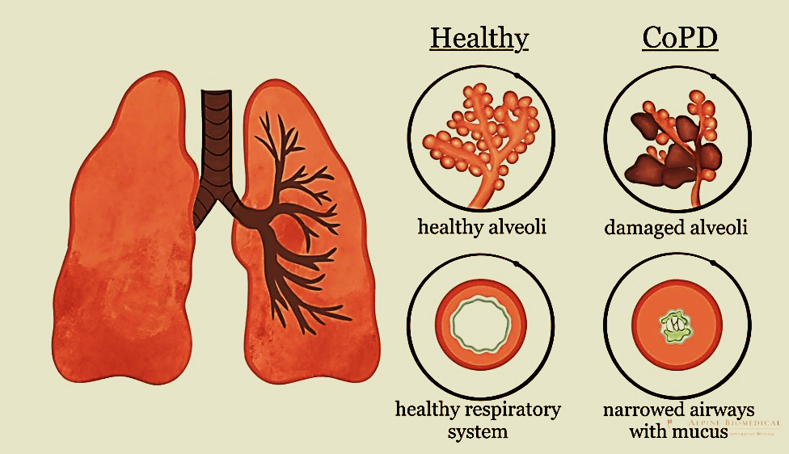
Figure 1: COPD
(Source: Alpine Biomedical, 2026)
Chronic Obstructive Pulmonary Disease (COPD) is viewed as a heterogeneous, progressive lung condition that is characterised by chronic, debilitating respiratory symptoms. These major symptoms consist of the chronic productive cough, persistent dyspnea and excessive sputum production. As per the Global Initiative for Chronic Obstructive Lung Disease (2025), these manifestations stem from the permanent abnormalities in conducting and parenchymal alveoli and airways, which lead to persistent and largely irreversible limitations in airflow. Locally, the National Institute for Health and Care Excellence (2019), defines this pathology using the structural airway remodelling and small changes in the airway that critically restrict the dynamics of expiratory flow. From the global epidemiological standpoint, WHO (2024), focuses on the fact that this obstruction is driven by the long-term toxicity and sustained injury of the tissue. Finally, the clinical consensus updates given by Agusti et al. (2023), confirm that the structural baseline consists of the critical interplay of the chronic bronchitis and destructive emphysema phenotypes, which collectively accelerate functional respiratory decline over time.
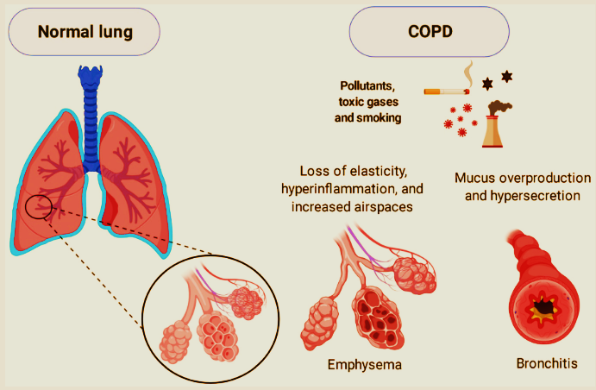
Figure 2: COPD phenotypes
(Source: Rodrigues et al., 2021)
Cellular exposure to inhaled toxic substances triggers a sustained, chronic inflammatory response within the respiratory tract. This constant inflammation contributes to mucous gland hypertrophy, hypersecretion and goblet cell hyperplasia. Over time, the structural tissue remodelling occurs. This leads to smooth muscle hypertrophy and fibrotic scarring that increasingly leads to the small peripheral airways (National Institute for Health and Care Excellence, 2019).
Emphysema consist of the permanent destruction of the alveolar walls without the obvious fibrosis. This structural breakdown contributes to the natural recoil of the lungs, which is vital to keep the airways patent during expiration. Consequently, the patients face dynamic hyperinflation, severe ventilation-perfusion (V/Q) mismatch and vital gas trapping that lead to chronic hypoxemia (Agusti et al., 2023).
COPD is no longer seen as a disease that is isolated to the lungs. The localised pulmonary inflammatory process spills over into the systemic circulation, which leads to the systemic inflammation that contributes to skeletal muscle wasting, enhanced cardiovascular risks and endothelial dysfunction (Barnes, 2020).
The clinical course of COPD is interspersed with acute exacerbations, which are characterised by the critical, sudden worsening of the baseline respiratory symptoms. These episodes are critically triggered by bacterial or viral infections or environmental pollutants. They need the additional medical therapy and, importantly, to speed up the long-term decline in lung function (Wedzicha et al., 2021).

Global Burden and Prevalence Profile
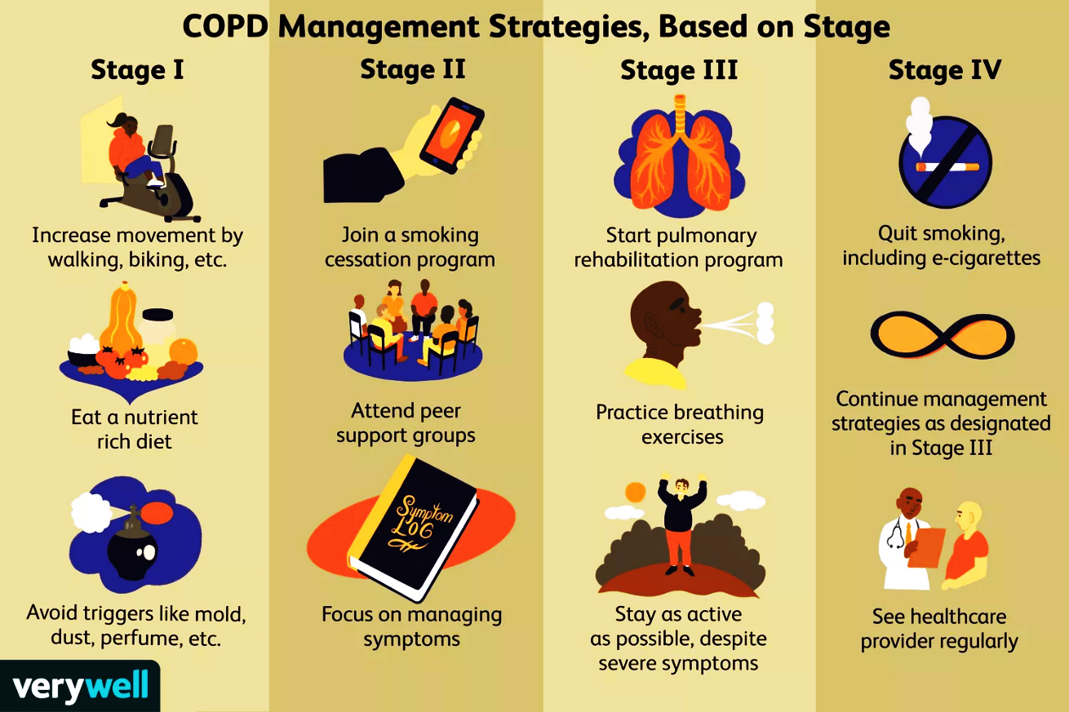
Figure 3: COPD Management Strategies, Based on Stages
(Source: Bezack, 2025)
On a global scale, COPD poses a critical challenge for public health and stands as the third leading cause of death globally. It leads to about 3.3 million deaths on a yearly basis, which shows roughly 6 per cent of all global deaths, and poses an increasing threat to the ageing populations (World Health Organisation, 2024).
The overall global prevalence of COPD among people aged 30 years and older is predicted at about 20.3%, translating to more than 390 million cases globally. The burden is moving towards the middle- and low-income nations due to the high rates of biomass fuel exposure and increasing prevalence of smoking (Adeloye et al., 2022).
Within the UK, about 1.4 million people are currently diagnosed with COPD. This affects about 2 per cent of the whole population of the UK, making it the second most common chronic respiratory condition across the nation, surpassed only by asthma.
Epidemiological modelling from the national dataset suggests that an additional 2 million people in the UK remain completely undiagnosed. Several people misinterpret early signs, such as a morning cough or mild exertional breathlessness, as the normal results of long-term or newly acquired smoking habits.
In the UK, COPD is closely related to socioeconomic deprivation. Emergency hospital admission rates, prevalence rates, and mortality rates are up to three times higher in the most deprived geographic areas in comparison to the most affluent areas, presenting clear health inequalities.
Financially, COPD is among the costliest conditions that are managed by the National Health Service (NHS). It costs direct clinical services more than £1.9 billion on a yearly basis. The majority of these funds are spent on emergency hospital admissions, which makes it a critical emphasis for preventive health policies.

Risk Factors and Aetiology

Figure 4: Risk Factors and Aetiology
(Source: Author, 2026)
Non-smokers who face chronic exposure to secondhand smoke face a significantly increased risk of developing airflow limitation. Inhaled toxins damage the epithelial cells and impair the normal mechanism of ciliary clearance of the lungs (Vogelmeier et al., 2021).
Cigarette smoking is found to be the major cause of COPD in high-income nations. It leads to 70% to 80% of the documented disease burden in the UK by driving oxidative stress and activating inflammatory cascades (National Institute for Health and Care Excellence, 2019).
On a global scale, the burning of biomass fuels (like animal dung, wood, and crop residues) in open fires or inefficient stoves for heating and cooking is a major reason for COPD. This exposure especially affects the children and women in the rural areas of the developing nations (WHO, 2024).
High concentrations of the ambient particulate matter (PM_{2.5} and PM₁₀), sulfur dioxide (SO₂) and nitrogen dioxide (NO2) lead to a quick decrease in the functions of the lungs, particularly in urban environments with vehicular traffic and heavy industrial areas (Thurston et al., 2020).
Exposure for the prolonged period to the chemical vapours, occupational dusts, fumes and irritants in industries like construction, agriculture, coal mining and textiles, importantly increases the risk of developing COPD, independent of smoking status.
Factors that affect the normal growth of the lung during childhood (like maternal smoking during pregnancy, low birth weight, recurrent childhood respiratory infections and premature birth) decrease the maximum attained lung function in early adulthood, increasing the susceptibility to COPD later in life.
The most clearly understood genetic risk factor in the case of COPD is Alpha-1 Antitrypsin Deficiency (AATD). This autosomal codominant genetic disorder leads to the critical lack of the circulating antiprotease protective enzyme, which leaves the lung parenchyma vulnerable to destruction by the neutrophil elastase (Strnad et al., 2020).
People with persistent airway hyper-responsiveness or chronic, poorly controlled asthma exhibit increased risk of developing the fixed, non-reversible airflow limitation as they age, a condition generally known as Asthma-COPD Overlap (ACO) (Postma and Rabe, 2015).

2 Multi-Dimensional Impact of COPD and NHS Treatment Pathways

Physical, Psychological and Social Implications
Physical Implications on Individuals
The hallmark symptom of the increasing exertional dyspnoea forces patients to restrict their physical activity in order to avoid breathlessness. This decrease in mobility contributes to muscle deconditioning, frailty, severe peripheral skeletal muscle dysfunction, and a loss of functional independence (Halpin et al., 2021).
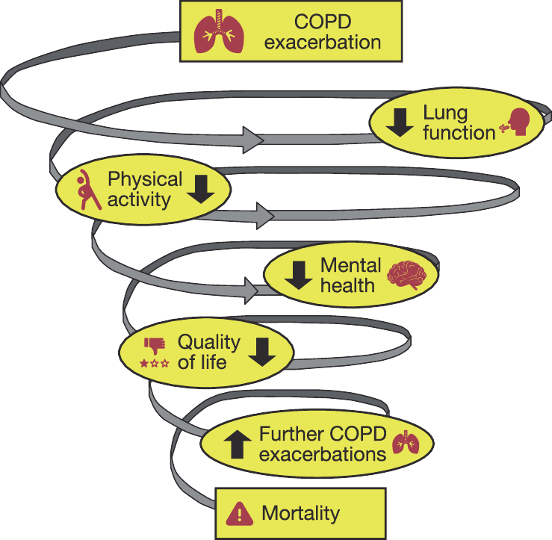
Figure 5: Downward spiral of COPD exacerbations
(Source: Hurst et al., 2020)
Structural changes in the mechanism of the lungs lead to oxygen desaturation and hypoventilation during sleep. This contributes to the frequent nocturnal awakening, chronic fatigue and daytime hypersomnolence.
Because of the shared inflammatory pathways, systemic oxidative stress, and chronic hypoxia, patients with COPD exhibit high rates of cardiovascular comorbidities, including heart failure, ischaemic heart disease and atrial fibrillation (Morgan et al., 2018).
Severe, advanced COPD is frequently crucial by pulmonary cachexia, which is the state of the involuntary loss of weight and muscle wasting. This condition is driven by high metabolic workload from breathing and elevated levels of the circulating inflammatory cytokines, like $TNF-α$ (Schols et al., 2014).
Psychological Impact on Individuals

Figure 6: The Panic Cycle
(Source: Author, 2026)
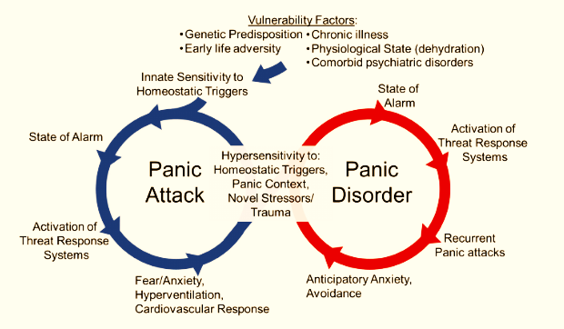
Figure 7: Cycle of panic disorder
(Source: McMurray and Sah, 2022)
The sudden onset of the critical breathlessness triggers acute panic and fear. This panic enhances the respiratory rate, which exacerbates hyperinflation and worsens dyspnoea, contributing to a distressing psychological cycle.
Chronic hypoxemia combined with hypercapnia can cause mild-to-moderate cognitive impairment. This influences executive functioning, attention span and visual-spatial memory, which can compromise the capacity of the patient to manage the critical medication regimens (Siraj, 2023).
Clinical depression affects between 40% and 57% of people living with moderate-to-critical COPD. This rate is significantly higher in comparison to the general population, driven by isolation, perceived lack of control and loss of role identity.
Patients who frequently face high levels of anticipatory grief and health anxiety as they observe their gradual physical decline, living in fear of the future acute exacerbation that could be fatal.
Social Implications for Individuals
Because of the physical limitations of breathlessness and logistical issues of transporting oxygen equipment, the patients generally withdraw from their social networks, which leads to loneliness and isolation
The progressive Nature of the condition generally forces people to leave the workforce prematurely. This loss of income, in combination with the extra costs of managing the chronic illness, can contribute to the significant financial strain.
Due to the strong public connection between COPD and smoking, several patients face external and internal stigma. This feeling of self-blame can contribute to shame, preventing them from accessing healthcare or seeking social assistance.

Wider Implications for Families and Caregivers
members generally step into the demanding caregiving roles without any sort of formal training. This generally contributes to the burnout for the caregivers, a high rate of clinical anxiety and depression among the relatives and physical exhaustion.
The members of families really face vicarious trauma when they see a loved one struggling with critical episodes of breathlessness. This can leave the caregivers feeling helpless and unsure about future crises.
Chronic illness can affect the established family dynamics. Adult children or spouses may find themselves taking on managerial or parental roles, which can lead to emotional strain or tension within the relationships.

Evidence-Based NHS Treatment Pathways
For patients who remain symptomatic despite short-acting therapy, long-acting dual bronchodilator therapy is initiated. A combination of the long-acting beta-agonist (LABA) with the long-acting muscarinic antagonist (LAMA) reduces the symptoms and optimises the lung function (National Institute for Health and Care Excellence, 2019).
Following the national guidelines, first-line management emphasises the inhaled bronchodilators to relieve the airflow limitations. Treatment starts with the short-acting beta-agonists (SABA) or short-acting muscarinic antagonists (SAMA) used as required for relief of the symptom (National Institute for Health and Care Excellence, 2019).
For patients facing frequent exacerbations (two or more moderate episodes or one leading to hospitalisation) alongside the blood eosinophil counts $≥300/μ\text{L}$Triple therapy, adding an Inhaled Corticosteroid (ICS), is suggested to lower readmission rates.
Pulmonary Rehabilitation is the major non-pharmacological pathway in the NHS. Does a multidisciplinary program consist of supervised physical exercise with education, Michelle, to improve the exercise tolerance and health-related quality of life (National Institute for Health and Care Excellence, 2019).
Long-Term Oxygen Therapy (LTOT) is suggested for patients with chronic obstructive pulmonary disease (COPD) with hypoxemia. When used for at least 15 hours every day, LTOT can offer an evidence-based survival advantage for the advanced cases (National Institute for Health and Care Excellence, 2019).
For patients who are admitted with acute-on-chronic respiratory acidosis due to an exacerbation, acute ward-based NIV is the gold standard treatment, which improves survival (National Institute for Health and Care Excellence, 2019).
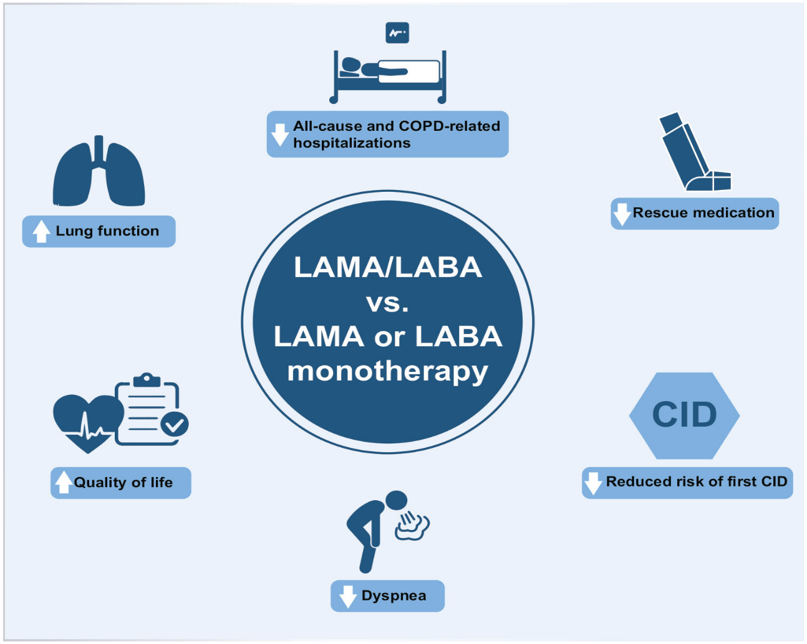
Figure 8: Potential benefits of LAMA/LABA combination therapy compared to LAMA or LABA monotherapy in patients with COPD.
(Source: Buhi et al., 2024)

3 Theoretical Frameworks and Models for Improved Outcomes
To effectively bridge the gap between reactive treatment and proactive clinical care, the health systems depend on the structural management models of care. For domestic application within the UK National Health Service, the clinical practices use the House of Care Framework, which explicitly incorporates personal care planning into the localised primary care infrastructure. However, for the wider international systems and the multi-layered strategies for global health, the organisations implement the Chronic Care Model (CCM), which is designed to optimise the population-level metrics across different private and public insurance networks.

UK Model: The House of Care Framework
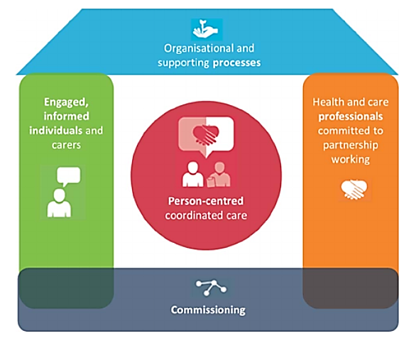
Figure 9: House of Care Model
(Source: Reidy et al., 2016)
The House of Care framework is used as a structural tool to integrate personalised care and assist in planning for primary care units in the UK. It ensures emphasis on what matters most to the patient.
The Roof (Organisational Infrastructure) element shows the digital and administrative systems to assist care. For COPD, this consists of maintaining accurate disease registers and sending diagnostic data to the patients before appointments (Coulter et al., 2023).
The Left Wall (The Empowered Patient) focuses on improving self-management skills, health literacy, and confidence. It shifts the role of the patients from passive receivers of care to active partners who co-produce the personalised goals (Alliance Scotland, 2024).
The Right Wall (The Healthcare Professional Partnership) world needs a transition from clinical paternalism. The staff members use shared decision-making and motivational interviewing to collaborate with the patients as equal experts in their own care.
The Foundation (Local Commissioning) base aggregates the data of individual care planning to inform the local service commissioning. It ensures funding goes towards the vital community assets, like peer-led support groups or local exercise facilities (NHS England, 2023).

International Model: The Chronic Care Model (CCM):
It was developed by Wagner and colleagues. This model focuses on restructuring the primary care systems to boost proactive and productive interactions between the informal patients and prepared professional teams (Wagner et al., 2001).
This pillar depends on the electronic health record registries to track the health data of the population. The systems generate automated alerts for missing spirometry reviews or overdue pneumococcal immunisations (Bodenheimer et al., 2022).
This element establishes a transitional culture that focuses on high-quality and safe chronic care management over acute and reactive treatments, which aligns the organisational goals with the metrics of chronic disease (Gee et al., 2021).
This element structures the clinical visits to separate acute care from chronic disease management. It clearly defines the roles and responsibilities of the multidisciplinary teams, using case managers and specialist nurses for critical cases (Barr et al., 2003).
This pillar sees the patient as the central manager of their circumstances. It offers the structural education, problem-solving strategies and goal-setting tools to assist them in managing their illness daily.
This aspect incorporates the evidence-based clinical guidelines directly into the daily practice. It ensures that the clinicians have access to updated expert standards, like the GOLD suggestions, via ongoing professional education (Stellefson et al., 2013).
This final component connects the healthcare institutions with the community programmes, like local smoking cessation services or exercise classes, to support the health goals of the patients outside the clinic.
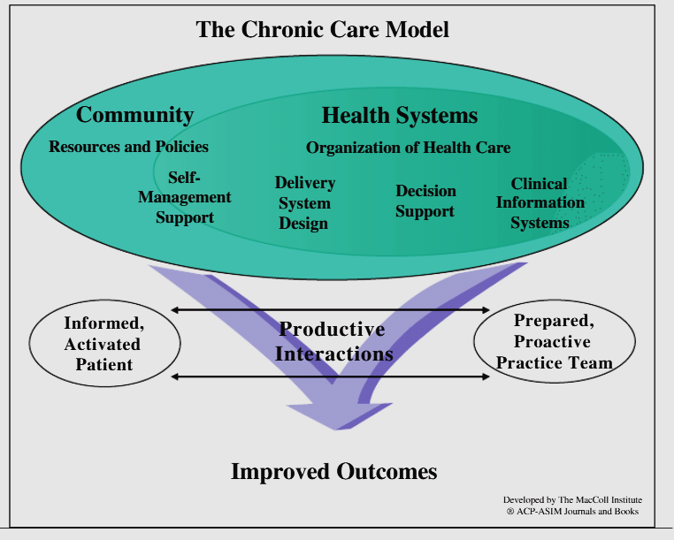
Figure 10: Wagner's chronic care model
(Source: Findley, 2014)

Comparative Analysis of the Models
Criteria | The House of Care Model (UK) | The Chronic Care Model (International)
Origin and adaptation | This was developed specifically to incorporate the personalised care planning into the primary care structures of the UK NHS. | This was developed in the US and adapted globally across the diverse public and private insurance systems.
Central emphasis | It centres on interpersonal and collaborative care planning conversations between the clinician and the patient. | It emphasises organisational and systemic design and population-level health metrics.
Community integration | It uses ‘social prescribing ' to explicitly connect patients with the local, non-clinical community resources. | It utilises the policies of the community but depends more heavily on the institutional healthcare connections.
Implementation challenge | It needs a vital cultural transition for healthcare professionals to abandon clinical paternalism. | It demands substantial upfront financial investment in the IT infrastructure and advanced digital registries.

4 Political Analysis: UK Health and Social Care Agendas

The NHS Long Term Plan (2019-2029)
The NHS Long Term Plan focus on respiratory disease and views it as the major clinical focus across England, with the aim of preventing about 90,000 emergency admissions by improving the early diagnosis and treatment pathways.
The policy funds the placement of specialist physiotherapists and respiratory pharmacists within the local primary care networks (PCNs), moving care out of the acute hospitals and into the community.
The creation of community diagnostic hubs will be mandatory to improve local accessibility to quality-assured spirometry, which can help to close the undiagnosed population gap across different areas.

Gold Standard Clinical Guidance: National Institute for Health and Care Excellence Guidelines
The NICE guidelines present a comprehensive approach for the management of stable COPD, moving away from the critical spirometry-only brackets towards addressing their specific ‘treatable traits’ like frequent exacerbations and breathlessness (National Institute for Health and Care Excellence, 2019).
The guideline sets the critical criteria for prophylactic antibiotic scripts, which balance the degrees of frequent exacerbations against the wider risk of generating antimicrobial resistance (National Institute for Health and Care Excellence, 2019).

Major Political Initiatives: Core20PLUS5 Framework
Developed by NHS England, this framework targets the poorest 20% of the population of the UK (Core20) alongside the locally identified vulnerable groups (PLUS), designating chronic respiratory disease as one of the five clinical areas that need urgent intervention (NHS England, 2022).
The policy directs funding toward targeted smoking cessation and community-based pulmonary rehabilitation in the historically deprived postcodes to decrease the health inequality gap (Marmot et al., 2024).

5 Person-Centred Recommendations for Practice
To optimise the holistic COPD outcomes across the NHS, future clinical practice needs to implement the four targeted initiatives:
Each patient should co-produce the digital or written action plan to track the baseline symptoms and safely direct the self-administration of the rescue therapies (National Institute for Health and Care Excellence, 2019).
Modernise the referral pathways to automatically enrol any patient with an MRC dyspnoea score of 2 or more into the virtual or hybrid pulmonary rehabilitation programs (National Institute for Health and Care Excellence, 2019).
Integrate the routine depression and anxiety screenings into the annual primary reviews, routing the isolated patients to community peer networks through the social prescribing link workers.
Initiate the proactive end-of-life care conversations early, using the ReSPECT framework for emergency preferences and low-dose opioids to manage refractory breathlessness.

References
Adeloye, D., Song, P., Thakar, R., Negrini, S., Noble, B., Forbes, H., Rudan, I. and Campbell, H. (2022) ‘Global, regional, and national prevalence of, and risk factors for, chronic obstructive pulmonary disease (COPD) in 2019: a systematic review and modelling analysis’, The Lancet Respiratory Medicine, 10(5), pp. 447–458. https://www.thelancet.com/pdfs/journals/lanres/PIIS2213-2600(21)00511-7.pdf
Agustí, A., Celli, B.R., Criner, G.J., Halpin, D., Anzueto, A., Barnes, P., Bourbeau, J., Han, M.K., Martinez, F.J., Montes de Oca, M. and Papi, A. (2023) ‘Global initiative for chronic obstructive lung disease 2023 report: GOLD executive summary’, European Respiratory Journal, 61(4), p. 2300239. https://academic.oup.com/ajrccm/article-abstract/207/7/819/8428320
Alliance Scotland (2024) Scotland's House of Care. Edinburgh: Health and Social Care Alliance Scotland. https://www.alliance-scotland.org.uk/past-work-and-projects/scotlands-house-of-care/
Alpine Biomedical (2026) Chronic Obstructive Pulmonary Disease (COPD). (Online). Available at: https://alpine-biomedical.ch/en/blog/copd/ (Accessed: 21 June 2026).
Barnes, P.J. (2020) ‘Cellular and molecular mechanisms of chronic obstructive pulmonary disease’, Clinics in Chest Medicine, 41(3), pp. 309–321. https://www.academia.edu/download/88566892/5.EPOC-MECANISMOS.pdf
Barr, V.J., Robinson, S., Marin-Link, B., Underhill, L., Dotts, A., Ravensdale, D. and Salivaras, S. (2003) ‘The expanded chronic care model: an integration of health promotion and disease prevention’, Hospital Quarterly, 7(1), pp. 73–82. https://d1wqtxts1xzle7.cloudfront.net/70022011/93f656d5c69f75b6769504ea61034df29933-libre.pdf?1632195395=&response-content-disposition=inline%3B+filename%3DThe_Expanded_Chronic_Care_Model_An_Integ.pdf&Expires=1782065401&Signature=TPOLOfJQhDnXMyOdO9PpRICvxrjX9P~KFitIN~xMzFqaxczKGZ-2Mo7DIDSwqXrF7QDriVO3o8fQK2Qc~OmY4Oebaw2BwNntkZadrG81SXPAtsNLTtFGKUjScANSDsGAGZp06UroTLcHOar~rxYEGO4T1GJKPzPx3LR576XOFfclqZmkMuiwfXoWaGdIM1P-LboBOLoitYXkKwdVCUth0sYy2ro0jOLi-PVY9tR7P-5VVjC4KnJ7-T7rGx3Bro4mWwGndPtK2zUh~jhy4GV397mBIOpCPWP2YmjwYvvVObNlv0rm2auXFyMhhNornyJw3SvL2GrU2nRgh0tNTDa0aA__&Key-Pair-Id=APKAJLOHF5GGSLRBV4ZA
Bezack, B. (2025). What Are the Four Gold System Stages of COPD? Available at: https://www.verywellhealth.com/stages-of-copd-gold-system-5071328 (Accessed: 26 June 2026)
Bodenheimer, T., Wagner, E.H. and Grumbach, K. (2022) ‘Improving primary care for patients with chronic illness: the chronic care model, Part 2’, JAMA, 288(15), pp. 1909–1914. https://d1wqtxts1xzle7.cloudfront.net/48956008/JAMABodenheimer10-02-libre.pdf?1474283332=&response-content-disposition=inline%3B+filename%3DImproving_Primary_Care_for_Patients_With.pdf&Expires=1782065514&Signature=STSLxuhZmkHseMb76v-04phQ7yHzWeCOmvzXUZ4GWk3aii7dh1oth17BXlXwVsZJCPEaAoDOK8q6vZjjUA8okxFO1bP-TUU~owst-eL1Alg3zbgLDfQIpHn9XnpiSe-6EfKSJ9mxtqOkailGZvnQ8zCQR~xjAXorHMT~9PKvpdO1MIAwCHNGxtuLx5exl269qkh3iGjf4SHYyHcxPgVByc2yFQ27hMDffefzLHO3A9AzltApqIk0F3AzCT-ebGEK8TuuNxIHP-DLP5QKizddSz2B2f9RvI-m88Pjhs2zgSFDowsZ-uUiyCZOu6ZTWwZojEDlvZRapKL3B05NEglZtw__&Key-Pair-Id=APKAJLOHF5GGSLRBV4ZA
Buhl, R., Miravitlles, M., Anzueto, A. and Brunton, S. (2024) ‘Long-acting muscarinic antagonist and long-acting β2-agonist combination for the treatment of maintenance therapy–naïve patients with chronic obstructive pulmonary disease: a narrative review’, Therapeutic Advances in Respiratory Disease, 18, p.17534666241279115. https://journals.sagepub.com/doi/pdf/10.1177/17534666241279115
Cleutjens, F.A., Janssen, D.J., Ponds, R.W., Dijkstra, J.B. and Wouters, E.F. (2023) ‘Cognitive impairment in chronic obstructive pulmonary disease: an underestimated comorbidity’, Respiratory Medicine, 176, p. 106268.
Coulter, A., Entwistle, V.A., Eccles, A., Ryan, S., Shepperd, S. and Perera, R. (2023) ‘Personalised care planning for adults with chronic or long-term health conditions’, Cochrane Database of Systematic Reviews, (3), p. CD010523. https://www.cochranelibrary.com/cdsr/doi/10.1002/14651858.CD010523.pub2/pdf/full
Findley, P.A. (2014) ‘Social work practice in the chronic care model: Chronic illness and disability care’, Journal of Social Work, 14(1), pp.83-95. https://www.researchgate.net/profile/Patricia-Findley/publication/273601691_Social_work_practice_in_the_Chronic_Care_Model_Chronic_illness_and_disability_care/links/560d2f6908ae57bb66d41573/Social-work-practice-in-the-Chronic-Care-Model-Chronic-illness-and-disability-care.pdf
Gee, P.M., Greenwood, D.A., Paterniti, D.A., Ward, D.H. and Miller, L.M. (2021) ‘The e-Health Enhanced Chronic Care Model: a theory derivation primer’, Journal of Medical Internet Research, 17(4), p. e86. https://www.jmir.org/2015/4/e86/' + match + '
Global Initiative for Chronic Obstructive Lung Disease [GOLD] (2025) Global strategy for the diagnosis, management, and prevention of chronic obstructive pulmonary disease (2025 report). Available at: https://goldcopd.org (Accessed: 18 June 2026).
Halpin, D.M., Criner, G.J., Papi, A., Singh, D., Anzueto, A., Martinez, F.J., Agustí, A. and Celli, B.R. (2021) ‘Global Initiative for the Diagnosis, Management, and Prevention of Chronic Obstructive Lung Disease: the 2021 GOLD Science Committee Report’, European Respiratory Journal, 57(1), p. 2004079. https://www.atsjournals.org/doi/pdf/10.1164/rccm.202009-3533SO
Hurst, J.R., Skolnik, N., Hansen, G.J., Anzueto, A., Donaldson, G.C., Dransfield, M.T. and Varghese, P. (2020) ‘Understanding the impact of chronic obstructive pulmonary disease exacerbations on patient health and quality of life’, European journal of internal medicine, 73, pp.1-6. https://www.sciencedirect.com/science/article/pii/S0953620519304431
Marmot, M., Allen, J., Boyce, T., Goldblatt, P. and Morrison, J. (2024) Health equity in England: The Marmot review 14 years on. London: Institute of Health Equity. https://discovery.ucl.ac.uk/id/eprint/10106434/3/Bockenhauer_BMJ%20Ten%20years%20essay2pg3.pdf
McMurray, K.M. and Sah, R. (2022) ‘Neuroimmune mechanisms in fear and panic pathophysiology’, Frontiers in Psychiatry, 13, p.1015349. https://www.frontiersin.org/journals/psychiatry/articles/10.3389/fpsyt.2022.1015349/pdf
Morgan, A.D., Zakeri, R. and Quint, J.K. (2018) ‘Defining the relationship between COPD and cardiovascular disease’, Therapeutic Advances in Respiratory Disease, 12, pp. 175–189. https://pmc.ncbi.nlm.nih.gov/articles/PMC5937157/
National Institute for Health and Care Excellence [NICE] (2019) Chronic obstructive pulmonary disease in over 16s: diagnosis and management (NICE Guideline NG115). London: NICE. Available at: https://www.nice.org.uk/guidance/ng115 (Accessed: 21 June 2026).
NHS England (2022) Core20PLUS5 (An approach to reducing health inequalities). London: NHS England. https://www.england.nhs.uk/about/equality/equality-hub/national-healthcare-inequalities-improvement-programme/core20plus5/
NHS England (2023) Social prescribing and community-based support: summary guide. London: NHS England. https://www.england.nhs.uk/publication/social-prescribing-and-community-based-support-summary-guide/
Postma, D.S. and Rabe, K.F. (2015) ‘The Asthma-COPD Overlap Syndrome’, New England Journal of Medicine, 373(13), pp. 1241–1249. https://web.eng.fiu.edu/brownm/BME3404/Asthma-COPD%20Overlap%20Syndrome.pdf
Reidy, C., Kennedy, A., Pope, C., Ballinger, C., Vassilev, I. and Rogers, A. (2016) ‘Commissioning of self-management support for people with long-term conditions: an exploration of commissioning aspirations and processes’, BMJ open, 6(7), p.e010853. https://scholar.google.com/scholar?output=instlink&q=info:CCMtNBMbcE4J:scholar.google.com/&hl=en&as_sdt=0,5&scillfp=4776703767321621119&oi=lle
Rodrigues, S.D.O., Cunha, C.M.C.D., Soares, G.M.V., Silva, P.L., Silva, A.R. and Goncalves-de-Albuquerque, C.F. (2021) ‘Mechanisms, pathophysiology and currently proposed treatments of chronic obstructive pulmonary disease’, Pharmaceuticals, 14(10), p.979. https://www.mdpi.com/1424-8247/14/10/979
Schols, A.M., Ferreira, I.M., Franssen, F.M., Gosker, H.R., Janssens, W., Muscaritoli, M., Pison, C., Rutten-van Mölken, M., Slinde, F. and Wouters, E.F. (2014) ‘Nutritional assessment and therapy in COPD: a European Respiratory Society statement’, European Respiratory Journal, 44(6), pp. 1504–1520. https://scholar.google.com/scholar?output=instlink&q=info:bwmCH-eDAaIJ:scholar.google.com/&hl=en&as_sdt=0,5&scillfp=17105528854196426836&oi=lle
Siraj, R.A., 2023. Comorbid cognitive impairment in chronic obstructive pulmonary disease (COPD): current understanding, risk factors, implications for clinical practice, and suggested interventions. Medicina, 59(4), p.732. https://www.mdpi.com/1648-9144/59/4/732
Stellefson, M., Dipnarine, K. and正, C. (2013) ‘The chronic care model and diabetes self-management education in primary care’, Preventing Chronic Disease, 10, p. E21. https://pmc.ncbi.nlm.nih.gov/articles/PMC3604796/pdf/PCD-10-E26.pdf
Strnad, P., McElvaney, N.G. and Lomas, D.A. (2020) ‘Alpha-1 antitrypsin deficiency’, New England Journal of Medicine, 382(15), pp. 1443–1455. https://discovery.ucl.ac.uk/id/eprint/10095434/7/Lomas_NEJMra1910234.pdf
Thurston, G.D., Kipen, H., Annesi-Maesano, I., Balmes, J., Brook, R.D., Cromar, K., De Matteis, S., Forastiere, F., Forsberg, B. and Frampton, M.W. (2020) ‘A joint ERS/ATS policy statement: what constitutes an adverse health effect of air pollution?’, European Respiratory Journal, 49(1), p. 1600419. https://publications.ersnet.org/content/erj/49/1/1600419?ctkey=shareline
Vogelmeier, C.F., Criner, G.J., Martinez, F.J., Anzueto, A., Barnes, P.J., Bourbeau, J., Celli, B.R., Chen, R., Decramer, M., Fabbri, L.M. and Frith, P. (2021) ‘Global strategy for the diagnosis, management, and prevention of chronic obstructive lung disease 2021 report’, Respirology, 26(1), pp. 9–37. https://www.atsjournals.org/doi/pdf/10.1164/rccm.201701-0218pp
Wagner, E.H., Austin, B.T., Davis, C., Hindmarsh, M., Schaefer, J. and Bonomi, A. (2001) ‘Improving outcomes in chronic illness’, Managed Care Quarterly, 9(4), pp. 14–32.
Wedzicha, J.A., Calverley, P.M. and Albert, R.K. (2021) ‘Prevention of chronic obstructive pulmonary disease exacerbations’, European Respiratory Journal, 41(5), pp. 1222–1235. https://www.academia.edu/download/69683815/The_prevention_of_COPD_exacerbations_by_20210915-21573-147lxkj.pdf
World Health Organisation [WHO] (2024) The top 10 causes of death. Available at: https://www.who.int/news-room/fact-sheets/detail/the-top-10-causes-of-death (Accessed: 21 June 2026).

