How did politics affect the art and architecture of the Athenian Acropolis between 480 and 420 B.C.E.

This project will focus on the effects of politics on the Athenian Acropolis. I will explore the Persian destruction of the Athenian Acropolis, in 480BC; how it affected the city and the Athenians subsequent to vow never to re-build the destroyed structures . I will also discuss the vows validity and in what way the 30 years of postponed building allowed a change in style and purpose of all buildings on the Acropolis. I will consider the Parthenon and examine the ambiguity of it purpose as a cult building by analysing both modern and ancient scholars to determine if it was used as a temple or as a public building. I will also debate the impact of Athens’ rising prosperity and military victory on the iconography of the Acropolis. I will compare the art and architecture found on the Acropolis to other iconographical features found across Athens and the wider Greek world. I will also debate the effect of the Periclean building reforms on the Acropolis, and how Athenian democratic system impacted buildings on the Acropolis due to them having to accommodate multiple different cult locations and function in public events. Overall I will attempt to evaluate which political factor had the greatest impact on the art and architecture of the Athenian Acropolis, and whether modern scholars consider all political factors when considering the meaning of the Acropolis’ iconography.

In 480BC Athens was still fighting a war against Persia. Both Athens the city and the Acropolis, had been destroyed by the Persian attack. Seeing the demolition and theft of many important political symbols Athenians made a vow in the wake of this event, stating that no sanctuaries in Attica would be re-built so they would remain a monument to the destruction and barbarism of the Persians. This vow was made in the face of the final battle against Persia at Plataea , as part of an attempt to unify Greeks into the Delian League. Many sanctuaries in Attica, including the entire Athenian Acropolis saw a 30-year period of halted building following this vow and later structures were also heavily shaped by the vows. The ruins were to act as a physical reminder of the devastating effect the Persians had on Greek culture. After thirty years, however, the Acropolis and many other sanctuaries in Attica saw efforts to reconstruct temples and cult sites. Due to this time gap a new architectural style developed in Athens; one that denotes the establishment of the Classical Period for art and architecture. The Classical style showed a movement away from the archaic designs of Athens’ past, and a venture towards hyper realistic and detailed depictions of humans and mythical creatures. It also welcomed a new grander architectural design that married Ionic and Doric elements to create a façade that is regarded as iconic throughout the ages. The Acropolis became a reflection of the new power Athens had in the Mediterranean; whilst functioning as the main sanctuary of classical Athens.

The gap of construction on the Acropolis is widely accepted to be due to the vow made by the Athenians in 480BC. Nevertheless, there remains a lot of debate in modern scholarship as to whether the vow was really made. The main problem that modern scholars face when contemplating the authenticity of the vow is that there is no contemporary evidence, archaeological or literary, that the Athenians’ really made a vow to keep the destroyed sanctuaries. Jon Mikalson draws attention to a surviving 4th C tablet summarising the oath the allied Greeks took against the Persians as evidence that the vow could have been made. Unfortunately, this inscription addresses the vow made by all of the Greek poleis against the Persian empire and not the Athenians’ own vow. The Athenians might not have considered their own vow appropriate to be memorialised, alongside a different agreement, but the tablet only proves that vows were being made at this time, not that the 480 vow is real. Diodorus and Lycurgus do record the inscription, but add the vow of the Athenians to keep the ruins. These works are often cited as complimentary evidence for the vow’s existence; but it is unclear where they got their information on this vow from. Examining the earlier works of Herodotus and Thucydides we see the vow of Platea is recorded but not the Athenians own vow. There are arguments that the vow was a fabrication of the Athenians, one debated by both modern scholars and the ancient historian Theopompus; a fourth century moralist who was a strong supporter of Monarchy over democracy. His views on the democratic Athens were critical and unfavourable making his accusations and credibility questionable. I believe that the vow was real and recorded in oral history, and wasn’t written down until later Roman times when traditions would have changed. The later Roman recordings may have caused the details of the vow to be incorrectly recorded, I consider the 30 years of halted building on the Acropolis acts as strong evidence for the vow’s existence.

The argument that the vow was real, and had impact on the Acropolis, is supported by the fact that the Parthenon may not actually be a traditional temple. The Parthenon began construction in 447BC and was completed in 433BC, built over the ruins of the former temple of Athena Polias. The moniker of ‘Parthenon’ that the building is known by today was not actually gained till the 4th C; with the name itself being a title given to the back chamber of the building. Its original name may have given away more about its actual purpose; however, this information is not available, due to the fact no records of its name have survived. What we can know is that the Parthenon was not designed as a temple, due to the building not having an altar nor attending priestesses inside of it. Even though a shell of a temple was re-built, the original temple was never re-instated at this site. In fact, the Parthenon was not widely called a temple until a century after its creation , this indicates that it was never intended to serve this purpose to the Athenian people. This also demonstrates that, although the oath may have been bent a little to allow the building of new structures, it was never intended to be out right broken and that it was not until the importance of the vow had been forgotten, that the Parthenon was called a temple.

There is enough evidence to convince certain scholars that the Parthenon was a state building, more akin to the Agora, and was instead a monument, with archaeological features of other temples being used as a dedication to the older temple that was destroyed. This argument has its good evidence, but is still not certified. Some modern scholars consider the archaeological features to be similar to painted tombs or the treasury at Delphi, which served not only as sanctuaries for religious practice but as public areas where wealth and elitism were displayed by powerful states. This is supported by rumours that the Acropolis once housed a Mycenaean palace associated with the “Mythical kings such…Cecrops and Erechtheus”.Others disagree with this view and consistently refer to the Parthenon as a temple. This is often initially due to the simple aesthetic similarities it shares with other temples built in the fifth century but is also linked to the religious practices that seem to frequently occur with the use of the Parthenon . These scholars argue that the lack of an altar was only to bypass the original vow and there is sufficient evidence to call the Parthenon a temple, predominately a passage from Pausanias, where he calls the Parthenon is called a ‘temple’. However, is an inaccurate translation as it does not use the Greek word ναός (Naos), which actually means temple. In passage 1.24.4, Pausanias acknowledges the space in front of the Parthenon was used in cult activity involving the slaughter of a cow. This suggest that the Parthenon fulfilled religious aspects of life for the community fuelling arguments that the Parthenon served as a temple, nonetheless it does not act as evidence as it was not uncommon for dedications to be made to the gods outside of temple environments in Greek society. I believe that it is more probable that the Parthenon functioned as a public building that hosted cult events, rather than an active temple.

A separate point, which modern scholars rarely focus on when discussing how Athenians circumnavigated the 480BC vow, is the purpose of the Erechtheion, where multiple altars are found. Scholarship rarely discusses the concept of the Erechtheion serving the replacement temple to Athena Polias, despite it housing the altar to her and containing the burnt xoanon of the original temple. Scholars, such as Barringer, do acknowledge the appearance of these cult artefacts, but fail to analyse why their appearance would have had significance to the Athenians of the time. By having a sanctuary containing cultic symbols of Athena without naming it after her, the Athenians did not break the vow, as they were merely re-using the ruins, rather than replacing them. This is helped by the fact that the Erechtheion also houses altars and dedications for multiple cults and deities. Overall, it is likely the Acropolis was not built to house a temple; but to host multiple religious and cult activities. Later authors such as Pausanias and the modern scholars after him, view the buildings through the cult images and practices surrounding it. Pausanias’ own interpretation of the Acropolis, and his desire to make his work interesting may lead him incorrectly identify the buildings on the Acropolis as religious buildings, rather than buildings that served the democracy of Athens, acting as a physical reminder of its strength and prosperity. This is in part due to his not being a native of Athens or a contemporary source. Modern scholars, such as Fullerton, who use Pausanias to explain structures on the Acropolis share the unreliability of the source material when they fail to criticise him.

When looking at political factors that affect the art and architecture of the Acropolis, it is important to consider the Periclean reforms alongside the aftermath of the Persian war. The defeat of the Persian empire was a huge social, political and economic event in the 5th century. The building reforms of Pericles used this major historical event to further Athens reputation by creating the Acropolis as a tribute to the Athenian triumph. During the construction of the Acropolis there was a focus on iconography that depicted battles between barbarity and civilisation. There was a huge increase in the number of depictions that hinted at or outright stated the Persian defeat in 480 BC; including multiple artistic portrayals of combat and warfare found on the Acropolis, with most modern scholars believing this to be a reflection of the Persian attack . This is most clear in the statues of heroes who fought against the Persians mentioned by Pausanias, which show that the war with the Persians was at the very least commemorated at the site. Spivey believes that this was a way of displaying not only Athens own victory against the Persians, but the might of democracy over monarchy. This is frequently found across Attic art created in the late fifth century and beyond and is a frequent and iconographical theme in public structures, not just on the Acropolis. Nevertheless, the Acropolis seems to focus on depicting the war between the Persians and Athens in particular. Greeks often used art to depict their victory over an enemy the Acropolis was created in the height of Athenian power and influence. Hughes argues that the Agora was the backdrop to Athenian democracy, and the Acropolis is viewed as a display of its success.

Mythical battle scenes are repeatedly found on the Acropolis, with metopes, friezes and statues all featuring some aspect of this battle. Theses depictions frequently consists of humanoids battling against mythical creatures, including Lapiths, Centaurs, Amazons and Giants . Spivey argues that the use of centaurs on the Parthenon is a mocking representation of the Persians; as the Persians were known to the Greek world and amongst themselves as a “horse loving” race. Their representation as centaurs may be a way of showing this trait as monstrous and uncivilised. Despite this evidence, we cannot be certain centaurs acted as iconographical shorthand for the Persians. Other depictions of Lapiths and Centaurs can be seen on the multi-regional temple of Zeus at Olympia, but there is no indication that they symbolise the Persians. When analysing the Acropolis’ iconography, the wider political climate and circumstance has to be considered. It must be discussed if mythical battles were expected at sacred sites, or did depictions of fighting mythical creatures expand into symbolic shorthand after the grand display on the Parthenon.

Whilst the comparisons to other temples and state buildings help us understand the impression the buildings on the Acropolis made to the people who saw it, we must also reflect on the fact that the Acropolis was built by and for the Athenian polis. The Athenian Acropolis is not a Pan-Hellenic site, unlike many sites it is compared to and the iconography of the Acropolis does depict victory; but due to the Acropolis’ celebrations only catering to citizens of Athens, it was probably only understood by Athenians. The continuous use of the monstrous imagery was to be viewed as part of a collective message, rather than separate scenes; emphasising the struggle between barbarism and civilisation. More recent scholars argue that there is actually less evidence of explicit victory being depicted. Arrington argues that unlike evidence found elsewhere in Attika, the creators of the Acropolis present a subtle version of Athenian victory. The artists and sculptors show points of battles where the outcome is undecided; Athenians are either depicted as weak or the Gods are shown to have not inflicted casualties on their foes. The Acropolis is considered to be a symbol of Athenian victory, an everlasting monument, but it is possible that the depictions of battle are a reflection of internal worries of the Athenian people. The ancient mindset saw the world pass through cycles and ages and Athenians may have worried that with such prosperity, there was the possibility for it to fade away. This seems particularly apparent when considering the context of the encroaching Peloponnesian war and the Delian League’s issues with Athens, but we must be aware of the fact that this is a view highly reliant on hindsight, and we cannot know for certain if these were the anxieties that Acropolis was meant to show. The creators of the Acropolis have long since died, the statement they created has not. The Acropolis was a tribute not only to the Athenians victory against Persia, but also to their culture, heritage and future. The mythic scenes represent the glory of Athens past, and depicted the internal pride and worries of contemporary Athens too. The Acropolis was built off the back of military victory and economic success, but is difficult to know if its creators had awareness of the struggles Athens would face in the future.

An example of how mythical creatures were being used to immortalise current political events is when evaluating the magnificent chryselephantine statue of Athena Parthenos, located inside the main chamber of the Parthenon. Although the statue no longer exists today, through the use of Roman copies and ancient texts we can visualise the depictions made on the statue. Focusing on the shield of Athena Parthenos and examining the depiction of the war between the Greeks and the Amazons, we know that Phidias, the sculptor, had included a portrait of Pericles fighting an Amazon within the scene. Barron comments on Pericles depiction seeming sacrilegious, but this relies on the statue having religious meaning, which Camp argues as unlikely without an altar. Most likely this would have been seen as an act of extreme hubris, but is not recorded to have been a moral issue for Pericles himself. What is known is that the Athenian democracy viewed Pericles with contempt, in regard to the great expense of the Acropolis that he had planned and that Phidias was banished from Athens in 432BC under the charge of impiety and exiled to Elis. Nevertheless, the Acropolis was clearly being used as a way to display Athens’ leaders, warriors and famous figures as equals to the epic mythological heroes of ancient times. This may not have always been taken well by the Athenian democracy, specifically Pericles and Phidias who were still alive at the time they were immortalised in stone and gold. Nonetheless depictions of an old King of Athens, Erichthonius, show him as a snake at Athena Parthenos’ feet and within the Erechtheion, the possible replacement to the temple of Athena Polias. This indicates that the Athenian people had little issue with giving their heritage and past kings a close link to the divine, so long as it was done for the glory of Athens own reputation, rather than that of an individual. The Acropolis was a place where “civic ideology and polis theology met” , but this was a fine line to walk and Pericles’ appearance on the Athena Parthenos lacked the subtlety needed to make such an illusion work.

The Periclean building reforms Athens made an impressive display of its potential, wealth and notoriety as an Empire through the Acropolis. With an influx of money, Athens set itself up as a new Greek empire, with the art and architecture showing this shift in political goals. The Acropolis became the spectacular response to the Persian influence and culture.There was much architecture that seems influenced by the Persian styles developing at the time. When examining the Odeion, historians like Hughes argue that its conical roof was an imitation of Xerses tent and acted as “an architectural two fingers up at the Persian might” . Other modern scholars argue that the mimicry found in Athenian Architecture was a way of competing with the larger empire. However other arguments focus on the similarities between the Athenian Acropolis and the Persian Persepolis. Lawrence argues that the Parthenon shows the most similarity to the Persepolis as the structures may well have the same sculptors working on it due to the similar dates of construction. Connelly evaluates these claims and admits the connection between the Acropolis and the Parthenon is compelling, especially considering the frieze of the Parthenon shows unusual mundane scenes, akin to those found on the Persepolis. Even in ancient Greece there was some level of similarity drawn between the two sites, with Alexander the Great burning the Persepolis as vengeance for the attack on the Acropolis in 480 B.C.E. These scholars argue that the Acropolis was not competing with the art and architecture of Persia, instead they argue that the Acropolis was influenced by the ideas that came from artists and sculptors that had worked on the Persepolis. With these arguments in mind it is most likely that the Persian elements found on the Acropolis during the Periclean reforms are a mixture of the influence of new artist and sculptors that worked on the Persepolis and Athens rising desire to present itself as an empire, as powerful as Persia was.

Despite the clear influence of the Persians it is important to not down play the Delian Leagues impact on the art and architecture of the Acropolis. Under Pericles’ advice the Athenians funnelled large amounts of money from the Delian league to fund the Acropolis, turning it into a “monument of Athenian imperialism”. This manipulation of funds had a large impact on the art and architecture of the Acropolis, with a lot of features showing the combination of styles and artists work from all across the Greek world. The Acropolis showed the impact of Athens’ interaction with other polies, with the combination of Doric styled elements with Athens’ own ionic style. This deliberate blending of styles from all different polies, implies that, despite modern historians focus on Athens being the controlling influence, it may have been more likely that a unified Greece allowed free movement of art and architecture to travel across the Aegean. This becoming more apparent when seeing that many architectural elements found on the Acropolis were styles that were highly popular across the Aegean. Older views in scholarship argue that the Delian leagues gave Athens the funds it could never have achieved on its own but its impact on the Acropolis was exclusively financial rather than iconographical or cultural. This argument is mostly based on the fact that large amounts of funds from the Delian League went to fund the statue of Athena Parthenos, which acted as a “virtual treasury” of the Acropolis. Nonetheless, more modern studies have found that this view does not take into consideration Athens own financial outputs, Although the funds of the Delian league allowed for speed of the Acropolis’ construction, part of it was paid for out of the profit from the Laurion silver mine and other parts by Athens’ other major export olive oil, to which Athena acted as a patron deity. Overall it is more likely that the Delian League had a large impact on the art and architecture of the Acropolis. Whilst not all stylistic elements can be attributed to them, the combination of the funds and artist that they involved in the Periclean Acropolis unquestionably shaped the sacred space.

Overall, when looking at how politics affected the art and architecture on the Athenian Acropolis 480 and 420 B.C.E it is impossible to say that any one political event had the greatest impact on the ancient site. Modern scholars identify the most noticeable political factors; Pericles providing the leadership the building reforms and the Delian league and Persian war booty providing the funds to create the iconic Acropolis. There is also a focus on the importance of the vow made by the Athenians to keep the ruined structures, this vow did allow for the change in style caused by the 30 years of halted building and could have caused the Parthenon’s questioned purpose, but these things are more consequential rather than deliberate. I believe that the greatest impact on the art and architecture lay in the far more subtle political factors. One example is the influx of new materials, artists and workmen from across the Aegean that allowed for the improvement of previous archaic designs, to create the new classical style that the Parthenon is renowned for. Without these influences it is doubtful that the Athenians would have been able to develop the iconic images and structures, even under the guidance of the skilled sculptor Phidias. Another less subtle, but still as impactful political change was that Athens was using the Acropolis as a way to present itself as a rising and powerful empire, within the Mediterranean world. This change in Athens political motivations caused the art on the Acropolis to not only have huge statement pieces, such as the Athena Parthenos, but also to consistently intertwine mythology and their own history making their claims as a powerful polis be more established throughout time. Whilst many scholars focus on the Acropolis being a reaction to the Persian war, the argument is now outdated and does not consider the broader impacts of the political climate at the time. The Acropolis presents both the internal political feelings Athens alongside the external perceptions of Athens as a powerful polis. The art and architecture act as a way to display both public and private perceptions of Athens, which was more than just victors in the Persian war; the Acropolis was created to display Athens as an Empire, unifier of the Greek world, and as the new centre of culture and innovation for the Mediterranean.

Bibliography
Modern Scholarship

Books

Arrington, N.T. (2014) Sacred Space and the Fallen Warrior, Ashes, Images, and Memories, Chapter 5. New York: Oxford University Press

Barringer. J.M. (2008). Art, myth, and ritual in classical Greece. Cambridge; New York: Cambridge University Press

Barron, J. (1981). An introduction to Greek sculpture. London: The Athlone Press.

Boardman, J., (1995). Greek sculpture: The Late Classical Period: a handbook, London: Thames and Hudson.

Camp. J. (2001) The archaeology of Athens. New Haven; London: Yale University Press

Connelly, J B (2014). The Parthenon enigma. New York: Knopf.
http://cpps.brepolis.net.ezproxy.uwtsd.ac.uk

Fehling, D. 1989. Herodotus and his "sources", J.G. Howie (trans), Leeds, Great Britain: Francis Cairns Ltd

Fehr, B. (2011). Becoming good democrats and wives: civil education and female socialisation on the Parthenon frieze. Berlin: Lit Verlag.
Found at: http://cpps.brepolis.net.ezproxy.uwtsd.ac.uk

Francis. R. (1995). Architecture and meaning on the Athenian Acropolis. Cambridge: Cambridge University Press

Fullerton, M.D., (2000). Greek art, Cambridge; New York: Cambridge University Press.

Giovannini, A. (2008). The Parthenon, the Treasury of Athena and the tribute of the allies. In Low, P (Ed.), The Athenian Empire (pp. 164-184). Edinburgh: Edinburgh University Pr.
Found at: http://cpps.brepolis.net.ezproxy.uwtsd.ac.uk

Goldhill, S. and Osborne, R. (1995). Art and text in ancient Greek culture. Cambridge: Cambridge Univ. Press.

Hau, L. (n.d.). Moral history from Herodotus to Diodorus Siculus. Edinburgh University Press, pp.172-193.

Hornblower, S. (2002). The Greek world. London: Routledge.

Hughes, B. (2011). The Hemlock Cup. New York: Vintage Books.

Hurwit, J. M. (2005). The Parthenon and the temple of Zeus at Olympia. In Barringer, J. M. & Hurwit, J. M. (Eds.), Periklean Athens and its legacy: problems and perspectives (pp. 135-145). Austin (Tex.): University of Texas Pr.
Found at: http://cpps.brepolis.net.ezproxy.uwtsd.ac.uk

Hurwit. J.M. Newton. A.D. (2004) The Acropolis in the age of Pericles. Cambridge: Cambridge University Press

Jenkins, I (2007). The Parthenon sculptures. Cambridge (Mass.): Harvard University Pr.
Found at: http://cpps.brepolis.net.ezproxy.uwtsd.ac.uk

Kallet-Marx, L (2009). War, plague, and politics in Athens in the 420s B.C. In Palagia, O. (Ed.), Art in Athens during the Peloponnesian War (pp. 94-127). Cambridge; New York: Cambridge University Pr.
Found at: http://cpps.brepolis.net.ezproxy.uwtsd.ac.uk

Kallet-Marx, L. (2009). Democracy, empire and epigraphy in the twentieth century. In , Papazarkadas, J. T., Nikolaos & Parker, R. C. T. (Eds.), Interpreting the Athenian empire (pp. 43-66). London: Duckworth.
Found at: http://cpps.brepolis.net.ezproxy.uwtsd.ac.uk

Kallet-Marx, L. (2007) The Athenian economy, in Samons L. J. (Ed) The Cambridge companion to the Age of Pericles, Cambridge ; New York: Cambridge University Pr.

Kallet-Marx, L. (1998) Accounting for culture in fifth-century Athens, in Boedeker. D. & Raaflub. K. A. (Ed) Democracy, empire, and the arts in fifth-century Athens , Cambridge ; Harvard University Pr.

Low, P (Ed.), The Athenian Empire (pp. 164-184). Edinburgh: Edinburgh University Pr.

Lyttkens, C.H. Gerding. H. (2015(13)). Understanding the Politics of Perikles around 450 BC: the benefits of an economic perspective. Working Paper / Department of Economics, School of Economics and Management, Lund University.

Meyer, E. (2013). Inscriptions and the City in Democratic Athens. In Árnason, J. P., Raaflaub K. A. & Wagner, P. (Eds) The Greek Polis and the Invention of Democracy, pp.205-223. John Wiley & Sons, Inc.
Found at: https://doi.org/10.1002/9781118561768.ch9

Mikalson, J. (2003). Herodotus and religion in the Persian Wars. Chapel Hill: University of North Carolina Press.

Moroo, A. (2016). “The Origin and Development of Acropolis as a Place for Erecting Public Decrees: Periclean Building Project and Its Effect on the Athenian Epigraphic Habit,” In Osada. T. (Ed.) The Parthenon Frieze. Ritual Communication between the Goddess and the Polis. Wien, Phoibos Verlag
Found at: http://www.academia.edu/23892830

Neils, J. (2012). The political process in the public festival: the Panathenaic festival of Athens. In Brandt, J. Rasmus & Iddeng, Jon W. (Eds.), Greek and Roman festivals: content, meaning and practice (pp. 199-216). Oxford: Oxford University Pr.
Found at: http://cpps.brepolis.net.ezproxy.uwtsd.ac.uk

Neils. J. (2001). The Parthenon frieze. Cambridge; New York: Cambridge University Press.

Richer. J. (1994) Sacred geography of the ancient Greeks: astrological symbolism in art, architecture, and landscape. Albany, N.Y: State University of New York Press

Ridgway, B. S. (2005). Periklean cult images and their media. In Barringer, J. M. & Hurwit, J. M. (Eds.), Periklean Athens and its legacy: problems and perspectives (pp. 111-118). Austin (Tex.): University of Texas Pr.
Found at: http://cpps.brepolis.net.ezproxy.uwtsd.ac.uk

Samons II. L. J. (2016) Pericles and the Conquest of History, A Political Biography. New York. USA. Cambridge university Press.

Shapiro, H. (2007). The Cambridge companion to archaic Greece. Cambridge: Cambridge University Press.

Shrimpton, G. (1991). Theopompus The Historian. Montreal: McGill-Queen's University Press.

Smith T.J. Plantzos. D. (2012). A companion to Greek art. Malden, Mass; Oxford: Wiley-Blackwell

Sparkes, B.A. & Classical Association, (2011). Greek art 2nd ed., Cambridge, U.K.; New York: Cambridge University Press.

Spivey, N. (1997). Greek Art. London: Phaidon Press Ltd.

Stevenson, T. (2003). The Parthenon frieze as an idealized contemporary Panathenaic festival. In Phillips, D. J. & Pritchard, D. M. (Eds.), Sport and festival in the ancient Greek world (pp. 233-280). Swansea; Oakville (Conn.): Classical Pr. of Wales.
Found at: http://cpps.brepolis.net.ezproxy.uwtsd.ac.uk

Vermeule, E., (1981). Aspects of death in early Greek art and poetry 1st pbk., Berkeley, Calif.: University of California Press.

Woodford. S. (1981) The Parthenon. Cambridge: Cambridge University Press

Zanker, G (2014). The Hellenistic theory of poetic genre-crossing : an analogy for interpreting Hellenistic art?. In Cojannot-Le Blanc, M., Pouzadoux, C. & Prioux, É. (Eds.), L' héroïque et le champêtre. 2, Appropriation et déconstruction des théories stylistiques dans la pratique des artistes et dans les modalités d’exposition des œuvres (pp. 59-72). Nanterre: Pr. universitaires de Paris ouest.
Found at: http://cpps.brepolis.net.ezproxy.uwtsd.ac.uk

Articles

Bates, W. N. (1901). Notes on the Old Temple of Athena on the Acropolis, Harvard Studies in Classical Philology, Vol. 12, pp. 319-326

Fowler, I. N. (1898). Pausanias's Description of Greece. American Journal of Archaeology Vol. 2, No. 5 , pp. pp. 357-366.

Geiger, J. (1981) Plutarch's Parallel Lives: The Choice of Heroes, Hermes, 109. Bd., H. 1, pp. 85-104

Habicht, C. (1985). An Ancient Baedeker and His Critics: Pausanias' "Guide to Greece." Proceedings of the American Philosophical Society, 129(2), pp.220-224. Available at: URL: https://www.jstor.org/stable/986990.

Healy, P. (2014). Max Raphael: Dialectics and Greek Art. Footprint, 1(1), pp.57–76.

How, W. and Wells, J. (1989). A commentary on Herodotus. Oxford: Oxford University Press.

Leyden, W., 1964. Time, Number, and Eternity in Plato and Aristotle. The Philosophical Quarterly, 14(54), p.35.
Available from: https://www.jstor.org/stable/2955440.

Lundgreen, B., 1997. A methodological enquiry: the Great Bronze Athena by Pheidias. The Journal of Hellenic Studies, 117, pp.190-197.
Available from: https://www.jstor.org/stable/632558.

Mansfeld, J. (1980). The Chronology of Anaxagoras' Athenian Period and the Date of His Trial. Mnemosyne, 33(1), pp.17-95.

Meiggs, R. (1963) The Political Implications of the Parthenon. Greece & Rome, Vol. 10, Supplement: Parthenos and Parthenon, pp. 36-45

Mikalson, J. (2003). Herodotus and religion in the Persian Wars. Chapel Hill: University of North Carolina Press.

Mitchell-Boyask, R. (2007). The Athenian Aesklepion and the End of the Philoctetes. Transactions of the American Philological Association, 137(1), pp.85-114. Available at: https://www.jstor.org/stable/4543304.

Mullen-Hohl, A. Christian, J., (1980). The Greek Traveler's Areas of Knowledge: Myths and Other Discourses in Pausanias' Description of Greece. Yale French Studies, 1(59), pp. 65-85.

Morgan, C. (1962). The Sculptures of the Hephaisteion: II. The Friezes. Hesperia, 31(3), p.221.
Available at: https://www.jstor.org/stable/147117?seq=1#metadata_info_tab_contents

Neils, J. (2012). Book Review of Becoming Good Democrats and Wives: Civic Education and Female Socialization on the Parthenon Frieze, by Burkhard Fehr. American Journal of Archaeology, 116(4).
Available at : https://www.ajaonline.org/book-review/1194

Kallet-Marx, L (1989) Did Tribute Fund the Parthenon?. Classical Antiquity, Oct 1, Vol.8(2), p.252
Found at: https://www-jstor-org.ezproxy.uwtsd.ac.uk/stable/25010908?seq=1#metadata_info_tab_contents

Kousser, R. (2009). Destruction and Memory on the Athenian Acropolis. The Art Bulletin, 91(3), pp.263-282.
Found at: http://cpps.brepolis.net.ezproxy.uwtsd.ac.uk

Lapatin, K. D. S. (2010) The "Art" of Politics. Arethusa, Vol.43(2), pp.253-265
Found at: https://muse.jhu.edu/article/383747/pdf

Lawrence, A., 1951. The Acropolis and Persepolis. The Journal of Hellenic Studies, 71, pp.111-119.
Available from: https://www.jstor.org/stable/628191.

Osada, T (2011). Also 10 tribal units: the grouping of cavalry on the Parthenon north frieze. American Journal of Archaeology, 115(4), 537-548. Doi: 10.3764/aja.115.4.0537
Found at: https://www-jstor-org.ezproxy.uwtsd.ac.uk/stable/10.3764/aja.115.4.0537#metadata_info_tab_contents

Palagia, O (1997) “Not from the spoils of Marathon: Pheidias’ bronze Athena on the Acropolis” The Journal of Hellenic Studies, Vol. 117
Available at: https://www.academia.edu/3505173/

Root, M. C, (1985) The Parthenon frieze and the Apadana reliefs at Persepolis: reassessing a programmatic relationship. American Journal of Archaeology, 89, pp.103–121.
Found at: https://www-jstor-org.ezproxy.uwtsd.ac.uk/stable/504773?sid=primo&origin=crossref&seq=1#metadata_info_tab_contents

Sassu, R. (2010) “Sanctuary and economics: the case of the Athenian Acropolis” Mediterraneo Antico. P. 247-261
Available at: http://www.academia.edu/6563654

Sioumpara, E. (2016). A new reconstruction for the archaic Parthenon, the archaic acropolis and the evolution of Greek architecture revisited. Revue Archéologique, N. S. (1), 196-205.
Found at: http://cpps.brepolis.net.ezproxy.uwtsd.ac.uk

Williams, D. (2013). The East pediment of the Parthenon: from Perikles to Nero. London: Institute of Classical Studies, University of London.
http://cpps.brepolis.net.ezproxy.uwtsd.ac.uk

Ancient sources

Diodorus Siculus, Library, C. H. Oldfather (trans) 1989 Harvard University Press; London: William Heinemann, Ltd.
Available at: http://www.perseus.tufts.edu/hopper/text?doc=Perseus%3Atext%3A1999.01.0084%3Abook%3D9%3Achapter%3D1%3Asection%3D1

Herodotus, The Histories, T. Holland (trans) 2013. London. Penguin Group

Lycurgus, Against Leocrates, J. O. Burtt (trans) 1962. Harvard University Press; London, William Heinemann Ltd.
Available at: http://www.perseus.tufts.edu/hopper/text?doc=Perseus%3Atext%3A1999.01.0152%3Aspeech%3D1%3Asection%3D80

Pausanias. Description of Greece W.H.S. Jones, Litt.D., and H.A. Ormerod, M.A (trans) 1918, Harvard University Press; London, William Heinemann Ltd.
Available at: http://www.perseus.tufts.edu/hopper/text?doc=Paus.%201.22.5&lang=original

Plutarch, Pericles, Bernadotte Perrin, Ed. (trans) 1916. Cambridge, MA. Harvard University Press. London. William Heinemann Ltd.
http://www.perseus.tufts.edu/hopper/text?doc=Plut.%20Per.%2012&lang=original

Thucydides, The Peloponnesian War, E. P. Dutton (trans) 1901, New York, J. M. Dent.
Found at: http://www.perseus.tufts.edu/hopper/text?doc=Perseus:text:1999.01.0200

Appendix

Fig 1
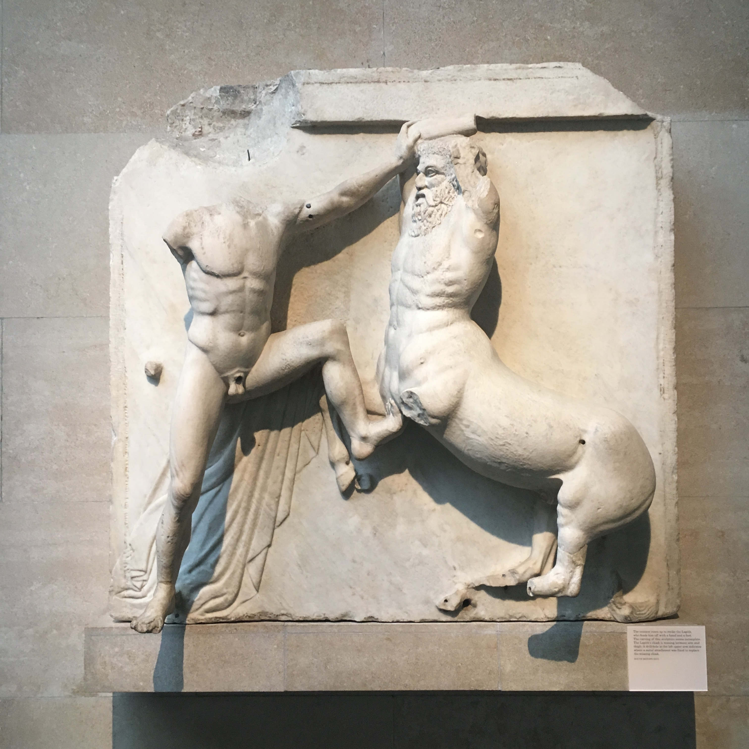
Parthenon South Metope
Lapith fighting Centaur
2018
Own pic: Becca Calder
British museum, London

Fig 2
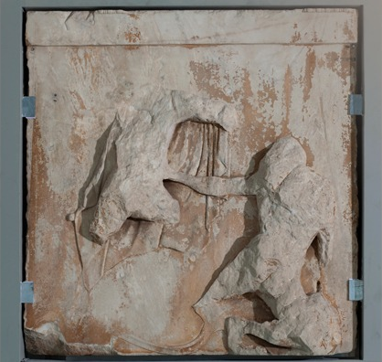
Parthenon East Metope 1
Scene from the Gigantomachy. Hermes defeats a Giant.
2019
The Acropolis Museum Athens
https://www.theacropolismuseum.gr/en/content/metopes-0/2

Fig 3
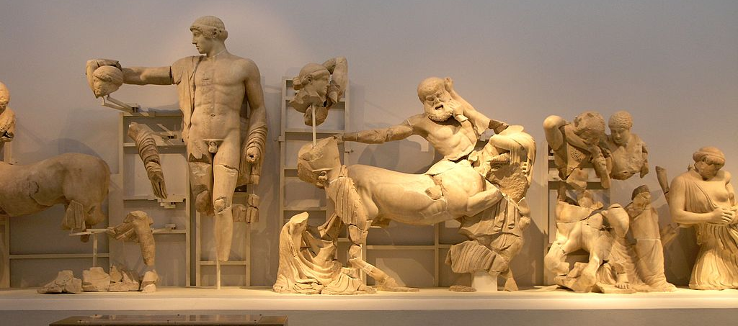
Temple of Zeus West pediment
Lapiths fighting Centaurs
Photographer: Angela Monika 2008
Olympia Museum
Wikimedia Commons
https://commons.wikimedia.org/wiki/Temple_of_Zeus_in_Olympia#/media/File:GR_08-04-23_Olympia_Museum_Zeustempel_Westgiebel.JPG

Fig 4
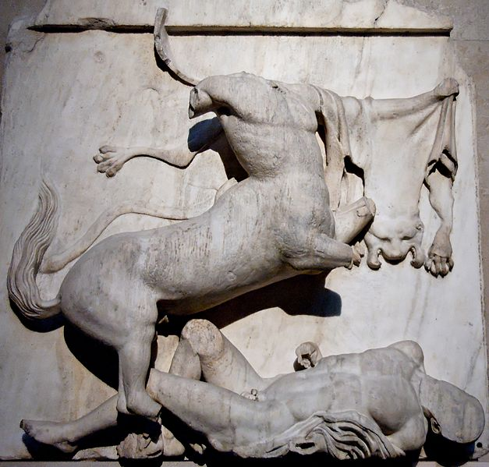
Parthenon South Metope
Lapith being killed by Centaur
Photographer: Jastrow (2006)
Wikimedia Commons
https://commons.wikimedia.org/wiki/File:South_metope_28_Parthenon_BM.jpg

Fig 5
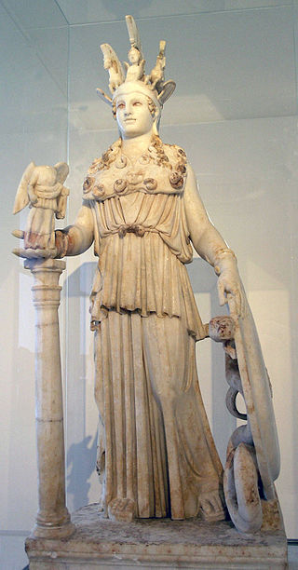
Athena Parthenos
Roman copy 3rd C A.D.
Wikimedia commons
https://commons.wikimedia.org/wiki/File:Athena_Varvakeion_-_MANA_-_Fidias.jpg#/media/File:NAMA_Ath%C3%A9na_Varvakeion.jpg

Fig 6
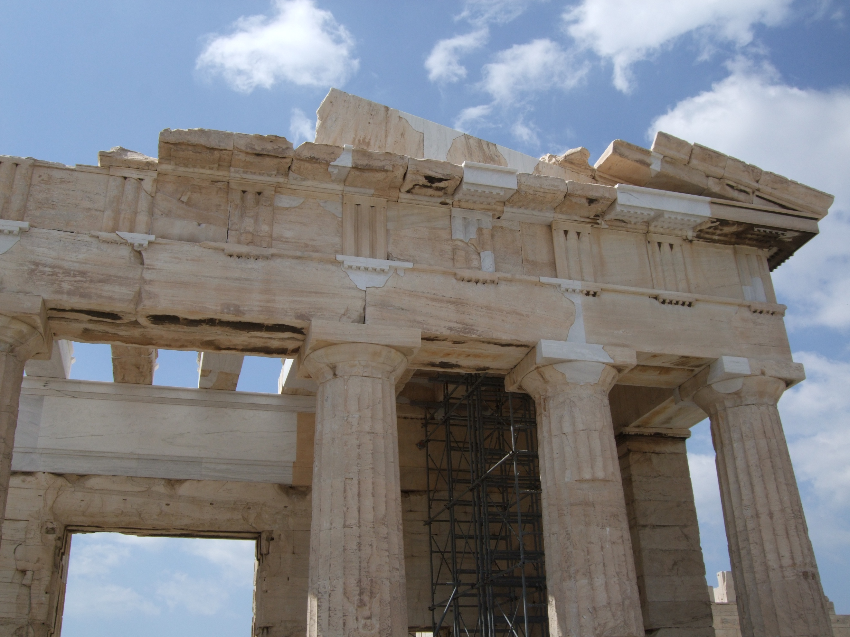
Parthenon exterior
Doric external columns with ionic internal freize
Uploaded Mar 30, 2014
Uwtsd Flickr

Lapatin 2010: 256
Hdt 8.51-53, Meiggs 1963: 37
Lyc. Leoc. 80-81
Diod. 11.29.2-4
Fullerton. 2000: 12. The Athenian Acropolis’ construction started in 447BC, other sanctuaries in Attica were also rebuilt at this time, but were often part of separate building schemes.
Fullerton. 2000: 13
Illustrations of Ionic and Doric order see Fullerton. 2000: 66
Plut. Per. 12-13
Camp 2001: 3
Mikalson 2003: 91
Meiggs 1963: 40
Lyc. Leoc. 80-81; Diod. 11.29.2-4
Hdt. 8.140A
Thuc. 2.5
How and Wells, 1989: 132
Lyttkens. 2015(13):6 – Lyttkens argues economic causes over religious ones.
Theopompus: FGrH 115 F 153, via Bates 1901: 235
Bates 1901: 235
Meiggs. 1963: 38
Mikalson 2003: 92; Fullerton. 2000: 11-12; Lyttkens. 2015(13):18
Barringer. J.M. 2008: 63
Camp 2001: 75
Barringer. J.M. 2008: 63
Hughes. 2010: 81; Neils 2001: 49-51; Shapiro. 2007: 47
Barron 1981: 78; Neils 2001: 173, 181; Fehr. 2011: 123
Spivey 1997: 248
Fullerton 2000: 95
Spivey, 1997: 145
Barron 1981: 95
Spivey 1997: 247
Goldhill and Osborne 1995: 62-3
Paus 1.25
Spivey 1997: 183; Barron. 1981: 106
Paus 1.25; Spivey 1997: 247
Hdt 8.55; Barringer 2008: 76; Barron 1981: 117
Paus. 1.26.5
Spivey 1997: 183
Habicht 1985: 220
Hughes. 80: 2010; Camp 2001: 72
Spivey 1997: 224; Goldhill and Osborne 1995: 64
Paus. 1.25; Arrington. 2014. 136
Spivey. 1997: 217
Barron. 1981: 78,96
Neils 2001: 36; Goldhill and Osborne 1995: 63
Hughes. 2010: 80
Hughes 2010: 81
Neils 2001: 49-51; Shapiro. 2007: 47
Goldhill and Osborne 1995: 64
Fig 1; Fig 2
Spivey. 1997: 224
Goldhill and Osborne 1995: 64; Shapiro. 2007: 235; Hornblower. 2002: 27; Fig 3
Neils. 2001: 181; Barron 1981: 78; Spivey 1997: 217; Barringer 2008: 83
Neils. 2012: 199
Arrington. 2014. 154
Arrington 2014: 141; Fig 4
Lundgreen, 1997: 196
Leyden, 1964: 43
Camp. 2001: 80; Fig 5
Paus. 1.24.5-7
Barron 1981: 93.
Camp 2001: 79
Plut. Per. 14
Mansfeld. 1980:47
Paus. 1.24.7
Mitchell-Boyask 2007:103
Arrington 2014: 168
Spivey 1997: 237
Hughes 2011. 82
Neils 2001: 182
Lawrence 1951: 111
Lawrence 1951: 111
Connelly 2014: chapter 5
Low 2008: 339
Lawrence 1951: 111-2
Giovannini 2008: 164
Kallet-Marx 1998:266
Lawrence 1951: 111-2; Fig 6
Neils 2002: 38; Barron. 1981: 94; Fullerton 2000: 59
Camp 2001: 75
Meiggs 1963: 43; Plut. Per. 14
Spivey 1997: 237; Hornblower 2002: 124
Hornblower 2002: 124
Hornblower 2002: 124; Barron. 1981: 100

