Configure and manage the
Virtualised Enterprise network

Module Name: Changemakers: Network Operating System
Module Code: ACCA5023

Student Name: Maricor Hernando Lindo
Student ID: 2440415
Group: 1

Lecturer’s Name: Md Sadeque Imam Shaikh
Date of Submission: August 14, 2026

Table of Contents
Introduction 2
1.Routing 3
1.1Routing in Birmingham Network 3
1.2 Routing in London Network 4
2. Domain Server Birmingham 6
2.1 Active Directory Forest Created 6
3. Encrypted Connection Between Birmingham and London 10
4. Users 11
4.1 Create User Accounts for the maricor.acca Domain 11
5. Domain Client 14
5.1Join L-CD, ClientS1, ClientL1 to the maricor.acca Domain 14
6. DHCP Server 17
6.1 Configure B-DC as DHCP Server 17
6.2 Configure L-CD as DHCP Relay Server 18
6.3 Client Receiving an IP Address Automatically via DHCP Server 19
7. Test and Troubleshoot 20
8. Disk drive 21
9. IIS SERVER 22
9.1 Create Website 22
10. Remote Desktop Services 24
Conclusion 25
References 26

Introduction
This report shows the configuration and implementation of a Windows Server 2019 network environment that is necessary for the given task. The task is consisting of Routing and Remote Access Services (RRAS), Active Directory Domain Services (AD DS), DNS, DHCP, VPN, user accounts, domain membership, disk Sharing, Internet Information Services, and Remote Desktop Services. Each of these was checked and tested to ensure that the Birmingham and London networks were Connected and working correctly.
The main aim of this project was to learn practical experience in installing, configuring and managing essential Windows Server services in a virtual world. Screenshot were gathered throughout the configuration process to show successful implementation and to check that each service was functioning properly.

1.Routing

1.1Routing in Birmingham Network
Figure 1.1 Routing and Remote Access Services
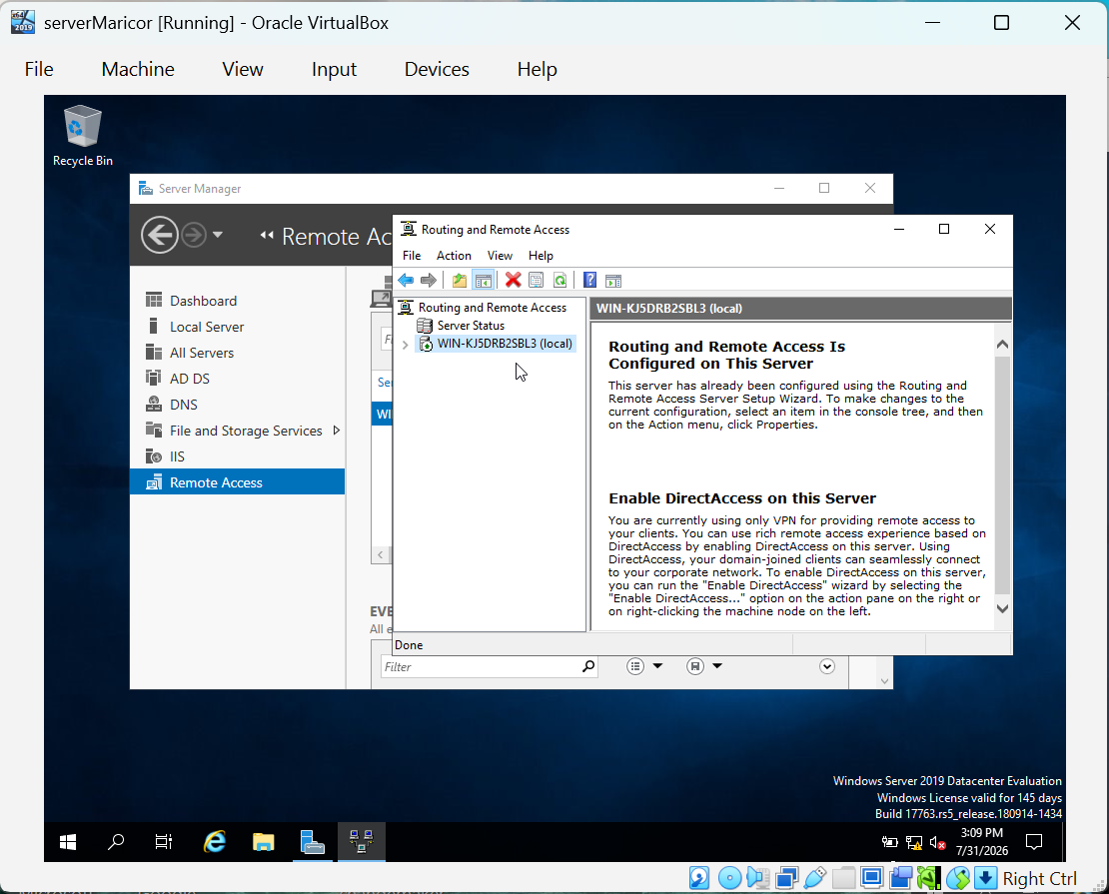

The image above shows that the Routing and Remote Access Service (RRAS) open on the serverMaricor virtual machine in Window Server. The RRAS was installed and configured, it allows the server to carry out routing functions into different network segments. A green arrow in the server is visible under the RRAS console which means that the server is running correctly.
The Windows server act as a router which enables the configuration, forwarding the IP packets between connected networks, VPN services and remote access. In this task, RRAS is used to assist communication between Birmingham and London network topology,
The RRAS setup wizard has been completely successful, and the server is ready to provide routing services, this is because the status message “Routing and Remote Access is Configured on this Server” confirms it.

1.2 Routing in London Network
Purpose of Routing and Remote Access Services
Routing and Remote Access Services allows Windows Server to act as a router by forwarding network traffic between different networks. It allows IP forwarding, routing and remote access, allowing devices on separate network segments to communicate. In this report, RRAS was assessed to enable routing and allow ICMP traffic for connectivity testing.

Figure 1.2 Creating and Outbound IP Filter
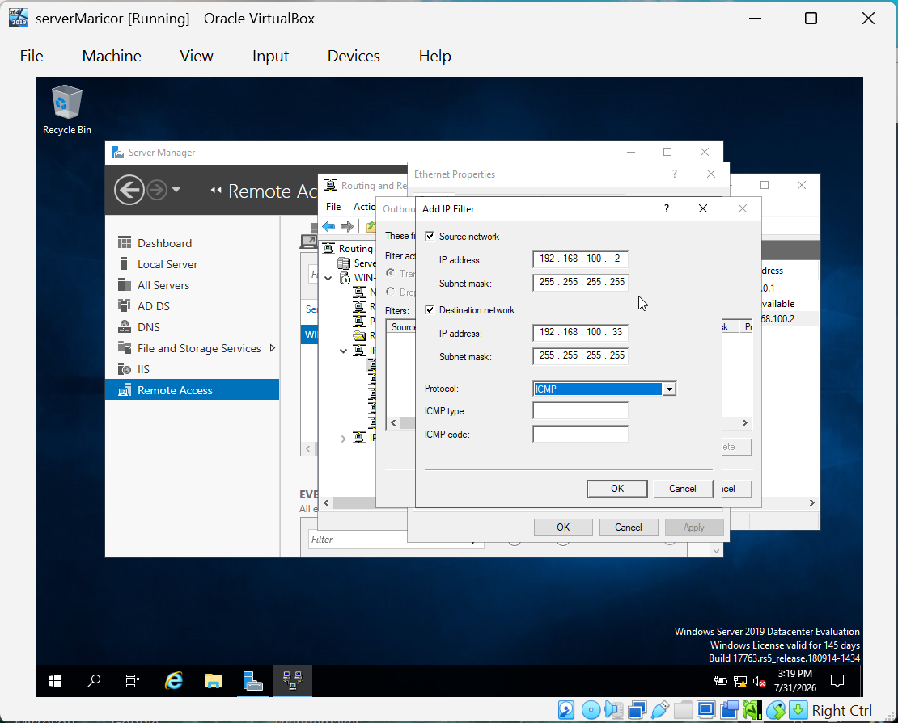

The image above shows the Add IP Filter window in RRAS, where an outbound IP filter is configured allow ICMP traffic between the Windows Server and the client. The destination is specified in the IP addresses, and the ICMP protocol is selected to permit ping requests and replies. This configuration lets network connectivity testing and verifies that routing is working correctly.

Figure 1.3 Outbound IP Filter Successfully Configured
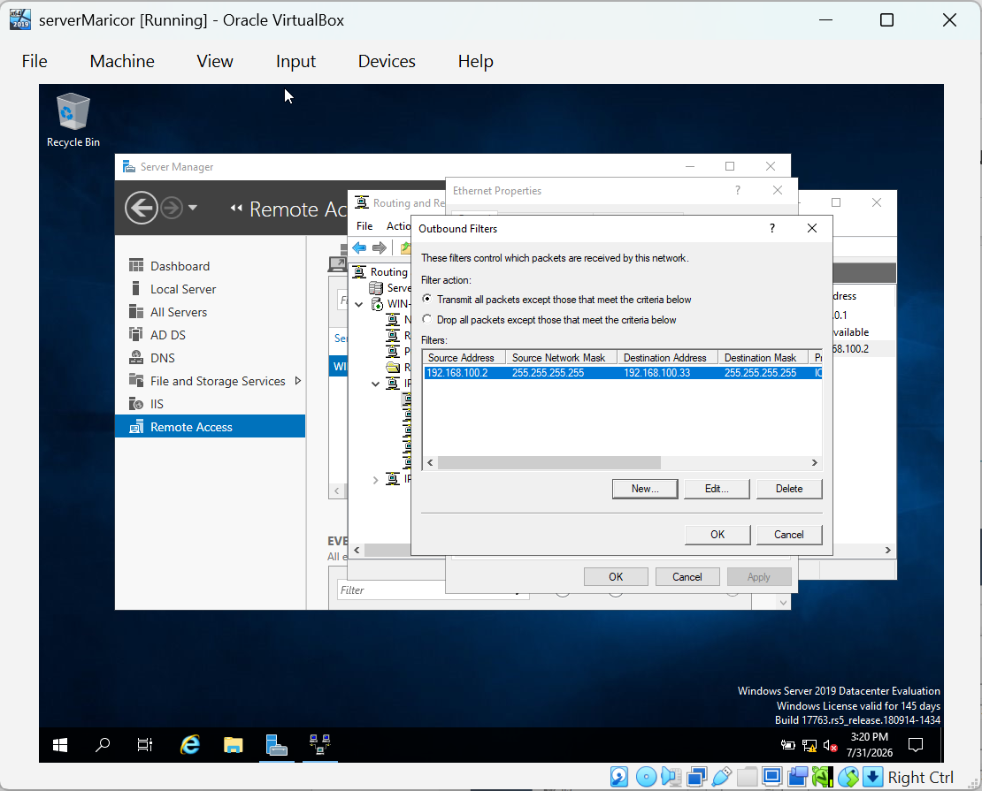
The image above shows the Outbound Filters window after the IP filter has been successfully added. ICMP shows in the filter list, acknowledging that the routing rule has been adopted to the network interface. This allows ICMP traffic to be forwarded through the server for communication and troubleshooting.

2. Domain Server Birmingham

2.1 Active Directory Forest Created
Figure 2.1 Active Directory Domain Services
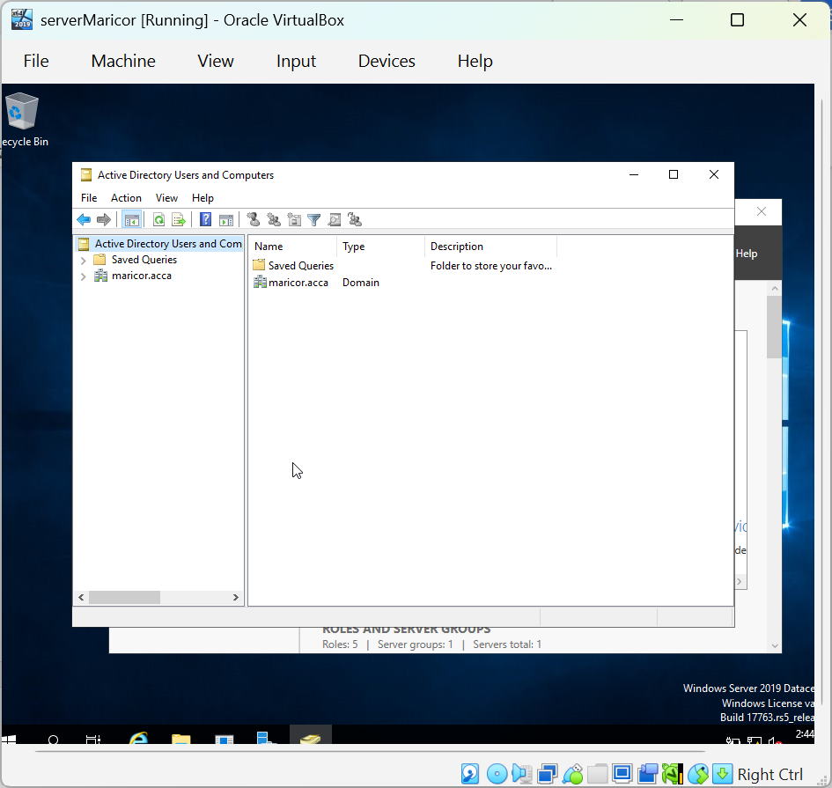

On this image, the Active Directory Users and Computers console after the successful installation of Active Directory Domain. Maricor.acca forest and domain are shown in the left side, confirming that the active directory forest was created successfully. This domain will be used to control the users, groups, computers, and other network resources within the Window Server environment.

Figure 2.2 Active Directory Forest Succesfully Created
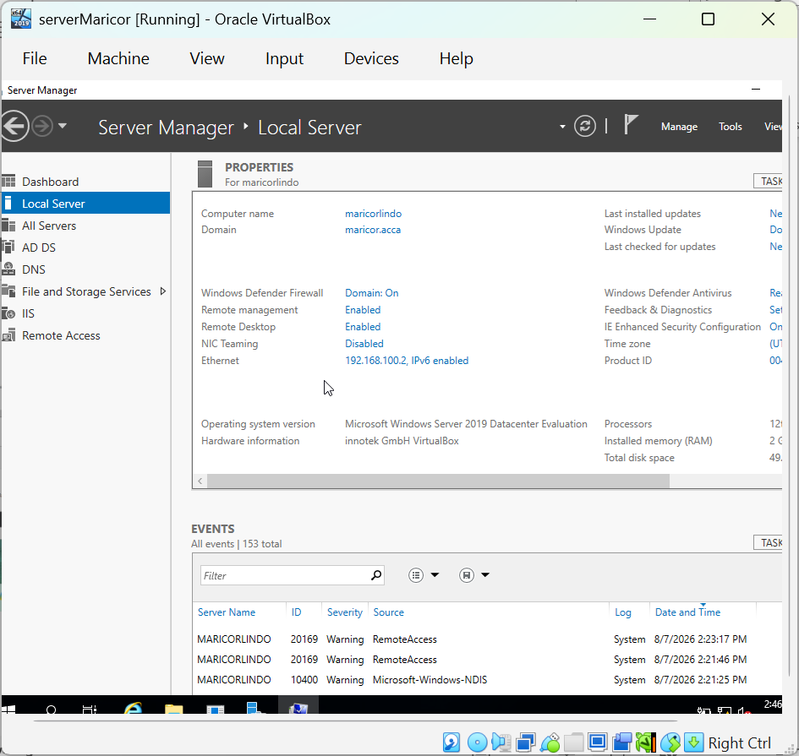

The screenshot shows the Active Directory Users and Computers console after the maricor.aacca forest has been successfully created. It is visible in the left navigation pane and verified that Active Directory Services has been setup and configured successfully. This console will be used to allow users, groups, computers and other domain resources around the network.

Figure 2.3 Completion of the Reverse Lookup Zone Creation Wizard
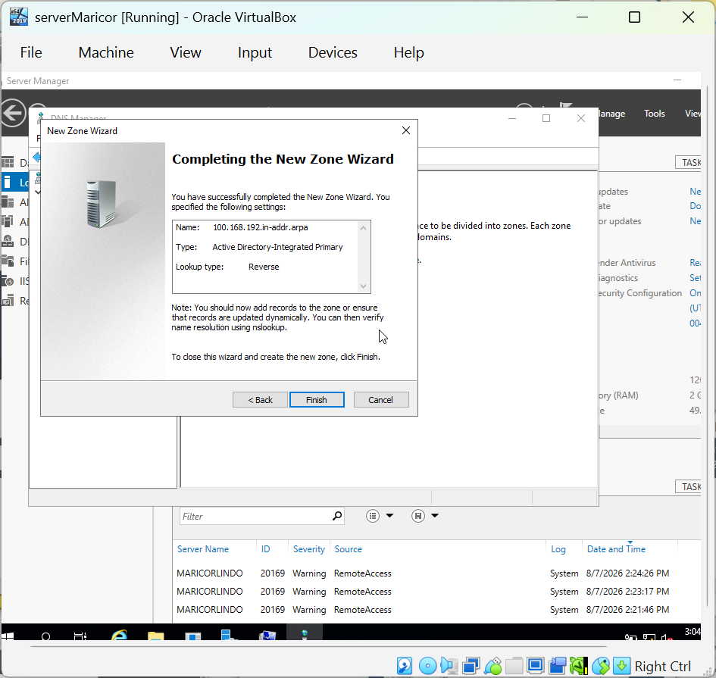

The image shows the completion of the New Zone Wizard in DNS Manager. An Active Directory-Integrated Primary Reverse Lookup Zone named 100.168.192.in-addr,arpa has been created. This reverse lookup zone will store Pointer PTR records that allows the DNS server to resolve IP addresses back to their corresponding hostname.

Figure 2.3 Reverse Lookup Zone with PTR Records
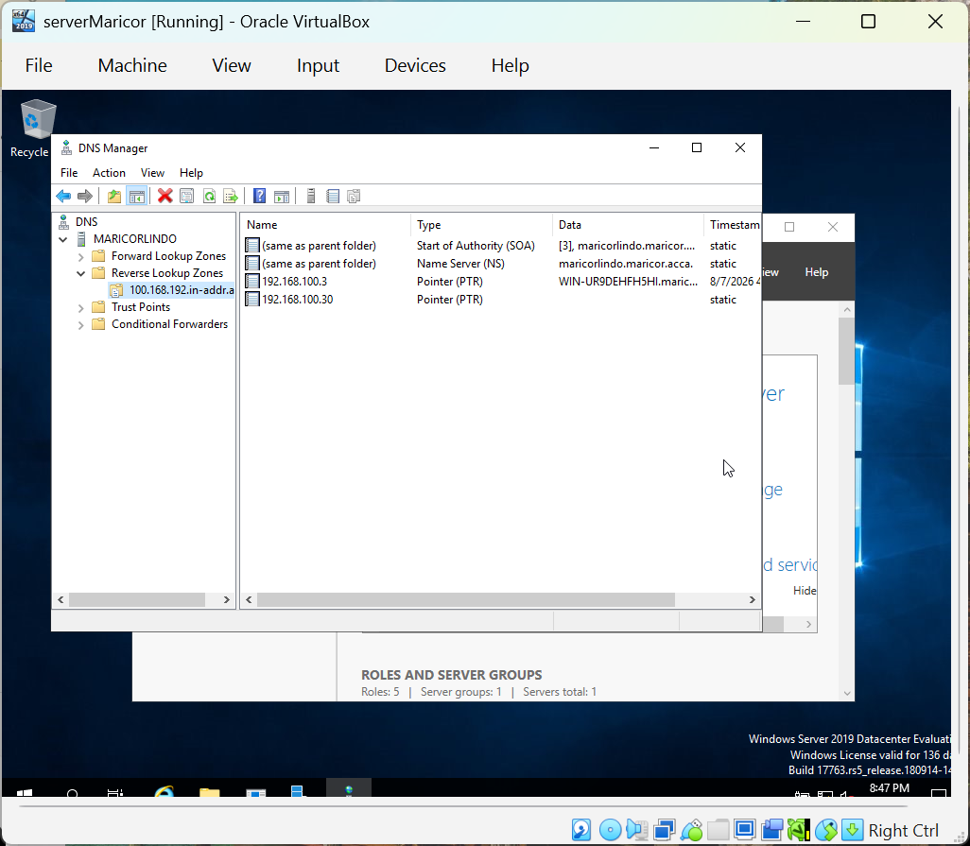
This is the reverse Lookup Zone in DNS Manager. The server is displayed in the PTR records, mapping the IP address 192.168.100.3 and 192.168.100.30 to their proper hostnames. It verifies that reverse DNS resolution has been successfully co99nfigured for the network.

3. Encrypted Connection Between Birmingham and London
A Virtual private Network creates a secure and encrypted connection between two remote networks over a public network, like the Internet. VPN’s give confidentiality, integrity and authenticity by encrypting data and protecting it from unauthorized access. They allow organizations to safely connect geographically separated networks, support remote access, reduce operational costs and keep sensitive information during transmission [1].
Figure 3.1 Configure Site to Site VPN to London Network
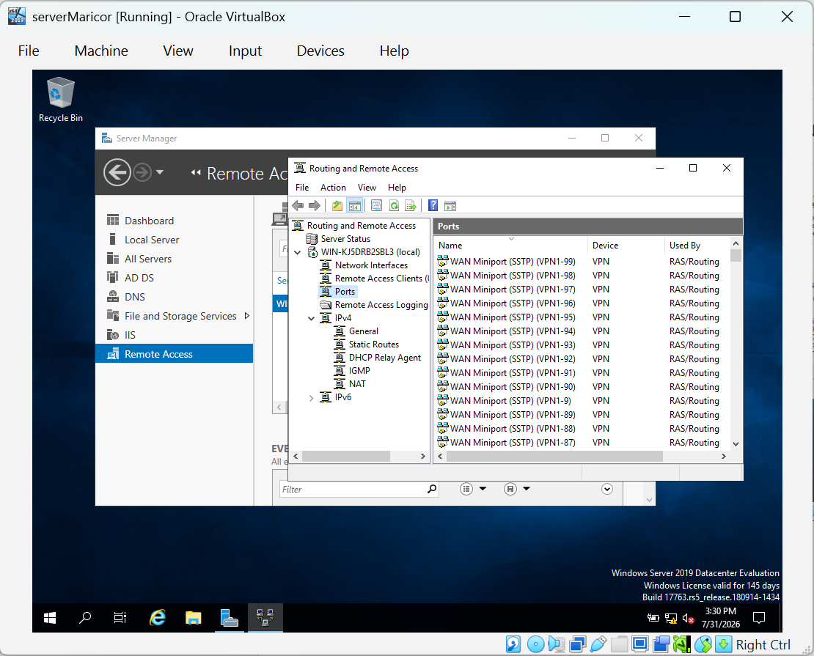
The image above shows the Routing and Remote Access management console on the Windows Server. The Ports indicates the available VPN protocols, including PPTP, L2TP, SSTP and IKEv2 that are used to create secure remote access and site to site VPN connections. These VPN ports confirm that the Routing and Remote Access Service has been successfully installed and configured, allowing the server to support VPN communication between different network location.

4. Users

4.1 Create User Accounts for the maricor.acca Domain
Active Directory Domain Services is used to develop and manage user accounts within Windows domain. Every user account has a unique identity that allows users to log on to the domain and access network resources into the assigned permissions. In this task, user accounts was created based on the data that was given in the user_list_update.xlsx document. The User Principal Name and SAM Account Name were configured with the use of the required naming convention of the first letter of the first name followed by a period and the last name.

Figure 4.1 Creating New User Account
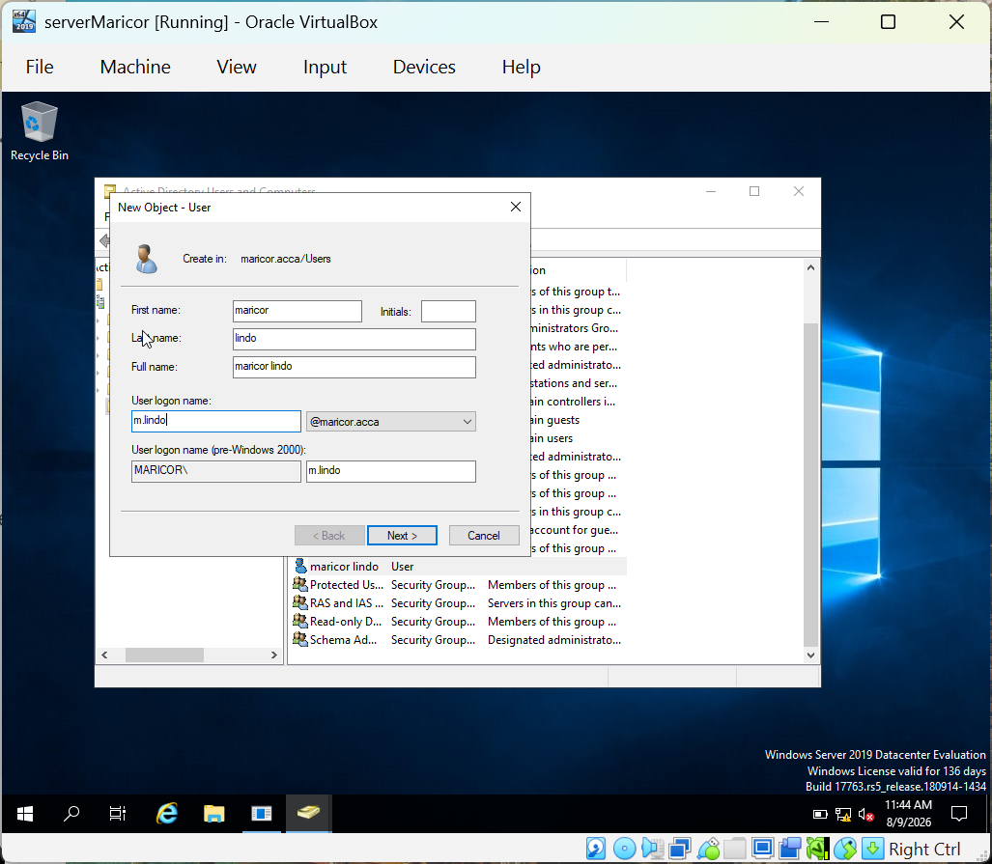

The image above shows the New Object-User wizard in Active Directory Users and Computers. The user’s personal details, first name last name and user logon name of the administrators need to be entered before creating the account in the maricor.acca domain.
Figure 4.2 User Account Properties
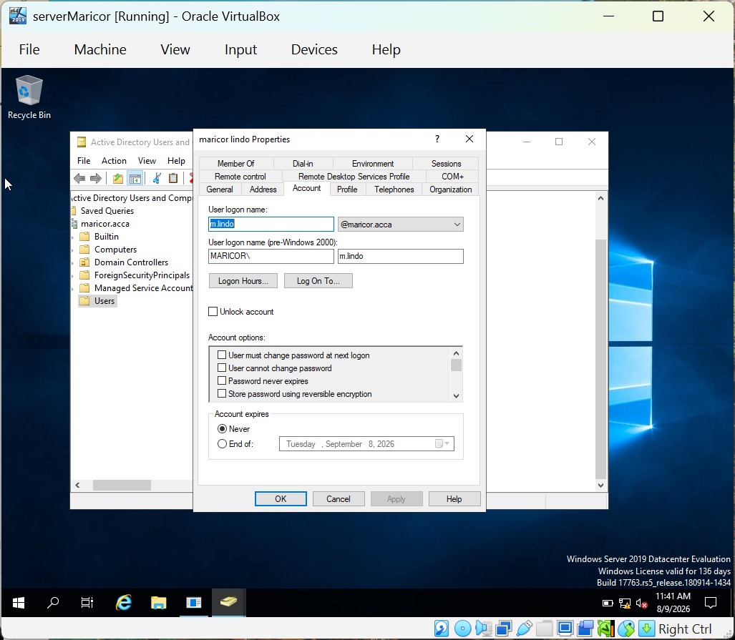
The image above shows the Account properties of the created user. The User logon name and SAM Account Name (pre-Windows 2000) are configured as m.lindo, that was indicated in the assignment task. These setup lets the user to authenticate and access resources within the maricor.acca domain.

Figure 4.3 Created User Account in Active Directory
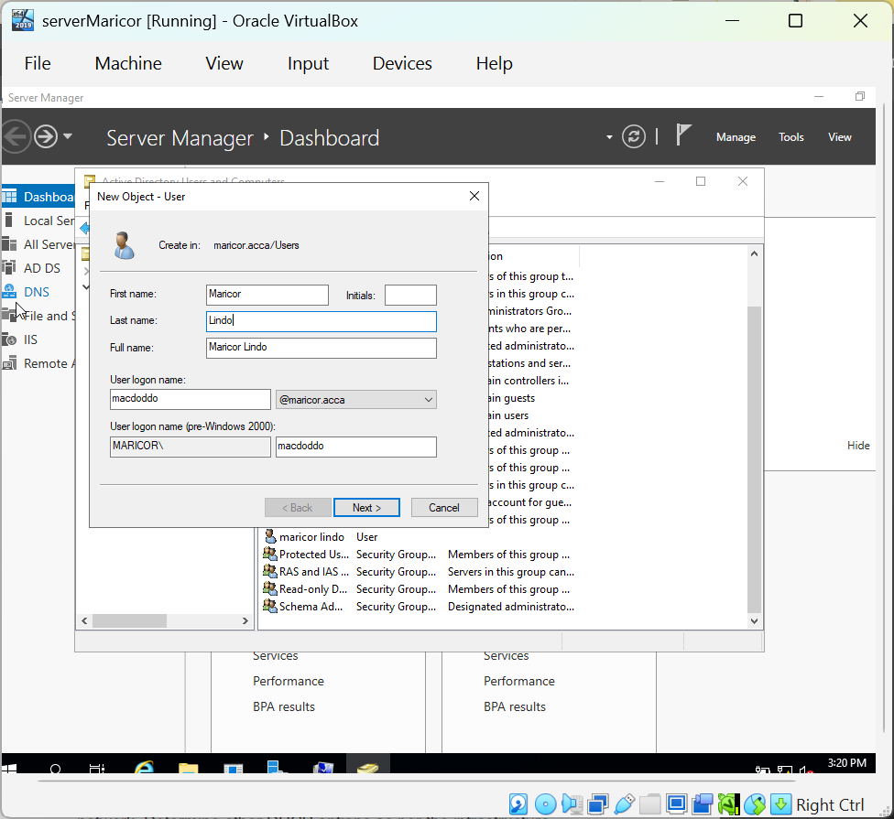
The image above shows that the User container of Active Directory Users and Computers has been successfully created as a user account. This verifies that the account has been added to the maricor.acca domain and is ready for domain authentication and access to network resource.

5. Domain Client

5.1Join L-CD, ClientS1, ClientL1 to the maricor.acca Domain
Putting the client computer to an Active Directory domain allows centralized authentication, administration and access to combined network resources. In this task, the appropriate network setting was configured by the client computer and successfully joined the maricor.acca domain. It was verified in Active Directory, and its IP configuration was checked to make sure that proper communication with the domain controller.

Figure 5.1 Client Computer Successfully Joined to the Domain
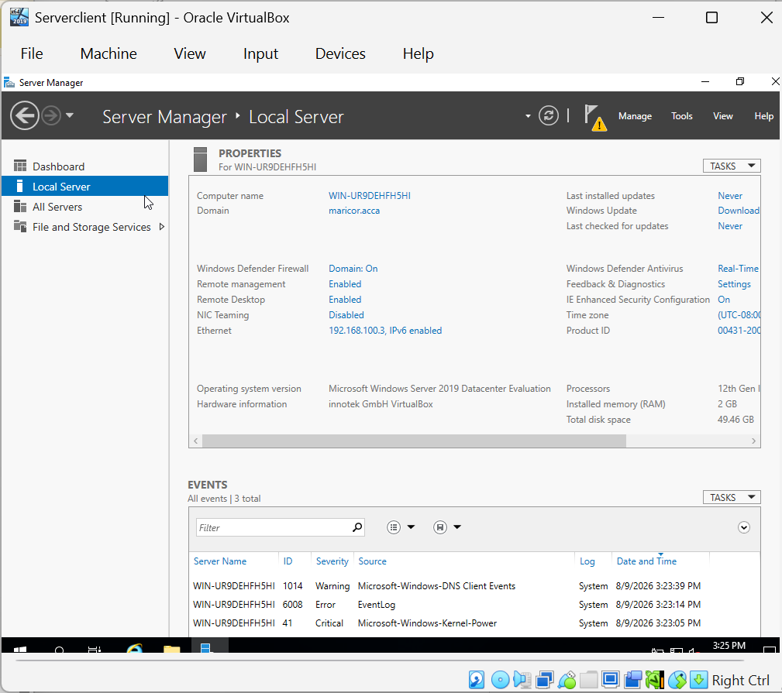
The image above shows the Local Server properties of the client computer after it is connected to the maricor.acca domain. The domain field shows maricor.acca, confirming that the client is now connected to the Active Directory domain instead of workgroup. This allows the client to verify using domain credentials and access centralized network resources.

Figure 5.2 Client Computer Registered in Active Directory
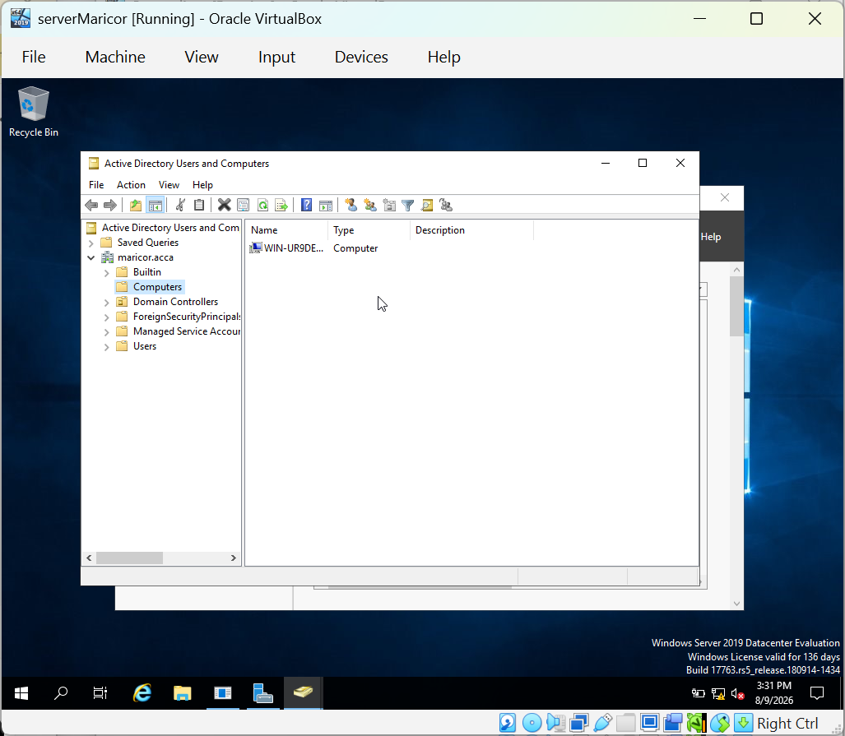
The image below shows the client computer WIN-UR9DEHFH5HI shows under the maricor.acca domain, stating that it has been accurately joined to the domain and registered in Active Directory for centralized management.

Figure 5.3 – Client IP Configuration
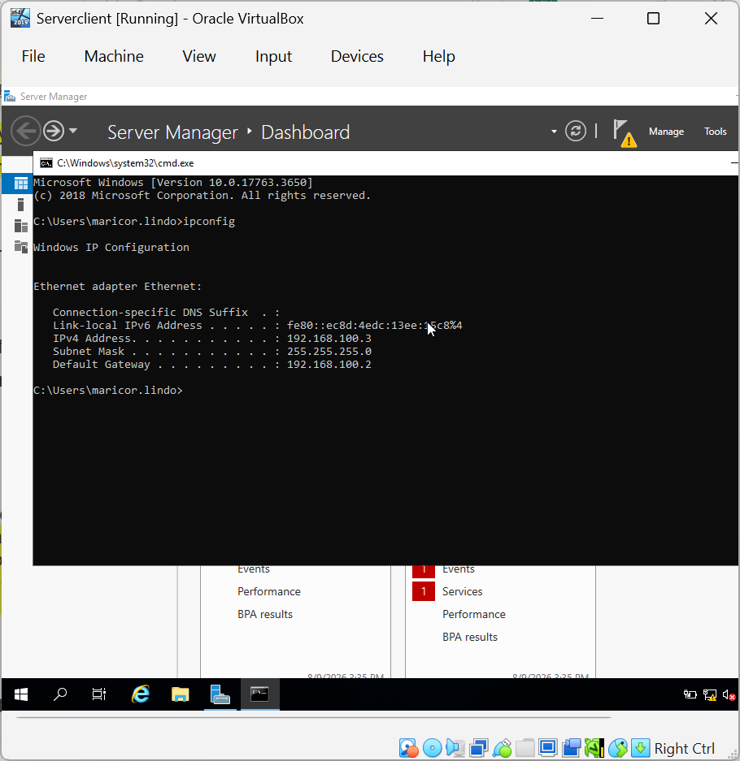
The image above explains the used of ipconfig command to check the network configuration of the client computer after linking the maricor.acca domain. The client was configured with the IPv4 address 192.168.100.3, subnet 255.255.255.0 and the default gateway 192.168.100.2 which is the IP address of the domain controller. These settings verified that the client was correctly assessed and able to communicate with the server over the network.

6. DHCP Server
The Dynamic Host Configuration Protocol (DHCP)is a network management protocol that instantly designate IP addresses and other network configuration settings. Most of these are subnet mask, default getaway, and DNS server, to devices connected to TCP/IP network. DHCP uses a client server model in which DHCP server provides configuration information to client devices, allowing them to join the network that doesn’t require manual IP address configuration [2]. With the use of automatic IP address allocation, DHCP can avoid configuration mistakes, simplify network administration and confirm that each device receives a unique IP address.
On this assignment, the DHCP Server was configured to allocate IP addresses instantly to client devices with the specific address range. A DHCP Relay Agent was also assessed to forward DHCP requests between different network segments, this allows clients on remote networks to acquire IP addresses from the central DHCP Server.

6.1 Configure B-DC as DHCP Server
Figure 6.1 Scope Successful Configured
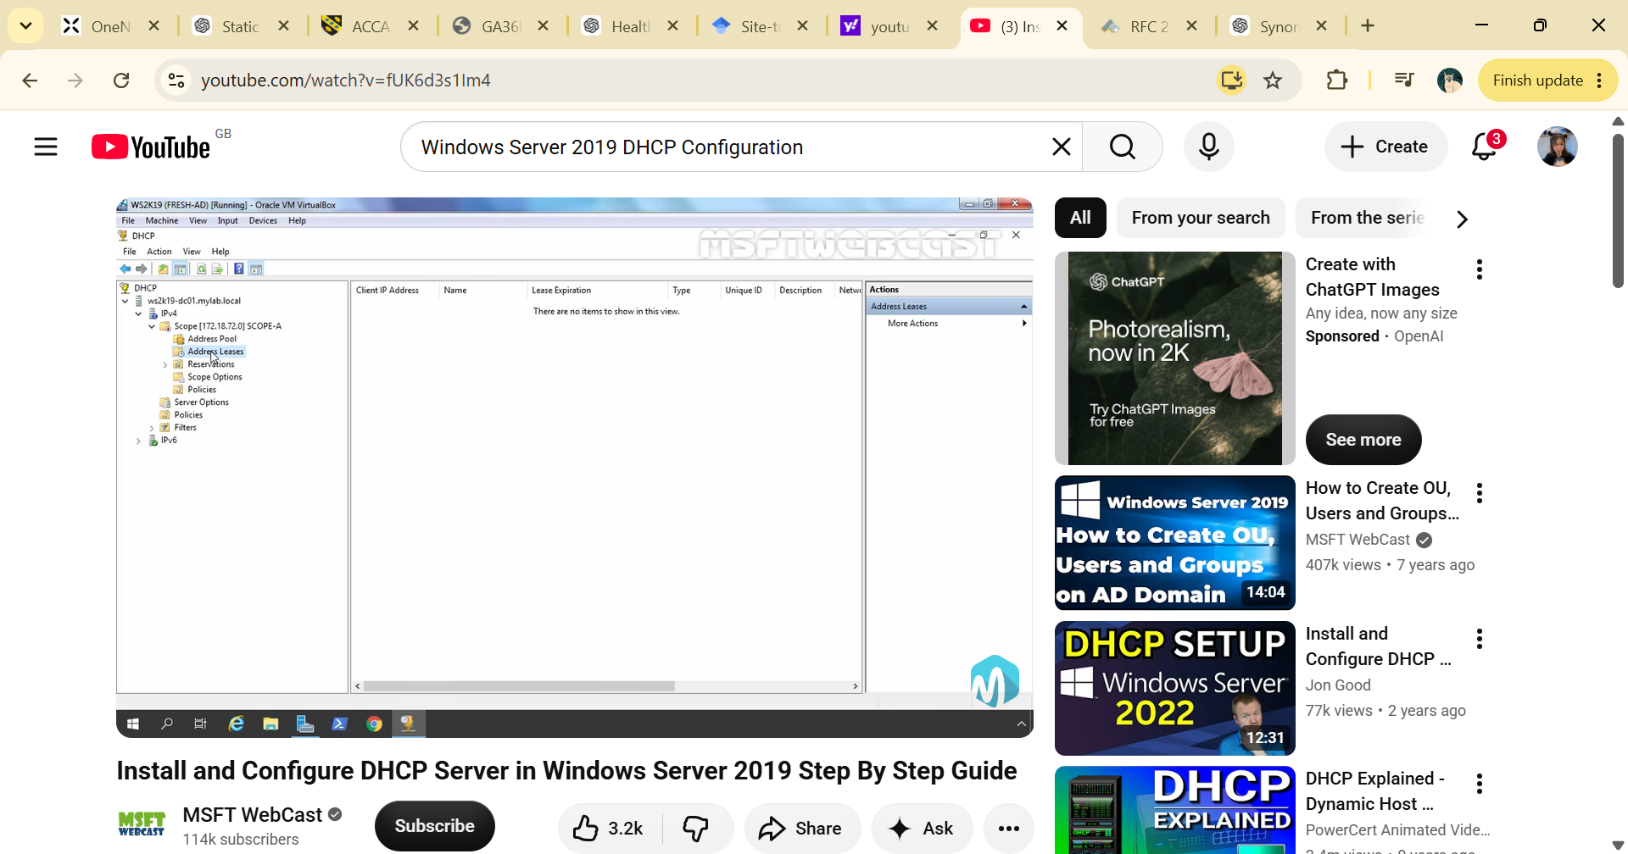
The image above shows the DHCP Manager after the DHCP Server was assessed. On this screenshot, I observed that an IPv4 scope had been created, which configured the range of IP addresses accessible for automatic assignment to client devices. With this configuration, client computers can instantly receive an IP address, subnet mask, default getaway and DNS server which does not require manual configuration.

6.2 Configure L-CD as DHCP Relay Server
A DHCP Relay Agent is used when client devices and DHCP server are assigned on different subnets. Instead of installing a DHCP server on every subnet, the relay agent sends DHCP requests from clients to a central DHCP server. This approach lessens the number of DHCP servers required, simplifies network management and allows a single DHCP server to provide IP addresses to several subnets [3].
Figure 6.2
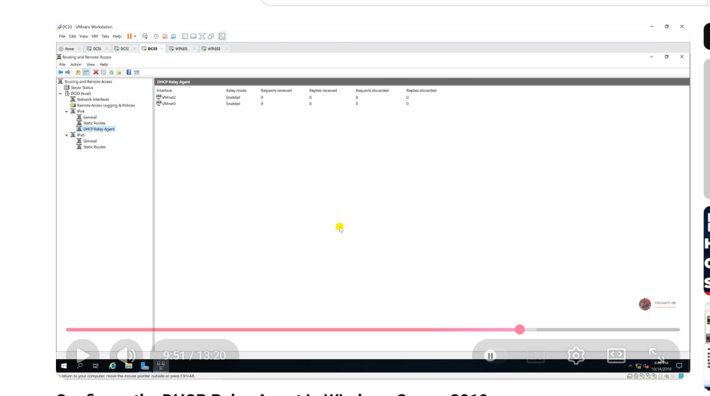[4]
This image shows that the DHCP Relay Agent configured within the Routing and Remote Access console. On this project, I noticed that the DHCP Relay Agent was allowed and associated with the network interfaces used to interact with different subnets. The relay agent sends DHCP broadcast requests received from client devices to the main DHCP server that lets computers on remote networks to deploy IP addresses automatically. This lessens the need to deploy a separate DHCP server on every subnet, helps network administration much effectively.

6.3 Client Receiving an IP Address Automatically via DHCP Server
Figure 6.3
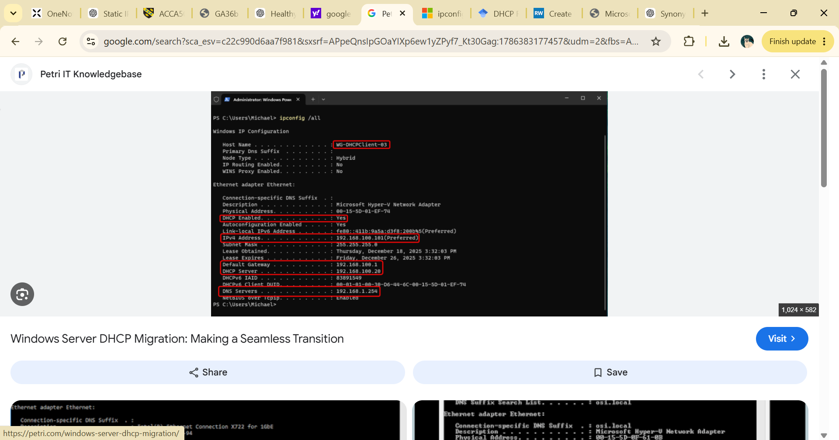[5]
This image above shows the output of the ipconfig /all command, showing that the client automatically received its network configuration from the DHCP server.

7. Test and Troubleshoot
Figure 7.1 Network Connectivity Test Between Window Server and Linux Client using ping.
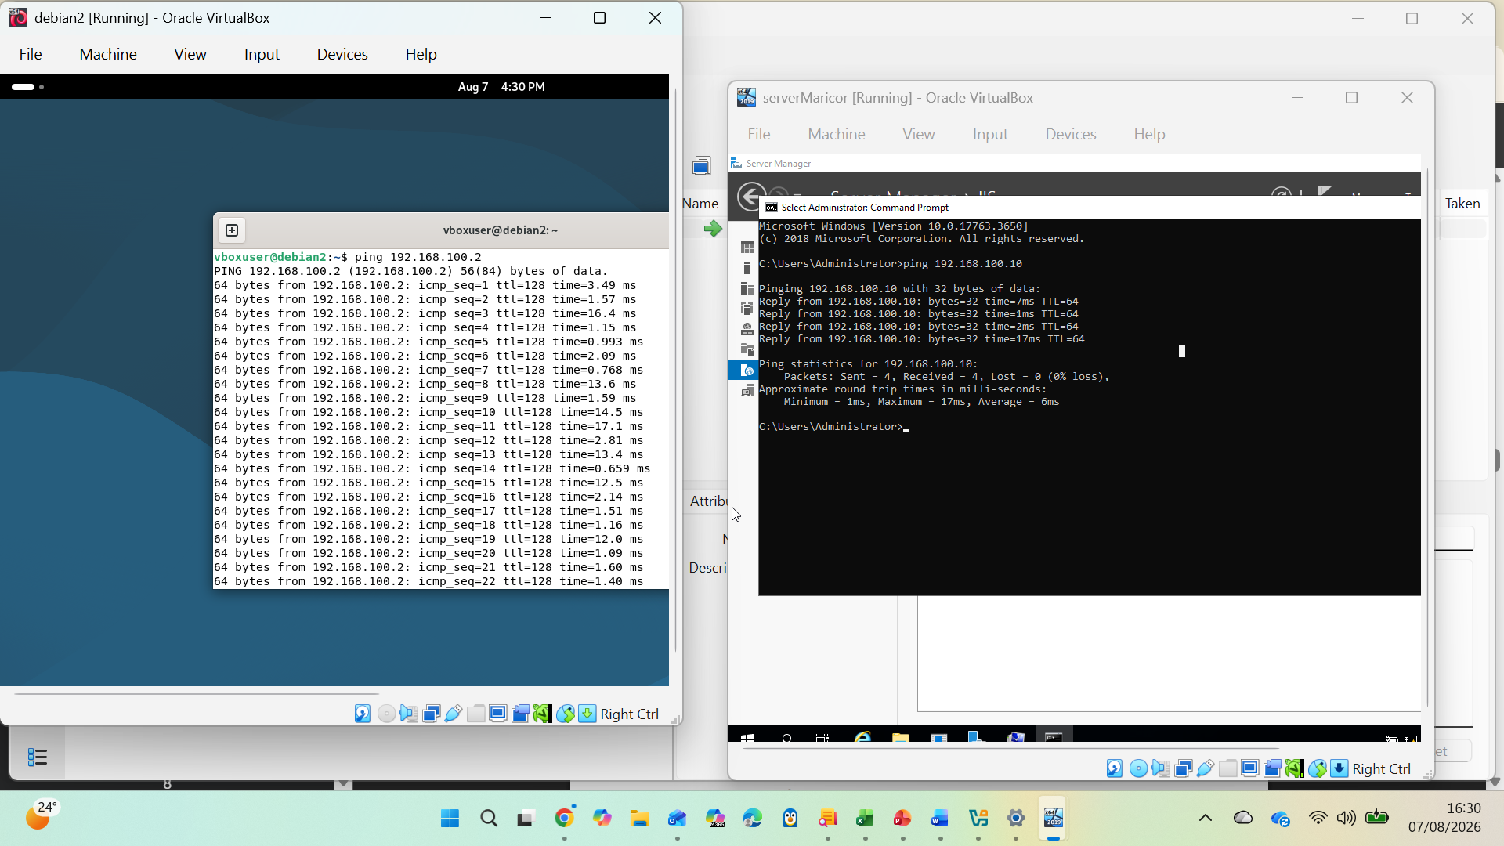
The image above shows the connectivity test that was conducted between the Windows server and the Linux machine. In order to confirm that the network is right, I used the ping command on both systems. At first the Windows Server successfully sent four ICMP echo requests to the Linux machine (192.168.100.10) and the answer were receive with 0% packet loss. I then tried the connection from Linux machine my pinging the Windows Server (192.168.100.2), which also has a succesfull response. These results states that both devices can communicate with each other over the network, showing that the IP addressing and network configuration was susesfully completed.

8. Disk drive
Figure 8.1 Mount Second Disk Drive to E:\BirminghamFiles
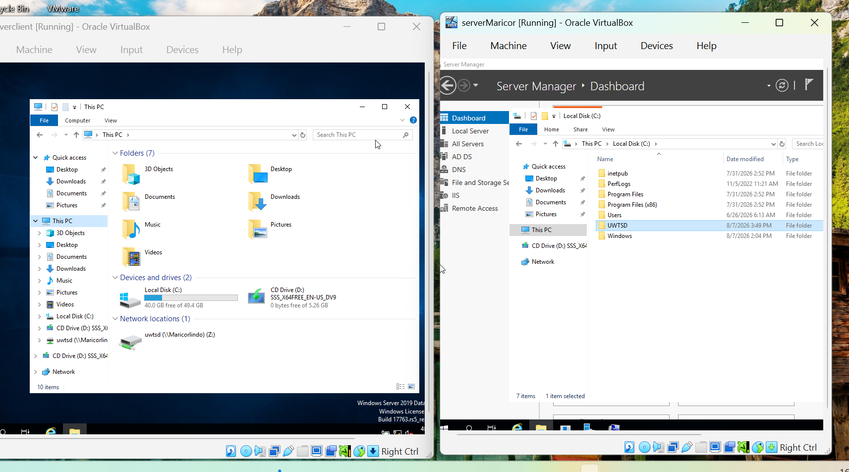
The image above shows that the shared folder on the server has been successfully mapped as a network drive on the client computer. The E:\BirminghamFiles on the server has been created on the shared folder and configured in the sharing permission so that the Domain Users were granted Full Control, while other network users were granted Read-only access. After logging into the client computer with the used of domain user account, I verified that the mapped network drive was accessible. This validates that the shared folder was configured properly and that the permissions were applied successfully.

9. IIS SERVER

9.1 Create Website
Internet Information Services is Microsoft’s web server software that is used to host a websites, web applications and web services on Windows Server. It lets administrators to make a content, administer websites, and configure authentication and security settings [6].
Figure 9.1 IIS Manager Showing the configured website
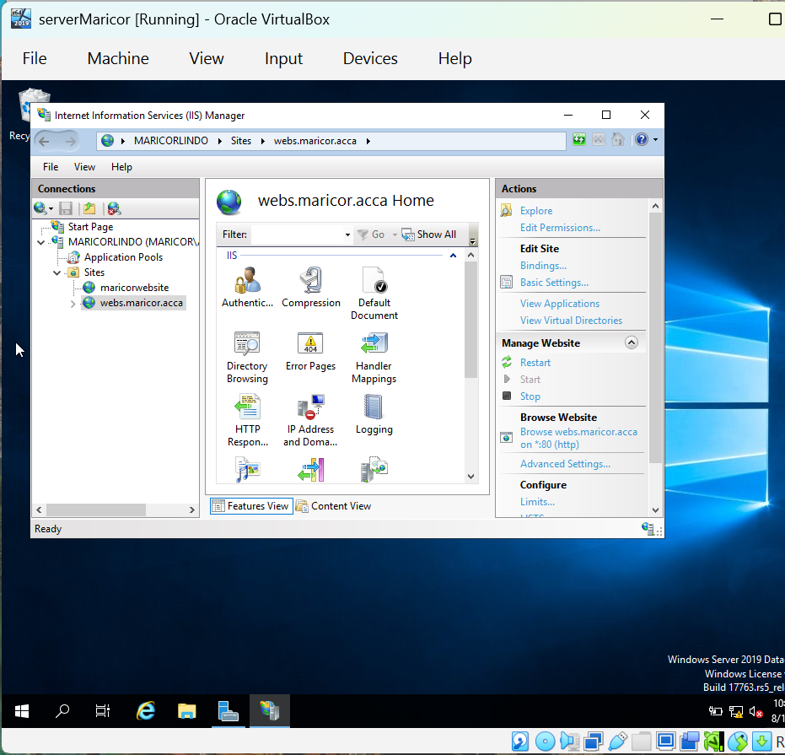
This image shows that the webs.maricor.acca has been installed and successfully launched using IIS.

Figure 9.2 Successfully Launched Website
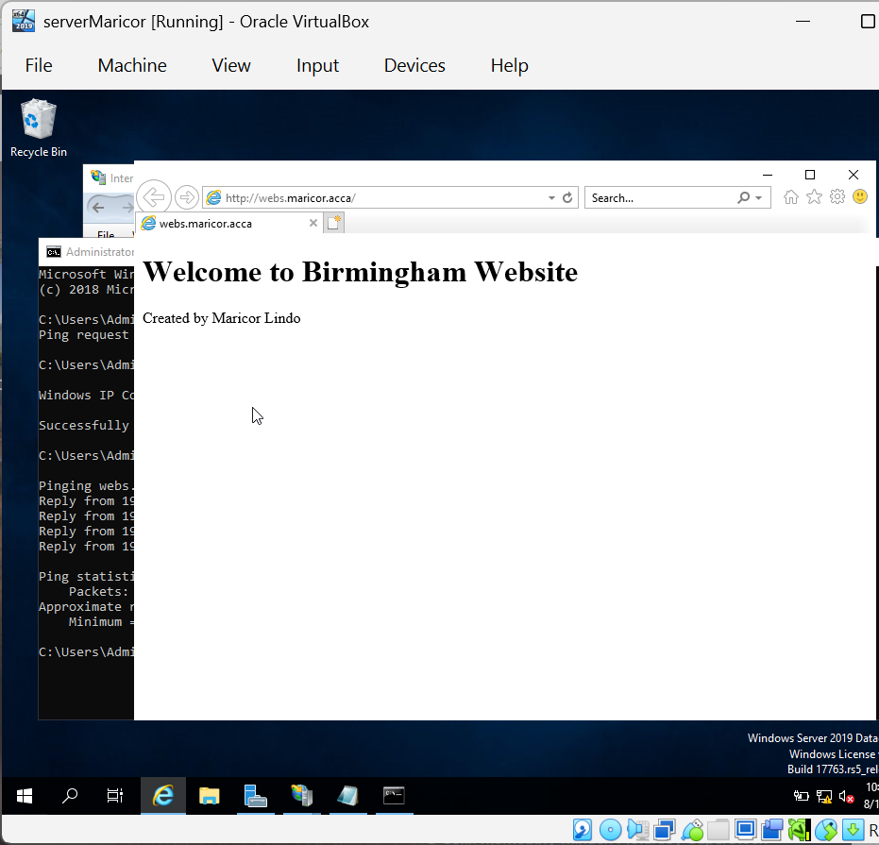

The image above shows that I have successfully installed and configured Internet Information Services (IIS) on the Birmingham Domain Controller to host a website named webs.maricor.acca. I configured its physical path and added the correct host name binding. DNS was also created so that the hostname could be resolve to the server’s IP address. Upon completion, I accessed the website using Internet Explorer with its custom webpage: Welcome to Birmingham Website”. This validates that the IIS web server and DNS configuration were working properly.

10. Remote Desktop Services
Figure 10.1 Successful remote Desktop Connection
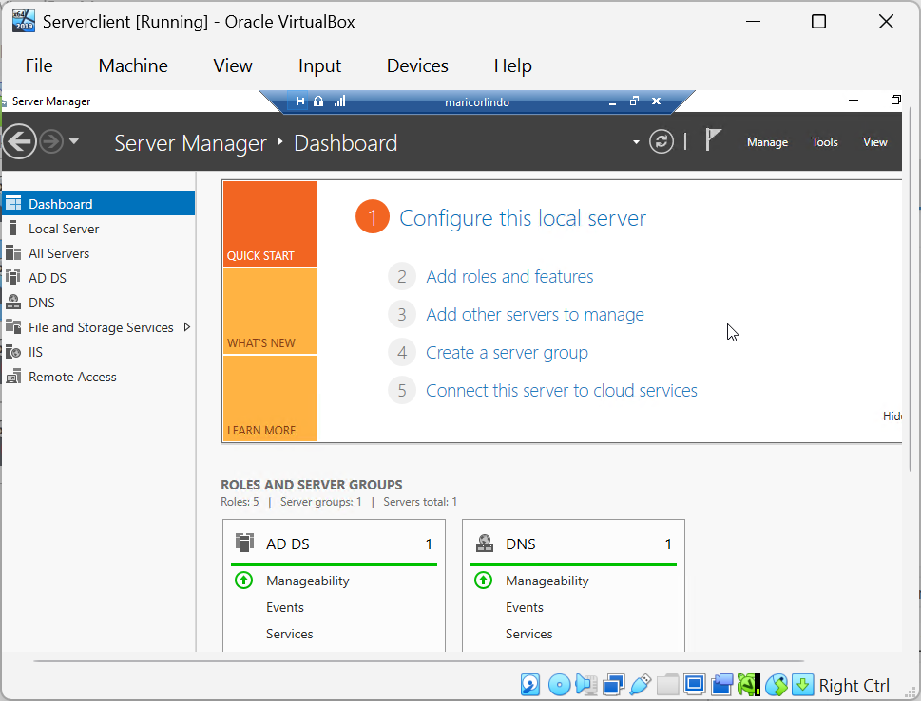
The image above shows that Remote Desktop Services on the Birmingham Domain Controller have been configured, this allows remote administration from another machine on the network. I used the Remote Desktop Connection from the client computer to connect the server using the server name and administrator credentials. The server Manager Dashboard of the Birmingham Domain Controller was shown, enabling remote connection successfully. This lets the server to be managed remotely without necessary having a physical access.

Conclusion
In conclusion, all the needed Window Server 2019 services were successfully checked and tested based on the task requirements. The network infrastructure was created by configuring routing, Active Directory, DNS, DHCP, VPN connectivity, Domain membership, file sharing, IIS and Remote Desktop. The connectivity between the Birmingham and London networks was checked through successful communication.
This project helps me to understand Window Server administration and present the importance of network planning, service configuration and system management. Most of the practical task gives valuable experience in implementing enterprise network services and troubleshooting configuration problems in a virtual environment.

References
[1] H. Abbas et al., , "Security assessment and evaluation of VPNs: a comprehensive survey," vol. 55, no. 13s, pp.1–47, 2023,
[2] R. Droms, "No title," 1997,
References
[3] R. Adipranata and I. Gunawan, "Penggunaan DHCP Relay Agent untuk Mengoptimalkan Penggunaan DHCP Serverp pada Jaringan dengan Banyak Subnet", in Seminar Nasional Aplikasi Teknologi Informasi (SNATI),
[4] Microsoft Lab, “Configure the DHCP Relay Agent in Windows Server 2019,” YouTube, Oct. 14, 2018. [Online]. Available: https://www.youtube.com/watch?v=6WQe18CGbFg. [Accessed: Aug. 11, 2026].
[5] M. Reinders, “Windows Server DHCP Migration: Making a Seamless Transition,” Petri IT Knowledgebase, Dec. 23, 2025. [Online]. Available: https://petri.com/windows-server-dhcp-migration/. Accessed: Aug. 9, 2026.
[6] Microsoft, Web Server (IIS) Overview, Microsoft Learn. [Online]. Available: https://learn.microsoft.com/en-us/previous-versions/windows/it-pro/windows-server-2012-r2-and-2012/hh831725(v=ws.11). [Accessed: Aug. 11, 2026].

