University of Wales Trinity St. David
Electrical/Electronic Engineering

ACDA6001

Matt Haycock
2012802

Assignment report – Design of an unsigned two
Number even Parallel Multiplier
And the design of a FSM in
Hardware and VHDL

Date 23 May. 2022

Abstract
The aim of this report was to show the process of designing, simulating and synthesizing an 8 bit x 8 bit number multiplier. The multiplier was designed based on a Braun multiplier. Xilinx software was used to fulfil this criterion. [1] The multiplier consisted of Half and Full Adders used in conjunction with various inputs to sum and carry digital signals in eight blocks to give out sixteen outputs. The total number achieved for the multiplier was 65,025. This was due to the number of bits was 255 multiplied by 255. The final design showed that the output Q result was a multiplication of both A and B inputs combined. Port mapping was used in the coding for the design to give repeating components a different identity for its ports for each line of the blocks.
The second aim of this report was to also show the process of designing, simulating and synthesizing of a 3 bit, 8 state Finite State Diagram. The FSM had to be solved using both VHDL, with Xilinx software, and a discrete gate circuit. Proteus software was used to build the circuit. [2] The gate circuit was created by compiling Karnaugh maps from state and next state tables from the diagram. Groups from the maps were simplified to show the input gates logic for the AND and OR gates for each D type Flip Flop. The circuit created was identified as a Class A Mealy Machine due to the input feeding straight through to the output module.
For the VHDL code for the FSM, various permutation was used on the test bench to use every path available. It was shown that the output was high when State H went to State A with a low input.

Introduction

Multiplier
A multiplier is an essential component in the overall system of many different digital circuits that require application that differ in a VLSI (Very Large Scale Integration), domain. By the multiplier having is consuming power reduced provides efficiency in the design by its level of consumption of power.
Half Adders and Full Adders were incorporated in the build of the multiplier at separate levels to acquire the operation needed. These adders were included to help the simulation and were integrated in order to enhance the output. They were also used in order to lower the amount of transistors in the system design that these multipliers are used in different digital circuits. [3]
There are many different multipliers in digital logic such as Booth, Wallace Tree, and Array among others. The Braun multiplier is the least complicated, as the products are gathered in parallel fashion. These products are obtained through the aid of the adders.

Finite State Machines
This is a state machine, which has computational model of mathematics. They are used in the design of logic circuits and computer programs. It is a machine that will be in a state of numbers that are finite. In the build of one of these machines, it has to be taken in account that the machine has to have all its states defined.
The current state is the state that the machine will be in at any given time. A transition occurs when a condition is met and the machine moves from one state to another. The Finite State Machine will be characterized by the ordered by the order of its states and the transition trigger.
These State Machines are widely used in today’s society. When offered events that are sequential in nature, they carry out actions from a predetermination of sequences in order to carry out a function.
Examples of these machines in everyday life include the action of traffic lights when cars are stationary, the order of lifts and the sequence of the doors opening/closing and then moving to the next designated level and vending machines, where coins drop in and active the machine to go to the next state and release the product to the consumer. [4]
The two types of state machine are Asynchronous and Synchronous. Asynchronous machine does not depend on a clock signal. State transition is determined by the input event. Synchronous are determined by a clock system, so are governed by a waveform input which is cyclic. [5]
Also, there are three classes of machine:-
- Class A (Mealy Machine)
- Class B (Moore Machine)
- Class C (Moore machine minus its output decoder)

Class A (Mealy Machine)

The Mealy Machine is governed by the condition of the present inputs and the state of the machine in present form.
INPUT
STATE MEMORY
OUTPUT
NEXT STATE LOGIC
OUTPUT LOGIC

Figure 1 - Class A mealy Machine [6]
The Class A Mealy Machine as shown in figure 1 is characterized by having an output module and the input is directly connected to this output module. [6]

Class B (Moore Machine)

The Moore Machines output is determined by the state of the system.

OUTPUT LOGIC
INPUT
STATE MEMORY
NEXT STATE LOGIC
OUTPUT

Figure 2 - Class B Moore Machine [6]
The Moore Machine as shown in figure 2 is characterized by having an output module, but its input does not go directly to the output module. [6]

Class C Machine
The Class C is also a Moore Machine and is once again determined by the state of the system.

INPUT
STATE MEMORY
NEXT STATE LOGIC
OUTPUT

Figure 3 - Class C machine

The Class C, as shown in figure 3 is characterized by the absence of an output decoder.
The discrete gate circuits’ class would be identified when the circuit was complete, as an output module and where the input is going to would determine this.

System Design

8x8 Multiplier
The Braun Multiplier included two 8-bit inputs and one 16-bit output. Intermediate signals were included to be connected a line to the next one below.
The multiplier was a system made of individual components compiled into blocks. These were all combined together and port mapping was used to map out each individual line of the multiplier.
Components that made up the multiplier were:
- Half Adder
- Full Adder
- Line 1
- Line X
The final result had to show 255 multiplied by 255, and give a result of 65,025. This was due to the highest number an 8-bit x 8-bit device can give out.
The full schematic for the multiplier is shown in figure 4.
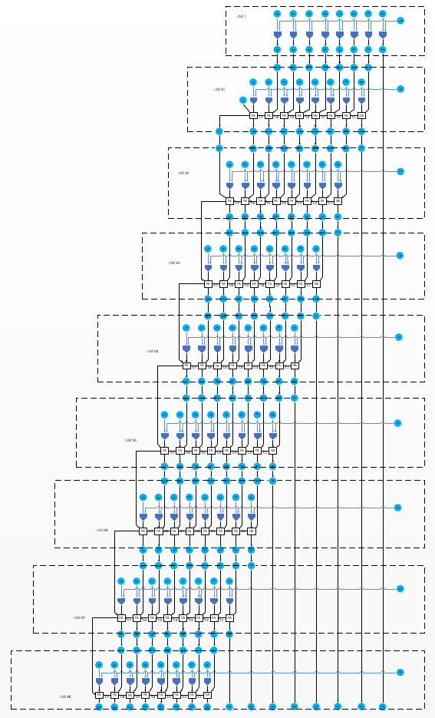
Figure 4 - Full schematic of 8 X 8 Braun Multiplier
As shown in Figure 4, the top block was Line 1, which connected to Line X1. This then connected to Line X2. This format continued to last line, which was Line X8. Port mapping enabled Line X1 to be repeated down to the last line due to the ports being reassigned their own identities for each line.
The following blocks were created individually via Xilinx VHDL to create the multiplier:

Half Adder

The Half Adder is a crucial design of logic made with simple logic gates. It contains two inputs, usually A and B, and two outputs, these are Carry and Sum. The component would make the carry and sum results from adding the two input terms. [7]

Schematic

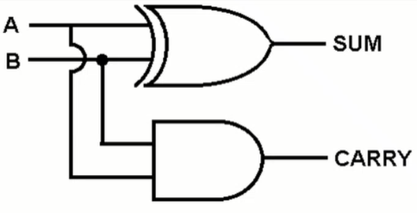

Figure 5 - Half Adder Cell [7]

Figure 2 shows the Half Adder cell which comprises of an AND gate and an EXOR gate. The cell will add, and give the output of either “1” or “2”. If either the A or B input is set, a SUM is produced. If A and B is set, CARRY is the output with no SUM. The total numbers of ‘1” is counted. In binary terms, SUM is “1”, where CARRY is “2”.

Truth table
The truth table for the Half Adder is shown in Table 3-1.
A | B | Sum | Cout
0 | 0 | 0 | 0
0 | 1 | 1 | 0
1 | 0 | 1 | 0
1 | 1 | 0 | 1

Table 3-1 - Half Adder truth table [8]
The Half Adder truth table shows logic 1 was only achieved when A or B was logic 1. The output C out was only logic 1 when A and B was logic 1. [8]

Module Code
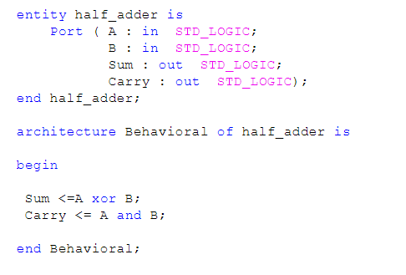
Figure 6 - VHDL code for Half Adder
Figure 6 shows the block of VHDL code that included Port A and B as inputs, Sum, and Carry Ports as outputs. The next line of code shows that the Sum output was an EXOR of inputs A and B. The last line shows that the Carry output were assigned inputs A and B.

Test Bench
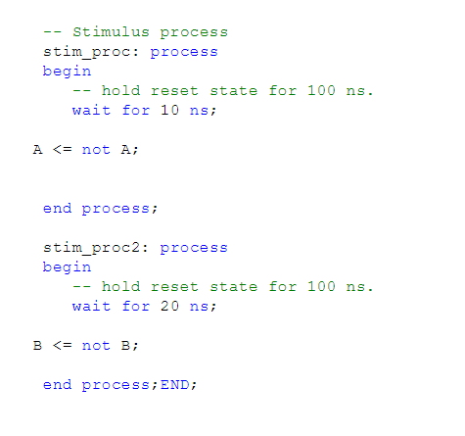
Figure 7 Shows Test Bench code for the Half Adder
Figure 7 shows the test bench code that ran the code previously built and simulated so the half adder process was viewed.
The code showed that the simulation switched A to not A every 10ns, and every 20ns, B switched to not B. If it was a “0”, it switched to a “1”. B switched at half the rate of A. The stimulation processes were named differently to run the processes at different times. Otherwise, all the actions would run at the same time.

Simulation

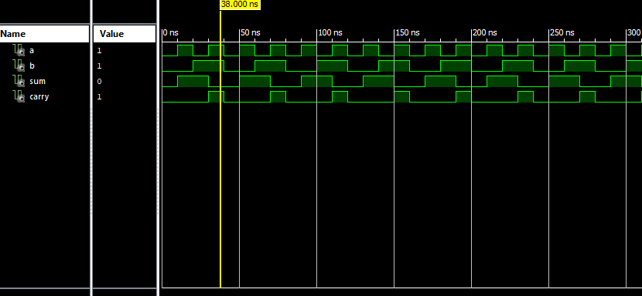
Figure 8 - Simulation of the Half Adder Test bench
As shown in figure 8, the simulation of the half adder test bench shows that when A and B input were “1”, the Sum showed “0” and Carry showed “1”. This matched what was displayed on the Half Adders truth table.

Full Adder
The Half Adder was expanded upon to create the Full Adder. This includes the addition of a C input. The build took the three inputs to create the Sum and Carry outputs. [7]

Schematic
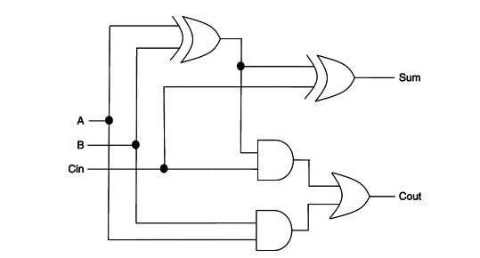
4
5
3
2
1
Figure 9 - Circuit schematic of Full Adder.(1) A EXOR B (2) A EXOR B AND C (3) A EXOR B AND C (4) A AND B (5) A EXOR B AND C OR A AND B. [9]
Figure 9 shows that the Full Adder was made up of three EXOR gates, two AND gates and one OR gate. Not only was there external signals like in the Half Adder, such as inputs A, B and C and outputs Sum and Carry, but there was also external signals within. These internal signals had to be included in the coding.

Truth Table
The truth table for the Full Adder is shown in Table 3-2.
A | B | Cin | Sum | Cout
0 | 0 | 0 | 0 | 0
0 | 0 | 1 | 1 | 0
0 | 1 | 0 | 1 | 0
0 | 1 | 1 | 0 | 1
1 | 0 | 0 | 1 | 0
1 | 0 | 1 | 0 | 1
1 | 1 | 0 | 0 | 1
1 | 1 | 1 | 1 | 1

Table 3-2 - Truth Table for the Full Adder [9]

Table 3-2 shows that logic 1 for the Sum output was active only when one or three inputs are logic ‘1’.Cout or Carry was only logic ‘1’ when logic ‘1’ was active on two or three of the inputs.

Module Code

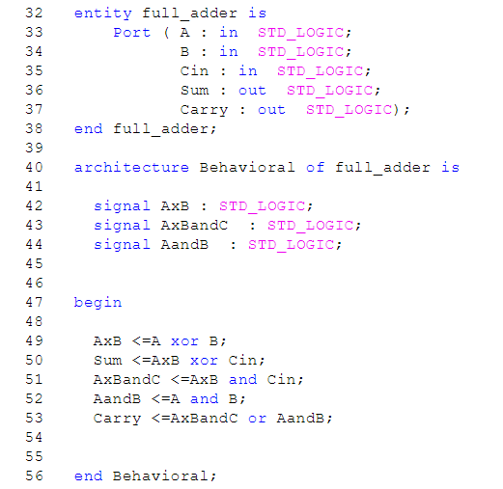
Figure 10 - VHDL code for Full Adder
As shown in figure 10, the block of VHDL code started with the description of the input ports A - C, and output ports Sum and Carry. C in was the Carry in from the Half Adder Carry out.
The internal signals are shown in lines 42 - 44, these show:
Line 42 - A EXOR B
Line 43 - A EXOR B AND C
Line 44 - A AND B
Lines 49 - 53 were the assigned lines for internal and externals signals. Referring to the Full Adder schematic as shown in figure 9
Line 49 - (1) - A EXOR B
Line 50 - (2) - The Sum was assigned A EXOR B OR C
Line 51 - (3) - A EXOR B AND C
Line 52 - (4) - A AND B
Line 53 - (5) - The Carry was assigned A EXOR B AND C OR A AND B

Test Bench
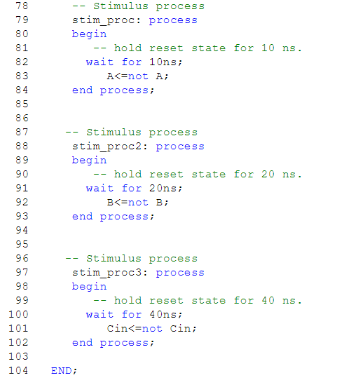
Figure 11 - Test Bench for Full Adder
As shown in figure 11, the stimulation processes showed that input A switched to not A every 10ns, B switched to not B every 20ns and C switched to not C every 40ns. This was inverting the signal to what it was previously. The following stimulation process would be that of its predecessor. The processes were spaced out to obtain a symmetrical time frame of the signals.
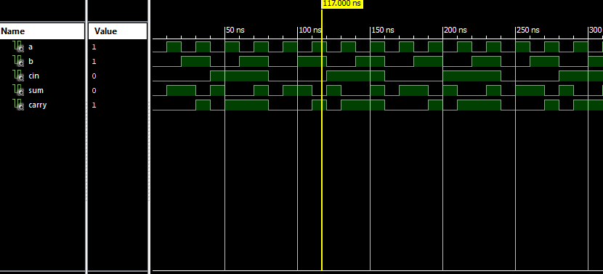
Figure 12 - Simulation of the Full Adder Test bench
As shown in figure 12, the simulation of the test bench for the Full Adder showed that when A and B were logic ‘1’ but C in and Sum were logic ‘0’, Carry out was logic ‘1’. This is because there are two inputs, therefore the Carry was set, but the Sum was not. When inputs A, B and C were logic ‘1’, a Sum and Carry were logic ‘1’.This matched with the Full Adders truth table.

Line 1
Line X was the first line of the entire multiplier. It consisted of nine inputs, A0 - A7 and B0, and eight outputs, Q0 - Q7. Each A input fed into the AND gate below on every line, with one B input per line feeding into all of the AND gates. Each AND gates had its own individual output. The first output would drop all the way to the bottom and become Q0, an external output, as shown in figure 13.

Schematic
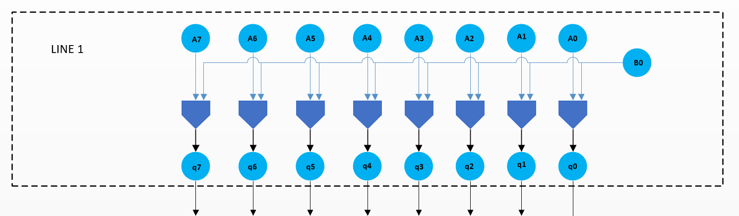
Figure 13 - Line 1 circuit schematic

Module Code
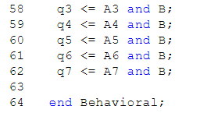
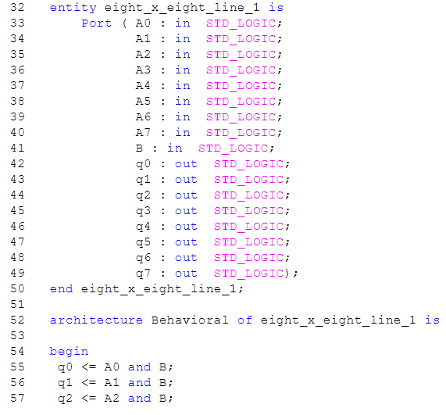

Figure 14 - VHDL code for Line 1
As shown in figure 14, ports A0 - A7 and B were the inputs, and q0 - q7 were the outputs. Line 55 - 62 showed the assigned inputs and outputs. It showed that q0 was A0 AND B, and so on to q7.

Test Bench

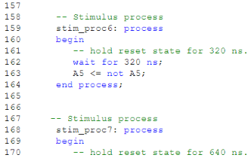
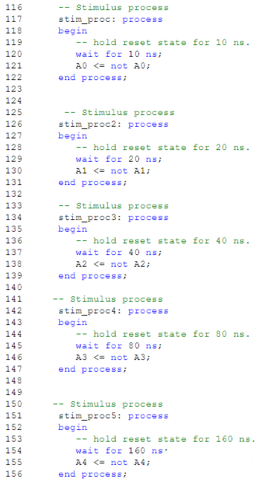

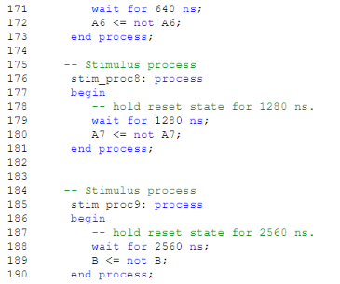

Figure 15 - Test bench stimulus process for Line 1
As shown in figure 15, the following wait time was double its preceding process. Following the same process as the half and full adders, the inputs switched from A to not A after their own individual wait times.

Simulation

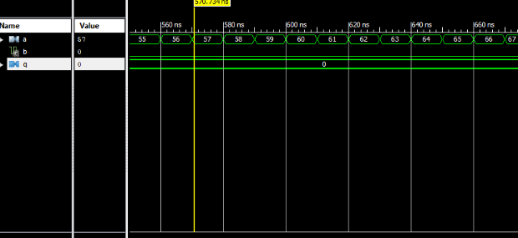
Figure 16 - Simulation of Line 1 Test bench when B is low
As shown in figure 16, when B was low or “0”, the output Q stayed low and showed ‘0’. It didn’t matter what was showing at input A. If B was low, the output showed ‘0’.
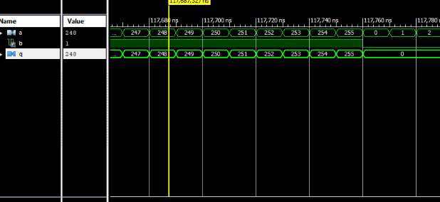
Figure 17 - Simulation of Line 1 Test bench when B is high
Figure 17 shows that when B was high or showing “1”, whatever was at input A, the output at B matched.

Line X

Schematic

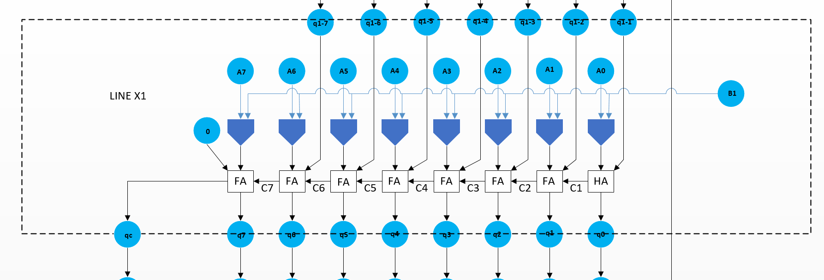
Figure 18 - Schematic for Line X of multiplier
Figure 18 showed that A0 - A7 was anded with B1. The first output from A0, fed into the Half Adder along with the previous lines A1. A carry signal fed all along the line through the Full Adders.
This process carried on throughout the next lines to the bottom. Due to a carry feeding down the lines, the “0” was no longer required on the other lines.

Module Code

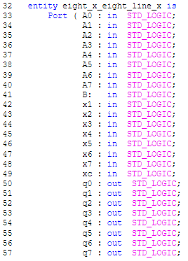

Figure 19- VHDL code for Line X

As shown in figure 19, inputs were A0 - A7 and B, as in Line 1. X1 - X7 was the internal inputs. XC represented a previous carry, but this didn’t exist, so “0” was set later in the mapping for this. Q0 - Q7 were the outputs of Line X, but were actually internal inputs of the whole multiplier. QC was the Carry output that was situated on the outside of the schematic and dropped into the following lines Full Adder.

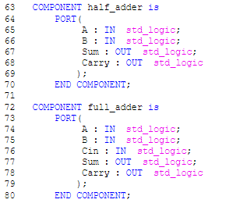
Figure 20- Components port for Half and Full Adders
Figure 20 shows the component code for the Half and Full Adder, which were required in the build of Line X.
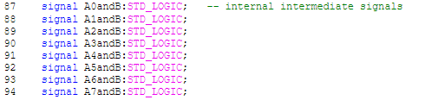
Figure 21 - Internal signals from AND gates to Adders
As shown in figure 21, lines 87 - 94 were internal signals located between the AND gates and the Half/Full Adders.

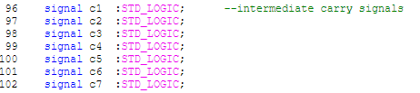
Figure 22 - Carry signals through Adders
Figure 22 shows c1 - c7 which were the intermediate carry signals through the Half and Full Adders.

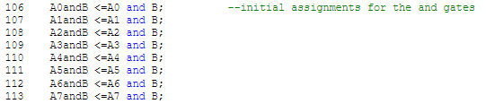
Figure 23 - Assigned signals in Line X
Figure 23 shows the assigned input signals for the AND gates in Line X.
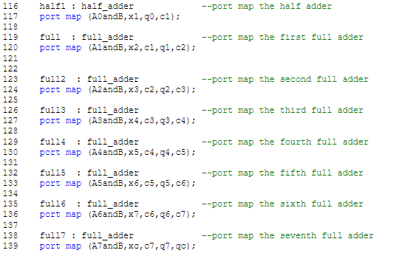
Figure 24 - Port mapping for Half and Full Adders
Figure 24 shows the port mapping of the Half and Full Adders. This took what was originally set in the adders and substitute the variable to be used.
The half Adder had two inputs and two outputs. As shown in figure 15, the schematic for Line X shows that A0 AND B was the first input, x1 was the second input, and was an intermediate signal from q1-1. The outputs from the Half Adder were q0, which was dropping into q0, which was the next output, and c1, which was carrying into the Full Adder next to it.
The Full Adder had three inputs and two outputs. The first Full Adders inputs were A1 and B, which were the main inputs. X2 was the second input, which was an intermediate signal from the output from Line 1, which was q1-2, c1 was the third input from the adjacent Half Adder.Q1 dropped into the next input on the next Line, which would be Line X2, c2 was the last output, which carried into the next Full Adder on this line.
This process carried all the way across Line X, until qc on Line 139, which dropped down to the next lines Carry, xc was another carry which was set to “0” for the full multiplier.

Test Bench

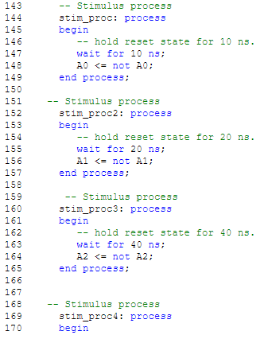
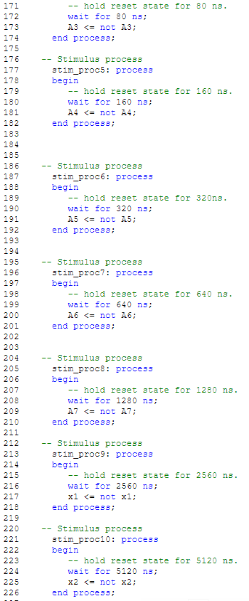
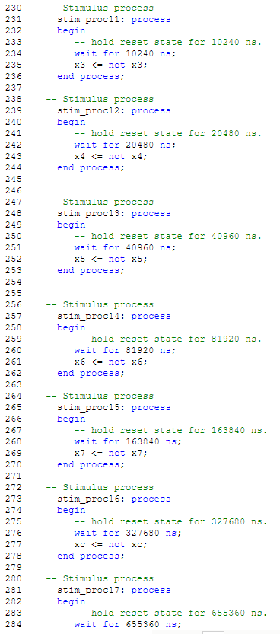
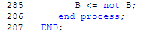
Figure 25 - Test bench stimulus process for Line X
Figure 25 shows all the input signals. A0 - A7, x1 - x7, xc and B for the stimulus process for simulation. As with the Half/Full Adder and Line 1, the inputs were all assigned with their corresponding identity. The wait was again double that of its predecessor.

Simulation

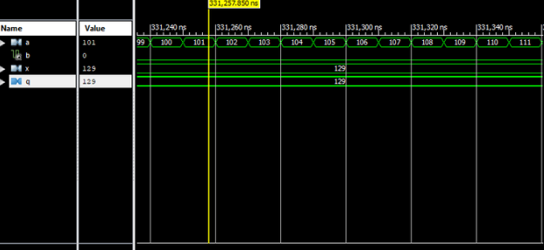
Figure 26 Simulation of Line X Test bench when B is low. A, X and Q were put into virtual buses to see the numbers easier
Figure 26 shows that when B was low, X went through, irrespective of the action of A to the output Q. The inputs and outputs had all been put in their respective virtual buses. This was done to see the numbers adding up and the total output being shown. The numbers were descending in order to show the most significant number first and the least significant number last. The radix were unassigned decimals.
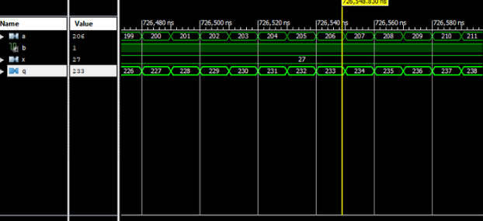
Figure 27 Simulation of Line X Test bench when B is high
Figure 27 shows that when B was high, it took the number from the A input and added it with the X input and the resulting number was displayed in the output Q, as shown in figure 27.
A = 206 X = 27,
Q = A x X = 233
Figure 28 - Calculation of output Q

Line Multiplier
This was the final block to create for the multiplier. It consisted of Line 1 and eight Line X’s. Port mapping was used to include these lines.

Module Code
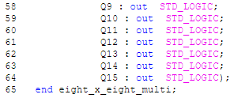
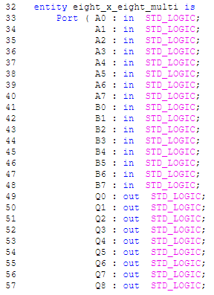

Figure 29 - All ported inputs and outputs for the multiplier
As shown in figure 29, every external input and output was used for the final multiplier assembly. There was fifteen outputs in total.
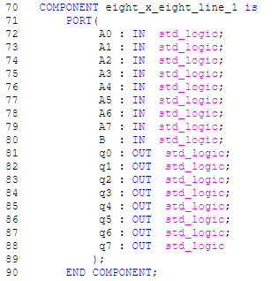
Figure 30 - Line 1 component, which had to be included in the multiplier build
Figure 30 and 31 shows the previously built Line 1 and Line X, that was required in the multiplier build. These were the first two lines in the complete multiplier.
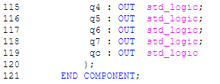
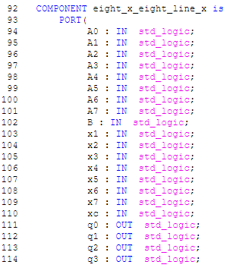

Figure 31 - Line X component, which had to be included in the multiplier build
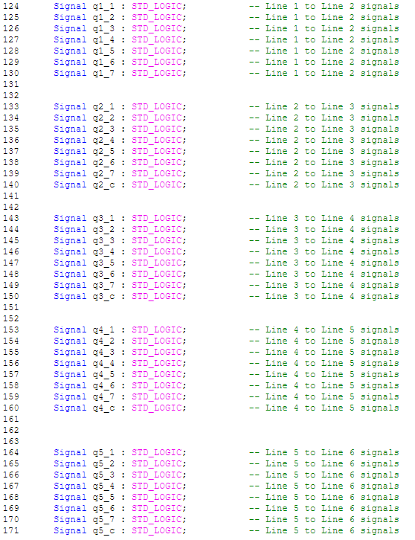

Figure 32 shows the internal signals that linked one line to the next one down. These had to be defined in order to port them later on in the build.

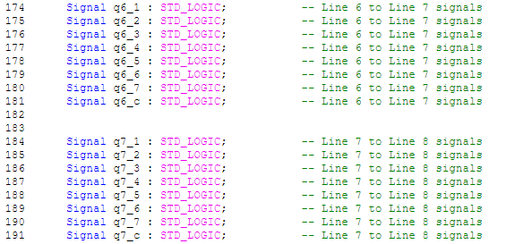
Figure 32 - Internal signal for the multiplier

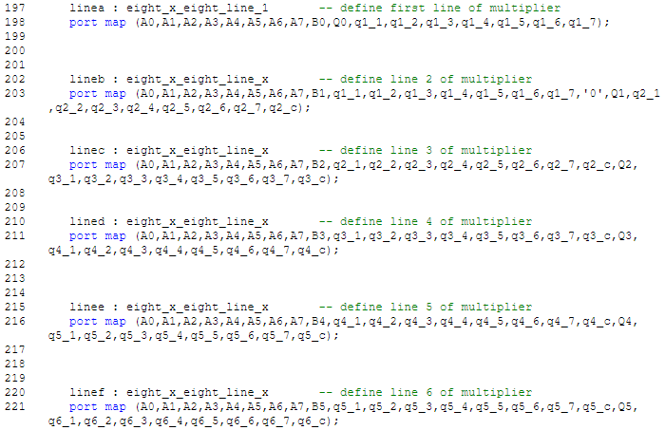
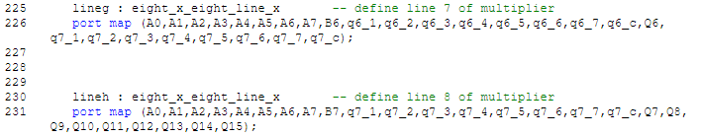

Figure 33 - Port map for the entire multiplier
Figure 33 shows the port mapping section of the coding. The defined first line, Line a, used the ports from Line 1 component and mapped in nine input signals , A0 - A7 and B0, and eight outputs, Q0 and q1_1 - q1_7. Q0 was an actual external output, as it dropped all the way to the bottom and counted up one every line, q1_1 - q1_7 were external from the point of view of this block, but overall, it was an internal signal incorporated within the multiplier. B0 was used only on the first line. B1 was used on the next line down and so on, until the last line used B7.
The second line, Line b, used the ports from the Line 1 component and mapped in seventeen inputs, A0 - A7, B1 and q1_1 - q1_7 which were outputs from Line a.
“0” was set due to that port relating to xc from Line X. This didn’t exist, due to there being no carry from the previous line so that was why “0” was entered. This only happened on this line.
The outputs on Line b were Q1, which dropped down to the bottom for an external output. Q2_1 - q2_7 were intermediate signals but were outputs for this block. These dropped down into the corresponding inputs on the next line.
This process continued all the way down from Line c to Line h, until the final external outputs were Q7 - Q15.

Test Bench

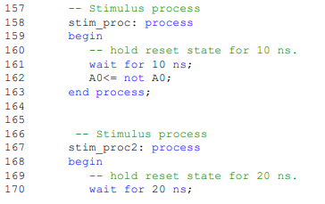

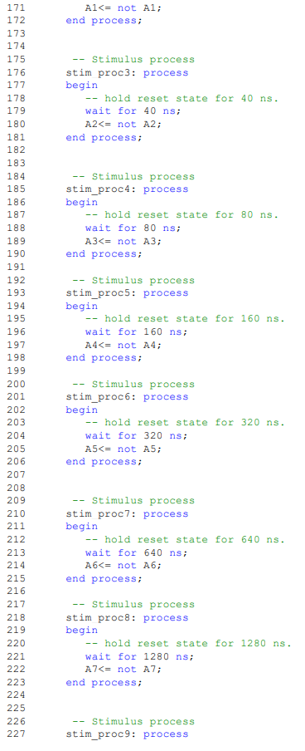
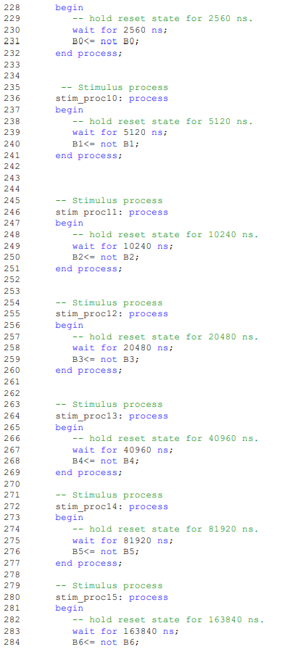
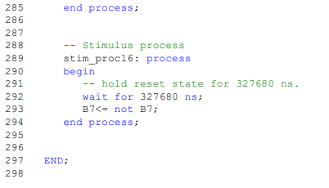
Figure 34- Test bench stimulus process for multiplier
Figure 34 shows all the outputs for the test benches stimulus process, A0 - A7 and B0 - B7. They were all assigned with a NOT function. For example, A0 switched to not A0 after its allotted wait time. This was the same reason as all the other test benches in the build, as they switched with their own wait time. This wait time doubled as they progressed, exactly the same as the other test benches.

Simulation

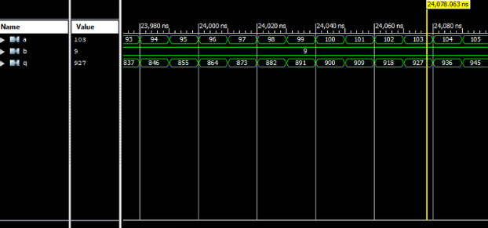
Figure 35 - Stimulation process of the completed multiplier. All inputs and outputs were put into their own virtual buses
Figure 35 shows the stimulated process of the multiplier. The A input counted up in sequence and whatever number input B showed, it was multiplied by A, the result is shown in output Q, as shown in figure 36.
A = 103 B = 9,
Q = A x B = 927
Figure 36 - Calculation of output Q

Finite State Map

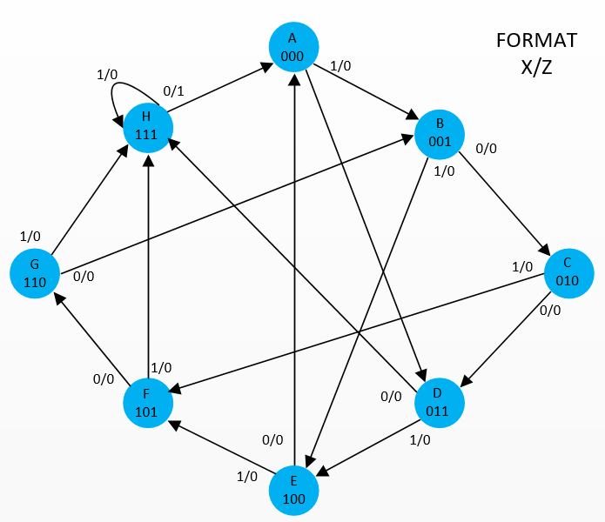
Figure 37 - Finite State Map

Figure 37 shows an eight state FSM that was simulated into VHDL and a gate solution.

VHDL

Module Code

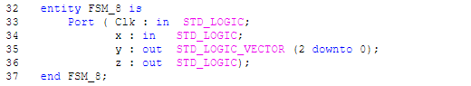
Figure 38
Figure 38 shows input ports Clk for the clock and x, output ports y and z. The x/z corresponded to the format shown in the state diagram.
Line 35 was an array, and allows a number of bits under its assigned port. In this case, Y.
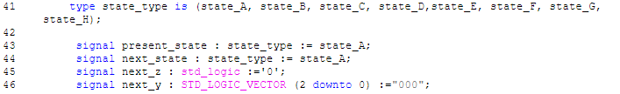
Figure 39
Figure 39 shows the block of code that dealt with the state. Line 41 the definition of the states, from A to H. The type was defined as state type.
Line 43 shows that the present state default was State A. This was the start position. Line 42 shows the preset for the next state. This was also set at State A. These presets shows how the FSM was entered.
Line 45 was created to line up when State H reached State A and have an output of “1”. Without this line the output would show “1” at State H, as shown figure 40, instead of when it was on its way to State A, as shown in figure 41. It also showed that it would start at State A or 000.
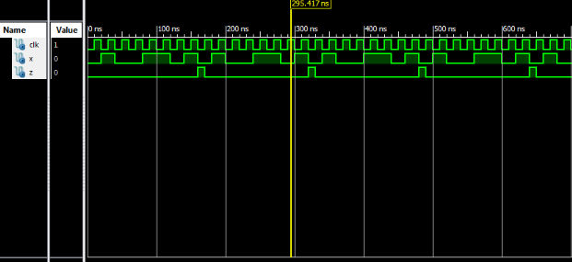
Figure 40 - Shows the simulation including the error in the coding. The output Z goes high before the transition from State H to State A.
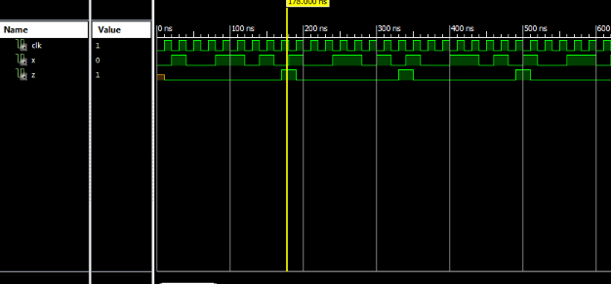
Figure 41 - Shows the simulation with the correction in the coding. The output Z goes high after the transition from State H to State A.

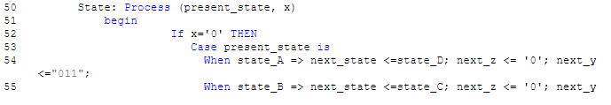
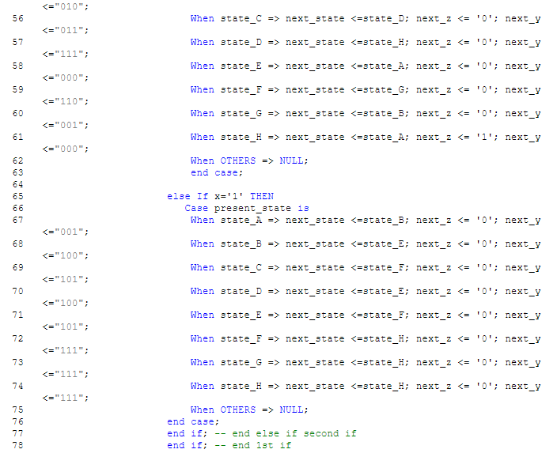
Figure 42 - Shows the VHDL module code
The process block is shown in figure 42. Line 54 - 61 shows what happened IF the output x was “0” from the present state to the next state. Example on Line 54 was when State A was “0”, the next state was State D. The output was then shown with either “0” or “1”.This carried on throughout the case.
For Lines 65 - 74, the case was IF x is “1”, from the present state to the next state. Example from Line 67 was that IF State A was “1”, the next state was State B. This also carried on throughout the case.
The Y assigned vector showed the next state in three bit binary. This allowed the states to be displayed in binary numbers in the test bench.
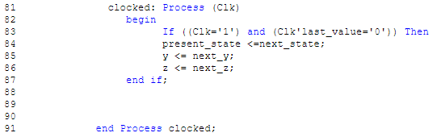
Figure 43 - Clock process for FSM VHDL
Figure 43 shows the clock process. Line 83 shows that when Clk, clock, is “1”, and Clk of the last value read was “0” then the present state was assigned the next state. Line 86 was to instruct the next state.

Test Bench

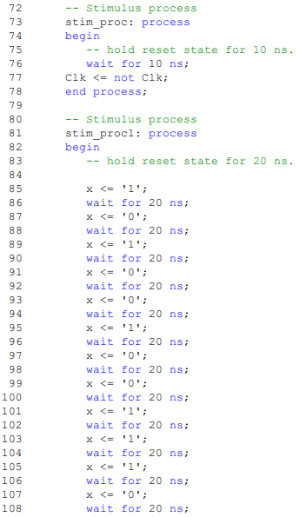
Figure 44 - Test bench for FSM
Figure 44 shows the stimulus process for the FSM. Line 77 shows that Clk was assigned not clock. This instigated the switching every 10ns. The next stimulus process started at Line 85 - 108. This was the route given to the FSM, and this happened every 20ns. This test bench process worked the outside and inside paths around the map. This showed twelve pulses before “1” was shown at the output.

Simulation

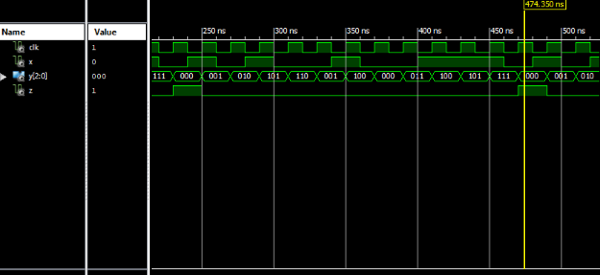
Figure 45
As shown in figure 45, the simulation follows the stimulus process as shown in figure 44, where the route taken around the FSM and pulsed twelve times before the output switched on.
The input entered in the test bench was:
1 - 0 - 1 - 0 - 0 - 1 - 0 - 0 - 1 - 1 - 1 - 0
The order of states this made was:
000 - 001 - 010 - 101 - 110 - 001 - 100 - 000 - 011 - 100 - 101 - 111 - 000
When State H (111), transitioned to State A (000), the output was “1”.

Discrete Gate Solution
In order to create a gate circuit for the FSM, the state diagram present state, next state inputs and output were compiled into the below table as shown in figure 46.

Present State / Next State Table

 |  | PRESENT STATE |  |  | INPUT | NEXT STATE |  |  | OUTPUT
 |  | A | B | C | X | A | B | C | Z
A | 0 | O | O | O | O | O | 1 | 1 | O
A | 1 | O | O | O | 1 | O | O | 1 | O
B | 0 | O | O | 1 | O | O | 1 | O | O
B | 1 | O | O | 1 | 1 | 1 | O | O | O
C | 0 | O | 1 | O | O | O | 1 | 1 | O
C | 1 | O | 1 | O | 1 | 1 | O | 1 | O
D | 0 | O | 1 | 1 | O | 1 | 1 | 1 | O
D | 1 | O | 1 | 1 | 1 | 1 | O | O | O
E | 0 | 1 | O | O | O | O | O | O | O
E | 1 | 1 | O | O | 1 | 1 | O | 1 | O
F | 0 | 1 | O | 1 | O | 1 | 1 | O | O
F | 1 | 1 | O | 1 | 1 | 1 | 1 | 1 | O
G | 0 | 1 | 1 | O | O | O | O | 1 | O
G | 1 | 1 | 1 | O | 1 | 1 | 1 | 1 | O
H | 0 | 1 | 1 | 1 | O | O | O | O | 1
H | 1 | 1 | 1 | 1 | 1 | 1 | 1 | 1 | 0

Figure 46 - Present and Next Sate table taken from FSM

As shown in figure 46, the present and next state table based on the state diagram was created to ascertain the sequences in the circuit and to determine if any states were deemed redundant. [10] Four Karnaugh Maps were taken from this table using D type Flip Flops. Three inputs, A, B and C, and the output Z.

D - Type Tables

Flip Flop A

Figure 47 - Karnaugh map for Flip Flop DA
Figure 47 shows the Karnaugh Map for D type Flip Flop. The five groups were colour coded for visibility.

SIMPLIFIED FUNCTIONS = /A.C.X + B.X + A. /B.X + A. /B.C + /A.B.C
Figure 48 - Extracted terms compiled to simplified functions from Flip Flop DA table
Figure 48 shows the terms for all the groups extracted from the table. These terms were then minimized by extracting the changing terms. This then gave the functions that had to be created.

Flip Flop B

Figure 49 - Karnaugh map for Flip Flop DB
Figure 49 shows the Karnaugh Map for D type Flip Flop B. The four groups were colour coded for visibility.

SIMPLIFIED FUNCTIONS = /A. /C. /X + /A.C. /X + A. /B.C + A.B.X
Figure 50 - Extracted terms compiled to simplified functions from Flip Flop DB table
Figure 50 shows terms taken from the state table and minimized to the function required.

Flip Flop C

Figure 51 - Karnaugh map for Flip Flop DC
Figure 51 shows the Karnaugh Map for D type Flip Flop C. The four groups were colour coded for visibility.
SIMPLIFIED FUNCTIONS = /A. /C + A.X + B. /C. /X + /A.B.C. /X
Figure 52 - Extracted terms compiled to simplified functions from Flip Flop DC table
Figure 52 shows terms taken from the state table and minimized to the function required.

Output

Figure 53 - Karnaugh map for Output
Figure 53 shows the Karnaugh Map for D type Flip Flop output. There was only one term for this output.

Figure 54
Figure 54 shows only one term taken from the state table. This was when A,B and C were on and X was off.

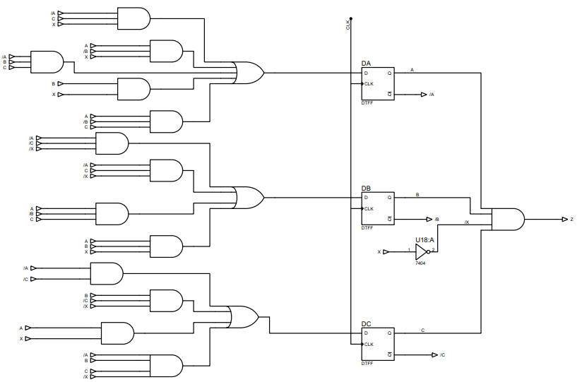
Figure 55 - Discrete gate logic circuit based on the FSM

The gate logic circuit created from the FSM, as shown in figure 55, showed that the system was a Class A Mealy Machine. This was due to the system including an output decoder and the input going straight to this output.

Results

8 x 8 Multiplier

Line 1
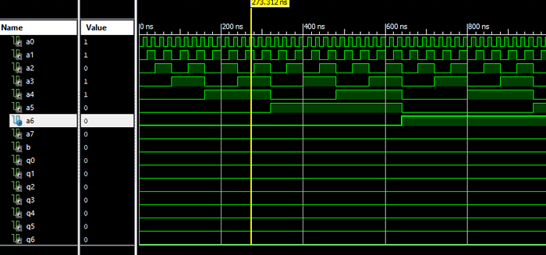
Figure 56 - Line 1 Stimulus Process with B low - No bus
Line 1 of the multiplier, as shown in figure 56, had no virtual buses, and showed that it did not matter how many inputs are high, as long as B is low, no outputs would be high. Four inputs are shown, but due to B being low, there were no outputs.
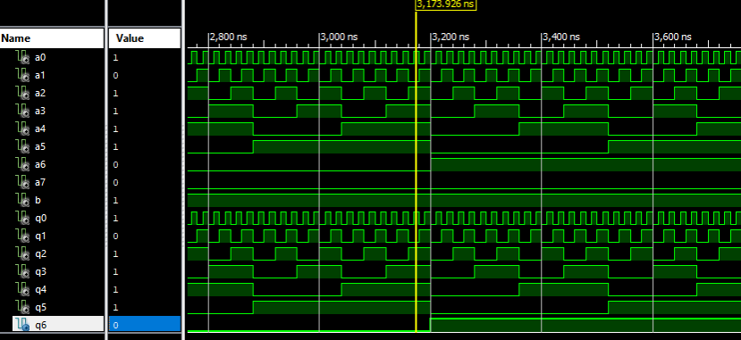
Figure 57- Line 1 Stimulus Process with B high - No bus
Only when B was high would the same amount of inputs be shown in the outputs. As shown in figure 57, five inputs were high and due to B being high, five outputs were high.

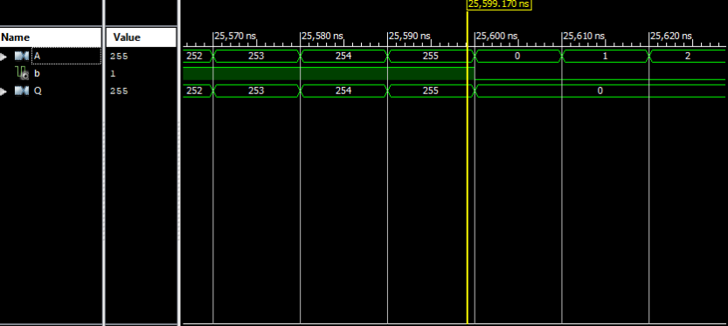
Figure 58 - Line 1 Stimulus Process with B high - With Virtual bus
The maximum value for an 8-bit number is 255. As shown in figure 58, Line 1 of the multiplier with virtual buses, which enabled easier representation of the count, the highest number available was showing as the input and due to B showing high, the same number was showing at the output.

Line x

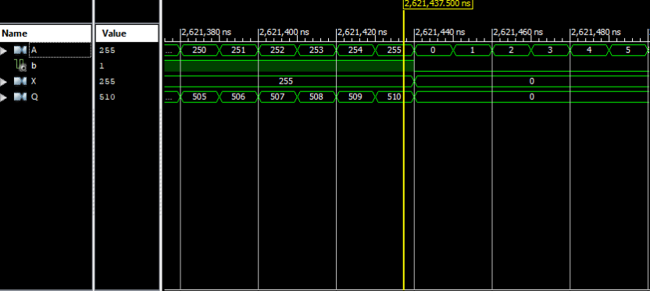
Figure 59 - Line X Stimulus Process with B high - With Virtual bus
Line X of the multiplier added together A and X signals, and the combined result was shown in output Q, as shown in figure 59. Virtual buses were used as a visual aid to see the count.

Multiplier

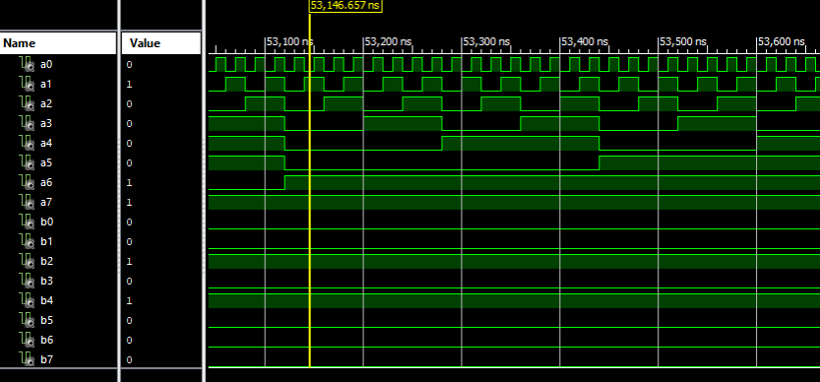
Figure 60 - Multiplier Stimulus Process with B high - With no Virtual bus
Due to having a high mount of inputs and outputs, the count was difficult to monitor for the final multiplier, as shown in figure 60.

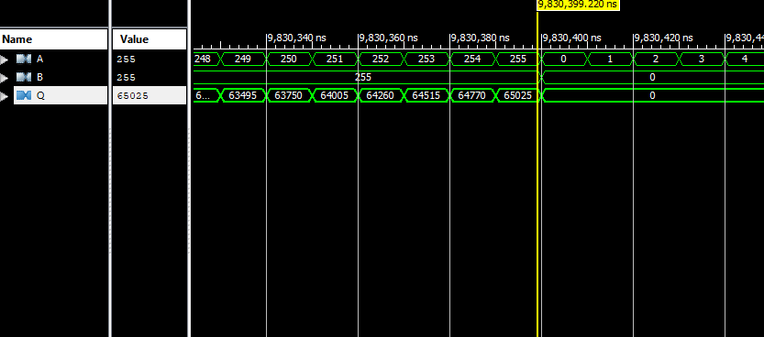
Figure 61 - Multiplier Stimulus Process with B high - With Virtual bus
Figure 61 shows the multiplier with virtual buses. It shows the highest number available for both inputs A and B, and then the result of these two inputs multiplied was shown in output Q.

FSM

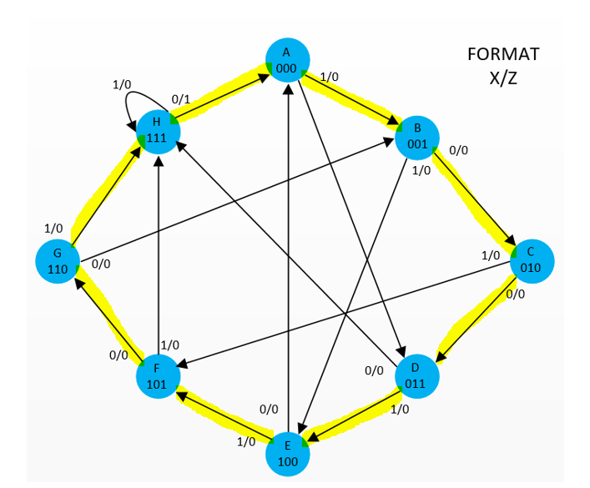
Figure 62 - Shows the outside path taken for the FSM test bench

An outside path was taken to check all the states for the test bench, as shown in figure 62. This route finshed with State H transitioning to State A. This route was taken to make sure that the output went high with a low input.

Test bench Simulation

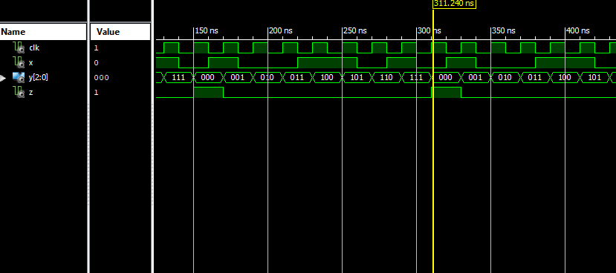
Figure 63 - Stimulated process for the FSM. All outside paths taken for each state
As shown in figure 63, the simulation pulsed through all eight states and followed an outside path around the diagram. It also confirmed that the transition between State H and State A produced the output Z to show a high state when the input X was a low state.
The input entered in the test bench was:
1-0-0-1-1-0-1-0
The order of states this made was:
000 - 001 - 010 - 011 - 100 - 101 - 110 - 111 - 000

Conclusion
In this report, it has been determined that:

- For a full 8 x8 multiplier using two 8-bit inputs and one 16-bit output, the total number will equal 65,025.
- For an AND gate, both inputs have show ‘1’ to obtain an output. It doesn’t matter how many A inputs are high, if the second input, B, is not high also, the output wont match the input.
- In the Half Adder, both inputs have to show high to CARRY the terms counted. If either input is high the SUM toggle is activated.
- For the Full Adder, all inputs have to be high for both out and Sum to activate and show high.
- Port mapping allows a components ports to be used to for whatever function you require. But has to have an assigned identity to function within a system.
- For the Finite State Map, only when State H transitioned to State A with on input of ‘0’, did the output show high.
- The discrete gate circuit was identified as a Class A machine due to the inclusion of an output module and also by way of the input going directly into the output.
- In the FSM VHDL module, all the state transitions were linked to the clock. When an assignment was created without the clock the output was situated in the wrong place in the simulation. An additional signal was created to instruct the system to change its output only when the next state was reached.

References

[1] | Xilinx, AMD, Accessed Mar 2022: https://www.xilinx.com/products/design-tools/ise-design-suite.html, Oct 2013.
[2] | Matlab, Labcenter Electronics Ltd, Accessed Mar 2022: https://www.labcenter.com/, 2015.
[3] | R. S. D Kiran, "VLSI Implementation of Braun Multiplier using Full Adder," Sep 2017. [Online]. Available: https://ieeexplore-ieee-org.ezproxy.uwtsd.ac.uk/document/8455157. [Accessed April 2022].
[4] | A. Abdel-Hamid, "Finite State Machine IP Watermarking: A Tutorial," June 2006. [Online]. Available: https://ieeexplore.ieee.org/document/1638200. [Accessed April 2022].
[5] | B. Jacob, "DRAM Device Organization: Basic Circuits and Architecture," 2008. [Online]. Available: https://www.sciencedirect.com/science/article/pii/B9780123797513500102. [Accessed May 2020].
[6] | L. Sarah, "Sequential Logic Design," 2022. [Online]. Available: https://www.sciencedirect.com/topics/computer-science/moore-machine. [Accessed May 2022].
[7] | I. Grout, "Introduction to Digital Logic Design with VHDL," Mar 2008. [Online]. Available: https://www-sciencedirect-com.ezproxy.uwtsd.ac.uk/science/article/pii/B9780750683975000064. [Accessed May 2022].
[8] | B. Holdsworth, "Arithmetic circuits," 2002. [Online]. Available: https://www.sciencedirect.com/topics/computer-science/half-adder. [Accessed May 2022].
[9] | L. Sarah, "Digital Building Blocks," 2022. [Online]. Available: https://www.sciencedirect.com/science/article/pii/B9780128200643000052. [Accessed April 2022].
[10] | A. Kanchana, "Total number of ways of transmission from a higher level to lower level using truth table and combinatorics," 2020. [Online]. Available: https://pdf.sciencedirectassets.com/305927/AIP/1-s2.0-S2214785320401762/main.pdf?X-Amz-Security-Token=IQoJb3JpZ2luX2VjEOL%2F%2F%2F%2F%2F%2F%2F%2F%2F%2FwEaCXVzLWVhc3QtMSJIMEYCIQDjRxWY6r55SuBhj6nwqoa8VdQ0EqRYJtzduDd6M7ReaAIhAK%2FVKT9fcYD76xwJioiymIMBJ4d08xe. [Accessed May 2022].

