Submit via Turnitin

School of Sport, Health & Outdoor Education

Assessment Feedback Sheet

Student No./Name: 1800977/Laura Colligan

Personal Evaluation – to support your academic progress please complete the section below BEFORE submitting your work.
What do you consider to be the best aspects of this work? |  |  | Linking theory with examples of practise.
Which aspects do you consider could have been improved in this piece of work? |  |  | A greater variety of links to theory.
What have you found most satisfying whilst undertaking this submission? |  |  | Recognising the impact that my training has had on learner development and progression, whilst also making the links to theory and practice.
ASSESSMENT CRITERIA | Learning  Outcomes |  | GRADE
ASSESSMENT CRITERIA |  |  | Poor  < 20% | Weak  20-29% | Unsatisfactory  30-39% |  | Satisfactory  40 – 49% | Good  50 – 59% | Very Good  60 – 69% | Excellent  70 – 84% |  | Exceptional  85– 100% | %
Overview of setting and evaluation of practical activities | 3 |  |  |  |  |  |  |  |  |  |  |  | 30%
Reflection and analysis of practical delivery. Linking reflections to child development, motor development theory and implications for future practice | 2,3 |  |  |  |  |  |  |  |  |  |  |  | 40%
Analysis of pupils’ physical skills and implications for their development, Physical activity and self-perceptions | 1, 2 |  |  |  |  |  |  |  |  |  |  |  | 30%
It is expected that students will present work that is proof read, correctly referenced and adheres to the Assessment Checklist. Therefore a range of 0 – 10 marks will be deducted for non-completion of any of the points on the checklist below.
TUTOR COMMENTS:

Submission date:  via Turnitin |  | Return date:  (at least within 4 weeks) |  |  |  | Tutor: Nalda Wainwright/ Amanda John |  |  |  |  | Mark:

Developing and Supporting Physical development in early childhood.

Reflective Journal

This written reflective essay will reflect, analyse and evaluate the practical delivery and activities of the SKIP (Successful Kinaesthetic Instruction for Pre-schoolers) Cymru training course. This essay will link reflections to child development, motor development theory and implications for future practice, in addition it will analyse pupils’ physical skills and implications for their development, physical activity and self-perceptions.

St Francis is a Voluntary Aided Catholic Primary School serving the Catholic and Christian community of Milford Haven, Pembrokeshire. We cater for the religious and educational needs of Catholic children age 3-11 years. The present number on roll is 138. The school comprises of five classes – Nursery/Reception, Year 1/2, Year 2/3, Year 3/4 and Year 5/6. The decision to implement SKIP-Cymru was made with the aims to develop motivation, resilience and engagement in pupils learning.

At the beginning of the project learners attitudes towards physical activity and sport were growing increasingly more negative as they progressed up the school. During PE sessions learner participation was reduced and learners were showing reluctance to join in with activities that required physical activity and movement. This was most likely due to lacking the important and critical skills we need to be able to play particular sports. We felt that if we were able to target these negative perceptions and develop learner confidence from a young age, then we would hopefully be able to see an improvement in learner attitudes and participation in physical activity in the future as the learners move throughout the school. ‘Physical literacy can be described as the motivation, confidence, physical competence, knowledge and understanding to value and take responsibility for engagement in physical activities for life.’ (International Physical Literacy Association, 2017)

Cycle one
A philosophy that underpins physical literacy is that mind and body are one. ‘Physical literacy can provide meaningful movement in all aspects of life. If we develop physical literacy right, we support the individual to become and remain active and healthy as they grow from a toddler to an adult.’ (SKIP Cymru, 2016)

The focus group was a mixed age Year 1 and 2 class consisting of 26 learners. There were 3 EAL learners, one ALN learner and 6 eFSM. Our Nursery and Reception class follow a play-based curriculum, with lots of opportunities for moving in their learning provided when learners transition to Year 1, however there are some movement skills that need to be taught and learners will not learn these skills simply through playing.

Many learners would demonstrate anxiety, poor pencil control, poor stamina. What I found most interesting to learn and make links through the training was that many of these difficulties could have been due to the learner not integrating reflexes as a baby or toddler. When the child is in their early years, if they do not integrate reflexes into more controlled movements then they may be retained, leading to difficulties in motor skills. Learning about the reflexes led me to understand how vital the processes of movement are on learning and development. I gained a greater understanding behind some of the possibilities and reasonings towards individual learners’ behaviours and movement development. Within daily life one learner presents over sensitivity to stimuli, poor balance and coordination and a strong sense of anxiety. This learner has also suffered with hearing difficulty since she was young, this led me to consider could her behaviours be due to the moro or startle reflex not having been fully integrated after 4 months due to hearing difficulties. There has been a notable positive change in this learner’s anxiety levels since taking part in daily SKIP activities.

Some of the learners in the focus group do not receive opportunities to take part in physical activity outside of the school environment, whether this be through out of school sporting clubs, or lack of access to open spaces such as gardens, parks and recreational areas. Lack of sensory integration (Ayres, 2005) within their early years will also play a role in a child’s physical literacy development. Ayres (2005, Pg 14) writes that ‘most of the activity in the first 7 years of life is part of one process: the process of organising the sensations in the nervous system.’ That being how senses and movement systems work together to make sense of the world.

Describing the definition of the term movement, Davies (2003) discusses a theoretical framework of movement where she talks of the common denominators of which movement springs, one of these denominators being space. I recognised that most learners struggled to participate within their own ‘space’ or ‘bubble’, resulting in lots of learners bumping into one another, causing disagreements, silly behaviour and a lack of focus. This reflection is in relation to ‘personal’ space surrounding the learners’ body (Davies, 2003, Pg 18). Davies (2003) goes on to state that ‘children carry their personal space with them as they travel in the general space in which they move’. My concerns here were that if the learners were struggling to remain in their personal space whilst being instructed to remain in one spot, how were they going to respect the personal space of others around them as they moved on to travel around the space?

I decided to introduce ‘home’ spots, coloured spots evenly distributed around the general space, learners were given one single spot each which became their ‘home’ spot, here they must start and end the session and not move off the spot and around the general area unless instructed to do so. The ‘home’ spots gave each learner sufficient personal space surrounding their bodies, this also enhanced their listening and recall skills as they had to travel back to the ‘home’ spots upon a signal. Reflection of this lesson found using the spots as ‘home’ spots would take some practice with the learners, they kept picking the spot up, sliding them across the floor with their foot, moving around off the spot. However, I felt that it would be a good warm up to use repeatedly for listening and control, when they heard the second tambourine, they all ran back to their spots as if it was a race, rather than travelling back in the given movement. As with everything with younger children, repetitiveness meant that eventually learners became less fiddly with the home spots and recognised the benefits of having their own personal space to develop their Fundamental Movement Skills.

Figure 1: Pre test measures – Catch
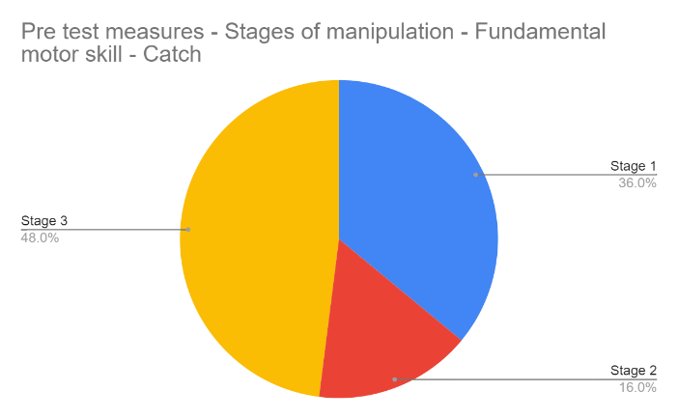

Following the Developmental Sequences of Five Manipulative Skills by Gallahue & Ozmun (2019) data was gathered at the start of the enquiry to assess their catching skills (Figure 1). Most of the focus group (48%) were sitting at stage 3 which sat within the emerging stage of the developmental skill. There were still 36% of pupils siting within stage 1, the earliest and initial stage of catching where they demonstrated a delayed reaction in most instances to catching the ball. There were no pupils that were working within the proficient stage of catching. With no pupils currently catching with their hands only, we understood that activities would need to be set that would encourage hand catching.
For the learners that I identified as being stages 1 and 2 of catching I recognised that they were unable to track the object or ball, tracking being the skill of following an objects movement. A successful and popular eye tracking activity was scarf catching, the scarves fall slow and gave the learners plenty of time to react and build their confidence in catching as they could follow the movement of the object. Once learners became proficient in catching scarves, I re-introduced the ball but this time encouraging the learner to roll the ball back and forth with a partner, tracking the ball as they go.
Before SKIP, I lacked the understanding of the importance for learners to be proficient in the FMS before moving on to perform particular sports and sporting activities. I now recognise that this is a common misconception and a contributing factor to learners’ lack of confidence and ability to participate in certain sports, leading to lack of engagement and enthusiasm for physical activity, where pupils have not broken through the proficiency barrier yet (Seefeldt, 1980). The Proficiency Barrier model (see figure 2) which shows the ‘Progression of Motor Proficiency Skill Levels’ (Seefeldt, 1980) was an integral part of the project, it demonstrated that many of our learners sat beneath the 'proficiency barrier' at the start of the enquiry, meaning that they lacked the proficient coordination and control in FMS to then transfer and apply the skills across specific sports and activities. If at the early point of the project we had asked the focus group to play a competitive game of rugby for example, they would have most likely failed and felt defeated, had a negative experience of the sport and become reluctant to participate again in future.
Figure 2: The Progression of Motor Proficiency Skill Levels (Seefeldt, 1980)
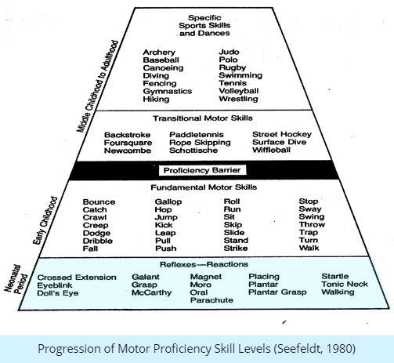
Another model that reflected the basis of the project on was the 'Motor Competence influences Physical Activity and Obesity Trajectories of Children' model (Figure 3) (Stodden et al, 2008). The model demonstrates the relationship between physical activity, competence, perceived motor competence and fitness in the early years can result in a positive experience and engagement with physical health and activities as the child grows up. I recognised that when a child is not motor competent, they are not participating in physical activity.

Figure 3: 'Motor Competence influences Physical Activity and Obesity Trajectories of Children' model (Stodden et al, 2008)
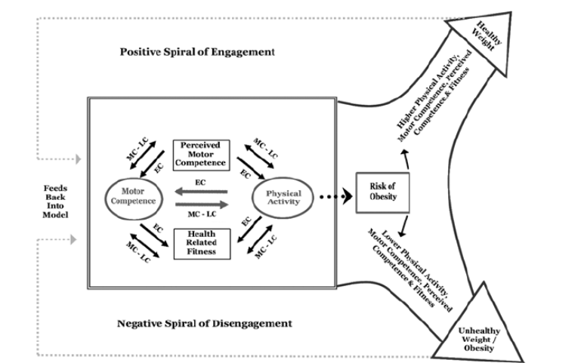
‘Play consists of a series of adaptive responses that make sensory integration happen’ (Ayres, 2005, pg 7). I wanted to ensure that a play-based learning environment was provided in the Year 1/2 classroom. During the initial stages of the project an audit of the current classroom environment and types of play opportunities that are provided on a daily basis within provision was conducted. (Figure 4)
Figure 4: Types of play opportunities within daily classroom provision audit
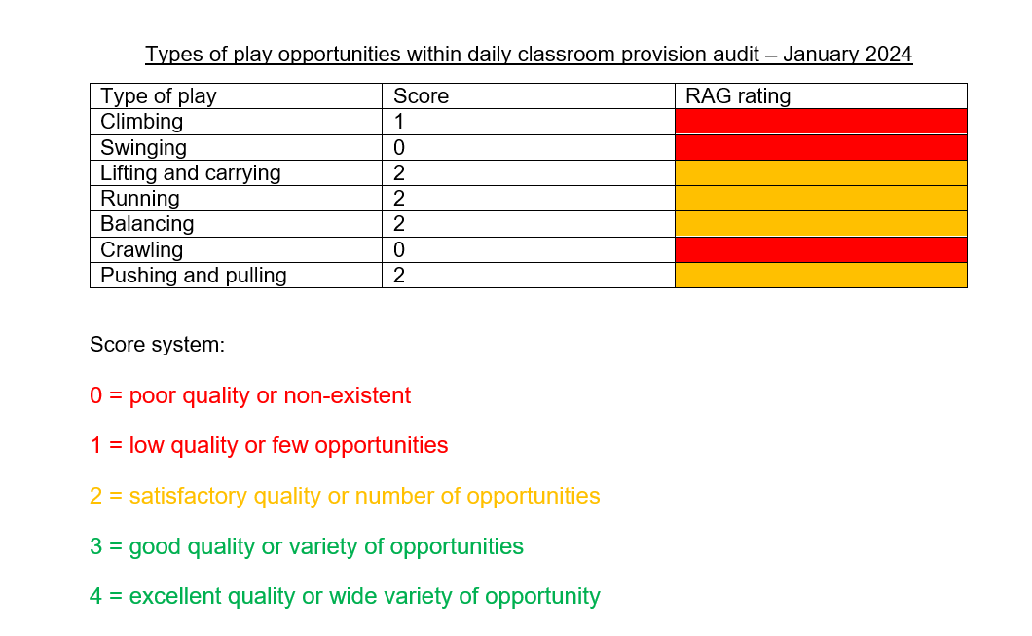

Cycle 2
Weekly Welly Wednesday sessions gave the learners the opportunity for quality movement and sensory experiences within nature. By allowing the learners to regularly explore the natural environment of the school grounds we have been able to develop their balance and co-ordination from the uneven surfaces, along with climbing and jumping as they explore trees, logs and wooded areas, and simply providing them with large open spaces to run, jump and chase one another has developed these fundamental movement skills, learners confidence have grown and they have been more open to taking risks, being risk aware but not risk averse.

It has been felt that one of the greatest impacts the SKIP training has had on my practise in delivering physical literacy is that of the ‘Constraints Theory’ (Newell, 1986, Cited in Haywood & Getchell, 2019. Pg 6) (Figure 5). Once I could identify the learners’ constraints, I ensured my planning allowed differentiation to develop that individual. As previously discussed, there are many factors that effect the physical development of a child which are sometimes out of our control, these can be seen as individual constraints. However, we can control the task and environmental constraints for the learner.

Figure 5: Constraints Theory (Newell, 1986)
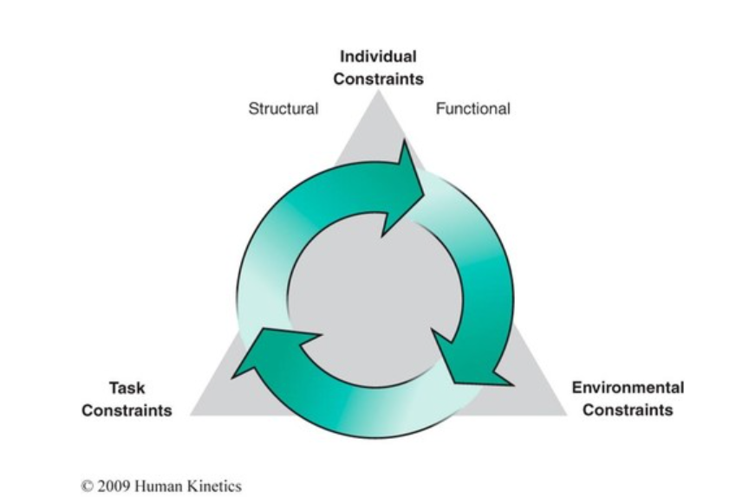

I adapted the equipment we used when delivering activities involving underarm throwing by adding a hoop to encourage the learners to step forward, in addition to this for learners who were struggling to step and throw with the opposite hands and foot, I stuck bright coloured stickers on the stepping foot and throwing hand.

Delivering the ‘Me to You’ garden was a wonderful opportunity to develop the throwing and catching skills of learners no matter which stage they were at as the nature of the activity allowed a variety of differentiation to be offered to learners whilst all carrying out the same activity. For those learners working within stages 1 or 2 I was able to adapt the activity to start by rolling the ball between their legs whilst sitting on the floor, introduced larger balls, and gave the opportunity to use beanbags. For the learners in stage 3, working towards stage 4 they were given smaller balls to pass. The learners also had the opportunity to make it easier/harder for themselves using their own judgement, if learners were more comfortable remaining on spots that were closer together, they did not have to move themselves up the river until they were confident. The teaching cues that I used during this activity for the thrower were to encourage the sender to aim their throw towards the ‘X’ zone of their partner, for the catcher I encouraged learners to have their hands out ready and also encouraged learners to track the ball and reach for the ball. In the first cycle most learners really struggled to throw into the ‘X’ zone, we had lots of different throwing styles going on, most learners were launching the ball or beanbag too high in the air making it difficult for their partner to catch. Many complained that their partners were not catching the ball/beanbag but couldn’t identify that their throwing technique could be developed to support this. Many were not tracking because their partners didn’t share when they would start throwing the ball/beanbag. Going forward I identified that next time I would add different size and texture objects to throw and catch, along with ensuring that we had access to a sufficient number of balls.

Conclusion
During the whole school Sport’s Day it was highly noticed by staff and parents how focused and supportive the pupils were in being able to support in leading the event through choosing and setting up the equipment, physically supporting others within the races and offering words of encouragement. They also recognised how they could adapt races to support the stages of others.

I was thoroughly inspired by the holistic approach that SKIP takes. From the training I did not feel that SKIP sessions were simply another ‘add on’ to our weekly or daily timetable, but instead I recognised the opportunities for activities to incorporate whole-body movement and manipulation to become integrated into my daily teachings and routines. The enquiry has allowed me to develop the idea of dynamics with the learners through simple tactile changes of daily routines and classroom practices, e.g. 'let's pretend we are walking on a cloud as we move to our tables', ‘let’s sidestep to the dinner hall’.

Word count: 2,179

Reference list
Ayres, A. J., & Robbins, J. (2005). Sensory integration and the child: Understanding hidden sensory challenges. Western Psychological Services.

Davies, M. (2003). Movement and dance in early childhood. Sage

Goodway, J. D., Ozmun, J. C., & Gallahue, D. L. (2019). Understanding motor development: Infants, children, adolescents, adults. Jones & Bartlett Learning..

Haywood, K.M., & Getchell, N. (2005). Lifespan motor development (4th ed.). Champaign, IL: Human Kinetics.

International Physical Literacy Association (2017), Available at: https://www.physical-literacy.org.uk/

Seefeldt, V. (1980). Developmental motor patterns: Implications for elementary school physical education. Psychology of motor behavior and sport, 36(6), 314-323.

Stodden, D. F., Goodway, J. D., Langendorfer, S. J., Roberton, M. A., Rudisill, M. E., Garcia, C., & Garcia, L. E. (2008). A developmental perspective on the role of motor skill competence in physical activity: An emergent relationship. Quest, 60(2), 290-306.

