How I can use the DIKW and CRAAP
Module code: BMSW4003
Name: Eseosa Darame
Student: 2108564
Lecture: Paul Ranson
Submission Date: 10/12/2021
Introduction
I am going to talk about Angela Duckworth research compare both my graph and hers and talk about the differences and we got to the score. I’m also going to talk about the CRAAP test the definition and how she passed it I am also going to talk about the DIKW pyramid and how I used it for my graph to gather information.
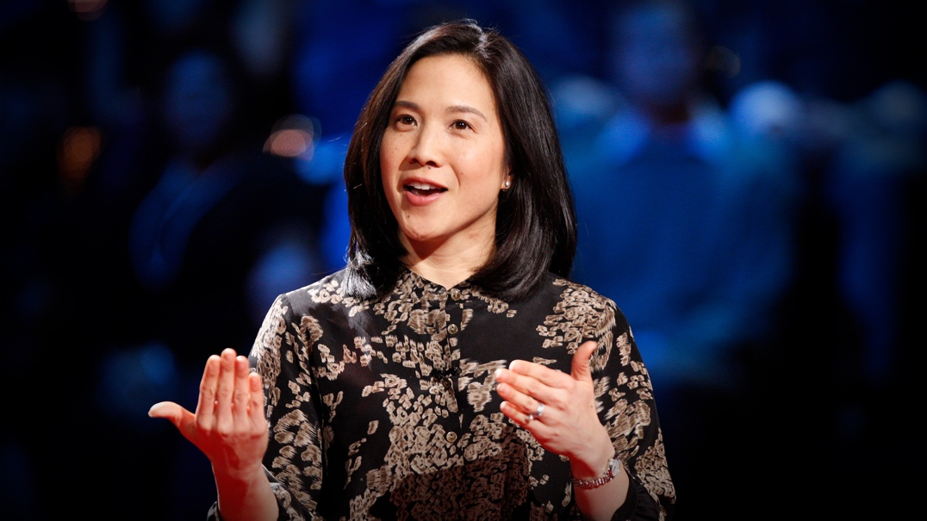
Angela Duckworth
Angela Duckworth is a psychologist born in 1970 age 51 she uses to be a teacher. She is a Professor of Psychology at the University of Pennsylvania where she studied grit and self-control. Angela Duckworth uses a grit scale to know how passionate and persevering the students are in studies.
On her grit scale there are ten questions each question there is five answers you can choose any answers because there is no right or wrong this grit scale is for students to be honest with them self’s. She also had a questionnaire that says who will become successful and why so she then went to west point military with her team and did the same thing but with different questions on which cadet will stay and drop out of the military training from there they went to different places with the same method but different answers for example National spelling Bee she also studied rookie teachers, they also partnered with private companies.
CRAAP test stands for currency, relevance, authority, accuracy and purpose. This are the five rules that will help you build a PowerPoint. People use CRAAP test to fix their mistakes by making sure that the audience get what the person is trying to pass on to them. This method helps a lot of people that normally do a lot of presentations to people for example business people, sports people like a coach when they are trying to do some strategies and they want to show it to the team or scientists when they are trying to find a cure for a virus or when they develop a new medicine so they then have to explain how it works.
Currency
Currency is the timeliness of information when you are building a PowerPoint you should know how old is the information are you getting it from the right place, when was the information create, published and posted on the Internet you should also make some research when was the information updated this will then make the information more accurate and more reliable.
Angela Duckworth passes the currency test because all the information that she is getting is recent all the information that she is given to the audience Is comes from the right place because she is doing herself, the information is recent and it’s updated. And it was also published on the Internet.
Relevance
Relevance is the importance of the information you provide or need for example does the information relate to the topic that you present to your audience is it also related to answers of your questions is the information at an appropriate level for example elementary school, high school, college or university. Who is the information meant for which audience? Also you need to look for different information before you choose the right information that you will be presenting to the Audience. Because the information you provide the audience will most likely listen to you and believe you with that, you’re going to look at variety of sources before determining that this is the right information for your audience.
Author is the source of information that comes from for example who is the creator, author and publisher of the information. What level of education does a person have a qualification to write or talk about the topic. Also you would want to know what are the persons statues are and privileges. As he ever had a documentary or does, he/her have any evidence. Also, you should find the authors affiliation this will then help you find the institution that the person belongs to. Angela Duckworth passes irrelevance test because the information that she provided is related to the topic and she is also talking at the appropriate level for the audience. For her to gain the trust of the houses she had to do some research she went to a graduate school and became a psychologist dare she studied kids and adult on to know who would be successful here and why in all different situations for example her and her research team went to West point military Academy to know Who will most likely be a cadet And stay in the military. training and which one will drop out of the academy. They also went to the national spelling bee and tried to know which children will advance farthest in the competition. They also partnered private companies and asked which of the sales people is going to keep their job and also who is going to end done most money. In all of this different situation she tested all of them and got the answers with that people are most likely to believe her because of the research and evidence that she made herself Plus she created a book which talks about all this stuff that as sold more than a million copies worldwide since it was published in 2016. She also has a good level of education because she went to university of Pennsylvania from 2002 – 2006, University of Oxford from 1994 - 1996 and she also went to Harvard of of Oxford College 1988 – 1992.
Accuracy
Accuracy is the ability of the truthfulness and correctness of the content that the person is showing. For example where does the information come from does he have any references to prove that the information is right is the information backed up with evidence are there any spelling grammar our typographical errors. Buy checking spelling grandmas it will be easier for the audience to read and also why do you trust it. Can the person verify in any of the information in other sources or from personal not knowledge with this question he/her will need to have evidence? Angela passes the accuracy test because she has the right information and also the evidence to back it up on a TEDTalk she didn’t really right nothing down she’s book everything clearly, she will to the audience so there was no need for her to make any corrections. Sure, sure has references.
Purpose
Purpose is the reason the information exists for example what is the purpose the information could be for information, to teach, to sell or to entertain also is the information a fact or an opinion. Someone times information could be objective or biased. Angela Duckworth passes the purpose test because she wanted to show to the audience and to the world that grit is what pushes people to advance in the future, she wanted to make it clear that without grit you would struggle to achieve what you want. She wants to o know how to keep the children motivated, how to have grit for the long run but she was honest to the audience and she said she doesn’t know with that I the audience knew she was honest and truthful to them.
DIKW
DIKW pyramid stands for data, information, knowledge and wisdom this method is used for measurements logging and tracking records all this are considered data. I will be explaining on how I use DIKW for my data.
Data
Data is the collection of facts and numbers that are unorganised. However, if there is no context or meaning to the data it means nothing for example 101010 is just a sequence of numbers without meaning or importance. But if we view it in a different way, it’s a date for example 10th of October 2010 by adding meaning to the numbers it now as value and importance.
In this way we have pictures from the right sequence of numbers into information.
Information
Information is easier to understand it’s easier to visualise and analyse data for specific purpose. Information is the next step in the DIKW pyramid this is data has been checked and cleaned and it’s much easier to understand the topic for example we can analyse Angelos Duckworth graph on how many people are successful and we can also compare our graph to hers if her method works or not by doing this I compared my graph to hers and my graph was going downwards and her graph was going upwards the shows that her method might not work or it’s because we had 10 to 15 people in our classroom and she had more people to do her tests with that she doesn’t matter I treat to her goal we also did a quiz in the class and we got the answers that we needed to do the graph.
Knowledge
The definition of knowledge of facts and skills acquired through education is also the understanding of this subject. Knowledge is the third step for Relevant knowledge. How does it get from collected data to relevant to our goals how are the pieces of information connected finally okay we applied information for our goals. Normally when you want to start to do something you go and teach yourself by teaching yourself you are studying by studying you are getting knowledge that you need to achieve your goal this will then lead to the final step wisdom.
Wisdom
The definition of vision is having experience knowledge and a good judgement it’s also been a wise person. Definition of fat is when provided all learn about something When trying to teach, example or to prove something. Wisdom is the final step for the pyramid and to get there you must answer questions when the audience or any person ask A question you must know the answer for example “why do something” and “what is the best” to make it simple wisdom is the knowledge applied in action.
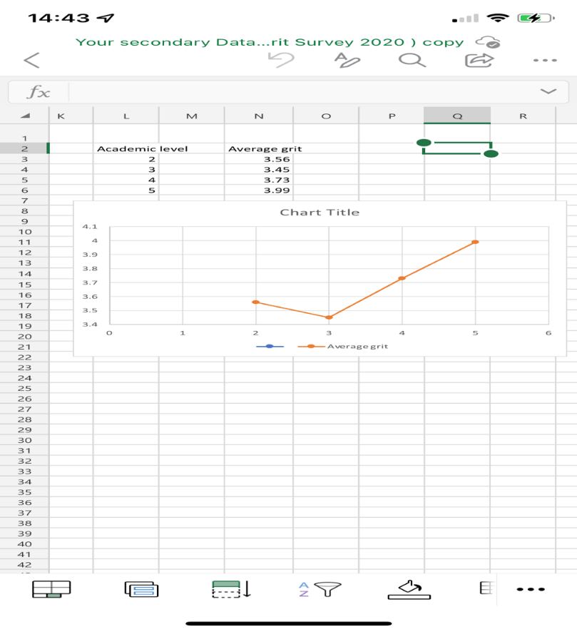
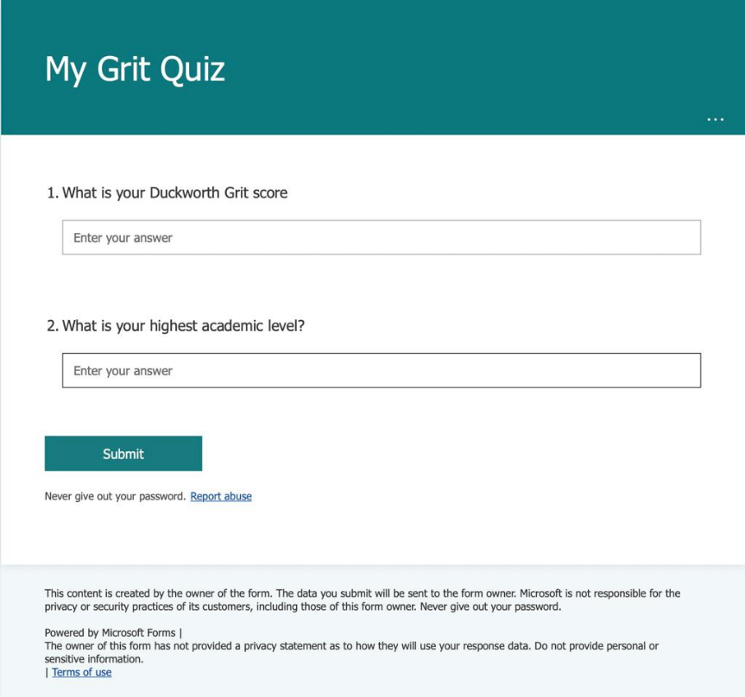
On my DIKW I did a graph I had two graphs one was Angela Duckworth research and one was mine for me to get the information we as a class worked together with that, we did a quiz test and got our answers. We got the great score and academic level then we averaged it and got the numbers we needed then we got the academic level average grade by doing that we put it in a scattered chart and we got our answers then we compared it to Angela Duckworth and we did the same thing we averaged her scores and got the answers. As you can see on her graph the average is going up and mine is going down, why because she had more people to be doing her test on with that, she was able to be more accurate on her results, we had 10 to 15 people to do our average test as a group so maybe it wasn’t as accurate as hers but we still got our answer.

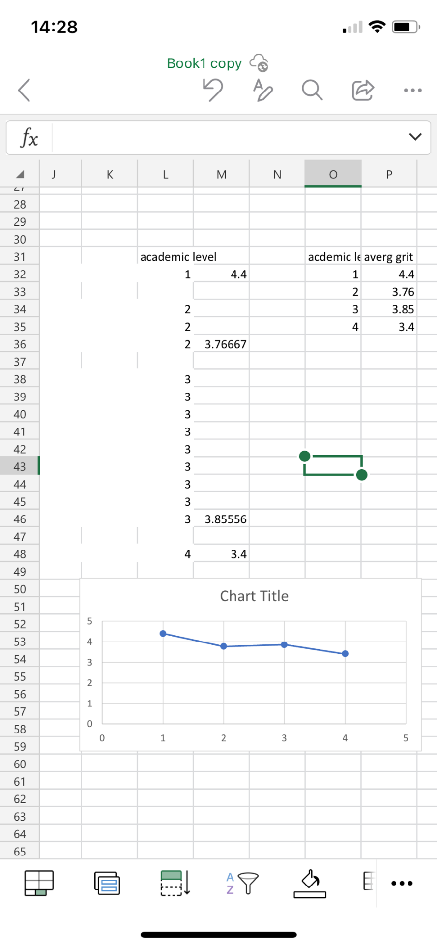

References
https://www.youtube.com/watch?v=H14bBuluwB8 - Grit: the power of passion and perseverance | Angela Lee Duckworth
https://www.youtube.com/watch?v=J-swZaKN2Ic - The power of yet | Carol S Dweck | TEDxNorrköping
https://www.scribd.com/book/308030757/Grit-The-Power-of-Passion-and-Perseverance?utm_medium=cpc&utm_source=google_search&utm_campaign=3Q_Google_Search_Beta_NB_UK&utm_term=&utm_device=m&gclid=CjwKCAiAksyNBhAPEiwAlDBeLPmmj-bU-adDavOVoeRncnFzO5RgEa8Dc9WZ8MmIX6q1Dg6rlDaVJBoC1yIQAvD_BwE
https://angeladuckworth.com/grit-scale/

