ACADEMIC AND EMPLOYABILITY SKILLS
BMSW4001
TERM 2

Student: Jesica Alexandra Alonso Beltran
Student ID: 1909628
Tutor´s name: Lloyd Beharry

Table of content

Introduction 3
Gibbs reflective style 3
Reflective writing 5
References 8
Appendix 1 9
9
Appendix 2 10
10
11

Introduction

Today as a citizen, we must learn new methods and ways of work, we can find this in the academic and work environment, we all have certain skills, we contribute knowledge but they are not sufficiently elaborated, we have to work on it.
The purpose of this report is to investigate students from the University of Wales Trinity Saint David TERM 2 to analyze the process of students learning about the course, analyzing their development from the beginning of the course .Analyzing with which skills they have arrived from the beginning of the course as they have developed.
To develop this assignment I will use Gibb’s reflective cycle is a popular version of mirroring. The version covers 6 stages of reflective and is attendance below as cited in DYE. (2011, pp.230).This model contains 6 stages given a full description helping you giving questions to ask yourself that reflect your or someone’s experiences.

Gibbs reflective style
Description

Action plan
Feelings

Conclusion
Evaluation

Analysis

‘It is not necessary an experience to learn, without reflecting on it may quickly be forgotten, it is from the feelings and thoughts from this reflection this can be generated and allow a new situation to be efficiently’. (Gibbs 1998).I t is a helpful mode of structured reflective writing that offers the chance to analyses an experience in detail in six different stages.
‘Gibbs developed the concept of a meditative cycle to motivate learners to think systematic about the experience.’ (Heyer, 2015). This cycle helps individuals to understand and get knowledge of their own experiences, dividing their experiences in six different stages. I will use this reflection model to reflect my learning experience in class. In my reflective writing I will divide my experience in six stages as this model requires.
The first step is description where I will write about my experience, telling what happened, who was there, writing about the background of the experience. In the second step I will discuss about my feeling and thoughts, reactions of the experience. In the third step I will say my opinion of how well I think the experience went also I will say the positive and negatives part of it. In the fourth step I will discuss what I consider that might helped me in the situation. In the fifth step I will write what I have learned of this experience. Finally, in the last step I will say what I will do for improve in the next experience.

Reflective writing

When I applied for University I did not imagine how difficult and intense the classes would be. Being my first time at University made me a great impact on me, over the course I have grown and learned more than I thought possible for me incident occurred when they asked me what did you know before the course and what have you learned during the course about academic and employability skills. These two questions frustrated me a bit because the answer was too long; there were many things I did not know, many things I had learned in those months. I have emphasized four academic work skills. I knew all these skills and knew how to use them before starting the course. I was frustrated because of each skill I had something to say but In addition to this I had also learned a lot of things in this course, those months at university had taught me so many skills that are important for work and academic environment, I gained experience from each of them thanks to class exercises, presentations in class, assignments and others.

Communication has been described as sharing and giving meaning happening at the same time across symbolic interactions (Sciler & Beall, 2005).Communicstion also has been defined when a message or information is transport from the sender to the receiver and followed by the receiver giving feedback.(Sulaiman,Marsi 1997).Communication for me was a skill that I had before the course, I communicated easily with others and I knew how to listen to them, I felt happy that my ability to communicate was good.
Time management means sort out your time efficiently. Means to the practice of distribute your time so that we all can achieve our objectives. Time management can be viewed as a way of monitoring and controlling time. (Eliahm & Aharon ,2003).Time management was a skill which I did not feel very sure because I was not using this skill very well, I did not manage time well I felt that I spent a lot of time on unnecessary things and also the time was never enough for me to complete my objectives.
Teamwork is defined by Scarnati (2001, p 5) ‘As a cooperative process that allows ordinary people to achieve extraordinary results’. Teamwork means individuals working together in the same environment to achieve a common goal through sharing knowledge and skills. (Fisher, Hunter & Macrosson, 1997).Teamwork this skill was always easy for me, I was confident in this skill. I never had any problems with any colleague, I knew how to keep quiet and obey the instructions form the group leader.
Presentation skills
Presentation skills this skill I felt frustrated and lost without any idea, I had no experience with this skill before starting the course, I felt scared every time I had to use this skill in my workplace or my studies.

At that time I had not understood how important each skill was and how much more I needed to learn. I did not see the importance of each class, in those months things were changing better, the classes were helping me a lot in my work environment I started applying those tips that I was learning and clearly, they were effective.

However, after starting the course I realized that in communication not only the message is important that also the appropriate way of transmitting the message is important while maintaining eye contact, body language, tone voice, in addition to this I have learned the different models of communication such as Shannon and weaver, Schramm, Berlo. I this course I have been able to see that time is the most important thing we have and therefore it is necessary to learn how to use it also I learned to recognize important and not important about my life and spent time on the important ones. Moreover, I learned the 80-20 rule, which is a very effective method that helps you to organize your time. In addition to this I realized that teamwork is a very important skill in the society you will always need it, teamwork includes many functions, each member is in charge of a function, as a team everyone needs to work hard to achieve the goal, it is also important to learn how to communicate with your colleagues in a constructive way to make a decision or resolve a conflict. I also realized that everyone feels nervous before a presentation that no one has presentation skills in their first presentation. That you need more than to lose the shame before the public, you need to dress appropriately for the occasion, have the correct tone of voice…

In retrospect, I would think differently when starting a new course, I would think as a new opportunity to learn something different. However this experience made me realize the importance of education in life, I think I have developed professional skills like know how important is to communicate with others in a professionally, work with another member without any conflict, manage time in the right way and make a professional presentation to the public.

In college vacation time, I plan to learn new skills that can be useful to me in environments, academic and employability. I would like to start short courses such as technology, languages, first aid course and more. This experience has made me realize that I need to acquire more skills and stop believing enough with what I know and always wants to learn more.

References

Eliah & Aharon(2003) Time management is life management. International Journal of trend in scientific.(2),748-752.
Fisher,Hunter & Macrosson(1997).Managers perceptions of the differences. Journal of Managerial Psychology,12(4),232-242.
Gibbs,G(1998) Learning by doing .A guide to teaching and learning methods. Oxford. Oxford further.
Henyer,R.(2017)Learning through reflection. British journal of midwifery, vol.25.No 10.
Scarnati,J (2001) On becoming a team player,team performance Management.An international Jounral 7(172) 5-10.
Sciler,W & Beall,M(2005) Communication; Making connections,6th ed. Boston.
Zanaton Haji Iksan et ad. (2012)`Communication skills among universities studies´ Procedia social and behaviors science, (59), 71-76.

Appendix 1

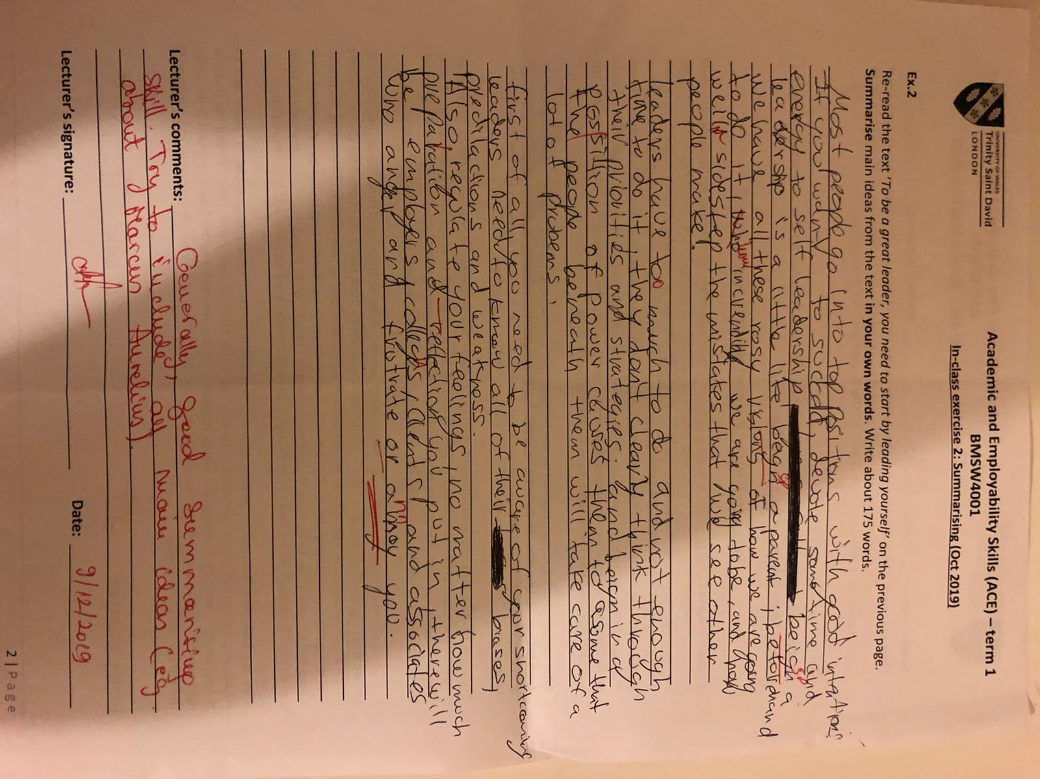

Appendix 2



