
a Journey with mary barra in today`s leadership
ESSAY

March 4, 2022
vERGINICA cARACAS (1906795)
UNIVERSITY WALES TRINITY SAINT DAVID

Introduction
This essay tries to explain the profile of Mary Barra, the first- ever female to manage a US automaker, a leader who changed the culture of one of the most famous corporate companies, i.e., General Motors. It discusses Barra`s background, leader traits and styles, as well as the way she succeeded in getting the company on the right track after it had gone bankrupt by combining the old leadership theories as Traits and Lewin theories with the new leadership theories, such as Bass theory (1985) which help leaders manage organisations in a changing environment.
The second part of the essay discusses my personal leadership style according to the results of my Leadership questionnaire as well as the way I could fulfil the role of a leader and how I would use this to ensure the success of improving motivation levels during the covid pandemic within an organisation.

Background of the leader
Nowadays, in this period of crisis, leaders are exposed to major changes, and enormous pressures. A leader who managed these changes well is Mary Barra, the CEO of GM, since 2014.
Mary Barra is the first female ever to lead a major international automaker in an industry that has been generally dominated by men. A graduate of Flint`s General Motors Institute, (now Kettering University) she has gained 40 years of experience working at General Motors which resulted in an illustrious career. During all these years, Barra has served the company in different capacities with positions in manufacturing, human resources, engineering and senior management. (McGrath, 2013)

Main body
The Leaders Traits and Style
What is Leadership? According to Davis (2003), leadership is an activity that can “bubble up” in various places within and is no longer only focused on formal leadership roles. Over the years, several theories and models have been developed to provide solutions for different leadership styles.
The Trait Theory was developed in the mid-1800s, by Scottish philosopher Thomas Carlyle based on the rationale that people are “born” with leadership traits, certain traits produce certain patterns of behaviour, and patterns are consistent across different situations. (Cherry, 2021) It is the first model based on the characteristics of many leaders, seeking to answer essential questions on why some individuals make good leaders, and other do not. (Management Study HQ, 2021)
Research in the 20th century has identified a set of core traits for successful leaders:
Leadership motivation means the desire to lead other people to achieve common goals.
Mary Barra took over the management of GM when it went bankrupt and together with the management team managed to get the company on the right track. After four years GM became The New General Motors, one of the most important car companies in the USA that is moving aggressively to define the future of transportation. (DeBord, 2018) This is an example of big commitment and effective leadership motivation.
Honesty and integrity are two traits of trustworthy, reliability and openness.
Self-confidence means that a leader to be confident in his/her vision and abilities.
Cognitive ability and Emotional Maturity. This means a good judgement, strong analytical abilities and fundamental skilles.
Shortly after Marry Barra became CEO of General Motors, she faced “a major crisis over safety malfunction in GM's older cars, the so-called "switch gate crisis." (Carrie, 2019) This crisis resulted in 124 deaths and 275 injuries. (Feloni, 2018), General Motors paying affected families $ 600 million in damages, and more than thirty million cars were recalled. She approached all issues with transparency, and she has earned a wide reputation for talent, honesty and integrity.” (Ellis, 2017) Barra testified before the US Senate, on which occasion she promised that she would change the fundamentals of the company's culture. (Moran, 2020). This crisis had changed her leadership style and changing the corporate culture had become a necessity. Respecting the promise made to the US Senate she has managed to change General Motors' corporate culture based on reducing costs, by building a social culture developing a new set of core values in which product quality as well as customer safety are paramount. Customer satisfaction would be at the centre of everything. (Ellis, 2017) This example highlights a good and mature judgement, self-confidence, honesty and integrity, traits that Barra as a leader had showed.
Business knowing
Throughout her career, Barra expanded the range of skills and abilities starting with engineering, quality control, product development, human resources and senior management, (GEEK MASTER, 2020) and she has gained 40 years of experience working at General Motors.
Charisma
Mary Barra focused on relationships with people, really listening to them, winning their hearts and minds. (Carrie, 2019) She inspired people to commit to goals by displaying a charismatic behaviour and by setting a strong personal example.
Trait theory provides constructive information about leaders and leadership and due to its advantages can be applied at all levels and in all organizations.
No other theory of leadership has been researched as extensively stated Northouse about Trait Theory. (Squires, 2018)
Another advantages of trait theory are it is verified by other research, serves as a benchmark and provides an understanding of the leader in the leadership process.
There are also limitations to the theory, such as the list of traits is long with over one hundred traits, the theory becomes too complex. Another limitation is the fact that no consensus has been gained on the most essential traits for a successful leader, and even the subjectivity that can intervene in the appointment of a successful leader. (Management Study Guide, 2021) Another weakness of the theory is the fact it is focusing on the leader without observing followers and situations.
Through her leadership, Barra encouraged people to speak up and really listened to them. In the ignition recall scandal, she initiated and implemented "Speak Up for Safety" a programme that encourage employees to come up with ideas to improve customer safety.
Furthermore, she empowered employees by allowing them participation in the decision-making process. The most intriguing measure Barra took on employee empowerment was to change the company's 10-page dress code policy to two words: "dress appropriately." These are characteristics that Kurt Lewin (1951) stated in his theory of Leadership Style for democratic leader. Democratic leaders encourage group members to participate, to produce ideas while keeping their right to the final decision. (Leadership & Performance Partners, 2019)
In an organisation with a democratic leader, the employees feel valued, which motivates them to increase productivity, and managers understand what the employees` needs and motivators are. (WGU, 2019) Barra is aware of Maslow's hierarchy of needs knowing that the staff are differently motivated and proceeding accordingly, she manages to communicate and inspire the team to perform.
Mary Barra is innovative and creative, and she focuses on electric vehicles, and on autonomous vehicles to keep the planet clean and safe for the next generations.
Moreover, Barra is a visionary, and she foresees that automobile industry will change in the next ten years more than it has in the last 50 years. To be one step ahead, Barra intends to implement the latest technology in all the GM products. She has launched Chevrolet Bolt EV, an electric car with a range of two hundred miles, which outlasts Tesla`. Barra said: “Put the safest, highest-quality cars on the road,” and for this, she set herself a goal for General Motors: zero crashes, zero emissions, zero congestions
A transformational leader demonstrates their creativity and innovation to become a role model for the leaders` team and for employees, showing them steps to follow.
There are several traits for a transformational leader, such as: being mindful, and aware of his/her strengths and weaknesses, being humble, but courageous to confront difficult situations, and follow their vision. Other traits include creativity, inspiration, and passion in their work, as well as strong relationships based on trust within the organisation.
By every definition, Barra is a transformational leader whose influence will permanently reshape General Motors. (Financhill,2021)
Regarding the type of power that Barra has adopted to GM's leadership, she has the expert power of the automobile industry in her background, and through respect, transparency and integrity she has gained the referent power. This is, according to psychologists John French and Bertram Raven (1959), a successful combination. Being CEO and Chairman for General Motors, she has legitimate power, which confers her rewarding power. Coercive power is not suitable to Barra`s behaviour.
In conclusion, Mary Barra has shown effective leadership by managing to get General Motors back on its feet after a bankruptcy, and to keep its reputation and that of GM intact after the crisis with the power button. Furthermore, she has managed to transform the corporate culture of the company, which had become obsolete with a social culture made of a new set of values, focused on customer satisfaction and safety.

Influence of The Leader

“An effective strategic leader is one who delivers goods in terms of what an organization naturally expects from its leadership in times of change.” (Adair, 2010) “The real job of a leader is not about being `in charge`, it`s about taking care of people in his charge.” (Sinek, 2017)
One of Barra`s strengths as a leader is that she cares about people in the community and the planet having the obligation to act responsibly and courageously for the people`, because she believes `the employees are the most important asset` a company could have.
Leadership strategies can help improve the ability to influence team action and performance. (CRESCOM International, 2016)
There are a few leadership strategies, but the most important five are:
Define and Communicate Vision
The leader's vision is a long-term strategy that projects an image of the company in the future that is measurable.
Mary Barra had the vision to make General Motors the most inclusive company in the world. She saw the benefits of having a diverse workforce and she strongly supports it, making it a high priority, and under her leadership, GM has consistently scored highly in gender equity reports. (The CEO Magazine, 2021)
However, leaders of several black-owned media companies accused Barra of being racist for what they described as her refusal to meet them. (Shafer, 2021)
According to Miller (2021) “helping GM achieve status as the world`s top company for gender equality” is the second top achievements in her book.
Rewarding and Recognition
Rewarding and recognizing inspires a sense of commitment and involvement in employees and they want to feel appreciated.
Speak from the Heart
The idea that the leader must always speak from the heart and not from the budget, means open and honest communication with people. Passion builds a bridge that allows the audience to connect with the leader.
In all public appearances Barra refers to the achievements as collective by referring to the team, and speaking with passion about the projects they develop, and about the future of transportation.
Empowering and Delegate
It means to give employees the responsibility and authority to do something, and they will become creative and innovative thus, increasing their productivity and performance.
Barra empowered all staff to `dress appropriate` making it from that moment on each employee`s responsibility to dress accordingly.
Continue education
Continued education refers to coaching and mentoring, as well as expanding the team. The role of coach / mentor makes a leader truly fulfilled by sharing knowledge and experiences with someone else. Mary Barra became a Doctor of Engineering Honorary Degree in 2014.
Mary Barra's strategy for GM is a transformational leadership strategy of changing corporate culture to social culture focused on customer excellence.
She has thus revived the company, aiming for GM to be a top automaker.
Together with the management team Mary Barra puts the wishes and needs of the clients in line with the company's objectives and announced a new state of values of the company focus on three factors - excellence, customers and relationships. (Desravines, 2020)
Personal Leadership Style
The responsibilities of a leader are “vital parts of a business, so effective leaders can help develop an impressive organizational culture and even financial success.” (Hordos, 2019) A leader must consider “the experiences, knowledge, skills and opinions of others and take responsibility for their work. Also, in order to gain the trust and respect of those who follow him, he must be honest and show integrity.” (Agile Business Consortium, 2021) According to my leadership questionnaire results (a score of 20), I am a leader who take the process of leadership seriously. On behaviour emphasis I also scored 20, which translates into the attention I pay to behaviour and actions rather than to personal qualities and traits. (Appendices, p.10)
The process of leadership is a complex, interactive, and dynamic working relationship between leader and followers that it is built over time. (BC campus Open Publishing, 2021) The leadership process is distinct from the leader and followers present in Figure 1 (Appendices, p1) It is interacting with the leader and the followers, in various situations depending on the environment, the tasks of the group, and possible legal changes. In the leadership process, communication must be open, honest and in both ways: leader to followers, which means from the top down, and at the same time followers to the leader, that is, from the bottom up. In the leadership process, the leader is available to answer the questions of those who follow it, to motivate and offer them guidance, remaining detached from the process to pay attention to achievements. The team concept is extremely important in the leadership process (Cyprus, 2022) the team refers to the leader, the followers and the relationship that it is built between them. Because I pay attention to followers, as well as to the relationship created between me us, I establish my strategy and approach the most appropriate style of leadership for each situation and context. I am a leader, rather than a manager. The leadership process gives me the opportunity to listen to people, to get to know their family background so, that I know how to motivate them, how to support them. This helps me to treat them honestly and openly and put people first because they are the most valuable resource a leader has. The leadership process is important because it encourages innovation and creativity thus, improving performance and productivity, and builds relationships of trust and respect within the team. However, the decision-making process can be time consuming and delay the solution due to participation of the followers in the process. Behavioural leadership has a different approach focusing on the behaviour and actions of leaders and not on their personal traits. In the leadership process, an interpersonal relationship is created between the leader and the followers. The right behaviour of the leader can build trust and efficiency in his team, while incorrect and bad behaviour will have the effect of losing followers. (Sinha, 2021) Behavioural theory brought in addition to Trait theory, which distinguished leaders from non-leaders, determines0 how diverse types of behavioural leaders influence the performance of followers. For example, I would include leadership by example to inspire and motivate team members. Rewarding performance, initiative, and creativity is a behaviour of recognition and appreciation that I apply when leading the team. Studies have shown that there are two styles of behavioural leaders: Production-centred leadership (tasks) means rules, procedures, standards, and employees are supervised and viewed as tools not as human beings.
Employee-centred leadership (relationship) focuses on human relationships by caring about the needs and well-being of employees, as well as their performance and career.
Task-focused leadership seems to involve more management and an effective leader chooses the employee-centred style as people are the essence of leadership, without people leadership does not exist.
For me, leadership is:
Listening
Empathy
Authentic
Dauntless
Ethical
Responsibility
Servant
Humble
Inspirational
Problem-solving
There are criticisms of behavioural leadership that the situational factor in different situations require different behaviours. Moreover, it doesn't take time factor into account.
The importance of a leader can be seen in both the business and in the team.
In business, the leader motivates and guides people in an ideal way, being admired, respected and followed as well as ensuring a continuous process of learning and development for employees. Consequently, the productivity of the team is improved thus, increasing the overall results of the organization.
In short, the leader must have a clear vision and strategy of the business and the ability to communicate it clearly and correctly to followers. Regarding my personal skills for a leadership role, I am a democratic leader asking people for opinions and treating them with honesty, respect, and dignity. Communication between leader and followers is particularly important in order to create a trustful and honest work environment, and it has been proved that motivated employees are more efficient and more committed to achieving the goals of the organization.

Leading of change
The leader is the first to embrace change. In an extremely dynamic environment where the ability to react and make decisions very quickly makes the difference, a leader with a team that admires and appreciates him will receive the latest information and feedback needed to adapt to change.
We live in a world of constantly changing technology, of the environment, with pandemics that are transforming our lives. Businesses need to adapt to change, and for that they need to focus on making sure they are prepared for change. Leaders must make effective use of the 3 Cs of change leadership: communication, collaboration, and commitment.
When a team becomes demotivated, and in times of change, people do not feel motivated enough, the leader intervenes to improve the level of motivation. The first thing I, as a leader, would do is listen to my subordinates to find out what worries them and what they expect from the leader. Then I encourage them to come up with ideas for improving the work environment and alternatives to current procedures. Extraordinary ideas that have a positive impact on the organization can come from where you least expect it. I would consider people motivation and engagement as top priority. Furthermore, I would try and give people what they need helping them to accept the change and therefore, becoming more efficient and loyal to the organization.
An example of change in my team may be when management has decided to reduce employee contracts due to the covid pandemic. As a leader, I listened to each member of the team, finding out how they felt, so that I could empathize with them, giving them a sense of security. I have communicated in an honest and transparent way the fact that I was also worried about the decrease in the number of residents, but I was also aware the situation was temporary, and that together we would find ways to help the organization maintain its activity.
For example, in my case, I have had fewer hours in my contract and so, I have been dealing with the management against unhealthy competition not to hire staff with 0 hours contract to fill the gaps in the activity This way I showed my empathy and collaboration with my team.
I put the team at the forefront and reorganized the work according to the availability of each one, showing them the advantages of this measure: more time to rest and to spend with family and less physical and intellectual effort at work, and better health. By enlivening the team and being a support for everyone all this time, I managed to keep the entire team, but for one member who had health problems, and was going to have surgery. After a month, the management returned to the decision and the employees returned to the initial contracts.
Assessing my leadership style, I was a democratic leader, empathetic, servant, and responsive, adapted to situation, and proved the necessary skills needed in the process of leadership change. I believe that my leadership style has been effective and given the profound change we have had to face, it has been a success.

Conclusion
As stated above, each of the theories has different characteristics and areas of study, but both can be combined in a variety of ways and applied depending on the context. This way leaders can choose the leadership style according to the culture of the organisation, its team members, and the given context.
Leadership is the way to guide employees to performance, development as well as a way to make them feel like they belong to the team. Leaders can help organizations improve their productivity, reduce staff turnover, and keep their image and reputation intact. Leadership roles are important in any organization because leaders are able to inspire and motivate employees to achieve a high level of performance and select the right people for the right jobs. Leadership brings better benefits to the organization when it is applied at every level.
As today's times are constantly changing, leadership styles must also be adapted to the new requirements. Thus, modern leadership trends are more toward an empathic, servile, democratic, or collaborative, and transformational style than an authoritarian style.
One conclusion about my own leadership style is that I am in the modern trends of leadership with an empathic style of listening and empathizing with people, and democratically by engaging subordinates in decision making. The power of example in leadership brings real benefits to followers (they will learn from the leader how to be efficient), to the company (improved productivity, profitability and customer satisfaction) and to the leader, who attracts respect and commitment from subordinates. Therefore, this is a win-win-win situation, when all the parties involved have something to gain. This combination of leadership styles suits the current business environment, but I could always better my communication and relationship skills.

Appendices

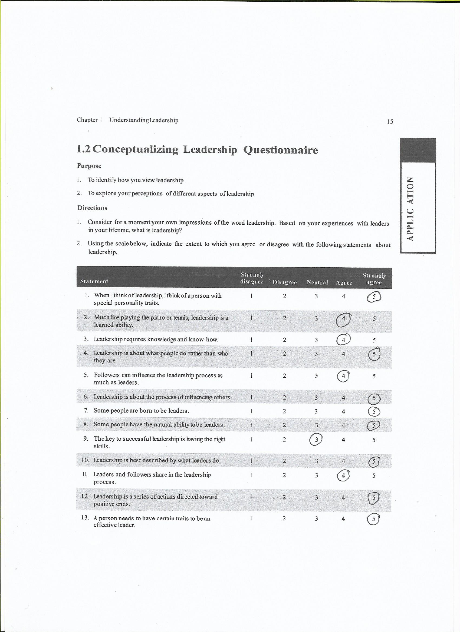

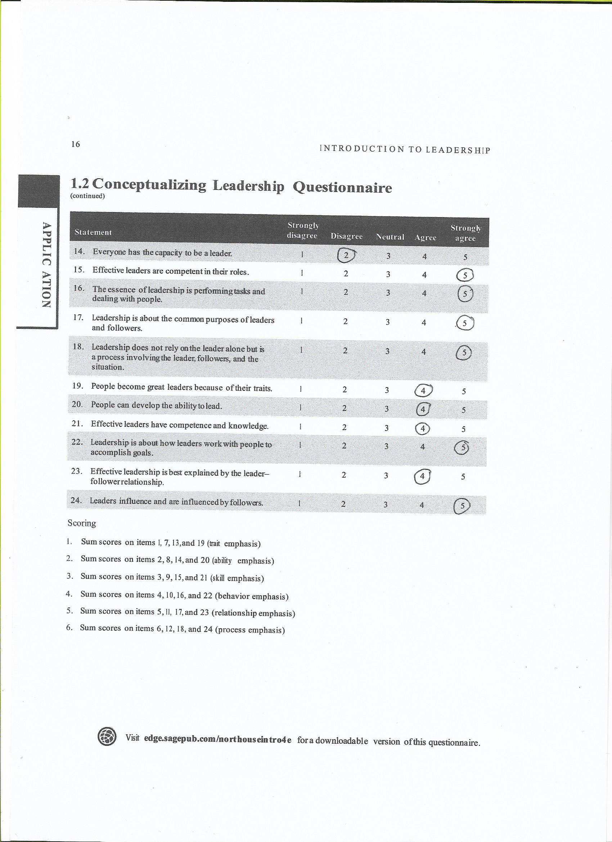

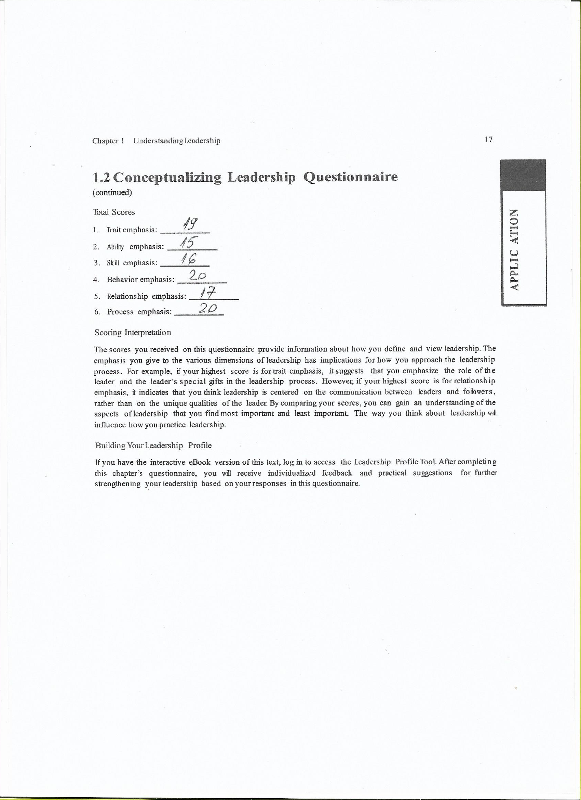

References List
- Adair, J., (2010) Effective Strategic Leadership: The Complete Guide to Strategic Management. Available at: http://www.books.google.co.uk (Accessed: 25 February 2022)
- Agile Business Consortium, (2021) Role and Responsibilities Available at: http://www.agilebusiness.org (Accessed: 15 January 2022)
- BCcampus Open Publishing, (2021) Organisational Behaviour. Available at: http://www.opentextbc.ca (Accessed: 12 February 2022)
- Carrie, A., (2019) Leadership Lessons from GM CEO – Marry Barra. Available at: http://www.industryleadermagazine.com (Accessed: 10 November 2021)
- CRESTCOM International, (2016) 5 Leadership Strategies Proven To Improve Performance on Your Team. Available at: http://www.crestcom.com (Accessed: 28 November 2021)
- Cyprus, S., (2022) What is the Leadership Process? Available at: http://www.smartcapitalmind.co (Accessed: 20 February 2022)
- DeBord, M., (2018) How GM went from a government bailout and bankruptcy being one of the world`s best-run car company one decade later. Available at: http://www.businessinsider.com (Accessed: 26 November 2021)
- Desravines, N., (2020) The Businesswoman: Mary Barra. Available at: http://wwwwomleadmag.com (Accessed: 26 November 2021).
- Ellis, B., (2017) Marry Barra – Transforming General Motors Through Powerful Leadership. Available at: http://www.brandingforresults.com (Accessed:26 November 2021)
- Feloni, R. (2018) GM CEO Mary Barra said the recall crisis of 2014 forever changed her leadership style. Available at: http://www.businessinsider.com (Accessed: 11 November 2021)
- Financhill, (2021) Mary Barra Leadership Style. Available at: http://www.financhill.com (Accessed: 23 November 2021)
- GEEKMASTER, (2020) Mary Barra – Leadership Style & Principles In The Spotlight. Available at: http://www.geenack.com (Accessed: 10 November 2021).
- General Motors, (2021) Mary T. Barra Chair and Chief Executive Officer. Available at: http://www.gm.com (Accessed: 9 November 2021).
- Hordos, L., (2019) Leadership Roles and responsibilities Available at: http://www.bizfluent.com (Accessed: 15 January 2022)
- Insights, (2021) Why empathetic leadership is so effective and how to use it. Available at: http://www.insights.com (Accessed: 12 February 2022)
- Leadership & Performance Partners, (2019) Lewin`s Leadership Theory Explained. Available at@ http://www.leadershipandperformance.com (Accessed: 11 November 2021)
- Management Study Guide, (2021) Trait Theory of Leadership. Available at: http://www.managementstudyguide.com (Accessed: 24 November 2021)
- McGrath, M. (2013) Mary Barra named GM CEO, Automaker`s First Female Chief. Available at: http://www.forbes.com (Accessed: 25 November 2021)
- Mind Tools, (2020) French and Raven`s Five Forms of Power. Available at: http://www.mindtools.com (Accessed: 25 November 2021)
- Miller, H., L., (2021) Mary Barra: From Co-Op Student Employee to GM`s CEO. Available at: http://www.leaders.com (Accessed: 1 December 2021)
- Moran, A. (2020) Mary Barra`s Leadership style: What Entrepreneurs Can Learn Available at: http://www.startingbusiness.com (Accessed: 10 November 2021).
- Rosen, B. (2014) Leadership Journey – Mary Barra. Available at: http://www.iedp.com (Accessed:10 November 2021)
- Shafer, E., (2021) GM CEO Mary Barra Accused of Racism in Ad Signed by Leaders of Black-Owned Media Companies. Available at: http://www.yahoo.com (Accessed: 11 November 2021)
- Sinek, S., (2017) Understanding Empathy. Available at: http://www.youtube.com (Accessed: 21 January 2022)
- Squires, V., (2018) `Book Review` Review of Leadership: Theory and Practice, by Northouse, P.G. (2016) Available at: http://www.journalhosting.ucalgary.ca (Accessed: 15 January 2022)
- The CEO Magazine, (2021) Diving Change: Mary Barra. Available at://http://www.theceomagzine.com (Accessed: 11 November 2021)
- WGU, (2019) Type of management styles for business leaders. Available at: http://www.wgu.edu (Accessed: 24 November 2021)

