Lindsay Davies
2414210
University of Wales Trinity Saint David
Mode/code: Health Promotion in Practice/(BMHN5002)
Title: Promoting Dietary Fibre Intake: A Health Promotion Event Evaluation
Word count: 2181
For this assessment, Generative AI was used only for research, structuring, proofreading, and learning support, in line with module guidance. Copilot supported the research process by helping to locate academic sources, summarise external materials, and clarify data-handling steps in Excel. Library search tools were used to find original theoretical papers, including the Behaviour Change Wheel, Self-Determination Theory, and the Transtheoretical Model. All analysis, interpretation, critical discussion, and written content were produced independently by the student. The table below outlines the AI tools used, their purposes, and the example prompts that supported my research and learning.

AI tool | Reason for use | Example prompt(s)
Copilot | Research | Find me the current consumption of fibre being consumed each day in the UK.
Copilot | Research | Show me a governing body that says that colorectal cancer is rising in the UK.
Copilot | Research | Show me an academic paper that shows that low fibre increases constipation and colorectal cancer.
Copilot | Research | Find me an academic journal that looks at increasing water intake when you increase fibre.
Copilot | Research | Find me an academic journal that speaks of the importance of partnership working in health promotion
Copilot | Research | Show me the Public Health stance on partnership working in health promotion.
Copilot | Research | What is the WHO stance on partnership working in health promotion? Show me the links.
Copilot | Research | What is the WHO's stance on sustainability? Show me the links.
Library | Research | Behaviour change wheel.
Library | Research | Self-determination theory.
Copilot | Research | How does Public Health evaluate its health promotion campaigns?
Copilot | Research | Find me an academic journal that looks at the importance of evaluating health promotion events.
Copilot | Research | Find me an academic journal that looks at the importance of working as a team to deliver a health promotion event.
Copilot | Research | Find me academic journals on health promotion in practice.
Copilot | Learning | Using these screenshots, tell me what I should insert into Excel, and give me a step-by-step guide on how to produce charts with this data.
Copilot | Learning | What do these results mean?
Library | Research | Original paper for the Transtheoretical Model (Stages of Change)
Copilot | Structuring | Suggest a logical structure and subheadings for my report.

Promoting Dietary Fibre Intake: A Health Promotion Event Evaluation

1 Background and Event Description
UK adults rarely meet the recommended 30 g/day fibre intake (OHID, 2025). Low fibre intake increases the risk of constipation and colorectal cancer (Bellini et al., 2021; WCRF, 2026). Colorectal cancer has risen steadily in the UK over the past two decades (Pedregal Pascual et al., 2025). The event was a fibre-focused educational stall designed to raise awareness of fibre and its health benefits. Hydration was included because adequate fluid intake supports normal bowel function (Bellini et al., 2021).
The event aimed to improve understanding of fibre by explaining its role, recommended intake levels, and simple ways to meet the dietary reference value (DRV). It also assessed participants' knowledge and encouraged reflection on personal habits.
Interactive and visual activities supported learning, with student-led explanations throughout. Posters and leaflets outlined fibre's role in health, and another display showed how to reach DRV with common foods. Physical food examples supported an interactive guessing activity, and the Bristol Stool Chart and Urine Colour Chart helped explain gut health and hydration. A short questionnaire assessed learning, and food-swap suggestions supported practical behaviour change.
The team planned the event through weekly meetings. Tasks were shared evenly, and roles were allocated to ensure smooth preparation. Team members designed posters, prepared leaflets, sourced food examples, created the questionnaire, and organised the stall layout. Evidence-based information from SACN and NHS resources supported accuracy (NHS, 2026; SACN, 2015).
On the day, the stall was set up in a public area with displays and interactive activities. Participants engaged with discussions about fibre and hydration, completed the fibre-ranking game, and filled in the questionnaire. Small freebies were offered as a thank you. All aims and objectives were met according to the post-event evaluation (n = 47).

Methods
The stall ran on 24 March 2025 at The Quad, University of Wales Trinity Saint David, from 10:00 to 16:00. Students approached fellow students and tutors to take part. A total of n = 47 participants completed the questionnaire. Participants were university affiliates aged 18 to 55+; gender was not collected. The questionnaire comprised 8 items (7 closed-ended knowledge/behaviour items and 1 open-ended intentions question, Q8) and was piloted with 2 students. Participation was voluntary; consent was obtained prior to completing the form, and responses were anonymous and stored securely. Ethical considerations were overseen by the supervising tutor as part of a teaching assessment. Descriptive analysis (counts and percentages) was performed in Microsoft Excel.

2 Questionnaire Results and Impact Evaluation
The questionnaire data (n = 47) were analysed using Microsoft Excel; findings are presented in Table 1 and Figures 1–5. Participants were university affiliates aged 18–55+; gender was not collected.

2.1 Knowledge-based results
Table 1. Overview of Participant Responses to the Fibre, Hydration, and Bowel Health Questionnaire (n = 47)
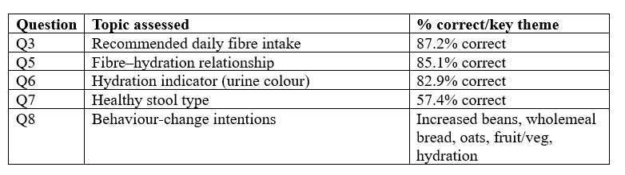

Figure 1. Percentage of correct responses across all knowledge questions (n = 47).

Figure 2. Knowledge of recommended daily fibre intake (n = 47).

Figure 3. Understanding of the fibre and hydration relationship (n = 47).

Figure 4. Knowledge of hydration indicators (n = 47).

Figure 5. Identification of healthy stool type (n = 47).

Across the knowledge-based questions, 57.4% to 87.2% of participants selected the correct answers. Knowledge of the recommended daily fibre intake was high, with 87.2% (41/47) correctly identifying 30 g/day (Figure 2). Understanding of the fibre–hydration relationship was similarly strong, with 85.1% (40/47) recognising that inadequate water intake can lead to constipation (Figure 3). Hydration knowledge was also good, with 82.9% (39/47) correctly identifying pale yellow urine as the indicator of adequate hydration (Figure 4). Identification of healthy stool type showed moderate understanding, with 57.4% (27/47) selecting Type 4 on the Bristol Stool Chart (Figure 5).

2.2 Public health evaluation link
Public health evaluation examines the delivery of an intervention, its short-term effects, and whether longer-term outcomes or standards were achieved (OHID, 2018). The questionnaire findings indicate short-term changes in knowledge, awareness, and intentions after the intervention. These short-term changes align with impact evaluation within public health practice (WHO, 2001). The high proportion of correct responses suggests improved understanding of fibre intake, hydration, and bowel health. These findings demonstrate immediate learning and attitudinal change. This evaluation reflects the final stage of the Public Health Nutrition Cycle, which emphasises programme evaluation to assess effectiveness and inform improvement (Lean and Combet, 2017).

2.3 Behaviour change intentions (Q8)
Open responses to Question 8 were summarised descriptively and grouped by common suggestions; illustrative responses are reported below. The most common suggestions included increasing bean consumption (e.g., baked beans, beans on toast), switching to wholemeal bread, adding oats or overnight oats, increasing fruit and vegetable intake, and improving hydration. These responses show that participants were able to identify simple, achievable dietary changes, indicating increased capability and motivation to improve fibre intake. This further supports the event's impact-level outcomes as defined by OHID (2018).
3 Critical Evaluation of Health Promotion Theories
Public health practice draws on multiple behaviour change theories, including stage-based models such as the Transtheoretical Model (Prochaska and DiClemente, 1983). The model proposes that individuals progress through stages from pre-contemplation to maintenance (Prochaska and DiClemente, 1983).
Although the stall was not designed using TTM, a stage-based perspective helps interpret the questionnaire responses. Behavioural change intentions in Question 8 suggest several participants were in preparation or action stages, indicating readiness for dietary change.
The event design primarily used the COM-B model within the Behaviour Change Wheel (Michie, van Stralen and West, 2011). Self-Determination Theory also helps interpret engagement, as autonomy, competence, and relatedness may have influenced participants' interactions (Ryan and Deci, 2000).

3.1 Self-Determination Theory (SDT)
Self-Determination Theory proposes that behaviour change is more likely when three psychological needs are supported: autonomy, competence, and relatedness (Ryan and Deci, 2000). The event addressed competence by providing clear, evidence-based information on fibre intake, hydration, and bowel health. Interactive elements, including the fibre-ranking game and visual charts, helped participants feel more capable of applying the information.
The stall also supported autonomy by encouraging participants to identify their own achievable dietary changes in Question 8. Responses such as choosing beans, wholemeal bread, or oats demonstrate that individuals selected changes that felt personally realistic. Relatedness was fostered through student-led discussions, which created a supportive, conversational environment. However, SDT highlights that long-term behaviour change requires sustained autonomy support, which a one-day stall cannot fully provide (Ryan and Deci, 2000). Follow-up resources or digital prompts could have strengthened ongoing motivation.

3.2 Behaviour Change Wheel (BCW) and COM-B
The Behaviour Change Wheel is a comprehensive framework for designing behaviour change interventions, with COM-B (Capability, Opportunity, Motivation–Behaviour) at its core (Michie, van Stralen and West, 2011). COM-B proposes that behaviour results from Capability, Opportunity, and Motivation interacting to generate Behaviour (Michie et al., 2011). The event enhanced psychological capability by increasing knowledge of fibre recommendations, hydration, and bowel health. Interactive activities also supported physical capability by helping participants identify high-fibre foods and interpret stool and urine charts.
Opportunity was addressed through changes to the stall environment. Visual cues, food examples, and demonstrations made fibre-rich choices more noticeable and accessible. Social opportunity appeared through peer interactions and student explanations, which normalised discussions about gut health.
The event influenced motivation through reflective and automatic pathways. It applied education, persuasion, and changes to the physical environment, key BCW functions supporting initial behaviour change (Michie et al., 2011). Educational content and the questionnaire supported reflective motivation by prompting participants to reflect on their habits. Automatic motivation was stimulated through engaging visuals, hands-on activities, and small freebies.
The BCW notes that sustained behaviour change often requires additional intervention functions, such as enablement or incentivisation (Michie et al., 2011). The event provided initial motivation but lacked longer-term mechanisms to support maintenance.

3.3 Critical reflection
Both SDT and the BCW show that the event increased knowledge and short-term motivation, aligning with its aims (Ryan and Deci, 2000; Michie et al., 2011). The interactive, supportive environment addressed key behavioural determinants, particularly capability and autonomous motivation. However, both theories also highlight important limitations. The intervention was brief, lacked follow-up, and did not address structural barriers such as cost or food access. It also did not support long-term habit formation, which both frameworks emphasise as essential for sustained change (Ryan and Deci, 2000; Michie et al., 2011). Future interventions could include digital reminders, recipe cards, or local partnerships to support sustained motivation and opportunity.

4 Partnership Working in Health Promotion
Effective health promotion relies on partnership working, as no single organisation or individual can address complex public health issues alone (WHO, 2016; WHO, 2022). Partnership working involves collaboration between stakeholders who share resources, expertise, and responsibilities to achieve a common health goal (Speller, 2007). In public health nutrition, partnerships may include universities, local authorities, health services, charities, community groups, and academic teams (Estacio et al., 2017). Working collaboratively enhances the reach, quality, and sustainability of interventions (Estacio et al., 2017).

4.1 Importance of partnership working
Partnership working strengthens health promotion by combining diverse expertise (Speller, 2007). It enables wider audience reach, supports consistent messaging, and allows interventions to be delivered more efficiently (Estacio et al., 2017). Shared planning and resource pooling reduce duplication and improve the quality of educational materials (WHO, 2022). Partnerships also support accountability and evaluation, as multiple stakeholders contribute to monitoring outcomes and refining approaches (WHO, 2022). This aligns with the Public Health Nutrition Cycle, which emphasises that successful interventions depend on effective planning, collaboration, and evaluation (Lean and Combet, 2017).

4.2 Partnership working in this health promotion event
The fibre health promotion event was developed through internal partnership working within the student team. Weekly planning meetings ensured that tasks were shared evenly, roles were clearly allocated, and resources were developed collaboratively. Team members contributed different strengths, such as poster design, leaflet creation, questionnaire development, and sourcing food examples. This multidisciplinary approach improved the clarity, accuracy, and visual appeal of the stall (Estacio et al., 2017). Partnerships also extended beyond the team. Tutors supported academic accuracy and planning, while SACN, NHS, and World Cancer Research Fund resources strengthened the credibility of information (SACN, 2015; NHS, 2026; WCRF, 2026). The university provided the venue, equipment, and visibility needed to engage the public. These partnerships collectively strengthened the intervention by ensuring that the content was accurate, accessible, and aligned with national dietary guidelines (WHO, 2022; COMA, 1991).

4.3 Critical discussion: strengths and limitations
A key strength of partnership working in this event was the high level of communication and shared responsibility within the team (Estacio et al., 2017). Collaborative planning ensured the stall was well organised and visually engaging, which contributed to strong participant engagement. The use of evidence-based external resources further enhanced the quality and reliability of the information delivered (Lean and Combet, 2017).

However, there were limitations. The partnership network was relatively narrow, involving mainly internal university stakeholders. Wider partnerships with local health services, community groups, or public health organisations could have increased reach and expertise (Speller, 2007). Time constraints limited deeper collaboration, and workload distribution could have improved through clearer contingency planning. These limitations reflect common partnership challenges, including coordination difficulties, uneven contributions, and limited external engagement (Estacio et al., 2017). Lean and Combet note that limited partnership breadth can reduce intervention reach and sustainability, which was evident in this event (Lean and Combet, 2017).

4.4 Why partnership working matters for public health
Partnership working is essential for addressing nutrition-related health inequalities, improving community engagement, and ensuring that interventions are sustainable (WHO, 2016; WHO, 2022). By drawing on multiple perspectives and resources, partnerships help create interventions that are more relevant, culturally appropriate, and impactful (Speller, 2007). In this event, partnership working supported effective planning, delivery, and evaluation, which are key stages of the Public Health Nutrition Cycle (Lean and Combet, 2017). Strengthening partnerships in future events could enhance reach, improve long-term impact, and support more comprehensive public health strategies (WHO, 2022).
Overall, the event followed the key stages of the Public Health Nutrition Cycle, from problem identification to evaluation (Lean and Combet, 2017). This demonstrated a structured and systematic approach to health promotion.

5 Summary of Main Findings and Learning Experiences
The health promotion event successfully increased participants' understanding of dietary fibre, hydration, and bowel health. The questionnaire showed strong knowledge gains across fibre recommendations, hydration indicators, and the fibre–water relationship. Qualitative responses also showed clear intentions to change behaviour, including choosing wholemeal options, increasing bean intake, and improving hydration. These findings indicate that the event achieved its aim of improving awareness and supporting practical dietary choices.
The process of planning and delivering the event also provided valuable learning experiences. Working collaboratively highlighted the importance of clear communication, shared responsibility, and evidence-based resource development. The event showed that interactive and visual activities effectively support capability and motivation. The experience also demonstrated that knowledge alone is insufficient; supportive environments and accessible information enable healthier choices.
Overall, the event strengthened understanding of how structured planning, partnership working, and reflective evaluation support effective health promotion practice. However, long-term sustainability requires follow-up support, wider partnerships, and ongoing opportunities for participants to apply knowledge in everyday settings.

Total word count: 2181
References

Bellini, M., Tonarelli, S., Barracca, F., Rettura, F., Pancetti, A., Ceccarelli, L., Ricchiuti, A., Costa, F., de Bortoli, N., Marchi, S. and Rossi, A. (2021) 'Chronic constipation: Is a nutritional approach reasonable?', Nutrients, 13(10), 3386. Available at: https://pmc.ncbi.nlm.nih.gov/articles/PMC8538724/ (Accessed: 15 April 2026).

Department of Health (1991) Dietary Reference Values for Food Energy and Nutrients for the United Kingdom: Report of the Panel on Dietary Reference Values, Committee on Medical Aspects of Food Policy (COMA). London: HMSO.

Estacio, E.V., Oliver, M., Downing, B., Kurth, J. and Protheroe, J. (2017)' Effective partnership in community based health promotion: Lessons from the Health Literacy Partnership', International Journal of Environmental Research and Public Health, 14(12), 1550. Available at: https://pmc.ncbi.nlm.nih.gov/articles/PMC5750968/ (Accessed: 16 April 2026).

Lean, M.E.J. and Combet, E. (2017) Barasi's Human Nutrition: A Health Perspective. 3rd edn. Boca Raton: CRC Press.

Michie, S., van Stralen, M.M. and West, R. (2011) 'The behaviour change wheel: A new method for characterising and designing behaviour change interventions', Implementation Science, 6, 42. Available at: https://pmc.ncbi.nlm.nih.gov/articles/PMC3096582/ (Accessed: 15 April 2026).

National Health Service (NHS) (2026) How to get more fibre into your diet. Available at: https://www.nhs.uk/live-well/eat-well/digestive-health/how-to-get-more-fibre-into-your-diet (Accessed: 15 April 2026).

Office for Health Improvement and Disparities (OHID) (2018) Evaluation methods: evaluation in health and wellbeing. Available at: https://www.gov.uk/guidance/evaluation-in-health-and-wellbeing-methods (Accessed: 16 April 2026).

Office for Health Improvement and Disparities (OHID) (2025) National Diet and Nutrition Survey 2019 to 2023: report. Available at: https://www.gov.uk/government/statistics/national-diet-and-nutrition-survey-2019-to-2023/national-diet-and-nutrition-survey-2019-to-2023-report (Accessed: 15 April 2026).

Pedregal-Pascual, P., Guarner-Argente, C., Tan, E.H., Golozar, A., Duarte-Salles, T., Weinberger Rosen, A., Delmestri, A., Man, W.Y., Burn, E., Prieto-Alhambra, D. and Newby, D. (2025) 'Incidence and survival of colorectal cancer in the United Kingdom from 2000 to 2021: A population based cohort study', American Journal of Gastroenterology, 120(12), pp. 2909–2917. Available at: https://pmc.ncbi.nlm.nih.gov/articles/PMC12662139/ (Accessed: 15 April 2026).

Prochaska, J.O. and DiClemente, C.C. (1983) 'Stages and processes of self change of smoking: Toward an integrative model of change', Journal of Consulting and Clinical Psychology, 51(3), pp. 390–395. Available at: https://www.researchgate.net/publication/16334721_Stages_and_Processes_of_Self-Change_of_Smoking_-_Toward_An_Integrative_Model_of_Change (Accessed: 16 April 2026).

Ryan, R.M. and Deci, E.L. (2000) 'Self-determination theory and the facilitation of intrinsic motivation, social development, and well-being', American Psychologist, 55(1), pp. 68–78. Available at: https://research-ebsco-com.uwtsd.idm.oclc.org/c/onvpsy/viewer/pdf/ohmn6w2khr (Accessed: 17 April 2026).

Scientific Advisory Committee on Nutrition (SACN) (2015) Carbohydrates and Health. London: The Stationery Office. Available at: https://assets.publishing.service.gov.uk/media/5a7f7cc3ed915d74e622ac2a/SACN_Carbohydrates_and_Health.pdf (Accessed: 15 April 2026).

Speller, V. (2007) Partnerships. In: Health Knowledge. Available at: https://www.healthknowledge.org.uk/public-health-textbook/disease-causation-diagnostic/2h-principles-health-promotion/partnerships (Accessed: 16 April 2026).

World Cancer Research Fund (WCRF) (2026) The facts about fibre. Available at: https://www.wcrf.org/living-well/health-guides-cookbooks/the-facts-about-fibre (Accessed: 15 April 2026).

World Health Organization (2001) Evaluation in health promotion: principles and perspectives. Copenhagen: WHO Regional Office for Europe. Available at: https://www.who.int/publications/i/item/9789289013598 (Accessed: 17 April 2026).

World Health Organization (2016) Shanghai Declaration on Promoting Health in the 2030 Agenda for Sustainable Development. Geneva: WHO. Available at: https://www.who.int/publications/i/item/WHO-NMH-PND-17.5 (Accessed: 16 April 2026).

World Health Organization (2022) Well-being and health promotion: Resolution WHA75.19. Geneva: World Health Organization. Available at: https://apps.who.int/gb/ebwha/pdf_files/WHA75/A75_R19-en.pdf (Accessed: 17 April 2026).

Appendix A: Meeting Minutes: Planning Session 1

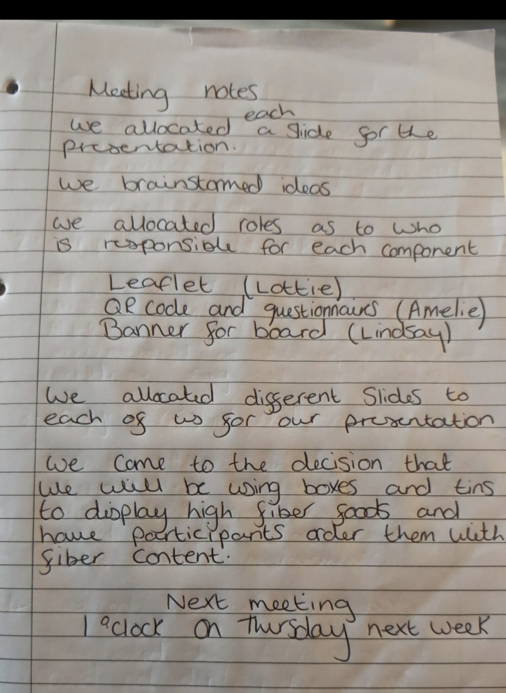

Appendix B: Meeting Minutes: Planning Session 2

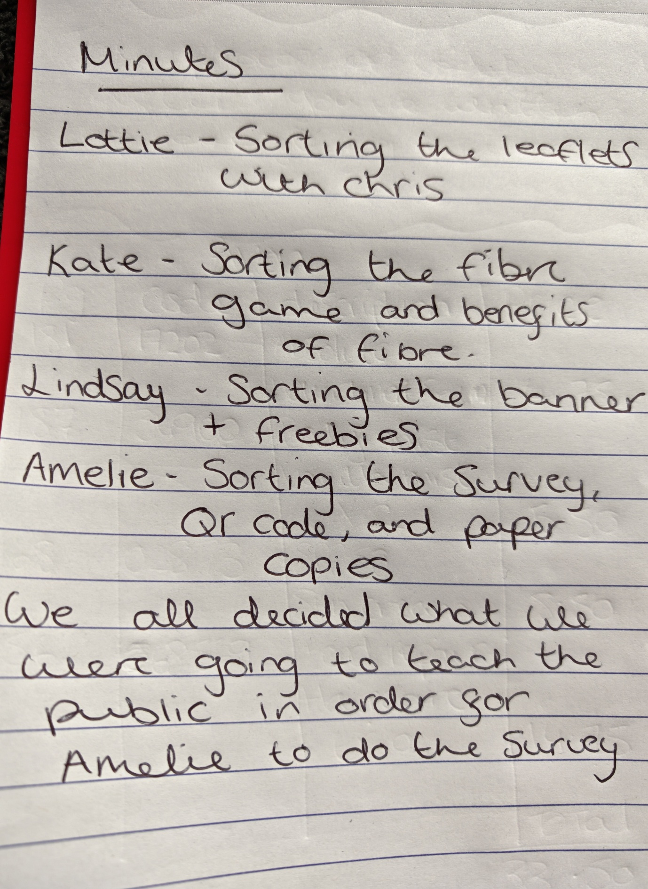

Appendix C: Team Collaboration: Banner Preparation for the Health Promotion Stall

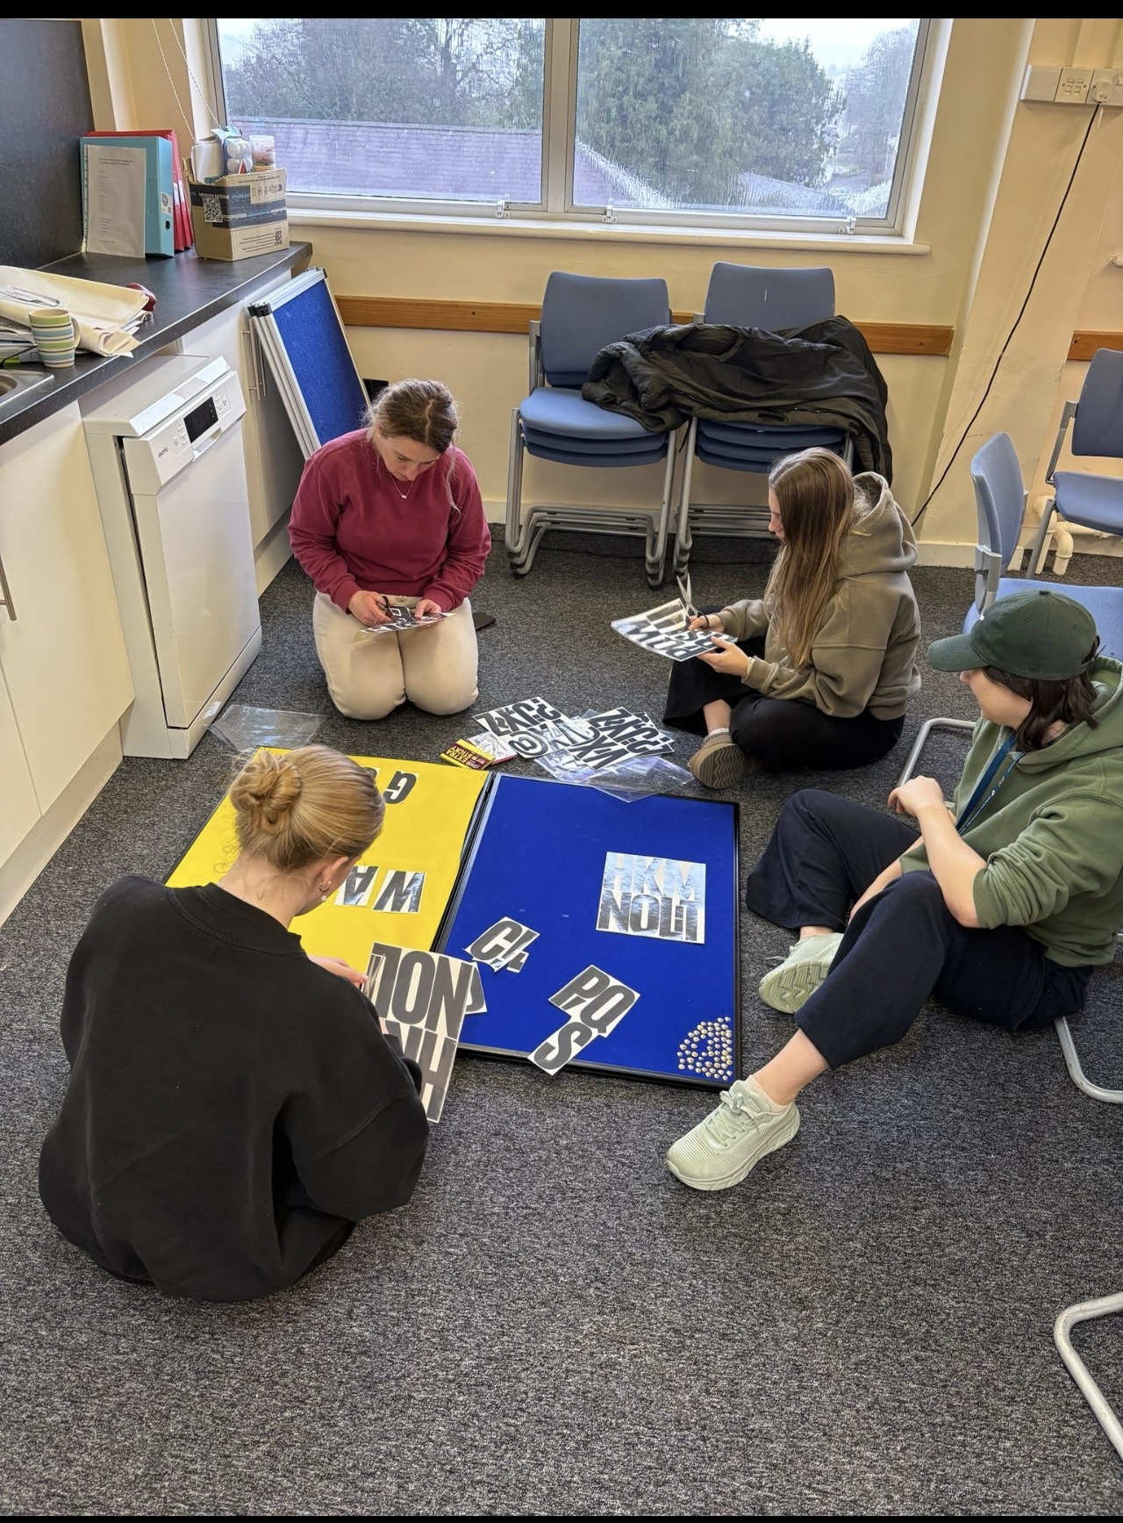

Appendix D: Example of Event Resources: Display Board, Leaflets, and Fibre Game Materials



