Water Bottle
Material: Stainless Steel
Height: 27cm
This bottle was purchased from an eco-pop-up shop (by Watson and Pratts) at Lampeter SU during the Greek week Sustainability Talks. It was made by a company called ‘Made Sustained’, who (as the name suggests) is a company committed to making sustainable products.
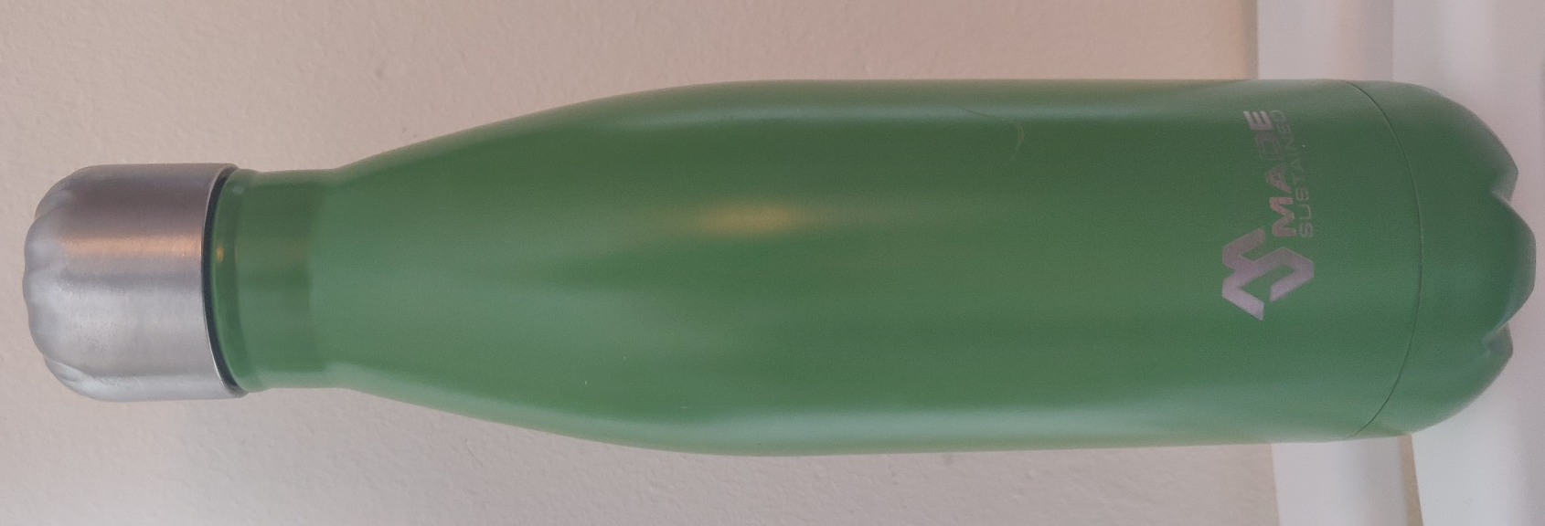
Metal water bottles, such as this one, have come into increasing popularity in recent years as a way of decreasing people’s environmental impact. From 2010 onwards we have seen a massive incline in the population’s environmental consciousness. This has manifested in numbers of people converting to a vegan lifestyle, but also in the massive increase of sustainable products to meet the demand.
Everyday hundreds of thousands of plastic water bottles are used and thrown away. This throw away culture has led to the destruction of our eco-system and it is only now that we are starting to see the horrendous impact the last 50-100 years of convenient single-use plastics has had.
The bottle is carried with the owner and can be re-filled at their convenience. It serves as more than just an alternative to plastic waste, but also a way of keeping healthy. There are many articles online that emphasise the important of drinking more water, re-usable bottles are one of the best solutions to this.
While many people are starting to turn to re-usable alternatives to single-use items this is often done within one’s own home. Stainless Steel water bottles, like this one, stand as a beacon of one’s stance on the environmental destruction. So, while many may look as simply see a bottle, others see a comrade in the fight against plastic.

