-Bird diversity study at Bempton cliffs, Yorkshire
Atlantic Puffins
Introduction
The Atlantic puffins are an endangered species usually found at Bempton cliffs in Yorkshire, this white chalk cliffside is an ideal breeding ground for these birds as it provides shelter and a feeding ground for them as well as easily being able to find a breeding partner, as they can easily get to and from the sea to get food for themselves and their young. The ease of navigation on these cliffs is essential for making nests and being able to easily find their nests when they go and catch fish for themselves and their pufflings. Furthermore, there is a lot of tourist activity on these white chalk cliffs, but they hardly disturb these Atlantic puffins from there day to day activities such as finding breeding partners and building their nests, however, when they do they risk disturbing the puffins which may lead to them abandoning their nests and potentially leaving their young pufflings to survive on their own which leads to them dying.
Aim
The objective of this survey is to document the Atlantic puffins breeding patterns and what keeps bringing them back to the Bempton cliffs, Yorkshire. This would be done through documenting the ratio of male: female birds and observing the breeding habits, we can work on trying to get them off the endangered species list. This will be do able by learning their behavioural patterns as well as the environmental challenges and human impacts we will be able to determine what is preventing them from breeding.
Site description
Bempton cliffs which is located along the Yorkshire coast is a breathtaking habitat renowned for its population of Atlantic Puffins (CHINERY, 1991) which is rapidly declining as they are on the endangered species list due to pollution, climate change and human interaction (Anon., ). This is a stunning coastal reserve, managed by the RSPB, provides a sanctuary for these charming seabirds during their breeding season. The towering chalk cliffs, rising dramatically from the North Sea, offer a secure nesting site for the Atlantic puffins, as well as other seabird species. (Anon., )The sight of these comical birds perched on the white chalk cliffs is a captivating spectacle for any nature enthusiast making it a popular torist attraction. Bempton Cliffs stands as a testament to the importance of conservation efforts in preserving the delicate balance of marine ecosystems (Anon., ).
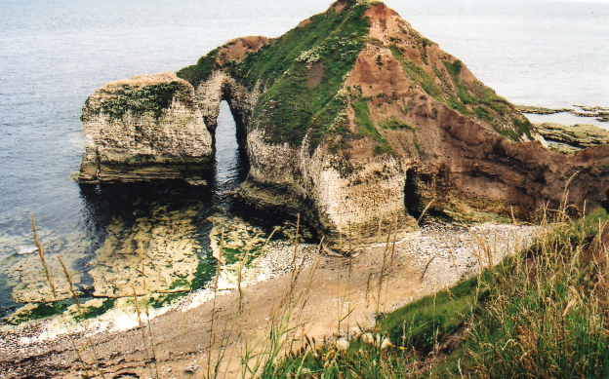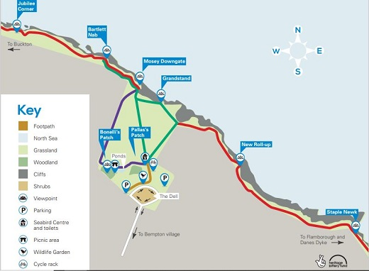
The questions I will ask whilst completing my survey are:
What is the sex ratio in puffins in Bempton cliffs, Yorkshire?
How are the breeding patterns affected by tourist activities?
What features of the cliffs are attracting the Atlantic puffins?
Having to take in these questions whilst doing my bird survey will help me record data and record things I wouldn’t have previously thought about
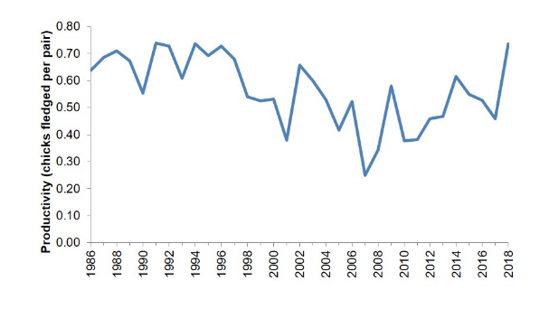
Some of the passive techniques used to record bird diversity data are techniques that are generally cheaper and can produce large amounts of data in short time making them a sufficient data collection method, these techniques are not being limited to needing to have ethics approval or other legislation, and no specific qualifications necessary to complete and carry out them. Some examples of these are;
Indirect counts, traces and nests
Some of the advantages of these are that; Footprints and tracks are usually a good identifier of cryptic birds in dense habitats, Group biased counts are normally useful as colonies of birds such as Atlantic puffins usually stand together making this good for estimating population sizes, if done by an experienced bird watcher or a specialist. Some territory mapping takes advantage of territorial breeding patterns in birds (Cyr, et al., 1995). Point counts make this technique repeatable, reliable and best to estimate abundance the chance of disturbing the nesting birds is low (Ralph, et al., 2012). Area searches have a greater certainty that all species are recorded in the area that you are surveying (Dieni & Jones, 2002).

Some of the disadvantages of these techniques are; that identifying by footprints is difficult due to the weather as it might rain or be windy and this will distort the footprints and tracks in the sand or sediment. Group biased counts which are used in colonies are difficult to preform due to the fact that they only congregate during breeding season, and you do not want to disturb them incase they abandon their chicks. The idea of territory mapping is only useful during breeding season, and it is incredibly time consuming. Conducting point counts relies on how good you are at IDing birds however there are guides if you are not familiar with differentiating species, and area searches have a drawback of greater disturbance which may impact the results of the bird survey.

Some of the non-passive techniques are generally more expensive and they require trained participants or extensive field guides. The training required for some of these techniques may take multiple years to complete and collect the data form and often a licence is required legally to be able to complete or plan to as they take a while to master or that they can potentially be harmful to the birds if done incorrectly and cause them distress, and majority of the time ethical approval is necessary to complete the non-passive techniques as they are invasive to the birds and can potentially cause harm or distress to the avian mammals.

Some of the advantages of these techniques are that the play back technique borderlines passive techniques and makes it a lot easier to observe birds which are difficult to find in their burrows. And following the procedure of bird catching allows you to be able to tag the birds with a coloured rings to track the birds you have collected data on already making it easy to spot which birds you have already identified and collected data from. However mist netting is so fine that the birds cannot see it to be able to avoid it so it gives a better estimate of the population and the sexes between them (Arizaga, et al., 2011). Cannon netting captures multiple birds at once making it quicker to identify birds at one time. Furthermore, nooses and traps are useful as they can be left out for a while making it beneficial if you are not on a tight time management plan.

Some of the disadvantages to these techniques are that, the playback technique exploits territorial behaviour and increases their stress levels which may impact the birds overall well being and affecting reproductive successes, the need for obtaining necessary data and minimising stress on the birds is a difficult challenge to overcome. The repeated exposure to recorded calls exploits aggressive behaviour. In bird catching the coloured rings used to show which birds have been collected data from may affect breeding with the bright colours. Mist netting is a widley used method for capturing birds has its limitations and has to move locations every 30 minutes to ensure no birds stay trapped and this has to be moved frequently to prevent birds from becoming trapped for extended periods of time and have to make sure they are closed after finishing research to make sure no birds get accidently trapped this is to minimise stress and protect their wellbeing. Furthermore, to do cannon netting you must be highly trained which takes a lot of time and nooses and traps are only useful for ground nesting species. In conclusion to this bird research technoiques are essential for understanding avian biology and behaviour these methods need to be used responsibly and by knowledgeable people and making sure there liceanced when it is required and to make sure they have the appropriate equipment

When we catch the specimens weather we use passive or non passive techniques we need to record data for wing size, head to bill length, bill length and width, leg size, tail length, body condition, brood patches, muscle around the breast, these are then tagged and released using PIT tags, I will record these on a data sheet including a table and pictures as aids.

My choice of surveying techniques are point counts and playback this is because playback allows you to survey burrows with minimal disturbance to the birds and point counts as puffins are highly visible with their colourful beaks on the chalk cliffs. Making them easy to conduct with very little disturbance to them and the mix of using both together will ensure I get all of the data I need making sure I take plenty of photos to ensure accuracy and something to refer to in my fieldwork notebook

Bird point count.
Choose a location which would be the Bempton cliffs in Yorkshire id choose three different point on the cliff to do my point counts which will last 10 minutes each, I will do this by using binoculars, a data recording sheet and a timer, recording all the data of bird sounds and seen within a 50 meter radius. Recording the number of puffins, behaviour and sex. Id repeat this three times and summarise my findings in a report.

Playback
Playback is a technique used by birdwatches to complete bird surveys and behavioural studies, there’s restrictions to protect birds during breeding seasons, use high quality recordings and avoid using playback to use distress calls as it can cause stress to the birds, also only using it for short durations to minimise stress and disturbance to the birds, this will also help sex the birds as they are not diverse enough to do it by sight alone, however if surveying breeding burrows you can assume each response received is a breeding pair

Conducting these using distance counts will be easier to do with very little disturbance.

Puffin number | Wing size | Head to bill length | Bill length | Bill width | Leg size | Tail length | Body condition | Brood patches | Muscle around the breast
1
2
3
4
5
6
7

References
Anon., . Bempton Cliffs: revamped seabird centre opens. [Online]
Available at: https://www.bbc.co.uk/news/uk-england-humber-32173894
[Accessed 29 11 2023].
Anon., . Puffins ‘gone from Yorkshire coast in 10 years’. [Online]
Available at: http://www.yorkshirepost.co.uk/news/puffins-gone-from-yorkshire-coast-in-10-years-1-7542521
[Accessed 29 11 2023].
Anon., . The RSPB. [Online]
Available at: http://www.rspb.org.uk/
[Accessed 29 11 2023].
Arizaga, J. et al., 2011. Monitoring communities of small birds: a comparison between mist-netting and counting. Bird Study, , 58(3), pp. 291-301.
Cyr, A., Lepage, D. & Freemark, K., 1995. Evaluating point count efficiency relative to territory mapping in cropland birds. [Online]
Available at: https://fs.fed.us/psw/publications/documents/psw_gtr149/psw_gtr149_pg63_68.pdf
[Accessed 29 11 2023].
Dieni, J. S. & Jones, S. L., 2002. A field test of the area search method for measuring breeding bird populations. Journal of Field Ornithology, , 73(3), pp. 253-257.
Perlman, M., 2000. Ethical issues in 'observational research'.. Paediatrics and Child Health, , 5(2), pp. 89-90.
Ralph, C. J., Sauer, J. R. & Droege, S., 2012. Monitoring Bird Populations by Point Counts. [Online]
Available at: https://fs.fed.us/psw/publications/documents/psw_gtr149/psw_gtr149.pdf
[Accessed 29 11 2023].
CHINERY, M. (1991). Kingfisher Concise Field Guide Animals & Plants of Great Britain & Europe.
Chinery, M. (1992). The Kingfisher natural history of Britain & Europe. Kingfisher.
Flegg, J., Hosking, D. and Hosking, E. (1990). Field guide to the birds of Britain and Europe. London: New Holland.

