Learner – Mr Martyn Stuart Capel
Student Number – 2237960
CIPD Membership Number - 8771738
Unit: 5HR01 / Unit Title: Employment Relationship Management
Assessment ID: CIPD_5HR01_22_01
Total Word Count (excluding reference criteria titles) Section 1 1,646 Words / Section 2 2,499 Words / Total 4,145 Words
This report is designed for the directors of Go Quest. This section has been prepared to better equip your senior and line managers with the knowledge and understanding of approaches to employee voice and how these can be best used to foster engagement, performance and better working lives.
AC 1.1 Review emerging developments to inform approaches to employee voice and engagement.

“Employee voice is defined as ‘the ways and means through which employees attempt to have a say, formally and/or informally,
collectively and/or individually, potentially to influence organisational affairs relating to issues that affect their work, their interests, and the interests of managers and owners’ (Wilkinson et al, 2020: 696)” (Taylor & Woodhams, 2022 p15)

Social media
Commentators (Holland et al, 2016;CIPD,2017) have suggested that “social media could play more of a role in enabling wider access to employee involvement and participation (EIP) and whilst management perception could be seen as this methodology being a threat, it does facilitate employee’s wider access and the ability to provide instant and real-time feedback.”
(Taylor & Woodhams, 2022 p16)
Direct Engagement
Marchington et al’s (2020) framework identifies four main forms of EIP:
- “Direct EIP, for example one-to one meetings with line managers, team briefing, problem-solving groups and teamworking.
- Representative EIP, for example joint consultation committees and works councils.
- Informal EIP, for example frequent interactions with managers.
- Financial involvement, for example profit sharing and share ownership schemes.”

The CIPD (2019b: 10) found that three of these examples are the most common EIP practices experienced by employees:
- “One-to-one meeting with line managers.
- Team meetings.
- Employee surveys”
(Taylor & Woodhams, 2022 p17,18)
GIG Economy
In contrast to your permanent workforce, the GIG economy is more specific to your temporary/flexible or contractor contingent labour market. This workforce is generally brought into an organisation to support a specific type of work which generally holds shorter assignment lengths with employees less likely to consider the organisations culture, goals, and strategy. (Taylor & Woodhams, 2022 p74)

impact of voice and engagement on psychological contract

“CIPD (2021b) defines the psychological contract as individuals’ expectations, beliefs, ambitions, and obligations, as perceived by the employer and the worker. These obligations are often informal and imprecise but tend to be seen as a ‘promise’ and
‘expectations’ by your employees. (Taylor & Woodhams, 2022 p102,103)

AC 1.2 Differentiate between employee involvement and employee participation and how it builds relationships.

Definition of employee involvement
Employee involvement is defined as “involved practices such as email communications, management briefings, problem solving groups, suggestion schemes and newsletters” (Taylor & Woodhams, 2022 p15)

Definition of employee participation
“Employee participation is defined where employees participate in organisational decision making through their representatives, which functions like a union, but isn’t one”. As outlined in AC 1.1 these examples outline employee participation. (Taylor & Woodhams, 2022 p15)

In keeping with employee participation and involvement, a theory completed by Hackman and Oldham’s (1975) outlined 5 different dimensions that make a job ‘good’, in terms of being linked to positive psychological states and these are: -

- “Skill variety: a job which challenges the individual to use a range of skills and abilities.
- Task Identity: a job which allows the individual to perform a whole piece of work and clearly identify the outcome of their efforts.
- Task significance: the perception that the job exerts a positive impact on others or the organisation as a whole.
- Autonomy: a job that gives the individual some control over how things get done.
- Feedback on performance.” (Taylor & Woodhams, 2022 p214)

Notwithstanding the above but understanding the difference between a unitarist and pluralist employee and how this will shape your narrative when thinking about robust relationship building is also an important characteristic to understand.

In the 1960’s Alan Fox completed a seminal piece of theory on the employment relationship suggesting that there are two main ways in which managers view employment relationship.

“The unitarist view characterises as the employee and employer relationship being united, aligned to the authority of the manager to pursue the organisational goals.

“The pluralist view characterises as the employee and employer having both similar and different interests in the employer relationship. Where a pluralist view is held by the manager, conflict is an inevitable feature of the employee relationship and systems for managing conflict (including for example, discipline and grievance procedures) are essential for sustaining effective employment relationships.”
(Taylor & Woodhams, 2022 p3,4)

Where an organisation has created an environment that encourages employee voice and participation through multiple
channels, it fosters a culture of trust which will allow a stronger relationship between both employee and employer.

AC 1.3 Assess three employee voice tools and two approaches that might be used to drive employee engagement.

Tool | Positive Impact of Tool | Negative Impact of Tool
1.Town Hall Meetings  (Professional Leadership Management, 2023) | - Non diluted communication – Instant update from the CEO/MD/Senior Leadership Team  - Regular throughout the year  - Provide organisational direction | - Employee fear of voice within a companywide forum  - Questions left unanswered creates speculation.
2.Employee Surveys  (Judd S, O’Rourke & Grant, 2018) | - Predict employee behaviour  - Can be question specific  - Employees feel heard | - Cannot mandate completion.  - Feedback is anonymous.
3.Internal Social Platform  (Enterprise Social, 2022) | - Establishes company culture  - Can recognise great work  - Develops collaborative work  - Promotes peer to peer relationships | - Cannot rely on employees actively using the platform.  - Cannot mandate interaction.  - Open to interpretation if employee doesn’t fully understand subject matter.  - Accessibility to all employees Gen Z/X.

Whilst considering the next 2 approaches to help drive employee engagement, it is also a recommendation to think about AC 1.2 and how you ensure you remain mindful of the unitarist and pluralist employees.

Implementing a reward and recognition scheme can increase employee engagement as they are able to apply a methodology for over performance. This scheme also demonstrates commitment to the employee from employer of the value it places on its workforce and the efforts they perform toward the organisations strategic goals(s).

“Reward management aims to provide a link between what the organisation values and how It communicates this to employees. Using pay and other aspects of reward is an effective way to do this. It can be an effective strategy tool in creating high -performing organisations” (Taylor & Woodhams, 2022 p84)

Engaging managers completing regular employee appraisals are more likely to have positive employee engagement. Employee appraisals offer dedicated time to discuss matters such as, individual and team performance, wellbeing, organisational performance, employee, and employer 360 feedback etc.

AC 1.4 Critically evaluate the interrelationships between employee voice and organisational performance.

In March 2021 the CIPD completed 4 independent case studies which looked at the interrelationships of employee voice pre and post organisational changes, and the impact these held. The 4 case studies were completed by Fircroft college, an airline logistics company, NMCN, and Nottinghamshire Healthcare NHS Trust. (CIPD, 2021)

Each organisation identified the organisational challenges, the initiatives, and were able to evaluate the outcomes. Using 2 of the case studies I have illustrated below some of the key features of its findings.

Organisation | Challenge | Initiative Undertaken | Evaluated Outcomes
Fircroft College (CIPD, 2021a) | - Imbalanced power culture among a minority of employees  - Developing work practices in the challenging environment of further education | - Changing the ethos of the organisation post-restructure  - Developing values and gaining buy-in from staff  - Changing internal communication processes  - developing a mission statement and aims | - Cultural change released a massive surge of positivity – “a can do” sort of attitude.’  - Broke down silos and enabled staff to work more collaboratively.
NMCN (CIPD, 2021b) | - Rapidly growing company that is integrating difficult business units into one large organisation  - Divide between office and site workers.  - Highly competitive market, working with tight margins and high-performance targets. | - Cultural change  - Communication channels  - Suggestion-box scheme  - Leadership briefings  - Site visits | - Rebranding and focusing on their values with their new motto – ‘Our people at the heart’.  - Working with the senior leadership team to examine the links between engagement, commitment, and performance.

AC 1.5 Explain the concept of better working lives and how this can be designed.

With the pandemic creating an unprecedented impact on employment, employees are much more likely to have a greater belief on what they define as ‘better working lives’ and as such are a lot more likely to want to create a balance between personal and professional environments.

“After the last economic recession, many people lost a level of trust in certain institutions and leaders. A decade or more later, and some of the same economic uncertainty lies ahead; but there are also very real challenges for the employment relationship, particularly around how safe and protected people feel in returning to work and what say they have in new working arrangements.” (Barber, 2020)

As outlined in the CIPD Good Work Index summary report and practical guidance June 2023, the CIPD believe that good work:

- “Is fairly rewarded and gives people the means to securely make a living.
- Allows for work-life balance.
- Gives opportunity to develop, and ideally a sense of fulfilment.
- Provides a supportive environment with constructive relationships.
- Gives employees the voice and choice the need to shape their working lives.
- Is physically and mentally healthy for people” (Young, 2023a).

The report also completed an evaluation on how employees view job design and the nature of their work.
“Forty-three per cent feel it is, 20% are in the middle, and 37% disagree. More worrying is the fact that those viewing work as transactional has increased from 36% in 2019, while the number of respondents who feel they would work even if they didn’t need the money, and work harder than needed to help the organisation, has dropped.” (Young, 2023b).
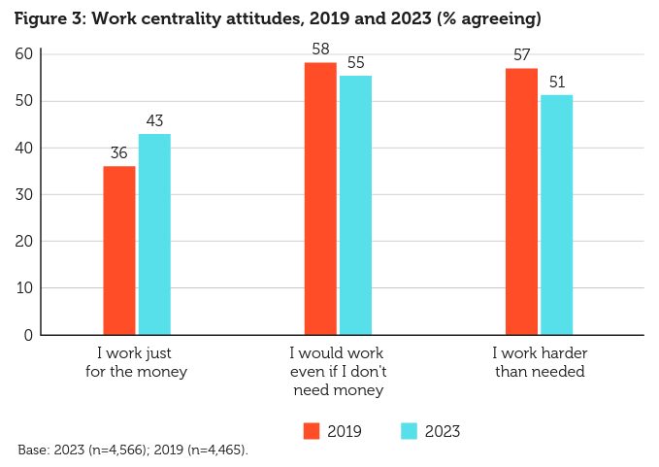
To support the organisations design for better working lives, consideration should be made to the following: -
- Employment contracts – Flexible options, agile, remote etc.
- Pay & reward – Competitive with the sector of work carried out.
- Health & wellbeing - Opportunity for employee enrichment in and out of work settings.
- Space for psychological safety - Free to speak own voice, free from fear and consequence.
- Progression opportunity – Career pathways identified for employees to visualise future career direction.

The next section of the report has been prepared to better equip your senior and line managers understand the different forms of workplace conflict behaviour; disputes and sanctions; the role and main provisions of collective employment law; third party interventions; and managing discipline and grievance resolution.
AC 2.1 Distinguish between organisational conflict and misbehaviour, and between informal and formal conflict.

“Organisational conflict, or workplace conflict, is a state of discord caused by the actual or perceived opposition of needs, values and interests between people working together.” (Wikipedia, 2020)

“Hollinger (1986) considered workplace misbehaviour as deviance’s form and found that sociological research conducted on employee misbehaviour mainly focuses on two factors: a) production deviance, and b) property deviance. Production deviance includes different types of counterproductive behaviour such as insubordination, slowdowns, substandard work, and the like. Property deviance is related to acts against assets and property of the organization such as embezzlement, pilferage, theft, vandalism, and the like.” (Definition, date unknown)

Informal conflict
Informal conflict may involve a minor clash or disagreement between two people and is less serious than formal conflict,
meaning no requirement for TU intervention.

Examples of informal conflicts: -
- “two employees not getting on
- an individual with a grievance against another member of staff
- rivalry between teams or departments
- a lack of trust and cooperation between groups of employees and management.” (NCVO, 2022)
The CIPD completed a report named ‘managing conflict in the modern workplace’ and within its publication it carried out
several variations of surveys to understand its drivers. (CIPD, 2020)

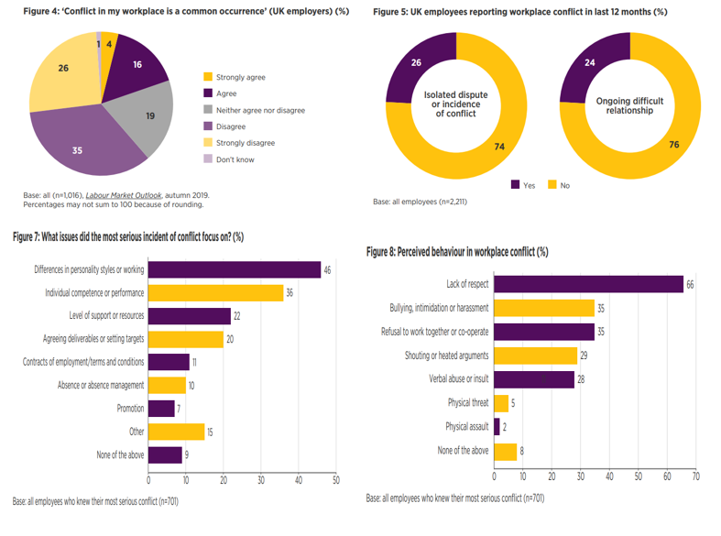
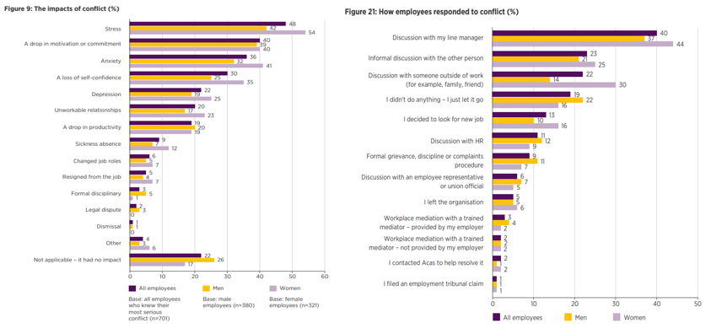

Formal conflict
Formal conflict is where it is most likely TU representation will be sought and a claim brought against your organisation
in an employment tribunal.

Examples of formal conflict: -
- “unfair dismissal
- discrimination at work
- breach of contract
- unauthorised deductions from your pay” (Gov, 2023)

According to Cassidy (2020) from a recent CIPD podcast titled ‘shifting the perception of workplace conflict’ discussed that artificial harmony can stifle employee/employer conflict and whilst traditionally held with a connotation of negativity, leaning into conflict can bring out differences of opinion for an inclusive work environment, resulting in less negative conflict, boosted productivity, and creating a stronger culture by having psychological safety enabling a free to speak environment. (Nigel Cassidy, 2020)

AC 2.2 Distinguish between official and unofficial employee action.

Official employee action would be legal, whereas unofficial employee action would not.

Official Employee Action
Official employee action, leading to “an official strike is when a trade union has followed all the legal rules. This includes holding a ballot for members to vote. A strike is unofficial if a trade union does not follow the rules, or employees take action that's not authorised by a union.” (ACAS, 2023)

It is important to recognise that employees are protected by law under official strike action (ACAS, 2023)

Unofficial Employee Action
As eluded above, any action not recognised by a TU would be deemed as unofficial employee action, and where official action
protects the employee by law, this route would not.

“Any form of industrial action, including a strike, which is not authorised or endorsed by a trade union, will generally be ‘unofficial.’ This will include where a non-member of a union purports to join in with strike action.

Where industrial action is unofficial, participating employees do not have statutory protection from unfair dismissal.
Some professions are banned from taking industrial action and for them striking will always be illegal. For example, industrial action by prison officers is prohibited by the Criminal Justice and Public Order Act 1994.” (CIPD, 2022)

AC 2.3 Assess emerging trends in the types of conflict and industrial sanctions.

Of recent times there has been increased conflict surrounding working conditions and pay with TU bringing strike action for its members, specific cases being linked to healthcare, education, and transport.

“Some of the UK’s biggest unions are battling scores of firms at the same time, with the number of industrial disputes well above pre-pandemic levels. GMB members entered into dispute with 42 employers between October 2021 and March 2022 – seven times the number of disputes in the same period in 2019-20. Unite members are currently involved in 30 disputes in England – almost four times the reported number involving the union three years ago.

Over the past 12 months, the Trades Union Congress has logged at least 300 disputes in different industries, indicating that more and more workers are challenging below-inflation pay offers after a decade of wage stagnation following the 2008 banking crash.” (The Guardian, 2022)

Data captured by the office of national statistics indicates that over the past 5 years, 1,908 days have been lost due to strike
action within the public sector alone. (Leaker, 2023)

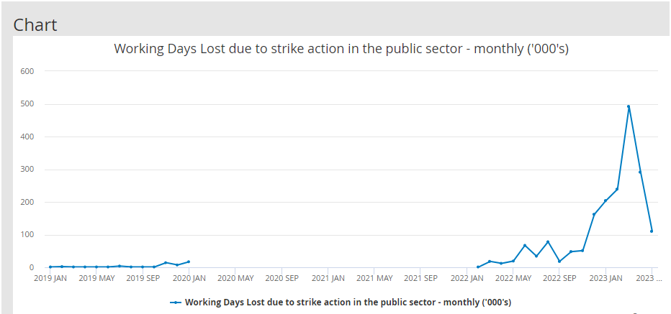

In 2019 the ONS created and published a set of research completed in the 90’s which looked at age groups, 16-64, and
sectors, to assess how being a TU member affected them get better pay and working conditions. (ONS, 2019)

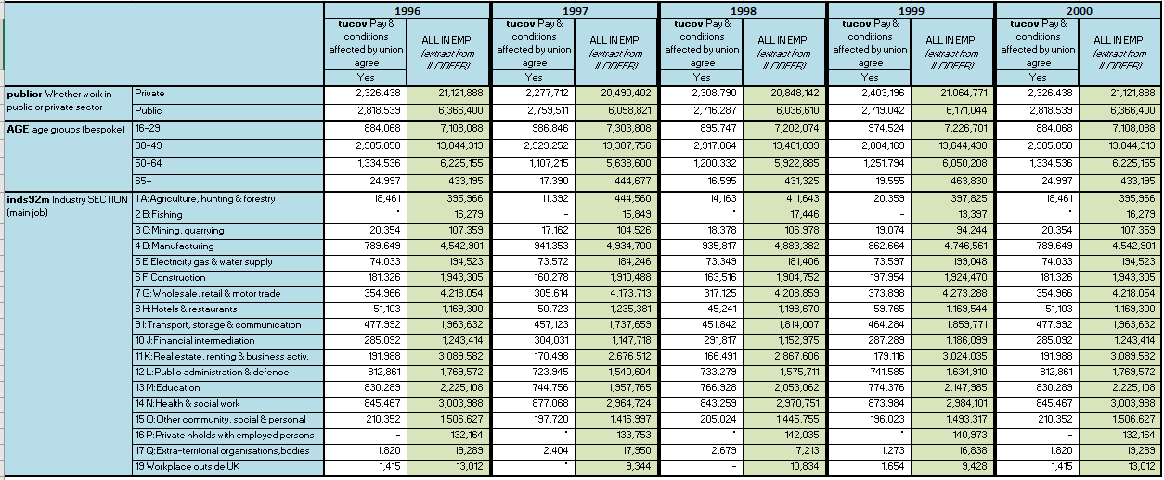
AC 2.4 Distinguish between third-party conciliation, mediation, and arbitration.

Conciliation
“Conciliation is the process of bringing both sides of a dispute together and helping them find a solution to their difficulties.”
(Daniels, 2022 p11)

“Conciliation is similar to mediation but is normally used to try to find a solution:

- before an employee makes a claim to an employment tribunal (known as early conciliation)
- after an employee makes a claim to an employment tribunal (known as conciliation)
Conciliation is voluntary - both the employee and employer must agree to it before it happens.” (Gov, 2023a)

Mediation
“In mediation the mediator will suggest solutions to the problem, but the parties are not bound to accept any of the solutions” (Daniels, 2022 p11)
“Mediation is when an independent and impartial third party discusses a problem with you and your employer (or between you and another employee) to try and find a solution. It’s often used after informal discussions have not come up with a solution.
Mediation is voluntary and the mediator cannot force you or your employer to accept a solution. Both you and your employer must agree on the way to solve the dispute.” (Gov, 2023a)

Arbitration
“Arbitration is the process of bringing in an independent body (e.g., ACAS) and letting it evaluate the situation and determine a solution.” (Daniels, 2022 p11)
“Arbitration is when a third-party makes a firm decision on a case after considering all the issues.
Employee and employer must agree to an arbitrator’s decision being legally binding. If the employee does not agree, they can still take a case to an employment tribunal.” (Gov, 2023a)
AC 3.1 Explain the principles of legislation relating to unfair dismissal in respect of capability and misconduct issues.
Capabilities
Capability covers knowledge, skill set and abilities within a role and help identify how an employee is performing. Often these are bench marked against a set of criteria which can be used as a metric to grade adherence or non-adherence.
“Capabilities include the ability and aptitude to perform a certain task or execute the duties of a certain role within a company. If employees don't have the capability to perform their jobs, this can result in poor performance and productivity. In some cases, a manager may aim to help an employee develop the capabilities required to perform their role effectively, but other companies may aim to recruit someone else who already possesses the capabilities needed for a certain role.” (Indeed, 2022)
Misconduct
Employee misconduct would be things such as continued lateness, incompleteness of tasks/duties, not following instructions etc (brighthr, 2023a)
There are several things an employees could commit to fall into grounds of gross misconduct, and these are where an employee behaviour has become unprofessional and not in line with company values.
Whilst there could be many a reason of what could be defined as gross misconduct, below are some examples: -
- “Theft or fraud.
- Physical violence or bullying
- Damage to property
- Serious misuse of an organisation's name or property
- Deliberately accessing internet sites that contain pornographic or other offensive material
- Setup of a competing business” (brighthr, 2023b)
“Unfair dismissal is entirely different from wrongful dismissal (which deals with employment contract breaches, such as giving insufficient notice for a dismissal). The provisions governing the right not to be unfairly dismissed come from statute and are mostly to be found in the Employment Rights Act 1996. Numerous other pieces of legislation cross-refer to unfair dismissal issues.” (CIPD, 2020)
Where an employer Is considering dismissal of an employee, it must be deemed as potentially fair and be one of the 5 reasons
listed below: -
- “Capability or qualifications
- Conduct
- Illegality or contravention of a statutory duty
- Some other substantial reason
- Redundancy” (CIPD, 2022)

Some examples of situations when dismissal is likely to be unfair include if the employee:
- “asked for flexible working
- refused to give up working time rights - for example, to take rest breaks
- resigned and gave the correct notice period
- joined a trade union
- took part in legal industrial action that lasted 12 weeks or less” (Gov, 2023b)

AC 3.2 Analyse key causes of employee grievances.

“Individual grievances: This happens when a single employee is experiencing a problem in the workplace. This could include issues involving pay and benefits, excessive workload, workplace favouritism, bullying or workplace discrimination, lack of a transparent promotion process, etc.

Group/Collective grievances: When a group of employees has similar complaints and experiences within the workplace, they can file a group grievance. Examples include grievances related to the gender pay gap, employee schedules, organisational changes, etc.

Union grievances: Unions file a grievance when they believe workers’ rights aren’t being protected. For example, a union might file a grievance if management didn’t properly deduct union dues.” (Indeed, 2023)

“Nearly a third (30%) of employers have seen employee grievances rise over the past two years, particularly around
relationships and pay.

The top three reasons for employee grievances are bullying or harassment (67%), relationships with managers (54%) and relationships with colleagues (49%). However, 37% of respondents reported pay and grading as the main cause of grievances.

Four in 10 respondents said managers were ineffective at resolving issues with employees prior to their concern being escalated as a formal grievance or disciplinary matter. Some told XpertHR that managers did not want to be seen as the “bad guy”, while others said a lack of training had left managers ill-equipped to deal with complaints.” (Webber, A, 2023)

AC 3.3 Explain the skills required for effective grievance and discipline-handling procedures.

As outlined in the (IRA 2016) publication titled ‘Advice on handling discipline and grievances at work’ it sets out 8 skills required
to support effective grievance and discipline-handling procedures: -

- Encouraging improvement
- Acting promptly
- Establishing the facts
- Being firm and fair
- Staying calm
- Being consistent
- Considering each case individually
- Following the disciplinary process
(IRA, 2016)

AC 3.4 Advise on the importance of handling grievances effectively.

“The number of claims to the ET has been of a concern to successive governments, The concerns have partly been about cost of running the tribunals service, but also about the amount of time employers have been spending in defending claims.” (Daniels, 2022b)

Handling grievances effectively not only mitigates risk to the employer should an ET be brought against them, but also supports
the fairness approach from an employee perspective with all processes being carried out correctly and ethically. It is therefore
important to make sure the correct procedures are carried outlined as such below: -

“1. Gather Evidence
2. Determine what importance the evidence proves
3. For each fact to be proved, assemble the evidence that pertains to it
4. Develop arguments based upon the facts
5. Place the arguments into a logical sequence
6. Make certain your arguments are consistent
7. If the dispute goes to arbitration, prepare an outline of the questions you will ask each witness
8. Consider that admissibility challenges will be made to keep your evidence out.” (Mark, 1999 p3)

If grievances are not carried out correctly, leading to an employee taking an employer to an ET, this holds significant costs, not
Only to any potential settlement but also on time spent from the employer creating its case of defence.

According to the British Chamber of Commerce, the average cost of an employment tribunal claim is around £8,500 with unfair
dismissal claims being up to a maximum of £16,320 and discrimination ranging from £27,400 to £45,600.
Where a case if found in favour to the employee, the employer will also find themselves liable for overall costs. (Peninsula Group, 2022)

AC 4.1 Explain the main provisions of collective employment law.

“In this Act “collective agreement” means any agreement or arrangement made by or on behalf of one or more trade unions and one or more employers or employers’ associations and relating to one or more of the matters specified below; and “collective bargaining” means negotiations relating to or connected with one or more of those matters.

The matters referred to above are—
- Terms and conditions of employment, or the physical conditions in which any workers are required to work;
- Engagement or non-engagement, or termination or suspension of employment or the duties of employment, of one or more workers;
- Allocation of work or the duties of employment between workers or groups of workers;
- Matters of discipline;
- A worker’s membership or non-membership of a trade union;
- Facilities for officials of trade unions; and
- Machinery for negotiation or consultation, and other procedures, relating to any of the above matters, including the recognition by employers or employers’ associations of the right of a trade union to represent workers in such negotiation or consultation or in the carrying out of such procedures.” (Trade Union and Labour Relations (Consolidation) Act, 2023)

AC 4.2 Compare the types of employee bodies, union, and non-union forms of employee representation.

Type of Representative | Purpose
Trade Union  (Unison, 2023b) | “The typical activities of trade unions include providing assistance and  services to their members, collectively bargaining for better pay and  conditions for all workers, working to improve the quality of public services,  political campaigning and industrial action.” (ACAS, 2014)
Representatives of employee safety | “Appointed in workplaces where TU is not recognised, or where groups  are out of scope.” (ACAS, 2014)
Information and consultation  representatives | “Representatives may be elected to negotiate the set up and/or be members  of a subsequent information and consultation body under the Information  and Consultation of Employees Regulations 2004 (known as ICE).” (ACAS, 2014)
European consultative bodies | “Employee members, whether union or non-union, of a special negotiating  body (a body established for the purposes of negotiating with central  management an agreement for a European Works Council (EWC).” (ACAS, 2014)
Pension representatives | “Workplace representatives, whether union or non-union, elected for the  purpose of consultation over changes to pension arrangement.” (ACAS, 2014)
‘TUPE’ representatives | “Where there are no trade unions recognised for collective bargaining  purposes.” (ACAS, 2014)
Collective redundancy | “Where there are no trade unions recognised for collective bargaining  purposes.” (ACAS, 2014)
Workforce agreement representatives | “Workplace agreements may be found in circumstances where employers  and employees agree the particular application of a statute to the  workplace concerning working time, maternity, and paternity and fixed  term employment. Representatives may be union or non-union.” (ACAS, 2014)

AC 4.3 Evaluate the purpose of collective bargaining and how it works.

“Collective bargaining is the process of negotiation during meetings between reps and their employer, often to improve pay and conditions. The collective bargaining process allows workers to approach employers as a unified group.
The aim of collective bargaining is to reach an agreement between employers and workers. Members can contribute to discussions by talking to their reps while negotiations take place.
Workplace bargaining and negotiating is also a golden opportunity to build a strong local union. Claims and agreements are a great way of recruiting new members and getting more members involved in the union.” (Unison, 2023)
Stages of negotiation within collective bargaining

“Preparation: You need to do careful preparation and research, especially in canvassing the views of your members.
The opening: One side tables a proposal and the other side responds. This stage can involve adjournments to collect further information and test out arguments. It also includes identifying the relative importance of issues, fall-back positions and ‘bottom lines’.
Trading: Both sides trade things in order to move from fixed opening positions to an agreement: “We’ll offer x if you’ll agree to y.” Again, there can be lots of adjournments to explore options, test arguments, consult, etc. This stage builds consensus and narrows down the areas of disagreement.
Agreement: This should include a phase where the final proposal is put to the members and ends with the agreement being documented for future reference.” (Unison, 2023)
An example of collective bargain in recent times would reflect the RCN (Royal College of Nursing) and its collective strike action
for better pay and working conditions. The outcome of the strikes resulted in Westminster proposing a 5% pay increase
alongside a one-off payment of up to £3,789. The outcome was met by the RCN council agreeing and putting the offer forward to its members with a recommendation to accept.

“Three months after the Royal College of Nursing’s (RCN) first ever day of strike action in England, the government in Westminster has made a new offer on NHS pay to bring industrial action to an end.
The offer consists of a one-off payment for the current financial year 2022/23 worth between £1,655 and £3,789 for Agenda for Change staff in England and a 5% consolidated pay increase for 2023/24.” (RCN, 2023)

By signing below, I confirm that the work/evidence presented is my own, unaided work. I understand the regulations pertaining to candidate malpractice and the action that may be taken as a result.

Signed (Print) – Mr Martyn Stuart Capel

Signed (Signature)
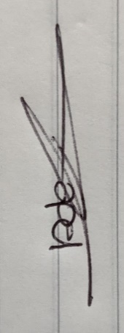

Bibliography
ACAS (2014). Non-Union Representation in the Workplace. Last Updated: March 2014. Available at: https://www.acas.org.uk/sites/default/files/2021-03/non-union-representation-in-the-workplace.pdf (Accessed 30 July 2023)
ACAS (2023). Strikes and industrial action. Updated: 2023. Available at: https://www.acas.org.uk/strikes [Accessed 29 July 2023)
Anna Verasai (2019). WHAT ARE THE LEADING CAUSES OF EMPLOYEE GRIEVANCES?. Last Updated: 20 June 2019. Available at: https://www.thehrdigest.com/what-are-the-leading-causes-of-employee-grievances/ (Accessed 30 July 2023)
Brighthr (2023). Gross misconduct at work. Last Updated: 2023. Available at: https://www.brighthr.com/articles/employee-conduct/gross-misconduct-at-work / (Accessed 30 July 2023)
Cassidy, N (2020). “Pod Cast 160”. Shifting the perception of workplace conflict. 2020. [Podcast]. Available at SoundCloud. (Accessed 22/07/2023)
CIPD. (2022). Dismissal: UK employment law. Last Updated: 14 October 2022. Available at: https://www.cipd.org/uk/knowledge/employment-law/dismissal/#key-legal-principles (Accessed 29 July 2023)
CIPD. (2022). Dismissal procedures. Last Updated: 9 December 2022. Available at: https://www.cipd.org/uk/knowledge/factsheets/dismissal-factsheet/ (Accessed 30 July 2023)
CIPD (2020). Managing conflict in the modern workplace. Last Updated: January 2020. Available at: https://www.cipd.org/globalassets/media/knowledge/knowledge-hub/reports/managing-conflict-in-the-workplace-2_tcm18-70655.pdf (Accessed 22 July 2023)
CIPD (2022). Trade union recognition and industrial action: UK employment law. Last Updated: 2022. Available at: https://www.cipd.org/uk/knowledge/employment-law/employee-relations/#key-legal-principles (Accessed 29 July 2023)
CIPD (2021). Talking about voice: Fircroft College. Last Updated: CIPD. Available at: https://www.cipd.org/uk/knowledge/case-studies/fircroft-college/ (Accessed 18 July 2023)
CIPD (2021). Talking about voice: Airline logistics company. Last Updated: CIPD. Available at: https://www.cipd.org/uk/knowledge/case-studies/airline-logistics-company/ (Accessed 18 July 2023)
CIPD (2021). Talking about voice: NMCN. Last Updated: CIPD. Available at: https://www.cipd.org/uk/knowledge/case-studies/nmcn/ (Accessed 18 July 2023)
CIPD (2021). Talking about voice: Nottinghamshire Healthcare NHS Trust. Last Updated: CIPD. Available at: https://www.cipd.org/uk/knowledge/case-studies/nottingham-healthcare-trust/ (Accessed 18 July 2023)
Enterprise Social. (2022). Six ways a social intranet can benefit employees in the digital workplace.unily.com. Available at: https://www.unily.com/insights/blogs/six-ways-a-social-intranet-can-benefit-employees-in-the-digital (Accessed 29 July 2023)
Gov.uk. (2023a). Mediation, conciliation, and arbitration. Gov.uk. Last Updated: 2023. Available at: https://www.gov.uk/solve-workplace-dispute/mediation-conciliation-and-arbitration (Accessed 22 July 2023)
Gov.uk. (2023b). Unfair and constructive dismissal. Last Updated: 2023. Available at: https://www.gov.uk/dismissal/unfair-and-constructive-dismissal (Accessed 30 July 2023)
Indeed Editorial Team. (2022). Capabilities vs. Competencies: What's the Difference?. Last Updated: 17 October 2022. Available at: https://www.indeed.com/career-advice/career-development/capabilities-vs-competencies (Accessed 30 July 2023)
Labour Relations Agency. (November 2016). Advice on handling discipline and grievances at work. Ira.org. Last Updated: November 2016. Available at: https://www.lra.org.uk/sites/default/files/2019-03/Advisory%20Guide%20-%20Advice%20on%20handling%20d (Accessed 24 July 2023)
Leaker, D. (2023). Working Days Lost due to strike action in the public sector - monthly ('000's). Last Updated: 11 July 2023. Available at: https://www.ons.gov.uk/employmentandlabourmarket/peopleinwork/employmentandemployeetypes/timeseries/ (Accessed 29 July 2023)
Young, J (2023). What is good work. CIPD Good Work Index 2023. 1(1), pp.2-3. Available at: CIPD Good Work Index 2023: Summary report (Accessed 18 July 2023)
Young, J (2023). Job design and the nature of work. CIPD Good Work Index 2023. Available at: CIPD Good Work Index 2023: Summary report (Accessed 18 July 2023)
Daniels, K (2022a). Introduction to employment law. 6th ed. London: Kogan Page. p.11
Daniels, K (2022b). Introduction to employment law. 6th ed. London: Kogan Page. p.32
Mark, L (1999). The 8 essential steps in grievance processing. Dispute Resolution Journal. 54(4), p.3. Available at: https://www.proquest.com/docview/198084301/4BC72F3E207C426FPQ/4?accountid=130472 (Accessed 24 July 2023)
NCVO. (2022). Handling conflict at work. Last Updated: August 2022. Available at: Handling conflict at work | NCVO (Accessed 22 July 2023)
ONS (2019). Workers reporting whether pay and conditions affected by union membership in the latter 1990s. Last Updated: 2 December 2019. Available at: https://www.ons.gov.uk/employmentandlabourmarket/peopleinwork/workplacedisputesandworkingconditions/ (Accessed 30 July 2023)
Peninsula Group, HR and Health & Safety Experts. (2022). Employment Tribunal Costs. Last Updated: 18 May 2022. Available at: https://www.peninsulagrouplimited.com/resource-hub/employment-tribunal/tribunal-costs/#:~:text=Accor (Accessed 30 July 2023)
Professional Leadership Institute. (2023). What is a Town Hall Meeting and How to Conduct One!. Last Updated: 2023. Available at: https://professionalleadershipinstitute.com/resources/what-is-a-town-hall-meeting/ (Accessed 29 July 2023)
Royal College of Nursing - The voice of nurses. (2023). UK government announces new NHS pay offer for nursing staff in England. Last Updated: 2023. Available at: UK government announces new NHS pay offer for nursing staff in England | Royal College of Nursing (rcn.org.uk) (Accessed 24 July 2023)
Scott Judd, Eric O'Rourke, and Adam Grant. (2018). Employee Surveys Are Still One of the Best Ways to Measure Engagement. Last Updated: 2018. Available at: https://hbr.org/2018/03/employee-surveys-are-still-one-of-the-best-ways-to-measure-engagement (Accessed 29 July 2023)
Sir Barber, B (2020). building back making working lives better. Last Updated: 23rd July 2020. Available at: https://www.acas.org.uk/building-back-making-working-lives-better-html (Accessed 18 July 2023)
Taylor, S. and Woodhams. (2022). Human Resource Management. 3rd ed. London: Kogan Page
Taylor, S. and Woodhams. (2022). Studying Human Resource Management. 3rd ed. London: Kogan Page
the definition. (unknown). Workplace misbehavior. Last Updated: unknown. Available at: https://www.the-definition.com/term/workplace-misbehavior (Accessed 30 July 2023)
Trade Union and Labour Relations (Consolidation) Act 1992 (2023). Collective agreements and collective bargaining.. Collective agreements and collective bargaining.. Unknown. Available at: chrome-extension://efaidnbmnnnibpcajpcglclefindmkaj/https://www.legislation.gov.uk/ukpga/1992/52/part/IV/chapter/I/data.pdf (Accessed 30 July 2023)
The Guardian. (2022). This article is more than 1 year old Industrial disputes in UK at highest in five years as inflation hits pay. Last Updated: 6 April 2022. Available at: https://www.theguardian.com/uk-news/2022/apr/02/strikes-in-uk-at-highest-in-five-years-as-pay-is-hit (Accessed 29 July 2023)
Unison. (2023a). Negotiating and bargaining. Last Updated: 2023. Available at: https://www.unison.org.uk/about/what-we-do/negotiating-and-bargaining/ (Accessed 24 July 2023)
Unison (2023b). What is a trade union?. Last Updated: 2023. Available at: https://www.unison.org.uk/about/what-we-do/about-trade-unions/ (Accessed 30 July 2023)
Webber, A (2023). Third of employers seeing more employee grievances. Last Updated: 1 February 2023. Available at: https://www.personneltoday.com/hr/employee-grievances-rise-xperthr/ (Accessed 30 July 2023)
Wikipedia. (2020). Organizational conflict. Last Updated: July 2020. Available at: https://en.wikipedia.org/wiki/Organizational_conflict (Accessed 30 July 2023)

