

Foreign Languages and Cultural Awareness (BMIH5003)
Assignment 2 – Cultural Awareness

Student Name: Nasima Akter
Student ID: 2210268
Lecturer Name: Heidi Prosser
Word Count: 1090 (Excluding Executive Summary, Content and Reference list)

Intercultural Competence and Leadership Report.

Name: Nasima Akter--Assistant General Manager of, Diversity Hotel and Spa, London
Date: 10th of November 2023

Executive Summary:
This report explores the importance of intercultural competence and leadership in the context of the Diversity Hotel & Spa’s expansion to a new country. The chosen country for expansion is Japan, this report begins with a brief overview of the Japanese culture and customers followed by a non - exhaustive analysis using the GLOBE Project’s culture and leadership study. It will also explain the importance of cultural intelligence and sensitivity and why it is significant for all hoteliers when expanding overseas. Finally, the report will provide recommendations for the General Manager which highlights key actions to ensure the success of a new hotel oversea.

Content:
Introduction _________________________________________________________Page 3
Culture Overview of Japan ____________________________________________Page 3 - 4
GLOBE Project Analysis ______________________________________________Page 4 - 5
Importance of Cultural Intelligence and Sensitivity ___________________________Page 6
Challenges__________________________________________________________Page 6
Recommendations__________________________________________________Page 6 - 7
Conclusion__________________________________________________________Page 7
References__________________________________________________________Page 8

Introduction:
This report is based on the intercultural competence and leadership for the upcoming visit of our General Manager to our newly expanded hotel overseas. This report will provide in depth analysis of the customs and culture of Japan, the significant practices and values according to the GLOBE Projects culture and leadership study as well as, examine the importance of being cultural intelligent and sensitive in the hospitality industry and offer recommendations to ensure the success of the hotel brands expansion overseas.
Culture Overview of Japan:
Japan is a country that is known for is rich history, deep rooted traditions, cuisine and unique customs (Richard, 2009). Japanese culture is characterised by its strong sense of hierarchy, having respect for authority and the emphasis on group unity and synchronisation. The culture also places high value of politeness, punctuality and keen attention to detail. It is a huge contrast to the culture in the current hotel location i.e. United Kingdom.
Within their culture there is a concept called ‘Omotenashi’ it is a Japanese expression which describes the art of hospitality, its core principles are ‘anticipation, selflessness and sincerity’ (Abbo, 2023). This concept is deeply ingrained within the Japanese society as it is a great form of showing respect towards guests, it ensures that any act of service is done with the intention to make guest feel valued and comfortable. Whereas, in United Kingdom there is no established concept to denotes such behaviour towards guest and customers.
The Japanese culture place a high emphasis on politeness and respect. This can be through body language such as greeting with a bow as shown in Figure 1 or by using honorific language such as ‘Keigo’ which literally translates to ‘respectful language’ and is encouraged in social settings.
Another valued custom is meticulous attention to detail, Japanese culture highly value perfection and emphasis that all endeavours are completed with the pursuit of excellence. Therefore, to deliver the concept of ‘Omotenashi’ they consider attention to detail as a vital tool (Bergstrom, A. 2023).

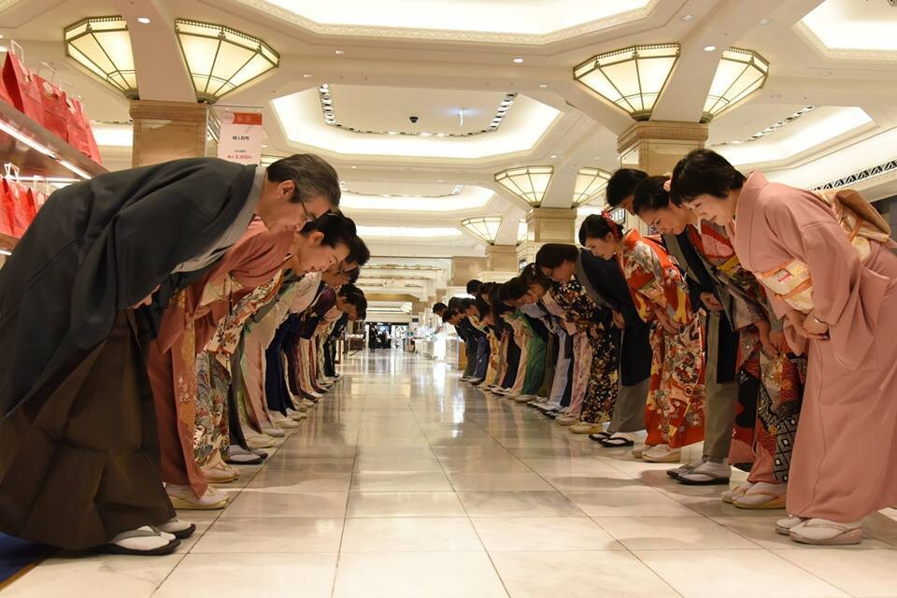
Figure 1: Japanese Hospitality: Omotenashi (adapted from Abbo, 2023)

GLOBE Project Analysis:
The GLOBE Project has provided great insights into working cultural practices and customs in Japan as shown in Figure 2 (House et al, 2004).
In-group collectivism: Japan is known for its resilient form of in-group collectivism; their practice score was 4.63 in the 2004 GLOBE Project. Individuals in Japan are able to demonstrate deep loyalty towards their organisation or place of work. This is a type of practice that supports well with the teamwork and collaboration necessary in the hospitality industry and specifically to our brand.
Power Distance: Japan has a relatively high power distance culture as seen in Figure 2, which demonstrated that within society hierarchical relationships such as managerial position, authority is highly respected. This form of leadership culture is one to adopt within the Diversity Hotel and Spa as it will ensure order and structure within the workforce and clearly help guest make distinction between senior and junior staff.
Uncertainty Avoidance: The Japanese culture demonstrate a medium level of uncertainty avoidance, this shows how the society thrives on have order and structure in order to overcome any unpredictable situations. The hotel workforce at Diversity Hotel and Spa should aim to adhere to procedures and protocols to support with delivering hotel services (Tung & Verbeke 2010).
Humane Orientation: The foundation of the Japanese culture is built upon the idea of showing kindness, compassion and empathy. Japanese cultural practices show that they exhibit a high level of Human orientation with a practice score of 4.3, in contrast to United Kingdom who have a practice score of 3.72. This is a practice that should be a priority for all staff within our hotel in order to delivery outstanding guest services. It is a practice to potentially adopted within the United Kingdom based locations to demonstrate consistency in the service.
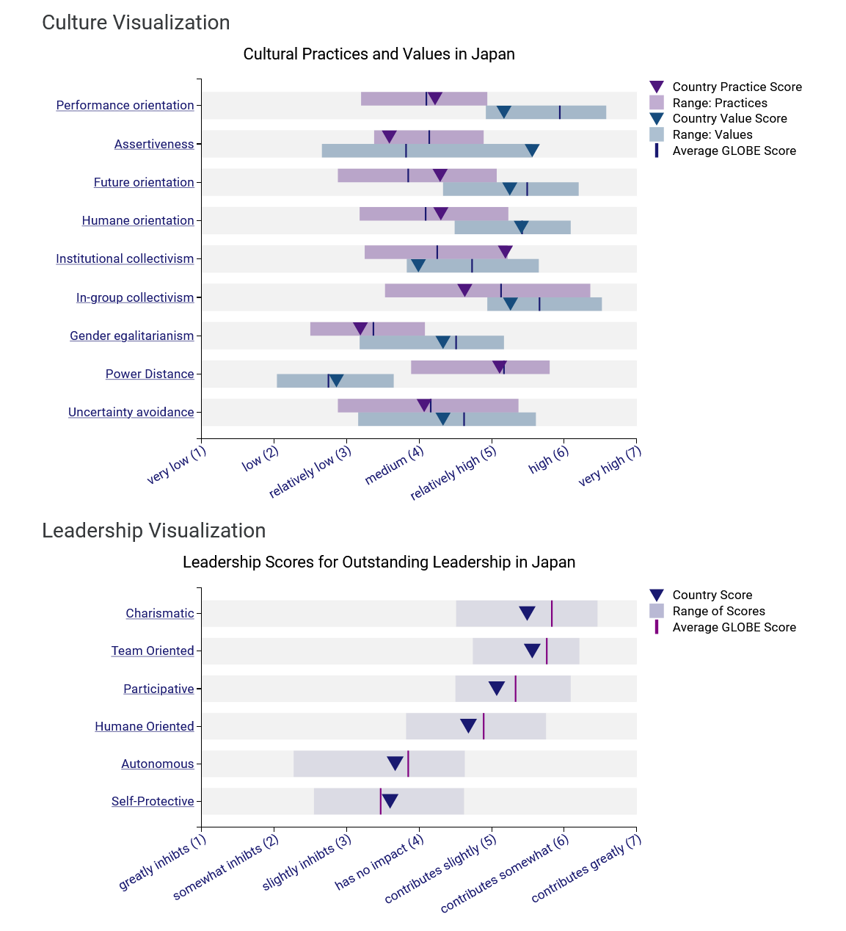
Figure 2: Culture, Leadership, and Organisations: The GLOBE Study of 62 Societies (adapted from House et al., 2004)

Importance of Cultural Intelligence and Sensitivity:
Cultural Intelligence and sensitivity refers to being aware of different diverse cultures, custom and languages and being open minded and unprejudiced when interacting with guests. Cultural Intelligence and sensitivity are essential values to uphold for all hotel personnel for several reasons.
Firstly, it supports with enhancing customer experiences, by being understanding and respectful of cultural norms and the preferences of guests from diverse backgrounds it will support with creating a personalised experience for the guest and will lead to positive customer feedback and overall customer satisfaction (Befu, 1984).
Furthermore, being cultural sensitive helps prevent any misunderstanding and conflicts from arising when interacting or communicating with individuals from different cultural backgrounds as empathised by the Guest Delight International (2023).
Lastly, these values are great assets for when expanding the brand overseas, it supports with maintaining a consistent brand image across all locations i.e. United Kingdom and sets the standard for the Diversity Hotel and Spa (Brown et al, 1989). Cultural intelligence will ensure that the hotel workforce is directly reflecting the values and practices of the local culture whilst still maintaining the brand image (Viken et al, 2021).

Challenges:
- Communication Style: The indirect communication style within Japan may pose as a challenged for a General manager who is accustom to a direct form of communication.
- Hierarchy: Due to the high power distance culture it will require a huge shift if leadership style.

Recommendations:
To ensure that there is a successful expansion of the Hotel brand in Japan the following recommendations are made for the General Mangers visit:
- Cultural Training: Providing cultural training and awareness programmes for all hotel staff it will help ensure they are familiar the Japanese culture, custom, mannerism and language (Acep, 2015).
- Leadership Training: Ensuring adequate training for Leadership staff such as hotel managers will support with adapting to the culture and will support with establishing respect for hierarchy. It will also help with effectively managing a multicultural team.
- Continuous Feedback: It is important to establish a feedback system, this entails receiving input from both staff and guest to ensure that the hotels amenities and services are in line with the local and global expectations.

Conclusion:
In conclusion, when comparing the United Kingdom and Japan, the culture and customs in Japan will hugely support a successful expansion of the Hotel brand. By implementing the recommendations outlined it can ensure a seamless integration of our brand into the Japanese’s market whilst still providing an exceptional service to guest’s and still preserving the essences of Diversity Hotel and Spa.

Reference:
Abbo, V. (2023) Japanese Hospitality: Omotenashi. Available at: https://www.linkedin.com/pulse/japanese-hospitality-omotenashi-von-eric-abbo (Accessed: 8 November 2023)
Acep, U., 2015. The importance of mastering foreign languages in developing hospitality and tourism industries. Journal of Business on Hospitality and Tourism, 1(1), p.9
Befu, H., (1984). Civilization and culture: Japan in search of identity. Senri Ethnological Studies, 16, pp.59-75.
Bergstrom, A. (2023) This Is Omotenashi: The Joy of Japanese Hospitality. Available at: https://blog.goway.com/globetrotting/this-is-omotenashi-the-joy-of-japanese-hospitality/ (Accessed: 6 November 2023)
Brown, L.T., Rugman, A.M. & Verbeke, A. (1989) Japanese joint ventures with western multinationals: Synthesising the economic and cultural explanations of failure. Asia Pacific J Manage 6, 225–242 https://doi.org/10.1007/BF01733766
Guest Delight International [GDI] (2023) The Significance of Cultural Sensitivity and Diverse Guest Satisfaction, Available at: https://www.linkedin.com/pulse/significance-cultural-sensitivity-diverse (Accessed: 8 November 2023)
House, R. J., Hanges, P. J.. Javidan, M., Dorfman, P. W., & Gupta, V. (2004) Culture, leadership, and organisation: The GLOBE study of 62 societies. Available at: https://globeproject.com/results/countries/JPN?menu=country#country (Accessed: 5 November 2023)
Richard, M. (2009) International management: culture and beyond, 4th edn. Chichester: Wiley
Tung, R. L. & Verbeke, A. (2010) Beyond Hofstede and GLOBE: Improving the quality of cross-cultural research. Journal of International Business Studies, 41, pp. 1259-1274.
Viken, A., Hockert, E.,& Grimwood, B.(2021) Cultural sensitivity: Engaging difference in tourism, Annals of Tourism Research, 89, article 103223, Available at: https://doi.org/10.1016/j.annals.2021.103223.

