Contents Page

Verginica Caracas (1906795)
1906795@student.uwtsd.ac.uk
Executive Summary
Marks and Spencer's seriousness and tradition have been strong allies in consolidating Customer Relationship Management and building an ethical and sustainable business. The purpose of this report is to analyze how M&S uses the customer relationship system, what challenges it has and how it faces them, as well as what theories / models of quality management apply in the organization. It was also briefly presented what research and documentation methods were used to make this report.
how Marks and Spencer relates with customers
REPORT

Contents Page

Introduction…………………………………………………………………………….2

Findings…………………………………………………………………………………….3

Marks and Spencer Background……………………….………………………….3
  - Customer Relationship Management (CRM)……………………………….4

Definition of CRM……………………………………………………………………4

CRM Advantages and Disadvantages……………………………………… 4
2.2.3 CRM at Marks and Spencer………………………………………………………5

Ethics……………………………………………………………………………………….…….6
    - Definition and terms………………………………………………………………6
    - Advantages and disadvantages of Ethical Business…………………7
    - Ethics at Marks and Spencer………………………………………………….7

Sustainability………………………………………………………………………………………….
    - Definition and terms…………………………………………………………………
    - Advantages and disadvantages of Sustainability…………………….
    - Sustainability at Marks and Spencer………………………………………
  - Quality…………………………………………………………………………………………
  - Segmentation………………………………………………………………………………

Conclusion………………………………………………………………………….

Recommendations…………………………………………………………….

Reference List…………………………………………………………………….

1.0 Introduction

This Special Report has been requested from the Marketing Research department by the CEO of Marks and Spencer. It has been compiled by Verginica Caracas in April 2021.
The aim of this report is to examine and evaluate the advantages and disadvantages of CRM within Marks and Spencer.
To describe, explain and evaluate the CRM system within Marks and Spencer a range of research methods were used in order to collect and analyse the type of data that has been generated by the investigations.

2.0 Findings
2.1 Marks and Spencer Background
Marks and Spencer, one of Britain`s loved retailers, started as a Penny Bazaar in Leeds, back in 1884 and has transformed today into an international multichannel retailer. M&S is a key retailer on the British high street, that have over 78,000 employees across 62 countries and 44 international websites. The retailer focused on own label businesses, including Food, Clothing & Home. (Marks and Spencer, History)
They sale quality, fresh food, clothing and homeware to millions of customers around the world.
In order to support their customers, M&S set up its own bank, and so they added a new service to satisfy their customers.
The chairman of M&S, Archie Norman has recently made a new addition to the Board by adding a new member, Fiona Dawson, who is currently Global President of Mars Food. She will join the board of M&S as Non-Executive Director. She has a strong expertise in sustainability, health and wellbeing.
M&S`s main stakeholders are the board, the employees, the suppliers, the customers, the shareholders, the government institutions. A formal definition of a stakeholder was given by Project Management Institute: `individuals and organisations who are actively involved in the project (business), or whose interests may be positively or negatively affected as a result of project (business) execution. ` (PMI, 1996). The internal stakeholders are the board and the employees, who actively participate in business, and the external stakeholders are the customers, shareholders, suppliers, and government institutions. They have a common interest in getting the business going.
Mark and Spencer (M&S) has had some problems in recent years, “with poor performance and criticism from the fashion pundits” (Rigby, 2017) because they have faced significant declines in the fashion clothing sector (Grant and Fernie, 2016). In June 2019 Jo Moran, Head of Customer Services at M&S speaking at the Retail Bulletin`s Customer Engagement Conference, stressed “the importance of linking customer engagement and employee...keeping our colleagues aligned to customers care initiatives and the wider customer-centric-culture.” (Clements, 2019)
In addition, an article in The Guardian shows that “M&S faces greater competition as the internet has made it easier than ever to shop around, to compare prices and access fashion from around the world.” (Wood and Butler, 2018) Due to online commerce, as well as the fact that there are too many shops and fashion rivals such as Zara, H&M and Primark “M&S is closing a third of its 300 high street stores which sell its full range of clothing, homewares and food.” This will directly affect Mark & Spencer's loyal customers. Moreover, M&S food halls have to face the fierce competition from competitors, such as Aldi, Lidl, and Waitrose.
Furthermore, Marks and Spencer “axed its final dividend for 2019-2020, saving £130m.” (Partridge, 2020) The retailer has warned that disruption caused by the Covid-19 crisis may last for the rest of 2020 and scrapped shareholder pay-out and this measure will affect shareholders.

2.2 Customer Relationship Management (CRM)
2.2.1 Definition of CRM
The term customer relationship management CRM was first used in the early 1990s. “Customer relationship management is a combination of practices, strategies and technologies that companies use to manage and analyse customer interactions and data throughout the customer lifecycle.”
According to Connick “the goal of CRM is to increase sales by improving customer loyalty and satisfaction.” (Connick, 2020)

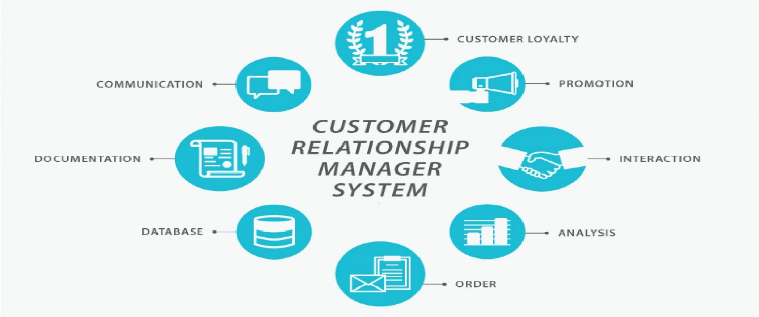

Four types of CRM have been identified:
• Strategic means a `customer-centric` strategy developing a business culture focused on the customer. The objectives of this type of CRM are to winning and keeping customers by creating and delivering value better than competitors. (Buttle, 2009)
• Operational is focused on the development of automating processes addressed to customers such as marketing, sales and customer service. Its aim is to provide customers with excellent communication across all channels by reducing costs and improving efficiency in organisation.
• Analytical CRM has the role of collecting, storing and analysing information about customers, i.e., general personal details, as well as data about marketing, sales and services (age, marital status, personal income category, buying habits).
• Collaborative CRM allows communication and exchange of information between companies). For instance, collaborative CRM can be used to manage promotions.
2.2.2 CRM Advantages/ Disadvantages
To paraphrase Sir Henry Ford, organisations that focus on providing excellent services to their customers will increase profits to embarrassing high values. (Brown, 2016)
On the advantages and disadvantages of CRM, Rohit Thakral, the CEO of Targeting Integration states `the advantages of a business using a CRM system greatly outweigh the disadvantages. (Thakral, 2021)
1. It allows for more effective sales and marketing. Creating a solid customer database that will allow the organization to build a correct image of its customers. In this way, the company can identify the most profitable consumers by targeting marketing communications to streamline the results.
2. It can speed up the sales conversion process. The sales conversion can be made much faster because it is automated making.
3. It increases staff productivity, lowers time costs, and boosts morale. CRM eliminates a big amount of paperwork and improves employee productivity by reducing the cost over time. Employees will have a high morale because their work will have another value, giving them more satisfaction.
4. A big advantage for those companies which operate in many countries or away from their home is that CRM enables widely dispersed teams to work closely. It helps organisations to be more effective in their communication with customers, as well as lower operating costs and provide easy on-site technical assistance.
5.Last but not least the advantage can improve customer loyalty through exceptional experience. Being able to efficiently access the database and transaction history provided by CRM system, employees can easily deal with many customer questions. This leads to a better customer experience and a better reputation for the company. An investment in a CRM system is an investment in customer loyalty.
According to Connick (2020) “another huge benefit for a business is the ability to map out an entire customer journey-from the first contact to the point of sale.”
In contrast, there are disadvantages:
1. Customer experience may be not better due to the excessive trust of staff in the system.
2. Issues with security and data protection may occur
3. High cost and long-time of implementing the CRM system.
4. CRM may not be suitable for all businesses.

Although CRM systems are able to map out an entire customer journey, which allows for accurate forecasting of customer needs, its implementation takes a long time, and it is also high cost. However, the advantages of CRM outweigh the disadvantages.
2.2.3 CRM at Marks and Spencer
The culture of Marks and spencer is “Premium customer experience (CX) has always been at the heart of the 130-years history of Marks and Spencer.”

Marks and Spencer consider that building up a long relationship between business and customers, based on a sense of trust and respect is essential for business success “this is an approach that has worked well for M&S, the retailer.” (Manifested Marketing, 2010).
In November 2017 M&S has established a transformation programme for the business. As part of this programme, at the beginning of 2018 M&S announced a new Technology Transformation Programme, and Tata Consultancy Services (TCS) as M&S`s main technology partner. Steve Rowe, M&S CEO stated: “we are committed to transforming M&S for our colleagues, customers and shareholders by delivering digital-first retaining across our stores and offices. Technology plays a huge role in this transformation.” (Marks and Spencer, 2018)
Under this program, M&S began the gradual implementation of the technology. Reviewing the old customer relationship system, they decided to completely replace the old contact centres with a Genesys platform. By connecting interaction channels to an omnichannel model that serves all retail outlets, as well as digital channels, this platform has allowed M&S to have a unique, 360-degree vision of customers. (Retail Technology, 2018)
Thus began the integration of each customer Touchpoint at M&S. After hard work M&S and Anana, managed to complete this project in seven months, which would normally have lasted two years.
By introducing touchpoint, using the Genesys platform and products, M&S had engaged on the biggest retail transformation in Europe, and achieved:
- a 360-degree vision of customers,
- unification and virtualization of both internal and external contact centres,
- overall sales has raised and especially online sales by real-time turnaround.
Through the implementation of Touchpoint M&S benefited from the increase of sales with web chat and better services and the contextual experience of customers on all channels. Touchpoint provides the customer with appropriate, relevant, meaningful and beloved interactions, developing in them feelings of trust and loyalty.
Forward, Marks and Spencer introduced new technology Rant & Rave platform that helps to understand what its customers think, and to shape its strategy accordingly. More precisely, to analyse the customer`s feeling in real time by understanding the voice expressed by the customer through webchat, email, etc. (Rigby, 2018)
Continuing the technological transformations, M&S in collaboration with Ingenico Group has implemented an omnichannel payment service. The Ingenico payment platform uses the latest security technologies to protect customers, thus helping M&S reduce PCI costs. (Retail Technology, 2019)
The usefulness and efficiency of these technological transformations led to the naming of the retailer Marks and Spencer the company with the Best Costumer Experience by Loyalty Magazine Awards because they place the “customer at the heart of every strategic decision.” Wightman-Stone, 2018)

Not all companies approach CRM the same way. They have different goals and objectives for their customers. M&S aims to gain a deeper understanding of customer preferences, as does the John Lewis Partnership, as opposed to the Debenhams which focuses more on providing a more personalized customer experience.
2.3 Ethics
2.3.1 Definition and terms
According to Jackson (2021) “ethics is a system of moral principles that help people make decisions.” Ethics comes from “ethos” a Greek word, that means “moral character”. It is about beliefs, customs and practices for an individual or organisation.
“Business ethics is the application of ethical values to business behaviour.” (Institute of Business Ethics, 2016) “Having ethical values and their application is critical for any organisation.” (Webley, 2016)
There are several principles of ethics:
- Altruism is regarding to respect for others
- Confidentiality is about keeping the promises
- Beneficence is a moral principle and means to help someone respecting autonomy.
- Nonmaleficence refers to not harm others
- Veracity is the principle of telling the true. On other words “honesty is the best policy.”
- Virtues correspond to principle of duties.
2.3.2 Advantages and disadvantages of Ethical Business
The benefits of creating an ethical business are:
- Gives consumers confidence to buy from an ethical company, because is more transparency and high standards, too. Customers prefer companies known for their ethical practices.
- Enhance the reputation of organisations. That leads to attract more customers, and more investors as well.
- Create a better working environment for employees improving employee happiness, loyalty and morale. Develop a stress-free work culture.
- An ethical business is better for Society to create a healthier planet, and a cleaning environment.
There are a few disadvantages of ethical business:
- It can reduce the ability of companies to maximise profit. To be ethical means to pay more for creating a safety and health workplace.
- Implementation the ethics process is time consuming and ethical practices must be updated to new laws, or changes.
2.3.3 Ethics at Marks and Spencer
Marks and Spencer has stipulated in its Code of Conduct ethical rules about:
Human Rights and Modern Slavery, Anti- bribery and Corruption, Inclusion, Diversity and Equal Opportunity, Supply chain and responsible sourcing, Environment. Separate from this general code there is a specific code: Marks and Spencer Code of Ethics and Behaviours. This code establishes the keys and procedures in the relations with clients, colleagues, suppliers, shareholders.
To assert its commitment to global environmental and social issues, M&S has launched Plan A. This plan is meant to drive M&S to make better choices for resources and planet, as well as raising wages and animal welfare in the company`s extensive supply chains.

Planet (Environment)
M&S focused on high-quality and long-lasting products. For fashion products they use ecological, recyclable materials, organic cotton, and they also offer a recycling program to shoppers.
They had an initiative about water reduction, and they purposed to eliminate hazardous chemicals from their production.
M&S has made a commitment to design plastic out and replace it with alternatives which are planet friendly. They did good actions for environment obtaining a good rating.
Debenhams, another retailer scored good as well.
People
M&S is certified by SEDEX Members Ethical Trade Audit who look at human rights in businesses. M&S advocates the abolition of modern slavery, human trafficking and all forms of discrimination. Seeing that M&S operates in some countries governed by oppressive regimes in Asia they had an inadequate approach these issues around empowerment and relationships with suppliers.
Except the issues from Asia, M&S manage well relationships with people and for people.
Debenhams looks better in this section with only an average human rights.
Animals
This is the section where Marks and Spencer have to be more focused. “The brand uses leather, down and cashmere without being transparent about its sources.” (Brown, 2018) They comply with wool regulations and moreover, they do not use angora fur and other furs from exotic animals.
M&S has a combined record on animal rights: highly ranked in BBFAW for its Policy on Farm Animal Health and Welfare, that is good, and serious problems with a dairy supplier who had broken the law, in addition to selling leather and other animal materials, as Brown said above.
Debenhams obtain a middle score, having problems due to the sale of leather, cashmere or feather products.
Concluding the comparison between Marks and Spencer and Debenhams both retailers are very close regarding to behave ethical.

2.4 Sustainability
2.4.1 Definition and terms
“Sustainability is the balance between the environment, equity, and economy.“ (UCLA, 2021)
A sensitive definition from the heart is given by Patricia Beaumont (2013)
“Our world, the earth, has been given to us as a gift with limited resources; sustainability is the act of not being a glutton of the earth. Each human knows in their heart that they can be better. Consider the earth as our temple; you do not own the temple, revere, care for and respect the earth as you would your children and your elders. Those who respect have the traits of conservation, goodness, giving, self-control and honesty.”
There are three interconnected spheres of sustainability: Environmental, Economic and Social.
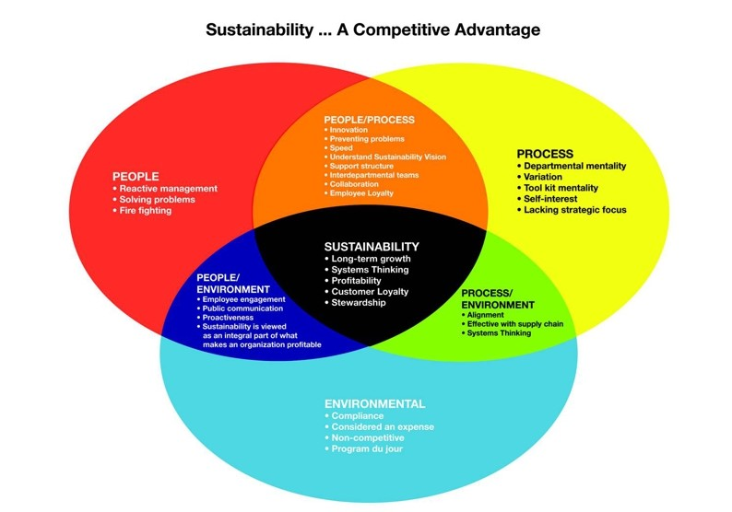

Environmental sustainability
Unnecessary environmental disturbances should be avoided as much as possible. A truly sustainable environment would create an ecosystem that would maintain functionality in the future. However, environmental impact should be a goal in any project, and environmental decisions should always be considered when making decisions.
Economic sustainability
Economic sustainability involves the creation of economic value from any project, or any decision taken.
Economic sustainability means it is when decisions are made in a fair and fiscally correct way, considering other aspects of sustainability.
There should be a balance in the profitability of a decision, on the one hand, and the environmental and social impact, on the other.
A few ideas for governs to support economic sustainability:
- to grant tax reductions for ecological development projects.
- to provide financial support for universities for research and development programs.
-reduction of bureaucracy.
Social sustainability
Social sustainability is when any project promotes the improvement of the quality of society. The concept also includes human rights and environmental law with the participation and involvement of people. However, if social sustainability is not part of any project or decision the quality of society would degrade.

2.4.2 Advantages and disadvantages of Sustainability
Nowadays, sustainability has an essential role in our lives, and at the same time it brings real benefits for society, people and the environment, but it also offers benefits to business.
Sustainability benefits:
1. Improving the reputation and awareness of the organization's brand by `doing good`. Sustainability brings value and competitive advantage in an organization. It was found that consumers prefer to shop at companies that prove a direct involvement in environmental conservation.
2. Reducing costs and implicitly increasing productivity. One of the goals of sustainability is to save. (natural resources, costs, waste of any kind)
A reduction of costs can also be achieved by switching from classic resources such as coal, oil, etc. to energies.
3. Helps organizations comply with regulations issued by authorities and not be fined. It has been observed that government agencies adopt laws to protect the environment. For any organization it will become an obligation to integrate sustainability into their action plan and budget. (Roger, 2016)

Although sustainability contributes to a clean environment, to the preservation of resources, as well as to a healthy economy and the well-being of people, there are some disadvantages:
1. Costs
Integrating sustainability involves additional costs for businesses that are costly, plus taxes. Giving up traditional forms of energy for green energy involves changing the infrastructure that represents other costs.
Due to costs, developing countries cannot afford to invest in sustainability.
2. Unemployment in certain areas
The conservation and conservation of resources leads to the reduction of activity or in some cases even its cessation in some industries that extract these natural resources.
3. More requirements for polluting businesses
For these companies, integrating sustainability is very difficult and very expensive. The additional requirements refer to the correct storage and treatment of waste, the reduction of carbon dioxide emissions. These are necessary, but they come in addition to other businesses.

2.4.3 Sustainability at Marks and Spencer
Marks and Spencer have integrated sustainability through Plan A. This is an updated project to transform sustainability in line with social and environmental issues and business development.
Plan A focus on five priority areas:
Products
Packing
Planet
People
Governance

Products

Raw materials

Regarding raw materials, M&S has taken important steps to respect the environment and the need for social equity. Thus, in order to obtain ingredients that offer good value and high-quality products for customers, M&S selected sustainable suppliers that meet the standards. for example, only 4% of firm suppliers did not meet the standards and are no longer their suppliers.
100% of tea and coffee remains Fairtrade certified.

Sustainable supplies

Starting in 2021, Marks and Spencer will apply a new own policy for suppliers `M&S Raw Material Requirements & Guidance for Nuts`.
This year they introduced the third party `Brands at M & S` which is a new online offer with complementary products of new guess brands (Sloggi, joules, Hobbs, Seasalt, Ghost, Phase Eight, Nobody`s Child).

Packing-Plastic packing

At this section M&S commitment is: “Helping customers to reduce, reuse,
and recycle.”
Their goal is to reach 100% recycle food packing in the UK in 2022.
M&S initiated a `plastic take-back` scheme through which customers could return the plastic packaging to the store, thus ensuring recycling.

Planet
M&S's strategic ambition to reach zero carbon neutrality by 2035.
Taking advantage of the Covid-19 M&S pandemic blockade
achieved an energy efficiency improved by 47%.
In The UK M&S and ROI stores use 100% energy from renewable sources.
M&S has acted on food waste developing new concepts with positive results.
The retailer's desire is to protect consumers from hazardous chemicals by achieving a record 100% recycled or recovered office and warehouse waste in The UK and ROI store.

People

Human rights
M&S uses only 100% cotton products from sustainable sources. Nearly a quarter of world cotton production comes from China, where forced labour has been proven.
This year M&S launched their own Human Rights for Food.

During the pandemic, Covid-19 M&S distributed 11.8 million meals to people in need.
MARKS & START Programme offered 350 UK placements.
M&S has raised with their customers and employees’ donations £2.4m for Community and Charity.

Governance
To ensure that Plan A will be achieved, M&S added an additional governance element by establishing a Board Sub-Committee on Environmental, Social and Governance (ESG).

2.5 Quality

2.5.1 Definition
“Quality is free. It`s not a gift, but it`s free. The `unquality` things what cost money.” (Crosby, 1979)
According to CQI “Quality management is about making organisation perform for their stakeholders – from improving products, services, systems and processes.”

2.5.2 Models and Theories of Quality

Developing quality control methods and techniques and a culture of employees who want to produce quality are vital to any business, to making sure that the whole organisation is fit and effective.
Quality management arose as a result of the need to verify the manufacturing processes of the products from the initial phase to the finished product.
In 1920 Shewhart has introduced a quality model in three steps: Plan, Do, See. Deming was the successor to Shewhart's model, designing the cycle in four stages: Plan, Do, Study, Act. Deming linked product manufacturing to customer needs.

Plan the stage of establishing consumer research methods to identify their needs.
Do the implementation and execution stage.
Check the step of measuring the results obtained.
Act / Adjust the stage of concluding and measuring performance.

Deming said quality management would increase product quality and customer loyalty while reducing costs and waste.
If Deming addressed the issue of product quality, Joseph Juran, another quality missionary, expanded the concept to the organizational level. Starting from Pareto's theory of "Vital Few and the Trivial Many" (that means 80% of the effects are due to 20% of the causes), Juran applied the concept on quality issues. Juran found that 80% of organizations' problems come from 20% of causes, preferring to say, "Few Vital and Useful Many."
Juran's model consists of three processes:
Quality Planning, Quality Control and Quality Improvement.

Quality Planning is the process of setting goals and activities to achieve them.

Quality control is a process of testing the quality of products and any deviation from the standard will need to be improved.

Quality Improvement. This phase is to improve, it is a continuous improvement of quality.
Another contributor to Quality Management is Philip Crosby, author of many books. Crosby conceived Crosby's Principle, "Doing it Right the First Time." In its principle four Absolutes are defined:
The First Absolute: Quality defined according to requirements.
The Second Absolute: The quality system is prevention.
The Third Absolute: `Zero defects` - performance standard.
The Final Absolute: Quality measurement.

Zero Defects is a performance method that shows the importance of monitoring and avoiding errors. (Monnappa, 2021)
Total quality management (TQM) is a collective effort of employees and management to continuously improve the quality of their products and services to ensure long-term customer loyalty and satisfaction. This concept was developed by W. Edwards Deming, Joseph Juran and Armand V. Feigenbaum and is structured in four phases: Plan, Do, Check, Act, being called PDCA cycle. The purpose of this model is to achieve and exceed the level of customer satisfaction.
A model of the process of being a loyal customer to the organization was developed by Cristopher et al. (1990)

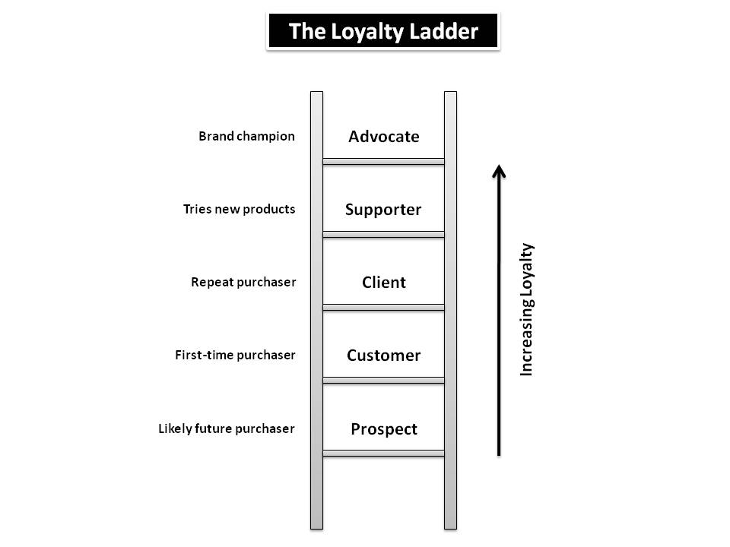

This model describes the path of a customer from the first contact with the company. At that moment the client is a prospect. After the first purchase he becomes a customer. After the customer tries other products from the company then he becomes a supporter. This is when a customer becomes a loyal customer.
In order to reward its loyal customers, M&S has a Sparks loyalty scheme, thus offering more benefits to loyal customers.

2.5.3 Quality at Marks and Spencer

As exemplified above, Marks and Spencer has a culture of premium customer experience. Their values, as found in the mission statement, are quality, value, service, innovation and trust.
As Marks and Spencer has made progress in implementing Plan A and introducing a new technology, it has significantly improved Customer Relationship Management and Company Sustainability. M&S is a customer-centric retailer which means that `the customer is always first` and wants to know the preferences and needs of the customers. In order to provide efficient services for customers, M&S conducts market research and uses customer feedback.
M&S demonstrated some features of the TQM system:
-the products are made for the clients' needs down to the details,
-makes products knowing what the customer wants,
-`the customer is always first`
-stimulating employees for ideas to improve quality and performance.
Also, by selecting the suppliers, it demonstrates a monitoring of the quality of the products in the production and transport chain.

2.6 Segmentation

2.6.1 Definition
Segmentation means to divide the marketplace into parts, or segments, which are definable, accessible, actionable, and profitable and have a growth potential. (The Economic Times, 2021)

2.6.2 Market Segmentation
Market segmentation is a marketing concept that helps companies group their consumers on different criteria.
A basic segmentation comprises the following segments:
Gender
Women and men have different preferences and interests, so the need for segmentation.
Age group
Dividing based on age group is an important way to segment the market. Organizations must have different marketing strategies for each age group.
Income
Usually, marketers divide consumers, depending on their monthly earnings, into three categories:
High income group
Medium income group
Low-income group
Organizations that have the majority of customers in the high-income group will have a different range of products, as well as different promotion strategies.
Marital status
It is important for a travel agency or a restaurant to know the marital status of the client.
Occupation
The needs and activities are so different, which makes the customer's occupation also an important segmentation.

There are three types of market segmentation:
1. Psychographic segmentation - the basis of this segmentation is the different lifestyle of individuals.
2. Behavioural segmentation
Organizations want customer loyalty, and loyalty is rewarded and so this segmentation is beneficial to both parties.
3. Geographic segmentation
Marketing strategies cannot be similar for people living in different places.

The new technology with omnichannel interface recently implemented by M&S ensures their market segmentation according to all criteria.

2.6.3 Marketing Mix at Marks and Spencer

A definition of Market Mix is given by The Financial Times: “The marketing mix refers to the set of actions, or tactics, that a company uses to promote its brand or product in the market. The 4Ps make up a typical marketing mix - Price, Product, Promotion and Place.”
- Price - means `value for money` or the value is put for a product.
M&S is a premium category retailer, the prices being in the medium to high range.
- Product – refers to the item actually being sold.
The M&S brand is very well known and loved for both the quality of products and services in the store or online. Their products are quality, appreciated by consumers. However, they still lost market share (upper end) in favour of John Lewis, or Primark and TK Maxx market share at the lower end.
- Place – this means the store, the point of sale.
M&S is an international company with over 1500 locations operating in 62 countries.
- Promotion – this refers to campaigns to make the products or services know.
In partnership with Ocado, the well-known distribution company, Marks and Spencer has introduced the home delivery service of food products through online orders. Customers received this action very well.

The importance of Market Mix
The elements of the market mix connect and influence each other. Putting them all together make up a business plan, a business plan that is properly managed can give business success.

- Conclusion
M&S has shown openness and honesty towards customers by offering them a certain level of choice at each point of contact, receiving in return value from its customers over time.
Even though M&S was recognized as a customer-centric retailer, wanting to know customers` needs and desires, it invested and designed a five-year strategy implementing a new high-performance technology. After the Covid 19 pandemic crisis, this move prepared the retailer to be competitive in the future and to resist on the high street, transforming M&S into a digital first retailer.
Marks and Spencer has taken significant steps to ensure a competitive customer relationship system. Also, the implementation of Plan A makes it possible for M&S to be a sustainable business, concerned both with customer satisfaction, the well-being of employees and people in the community, as well as the preservation of the planet's resources and a healthy economy.

- Recommendation
It is clear that M&S has made great strides and is a successful business. But as nothing in this world is perfect, but perfectible, there are opportunities for improvement and improvement, some recommendations can be set up that would help maintain sustainability.
A good human resources team would be a real help for the company's management (it is known that the human resources team has the ability to lead the organization).
M&S should learn from the past, analyze real and objective what is happening on the market at the moment and be more connected to consumer trends and requirements. Maybe an update of the clothing offer is needed to attract other target customers. Another recommendation could be an extension of quality management by adding other techniques, such as Pareto analysis. This could prevent waste and reduce costs.

- References
- Brown, C. (2018) How Ethical Is Marks and Spencer? 18 December. Available at: http://www.googonyou.eco (Accessed: 23 May 2021)
- Beaumont, P (2013) 5 Definitions of Sustainability, 5 June. Available at: http://www.blog.rochester.edu (Accessed: 23 May 2021)
- Brown, J. (2016) 38 Memorable Henry Ford Quotes. Available at: http://www.addicted2success.com 9 January (Accessed: 3rd May 2021)
- Buttle, F. (2009) Customer Relationship Management concepts and technologies 2nd Edition. Butterworth-Heinemann: London
- Chai, W., Ehrens, T., Kiwak, K. CRM (customer relationship management) Available at: http://www.searchcustomerexperience.techtarget.com (Accessed: 14 May 2021)
- Chen, I.J., Popovich, K. (2003) Understanding customer relationship management (CRM). Available at: http://www.scholar.google.com (Accessed: 1st May 2021)
- Clements, A. (2019) Mark & Spencer gets real about customer-centricity 6 June. Available at: http://www.retailconnections.co.uk (Accessed: 8 April 2021)
- Connick, W. (2020) What Is Customer Relationship Management (CRM)? Available at: http://www.thebalancecareers.com 23 September (Accessed: 1st May 2021)
- Crosby, P.B. (1979) Quality is free The art of making quality certain McGraw-Hill: New -York
- CQI and IRCA What is Quality? Available at: http://www.quality.org (Accessed: 28 May 2021)
- Grant, D. B., Fernie, J. (2016) Mark and Spencer-Faced the Challenges Ahead 13 January. Available at: http://www.koganpage.com (Accessed: 8 April 2021)
- Institute of Business Ethics, 2016 What is business ethics? Available at: http://www.ibe.org.uk (Accessed:22 May 2021)
- Jackson, M. (2021) Simple Definition of Ethics 28 April. Available at: http://www.matt-jackson.com (Accessed: 25 May 2021)
- Manifested Marketing, (2010) Marks and Spencer – Customer Relationship Marketing 23 July. Available at: http://www.manifestedmarketing.wordpress.com (Accessed: 3rd June 2021)
- Marks and Spencer, (2018) Marks and Spencer Announces Technology Transformation Programme 9 January. Available at: http://corporate.marksandspencer.com )Accessed:12 June 2021)
- Monnappa, A. (2021) Deming, Juran, and Crosby: Pioeers of Project Management
- Partridge, J. (2020) Marks and Spencer scraps shareholder payout amid Covid-19 crisis. 28 April. Available at: http://www.theguardian.com (Accessed: 10 April 2021) 2nd May. Available at http://www.simplilearn.com (Accessed: 7 June 2021)
- Project Management Institute, (1996) Stakeholder analysis. Available at: http://www.pmi.org/learning/library/stakeholder-analysis (Accessed: 1st May 2021)
- Retail Technology, (2019) Marks and Spencer is developing a true omnichannel payment experience for its customers in the UK 1st October. Available at: http://www.retailtechnology.co.uk (Accessed:28 May 2021)
- Rigby, C. (2017) Mark & Spencer: reaching core customers 1 March. Available at: http://www.internetretailing.net (Accessed: 8 April 2021)
- Rigby, C. (2018) M&S introduces new technology to help shape its strategy around what customers want, 14 September. Available at: http://www.internetretailing.net (Accessed: 12 June 2021)
- Riley, J., (2009) Q&A-What are the main interest of business stakeholders? 1st May. Available at: http://www.tutor2u.net/business/blog (Accessed: 1st May 2021)
- Roger, M. (2016) 6 Benefits of Becoming Sustainable Business 29 March. Available at: http://www.environmentalleader.com (Aceessed: 23 May 2021)
- Secondary Research at Work, (2018) Secondary Research at Work. Available at: http://www.youtube.com 26 December (Accessed: 1st May 2021)
- Thakral, R. (2021) Advantages and disadvantages of CRM 2nd March. Available at: http://www.targetintegration.com (Accessed: 9 May 2021)
- The Economic Times, (2021) Definition of `Segmentation` 24 June (Accessed: 24 June 2021)
- The free dictionary Customer Relationship Management. Available at: http://www.encycopedia2.thefreedictionary.com (Accessed: 3rd May 2021)
- Webley, S. (2016) What is business ethics? IBE Pearls of Wisdom [video]. Available at: http://www.yotube.com/watch?v (Accessed:22 May 2021)
- Wightman-Stone, D. (2018) Marks and Spencer recognised for customer experience 25 June. Available at: http://www.fashionunited.uk (Accessed: 12 June 2021)
- Wood, Z., Butler, S. (2018) Seven reasons why Marks & Spencer is in trouble 23. Available at: http://www.theguardian.com (Accessed: 8 April 2021)

