PROJECT OUTCOMES WRITTEN ASSIGNMENT



STUDENT NAME: NOREEN AKHTAR
STUDENT NUMBER: 2016543
MODULE: BMHP5014
ASSIGNMENT: CHANGEMAKERS: CREATIVITY AND VALUE CREATION
LECTURER: DR AZORA HURD

CONTENTS

INTRODUCTION 3
UNIT 1: WHO AM I? MY SENSE OF SELF 4
THE IDEA OF SELF 4
SOCIAL INFLUENCES 4/5
DEVELOPING CREATIVE CONFIDENCE 5
UNIT 2: CHANGE MAKING- THE ACT OF CREATIVE VALUE 5
WHO AND WHAT ARE CHANGE MAKERS? 5/6
VALUE CREATION PEDAGOGY 6
THE PRACTICE OF CHANGE MAKING 7
UNIT 3: COLLABORATION NOT COMPETITION 7
ESTABLISHING A SUPPORTIVE NETWORK 7
STAKEHOLDER ANALYSIS 7/8
CREATING A STAKEHOLDER MAP 8
UNIT 4: CLOSING THE LOOP 9
SKILLS AND ATTRIBUTES 9
SHOWING YOUR WORK 9/16
MY LEARNING AND CONCLUSION 17
REFERENCES 18/19

INTRODUCTION

This assignment is about recognizing key learning points of e- learning which I have gained from doing the activities on the module units. There are four units with four topics in each. I had to complete each topic for the assignment. I will reflect on my learning and personal path, which has supported me to recognize my awareness and critical knowledge of innovation, creativity, and an enterprising mindset, while also acknowledging the values and involvement that creativity makes to the common good within the health and social care profession.
The four units I will be working through and doing the activities on are as follow:
Unit 1: ideas and values
Unit 2: creative solutions
Unit 3: mobilizing support
Unit 4: evaluation

UNIT 1: who am I? My sense of self
This topic was about identifying passions that will move you forward. It helps us to recognize how our enthusiasm may inspire us to think creatively and produce new ideas. There was a video on YouTube in the first session of René Descartes' (The School of Life.2015).
René Descartes' philosophical statement "I think, therefore I am" is among his most famous. Descartes believed in the force of intrinsic ideas and was a rationalist. Descartes begins his inquiry into the physiological effects and influence of these six fundamental emotions (wonder, desire, love, hatred, joy, and sadness) with these six primary passions. Descartes advocated for the thesis of intrinsic knowledge, claiming that all individuals were born knowing something because of God's greater power.
Also, recognize how other people influence our feelings, ideas, and actions and how our perception of ourselves differs from others' perceptions of us. Videos available on this in the second session of social influences (CrashCourse,2014) and (Miller, 2015)
The idea of self
Self is described as a person's true self, knowledge of the individual or individual attributes. Each individual is an example of a self. Confirmation of identities gives a sense of worth and value, whereas proof of role identities gives a self-esteem or ability, and confirmation of individual identity generates a sense of being one's actual self. People are increasingly thinking of themselves as a collection of identities that they try to verify in their relationships with others, and depending on whether or not they succeed, they will experience either pleasant or negative feelings (Burke and Stets, 2009).
Social influences
Planned and unplanned attempts to modify another person's views, attitudes, or conduct are referred to as social influence. Unlike persuasion, which is usually deliberate and needs some level of knowledge on the target's side, social influence can be unintentional or unintentional. Individuals adapt their behavior to match the needs of a social context, which is referred to as social influence. According to social impact research, minority and independent behaviour are the triggers for social change. A minority, for example, might question the majority's views and values, prompting them to reassess or re-evaluate their beliefs (Changingminds.org. 2022).
Developing creative confidence
Creative confidence is the idea that all of us are creative and that creativity is a way of looking at the world rather than the ability to draw, write, or construct. A lack of faith in our talents or ideas might lead to a complete avoiding of new ideas and the crucial process of experimenting. Someone who doesn't feel they have what it takes to be genuinely creative, like the beginner who simply wants to be a content creator, avoids coming up with fresh ideas.
UNIT 2: Change making-The act of creating value
This topic is about change making and the link between change and value creation. Change makers are those who can recognize patterns in their environment, identify issues in any circumstance, devise solutions, create flexible teams, lead collective action, and then adjust as conditions change (Brooks, 2018). Also, a change maker is someone who wants to see the world change and works to achieve that goal by gathering information and resources.
Makiguchi discovered this in the arena of "value," which he described as the most urgent and vital topic of our everyday existence. Happiness, like beauty, benefit and good is a value, as a concept, happiness encompasses, embraces, and integrates these other values. Makiguchi's ultimate purpose of educational activities was to strengthen people's potential to produce value (Makiguchi, 2015).
Who and what are change makers?
A change maker is someone who takes innovative steps to address a social issue. This may appear to be a straightforward task but looking into the elements of the definition of "change maker" reveals a path to making a significant difference. When change makers perceive a problem, they see an opportunity to create a solution. They have a good influence by utilizing important abilities such as empathy, teamwork, and leadership.
Value creation pedagogy
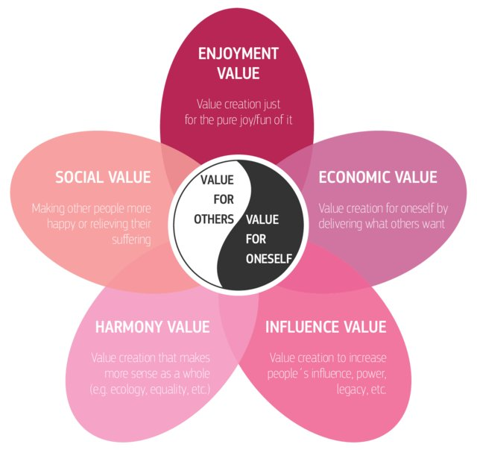
(Williams-Middleton, 2020)
Compassion, imagination, leadership, and cooperation are pedagogic methods that foster innovation, critical thinking, student voice, and entrepreneurship. Social entrepreneurs are bold and persistent, attacking huge challenges and proposing innovative solutions for social transformation. They serve as role models for change makers and ignite organizations and movements where everyone may be a change maker. The crucial critical force is social entrepreneurs.

The practice of change making
In active listening, the listener pays close attention to the speaker's words and replies appropriately. Passive listening, on the other hand, occurs when the listener just hears the speaker's message but does not respond. Without argument or conversation, just proclaiming an independent point of view. There will never be a relationship if you don't listen to the other person and take the time to understand their truth (TEDx Talks, 2019).
UNIT 3: COLLABORATION NOT COMPETITION
This topic is about establishing a supportive network by offering access to potentially important resources; these personal relationships can help in the creation of concepts and the sustainability of a new enterprise. These networks can also help with emotional support and resilience.
Establishing a supportive network
A support network is a group of individuals in your life who assist you in achieving your individual and career goals. A support network refers to 'your team,' or the individuals in your life who may offer you encouragement, support, and opportunities for personal improvement. Your support network can be made up of anybody you choose, but it is most often made up of the individuals with whom you have the strongest bonds. This might include your family, friends, neighbors, and colleagues, to mention. When things go tough, these are the individuals you turn to for guidance, to ask their opinion on a matter, to ask for support in a time of need, or to just seek advice from. In most situations, you'll discover that you have an immediate and a wider network, people you'd call on right away (Donnancoachingservices.com. 2021)
Stakeholder Analysis
Stakeholders are crucial for several purposes. Internal stakeholders are crucial since the company's procedures rely on their capacity to collaborate in order to achieve the company's objectives. External stakeholders, on the other hand, might have an indirect impact on the firm. Maintaining internal and external stakeholder relationships is critical to a company's long-term success.
Stakeholders can be divided into the following categories:
- Primary: Those who are immediately impacted by an organization’s goals, either effectively or poorly.
- Secondary: Someone who is impacted by a company's activity in a non-direct way.
(Asq.org. 2022)
Creating a stakeholder map
It is important to have a stakeholder map to help you to invest in the right places. Also, recognizing your stakeholders is critical since it helps you determine where to focus. In other words, it assists you as the project manager in identifying who the important decision makers are at any given time, allowing you to guarantee that you're speaking to the appropriate people at the right time.
Example of a stakeholder map:
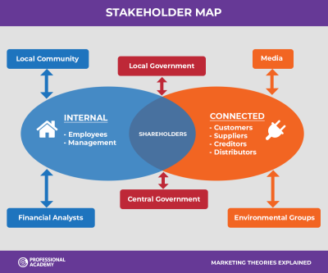 (Professionalacademy.com. 2022)
UNIT 4: CLOSING THE LOOP
This topic is about assessing what we have learnt over the other units and evaluating our findings in each topic.
Skills and attributes
No matter how old you are if you have an idea never let it go. If dreams can come true so can ideas. Dreams, thoughts or ideas all do come true. All we have to do is to take them forward. Ten years ago I would have never thought of me studying to become a nurse. With ideas become our future. The good qualities and values I have to succeed in life are:
- I am trustworthy, helpful and reliable
- My loyalty to other people
- I am considerate of other people’s feelings
- I give my 100% in what I am doing
- I am creative
We frequently go through a study exercise without the opportunity to reflect on what we have learned. We went through a large number of exercises and activities in this module which enabled us to do so and by doing so I have been able to build on my strength of understanding more clearly and progressing further.
Showing your work
From the e-learning material and these units I have found various ways to show and evaluate my work. I presented the following work on the coursework unit blog
“While doing level 4 one of the lecturers said the more creative you are in your assignments the more marks you will get on your work. I did some creative work on one of my assignments which the lecturer was happy to see I went on to not only pass but pass with a distinction. It has now encouraged me to do that little bit more to get a higher mark. Also, I will walk away being proud of myself.”
Posted on the blog 06-02-2022.
The following are a few more pieces I have completed throughout the units:
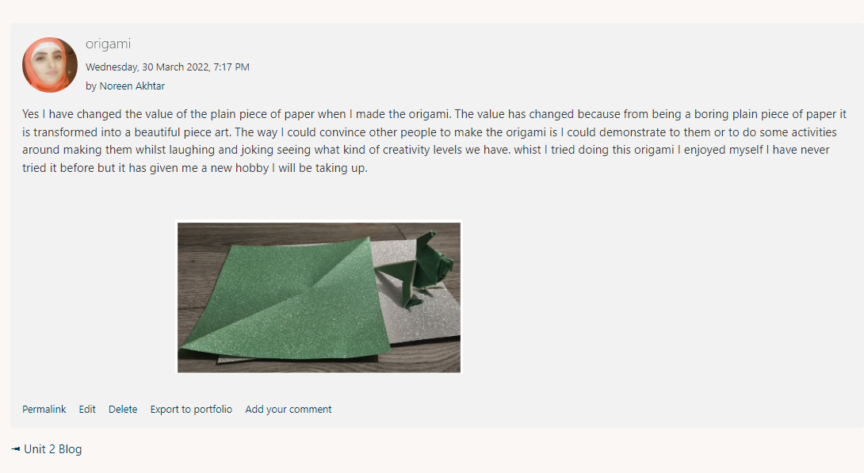
This was an origami activity I did in unit 2. After completing the activity, I had to post it on the blog.

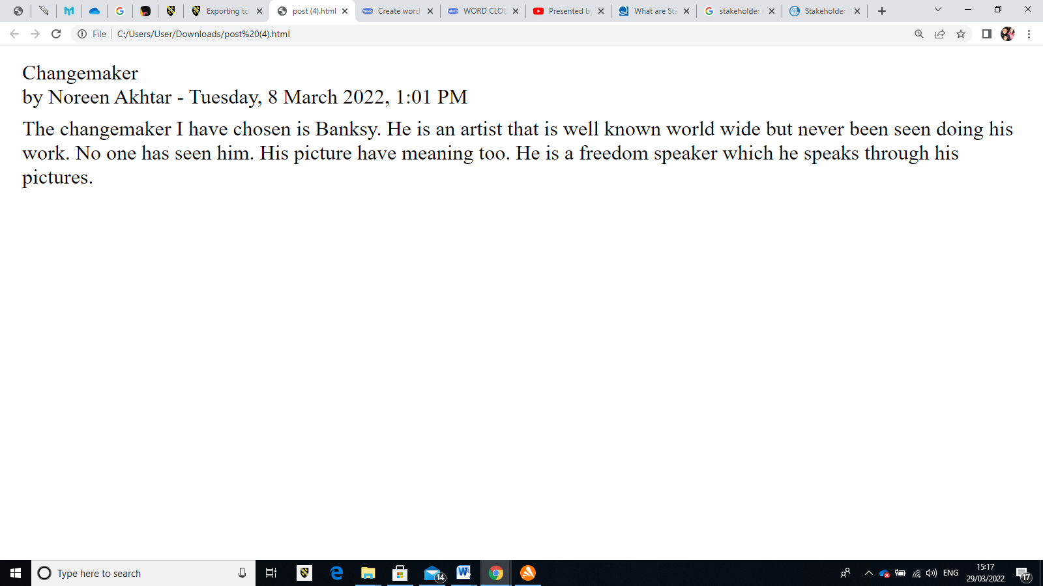
This is a blog I did on a change maker’s activity.

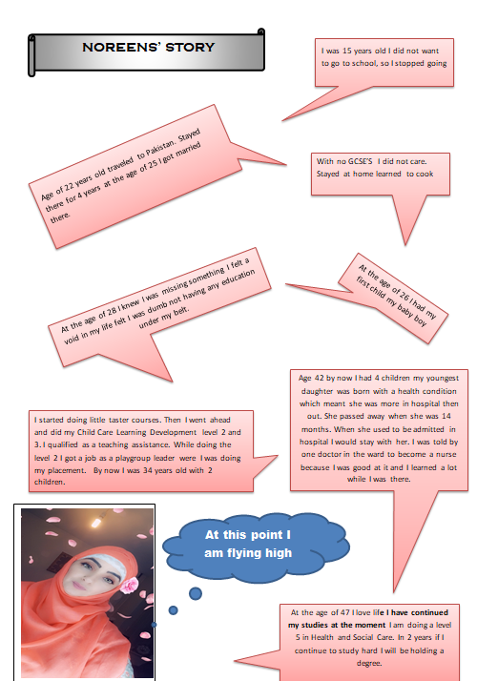

In this activity I had to write a story about myself.

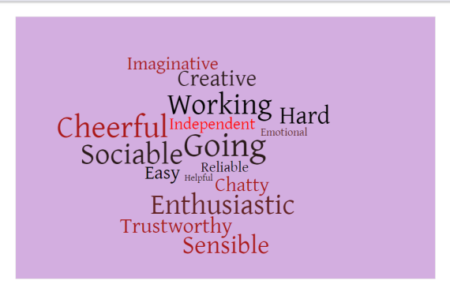
This activity was to make a word cloud about us and post it on the module padlet.
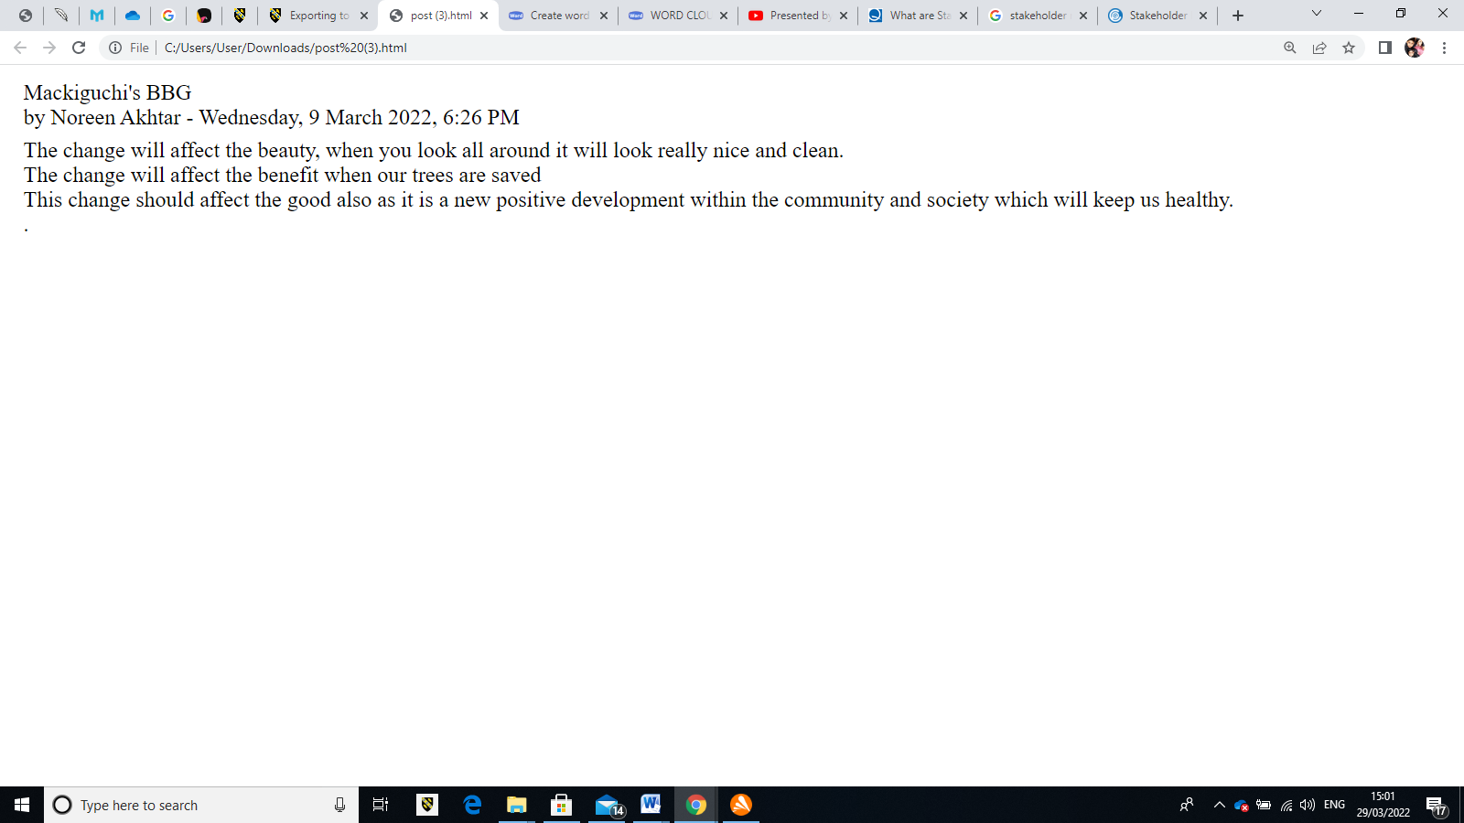
This is a posting I did on a forum in unit 2 about Mackiguchi’s BBG.
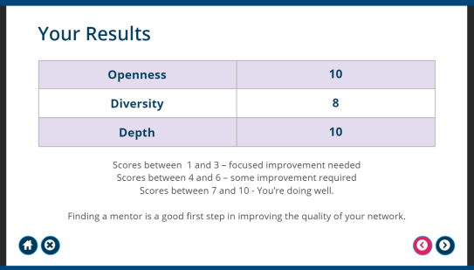
The quality and structure of a network are more significant than the quantity of individuals in it. This is an activity I did in unit 3.

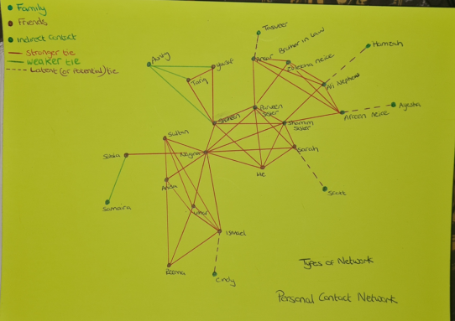

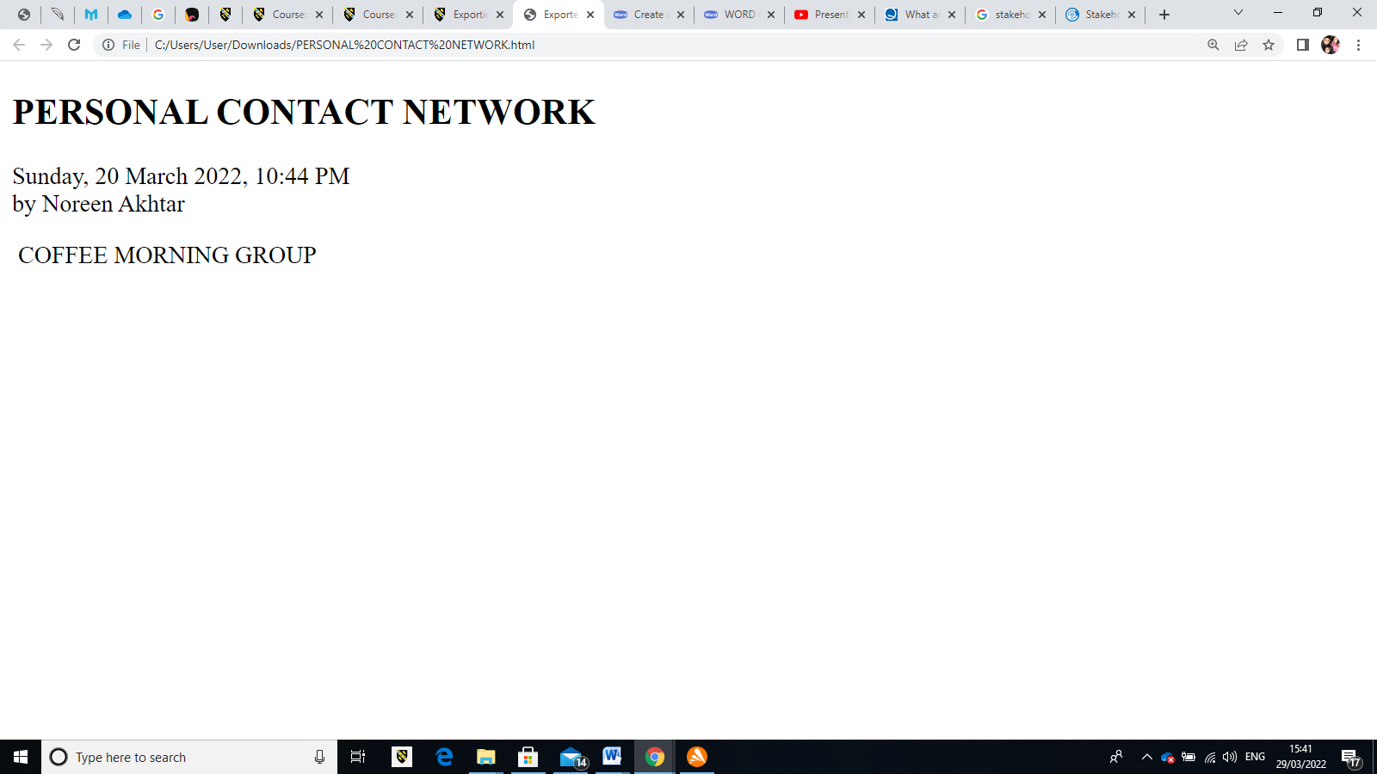

This is an activity I did in unit 3. It was about my personal contact network. I did this with the coffee morning group I go to every Fridays.

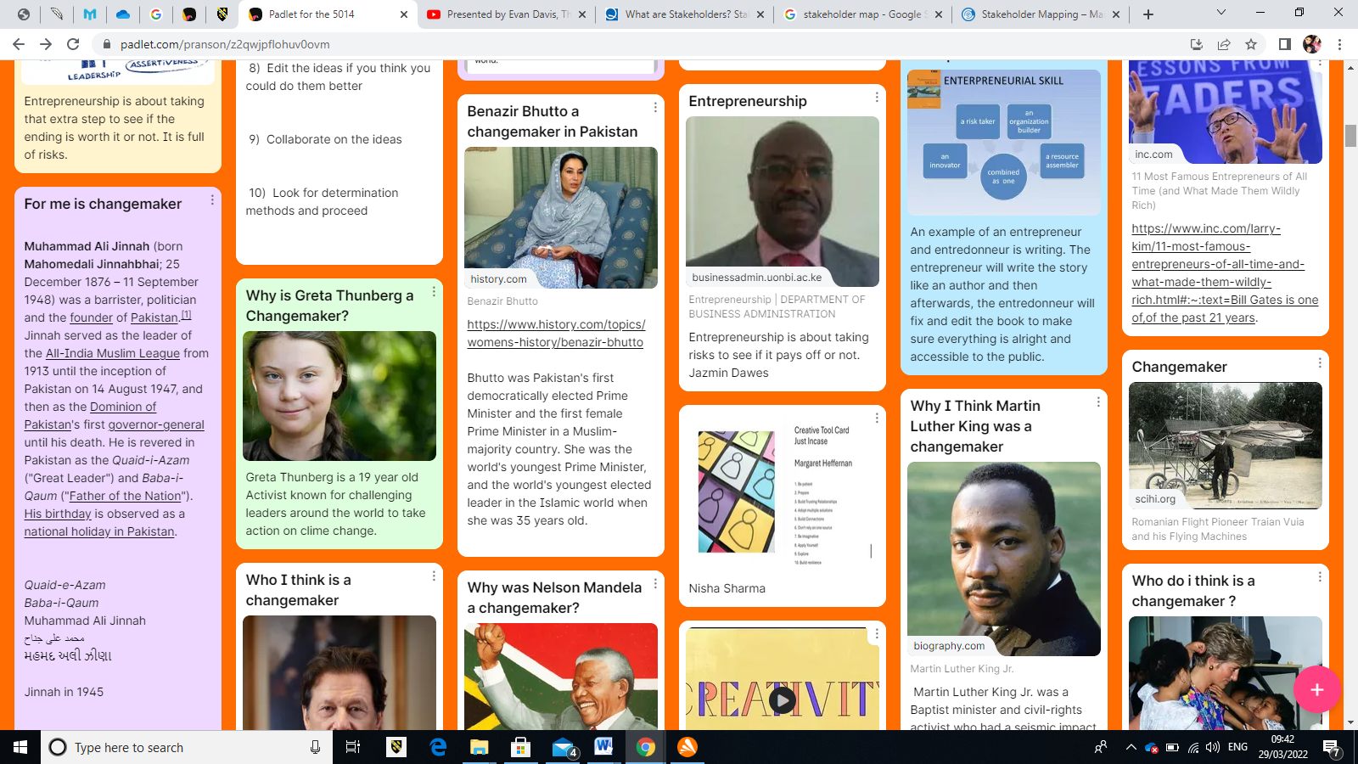

This activity I had to do was to find a person who I think is a change maker that has made a change in the world. I had to post this activity on the module padlet.
MY WELL-BEING MAP
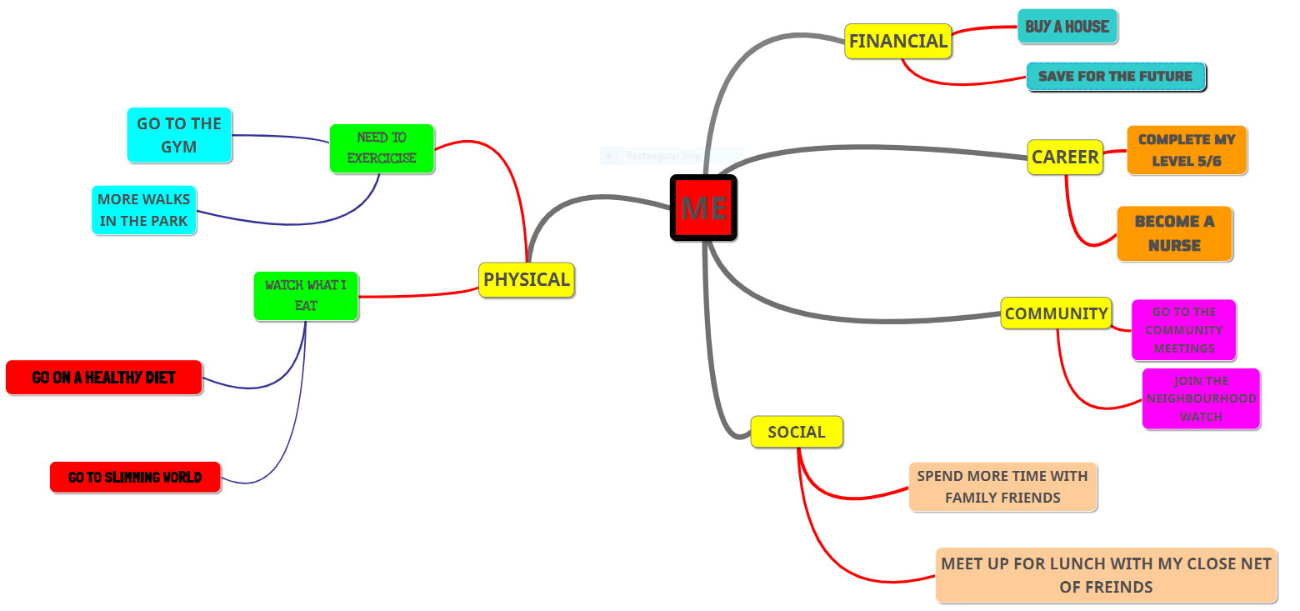

This is a post from unit 4 on the forum.
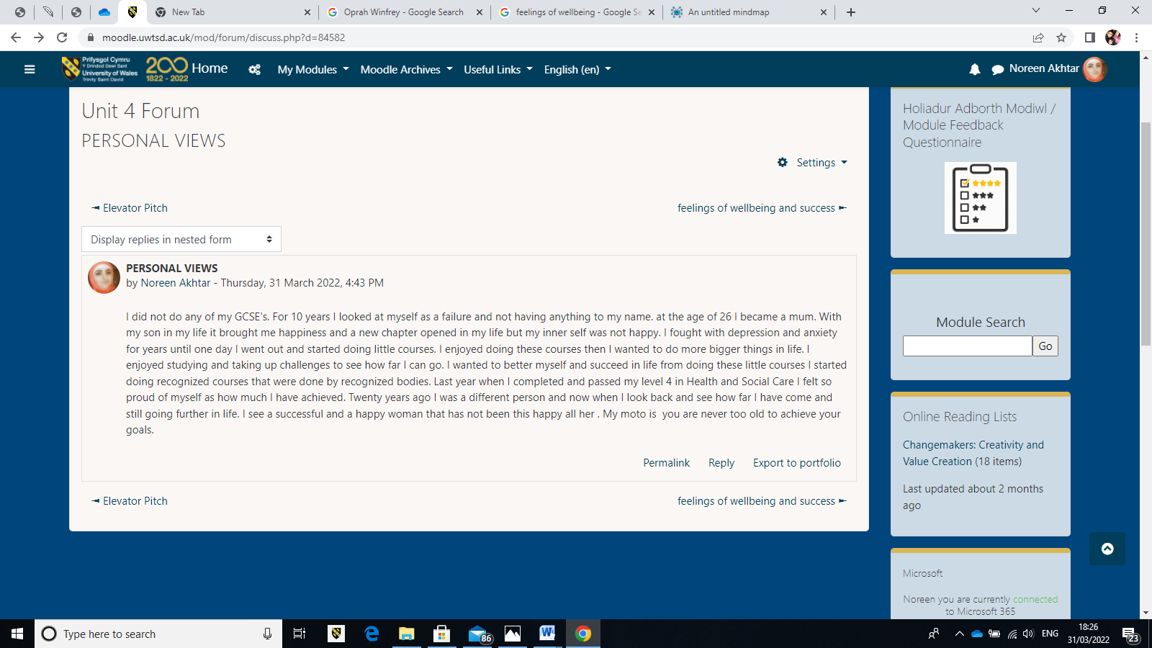
This is a activity I did on unit 4:
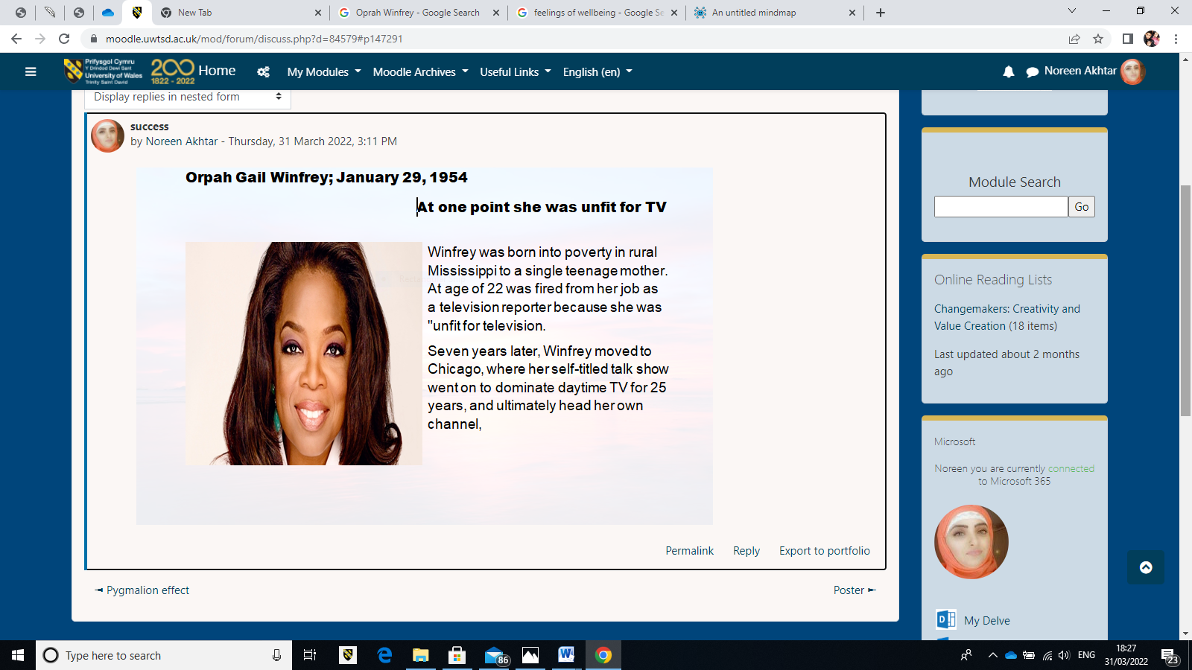
This activity I did was in unit 3 on social media.
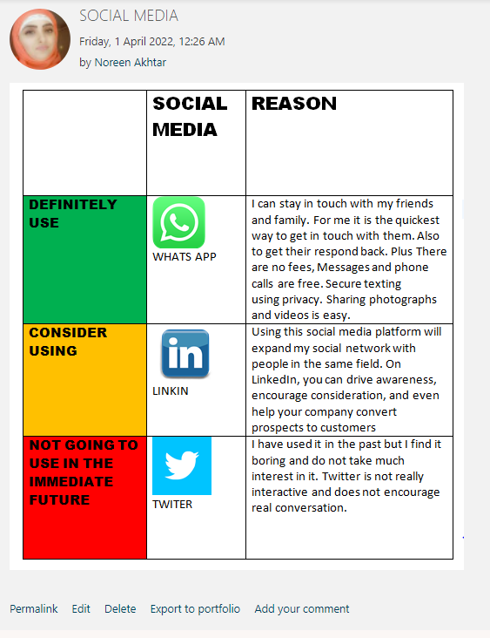

MY LEARNING and CONCLUSION
I have learnt that creativity is important in making a human connection and how we allow real innovation a chance to have an effect in healthcare. Creativity also recognizes the necessity of taking risks, which patients sometimes do not want to hear, such as the routine reaction. Nursing involves imaginative thinking and action in the service of the larger good. Examining the first topic revealed that nurses' creativity contributes to high quality patient care. It prevents more intrusive treatments, increases patients' participation and satisfaction, and facilitates patient care.
One day my passion is to become a cardiac nurse. If I am not looking after my needs properly, for example not eating or sleeping properly, it will affect my way of thinking. I will not be able to reach my goal. My ability to think freely and creatively will show more when I'm looking after myself and my health. Losing a child with a heart condition at a young age I would like to create a scan machine that would show us how server the child's disability is while they are still in the womb and put a plan in place for when the child is born. So, the child has a better chance of survival in this world.
The impact of innovation aids growth and plays a critical part in economic development. It improves issue solving, which is increasingly important as the world's challenges grow. Companies, particularly in developing nations, benefit from innovation because it allows them to keep on top of continuously changing difficulties. It will take time to try and better the world there will be fails but they continue to achieve their goals.
“In my experience of the education system I agree with the comments of Ken Robinson. Creativity should be treated as the same level as Literacy. Creativity is also a method for people of all ages to make an effect on the world and others around them. A lot has changed since Ken Robinson's talk that was recorded in 2006. Since then, technology has developed a lot more. Technology has become more advanced and still is. There is more variety to engage in and to make learning fun”. Posted on the blog 06-02-2022.

REFERENCES

Asq.org. (2022). What are Stakeholders? Stakeholder Definition | ASQ. [online] Available at: <https://asq.org/quality-resources/stakeholders#Analysis> [Accessed 28 March 2022].

Brooks, D., (2018). Opinion | Everyone a Changemaker (Published 2018). [online] Nytimes.com. Available at: <https://www.nytimes.com/2018/02/08/opinion/changemaker-social-entrepreneur.html> [Accessed 26 March 2022].

Burke, P. and Stets, J., (2009). Identity theory. Oxford: Oxford University Press.

Changingminds.org. (2022). Social Influence. [online] Available at: <http://changingminds.org/explanations/theories/social_influence.htm> [Accessed 26 March 2022].

CrashCourse,(2014), Social Influence: Crash Course Psychology #38,Youtube.com. (2014). [video].Available at: <https://www.youtube.com/watch?v=UGxGDdQnC1Y&t=334s> [Accessed 24 March 2022].

Donnancoachingservices.com. (2021). [online] Available at: <https://www.donnancoachingservices.com/post/the-importance-of-building-support-networks> [Accessed 28 March 2022].

Makiguchi, T., (2015). Selected Writings on Education by Tsunesaburo Makiguchi Released in Simplified Chinese |Tsunesaburo Makiguchi Website. [online] Tmakiguchi.org. Available at: <https://www.tmakiguchi.org/news/2015april15-selected-writings-on-educ.html> [Accessed 26 March 2022].

Miller, B., (2015). Charles Cooley- Looking glass self | Individuals and Society | MCAT | Khan Academy, Youtube.com [online]. Available at: <https://www.youtube.com/watch?v=bU0BQUa11ek> [Accessed 24 March 2022].

Professionalacademy.com. (2022). Stakeholder Mapping – Marketing Theories. [online] Available at: <https://www.professionalacademy.com/blogs/stakeholder-mapping-marketing-theories/> [Accessed 28 March 2022].

TEDx Talks, ( 2019). How to actively listen to others | Scott Pierce | TEDxBirmingham Youtube.com. [online]. Available at: <https://www.youtube.com/watch?v=Yq5pJ0q3xuc> [Accessed 26 March 2022].

The School of Life, (2015). PHILOSOPHY - René DescartesYoutube.com. [video]. Available at: <https://www.youtube.com/watch?v=CAjWUrwvxs4&t=202s> [Accessed 24 March 2022].

Williams-Middleton, K., (2020). [online] Available at: <https://www.researchgate.net/publication/341285992_The_entrepreneurial_employee_in_the_public_and_private_sector_What_How_Why/figures> [Accessed 26 March 2022].

