

Component 1- Task-1: Blog

MSc Public Health and Social Care in Practice
Module Title: Population Health and Digital Health Promotion
Module Code: LCHS7007
Assignment Title: Component 1 Task 1- Blog
Task 2- Poster Design
Student Name: Jahanara Begum
Student ID: 1813593
Lecturer Name: Dr Diola Bijlhout

Table of content

1. Blog One 1
1.1 Obesity Epidemic: A Growing Public Health Concern in the UK 1
1.2 Health Implications of Obesity 1
1.3 Technological Intervention: The NHS "Weight Loss" App 2
1.4 Empowering Individuals: The Effectiveness of NHS's "Weight Loss" App 2
2. Blog 2 4
2.1 The Soaring Prevalence of Type 2 Diabetes in the UK 4
2.2 Technological Advancements in Type 2 Diabetes Management 5
2.3 Empowering Diabetes Patients: The Impact of CGMs 5

1. Blog One

1.1 Obesity Epidemic: A Growing Public Health Concern in the UK
Obesity is a very common public health concern in recent years and the alarming fact is that it is getting bad day by day. According to Office for health Improvement and Disparities (2023), the prevalence of overweight and obesity in the UK was 63.8% among the people aged 18 and over. At the same time, Baker (2023) reported that the prevalence of overweight among adults aged 18 and over was 37.9% and obesity prevalence was 25.9% in 2021. So, it can easy to understand that the prevalence rate is increasing gradually. Obesity became a key public health concern because of many reasons but the most key reason is its link to other chronic health conditions. Das (2021) stated that obesity or overweight is the root cause of ranges of long-term conditions including cardiovascular diseases, hypertension, coronary heart diseases, diabetes, stroke, gallbladder disease and musculoskeletal disorders. NHS (2022) reported that more than half (53%) of all deaths caused by heart and circulatory diseases in the UK is directly linked to overweight and obesity. As a result, it is necessary to tackle this health problem.
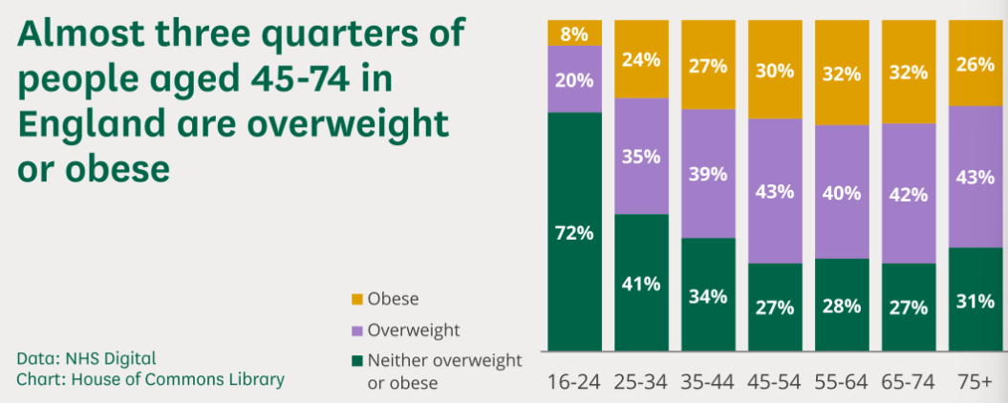
(Source: medium.com)

1.2 Health Implications of Obesity
For tacking obesity, the mobile application-based technology plays an important role. In the UK, NHS is playing the major role by addressing this public health issue and they are now using mobile app called “Weight Loss” to involve the people who are at risk due to overweight and obesity (NHS, 2022). It is a free application that can be installed in mobile and used by an individual by customizing its features to achieve a weight-loss goal. This is an effective technology used in tackling obesity by involving the individuals to ensure an overall impact on this public health issue. NHS promotes it as the most convenient healthcare intervention to reduce obesity nationally.
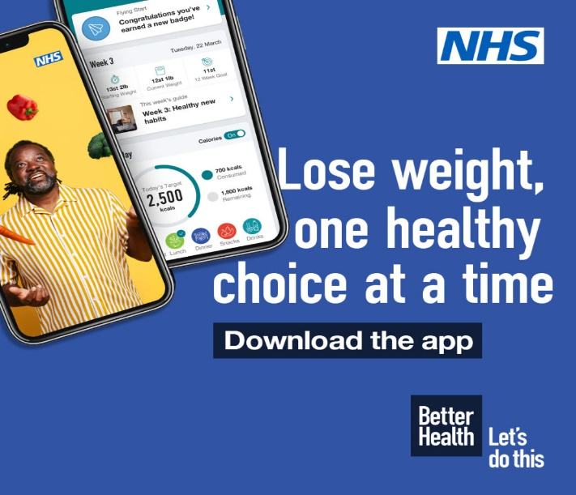
(Source: partnershealth.co.uk)

1.3 Technological Intervention: The NHS "Weight Loss" App
In terms of losing weights, NHS’s “Weight Loss” app plays an important role. Allen (2023) reported that this app is found very popular among people who wants to lose weight and maintain a healthy weight as well as preventing the negative consequence of obesity. The effectiveness of this NHS’s “Weight Loss” app is concentrated to its features as it allows its users to track their weight, meals and level of physical activities (Noreik et al., 2021).

1.4 Empowering Individuals: The Effectiveness of NHS's "Weight Loss" App
This app has a positive impact on obesity reduction initiatives taken by the government as it allows an individual (obese or overweight person) to be engaged in the weight loss process directly. According to Allen (2023), the key advantage of NHS’s “Weight Loss” app is that it offers interpersonal engagement with the user and also offers customization to fit into the needs and requirement of the app user. For example, an individual with weight over 100 lbs. can and an individual weight over 15 lbs. can use this app conveniently by setting their weight loss targets as their health condition and preferences. In contrast, this app does not have any feature to be engaged with a community who are also using the app or involved in weight loss process. On that occasion, this shortfall can be overcome by introducing a new feature to be connected with the app user community or other communities that are involved in similar kind of approach.

Bibliography
Allen, V. (2023) NHS weight loss app is as good as visit to a slimming group with people one stone lighter in a year, study finds. Available at: https://www.dailymail.co.uk/news/article-11317457/NHS-weight-loss-app-good-visit-slimming-group-people-one-stone-lighter-year.html [Accessed 1 November 2023].
Baker, C. (2023) Obesity statistics. Available at: https://researchbriefings.files.parliament.uk/documents/SN03336/SN03336.pdf [Accessed 1 November 2023].
Das, S. (2021) Effect of Obesity in the Cardiovascular System. Obesity and Its Impact on Health, 15(2), pp.67–90.
NHS (2022) Rapid NHS rollout sees 200,000 diabetes patients get lifechanging devices. Available at:https://www.england.nhs.uk/2022/12/rapid-nhs-rollout-sees-200000-diabetes-patients-get-lifechanging-devices/ [Accessed 1 November 2023].
Noreik, M., Madigan, C. D., Astbury, N. M., Edwards, R. M., Galal, U., Mollison, J., Ghebretinsea, F. andJebb, S. A. (2021) Testing the short‐term effectiveness of primary care referral to online weight loss programmes: A randomised controlled trial. Clinical Obesity, 22(5), pp.11-26.
Office for health Improvement and Disparities (2023) Obesity Profile: short statistical commentary May 2023. Available at: https://www.gov.uk/government/statistics/obesity-profile-update-may-2023/obesity-profile-short-statistical-commentary-may-2023#:~:text=In%202021%20to%202022%2C%2025.9,%25)%20and%20men%20(25.8%25). [Accessed 1 November 2023].
medium.com. (Source: https://medium.com/@gercep.foundation/tips-to-avoid-obesity-and-how-to-treat-obesity-0d9e516f85a2).
partnershealth.co.uk. (Source: https://partnershealth.co.uk/march---mental-health-resources).

2. Blog 2

2.1 The Soaring Prevalence of Type 2 Diabetes in the UK
Type 2 diabetes is a key public health concern for the last 3-4 decades all over the world and the UK is not an exception. It can be found that the prevalence of type 2 diabetes in the UK is very high and that is the key concern to the public health. Diabetes UK (2021) reported that the around 4.3 million people are living with type 2 diabetes in the UK where there are Additional 2.3 million people are at risk of developing type 2 diabetes.
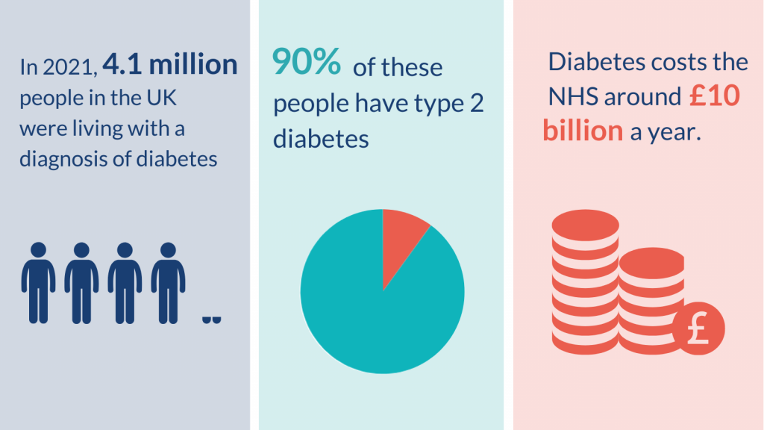
(Source: evidence.nihr.ac.uk)

The important factor to address is that type 2 diabetes is responsible to cause other chronic health problems including cardiovascular diseases, heart attacks, hypertension, stroke and disorder of different body organs.

2.2 Technological Advancements in Type 2 Diabetes Management
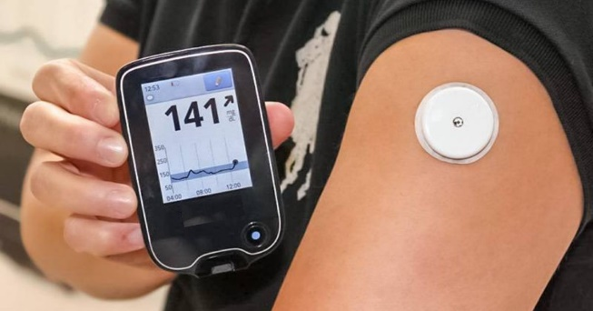
(Source: sydenhamclinic.com)

Different types of technologies are used for tackling type 2 diabetes, where some technologies are used for diabetes management and some are used for treatment of diabetes. On-invasive glucose monitoring devices (CGMs) are used as technologies for effective diabetes management as it is used as an assistive device to control diabetes (NHS, 2022). The new element of this device is the integration of AI algorithm. It is the only possible upgrade that the CGM device can integrate in its software for getting live data.

2.3 Empowering Diabetes Patients: The Impact of CGMs
The use of artificial intelligence algorithms in Continuous Glucose Monitoring (CGM) devices signifies a notable development in health promotion (Lu et al., 2023). Due to this technical progress, the device can now provide people with diabetes with more accurate and immediate measurements of their blood glucose levels. The use of AI algorithms enables the CGM gadget to provide more accurate trend analysis and projections by efficiently processing vast quantities of data.
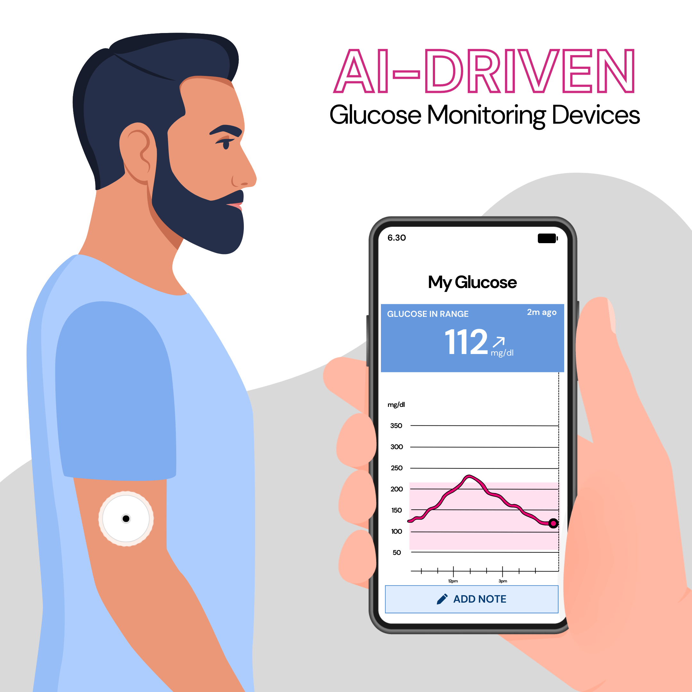
(Source: Self-made)
This technology facilitates proactive health management by empowering individuals to effectively modify their food, medicine, and lifestyle in accordance with fluctuations in their blood glucose levels (de Moraes Lopes et al., 2020). AI has the capacity to enhance patient-centered diabetes treatment by allowing continuous glucose monitors to identify distinct trends and deliver customized suggestions.
Moreover, patients may enhance their compliance with treatment programs by modifying their glycemic control via the continuous feedback loop facilitated by AI-powered CGM devices. This promotes overall health by mitigating the adverse consequences of diabetes and improving existing well-being. The incorporation of artificial intelligence algorithms into continuous glucose monitors (CGMs) represents a notable advance in the realm of health promotion. Individuals afflicted with diabetes are given access to the necessary resources for effectively managing their condition and improving their overall well-being (American Diabetes Association, 2020).

References:
Diabetes UK (2021) around 31,000 heart and circulatory deaths attributed to excess weight and obesity every year. Available at: https://www.bhf.org.uk/what-we-do/news-from-the-bhf/news-archive/2021/april/31000-heart-and-circulatory-deaths-obesity-each-year#:~:text=Concerning%20obesity%20levels&text=Around%20half%20(53%20per%20cent,including%20heart%20attack%20and%20stroke. [Accessed 1 November 2023].
Lu, H.Y., Ding, X., Hirst, J.E., Yang, Y., Yang, J., Mackillop, L. and Clifton, D., 2023. Digital health and machine learning technologies for blood glucose monitoring and management of gestational diabetes. IEEE Reviews in Biomedical Engineering.
de Moraes Lopes, M.H.B., Ferreira, D.D., Ferreira, A.C.B.H., da Silva, G.R., Caetano, A.S. and Braz, V.N., 2020. Use of artificial intelligence in precision nutrition and fitness. In Artificial Intelligence in Precision Health (pp. 465-496). Academic Press.
American Diabetes Association, 2020. 5. Facilitating behavior change and well-being to improve health outcomes: Standards of Medical Care in Diabetes—2020. Diabetes care, 43(Supplement_1), pp.S48-S65.
evidence.nihr.ac.uk. (Source: https://evidence.nihr.ac.uk/collection/diabetes-putting-people-at-the-heart-of-services/).
sydenhamclinic.com. (Source: https://sydenhamclinic.com/continuous-glucose-monitoring-what-is-it/).



