Foreign Languages and Cultural Awareness

BMIH5003
Intercultural Competence Report-Italy
Lecturer: Heidi Prosser
Student id: 2219073
Student name: Roxana-Mihaela Panainte
Date: 26/02/2024

Executive summary

This report examines the operational and cultural differences within the London, England, and Italy locations of the Inclusivity Hotel & Spa, as highlighted by the GLOBE Project's cultural dimensions and leadership styles. This analysis unveils unique societal practices and cultural norms that exert an impact on leadership inclinations, group interactions, and managerial methodologies in every geographical area. The analysis underscores the criticality for hospitality industry executives to foster cultural sensitivity and adaptability in order to proficiently oversee a diverse workforce. Through the recognition and valuation of these distinctions, leaders are capable of executing tactics that reconcile cultural imbalances, foster inclusiveness, and capitalise on cultural variety as a means to gain a competitive superiority. The knowledge and understanding outlined in this report are crucial for organisations striving to attain operational efficiency and service excellence on a global scale.

Contents
Executive summary 2
Introduction 4
Key differences between England and Italy 4
Analysis 6
Difficulties associated with intercultural leadership in the hotel sector 8
Conclusion 8
Recommendations 9
References 10

Introduction

Culture functions as a structural foundation that regulates discernible conduct and the fundamental principles and standards that underpin such conduct. In addition to being a component of people's daily existence, it is a product of their history and influences their expectations, values, and behaviour (Hampden-Turner and Trompenaars, 2020). Cultures undergo dynamic transformations over time as a result of internal progress and external factors, including globalisation, which may induce cultural homogenization or combining. Notwithstanding these transformations, culture remains an indispensable factor in cultivating a sense of identity, inclusion, and comprehension among the members of a society (Christiansen, Branch and Karmowska, 2020). Focusing on culture, customs, and leadership practices, this report examines the operational and cultural distinctions between the Inclusivity Hotel & Spa in London, England, and its branch in Italy.

Key differences between England and Italy

It is evident from the visualisations derived from the cultural dimensions of the GLOBE Project that England and Italy differ significantly with regard to cultural values and practices. The GLOBE Project (2020), an investigation into the interconnections among organisational leadership, societal culture, and organisational culture, provides significant knowledge regarding the potential variations in these factors across countries. As an illustration, with regard to societal practices, Italy exhibits superior scores in assertiveness, future orientation, and performance orientation when compared to England. This implies that Italy places a heightened value on competitiveness, proactive and assertive conduct, and an emphasis on outcomes in both professional and social spheres (Hofstede, Hofstede, and Minkov, 2010). On the contrary, England attains a higher score in institutional collectivism, which signifies a more pronounced adherence to collective action and the distribution of resources collectively within societies and organisations (The GLOBE Project, 2020). Compared to the English, Italians prioritise in-group collectivism more highly, indicating a stronger value system for family and group cohesion. In contrast, the English place a greater emphasis on humane orientation and performance orientation, as measured by value scores, which reflects a societal predilection for excellence, innovation, and equitable treatment of individuals. Comprehending these distinctions is imperative for the efficient management of a diverse team. The staff may be highly motivated to achieve excellence and remain competitive due to the Italian emphasis on performance and assertiveness. Conversely, the English value of institutional collectivism may promote teamwork and collaboration. When these divergent practices and values intersect, particularly in the domains of leadership and management, reward systems, and communication within the hotel operations, a potential for conflict emerges (Abramson and Moran, 2018).

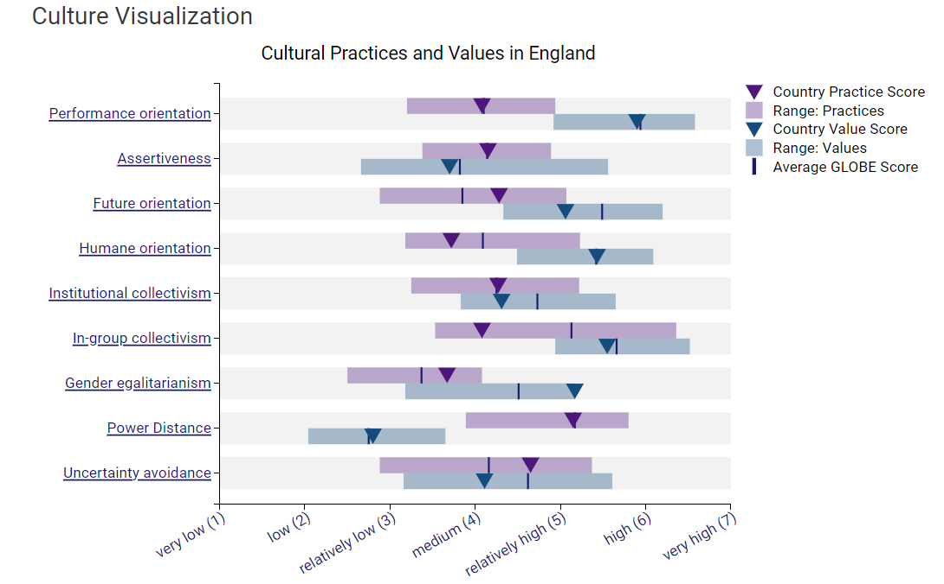
Globe Project (2020). Cultural practices and values in England
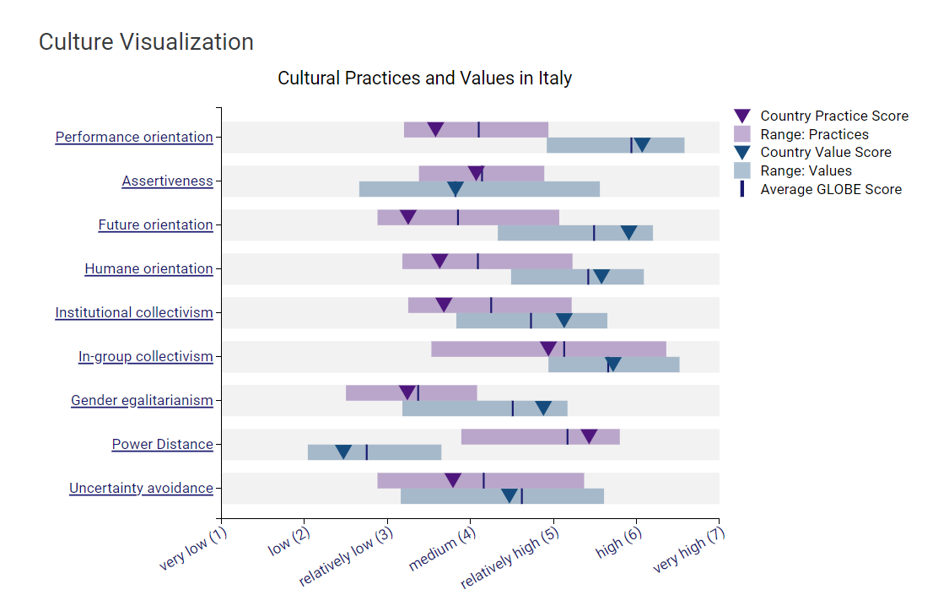
Globe Project (2020). Cultural practices and values in Italy

Analysis

The leadership study conducted by the GLOBE Project (2020) offers valuable insights into the behaviours and qualities that are widely endorsed and promoted among leaders in various societies. An analysis of the leadership scores for Italy and England enables the identification of leadership styles that are more aptly suited to achieve success in their respective nations. Italy outperforms England with regard to charismatic and team-oriented leadership, suggesting that Italian society places a premium on leaders who possess qualities such as inspiration, foresight, and the ability to cultivate a sense of unity within the team. It is expected that leaders in Italy exhibit decisiveness, performance-orientedness, and the ability to foster harmonious team dynamics (Hofstede, Hofstede, and Minkov, 2010). Italy also assigns a positive rating to the participative leadership dimension, indicating that leaders are anticipated to engage others in the decision-making process, which encourages a sense of cooperation and collective accountability. A predisposition for participative and humane-oriented leadership styles is evident in England. In English culture, leaders who achieve high scores on the Humane Orientation are regarded as exhibiting qualities such as generosity, compassion, support, and thoughtfulness (GLOBE Project, 2020). The elevated score for participative leadership in England is consistent with a democratic leadership style that values consensus and team member participation in the decision-making process; this reflects a cultural inclination towards inclusiveness.

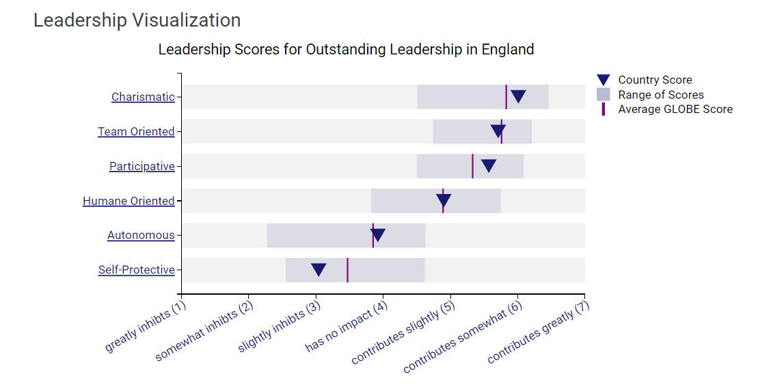
Globe Project (2020). Leadership in England
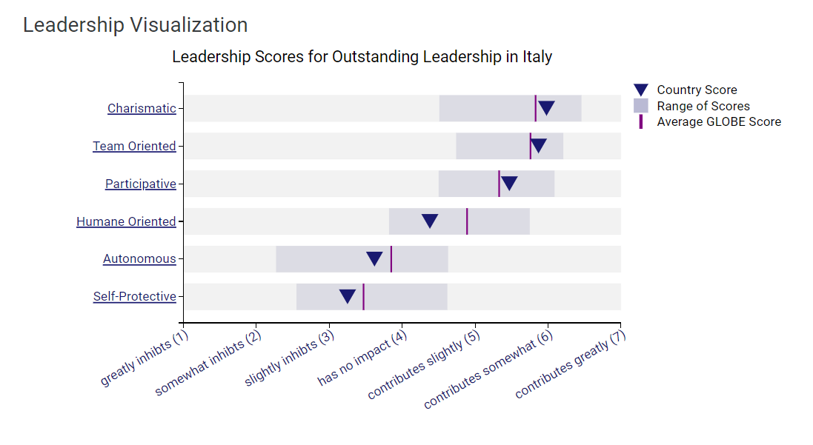
Globe Project (2020). Leadership in Italy.

Difficulties associated with intercultural leadership in the hotel sector

There is a consensus in the literature regarding the imperative for leaders to develop cultural sensitivity and diplomacy in order to nurture harmonious and mutually beneficial relationships with individuals of various races and ethical orientations (Maheshkar and Sharma, 2018). In addition, Hofstede, Hofstede and Minkov (2010) further stresses the significance of cultural sensitivity, not solely in relation to expatriates but also in relation to the domestic front. This emphasises the imperative of an organisational culture that is inclusive and flexible in response to subtleties on a global scale. Furthermore, Ambramson and Moran (2018) emphasise the importance of capitalising on cultural disparities as a valuable asset, delineating the considerable advantages that can be gained by comprehending and employing these disparities efficiently in multinational enterprises. In a similar vein, Hampden-Turner and Trompenaars (2020) put forth a framework that aims to resolve cultural quandaries through the promotion of cultural difference awareness, respect, and ultimately, reconciliation as means to attain transcultural competence.

Conclusion
In conlusion, the analysis of leadership practices and cultural differences between the Inclusivity Hotel & Spa in London and its Italian counterpart demonstrates that cultural values have a significant influence on the functioning of organisations and the effectiveness of leadership. The GLOBE Project has identified cultural dimensions that exemplify notable distinctions in leadership preferences and societal practices between England and Italy. These differences have substantial implications for team dynamics, management strategies, and the overall operational approach. The hospitality industry presents inherent difficulties in intercultural leadership, which emphasise the criticality of cultural sensitivity and the implementation of adaptable, inclusive leadership approaches. By utilising the knowledge acquired from these comparative analyses, organisations can effectively manoeuvre through the intricacies of cultural diversity, cultivating a cohesive workplace atmosphere that leverages the advantages of diverse cultural viewpoints. As a result, service quality and operational achievements can be significantly improved.

Recommendations

- Harmonise management and communication approaches to accommodate the cultural inclinations of personnel from both the English and Italian backgrounds. It is imperative to find a harmonious equilibrium that acknowledges and accommodates variations in performance orientation, future orientation, and assertiveness, all while fostering a unified team dynamic (Gerardo, 2023).
- Develop initiatives that foster cultural interchange among personnel, including communal dining experiences, educational excursions, and language exchange schemes. This can foster greater appreciation and mutual comprehension, by this means contributing to a more harmonious and inclusive work environment (Zlatko and Maciej, 2019).
- A leadership development programme that integrates the contrasting leadership styles of Italy and England, which are characterised by a preference for charismatic and team-oriented leadership, as opposed to a preference for participative and humane-oriented leadership, has the potential to yield significant advantages. The objective of this programme ought to be to furnish leaders with the necessary abilities to adeptly navigate and unify the varied expectations of leadership (Ignacio, David and Nelson, 2022).

References

Abramson, N.R. and Moran, R. (2018) Managing Cultural Differences: Global Leadership for the 21st Century. 10th Ed. Abingdon: Routledge
Christiansen, B., Branch, J.D. and Karmowska, J. (2020) Cultural Factors and Performance in 21st Century Businesses. Hershey : IGI Globa
Gerardo, R.R. (2023). Using Organizational Culture to Resolve Business Challenges. [online] Google Books. IGI Global. Available at: https://www.google.co.uk/books/edition/Using_Organizational_Culture_to_Resolve/7ZnUEAAAQBAJ?hl=en&gbpv=1&dq=n+Ord%C3%B3%C3%B1ez+de+Pablo [Accessed 6 Feb. 2024].

Globe Project (2020). Results - England GLOBE Project. [online] Available at: https://globeproject.com/results/countries/GBR%3Fmenu=list.html#list.

Globe Project (2020). Italy Results - GLOBE Project. [online] Available at: https://globeproject.com/results/countries/ITA%3Fmenu=list.html#list.

Hampden-Turner, C. and Trompenaars, F. (2020) Riding the Waves of Culture. 4th Ed. London: John Murray Press
Hofstede, G., Hofstede, G.J. and Minkov, M. (2010) Cultures and organizations: software of the mind. 3rd Ed. New York: McGraw-Hil
Ignacio, P.-U., Rafael, David, O.-G. and Nelson, M.-M. (2022). Handbook of Research on Promoting an Inclusive Organizational Culture for Entrepreneurial Sustainability. [online] Google Books. IGI Global. Available at: https://www.google.co.uk/books/edition/Handbook_of_Research_on_Promoting_an_Inc/VtibEAAAQBAJ?hl=en&gbpv=1&dq=n+Ord%C3%B3%C3%B1ez+de+Pablo [Accessed 6 Feb. 2024].

Maheshkar, C. and Sharma, V. (2018) Handbook of Research on Cross-Cultural Business Education. Hershey: IGI Global.

Zlatko, N. and Maciej, B. (2019). Recent Advances in the Roles of Cultural and Personal Values in Organizational Behavior. [online] Google Books. IGI Global. Available at: https://www.google.co.uk/books/edition/Recent_Advances_in_the_Roles_of_Cultural/6q2rDwAAQBAJ?hl=en&gbpv=1&dq=Nedelko [Accessed 6 Feb. 2024].
‌

