

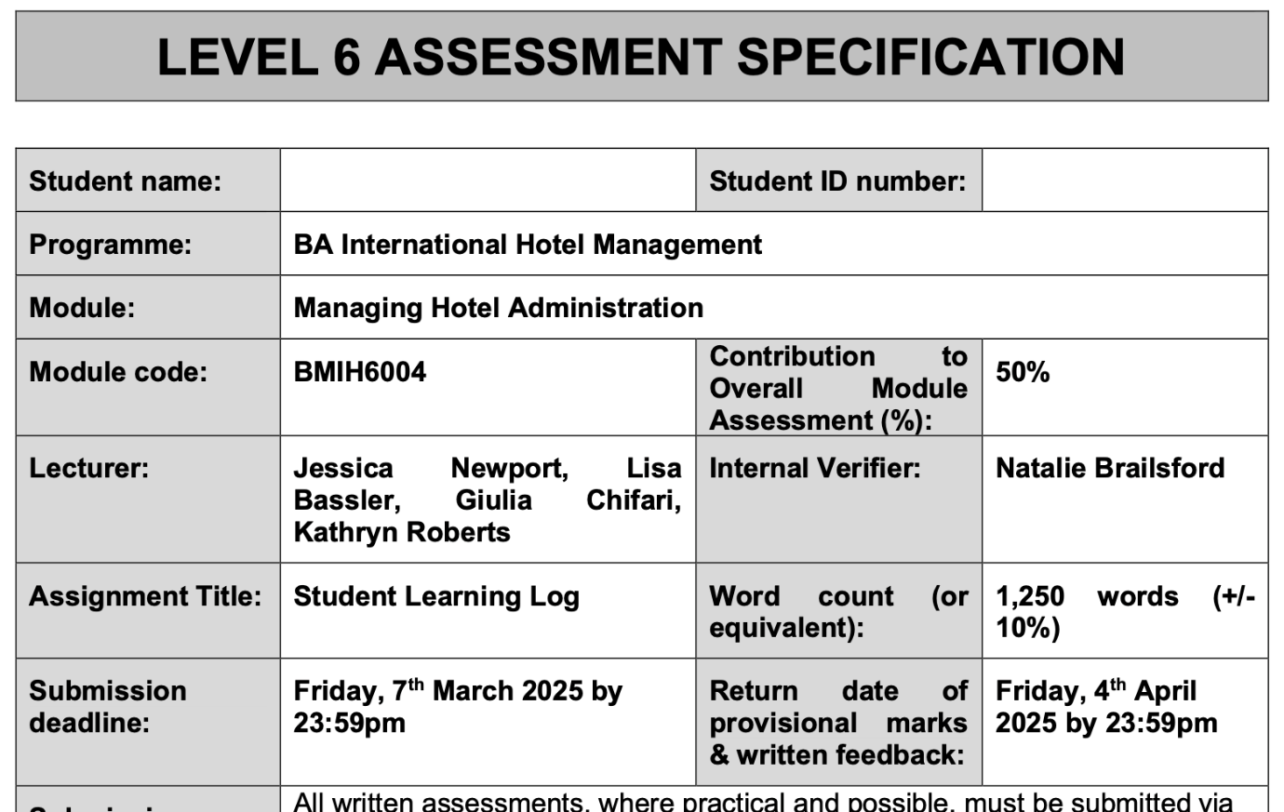

Student name: jahanara begum
Student id number: 2128162

Reflections on Front Office Operations: A Learning Experience at Mercure Birmingham West Hotel

Introduction
Having worked at the front desk of the Mercure Birmingham West Hotel has given me the chance to pick up and hone a broad spectrum of administrative and guest service techniques. The front desk is essential for guaranteeing seamless operations and providing guests with excellent service, which directly affects the client happiness and reputation of the hotel (ASET 2017). Among the other responsibilities the department handles are guest communication, reservation handling, check-in and check-out processes, and handling of guest requests and complaints (Fallon, & Rutherford, 2010). I was able to shadow a supervisor throughout my placement, which let me see personally the vital knowledge and ability needed in running front office operations of a hotel.

For this placement, my learning objectives comprised:

- To better understand front office operations—including guest check-in, bookings, and guest request management—including front office operations.
- To increase my interpersonal skills and communication when dealing with colleagues as well as visitors.
- To develop understanding of the organizational difficulties hotel management faces and suggest remedies.
In order to understand the technical understanding needed for front office system and technology efficient utilization.
To investigate how department operations and the general guest experience change depending on leadership and teamwork.
Using Kolb's (1984) Learning Cycle, this reflective learning log evaluates my experiences during this placement, critically assesses the skills I acquired, and examines a departmental organizational problem.

Section 1: Reflection on Experience and Personal Development

According to Kolb's Learning Cycle (1984), four stages—Concrete Experience, Reflective Observation, Abstract Conceptualization, and Active Experimentation—suggestive of effective learning. Using this approach, I may consider how these phases improved my skills and helped me to better grasp the front office processes.

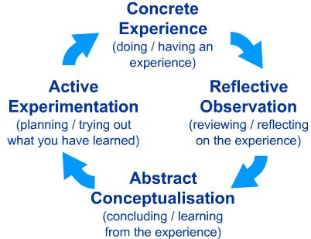
Figure 1, Kolb's Learning Cycle (1984 : https://www.pugetsound.edu/experiential-learning/available-resources/creating-critical-reflection-assignments-resource-1/kolbs

Concrete Experience: During my stay at the Mercure Birmingham West Hotel, I helped with daily reception and front office duties, shadowing managers and guest interaction. Direct exposure to hotel management came from guest check-ins, reservations handling, and guest correspondence.
Reflective Observation: When I thought back on these encounters, I saw how crucial good communication and meticulous attention to detail are to guaranteeing guest satisfaction. Furthermore, seen was how the front office/reception department first interacts with guests, hence it is rather important for determining how the guests view the hotel. Moreover, I saw how under control heavy guest traffic—especially at peak hours—teamwork was essential, and how well supervisory staff led by example guaranteed a seamless flow.

Abstract Conceptualisation: Academic background has given me basic understanding of front office operations and hotel management. For instance, ideas from Bardi (2010) on guest service management and the value of personalization in visitor encounters allowed me to realize how directly attentiveness to client needs contributes to general happiness. Furthermore, Johnston et al. (2012) underlined the importance of cooperation and service operations in hospitality, which I could personally connect to from my visits to the hotel.
Active Experimentation: Based on what I observed, I actively experimented with my learning by instantly using theories and approaches. For instance, I concentrated on a good and quick check-in procedure using my knowledge of communication tactics to enhance visitor contacts (Dogara, et al; 2020). Under the direction of top staff, I also actively helped to address visitor complaints utilizing problem-solving strategies I had acquired during my academic career.
This cycle of education helped me to improve my communication, problem-solving, task management, and knowledge of front office operations by means of consolidation of knowledge and skills.

Section 2: Critical Analysis of Work-Based Skills and Technical Knowledge
Within the framework of hotel management, the work-based knowledge and technical expertise I acquired during my placement were very vital for guaranteeing flawless guest service and smooth operations (Thapa, 2024). Development. One can classify these abilities under communication, teamwork, task management, and technical knowledge.

Communication: Hotel management revolves mostly on effective and clear communication. Vallen and Vallen (2014) emphasize that the front desk is the main point of contact for visitors; so, good handling of questions, bookings, and guest requests depends on efficient communication. By dealing with guests and answering emails and phone calls, I honed my written and verbal communication abilities over my placement. Whether it was a straightforward question or a more complicated demand, I also learned how to adjust communication approaches to fit various guest demands and circumstances.

Teamwork: Working within a team was yet another crucial component of my placement. Tewan (2009) claims that effective completion of tasks and preservation of visitor pleasure depend on cooperation and teamwork. To guarantee that visitor needs were satisfied, I collaborated with managers, receptionists, and other departments—including housekeeping and maintenance—that Especially at busy times when visitor traffic was high, I saw how cooperation enhanced the effectiveness of procedures.

Task Management: Particularly in a fast-paced environment like a hotel, good task management is essential to guarantee timely completion of chores. Shadowing supervisory personnel helped me to learn about their priorities, task distribution, and handling of unanticipated events (Victor, 2024). Ensuring that guest services are neither delayed or compromised depends critically on your capacity to manage several chores simultaneously and be orderly.

Technical Knowledge: Hotel management cannot function without the usage of technology. The front office administration systems of the hotel, which handle guest profiles, check-ins, and bookings, grew familiar to me throughout my placement. Bardi (2010) stated that effective front office activities depend on knowing about such systems. Using these technologies to update reservation information, check in guests, and manage guest preferences gave me practical knowledge. Effective management of hotel operations depends on these abilities since they directly affect guest service, employee efficiency, and general operational performance.

Section 3: Reflection on Organizational Issues
I ran across a management problem with visitor check-in at peak hours throughout my employment. Often running late during peak hours, the hotel was causing guest discontent. After some thought, I came to see that the problem resulted from technological problems with the hotel's booking system, a lack of cooperation between the reception and housekeeping departments, and a small staff during peak hours.
This had a notable influence. Longer wait times for checking in caused irritation and bad feedback among guests. Staff members' performance and morale suffered as they tried to manage a large visitor load. Because rooms were not being cleaned in time for check-ins, this problem also caused a backlog of housekeeping needs.

I would advise using a more flexible staffing plan that changes depending on guest traffic to handle this problem. Furthermore, better use of technology and more coordinated departments could help to simplify the check-in procedure. For instance, changing the booking system to guarantee correct reflection of hotel availability might help to prevent needless waits. Wood (2013) claims that enhancing efficiency and raising client satisfaction depend on the use of technology in hotel management.

Conclusion and Action Plan

When I consider my position at the front desk of the Mercure Birmingham West Hotel, I have learned a great deal about the technological know-how and abilities needed for good hotel management. My experience has helped me to appreciate more the value of technical expertise, communication, teamwork, and task management in front office operations management.
I intend to keep improving my communication and problem-solving capacity in order to shar my talents. Along with learning more about the nuances of hotel operations, I will also concentrate on raising my technological competency with hotel management systems. Furthermore, I shall keep using the ideas of leadership and teamwork to guide my next career activities.
Ultimately, my placement has given me a thorough grasp of hotel management, which will be quite helpful in my next employment in the hospitality sector. Applying my knowledge to upcoming professional practice and keeping on building on past experiences excites me.

References
- ASET (2017) Good Practice Guide for Workbased and Placement Learning in Higher Education. Sheffield: ASET.
- Bardi, J. (2010) Hotel Front Office Management. London: Wiley.
- Dogara, G., Saud, M.S.B. and Kamin, Y.B., 2020. Work-based learning conceptual framework for effective incorporation of soft skills among students of vocational and technical institutions. Ieee Access, 8, pp.211642-211652.
- Fallon, M. & Rutherford, D. (2010) Hotel Management and Operations. London: Wiley.
- Johnston, R., Clark, G. & Shulver, M. (2012) Service Operations Management: Improving Service Delivery. 5th Ed. London: Pearson.
- Kolb, D.A. (1984) Experiential Learning: Experience as the Source of Learning and Development. Englewood Cliffs: Prentice Hall.
- Tewan, J. (2009) Hotel Front Office: Operations and Management. Oxford: Higher Education Press.
- Thapa, H.S., 2024. Development of employability skills through work-based learning. Journal of Technical and Vocational Education and Training, 18(1), pp.102-111.
- Vallen, G.K. & Valen, J.J. (2014) Check-In Check-Out: Managing Hotel Operations. 9th Ed. Harlow: Pearson Education Limited.
- Victor, T., 2024. ELECTRONIC HUMAN RESOURCES MANAGEMENT AND ADMINISTRATIVE EFFECTIVENESS OF HEADS OF TERTIARY INSTITUTIONS IN SOUTH-SOUTH, NIGERIA. BW Academic Journal.
- Wood, R.C. (2013) Key Concepts in Hospitality Management. London: SAGE Publications Ltd.

