
STUDENT NAME : SYED ARIF AHMED
STUDENT ID NUMBER : 2121873
PROGRAMME : INTERNATIONAL HOTEL MANAGEMENT (BA HONS)
MODULE : ORGANISATIONAL CONSULTANCY
MODULE CODE: BMIH6005
LECTURER : JALIYA DE-SILVA
ASSIGNMENT TITLE : CONSULTANCY REPORT

Consultancy Organisation: PA Consulting
Client: Sébastien Bazin, Chairman and CEO of Accor.

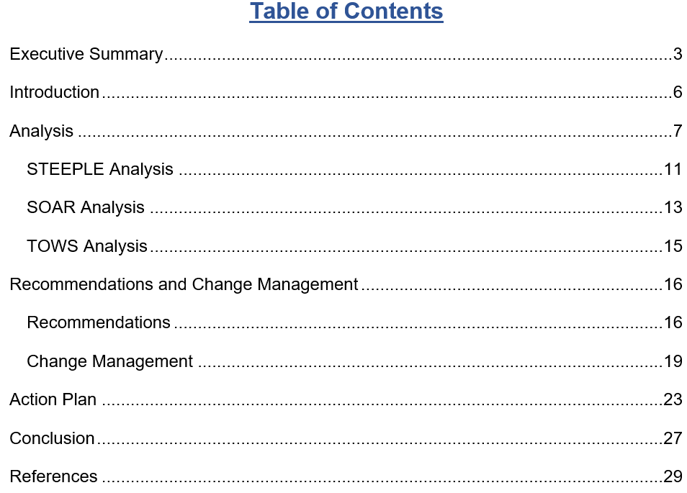

A major participant in the hospitality sector, Accor is now dealing with serious issues like rising operating expenses, rising inflation rates, and labour scarcity (Bader, and Lababedi, 2021). This paper seeks to address these concerns by offering a strategic solution to solve the issues at hand as well as an in-depth examination of the topics at stake.
The paper commences by delineating the principal predicaments confronting Accor Hotel, such as the monetary pressure resulting from escalating operating expenditures, the influence of inflation on buying power as well as economic viability, and the challenge of attracting and maintaining skilled staff in the midst of a labour scarcity (Delardas, et al, 2022). It has been found that these difficulties pose a danger to the hotel's capacity to provide outstanding guest experiences, as well as its operational effectiveness and financial health. As per RSK Hotels Tracker, the energy expenses have doubled in 2022. As a result, the operational cost of Accor has risen to a high level (Lee, and Chen, 2022). In February 2022, it was found that utilities peaking expenses were at £8.03 per room. Moreover, food costs have rocketed high in 2023 as well. As a result, Accor has to face difficulties with increasing the price of food.
Furthermore, In the UK, as of July 2023, the inflation rate has resulted in 6.8%, according to the Office for National Statistics, (2023). In comparison with 2020, the inflation rate has rocketed high in 2023. Although it is less than that of 2022, Accor is still facing difficulties posed by the increasing inflation rate. In comparison with 2020, the inflation rate has rocketed high in 2023. Although it is less than that of 2022, Accor is still facing difficulties posed by the increasing inflation rate.
Moreover, changes in the hotel sector's talent pool as well as shifting attitudes about hospitality jobs are potential causes of the labour shortage. Also, Brexit is another reason for the labour shortage in the UK’s hospitality sector. As per Rutherford, (2021), hotels and restaurants are facing the highest number of labour shortages. Also, it can be seen that due to COVID-19, the occupancy rate in the UK’s hotel companies has decreased to a great extent. While comparing 2019 and 2021, huge differences can be seen. It is believed that it can be difficult for hotels to obtain pre-covid positions quickly.
A thorough examination of the internal as well as external factors causing these difficulties has produced a number of important conclusions. They have been analysed using STEEPLE analysis, SOAR analysis, and TOWS analysis (Sheela, 2022). In this case, it has been found that Accor has built-in advantages that it can use to its advantage, including its well-established brand recognition, worldwide reach, and dedication to innovation. Moreover, in order to reduce risks as well as increase its chances of success, the lodging establishment must handle both internal issues as well as external threats.
On the basis of this analysis, the research provides Accor with a number of strategic suggestions to solve the issues found as well as take advantage of growth potential (Victor, et al, 2021). In this case, these suggestions include putting cost-cutting measures into action, adopting varying sources of income, embracing technology, putting staff development on the top of the priority list, supporting sustainability projects, forming strategic alliances, and encouraging an innovative as well as continually enhanced culture. This paper also highlights how crucial it is to have efficient change management procedures in place to guide the use of suggested tactics (Hay, 2020). In this case, in order to ensure a seamless transition as well as reduce worker resistance, Accor can benefit from transparent discourse, employee involvement, instruction as well as growth, strong feedback systems, recognition as well as awards, and other support systems.
Moreover, through the use of feedback and surveys, before-and-after comparisons, KPIs, as well as continuous monitoring as well as modification, Accor Hotel can assess the effectiveness and impact of the suggested measures (Chakraborty, 2023). Also, through monitoring pertinent indicators as well as obtaining input from relevant parties, the hotel can evaluate the success of its programs, pinpoint areas that need improvement, and seize chances for more expansion and creativity. Furthermore, an action has been developed in order to deal with identified problems (Onaran, 2023). It can be seen that it will take two months to deal with higher operational expenses, four months to deal with the increasing inflation rate, and six months to deal with labour shortages.
To conclude, this report emphasises how critical it is to take proactive as well as strategic measures to solve the issues that Accor is facing. In this case, through the strategic implementation of suggested tactics, adaptability, and strength-based approaches, Accor can raise its level of competition as well as operational effectiveness while securing a prosperous future in the ever-changing hospitality sector. This is to inform you that PA Consulting is still dedicated to helping Accor achieve its ambitions of outstanding service, creativity, and guest happiness. PA Consulting is looking forward to working together to achieve more common goals as well as objectives in the future.

Introduction
Global economic changes have left the hospitality sector with many obstacles to overcome. In this case, Accor, which is one of the well-known hotel companies, is among them. Furthermore, being a prominent participant in the hotel industry, Accor is well-known for its comfort, elegance, and first-rate service (Bader, and Lababedi, 2021). Although the company is one of the prominent lodging establishments in the world, there are a number of significant obstacles in the way right now, from a rising inflation rate to growing labour shortages as well as higher operating expenses. Moreover, these difficulties threaten the lodging establishment's bottom line right now as well as make it more difficult for it to continue providing the unmatched client experience for which it is known.
As far as problematic issues are concerned, above all, Accor faces a dire threat from growing inflation, which has increased operating costs as well as reduced profit margins. This is to say, due to the rising costs of products as well as services, the hotel company has to strike a careful balance between keeping rooms affordable for visitors as well as preserving its own financial stability (Delardas, et al, 2022). Also, rising inflation also results in greater costs for necessities like utilities, food, and maintenance, which puts an additional burden on the lodging establishment's tight budget. Apart from these, the ongoing issue of a labour shortage that besets the hotel sector as a whole exacerbates these financial difficulties (Henschel, et al, 2018). In this case, Accor places a great deal of emphasis on its knowledgeable staff to provide excellent service as well as maintain its stellar reputation. But with fewer skilled workers and increased rivalry, hiring new employees as well as keeping existing ones have become more difficult challenges for Accor. In addition to placing stress on current employees, the lack of competent workers jeopardises the quality of hotel services, which can drive away devoted guests as well as damage the company’s overall reputation (Lee, and Chen, 2022). In addition, the rising operating costs are another problem which includes a wide range of charges from utility costs to facility maintenance, and are still another worry for Accor. In this case, with power costs skyrocketing as well as regulations tightening, the hotel company has to strategically cut costs without compromising guest experience as well as operational effectiveness (Liu, et al, 2022). It is clear that if these growing costs are not addressed, profitability can suffer to a great extent as well as long-term viability can be hampered.
Accor S.A. runs its operations in more than 110 countries. It was established in 1967 in France Paris. Now, it is conducting its operations in 5,445 locations including the UK (London, Birmingham, and others). Furthermore, Accor has long been recognised as a shining example of superior hospitality (Gurl, 2017). Also, the hotel provides visitors with an oasis of comfort as well as elegance in the busy metropolis, with around 802,269 rooms. Moreover, with 28-36 sqm of room size as well as various amenities, such as co-working and business services, restaurants, entertainment, bars, and others, Accor is providing wonderful services to consumers (Deroos, 2010). Furthermore, this hotel company has received a great deal of praise throughout the years for its faultless service, outstanding food, and dedication to going above and beyond for guests.
I work in PA Consulting, which is one of the well-known consulting companies in the UK. As a professional organisational consultant in this company, I have to provide consultancy to Accor about some problematic things like higher operating costs, increasing inflation rate, and the labour shortage. PA Consulting provides personalised solutions to companies with a team of decades-experienced specialists (Dawson-Shepherd, et al, 2013). Also, this company help customers adapt, innovate, and succeed in a changing world by integrating data analysis, market study, and company best practices. In this report, various tools will be used, such as STEEPLE analysis, SOAR analysis, and TOWS analysis.

Analysis
In the setting of Accor, it has been found that higher operating costs, increasing inflation rate, and the labour shortage are major issues. For Accor, the rising cost of operations is a serious problem that affects both its operational effectiveness as well as financial stability (Rutherford, 2021). In this regard, there are many other factors that significantly contribute to increasing expenses, such as rising power bills, greater pricing for products as well as services, and greater expenses for upkeep. Moreover, this problem is made worse by inflationary pressures, which put a further financial burden on the lodging facility's budget (Sheela, 2022). It has been found that increasing expenses immediately reduces profit margins, making it more difficult for the hotel to make additional investments in facilities for guests, staff development, and improvements to the infrastructure. Furthermore, cost-cutting strategies can unintentionally lower service quality, which would leave customers unhappy as well as harm the company's image (Victor, et al, 2021). As per RSK Hotels Tracker, the energy expenses have doubled in 2022. As a result, the operational cost of Accor has risen to a high level. In February 2022, it was found that utilities peaking expenses were at £8.03 per room (Onaran, 2023). The price was decreased later, however, it is still an increased amount, compared with that of the pre-pandemic situation. Moreover, food costs have rocketed high in 2023 as well. As a result, Accor has to face difficulties with increasing the price of food. Although the price of food has risen to a great extent, Accor could not raise its food price because it did not want to lose existing consumers.
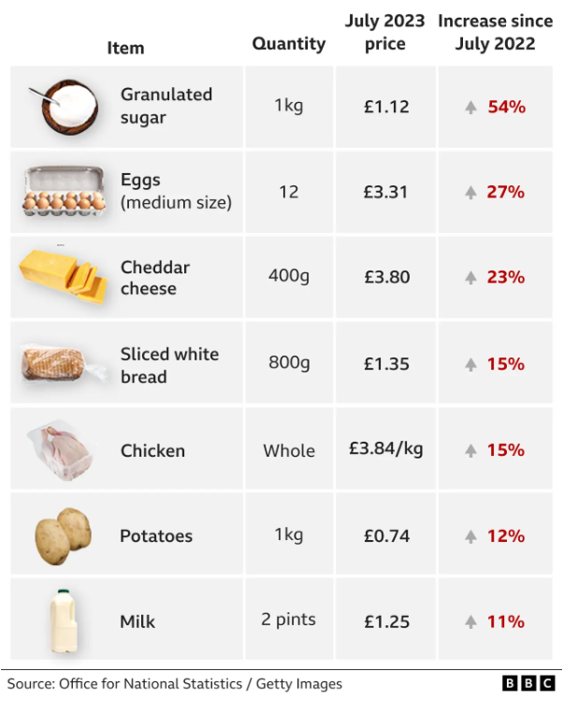
Figure: Increasing price of food in the UK in 2023
Source: Office for National Statistics, (2023)
In addition to increasing operating expenses, the growing rate of inflation rapidly lowers the hotel's as well as its patrons' buying power. As a result, this leads Accor to a tough situation where it is harder for the company to maintain cost without compromising quality (Zientara, et al, 2023). In this case, Accor finds it more difficult to maintain profitability while still offering customers value as a result of inflation's erosion of the actual worth of income. Also, Accor has to change its pricing tactics, which can drive away price-conscious clients as well as encounter opposition from visitors used to the old pricing schemes. In the UK, as of July 2023, the inflation rate has resulted in 6.8%, according to Edwards, et al, (2023). In comparison with 2020, the inflation rate has rocketed high in 2023. Although it is less than that of 2022, Accor is still facing difficulties posed by the increasing inflation rate.
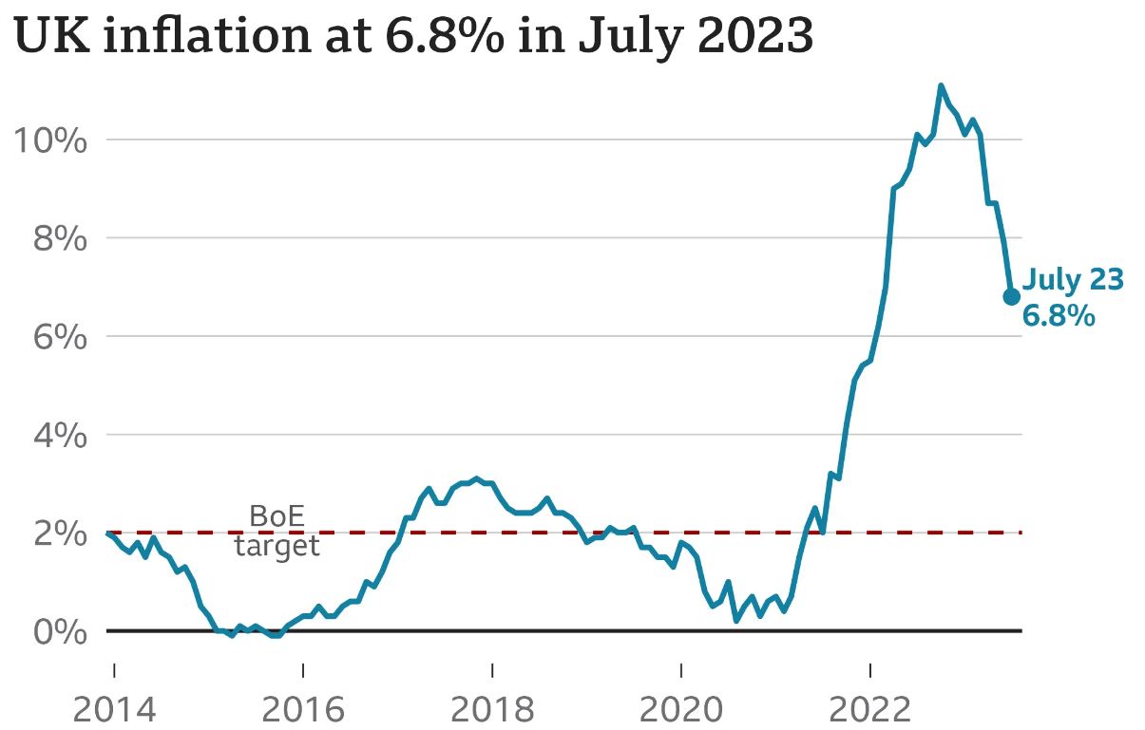
Figure: Inflation Rate in the UK as of July 2023
Source: (Chakraborty, 2023)
Another major barrier to providing outstanding service along with maintaining Accor’s stellar reputation is the lack of competent staff. It has been said that changes in the hotel sector's talent pool as well as shifting attitudes about hospitality jobs are potential causes of the labour shortage (Cascaldi-Garcia, et al, 2023). Also, Brexit is another reason for the labour shortage in the UK’s hospitality sector. Moreover, a lack of workers can force current employees to take on more work, which can ultimately raise turnover rates as well as cause fatigue and low morale (Gupta, et al, 2023). Besides, a shortage of qualified staff can significantly lower the quality of service, which would impair guests' entire encounter as well as damage the hotel's stellar reputation for first-rate hospitality. As per Oxford Analytica, (2023), hotels and restaurants are facing the highest number of labour shortages. Also, it can be seen that due to COVID-19, the occupancy rate in the UK’s hotel companies has decreased to a great extent. While comparing 2019 and 2021, huge differences can be seen. It is believed that it can be difficult for hotels to obtain pre-covid positions quickly.
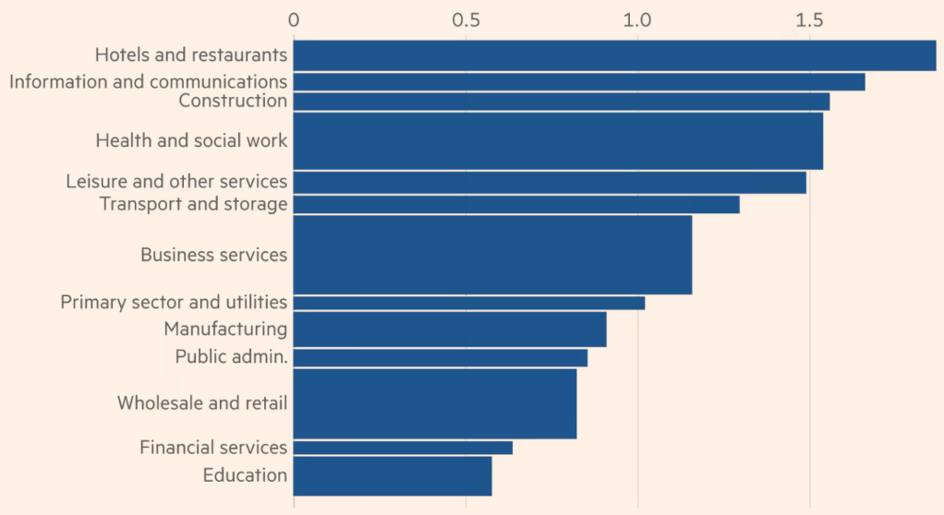
Figure: The sectors facing the labour shortage
Source: (Sealy, et al, 2023)
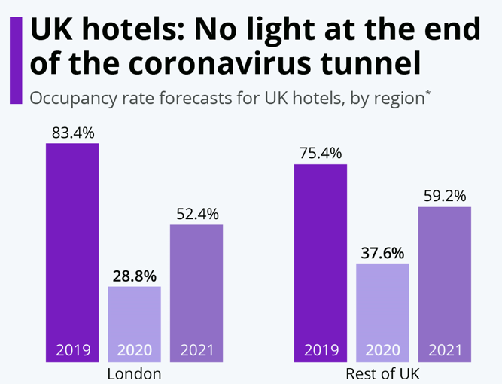
Figure: Occupancy rate in UK Hotels
Source: (Olivi, et al, 2023)
The capacity of Accor to successfully collect as well as handle visitor input can be negatively impacted by the confluence of rising operational expenses, increasing inflation rate, and huge labour shortages (Bedyński, et al, 2023). Furthermore, unfavourable experiences brought on by operational difficulties can considerably lead to negative evaluations, harming the hotel's brand as well as turning away prospective customers. In order to pinpoint areas for development as well as preserve its competitiveness in the market, Accor depends on guest input (Sümer, 2023). In this case, operational limitations, however, can make it more difficult for the hotel to react quickly as well as efficiently to complaints from visitors, which would ultimately increase discontent as well as damage the hotel's brand.
Therefore, it is apparent that the combined effect of these problems imperils the ability of Accor to generate revenue as well as its chances for long-term development (Poretti, et al, 2023). Furthermore, amidst persistent operational issues, the company can find it difficult to sustain income sources, broaden its market accessibility, and fund future growth efforts. Moreover, Accor’s capacity to adjust to shifting market circumstances, reduce operational hazards, and seize new possibilities can determine its capacity to generate income as well as expand its company (Cavallo, 2023). Nevertheless, Accor’s monetary agility is limited, and its potential for strategic development as well as diversification is curtailed by a combination of rising operational prices, an increasing inflation rate, and workforce shortages.

STEEPLE Analysis

Social Factors
Changes in consumer tastes as well as ageing populations have an effect on demand trends in the hotel industry. In this case, they affect the operating expenses as well as income streams of Accor (Sakshi, et al, 2020). Furthermore, changing consumer preferences, such as a greater focus on wellness travel as well as long-term viability call for purchases of new facilities or technology, which ultimately raise the operating costs of the hotel company.

Technological Factors
Although technological innovations like digitisation as well as automation significantly improve productivity as well as simplify processes, they also come with hefty upfront as well as continuous maintenance expenses (Smart, et al, 2021). Additionally, in order to stay competitive in the marketplace, Accor needs to make efforts in digital advertising as well as control of reputation due to the revolution in customer behaviour and expectations brought about by the emergence of digital reservation platforms as well as online assessment sites.

Economic Factors
The operating expenses of Accor are directly impacted by economic variables like increasing inflation rates. Furthermore, variables like labour, utilities, and procurement also reduce profit margins to a great extent (Canhoto, and Wei, 2021). Moreover, financial crises have significantly reduced customer desire for travel, making Accor’s income problems even more severe.

Environmental Factors
Accor needs to invest in sustainable operations as well as infrastructure renovations as a result of growing green laws and customer recognition of sustainability problems. Therefore, this can result in higher operating expenses within Accor (Atkinson, and Brander, 2021). Additionally, unpredictable weather patterns as well as natural catastrophes can considerably cause extensive property damage, expensive repairs, and upgrades. They can also interrupt the activities of Accor to a great extent.

Political Factors
The operational costs as well as profitability of Accor are directly impacted by political choices made on labour laws as well as tax policies (Bailey, 2017). For instance, Accor pays 25% corporate tax, which ultimately influences the profitability of the company. Furthermore, the expense of imported products, as well as services, are impacted by trade arrangements and taxes, which have an impact on Accor pricing as well as sourcing strategy.

Legal Factors
Accor’s labour expenses as well as recruiting tactics are impacted by legal regulations pertaining to pay, benefits, and working environment (Öğüt, and Onur, 2022). Also, adherence to health and safety protocols, especially during public health emergencies, such as COVID-19, needs further expenditures for sanitation protocols as well as personnel education.

Ethical Factors
While ethical procurement as well as CSR activities result in higher expenses for Accor, they also improve client retention as well as the brand's image to a great extent (Filimonau, and Delysia, 2019). Moreover, in order to uphold moral labour standards as well as equitable employment procedures, Accor needs to make investments in staff development, raising operating expenses while promoting a good workplace environment.

SOAR Analysis
Strengths  - Established Brand Reputation  - Global Presence  - Innovation | Opportunities  - Market Expansion  - Sustainability  - Digital Transformation
Aspiration  - Establish industry standards  - Encouraging staff members' creativity and teamwork  - Provide attentive service as well as life-changing experiences all over the globe. | Results  - Increased Profitability and Earnings  - Improved Guest Satisfaction  - Industry Recognition

Strengths
- Accor has a well-established reputation for providing outstanding service, opulent rooms, and top-notch cuisine. In this case, all of these things significantly encourage repeat business as well as excellent word-of-mouth from its clientele (Sarsby, 2016).
- The company has strong brand awareness, economies of scale, and exposure to a variety of consumer groups because of its extensive presence in major markets globally (Sheela, 2022).
- In order to improve the customer experience as well as maintain its position as a market leader, Accor consistently advances its product lines, using consumer trends as well as technological breakthroughs in order to upgrade its services and facilities (Victor, et al, 2021).

Opportunities
- By taking advantage of unexplored consumer categories as well as the rising popularity of travelling, Accor has the chance to enter new markets (Edwards, et al, 2023).
- Accor can take advantage of chances to set itself apart via eco-friendly products as well as sustainable activities as customer awareness of ecological issues grows to a great extent (Perera, 2017).
- Accor has a lot of potential to increase income as well as improve its operational effectiveness by using technology to improve interaction with consumers, optimise business processes, and customise customer service (Liu, et al, 2022).

Aspiration
- In order to lead the hotel sector in environmentally friendly as well as socially responsible practices, establishing industry standards is the aspiration of Accor (Henschel, et al, 2018).
- In order to develop an environment of innovation as well as ongoing development, encouraging staff members' creativity and teamwork in order to boost customer happiness and commercial success is another aspiration of Accor (Gurl, 2017).
- In order to make the company the hotel of choice for discriminating guests looking for unmatched elegance, Accor aspires to provide attentive service as well as life-changing experiences all over the globe (Delardas, et al, 2022).

Results
- Accor Hotel's strategic objectives have led to a steady rise in earnings as well as profitability (Bader, and Lababedi, 2021). Furthermore, this improvement has been fuelled by excellent brand awareness, operational effectiveness, and customer happiness.
- Moreover, Accor has achieved a high standard of customer satisfaction as shown by positive feedback, referrals, and recommendations (Sheela, 2022). In this case, it happens due to the hotel's emphasis on providing outstanding service as well as novel offers.
- Accor’s leadership in the hospitality business has been reaffirmed by the industry honours as well as distinctions that it has received for its accomplishments in ecological responsibility, creativity, and excellent client service (Whittaker, 2018).

TOWS Analysis

Strengths-Opportunities (SO)
- Forming strategic alliances with suppliers can help Accor to bargain for long-term agreements as well as substantial savings (Boella, and Goss, 2013). In addition, Accor can utilise its strong brand to negotiate beneficial terms despite rising prices.
- To improve operational efficiency, reduce worker dependency, and mitigate labour shortages, Accor should use technological advancements, such as automation and data processing. This is supposed to reduce operating costs and increase performance (Ushakov, et al, 2020).

Weaknesses-Threats (WT)
- To combat growing operational expenditures due to inflation, Accor should use cost-containment initiatives, such as energy-saving programs as well as lean management. This can provide Accor financial stability and longevity (Ndiuini, & Baum, 2021).
- In order to manage labour shortages as well as reduce the possibility of losing qualified workers to rivals, Accor needs to develop complete methods for retaining talent that include competitive compensation, employee perks, and possibilities for career progression (Kwok, 2022).

Recommendations
Accor should look at ways to generate income other than just providing lodgings, such as organising events, providing food experiences, collaborating with nearby attractions, and others (Wood, 2024). Furthermore, the company needs to create creative packages as well as promos that are aimed at certain market niches, making use of Accor’s distinctive features as well as strategic position to draw in a wider spectrum of visitors. Also, in order to increase visitor happiness as well as maximise income per guest stay, the hotel company needs to consider investing in auxiliary services as well as upselling possibilities like room improvements, spa therapies, and personalised concierge support (Ntounis, et al, 2022). Besides, Accor must increase accessibility as well as reach by using online platforms in order to enter emerging markets as well as income streams while lowering distribution expenses.
Within Accor, professionals need to perform an extensive analysis of operating costs to pinpoint areas that can be cost-effective, for example, energy use, sustainable purchasing, and waste minimization (Rahman, 2023). Furthermore, in order to reduce utility expenses, Accor needs to make investments in energy-efficient practices as well as technology, such as water-saving appliances, HVAC systems, and energy-efficient LED lighting. Also, the company should utilise its buying power as well as established relationships in order to negotiate advantageous agreements with vendors as well as suppliers so that it can get affordable rates as well as huge discounts (Kirk, 2020). Moreover, Accor should adopt lean management techniques in order to reduce organisational inconsistencies, simplify processes, and allocate resources optimally.
In the face of labour scarcity, Accor should give staff training top priority as well as arrange development programs in order to increase the rate of retention, raise employees’ spirits, and strengthen their skills. In this case, this entails making investments in courses that foster leadership, chances for cross-training, and continuous professional growth (Mamatzakis, et al, 2023). Furthermore, the company needs to adopt a work-life balance as well as time-management policies in order to meet the requirements as well as preferences of a varied workforce, which will significantly improve morale as well as lower attrition. In order to draw in and maintain the best employees in an increasingly competitive labour market, the hotel company needs to provide competitive remuneration packages that include perks, recognition programs, and performance-based rewards (Anser, et al, 2020). Besides, in order to increase staff participation as well as devotion, Accor should cultivate an environment that values diversity, inclusion, and employee empowerment by offering mentoring, career growth chances, and comments.
In order to deal with identified issues, Accor needs to adopt technological solutions. This is to say, the company needs to do it in order to increase overall effectiveness, boost customer service, and simplify processes (Prakash, et al, 2023). In this regard, this entails putting in place smartphone check-in and check-out, cashless payment methods, internet-based property management systems, and others. In order to get knowledge about customer preferences, market developments, and performance in operations, the company should capitalise on data mining as well as business intelligence solutions. It has been said that this will help Accor to make well-informed decisions as well as implement focused marketing campaigns (Sharma, 2023). Also, in order to decrease reliance on labour as well as boost productivity, the hotel company should look at automation options for repetitive jobs as well as procedures like cleaning, inventory control, and revenue management. Moreover, in order to increase direct reservations, the company needs to decrease dependency on outside distribution methods and gather useful guest information for individualised advertising efforts. Apart from these, Accor should improve its online booking systems as well as digital advertising initiatives.
Accor needs to establish strategic alliances with government organisations, neighbourhood companies, and trade groups in order to pool resources, exchange best practices, and push for legislative reforms that will help the company (Emara, et al, 2023). Moreover, Accor should work together with other companies in order to come up with novel approaches, negotiate advantageous terms, and promote reciprocal benefits via common goals. Besides, in order to increase brand awareness as well as reach new audiences, Accor needs to look at co-branding, cross-marketing, and cooperative marketing efforts with related companies, attractions, and activities. Apart from these, the hotel company must work with academic institutions as well as career-training programs in order to develop a pool of qualified candidates, support internships, and close the knowledge disparity between industry demands and academics (Giousmpasoglou, and Marinakou, 2021).
As customer tastes for eco-friendly lodgings change, Accor needs to adapt to the effect of growing operating expenses by committing to environmentally friendly procedures as well as environmental responsibility (Gallego, et al, 2023). Also, in order to reduce the impact on the environment as well as utility costs, Accor needs to make investments in waste reduction programs, green power sources, resource-efficient devices, and others. Moreover, sourcing locally produced products as well as services considerably promotes sustainable tourist practices, preserves historical significance, and helps communities to become more resilient. In this case, it also lowers transportation expenses (Alreahi, et al, 2023). Additionally, by educating visitors, obtaining eco-certifications, and being honest about the green initiatives, Accor can attract eco-aware tourists as well as further improve its brand's image.
In order to keep tabs on how far down the road to cost savings, income, guest pleasure, and sustainability, Accor needs to set up some metrics as well as use KPIs (Marques, 2023). Furthermore, in order to stay ahead of the curve as well as make the necessary adjustments in a timely manner, it is important for the company to regularly examine as well as assess plans, campaigns, and market conditions. In this case, this will help Accor to see new trends, possibilities, and difficulties. Moreover, Accor needs to promote an atmosphere where employees are willing to try new things, take criticism well, and adjust to new circumstances in order to create a culture of creativity, responsiveness, and continual progress (Hamid, and Abboudumeir, 2023). In addition to this, it is essential for Accor to maintain its nimbleness as well as resilience in the face of a constantly shifting market by keeping up with industry news, technical breakthroughs, and legislative developments via industry groups, seminars, and market analysis.

Change Management
In order to guarantee a seamless transition as well as reduce employee opposition, changes must be carefully planned, communicated, and supported in the setting of Accor (Mehta, et al, 2023). In this regard, some methods as well as techniques for change management have been given below that Accor should implement.
In Accor, this is necessary to involve employees in the procedure of change by asking for their opinions, recommendations, and comments. In this case, employees become more open to suggested improvements as a result of this, which ultimately promotes a feeling of empowerment as well as responsibility (Erdem, and Barakazı, 2023). In order to get opinions as well as suggestions from its staff, Accor can host group discussions, conferences, and questionnaires.
This is recommended that higher professionals of Accor should provide concise details on the reasons behind the adjustments, such as the need to adjust to external problems, such as increased labour shortages as well as higher operating expenses (Hsieh, 2022). Moreover, employee resistance, as well as misunderstanding, are decreased when there is open as well as transparent discussion about the reasons behind the changes.
Within Accor, it is vital to identify as well as provide authority to change enthusiasts who can inspire their peers, promote suggested modifications, and clear up any misunderstandings (Boardman, and Barbato, 2018). Moreover, these people support acceptance as well as implementation of the reforms by acting as role models.
This is essential to assist staff members in acquiring the information as well as abilities necessary to adjust to changing work schedules, dress codes, and responsibilities by offering them the necessary guidance as well as assistance (Gröschl, 2019). In this regard, ensuring that employees feel knowledgeable and secure in their responsibilities, helps the company to lower anxiety and decrease resistance to change among employees.
In order to deal with resistance to change, Accor needs to give acknowledgement as well as rewards to staff members who welcome the changes and exhibit adaptation, agility, and a positive outlook (Fyall, and Spyriadis, 2023). It has been said that recognising their efforts helps them maintain the desirable behaviours as well as inspires others to do the same, which promotes an innovative and continually enhanced environment.
Accor should establish feedback tools in order to get regular input from employees on how the changes are affecting their morale, efficiency, and work environment (Bogetić, et al, 2015). Furthermore, in order to find out how staff members are feeling as well as what needs to be improved, Accor should set up suggestion boxes, do routine check-ins, and use anonymous polls.

Support Networks
Within Accor, it is essential to establish groups of support as well as peer-to-peer mentorship programs so that staff members can ask questions, exchange experiences, and offer one another support during this time of change (Santos, et al, 2016). Moreover, employees who have a support structure in place, are better able to overcome obstacles, develop durability, and feel appreciated as well as encouraged by their peers.

Impact Measurement

KPIs
In order to gauge the effectiveness as well as influence of the suggested tactics, Accor needs to set up certain KPIs. In this regard, these KPIs ought to fall in line with the goals of the modifications. They have been listed below.
- Income Growth: They need to monitor the rise in income from direct bookings, upselling possibilities, and other revenue sources (SINGH, and RAI, 2024).
- Guest Contentment: In order to determine the effect of modifications on visitor experiences as well as opinions, Accor needs to examine guest satisfaction ratings, online feedback, and repeat reservations.
- Cost Savings: Professionals of Accor should calculate how much the implementation of cost-cutting strategies as well as efficiency enhancements has reduced operating expenses (Bader, and Lababedi, 2021).
- Employee Happiness: Higher professionals of Accor should keep an eye on variations in rates of retention, staff happiness ratings, and comments about the introduction of new work schedules, attire, and responsibilities.
In order to evaluate the efficacy of the suggested techniques, Accor needs to do before-and-after comparisons. In this regard, this entails gathering data before in order to deploy as well as contrasting it with data gathered after the completion of the adjustments (Dawson-Shepherd, et al, 2013). Moreover, Accor can ascertain the magnitude of the effect as well as pinpoint areas that need more development by examining trends as well as fluctuations.

Surveys and Feedback
It is essential for Accor to gather input from staff members as well as visitors via individual interviews, focus groups, and questionnaires because they can provide insightful information about how well the suggested tactics are working (Delardas, et al, 2022). Also, in order to determine the overall effect of the modifications, Accor needs to collect input on variables like staff morale, customer happiness, and operational effectiveness.

Cost Savings
By putting cost-cutting strategies into place as well as boosting productivity, Accor can save a lot of money as well as become more profitable and financially stable even as a result of growing operating expenses and increasing inflation rate (Henschel, et al, 2018).
Engaging in training, offering chances for participation as well as acknowledgement, and cultivating a happy workplace will significantly boost staff morale, rate of retention, and effectiveness, which will ultimately increase client happiness and commitment within Accor (Lee, and Chen, 2022).

Revenue Growth
In order to counteract possible revenue losses brought on by difficult economic times as well as a labour shortage, Accor can increase revenue by diversifying their sources of income, improving customer service, and optimising pricing methods (Liu, et al, 2022).

Operational Efficiency
Reducing expenses, increasing visitor pleasure via quicker services as well as better facilities, streamlining processes, optimising the use of resources, and putting automated systems into place can all help Accor to increase operational effectiveness as well as efficiency (Perera, 2017).
By using technology, supporting sustainability programs, and providing individualised offerings, Accor can considerably improve visitor experiences, set itself apart from rivals, draw in new business, and eventually increase revenue and reputation (Rutherford, 2021).
Particulars | Total (£)
Training and Development Programs | 1,500
Technological Integration | 3,000
Implementation of Cost-Saving Measures | 1,000
Sustainable Initiatives | 800
Collaboration | 500
Monitoring and Control | 700
Total= | £7,500
Being one of the well-known companies, Accor can afford the cost of change management, which is only £7,500.

Action Plan
Number | Problem | Solution | Desired Outcome | Time Scale | Completion date | Planned Budget
1. | Higher Operational Cost | In order to reduce utility costs, Accor will make investments in waste-reduction programs, green power sources, resource-efficient devices, and others (Sheela, 2022). Furthermore, the company will make investments in energy-efficient practices as well as technology, such as water-saving appliances, HVAC systems, and energy-efficient LED lighting (Whittaker, 2018). Accor will increase accessibility as well as reach by using online platforms in order to enter emerging markets as well as income streams while lowering distribution expenses. | The operational cost will decrease by half. | 2 months | 31/03/2024 | 1,000
2. | Increasing Inflation Rate | Accor will create creative packages as well as promos that are aimed at certain market niches, making use of its distinctive features as well as strategic position to draw in a wider spectrum of visitors (Hay, 2020). | At the time of a rising inflation rate, Accor can attract consumers from all over the world by proving promotional discounts as well as varied packages. | 4 months | 31-05-2024 | 800
3. | Labour Shortages | Accor will give staff training top priority as well as arrange development programs in order to increase the rate of retention, raise employees’ spirits, and strengthen their skills (Edwards, et al, 2023). Moreover, Accor intends to work with academic institutions as well as career-training programs in order to develop a pool of qualified candidates, support internships, and close the knowledge disparity between industry demands and academics (Onaran, 2023). Accor aims to promote an atmosphere where employees are willing to try new things, take criticism well, and adjust to new circumstances in order to create a culture of creativity, responsiveness, and continual progress. | By providing the necessary training, Accor will be able to develop various skills among employees and make them skilled personnel. Also, Accor will be able to attract a wide number of top talents by providing internship programs. | 6 months | 31-07-2024 | 1,500

Conclusion
To conclude, the overall analysis in this report has shown many obstacles that Accor is confronting, such as escalated operating expenses, rising inflation rates, and a scarcity of labour. Furthermore, these difficulties have made it necessary to take a proactive stance in order to find as well as apply strategic solutions that can protect the hotel's financial stability, operational effectiveness, and guest happiness (Zientara, et al, 2023). In this regard, several important conclusions have been reached after a thorough study and suggestion process. Thus, it can be said that Accor is suffering from increased operational expenditures due to inflation and a workforce scarcity. Oxford Analytica (2023) also notes that these issues affect the hotel's competitiveness, profitability, and service to clients. Moreover, despite its challenges, Accor has strengths including brand awareness, global reach, and innovation. Also, the aforementioned benefits allow the hotel to capitalise on revenue diversification, cost-cutting, and technological advances to boost its flexibility and market competitiveness (Cascaldi-Garcia, et al, 2023). Also, the paper has delineated many suggestions to tackle the recognised obstacles as well as leverage prospects for improvement. In this case, employing cost-cutting measures, expanding income sources, embracing technological advances, putting employee development in action, supporting sustainability projects, forming strategic alliances, and encouraging an innovative as well as constantly improving culture are some of these tactics. Additionally, effective change management strategies, such as recognition and awards, change winners, staff involvement, education and training, feedback systems, open communication, and support systems, can assist Accor in handling the execution of suggested changes (Gupta, et al, 2023). Moreover, through the use of feedback and surveys, before-and-after comparisons, KPIs, as well as continuous monitoring as well as modification, Accor Hotel can assess the effectiveness and impact of the suggested measures (Olivi, et al, 2023). Also, through monitoring pertinent indicators as well as obtaining input from relevant parties, the hotel can evaluate the success of its programs, pinpoint areas that need improvement, and seize chances for more expansion and creativity.
As a part of PA Consulting, I am grateful to Accor for giving us the chance to offer opinions as well as strategic counsel. Furthermore, we applaud Accor for its prompt approach to resolving issues in the fast-paced hospitality sector as well as its dedication to ongoing development. Moreover, this company is in a strong position to manage the present environment, boost its competitive advantage, and accomplish long-term accomplishments by embracing the shift using its best qualities, and putting strategic plans into action (Sümer, 2023). Finally, I would like to say that we are still fully dedicated to helping Accor achieve its objectives of superior service, creativity, and guest happiness. Moreover, we are looking forward to working together to achieve these shared aspirations in the future.

References
Alreahi, M., Bujdosó, Z., Dávid, L.D. and Gyenge, B., 2023. Green supply chain management in hotel industry: A systematic review. Sustainability, 15(7), p.5622.
Anser, M.K., Yousaf, Z., Usman, M. and Yousaf, S., 2020. Towards strategic business performance of the hospitality sector: Nexus of ICT, E-marketing and organizational readiness. Sustainability, 12(4), p.1346.
Atkinson, H. and Brander Brown, J., 2021. Rethinking performance measures: assessing progress in UK hotels. International Journal of Contemporary Hospitality Management, 13(3), pp.128-136.
Bader, E. and Lababedi, A., 2021. Hotel management contracts in Europe. Journal of retail & leisure property, 6(2), pp.171-179.
Bailey, R., 2017. UK hotel industry brand equity: Tts meaning and uses for brand management. Sheffield Hallam University (United Kingdom).
Bedyński, W., Pecníková, J., Strnádová, P., Čada, K., Ágnes, E. and Katalin, K., 2023. The impact of Brexit on migration from the V4 countries to the UK: migrant strategies. Report from qualitative research 2019-2023.
Boardman, J. and Barbato, C., 2018. Review of socially responsible HR and labour relations practice in international hotel chains. ILO, 12(7).
Boella, M.J. and Goss-Turner, S., 2013. Human resource management in the hospitality industry: A guide to best practice. Routledge.
Bogetić, S., Antić, Z. and Lekić, N., 2015. Analysis of hotel enterprises competitiveness aspects in modern business. Journal of Engineering Management and Competitiveness (JEMC), 5(2), pp.90-101.
Canhoto, A.I. and Wei, L., 2021. Stakeholders of the world, unite!: Hospitality in the time of COVID-19. International Journal of Hospitality Management, 95, p.102922.
Cascaldi-Garcia, D., Orak, M. and Saijid, Z., 2023. Drivers of Post-pandemic Inflation in Selected Advanced Economies and Implications for the Outlook.
Cavallo, A., 2023. Inflation with Covid consumption baskets. IMF Economic Review, pp.1-16.
Chakraborty, O., 2023. Inflation and COVID-19 Supply Chain Disruption. In Managing Inflation and Supply Chain Disruptions in the Global Economy (pp. 10-23). IGI Global.
Dawson-Shepherd, A., Kellner, K. and Neumann, J.E., 2013. Developing organisational consultancy. Routledge.
Delardas, O., Kechagias, K.S., Pontikos, P.N. and Giannos, P., 2022. Socio-Economic Impacts and Challenges of the Coronavirus Pandemic (COVID-19): An Updated Review. Sustainability, 14(15), p.9699.
Deroos, J.A., 2010. Hotel management contracts—Past and present. Cornell Hospitality Quarterly, 51(1), pp.68-80.
Edwards, P., Baden-Fuller, C., Pissarides, C., Rubery, J., Crouch, C. and Taylor-Gooby, P., 2023. Inflation, wages and equality: cross-disciplinary conversations. Journal of the British Academy, 11, pp.25-41.
Emara, O.A.M., Halim, H.T., El-Deeb, M.S. and Halim, Y.T., 2023. Toward a sustained recovery of the lodging sector: a management path to lessen the Corona Variants upshots. Future Business Journal, 9(1), p.1.
Erdem, A. and Barakazı, M., 2023. Innovative Technology Applications in Hotel Businesses. In Digital Transformation of the Hotel Industry: Theories, Practices, and Global Challenges (pp. 17-36). Cham: Springer International Publishing.
Filimonau, V. and Delysia, A., 2019. Food waste management in hospitality operations: A critical review. Tourism management, 71, pp.234-245.
Fyall, A. and Spyriadis, A., 2023. Collaborating for growth: The international hotel industry. Journal of Hospitality and Tourism Management, 10(2), pp.108-124.
Gallego, I., González-Rodríguez, M.R. and Font, X., 2023. A multi-criteria, composite index methodology to measure the suitability of target markets for the hotel industry. Tourism Management Perspectives, 47, p.101104.
Giousmpasoglou, C. and Marinakou, E., 2021. Hotel internships and student satisfaction as key determinant to career intention. Journal of Tourism Research, 25, pp.42-67.
Gröschl, S., 2019. Diversity management strategies of global hotel groups: A corporate web site-based exploration. International Journal of Contemporary Hospitality Management, 23(2), pp.224-240.
Gupta, R., Hasan, M.M., Islam, S.Z., Yasmin, T. and Uddin, J., 2023. Evaluating the Brexit and COVID-19’s influence on the UK economy: A data analysis. Plos one, 18(6), p.e0287342.
Gurl, E., 2017. SWOT analysis: A theoretical review.
Hamid, M.A. and Abboudumeir, A., 2023. The Role of Change Management Strategies in Achieving Strategic Momentum: Analytical Descriptive Research. change, 31(2).
Hay, C., 2020. Good inflation, bad inflation: The housing boom, economic growth and the disaggregation of inflationary preferences in the UK and Ireland. The British journal of politics and international relations, 11(3), pp.461-478.
Henschel, U.K., Gruner, A. and Von Freyberg, B., 2018. Hotel management. In Hotelmanagement. De Gruyter Oldenbourg.
Hsieh, Y.C., 2022. Hotel companies' environmental policies and practices: a content analysis of their web pages. International journal of contemporary hospitality management, 24(1), pp.97-121.
Kirk, D., 2020. Environmental management for hotels. Routledge.
Kwok, L., 2022. Labor shortage: a critical reflection and a call for industry-academia collaboration. International Journal of Contemporary Hospitality Management, 34(11), pp.3929-3943.
Lee, C.C. and Chen, M.P., 2022. The impact of COVID-19 on the travel and leisure industry returns: Some international evidence. Tourism Economics, 28(2), pp.451-472.
Liu, A., Kim, Y.R. and Song, H., 2022. Toward an accurate assessment of tourism economic impact: A systematic literature review. Annals of Tourism Research Empirical Insights, 3(2), p.100054.
Mamatzakis, E., Pegkas, P. and Staikouras, C., 2023. Labour market regulations and efficiency in tourism industry. Tourism Economics, 29(4), pp.1032-1054.
Marques, J., 2023. Digital transformation of the Hotel Industry: Theories, practices, and global challenges. Springer Nature.
Mehta, M.P., Kumar, G. and Ramkumar, M., 2023. Customer expectations in the hotel industry during the COVID-19 pandemic: a global perspective using sentiment analysis. Tourism Recreation Research, 48(1), pp.110-127.
Ndiuini, A. and Baum, T., 2021. Underemployment and lived experiences of migrant workers in the hotel industry: policy and industry implications. Journal of Policy Research in Tourism, Leisure and Events, 13(1), pp.36-58.
Ntounis, N., Parker, C., Skinner, H., Steadman, C. and Warnaby, G., 2022. Tourism and Hospitality industry resilience during the Covid-19 pandemic: Evidence from England. Current Issues in Tourism, 25(1), pp.46-59.
Office for National Statistics, 2023. Consumer price inflation, UK - Office for National Statistics.
Öğüt, H. and Onur Taş, B.K., 2022. The influence of internet customer reviews on the online sales and prices in hotel industry. The Service Industries Journal, 32(2), pp.197-214.
Olivi, A., Sterk, V. and Xhani, D., 2023. Optimal Monetary Policy during a Cost-of-Living Crisis.
Onaran, Ö., 2023. The political economy of the cost of living crisis in the UK: what is to be done?.
Oxford Analytica, 2023. UK employment and nominal wage growth will weaken. Emerald Expert Briefings, (oxan-db).
Perera, R., 2017. The PESTLE analysis. Nerdynaut.
Poretti, C., Jérôme, T. and Heo, C.Y., 2023. Business strategies and financial reporting complexity in hospitality firms. International Journal of Hospitality Management, 110, p.103429.
Prakash, S., Sharma, V.P., Singh, R. and Vijayvargy, L., 2023. Adopting green and sustainable practices in the hotel industry operations-an analysis of critical performance indicators for improved environmental quality. Management of Environmental Quality: An International Journal, 34(4), pp.1057-1076.
Rahman, M., 2023. Trade Union Effectiveness in the UK Hospitality Sector: A Case Study Approach (Doctoral dissertation, London South Bank University).
Rutherford, D.G., 2021. Hotel management and operations.
Sakshi, Shashi, Cerchione, R. and Bansal, H., 2020. Measuring the impact of sustainability policy and practices in tourism and hospitality industry. Business Strategy and the Environment, 29(3), pp.1109-1126.
Santos, M., Brochado, A. and Esperança, J., 2016. Foreign direct investment patterns of global hotel chains. Journal of Business Research, 69(11), pp.5235-5240.
Sarsby, A., 2016. SWOT analysis. Lulu. com.
Sealy, W.C., Jenkins, P. and Jalley, A., 2023. The Recruitment Crisis in the British Hospitality Industry: A Case for More Sustainable Practices. In Embracing Business Sustainability Through Innovation and Creativity in the Service Sector (pp. 31-46). IGI Global.
Sharma, R., 2023. Hospitality sustainable practices, a global perspective. Worldwide Hospitality and Tourism Themes, 15(3), pp.212-219.
Sheela, A.M., 2022. Economics of hotel management. New Age International (P) Ltd., Publishers.
SINGH, A. and RAI, B., 2024. Conception of sustainable accommodation practices in hotels for tomorrow. Managing Sustainability in The Hospitality And Tourism Industry, p.431.
Smart, K., Ma, E., Qu, H. and Ding, L., 2021. COVID-19 impacts, coping strategies, and management reflection: A lodging industry case. International Journal of Hospitality Management, 94, p.102859.
Sümer, L., 2023. The Global Risks and Problems of the Economic and Financial Systems. In The World Economy and Financial System: A Paradigm Change Offering a Sustainable Approach (pp. 53-86). Cham: Springer International Publishing.
Ushakov, R.N., Kryukova, E.M., Khetagurova, V.S., Mukhomorova, I.V. and Zelenov, V.V., 2020. Efficiency of hotel management. Training of specialists in hotel industry field. Journal of Environmental Management & Tourism, 11(2 (42)), pp.388-395.
Victor, V., Karakunnel, J.J., Loganathan, S. and Meyer, D.F., 2021. From a recession to the COVID-19 pandemic: Inflation–Unemployment Comparison between the UK and India. Economies, 9(2), p.73.
Whittaker, C., 2018. Hotel operator motives in UK sale and leaseback/management-back transactions. International Journal of Hospitality Management, 27(4), pp.641-648
Wood, R.C., 2024. Working in hotels and catering. Taylor & Francis.
Zientara, P., Adamska-Mieruszewska, J. and Bąk, M., 2023. Unpicking the mechanism underlying hospitality workers’ intention to join a union and intention to quit a job. Evidence from the UK. International Journal of Hospitality Management, 108, p.103355.

