Risk Assessment and ALARP Justification

Anna Katherine Victoria Williams (2023597)

L5- Safety & Hazard Assessment (ACDB5013)

UWTSD - School of Applied Computing

21st July 2023

Risk Assessment for L118 Light gun- 105mm Howitzer
No | Hazard Description | Who/what could be harmed | Residual Risk Rating before controls | Control Measures | Residual Risk Rating after controls
 |  |  |  |  | Likelihood | Severity | L,M,H
1 | Unintentional initiation of round during storage causing fatality, burns, injury or damage from: Blast, Fragmentation, Noise, Heat, Smoke and Fire |  |  | - Anyone using, storing, or visiting the storage facility should adhere to the building licence limit for NEQ, and should only store munitions with compatible types. Munitions should not be overcrowded on shelf.  - Aids should be used when moving e.g. forklift  - Storage facility will be climatically controlled and be weatherproof and secure  - No contraband will be taken into the storage facility  - Separation distances to other magazines are in place to prevent an onset of a higher order event  - The storage facility will be regularly maintained to a good standard with regular inspections  - Custody holders will carry out regular checks to inspect the condition of stores and their shelf-lives  - There will be controlled access to the facility to prevent unauthorised access  - Insensitive munitions will be used where possible to prevent the risk of detonation occurring. | 1 | Critical | Medium
2 | Unintentional initiation of round during firing causing fatality, burns, injury or damage from: Blast, Fragmentation, Noise, Heat, Smoke and Fire | Up to 4 operators, damage to surrounding areas/infrastructure |  | - Standard Operating Procedure (SOP) for firing the munition should be followed at all times, including barrel checks  - All staff using the munition must have adequate training on the system prior to the task  - An appropriate gap should be left between firing rounds to prevent cook-off igniting  - If a misfire occurs, a waiting time of 30 minutes should be implemented before inspection of the problem can begin  - No contraband should be used around the munitions or weapon system  - The use of correct tooling should be implemented at all times  - Visual checks should be conducted when arming and firing the weapon, to ensure there are no hazards or blockages in the munition  - Insensitive munitions will be used where possible to reduce the risk of detonation occurring. | 1 | Critical | Medium
3 | Noise from firing the munition causing permanent hearing loss, shock, and illness from vibration and loud noise | Up to 4 operators, damage to surrounding areas/infrastructure |  | - All personnel should as far away from the munition when operating as possible to reduce the noise effecting them  - Training should be provided to staff prior to use to ensure they are aware of the risks of noise exposure  - The lowest increment of propellant should be used as possible to reduce the noise produced during firing  - All staff should wear EN352 standard hearing protection at all times when operating the munition | 2 | Moderate | Low
4 | Poor manual handling leading to injuries resulting in temporary disability | 1 operator off work short-term |  | - 2 or 3 man lifts should be used where possible to reduce amount of weight individuals are carrying  - Manual handling best practice should be used at all times during lifting and moving objects  - Trip hazards should be removed on loading paths before use  - Use aids if needed, e.g. lifting trolley or pallet  - Manual handling training is required and should be refreshed every 3 years as per company policy  - Travel distances between munitions and gun for loading should be minimised, without compromising the safety of the munition being stored away from the gun. | 2 | Minor | Very Low

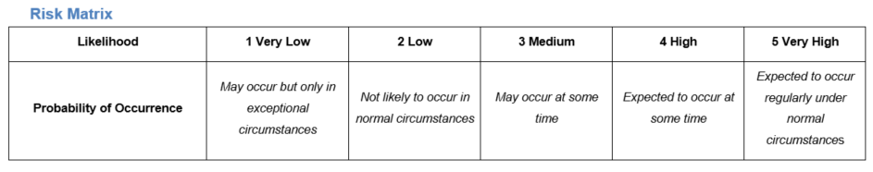
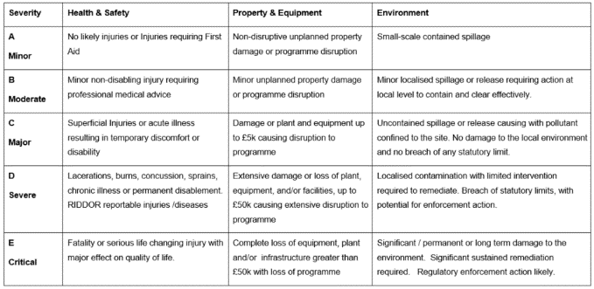

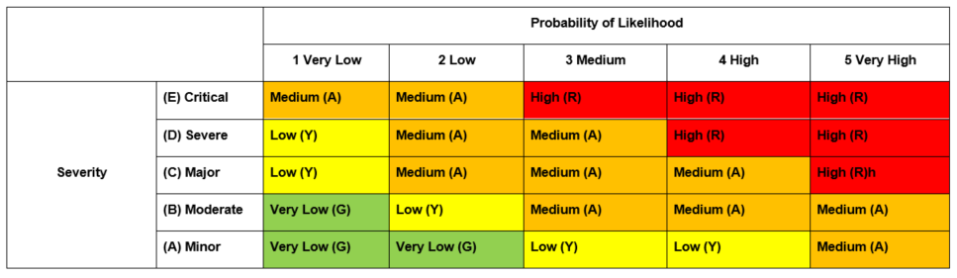

ALARP Justification
After completing the risk assessment for the storage and use of the 105mm gun, it is clear to see that the overall risk has been reduced significantly by the controls and that this is As Low As Reasonably Practicable (ALARP). This is the case because the gun is still able to be operated, but is significantly safer than its use prior to controls and the risk has been removed as far as is possible without compromising the operational capability of the weapon.
The theory of ‘being ALARP’ is a common practice that allows safety measures to be put in place on a system, but doesn’t constrict it so much that the process cannot still be followed [1]. Making procedures across the defence industry ALARP is required by the Secretary of State for Defence. This is also sometimes referred to as So Far As Is Reasonably Practicable (SFAIRP). ALARP allows a process to be brought down from having intolerable risks to being tolerable so that work can continue. Figure 1 below depicts this theory:
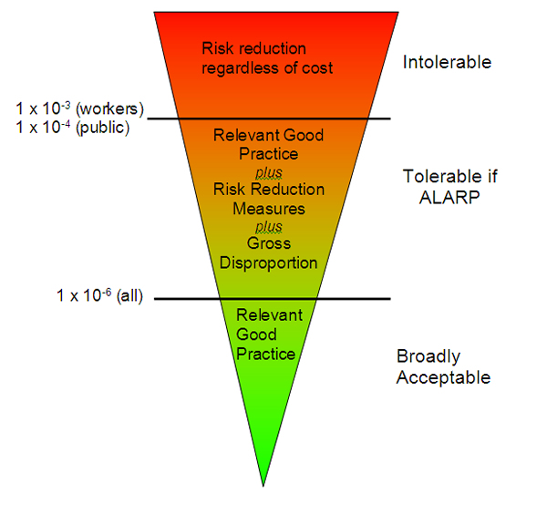
Figure 1- pictorial showing the ALARP theory [2].
Having controls in place for this weapon system allows risk that would not usually be tolerated to be tolerable as the controls are put in place to limit the amount of harm or damage that is caused by the hazards. The weapon system is still operable, but the operators are more protected from the hazards of the weapon and the surrounding damage should also be limited by the controls. This report will now focus on the hazard of having an unplanned detonation during storage, and justify why all of the controls are necessary to make the hazard ALARP.

When considering the reduction in risk to an unplanned detonation occurring during storage, the risk has been reduced to an ALARP standard in order to achieve a manageable level of risk. To understand the full effect of the controls, we must first look at the risk this hazard poses when uncontrolled. Prior to controls, the risk is thought to be at HIGH Residual Risk Rating, due to having a likelihood of 3 and severity of critical. This is clearly not a tolerable level of risk, and so controls need to be in place to make the system safe.
Firstly, many of the controls in place such as best practice for storage and adhering to building licences are required by DSA 02.OME: Defence Ordnance, Munitions and Explosives (OME) regulations (and 03) [3], and also in the Explosives Regulations 2014 [4]. Other controls that are legally required are abiding to explosive building separation distances, removing contraband before accessing the explosive storage area, maintenance of the storage facility to a good standard, not overloading the storage facility, and ensuring that custody holder checks are carried out regularly. All of these controls should be in place if the relevant staff are trained correctly and the building is maintained correctly. Abiding to building separation distances ensures that if an event were to occur in one of the magazines, the event should be contained to that magazine only and the event should not dissipate out to other storage facilities. Without this control, not only would the licencing for the building be invalid but the possibility of the event propagating to other buildings is much higher. Removing contraband reduces the risk of unplanned detonation by removing potential ignition sources from the vicinity of the explosive, and also reduces the chance of risk to operators by removing things like food and drink, which could propagate contamination into the body via ingestion. Maintenance of the storage facility and conducting building checks are good practice to ensure that the facility remains compliant with regulations, but also ensures that bad practices such as stacking too closely together or overcrowding the storage facility do not happen and can be eradicated quickly. Without this maintenance and checks, the standard of the facility could be greatly reduced and therefore affect the integrity of the munition being stored there. This could also mean that the operational capability of the storage facility is reduced, which can compromise the safety of the munition whilst in storage.
In addition to what is legally required, the controls such as climatic regulation can be used to make the environment in which the munitions are stored safer for the munition. Climatic control will make the munition less sensitive and less prone to unplanned detonation as it stabilises the humidity and temperature at which the munition is stored. This can be changed for varying munitions, however it is ideal as conditions that are too dry or extreme in temperature can have an effect of increased unplanned detonation. Another control which is not required legally but does reduce the risk of harm is using insensitive munitions where possible. Using insensitive munitions reduces the net explosive quantity (NEQ) within the munition, which means that if an event were to occur then the risk should be reduced as the event will be much smaller in nature. This also helps with reducing the risk for when the munition is fired in the weapon for the same reasons.
All of the controls mentioned above have been deemed reasonably practicable to this system when weighing up the cost, effort and time to implement them. The effort and cost of implementing the control of abiding by the explosive building licences is minimal as this is required by law anyway, so should incur no extra cost or effort. This is also the case for removing contraband- the effort for this is minimal and requires no additional cost, so this control is reasonable to implement. Maintaining the storage facility is also a requirement so should incur no extra effort or cost, and conducting building checks also requires minimal cost with slight effort, however the effort does not outweigh the risk. When considering using insensitive munitions where possible, this does not require any extra effort or cost as this is just the same process as if sensitive munitions were used. This therefore shows that this control is reasonable and easy to apply, and so should be used to reduce the risk of the hazard significantly. The cost of adding climatic control may be substantial, and so to see if this control is reasonably practicable a cost benefit analysis should be conducted. A simple way of doing this would be to look at the formula for grossly disproportionate cost which is below:

Grossly disproportionate cost = Probability of accident x value of preventative fatality x GDF [2]
(GDF= grossly disproportionate factor)
This gives a basic idea of how disproportionate the cost would need to be to prevent the control of implementing climatic control being used. This figure can then be compared to the actual cost of implementing the control to see if this measure is disproportionate and not reasonably practicable. This shows that it is not grossly disproportionate to have climate controlled storage as a control, and therefore shows ALARP.
In this instance there were no controls that were considered that were not used as they were not ALARP, however any control that meant the munition wouldn’t be able to fire or was grossly disproportionate in cost or time or energy would be ruled out due to not being reasonable.
With all of the controls in place to make the system ALARP, this Residual Risk Rating is now reduced to MEDIUM due to having a reduced likelihood of 1, but damage remaining CRITICAL if an event did occur. This brings the process down into the ALARP tolerable risk region, which while not ideal is still workable and allows the munitions to still be stored safely for use in the weapon.
In terms of considering how to maintain the ALARP status of this system, adhering to the regulatory controls will need to take place constantly. This could be monitored through the building/custody holder checks, and these checks should pick up any problems if necessary and then the ALARP procedure can be readdressed. In terms of maintaining the climate control, this could also be captured during checks, but also team members should check the conditions at least daily to ensure that the humidity and temperature levels are normal. This should also be captured in annual inspections of the system is practicable. The use of insensitive munitions would be captured in the standard operating procedure so should be continuously maintained as well.

To conclude, this hazard has had its residual risk rating reduced from HIGH to MEDIUM, which is now tolerable and ALARP. Going any further than this in an attempt to reduce the risk to LOW would likely mean that the system does not operate the way it is supposed to and the operational capability would be reduced.

Bibliography

[1] | IMechE Safety and Reliability Group , ALARP : Costs, safety and risk, how low is reasonable?, London: Institution of Mechanical Engineers, 2011.
[2] | HSE, “Guidance on ALARP Decisions in COMAH,” HSE, London, 2023.
[3] | DSA 02 OME: Defence Ordnance, Munitions and Explosives (OME) Regulations, 2021.
[4] | The Explosives Regulations, 2014.

