

Software Development
Programming in C
Mike Dacey/ Tim Bashford
Ruzy Aktar | 1708215 | 5/04/2019
Introduction
In programming it is very important to execute code systematically, the student will be understanding the syntax and semantics of high-level programming language and develop programs by executing appropriate practices. Also, the student will be using simple basic algorithms to develop solutions to figure out any programming difficulties. Along with solving the problems this student will be making a list of problems solved easiest to hardest. Evidence of problems being solved before coding, this can be through drawings, written notes etc. however, also stages of the development such as distinguishing the patterns applied through each step and the associated tests. As well as that the student will be providing screenshots of results, with description of the aim of the test, the input and the expected outputs.

Exercise 1
For the first exercise the student will be building a two-player game, the game works by the first player entering 7 values between 1 and 10. The first value is shown to the second player in the game. Both players must figure out if the next value is higher or lower than the one being shown. After entering their guess, the next value is presented out and this process will repeat until all 7 values are shown.
However, after all values are shown the game will end and the second player wins, furthermore if the second person inputs incorrect guessed then first player will win. Here is an example of the game and what it should look like. Below the student will be now trying this using visual studio and providing own screenshots of the process of building this game. This student will be using arrays to help and functions to create the game, below is an example of what the game should appear to be like.

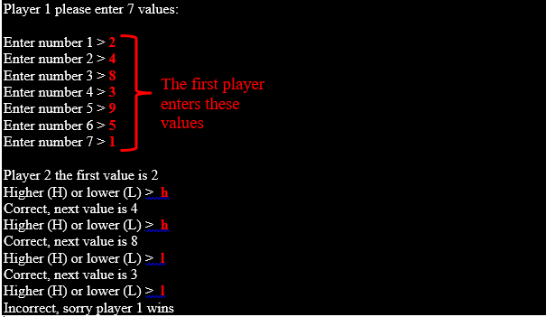

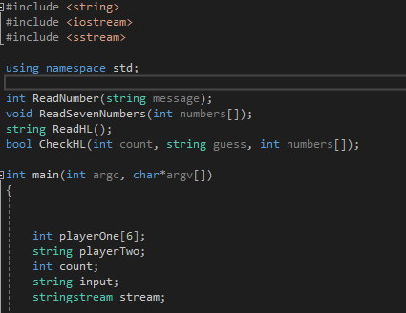

So the student to start off the game has created pieces of code. The top lines are function declarations which tells the complier that the functions exist within the program.
The following lines after the main function are the variables that the student has created. Variables which an item that can increase more than one value during its runtime in the program.
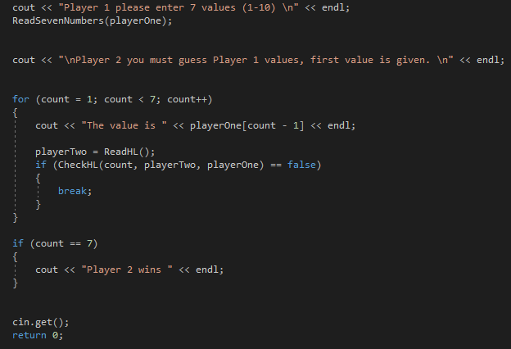

Here above in this screenshot it shows the next step the student has created to make the game. Here the student has added a print to data to console, this acts as a friendly user interface, this is important when considering the user experience. This the first line and second line in the screenshot. The rest of the code the student has created a For Loop. A for loop is important and is acquainted to monitor for certain conditions and then constantly execute blocks from codes to those conditions met. Inside the For Loop it’s checking if the player two has guessed the right value of player one’s input. If not, it will break
To check if players two guesses are equal to the seven values of player one, then this will display if player two wins. This is the If statement shown on the screenshot above
And this is the outcome, it shows the player one has entered 7 values to start off the game. Within the function contains a For Loop which allows player one to enter a value 7 times. This is linked to the input text pattern within the Main. And below shows the student has been able to do this successfully. Also, the while Loop makes sure the player cannot enter anything above 10 must stay between 1-10.

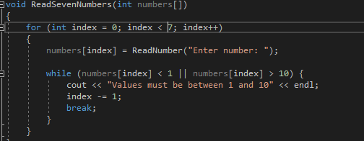

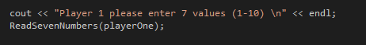

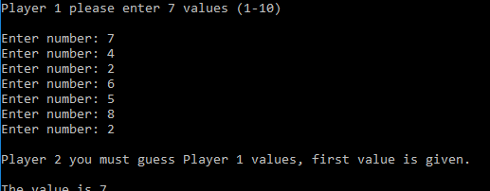

So as you can see here the student has been able to build the first part of the program. The game is asking the player one to enter 7 values using the first input text pattern, and as you can see the player has done this. and now the second input text pattern is put into place and is asking player two to guess player ones values . In order for these values

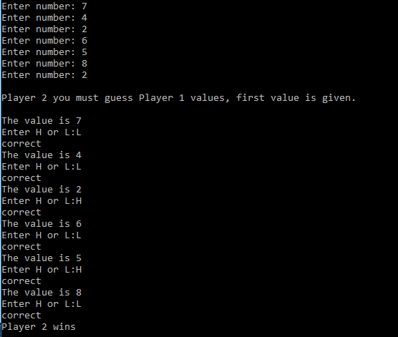
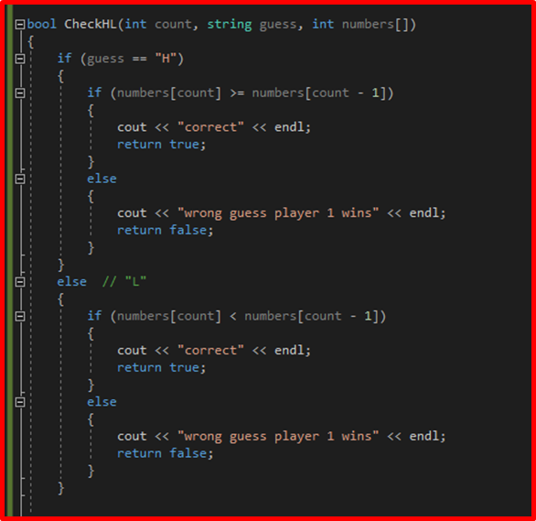

To complete the last stages of the game, player two must now guess player one’s values. Above in the report is a screenshot of player one inserting 7 values on page 3. As you can see above player two has won by making the right guess correctly throughout the game.
The student was able to accomplish this by using a set of functions such as Bool. This function withholds two values to determine if it’s true or false. So now the if statement it checks if the guess of player two (H or L) is equal to more than or less than the values of player one. If so, the bool will check this, if the assumption matches player one’s values then the next value of player one will be shown in order, this process will repeat until player two has correctly guessed all six values of player one. Determining player two to become the winner, or until player two makes an incorrect guess resulting in player one becoming the winner.

Below is a screenshot of showing what it would look like if player two loses.
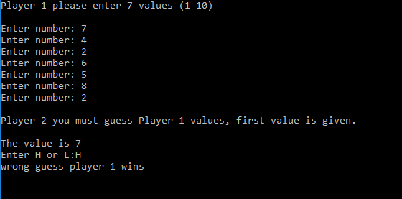

Also, the while Loop previously mentioned this is an example of what it would look like if player one was to enter a number above 10.
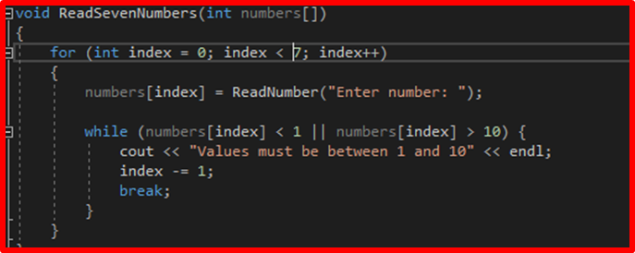

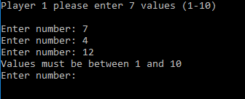

And lastly below in the screen shot the first half of it is a number pattern, which allows player one to enter the numbers. And then the ‘string ReadhL’ code is to allow the player two to guess higher or lower.
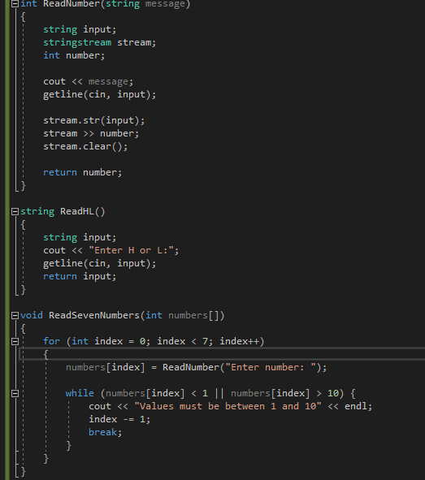

Exercise2

Build a two player game where the first player hides 3 hidden treasures and the second has to guess where they are by entering the X and Y coordinates of a location on an 8x8 grid. The player starts with 3 lives. If they fail to find the treasure then an N character should be placed on the grid and they lose a life. An X should be displayed if they find the treasure, and they win if they discover all three treasures. The player grid should be re-displayed after each guess, as well as appropriate messages such as “You found the first treasure”. The game might look like this:
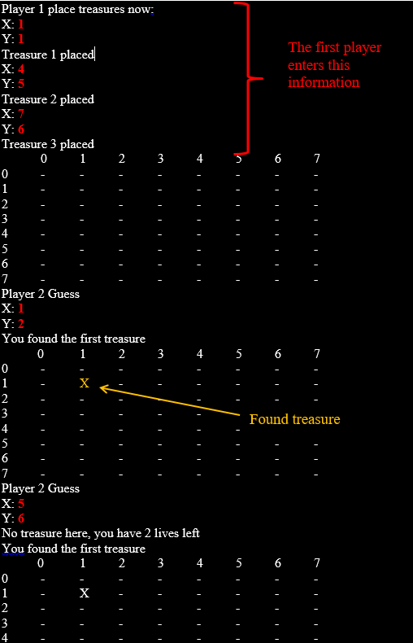

For this section of the assignment the student has attempted but hasn’t been able to complete it. Below is what the student has done.
The student has made .
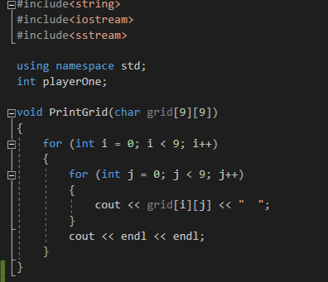

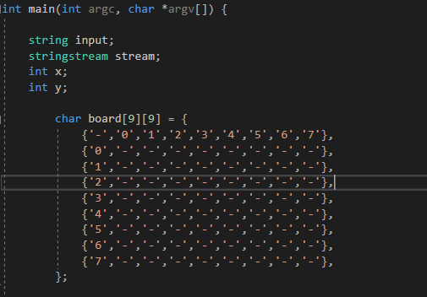

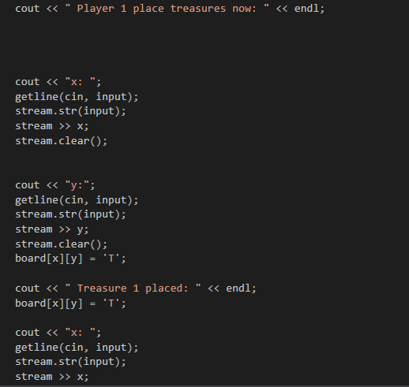

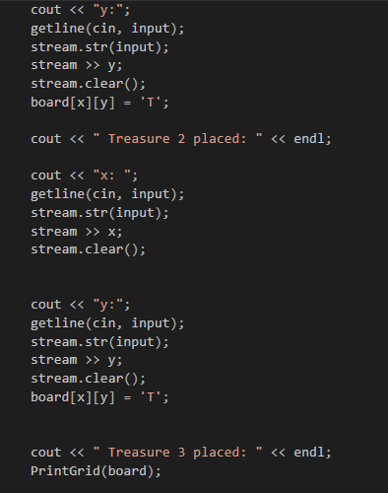

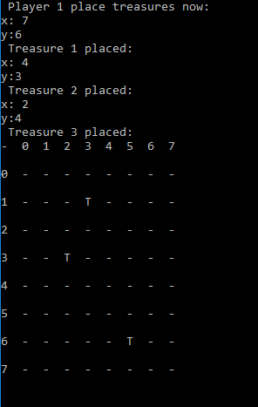
the outcome of the program .

Appendix exercise1.

#include <string>
#include <iostream>
#include <sstream>

using namespace std;

int ReadNumber(string message);
void ReadSevenNumbers(int numbers[]);
string ReadHL();
bool CheckHL(int count, string guess, int numbers[]);

int main(int argc, char*argv[])
{

int playerOne[7];
string playerTwo;
int count;
string input;
stringstream stream;

cout << "Player 1 please enter 7 values (1-10) \n" << endl;
ReadSevenNumbers(playerOne);

cout << "\nPlayer 2 you must guess Player 1 values, first value is given. \n" << endl;

for (count = 1; count < 7; count++)
{
cout << "The value is " << playerOne[count - 1] << endl;

playerTwo = ReadHL();
if (CheckHL(count, playerTwo, playerOne) == false)
{
break;
}
}

if (count == 7)
{
cout << "Player 2 wins " << endl;
}

cin.get();
return 0;
}

int ReadNumber(string message)
{
string input;
stringstream stream;
int number;

cout << message;
getline(cin, input);

stream.str(input);
stream >> number;
stream.clear();

return number;
}

string ReadHL()
{
string input;
cout << "Enter H or L:";
getline(cin, input);
return input;
}

void ReadSevenNumbers(int numbers[])
{
for (int index = 0; index < 7; index++)
{
numbers[index] = ReadNumber("Enter number: ");

while (numbers[index] < 1 || numbers[index] > 10) {
cout << "Values must be between 1 and 10" << endl;
index -= 1;
break;
}
}
}

bool CheckHL(int count, string guess, int numbers[])
{
if (guess == "H")
{
if (numbers[count] >= numbers[count - 1])
{
cout << "correct" << endl;
return true;
}
else
{
cout << "wrong guess player 1 wins" << endl;
return false;
}
}
else // "L"
{
if (numbers[count] < numbers[count - 1])
{
cout << "correct" << endl;
return true;
}
else
{
cout << "wrong guess player 1 wins" << endl;
return false;
}
}

}

Appendix 2
#include<string>
#include<iostream>
#include<sstream>

using namespace std;
int playerOne;

void PrintGrid(char grid[9][9])
{
for (int i = 0; i < 9; i++)
{
for (int j = 0; j < 9; j++)
{
cout << grid[i][j] << " ";
}
cout << endl << endl;
}
}

int main(int argc, char *argv[]) {

string input;
stringstream stream;
int x;
int y;

char board[9][9] = {
{'-','0','1','2','3','4','5','6','7'},
{'0','-','-','-','-','-','-','-','-'},
{'1','-','-','-','-','-','-','-','-'},
{'2','-','-','-','-','-','-','-','-'},
{'3','-','-','-','-','-','-','-','-'},
{'4','-','-','-','-','-','-','-','-'},
{'5','-','-','-','-','-','-','-','-'},
{'6','-','-','-','-','-','-','-','-'},
{'7','-','-','-','-','-','-','-','-'},
};

cout << " Player 1 place treasures now: " << endl;

cout << "x: ";
getline(cin, input);
stream.str(input);
stream >> x;
stream.clear();

cout << "y:";
getline(cin, input);
stream.str(input);
stream >> y;
stream.clear();
board[x][y] = 'T';

cout << " Treasure 1 placed: " << endl;
board[x][y] = 'T';

cout << "x: ";
getline(cin, input);
stream.str(input);
stream >> x;
stream.clear();

cout << "y:";
getline(cin, input);
stream.str(input);
stream >> y;
stream.clear();
board[x][y] = 'T';

cout << " Treasure 2 placed: " << endl;

cout << "x: ";
getline(cin, input);
stream.str(input);
stream >> x;
stream.clear();

cout << "y:";
getline(cin, input);
stream.str(input);
stream >> y;
stream.clear();
board[x][y] = 'T';

cout << " Treasure 3 placed: " << endl;
PrintGrid(board);

cin.get();
return 0;
}

