

12/04/2022
Adam Cross (2106959)

Electrical Engineering
Assignment 1

Contents
2 Abstract 2
3 Introduction 2
3.1 Power Factor 3
3.2 Circuit Resonance 3
4 Method 4
4.1 Proteus Simulation 4
4.2 Excel 5
4.2.1 Active Power (P) 5
4.2.2 Reactive Power (Q) 5
4.2.3 Apparent Power (S) 5
4.2.4 Power Factor and Phase Angle 5
4.2.5 Power Factor Correction 6
4.3 Graph of power factor against capacitor value 7
5 Results 9
5.1 25Hz Below Resonance 9
5.2 Resonance 10
5.3 25Hz Above Resonance 10
5.4 50Hz Frequency 11
6 Discussion 11
7 Conclusion 12
8 References 13

Abstract
This report contains calculations, simulations and background information of parallel RLC circuits, containing source (Rs) and load resistors (Rs), an inductor (L) and a capacitor (C), while further delving into the importance of circuit power factor and the resonance of AC circuits containing inductive loads.
To summarise, it was found that an inductive load has a negative effect on the power factor of a circuit, introducing an inductive reactance that increases the apparent power in the circuit and reduces overall efficiency. A parallel capacitor helps to counteract the negative effects of the inductive load by producing reactive power back into the circuit to offset the reactive power absorbed by the inductor while decreasing circuit impedance to improve power transfer.
Calculations determined that for a circuit with source resistance of 2.1Ω, load resistance of 59Ω and an inductive load of 690mH, a power factor correction capacitor of 12.343µF is required to correct the power factor of the circuit from 0.27129 to $≥0.95$.

Introduction
Circuits containing inductive loads such as motors require reactive power to create the magnetic field to allow a motor to operate, although the greater the reactive power, the greater the phase angle ($ϴ)$ between apparent power and active power and as a result the power factor of the circuit is reduced. This means that the circuit is inefficient requiring more active power to do the same amount of work, increasing the load on the electrical distribution network. To combat this issue and to correct power factor, a capacitive load is added to the circuit, parallel to the inductive load. Current flowing through a capacitor leads the voltage by 90˚, whereas an inductive current lags behind the voltage. A parallel capacitor will supply reactive power to the circuit to compensate for the reactive power absorbed by the inductive load.
This report shows how the value of this power factor correction capacitor can be established and the effect it has on the system.
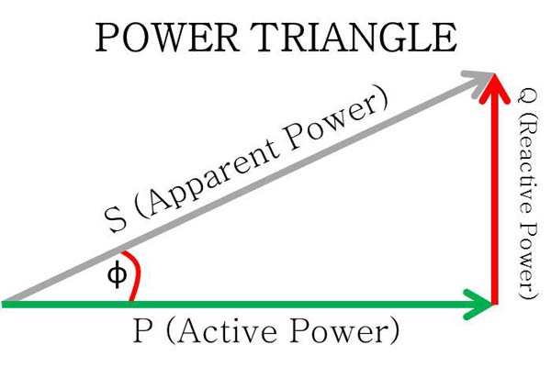
Figure 1 [1]
Active Power (P) – This power is also known as the average/real power in the circuit and is the power that is consumed to transform electrical energy into non-electrical energy. [2] It is measured in Watts (W) or Kilowatt (kW) units.
Reactive Power (Q) – Reactive power is the imaginary or complex power produced in a capacitive or inductive load. This power is stored and then released, causing an oscillation between the source and load through the sinusoidal AC waveform. This increases the overall current in the circuit, creating unwanted power loss. This is measured in Voltampere (VA) or Kilovolt-ampere (kVA) units. [3]
Apparent Power (S) – The combination of both reactive and active power; apparent power represents the voltampere capacity that is required to supply the active power. If the power factor of the system is not 1, then the apparent power required by the device is larger than the active power used by the device. [2] Measured in Voltampere reactive (VAr) or Kilovolt-ampere reactive (kVAR) units.

Power Factor
Power factor is an expression of how energy efficient a system is, usually expressed as a value between -1 and 1. A power factor of 1 is known as unity power factor, where active power (kW) and apparent power (kVA) are the same and thus supply voltage and current are also in phase with one another. The aim of power factor correction is to bring the current, which would usually lag behind the voltage due to an inductive load, back in phase with the supply voltage by installing a parallel capacitor(s).
In a purely resistive circuit, true power will be equal to apparent power due to no reactive elements. Whereas in an RLC circuit, containing capacitive reactance (XC) and inductive reactance (XL), the reactive power to active power ratio is higher causing a phase difference to occur between supply voltage and supply current waveforms. This phase angle theta (ϴ) is used to calculate the circuit power factor.
$p.f= \frac{Active Power}{Apparent Power}$ Or $p.f= cos⁡(ϴ)$
There are two types of power factor, along with unity power factor of course, these are lagging and leading power factor. Leading power factor implies that the current is leading the voltage due a capacitive load, whereas a lagging power factor implies that the current is lagging behind the voltage due to an inductive load. In a purely inductive circuit the current will lag the voltage by 90$˚$ and the current will lead the voltage by 90$˚$ in a purely capacitive circuit.

Circuit Resonance
Circuit resonance, also known as the centre frequency, is important in AC RLC circuits, it is the frequency at which the supply current is in phase with the supply voltage due to the inductive and capacitive loads becoming equal in amplitude at this particular frequency, causing the two components to cancel each other out. [2] Therefore, at circuit resonance the net reactive power will be equal to 0 and the power factor will be unity.
As $XL =2πfL$ And $XC=\frac{1}{2πfc}$
These equations show that the impedance function (reactance) of inductance and capacitance is based on frequency. If the supply frequency is increased, capacitive reactance (impedance) decreases, while inductive reactance increases, this causes the circuit to become predominately capacitive creating a leading power factor. Whereas below resonant frequency, capacitive reactance increases and inductive reactance decreases, creating a lagging power factor.

Method

Proteus Simulation
Figure 2 below is a model of a parallel RLC circuit, the value of each component coming from the student number. The circuit is made up of a sinusoidal source along with a source resistor, load resistor and inductive load.
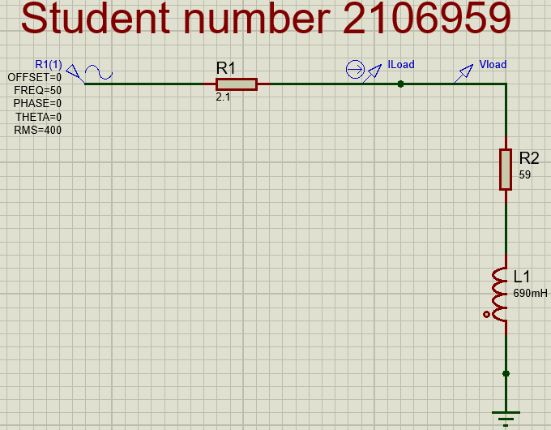

Figure 2

You can see from the analogue analysis of the circuit, shown in figure 3 below that without a parallel capacitor, the current (shown in red), lags the voltage (shown in green) by a phase angle calculated to be -72.054$˚$.
To calculate this phase difference, the peak of the current and voltage waveforms are plotted against time and the difference is measured.
Frequency of system = 50Hz – Period (T) = 20ms
Current = 49.154ms. Voltage = 45.151ms
Current lags by 4.003ms (t)
Phase angle equation:
$$ф= \frac{t}{T} ×360$$
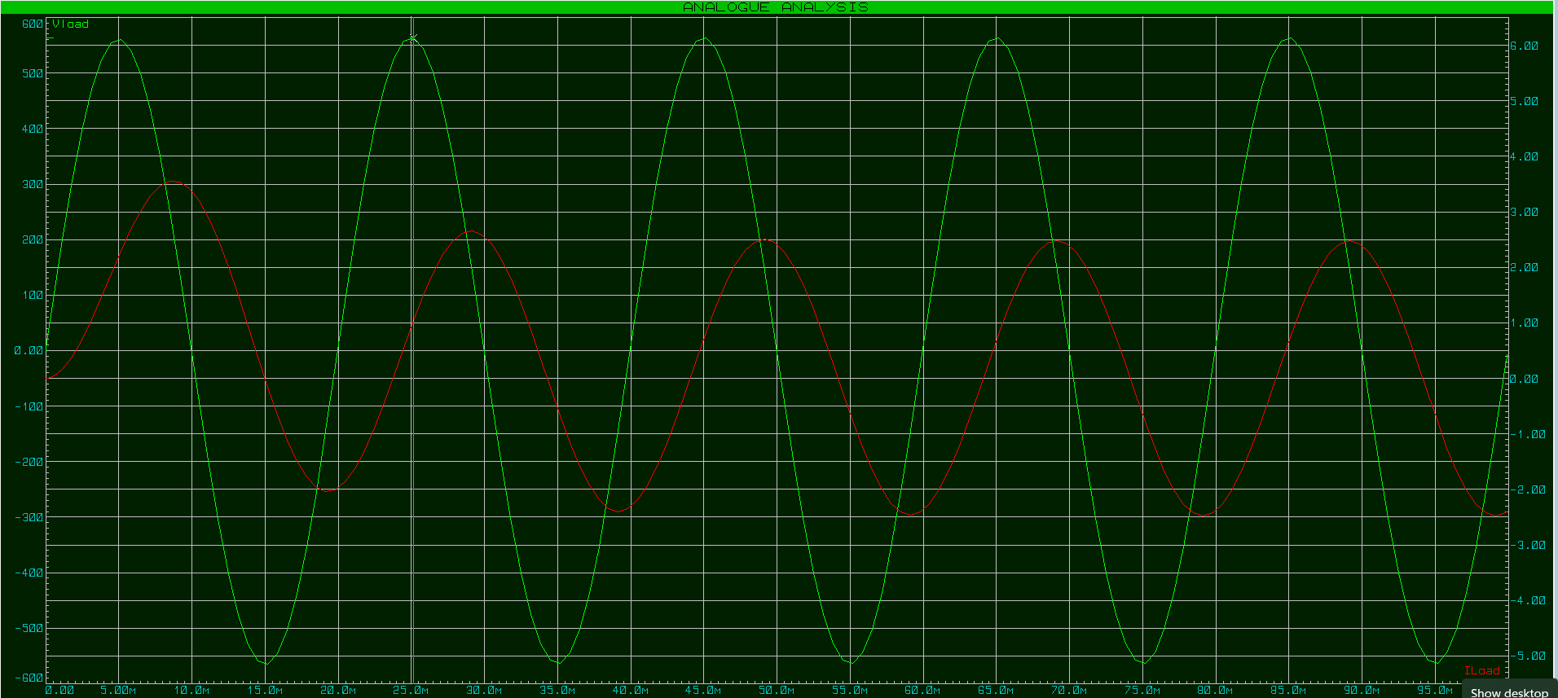
Thus
$ф= \frac{4.003}{20} ×360=-72.054˚$
Figure 3

Excel
Calculating the active, reactive, and apparent power using excel:
First calculate the impedance of the circuit, which is the sum of the resistive elements and the inductive reactance (XL).
$$XL =2πfL$$
Formula for impedance in complex form: =COMPLEX(2.1+59,2*PI()*50*0.69)
Impedance (Z) = 61.1+216.769893097696i Ω
Voltage (V) = 400V
Then calculate the current.
Current (I) = $\frac{V}{Z}$
Formula for current: =IMDIV(COMPLEX(400V,0),Z) - 400V,0 means there is no imaginary part
I = 0.481838431553208-1.70946097050983i A
Next, the power.
Power (P) = $I^{2}Z$
Formula: =IMPRODUCT(I,I,Z)
Power = 192.735372621283-683.784388203933i W

Active Power (P)
Using formula: =IMREAL(P) - real part of power calculated previously is equal to the active power.
Active power = 192.7353726 W

Reactive Power (Q)
Using formula: =IMAGINARY(P) – reactive power is equal to the imaginary part of the power
Reactive power = -683.7843882 VAr

Apparent Power (S)
Using Pythagoras to calculate the hypotenuse of the power triangle.
$$S= \sqrt{P^{2}+Q^{2}}$$
Apparent power is therefore equal to the absolute value of the complex power.
Formula: =IMABS(P) is used.
S = 710.4280494 VA

Power Factor and Phase Angle
$$p.f= \frac{Active Power}{Apparent Power}=\frac{192.735}{710.428}$$
P.f = 0.27129
Phase angle can be found by multiplying the p.f by the inverse cos or by using the ‘imargument’ function of the power on excel. The argument of a complex number gives the angle from the real axis in the direction of the complex plane (vertical axis).
Formula: =DEGREES(IMARGUMENT(P))
Phase angle $Ф$ = -74.25867575

Power Factor Correction
There are many variables that need to be calculated to find the appropriate capacitor value to correct the power factor of the load to$≥0.95$, these are:
Resistive current, this is the value of real current from the total circuit current.
Formula: =IMREAL(I)
Resistive current = 0.481838432 A
Reactive current, this is equal to the absolute value of the complex power.
Formula: =ABS(IMAGINARY(I))
Reactive current = 1.709460971 A
To find the new phase angle required to reach a power factor of 0.95.
Formula: =DEGREES(ACOS(0.95))
Phase angle $Ф=\cos^{-1}{0.95=18.19˚}$
New current.
$$New current=\frac{Resistive current}{cos⁡(new phase angle)}= \frac{0.4818}{cos⁡(18.19)}$$
Formula = Resistive current/COS(RADIANS(18.19))
New current = 0.507198349 A
New reactive current.
$$New reactive current= \sqrt{New current^{2}-resistive current^{2}}$$
Formula used: =SQRT((0.5072*0.5072)-(0.4818*0.4818))
New reactive current = 0.158372634 A
Capacitive current.
$$Capacitive current=Reactive current-new reactive current$$
$$Capacitive current=1.709-0.158$$
Capacitive current = 1.551088337 A
Capacitive Reactance.
$$XC=\frac{V}{Capacitive current}=\frac{400}{1.551088337}$$
XC = 257.8834426 Ω
Capacitor required.
$$XC=\frac{1}{2πfc}$$
Formula used: =1/(2*PI()*50*257.8834426)
Capacitor required = 12.343µF

Graph of power factor against capacitor value
Figure 3 below shoes the graph of capacitance against power factor. The graph shows that a power factor of 1 is reached at approximately 13.5µF and a capacitor of capacitance value less than or more than this will reduce the power factor by creating an unwanted lagging or leading circuit power factor.

Figure 4

To plot this graph, firstly at capacitance value of 1 µF:
Find the impedance of the circuit (ZRL).
$$ZRL=Real resistance+imaginery=59+(2πfL)$$
Formula used =COMPLEX(R,2*PI()*50*L*0.001)
ZRL = 59+216.769893097696i Ω
Capacitive reactance.
$$XC=\frac{1}{2πfc}$$
Formula used =1/(2*PI()*$50*1*0.000001)
XC = 3183.099 Ω
Load impedance ZLC.
$Zload= \frac{ZRL ×XC}{ZRL × XC}$ (Multiplying by the conjugate gives a non-negative real number).
Formula used: =IMDIV(IMPRODUCT($Zload,COMPLEX(0,-1)),IMSUM($Zload,COMPLEX(0,-1)))
ZLC = 67.9112717856526+231.259999209052i Ω

Ztotal.
Ztotal is simply ZLC + source resistance of 2.1 Ω
Ztotal = 70.0112717856526+231.259999209052i Ω
Next find Vload.
$$Vload=Vs×\frac{Zload}{Rsrc+Zload}$$
Formula used: =IMPRODUCT(COMPLEX($400,0),IMDIV(Zload,Ztotal))
Vload = 398.992691286791+3.3273243904662i V
Then find IRL which is the load current.
$$IRL= \frac{Vload}{Zload}$$
Formula: =IMDIV(Vload,$Zload)
IRL = 0.480716125599882-1.70978743671456i A
Next IC, the capacitive current.
$$IC= \frac{Vload}{Capacitance value}$$
Formula: =IMDIV(Vload,COMPLEX(0,-1))
IC = -0.00104530978611987+0.12534725077826i A
Finally, ‘Isupply,’ which is the sum of the capacitive and inductive currents.
$$Isupply=IRL ×IC$$
Isupply = 0.479670815813762-1.5844401859363i A
Phase and power factor.
$$ф=\tan^{-1}{\frac{Isupply imaginery}{Isupply real}}$$
Thus, phase angle for 1µF capacitor = $\tan^{-1}{\frac{-1.584}{0.47967}= -73.153˚}$
With this the power factor can be calculated.
$$p.f= cos⁡(-73.153)$$
Power factor at 1µF is 0.289751
These steps are repeated for each capacitance value to help plot the points of power factor compared to capacitance over of range of 1-30µF.
As explained in the introduction section, inductive loads absorb reactive power while capacitive loads produce reactive power. During passive phases both consume and return energy to the source of the circuit resulting in a net zero average power consumption [4]. At power factors close to 1, the amount of energy being absorbed by the inductive load is slightly more or equal to the amount of reactive power being produced by the capacitor to help counteract the lagging current effect that the inductive load has on the system.

Results
A phasor diagram contains vector lines showing the component voltages and current of which their length and direction represents the amplitude and phase angle of a sinusoidal signal. The phase angle of each line is measured counter-clockwise from the positive real axis. [2]
Resonant frequency equation.
$Fo=\frac{1}{2π} ×\sqrt{\frac{1}{LC}- \frac{R^{2}}{L^{2}}}$
The equation used in excel to calculate resonance frequency of the circuit.
=(1/(2*PI()))*SQRT((1/(690*0.001*12.343*0.000001)-(59^2/(690*0.001)^2)))
Resonant Frequency (Fo) with a power factor correction capacitor of 12.343µF.
Fo = 52.81098081 Hz

25Hz Below Resonance
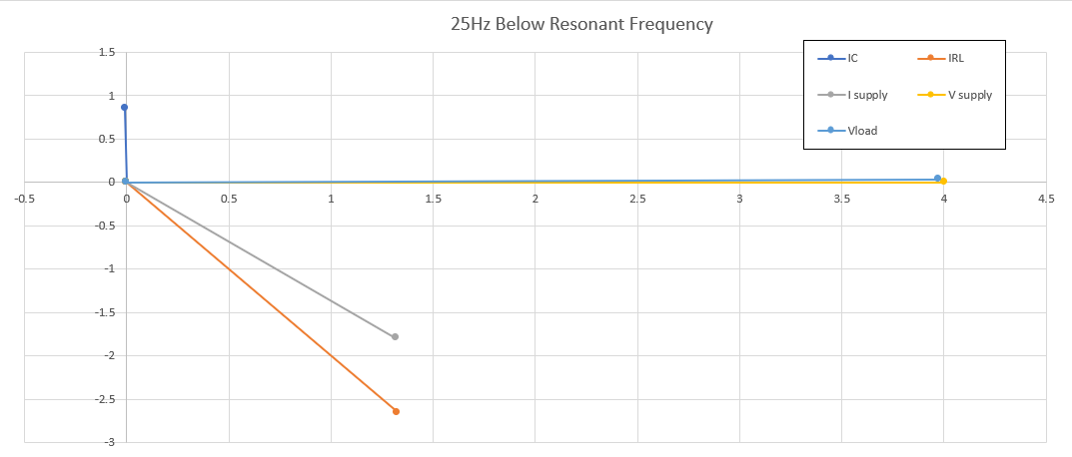
The phasor diagram below (figure 5) shows the circuit at 25Hz below resonance, the supply current shown in grey lags the supply current by -53.6259˚, resulting in a power factor of 0.59305 which means poor circuit efficiency. This is due to a rise in capacitive reactance and decrease in inductive reactance, meaning the inductor draws more current. This inductive current (IRL) is shown in the orange vector while the much smaller capacitive current (IC) is shown in the blue vector.
Figure 5

Resonance
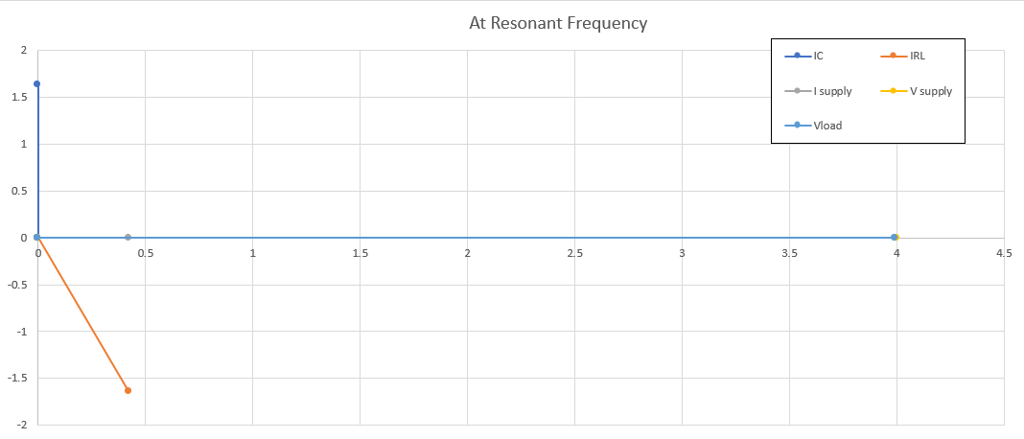
The phasor diagram below (figure 6) shows the circuit at resonant frequency. The supply current shown in grey is in phase with the supply voltage, resulting in a unity power factor of 1. Both capacitive and inductor reactance (blue and orange vectors) are equal, resulting in a net zero current. A power factor of 1 means the circuit is making use of power most efficiently.
Figure 6

25Hz Above Resonance
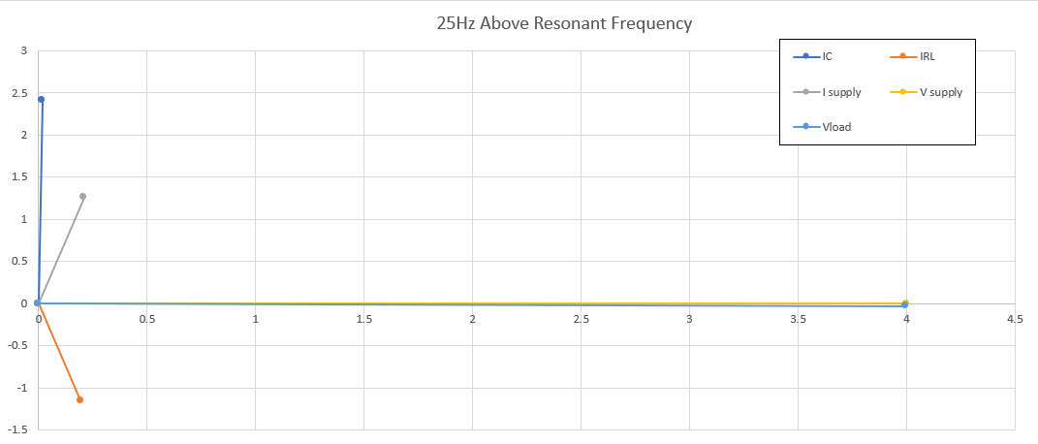
The phasor diagram below (figure 7) shows the circuit at 25Hz above resonance. This results in a poor power factor due to a decrease in capacitive reactance (impedance) and an increase in inductive reactance causing the circuit to become predominately capacitive creating a leading power factor. The supply current leads the supply voltage by a phase angle of 80.56965˚.
Figure 7

50Hz Frequency
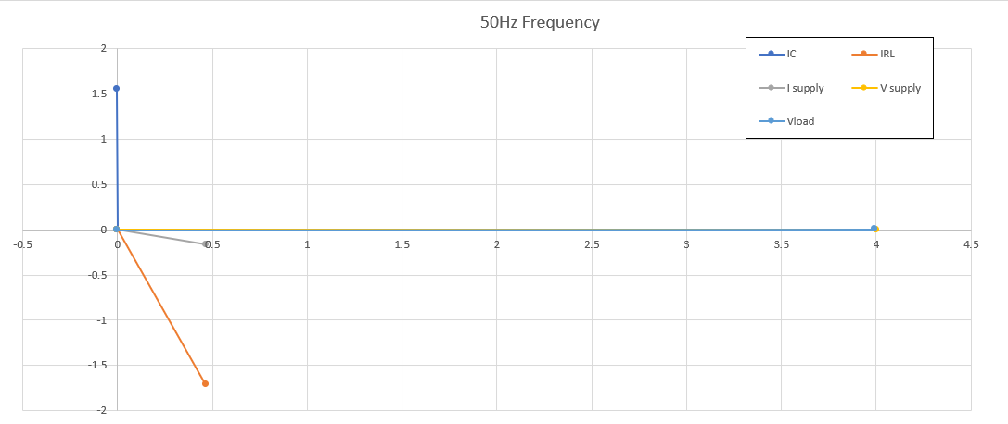
50Hz supply frequency of the national grid is just below the resonant frequency of this circuit, this therefore causes the supply current to lag by a phase angle of -19.5967˚, slightly worse than unity power factor phase angle of -18.19˚. The 12.343µF capacitor in parallel, calculated using excel helps to raise the power factor to 0.95 and therefore makes the system more efficient.
Figure 8

Discussion
Following the simulations from task 1 and plotted data from task 2, it is clear to see that power factor (p.f) correction is important in AC systems.
Without the appropriate power factor correcting capacitor, the proteus simulation showed that the current was lagging the supply voltage by a phase angle of $-72.054˚$, and the excel calculations of the circuit further illustrated this, as the apparent power in the circuit was far higher than the active power due to the inductive load, which resulted in a circuit p.f of 0.27129.
Using excel, an appropriate power factor correcting capacitor was determined to correct the power factor of the load to $≥$0.95 to ultimately make the system more efficient. The value of this capacitor was 12.343µF. With this parallel capacitor in the circuit, the phasor diagram (figure 8) at 50Hz shows that the amount of current being absorbed by the inductive load is almost equal to the capacitive current, resulting in an almost net zero current.
When the supplied generated power from the grid is at 50Hz, this becomes a fixed constant and resonant frequency is not possible, to correct power factor the value of capacitance must be changed. The phasor diagrams in task 2 showed that the circuit at 50Hz supply frequency was not quite at resonance, whereby unity power factor is established. This was due to correcting the circuit to 0.95 p.f with a phase angle of $-18.19˚$ and not a unity power factor of 1.
Resonant frequency for the circuit was in fact 52.81098081Hz, at this frequency the current and voltage are in phase, thus the active and apparent power are equal due to the inductive and capacitive currents thereby cancelling each other out, making the total impedance of the circuit purely resistive.
At 25Hz below resonance the circuit becomes predominately inductive, resulting in a phase angle of -53.6259˚ and a power factor of 0.59305, this is due to a rise in capacitive reactance and decrease in inductive reactance, meaning the inductor draws more current.
At 25Hz above resonance, the circuit starts to become more capacitive, thus the supply current leads the supply voltage by a phase angle of 80.56965˚ resulting in a circuit power factor of 0.16385. This is due to a decrease in capacitive reactance (impedance) and an increase in inductive reactance causing the capacitor to draw more current, creating a leading power factor.
Maximum power transfer in an RLC circuit refers to the maximum amount of power that is transferred from the source to the load and is dependent on the source to load impedance. Thus, if the source impedance Zs = (R+jX) Ω (X being the circuit reactance) and the load impedance is the complex conjugate of this ZL = (R+jX) Ω, maximum power transfer can occur. [5] At a circuit power factor close to 1 the combination of the inductor and capacitor have a low impedance, making the circuit almost purely resistive, matching the low impedance of the source. When this occurs, maximum power can transfer through the circuit.

Conclusion
To conclude this report, it is clear to see that without a power factor correction capacitor for the load, circuit efficiency is very much affected, with a current lagging phase angle of $-72.054˚$ and a very low power factor of 0.27129, thus decreasing circuit efficiency and ultimately increasing the load on the electrical distribution network.
To correct the power factor to $≥$0.95, it was determined that a power factor correction capacitor of 12.343µF was required. This capacitor helps to compensate for the reactive power that the inductive load absorbs by producing its own reactive power back into the circuit when current is passed through it.
Results showed that frequency of the circuit very much affects the power factor of the circuit. It was found that at a resonant frequency of 52.81098081Hz, unity power factor is reached and therefore supply current and voltage are in phase with one another due to the inductive and capacitive circuit impedance having a net zero value and thus at this point maximum power transfer can occur.

References
[1] “Explanation of Power Triangle and Three Types of Power - My Electrical Diary.” https://diary-of-electric.blogspot.com/2020/05/explanation-of-power-triangle-and-three-types-of-power.html (accessed Apr. 09, 2022).
[2] “Electric_Circuits_9th_Edition_by_James_W”.
[3] “Active, Reactive, Apparent and Complex Power.” https://www.electricaltechnology.org/2013/07/active-reactive-apparent-and-complex.html#what-is-reactive-power-q (accessed Apr. 09, 2022).
[4] “Reactive Power Compensation of Reactive Components.” https://www.electronics-tutorials.ws/accircuits/reactive-power.html (accessed Apr. 10, 2022).
[5] “Maximum Power Transfer Theorem in AC Circuit - Electrical Concepts.” https://electricalbaba.com/maximum-power-transfer-theorem-in-ac-circuit/ (accessed Apr. 10, 2022).

