
University of Wales Trinity Saint David-London Campus
Certificate in Higher Education, Skills for the Workplace

Reflective Report

Student name: Janina-Eveline Oros
Student ID:2128948
Module name: Academic and Employability Skills
Module code: BMSW4001
Module lecturer: Dr. Lizeta Demetriou

Table of content

- Introduction…………………………………………………… 1
- Gibb’s reflective model……………………………………….. 2
- Time management.………………………………………….…. 3
- Academic Writing/Language………………………………….. 4
- Reflection…………………..………………………………….. 5
- Public Speaking and Giving Presentations……………………. 6
- Conclusion…………………………………………………….. 7
- References…………………………………………………….. 8
- Appendix……………………………………………………… 9


1.Introduction
- Reflection is a purposeful activity in which you analyse experiences, or your own practice/skills/responses, in order to learn and improve.
- I think that the reflection is the most important part of the learning process.
- When you did something wrong or failed, reflection gives you the chance to think back and understand why and where you went wrong.
- There are many of reflective models, among which: Gibb’s Reflective Cycle (1988), Kolb’s Experiential Learning Cycle (1984), Driscoll’s Model (1994,2000).
- In this report, I will reflect following Gibb’s Reflective Cycle (1984).

2. Gibb’s Reflective Cycle (1984)
According to Charles Smith (2021) “Gibbs’ Reflective Cycle is a self-reflection and management tool that helps people think clearly and systematically about learning experiences. It encourages them to make sense of situations and work out how to do better next time.”
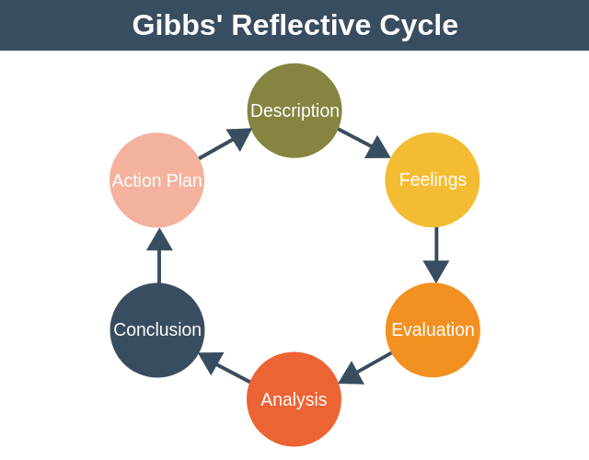

3.Time Management

Description: Time Management is an important skill which helps you organize and plan your time between several activities.

Feelings
At the beginning of this course, I didn’t really know how to organize my time. I was very chaotic, I was trying to do several things at once, I was trying to solve them all at the same time, on the same day. It was difficult for me, but by paying attention in classes and reading, I started to learn more about how I must manage my time, after that I started to be more organised.
I started to prioritize my things by making to-do-lists, and I started by doing the important things firs and efficient ones, and first in order not to waste my time doing things that are not important for me and my life.

Evaluation
Everything went well, I understood that I didn’t manage my time and the things I had to do well before, but things are going well, and I hope that in the future it will go very well. Although I was trying to do a lot of things at once and finish them in the same day and every time, I ended up being exhausted, now I manage to do the important things first and the less important things after, but in the end, they are also solved.

Analysis
I mostly knew what time management meant, the only problem with me was that I didn’t put into practice correctly. I thought that if I manage to do all the things, I set out to do in one day, that means I managed the correctly, but it wasn’t correct at all, because being tired, the next day I couldn’t cope with the tasks I had to do in the following days.

Conclusion

I am very happy that by completing this course I learned how to plan all the things in my life, to put the important things first and to make my life easier by taking good decision. Maybe if I had put in the effort from the beginning it would be much easier for me now, but I’m proud that I have learn how to manage my time and make life easier for me and for my family.

Action Plan

In the future, when I know that I will have something to do, or something to learn, or I will be aware that I will meet something new I will be much prepared. First, I will search, I will read more, I will take notes, and, in that way, I will be prepared, and I will be confident in what will follow.



4.Academic Writing/Language

Description
Academic writing is arguably the most important skill in academic contexts, since writing is the main method of academic communication. (Alexander, O., Argent, S. and Spencer, J. ,2008).

Feelings

At the first I was very afraid and nervous of how I would manage everything, what my colleagues would say about how I speak, how I write, because English is not my first spoken language. Later, I calmed down when I saw how understanding and how much the teachers and even the colleagues help each other.


Evaluation
Things went well, because I remembered what I did before at school, and it seemed to be a little bit easier. Only by working hard can you make things go well.

Analysis
At the first it was more difficult until I remembered what I did before, it’s a little bit different from what I knew, but the help of lecturer step by step I remembered, and I knew what is was about, how to paraphrase, how to summarise, everything started to take shape.

Conclusion
I learned much more than I knew. I learned that my vocabulary can be perfected and that instead of using google translate it is much better and correct to use the dictionary, because it helps me to write correctly.
And to improve my speaking and writing skills I will take English courses.

Action Plan
In the future, as I wrote above, I will do my best to improve my writing and speaking in English, so I will be sure that I will not encounter the problem of

correct expression and writing as well. I am very emotional and sometimes more restrained, but I am very motivated to get what I want and succeed in life.

5.Reflection

Description
Reflection is a process of exploring and examining ourselves, our perspectives, attributes, experiences and actions / interactions. It helps us gain insight and see how to move forward. (Gillett, A., Hammond, A. and Martala, M. (2009) )
I reflected a lot on what I knew and learned so far, a lot of new and good information at the same time.

Feelings
I don’t know how the colleagues were, but I sat and think about reflection mean, I knew that is thinking about something not very successful that happened in the past and trying to prevent that thing from happening again the future, so in though it was easy, but when it was put into practice it was much more difficult.

Evaluation
I sat and thought and listened to what the teacher tells us and explained to us, and she gave us examples to do this easy for us, in this way it was to understand what reflection is. In this way I will be prepared for the world of work.

Analysis
In order to better understand and know better what we are facing, we tried to reflect on a problem from the past, and only by siting and thinking about what was in the past, and what goes wrong, we know in the future how to avoid going through that problem again and solve it.

Conclusion
Reflection is an important thing in a person’s life. You must know how to reflect in order to avoid making the same mistakes or making another mistake without thinking about it. I am glad that it was brought back to my attention and I’m sure that in the future it will be helpful.

Action plan
I am very sure of myself and confident in everything I will do, and, in the decisions, I will make in the future. I have learned from my mistake, and I do not want to repeat them under any circumstances.

6.Public Speaking and Giving Presentation

Description
In order to speak in public and give a presentation you must have the ability to speak clearly, be confident and leave emotions aside, easy to say, hard to do.

Feelings
First, this was my biggest fear to speak in front of the crowd, because I am a very emotional person, but just in the front of the crowd, because there everyone is looking at me. I have no problem when I am on the other side. I had a lot of emotions before and during the presentation, my hands were sweating, and my voice was shaking. After the presentation everything came back to

normal. I was very scared if I make a mistake or if I don’t know how to express myself correctly? How my colleagues will react, how my lecturer will react? It was quite difficult.

Evaluation
I am confident, I even talked about how many emotions I had and even answered the questions. Honestly, I would have liked to talk more, to try control my emotions more. Although my colleagues did not complicate my situations at all, they were wonderful.

Analysis
Speaking in front of my colleagues did not go well because of emotions, I don’t understand why? Because I have only talked about the things I like and about my future, my family future, my dream career. But I think that all bad for good.

Conclusion
Before the presentation, our lecturer asked us to do a test before the official presentation, at first, I was stressed and angry, but now I’m glad he did that, because maybe if I didn’t do it I wouldn’t be able to say two words. So yes, practice to prepare when you must make a presentation in front of a crowd, it helps you a lot.

Action plan
At my next presentation I will do my best to reduce a lot of emotions, to prepare and listen to what is said to me. I will take my friends and I will take tests in front of them, just to improve these skills and to overcome my fear of public speaking, and hopefully by then I will also improve my English.

7.Conclusion

I am very proud that I got this far, that I managed to complete my report. I am very proud that I enrolled at the University of Wales Trinity Saint David, and I have the chance to pursue my dream. Here I learned many things: I learned how to reflect on things and improve them, I learned how to make a presentation and speak in front of an audience, I learned how to write a CV.
For example, Time-Management is an important thing for my future career job, and I am very happy that I learned about it. All this what I learned will be of great help to me personally and professionally.
In conclusion you are never to old to follow your dreams and finish your studies, and I am more than happy that I took this step.

8.References

- Alexander, O., Argent, S. and Spencer, J. ,(2008) EAP Essentials: A teacher’s guide to principles and practice. Reading: Garnet Publishing Ltd. Gillett, A.,
- Gibbs, G. (1988). Learning by doing: A guide to teaching and learning methods. London: Further Education Unit.
- Hammond, A. and Martala, M. (2009) Successful academic writing. Harlow: Pearson Education Limited.
- https://www.mindtools.com/pages/article/newHTE_00.htm

9.Appendix



