University of Wales Trinity Saint David
Wales Institute of Science & Art

Kinetic Energy Recovery
Alternative Propulsion Systems (ACHA5010)

Jake Hicks
2306026
December 2024
Contents
1 Introduction 2
2 Test Vehicle Specification 3
3 WLTP Results 4
4 Possible Kinetic Energy Recovery System Requirements 7
5 Suggested Kinetic Energy Recovery System 8
6 KERS Results 9
7 Viability of Suggested Kinetic Energy Recovery System 10
8 Conclusion 12
9 References 13

Figure 1 – Graph of the resistances on the vehicle across the cycle duration 4
Figure 2 – Graph of the rolling resistance across the cycle duration 5
Figure 3 – Graph of the cumulative tractive and braking energy across the cycle duration 5
Figure 4 – Graph of energy expended and potential energy recovered across the cycle duration 6
Figure 5 – Graph of points of maximum energy recovery across the cycle duration 7
Figure 6 - Graph of recovered energy and power across the cycle duration 9

Table 1 - Dynamic Characteristics of the Nissan Skyline GT-R (R34) 3

Introduction
This report will suggest a theoretic kinetic energy recovery system (KERS) for a specific car, with reference and testing related to the worldwide harmonised light vehicle test procedure (WLTP test).

Test Vehicle Specification
For this report, the Nissan Skyline GT-R (R34), built from 1999 to 2002, has been chosen. The dynamic characteristics that will be important for this report are as shown:
Curb Weight | 1560kg (Nissan Global, 2023)
Test Mass | 1752kg
Power | 206kW (Nissan Global, 2023)
Top Speed | 156mph (251kmph)
Pmr | 117.28W/kg
Frontal Area | 2.4276m^2 (Smigzy, 2007)
Coefficient of Drag | 0.34 (Smigzy, 2007)
Rolling Resistance Coefficient (10kmph) | 0.009
Rolling Resistance Coefficient (250kmph) | 0.033
Standard Tyre | 245/40R18 (Auto-Data.net, 2024)
Standard Tyre Pressure | 36psi (TirePressure.com, 2024)
Table 1 - Dynamic Characteristics of the Nissan Skyline GT-R (R34)
Due to the vehicle’s 117.28W/Kg Pmr and top speed of 251kmph, it is identified as a Class 3b vehicle for the worldwide harmonised light vehicles test procedure (WLTP or WTLC) and thus will use the Class 3 test procedure.
The WLTP goes through four phases in order to test a vehicle for emissions and fuel consumption. There are three classes split into four distinct groups.
- Class 1 vehicles are those with the lowest power to weight ratio, typically heavy goods vehicles.
- Class 2 vehicles are those with a slightly higher power to weight ratio to class 1 and typically feature low powered vehicles such as large vans or small cargo vehicles.
- Class 3 is split into two separate groups, class 3a and class 3b, depending on the vehicles top speed. If the top speed exceeds 120kmph, then they fit into class 3b, which is where most passenger vehicles are found. Class 3a vehicles are typically slow but light passenger vehicles, akin to the Peel P50.

WLTP Results
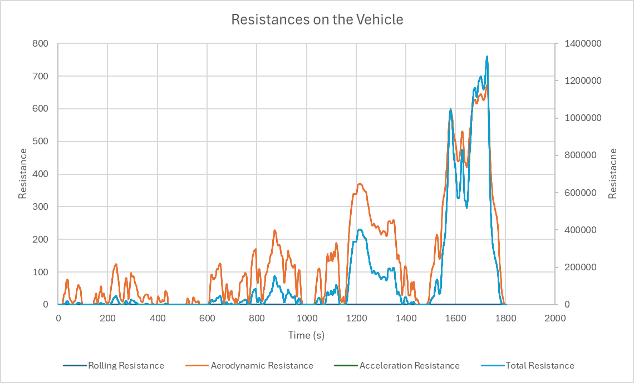
Figure 1 – Graph of the resistances on the vehicle across the cycle duration
Figure 1 features all three resistances acting on the vehicle, plus total resistance of them all summed together. Rolling resistance is negligible compared to the other three series that are plotted. Of those, aerodynamic resistance adheres to the resistance scale on the left of the graph, whilst acceleration and total resistance adhere to the scale on the right. Acceleration appears to be missing on the graph, but actually follows total resistance so closely that it remains obscured beneath it across the entirety of the graph. All three components of the total resistance are massively different from one another in the size of their values, which may be down to a rounding error, but beyond that, they all follow the exact same shape of their plotted lines except with varying levels of amplitude.
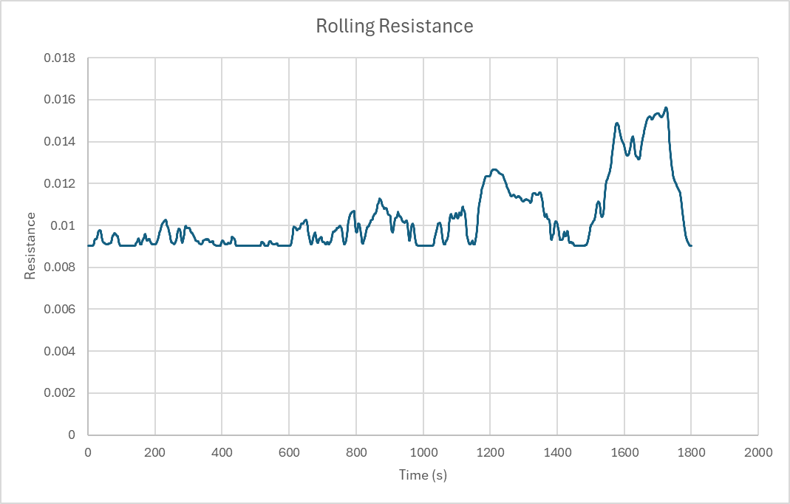
Figure 2 – Graph of the rolling resistance across the cycle duration
Rolling resistance appears negligible and unreadable on figure 1, thus has been plotted on its own for clarity purposes.
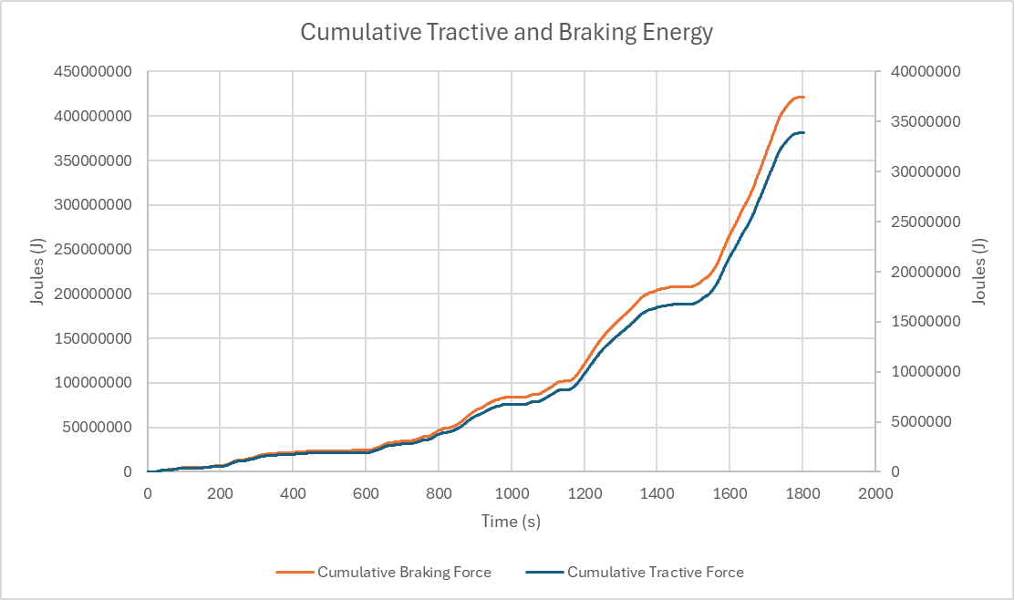
Figure 3 – Graph of the cumulative tractive and braking energy across the cycle duration
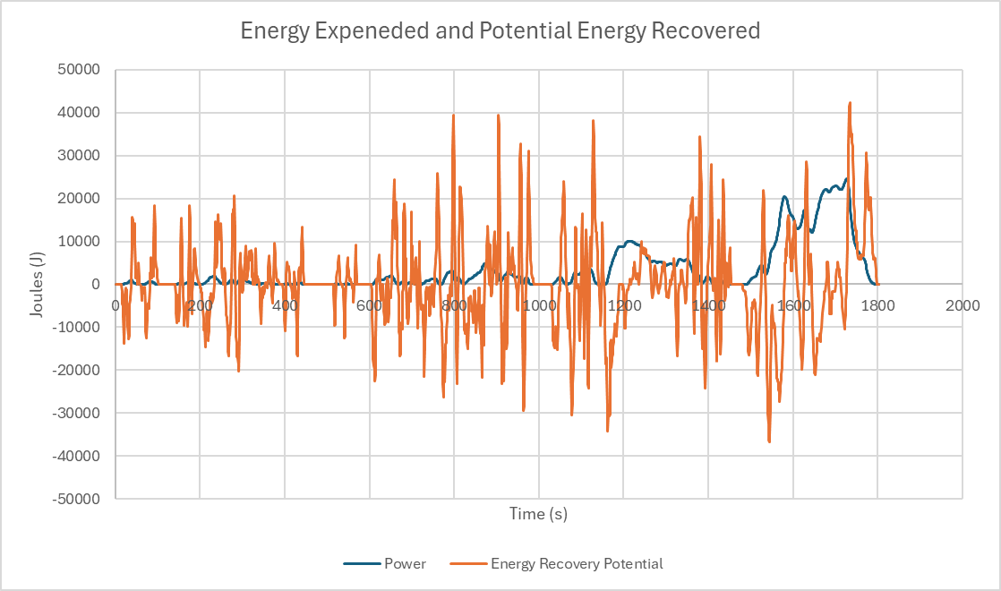
Figure 4 – Graph of energy expended and potential energy recovered across the cycle duration

Possible Kinetic Energy Recovery System Requirements
A kinetic energy recovery system (or KERS) is a form a system that harvests energy from braking, that is usually converted to and expelled as heat, and storing it for later use.
KERS consist of 3 main components:
- a generator unit which converts mechanical energy into electricity as well as the opposite
- a power control unit which controls the direction of the electric current
- the storage device which stores the left-over energy (University of Calgary, 2015).
A well-known use of KERS is found in Formula 1 machinery with the now named MGU-K (motor generator unit – kinetic), which was first introduced in 2009 with the purpose of storing kinetic energy from braking and converting it to extra engine power that could be utilised (Angadi, 2023).
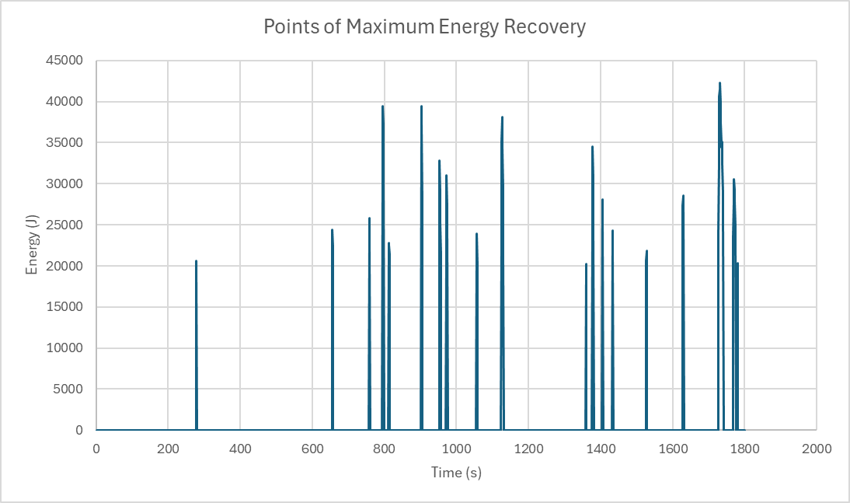
Figure 5 – Graph of points of maximum energy recovery across the cycle duration
The above graph shows the points of maximum potential energy recovery from the WLTP test of the Nissan Skyline R34, being the 18 spikes where the potential energy recovered reached above 20kJ, up to the highest point of 42.28kJ of energy that could potentially be recovered. These peaks could give induction in deciding the maximum storage for a KERS system as it reveals how much energy could be recovered under hard braking.

Suggested Kinetic Energy Recovery System
The particular kinetic energy storage system chosen to be used on this occasion is the flywheel system. These systems are a common choice for motor vehicles that wish to incorporate an energy recovery system; a major example being the systems used within Formula One vehicles as part of their ERS that aim to harness energy absorbed during breaking in order to apply it as extra power for straight line speed, or as an aid for overtaking and defensive manoeuvres in on track racing situations (Collins, 2011).
Flywheel systems often feature high storage capacities, some being capable of harnessing up to 200kW on the higher end of the scale; this will likely be more than enough when, as seen in figure 5, the vehicles will rarely harness more than 30kW at once. Although, the flywheel system has an average efficiency of 85% (Sopian and Al-Hinai, 2020), meaning that 15% of energy collected would be lost before being transmitted back to give extra propultion the vehicle, though this efficiency will decrease through the flywheel’s lifetime.
A capacity of 200kW, or even far less, will suffice for the Nissan Skyline R34 that it is being suggested for by this report as the energy will be consumed when the vehicle accelerates, which should keep the amount of energy in storage below the maximum capacity. This relationship could be pictured as a keg with a spout. When the liquid comes into the keg, it begins to fill up, but when the spout is opened, the keg will begin to empty: the liquid within the keg can be seen as the currently stored energy, the spout the output of energy and the liquid being poured in, the energy harnessed under breaking.

KERS Results
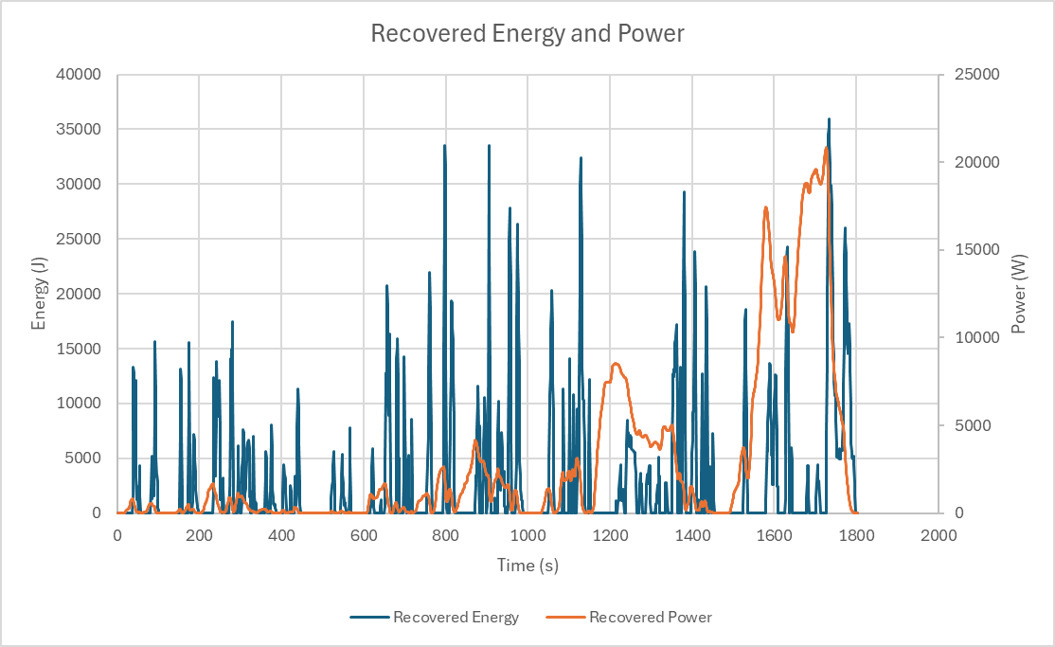
Figure 6 - Graph of recovered energy and power across the cycle duration
Figure 6 shows the recovered energy and power after taking the efficiency of 85% into account in order to express the amount of potential energy available to be delivered back to the wheels in order to help propel the vehicle. The form of the recovered power plot is very similar to the original power value along with the resistance plots, though this is because all these values are related. The plots for recovered energy have been cut to only show the positive energy developed as that is the energy that will be stored within the kinetic energy recovery system. Beyond it sharing the moment in which they reach their highest value during the cycle duration, there is hardly a discernible relation between the two plots.

Viability of Suggested Kinetic Energy Recovery System
Flywheel kinetic energy recovery systems are a desirable method of developing an energy recovery system, especially for a passenger vehicle such as the Nissan Skyline R34, as they have numerous advantages.
These systems tend to have a long working life, which is ideal for a passenger vehicle as they will be subject to frequent use, and thus will need components that will not need replacing or maintained frequently. A vehicle with poor reliability will not be desirable for the consumer and thus will sell far less than a vehicle with excellent reliability; furthermore, a vehicle that frequently requires repairs will not be ideal for the company producing the vehicle as it will leave a negative economic effect. This reliable aspect of the flywheel system is paired well with the ease of maintaining the flywheel as limited amount of effort is required for this (Sopian and Al-Hinai, 2020).
The flywheel system does not have any direct adverse effects on the environment and can only have a positive effect in that it conserves fuel in regular driving situations by utilising the power, usually expelled via heat, generated during breaking. The manufacture methods may be nonenvironmentally friendly, but that will depend on the source and manufacture. The use of the system should only make the vehicle more economical and less pollutive once it is in use.
For an energy recovery system, an average efficiency of 85% is impressive and can be seen as a positive over other systems, such as thermal energy storage (TES) which typically only manages 30%-60% efficiency (Sopian and Al-Hinai, 2020). Efficiency refers to the amount of energy lost between harvesting and eventual redeployment, caused by the transfer of the energy between the components. These losses are dependent on the specific components used and will vary, along with traits such as the maximum storage value. Though, the capability of having maximum capacities of up to 200kW is a large advantage of the flywheel system.
Another advantage of this system is its high-power output which makes it a utility worth having. These systems will take up space within the vehicle and will contribute to its overall weight, with systems being able to weigh up to 45 kilograms (Sarkar, 2016), which will have an effect on the vehicle’s fuel consumption, but that much is a sacrifice that will be balanced out by the fuel saving caused by the use of the kinetic energy recovery system. It is this weight penalty that caused many Formula One teams to decide against the use of the technology when it first hit the mainstream in the late 2000s, before later becoming used by most teams in 2011 onwards; from a competitive standpoint, the weight loss was not worth the extra power the system could supply (Collantine, 2009). When considering them from a commercial automotive standpoint, an extra 45kg is not a massive addition on top of the weight of most passenger cars. Taking the Nissan Skyline R34, an additional 45kg would only account for 2.8% of its total mass, a largely inconsequential amount outside of competition.
Finally, the main issue with flywheel systems is that they can be expensive. Expenses are an aspect of designing a car that must be kept track of as once the vehicle is completed and ready for sale: it needs to be within a price bracket in which consumers will purchase it. Applying many expensive features to a vehicle will only increase the production cost, and in order to turn a profit, the price of the vehicle will need to be greater than its production costs. Therefore, it would not be viable to implement a kinetic energy recovery system into a vehicle designed to be affordable, like the Dacia Sandero, but would be viable to implement to vehicles designed to fit into a higher price bracket.

Conclusion
A flywheel kinetic energy recovery system could make a positive effect on the Nissan Skyline R34 with its numerous benefits, namely the aid in reducing fuel consumption by converting leftover energy into power. The main disadvantage does not apply strongly to the vehicle in question and thus could be used if it were still in production to improve the vehicle to be more economical.

References
Nissan Global (2023) Nissan Heritage Collection No.280 Skyline GT-R V⋅spec II (2000: BNR34) Available at: https://www.nissan-global.com/EN/HERITAGE_COLLECTION/280_skyline_gt-r_v-spec_ii.html (Accessed: 30 November 2024)
Smigzy (2007) [Skyline Owners] Available at: https://www.skylineowners.com/threads/drag.72690/ (Accessed: 30 November 2024)
Auto-Data.net (2024) 1999 Nissan Skyline GT-R X (R34) 2.6 i 24V Turbo 4WD (280 Hp) Available at: https://www.auto-data.net/en/nissan-skyline-gt-r-x-r34-2.6-i-24v-turbo-4wd-280hp-360 (Accessed: 30 November 2024)
TirePressure.com (2024) 245/40R18 Tire Pressure Available at: https://tirepressure.com/245-40r18-tire-pressure (Accessed: 30 November 2024)
Angadi, D (2023) Is KERS still used in F1? Exploring its uses, how it works, and more Available at: https://www.sportskeeda.com/f1/is-kers-still-used-f1-exploring-uses-works (Accessed: 30 November 2024)
Energy Education (2015) Kinetic energy recovery system Available at: https://energyeducation.ca/encyclopedia/Kinetic_energy_recovery_system (Accessed: 30 November 2024)
Collins, S (2011) Flywheel hybrid systems (KERS) Available at: https://www.racecar-engineering.com/articles/f1/flywheel-hybrid-systems-kers/ (Accessed: 30 November 2024)
Sopian, K and Al-Hanai, A (2020) ‘Review of energy storage services, applications, limitations, and benefits’, Energy Reports, 6(7), pp. 288-306 Available at: https://doi.org/10.1016/j.egyr.2020.07.028
Sarkar, A (2016) Kinetic Energy Recovery Systems in Formula 1 Available at: http://large.stanford.edu/courses/2015/ph240/sarkar1/ (Accessed: 1 December 2024)
Collantine, K (2009) ‘Williams defy FOTA over KERS in 2010’ RaceFans Available at: https://www.racefans.net/2009/09/23/williams-defy-fota-over-kers-in-2010/ (Accessed: 1 December 2024)

