MARKETING MANAGEMENT
REWORK-ASSESSMENT 2

STUDENT NAME: ALISHA SANGHANI
STUDENT ID: 2122542
SUBJECT CODE: LCMB7001

Table of Contents
INTRODUCTION 3
MARKETING MIX OF TESCO 3
ANALYSIS OF INTERNAL ENVIRONMENT: 5
ANALYSING EXTERNAL ENVIRONMENT: 7
SEGMENTATION, TARGETING AND POSTIONING: 9
RECOMMENDATION: 10
Conclusion 11
References 12

INTRODUCTION
This study is going to evaluate environmental marketing analysis of discovery in the context of globalization and the digitalization era first up Sovereign types of complexity has arisen in business organization for the rising expectation of potential customers. If we see, strategies are necessary to improve the marketing system in order to maintain a competitive advantage in the global marketplace. Internal environmental factors of test scope have been analyzed to understand everything about this organization to manage its financial and non-finance cell resources to sustain its performance. A marketing plan plays a vital role in order to improve competitiveness in the global marketplace which is going to be discussed in this study and here a session about strategy is going to recommend this organization for long term decision making.

MARKETING MIX OF TESCO
People
Tesco PLC is one of the largest retail marketers in the UK however the quality of service of this organization is decreasing day by day. The company has suffered to understand the cultural diversity of global consumers. As per the opinion of Rosnizam et al. (2020), Tesco PLC does not include so many diverse team members in operational activities because it is hard to manage them in a strategic way. It requires different talent and culturally diverse strategies to expand business worldwide to sustain its existence in the era of globalization. The organization does not have efficient leaders in different regions that can manage your changing environment to sustain their competitive advantage consistently.
Product
Products are the most important marketing factor to attract potential consumers. According to the view of Eastmure et al. (2020), Tesco PLC has executed great service quality to the potential consumer consistently however arrival of digital marketing era has allowed a large number of entrances into the global marketplace. For this reason, consumers have got several types of alternatives that have decreased demand for the products of Tesco PLC. Tesco has undertaken low-cost strategies for its potential consumer however it has impacted the profit margin. In this case, operation management has decreased the quality of products and services to maintain their profit margin and satisfy stakeholders. Reduction in product quality has infected the operational performance of Tesco PLC.
Price
Tesco PLC has suffered to produce high-quality products at a low price because of increasing market competition and changing business environment. Continuous growth and forecasting power has decreased due to emergency uncertainty. As stated by Awadari and Kanwal (2019), Competitiveness and awareness are dependent on activities of an organization however Tesco PLC has faced a lot of complex situations to operate technologically advanced devices within the organization in order to attract potential consumers. Increasing tax rates and different legislation in different regions have affected the price of products of Tesco PLC. Covid-19 has greatly impacted the labour market of the UK and the unemployment rate is decreasing day by day. Tesco PLC has to maintain its pricing strategy and implement efficient initiatives in order to improve operational performance.
Place
The vision of Tesco PLC is to become a market leader in the international marketplace. As stated by Ren (2021), Tesco PLC operates its business activities around 12 countries however this organization has to expand its business globally to become a market leader. Politics and legislation in the environment are not equal in different regions and making a business plan has become complicated. Tesco PLC has the Largest Marketplace in the UK however it is not as effective in foreign countries.
Process
Tesco PLC believes in expanding business by acquisition of new stores and adopting retail consumer engagement. An efficient supply chain management network and provide a high-quality product at the lowest possible price. As per the opinion of Palmer (2021), Tesco PLC provides daily essentials that make consumer life easier every day. Focusing on maintaining cost leadership in a competitive market has impacted its business performance. Process of Tesco PLC to operate international business organizations is not sustainable because organizations are implementing advanced technology day by day and sustaining their market capture by providing the best service quality with digital tools.
Physical evidence
Tesco PLC has undertaken digital supply chain management to enhance productivity and performance in an ever-changing environment. According to the view of Woohyoung et al. (2020), testimonials and the forward-thinking strategy of Tesco PLC are not sustainable because employees and team members operate advanced technology efficiently. Covid-19 and Brexit infected the global business. The labour market of the UK has become unstable during these situations because a large number of employees are fired to protect the economic balance of the business organization in the UK. It has infected the labour market of the UK that escapes and faces different kinds of operations with employees.
Promotion
Go location service is provided by Tesco PLC to its potential consumers. This organization promotes its business activities and availability of products through social media platforms that have created brand value in a competitive marketplace. As stated by Ocicka and Raźniewska (2018), Understanding the international environment and cultural diversity is slow in Tesco PLC and promotional activities are not as effective as in the UK in other countries. Efficient employees are not available in Tesco PLC who can manage digital marketing tools to promote their brand to the target consumer.

ANALYSIS OF INTERNAL ENVIRONMENT:
Resources
Internal environment of Tesco PLC is stable in the UK because human resource management and suppliers of raw materials are easily available in the UK marketplace. As stated by Jones and Comfort (2021), Human resource management was impacted after covid-19 and Brexit. The company operates its business in a diverse marketplace globally that requires efficient transportation services to collect organization resources to fulfil consumer demand. The company has suffered to collect raw materials at a reasonable price in the global marketplace which has affected the business activities of this organization.
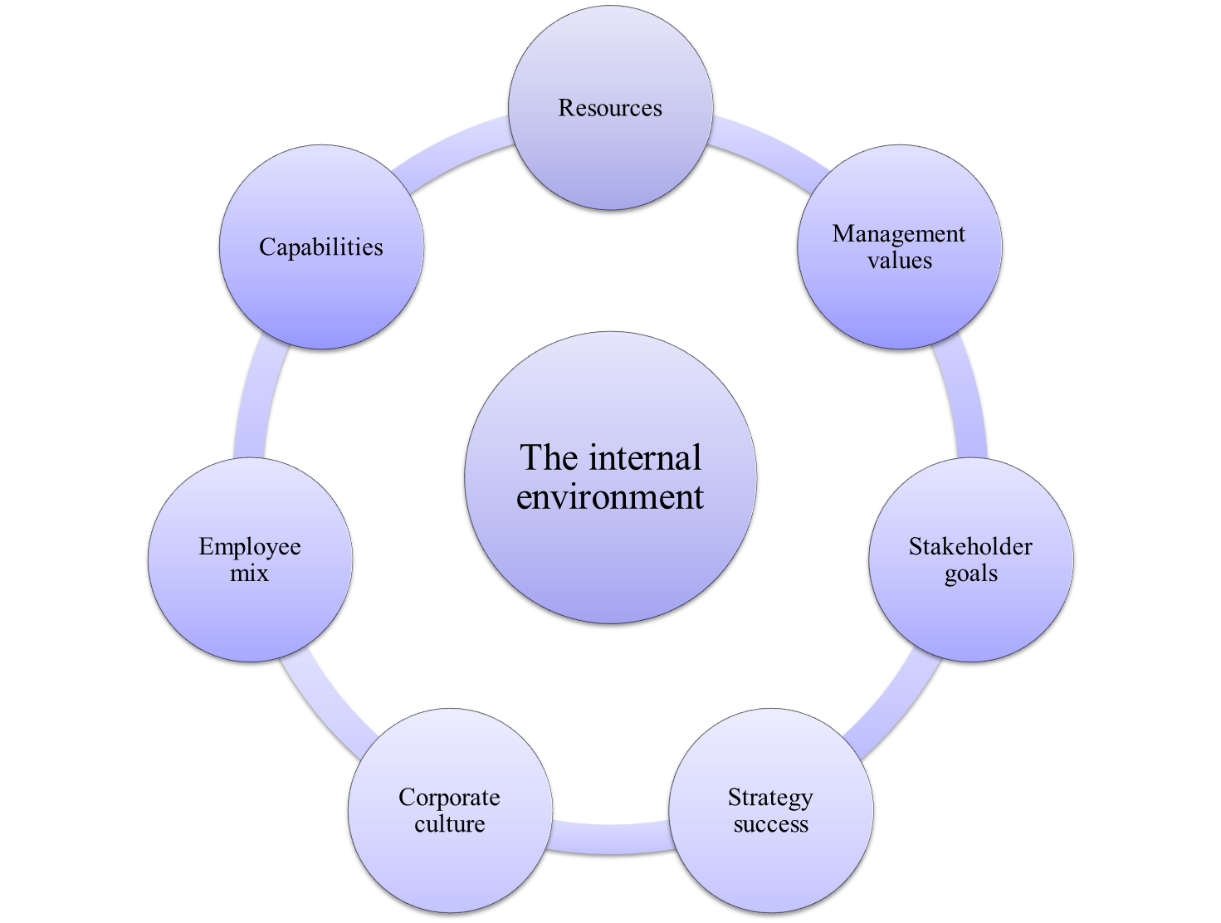
Figure 1: Analysis of the internal environment
(Source: Rosnizam et al. 2020)
Management values and stakeholder goal
The company always focuses on minimizing operation issues and providing the best quality service to the potential consumer. Sales growth of the company has decreased by 0.35 % in the year 2021 which has impacted the gross income of this organization. Earnings before interest and Tesco PLC have been used that have an impact on the dividend of stakeholders in the current markets scenario. The maintenance cost of a retail store has increased and managing human resources become complicated after a covid situation in which organizations are unable to fulfil the film stakeholders' goal within the required period.
Strategy and corporate culture
Different kinds of conflicts and negotiations have been seen in Tesco PLC due to a lack of efficient leadership within the organization. Corporate culture is dependent on the strategic distribution of responsibilities to the workers of the organization. As per the opinion of Mkansi et al. (2018), the competitor of Tesco PLC is increasing day by day in the British grocery market however Tesco uses the largest grocery supply chain management and focuses on improving online getaways for procurement. Customer federalisation and smart technologies are undertaken in Tesco PLC however the practical implementation is not as effective as its strategy.
Employees' mix and capabilities
The ability to invest in different expansion projects is becoming complicated and challenging for Tesco PLC because the average debt of this organization is increasing day by day. A lot of products of the company have withdrawn from the market because of a financial crisis. As per the opinion of Rosnizam et al. (2020), the Labour market of the UK has been affected by the covid-19 situation the availability of efficient employees is decreasing day by day. Most of the employees of Tesco are migrants however uncertainty has impacted the employees. Employee's return rate is decreasing by day by day.

ANALYSING EXTERNAL ENVIRONMENT:
External Environmental analysis can be done by conducted by relating the models such as Porter’s Five Forces with the Company.
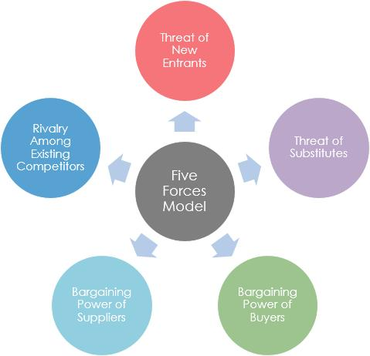
The Porter’s Five Force model includes
- Competitive Rivalry in the Market
- Threat of Substitutes
- The Threats of new Entrants
- Bargaining power of Buyers
- Bargaining power of Suppliers
Competitive Rivalry in the Market:
The competitive competition in the retail enterprise is excessive due to the community’s elevated demand for and deliver of commodities to satisfy primary desires. As a result of this growth, a number of agencies and agencies have captured the marketplace to offer a couple of systems for the customers to purchase from, resulting in fierce competition amongst mounted players. The primary competition of the group is Sainsbury’s, Asda, Morrisons, Aldi, and The Cooperative. As of December 2020, Tesco is taken into consideration the steady market chief in phrases of the grocery market proportion of 27 percentage. In assessment, others are preventing at the back of with 15.7, 14.1, 10.3, 7.7, and 6.3 percent of the grocery market percentage, respectively (Statista, 2021). Hence the existence of such massive names within the enterprise makes the environment greater aggressive for each different in terms of operations.
Threats of Substitutes:
The risk of getting substitutes is usually low in the retail enterprise due to the fact, as a way to meet the demand and supply of groceries and different meals products, outlets are considered key gamers. There are some alternatives to retail stores merchandise which are typically on hand. However, the differentiating aspect of a limited selection of substitutes makes it tough for customers to switch away from Super chains-branded products. Furthermore, some options are more high-priced than the shop’s low-cost gadgets & services. The use of advanced technology and the effect of online buying and e-commerce have modified the manner of doing commercial enterprise and making greater conscious (Pantano et al, 2017), but it can't be termed an alternative for retailing. Therefore, the hazard of substitutes inside the retail region is minimum.
The Threats of New Entrants:
The threat of recent entrants within the retail enterprise is normally high as even inside the presence of retail giants and rising save agencies can clearly input the marketplace. Small groups would possibly come into the marketplace and participate in handy accessibility, locality, specialty, and different reasons. However, the capital is not taken into consideration the issue as retail products may be installation as in keeping with the requirement of latest entrants that might be both on a small or medium degree. Although the ground area requirement might be a barrier to access for brand spanking new start-up’s (Sadun, 2015). It increases a sense of healthy opposition among corporations due to the character of the retail enterprise. Hence, the new entrant chance is excessive.
Bargaining Power of Buyers:
The Bargaining strength of clients within the retail enterprise’s angle is excessive because there are various carriers within the marketplace; human beings should buy from whichever one they like. Furthermore, the product gives, and prices of such groceries and shops are comparable, ensuing in a significant degree of client energy. The recognition of the clients has accelerated due to the internet channels concerning the product prices and gives, which impact the shopping for conduct of clients. Also, there's no binding to keep from a particular retailer, and the switching price is low among stores, similarly increasing patron strength (Stan, 2015). Therefore, purchasers have extra had an effect on inside the context of the retail enterprise.
Bargaining Power of Suppliers:
The Bargaining electricity of suppliers in the industry is considered to be low to moderate due to the presence of a big wide variety of suppliers in the industry, which usually have a low impact on firms. Furthermore, Individual Suppliers have a reduced effect on massive retail corporations. In addition, a huge number of suppliers compete for a constrained room in stores. The extended supply capability makes it hard for suppliers to have an effect at a hit growth of the organisation, which permits them to keep specific authority over them (Wang, Tang and Zhao, 2018). Thus, provider energy of bargaining in context to the retail enterprise is kept low to mild.

SEGMENTATION, TARGETING AND POSTIONING:
- SEGMENTATION:
Consumers inside the Retail (Grocery) enterprise vary of their wishes, needs, needs, sources, places, access to generation, cultural variations, buying attitudes, and give up use of the products and offerings. Market segmentation is the system via which Tesco decides to segment the general market in smaller segments and agencies which have similar attributes, shopping for behaviour, socio financial history, and so on. This is done to reach out to the organization of clients extra successfully and efficiently.
There are many Types of Segmentation example of some of the most important are:
- Geographical Segmentation
- Demographical Segmentation
- Psychographic Segmentation
- Behavioural Segmentation.
- TARGETING:
After identification of diverse patron segments in the marketplace, Tesco desires to goal a selected marketplace. The choice of goal market is depending on ten important factors
Competition in the Market – What is the extent of opposition inside the target phase. If the competition is fierce then there is much less likelihood of sustainable margins in long term. Product Life Cycle Stage – It is noticeably relevant in the worldwide situation wherein the product lifestyles cycle is at specific levels primarily based on social, economic, regulatory, and political reasons. Tesco wishes to find out at what stage of the product lifestyles cycle the target section is.
Financial resources to goal a specific segment – Does the enterprise has advertising capabilities, operational talents, and financial sources to goal a specific phase of consumers.
- POSITIONING:
Brand positioning and cost proposition positioning are essential to marketplace fulfilment in these day’s competitive market. Tesco desires to put its product in this type of manner that it creates a – wonderful photograph, gives a particular identification / reference point of the product and services in the client’s mind. Brand positioning and product differentiation have turn out to be an increasing number of critical due to the driving down of production prices inside the Retail (Grocery) enterprise and the direct get admission to consumers the usage of e-commerce and different online retailing strategies.

RECOMMENDATION:
Evaluating internal and external marketing positions of Tesco PLC it can be said that the organization is efficient however it requires some changes to improve the operation of all activities and sustain its existence. At first, the organization has to implement advanced technology to upgrade its supply chain all over the globe. Acquisition strategy for business expansion is effective in the current era however the company needs to implement their own strategic decision to improve operation and maintain brand value in a competitive marketplace.
Branding is one of the most important factors for marketing products in the global marketplace. As stated by Jones and Comfort (2021), TESCO PLC has to participate in different kinds of social campaigns and implement strategies to improve social standards in this way the organization is able to become the most preferable organisation to purchase grocery products. Globalization has allowed urbanization in developing and underdeveloped countries. In this situation, Tesco PLC has to take initiative to make a marketing plan for this type of country and make their brand most preferable through their social activities. Operating business only in the UK is not going to be sustainable marketing plans that have to implement strategic tools and techniques to improve its production line and overall performance.

Conclusion
Analysing the environmental marketing strategy of Tesco PLC, it has found that the organization is suffering from different kinds of complex situations due to globalization and uncertainties. One of the main factors that affect performance of the company is increasing debt and employee collaboration. The organization has to implement strategic decisions to manage the employee team and utilize digital software to maximize profitability by decreasing product costs. The organization has to reduce its depth by efficient financial strategies to improve financial performance of the organization. Brand value of an organization is dependent on operation performance and strategic decisions to deal with the emerging environment. A marketing plan is essential for every organization to control internal and external environments efficiently. Evaluating this study, it can be set that Tesco PLC is suffering to satisfy their potential consumers by providing the best service quality. Tesco PLC is not efficient enough to satisfy its potential take holders that marketing plan development is essential for this organization to maintain its competitiveness in the global marketplace.

References
Journals
Awadari, A.C. and Kanwal, S., 2019. Employee participation in organizational change: A case of Tesco PLC. International Journal of Financial, Accounting, and Management, 1(2), pp.91-99.
Jones, P. and Comfort, D., 2021. Animal Welfare and UK Food Retailers. International Journal of Sales, Retailing and Marketing, 10(1), pp.14-22.
Mkansi, M., Eresia-Eke, C. and Emmanuel-Ebikake, O., 2018. E-grocery challenges and remedies: Global market leaders’ perspective. Cogent Business & Management, 5(1), p.1459338.
Ocicka, B. and Raźniewska, M., 2018. Food waste reduction as a challenge in supply chains management. LogForum, 14(4).
Philip Kotler & Kevin Lane Keller (2016), Marketing Management, 15th ed. (Hoboken, NJ: Pearson Education, 2016), p. 5.
Ansoff, H., 1957. Strategies for diversification. Harvard business review, 35(5), pp. 113-124.
Ren, J., 2021, December. The Research of Tesco’s Current Investment Portfolio and Some Recommendations. In 2021 3rd International Conference on Economic Management and Cultural Industry (ICEMCI 2021) (pp. 1461-1465). Atlantis Press.
Rosnizam, M.R.A.B., Kee, D.M.H., Akhir, M.E.H.B.M., Shahqira, M., Yusoff, M.A.H.B.M., Budiman, R.S. and Alajmi, A.M., 2020. Market opportunities and challenges: A case study of Tesco. Journal of the Community Development in Asia (JCDA), 3(2), pp.18-27.
Woohyoung, K., Kim, H. and Hwang, J., 2020. Transnational corporation’s failure in China: Focus on Tesco. Sustainability, 12(17), p.7170.
Stan, V., 2015. Antecedents of customer loyalty in the retailing sector: the impact of switching costs. Journal of Applied Business Research (JABR), 31(2), pp.371-382.
Sadun, R., 2015. Does planning regulation protect independent retailers? Review of Economics and Statistics, 97(5), pp.983-1001.
Pantano, E., Priporas, C.V., Sorace, S. and Iazzolino, G., 2017. Does innovation-orientation lead to retail industry growth? Empirical evidence from patent analysis. Journal of Retailing and Consumer Services, 34, pp.88-94.
Websites
tescoplc.com, (2022), COMPANY PROFILE. Available at: https://www.tescoplc.com/ [Assessed on 7th April 2022]
Tesco, 2020. Annual Report. [online] www.tescoplc.com. Available at: https://www.tescoplc.com/media/755761/tes006_ar2020_web_updated_200505.pdf.
Statista, 2021. Great Britain: Grocery market share 2017-2021 | Statista. [online] Statista. Available at: https://www.statista.com/statistics/280208/grocery-market-share-in-the-united-kingdom-uk/

