
Application of the coaching process final document
Cody Peacey (2404220)


Contents page
Contents
Contents page 1
Coaching Session Plan Group. 2
In class test 1. 6
In class test individual 11
Journal review 1 14
Journal review 2 15
In class test 2 16

Coaching Session Plan Group.

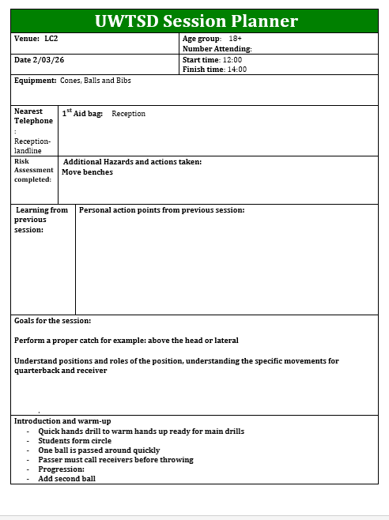
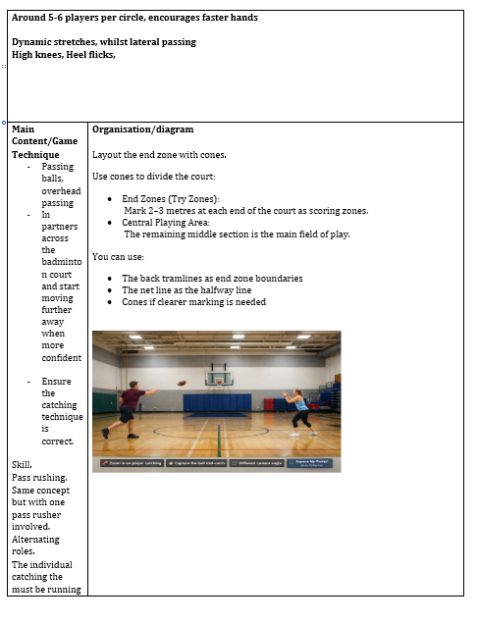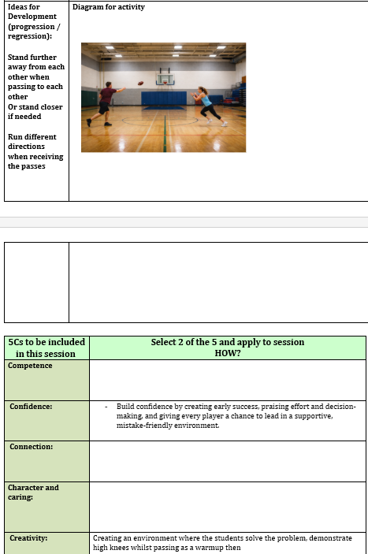

In class test 1.

Cody Peacey (2404220)
Test
Question 1
The term generalization in childhood sports development relates to a child playing many different sports at once, learning the different skills from the sports that are also transferable between the sports they play. For example, a young footballer also plays basketball as you can carry skills learnt through each of the sports.
Question 1.1
Specialization in childhood sports development refers to a child only participating in one certain sport and developing skills for only that sport. You see this in young footballers often, when they join academies from a very young age and play football 5 days a week. This benefits them in a footballing aspect as that is all they learn, however there won't be a chance to develop skills in other sports due to the effort put into one particular sport.
Question 1.2
The example of Roger vs Tiger in the aspect of generalization vs specialization regards Roger Federer, a professional tennis player and Tiger Woods, a professional golfer. Roger generalized in many different sports in the early year before becoming a full-time tennis player. Generalizing benefited him in many ways due to the increase of skills like coordination and agility gathered from the other sports he played. On the other hand, Tiger from a very young age was going to golf courses and playing golf with his father every week, by the time he was a young teenager Tiger was playing against adults, this is because of the amount of time he was spending on the golf course at such a young age.
Question 1.3
The Polgar sisters were three sisters who all specialized in chess. This was due to the fact that their father believes that geniuses weren’t born, they were made, and he wanted to prove that by generating three world class chess players. From childhood, their father ensured that they were learning chess consistently for many hours every day. Each of the sisters all went on to achieve great successes in chess such as world championships and grand masters.
Question 1.4
Chunking in relation to the above question refers to when the Polgar sisters were playing chess after years of experience they started to realize patterns of play instead of just normal chess. They broke the information down into different patterns to work out attack and defense techniques.
Question 2
Knowledge | Skills | Qualities and attitudes
Technical knowledge of different drills to give to players. | Communication, clearly speaking to the team, gives them clear instructions. | Positively reinforcing players if they make mistakes.

Question 2.1
Parents will want their children to have enjoyment during the session. Also, for their children to be included and show that everyone is part of the session no matter the ability.

Question 2.2
A- Advanced, advancing the session into harder drills to push players to improve.
P – Pressure, generating pressure moments similar to in game scenarios.
E- Environment, creating the right environment where players can thrive from.
S-Skills, developing the players skills throughout the session.

Question 2.3
If the child is drawing the attention of other kids in the session, I will ask a person helping with the session or the child's parent to try and deal with the child whilst I tell the other kids what to do.

Question 2.4
If they have a bad leg and want to sit out, due to the age you can't force them to carry on therefore you speak with the parent to ask if they are actually enjoying the session s or if there is anything that can improve to help that child because often they aren't actually injured.

Question 2.6
If an adult starts swearing at other players during the lesson I would firstly give him a verbal warning and try and calm them down, if they carry on in further session constantly shouting and swearing at other players then it could lead to asking them to leave the club as it brings down the other players in thew squad and can impact performances.
Question 2.7
Principles of learning are:
P- Performance
R-

Question 3
The coaching process means the way that different coaching will conduct their sessions to teach others. Each coaching process can be different as there are many ways to reinforce skills on players, and some may be better suited than others.
Question 3.1
Instuction and explanation
- Give clear instructions to players
- Explain thoroughly to players so they know what to expect in the session
Demonstrations
- Show others in the session how the skill is correctly done
- Demonstrate differential scenarios that can happen if in a game environment
Observation and analysis
- Observe how the players are doing within the session
- Analyze how your session went to plan and if it benefited the other players
Provide feedback
- Give feedback to the players whether it be good or bad
- Ask for feedback on the session so you can know if improvements can be made to benefit the team in the future
Question 3.2
WRUS coaching process
Play
Detail
Review
Question 3.3
FAW Coaching process
Organization
Detail

Question 3.4
Enjoyment- Ensure all those who participate will enjoy the session
Skillset- Explain the skill set that they will be working on during the session
Take-aways- Identify a piece of information that all the players can take away and improve on by the time they come back

Question 4
Technique is the ability to perfect an aspect of a specific sport.
Question 4.1
An example of technique in a sport would be a finesse shot into the top corner in football
Question 4.2
A skill is something that is developed through learning in a sport
Question 4.3
An example of a skill is keep ups in a football session
Question 4.4
The benefits of a technical practice session are that players can develop further techniques that can be used when in a real game scenario, which also enhances their technical player development.
Question 4.5
The limitations of a technical practice session are that you don't develop any general skills, and you spend a lot of time just focusing on one part of the technique.
Question 4.6
The benefits of a skill practice session are that the skills gained from the session carry over straight into a game and you can clearly measure the difference with the skills.

In class test individual

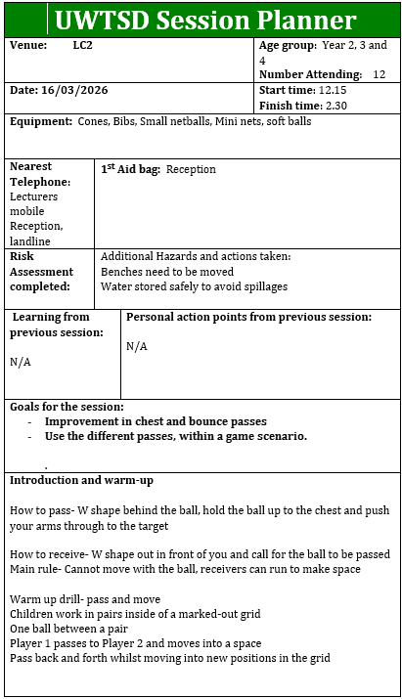

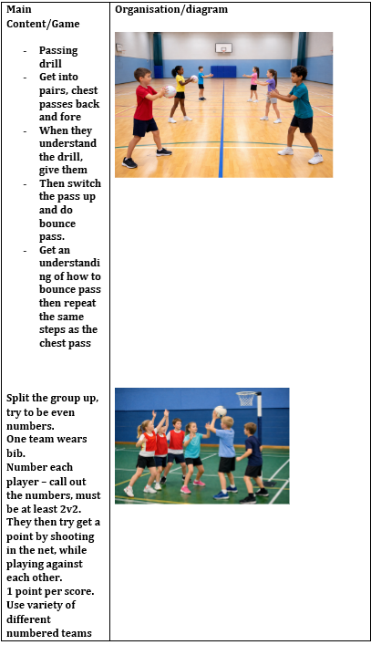

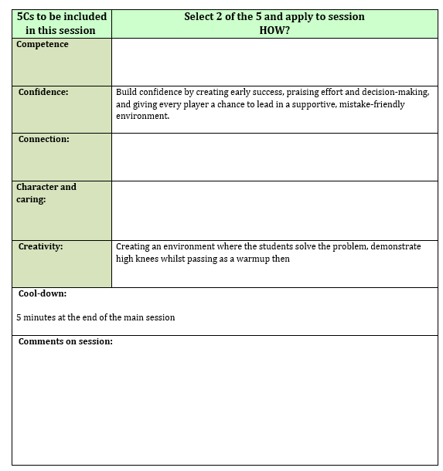

Journal review 1

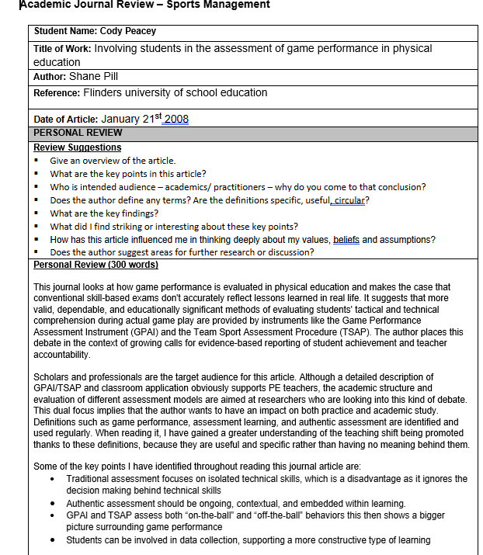

Journal review 2

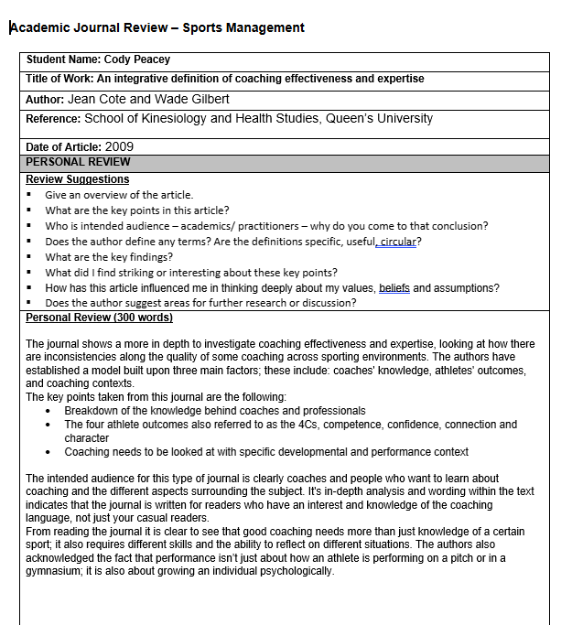

In class test 2

Pupils' assessment card
Pupils card 1.
Rugby Pass
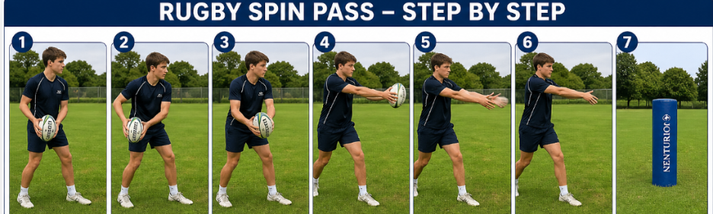
Skill | Directions | Performance Criteria | 1st | 2nd | 3rd
Rugby pass | Stand sidewards to perform a standard spin pass using a rugby ball  Pass it to a target in front of the person  Hit the target 3 times then swap with the partner  Mark the performance each go  At the end of the 3 turns write in what went well and what could be improved in the summary box | - Looking forward towards the target  - Pull the ball back from the hip, with one hand on front and back  - Push hands through the ball  - When releasing the ball add a spin for more power and accuracy  - Finish with fingers pointing through to the target

Pupils card 2
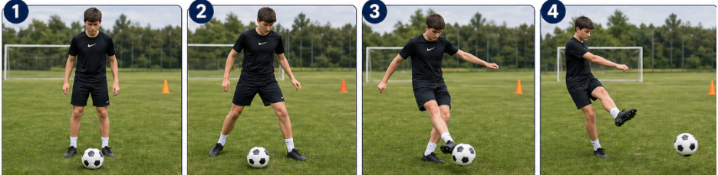
Skill | Directions | Performance Criteria | 1st | 2nd | 3rd
Football pass | Stand face on to the ball  Kick the ball using a push pass  Do 3 times and swap with partner  Complete summary box with what went well and how to improve | - Hips square towards target  - Plant foot to the side of the ball  - Leg swing back, side of the foot connecting with the ball  - Leg following through to create more accuracy on the pass

Pupils card 3
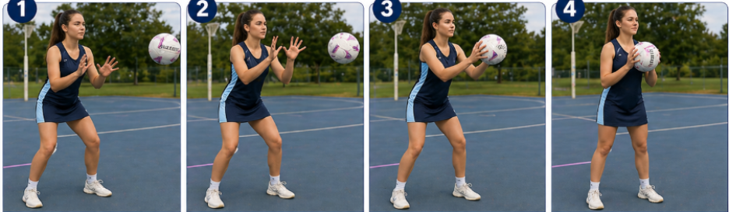
Skill | Directions | Performance Criteria | 1st | 2nd | 3rd
Netball catch | Stand opposite a partner who passing the ball  Be ready to catch a ball with two hands  Catch 3 times in a row then swap  Complete summary box with what went well and how to improve | - Feet shoulder width apart with a strong base  - Hands out in a ‘W’ shape preparing to catch the ball  - Catch ball firmly without dropping  - Bring hands close to chest, keeping thew ball secure

Pupils card 4
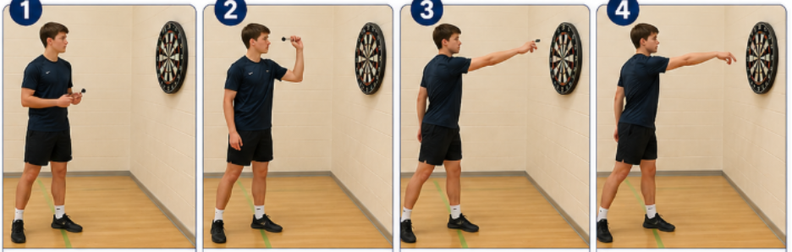
Skill | Directions | Performance Criteria | 1st | 2nd | 3rd
Darts throw | Stand sideways facing side on to the dart board  Use a throwing motion to get the dart into the board  3 throws towards bullseye then swap with partner  Complete the summary box with what went well and how to improve | - Feet set on the floor providing a solid base for throw  - Three fingers gripped around the dart  - Lift arm up in line with the dart board  - Aim with the hand and eye towards the bullseye  - Release the dart from the hand, following the hand through to the target
Summary

Pupils card 5
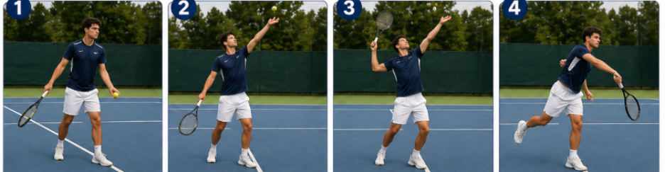
Skill | Directions | Performance Criteria | 1st | 2nd | 3rd
Tennis serve | Stand on court with ball in one hand and racket in the other, ready to serve  Serve the ball to other side of the court  Perform 3 serves then swap with your partner  Complete the summary box with what went well and how to improve | - Stand diagonally with the ball in your left hand and racket in the right hand (swap if left-handed)  - Throw ball up with one hand testing the height of the serve, imagining hitting it  - Throw the ball up, striking it with the racket above head  - Swing through the ball with a body rotation adding full power to it
Summary

