

Sefydliad Dysgu Canol Dinas /
Institute of Inner-City Learning

BA Leadership and Management

Assessing the impact of warehouse automation (AMRs/AGVs, automated picking, conveyor systems) on operational efficiency at a large UK logistics depot

Dumitru Alexandru Dumitru
2309588

Rebecca Stewart

Dissertation submitted as part of the requirements for the award of BA Leadership and Management

07/2026

DECLARATION

I, Alex Dumitru, 2309588, declare that I have only used GAI tools by respecting University regulations in regards to the use of GAI Tools and that the submitted work is entirely my own work.

DUMITRU ALEXANDRU DUMITRU 27.07.2026

ACKNOWLEDGEMENTS

I wish to show my heartfelt gratitude to every person who was a part of making this dissertation a success.
I will be expressing my heartfelt gratitude to everyone. It would really be an exaggeration to say but there have been people who have been at the core of completing this project. I want my gratitude to be acknowledged first of all.
My deepest appreciation goes to my supervisor for their invaluable support and assistance throughout the research process, including the guidance, suggestions, and feedback at the right time, which really made a lot.
I am truly thankful to the University of Wales Trinity Saint David and the Institute of Inner-City Learning for providing me with all the necessary academic resources and a conducive learning environment so that the project could be carried out at the same speed.
I am also indebted to all the respondents for their time and honesty that enabled me to collect both quantitative and qualitative data. The information revealed by their answers formed a fundamental part in shaping my work. I would like to extend my thanks to all of you for taking part in this study that was really meaningful for me as a researcher.

CONTENTS

DECLARATION 3
ACKNOWLEDGEMENTS 4
LIST OF FIGURES 8
GLOSSARY 9
Chapter 1: Introduction 11
1.1 Introduction to the Study 11
1.2 Background of Warehouse Automation 11
1.3 Research Problem 12
1.4 Research Aim 12
1.5 Research Objectives 13
1.6 Research Questions 13
1.7 Significance of the Study 13
1.8 Dissertation Structure 14
Chapter 2: Literature Review 15
2.1 Introduction 15
2.2 Overview of Warehouse Automation in Modern Logistics 15
2.3 Warehouse Automation Technologies 16
2.4 Operational Efficiency in Warehouse Operations 17
2.5 Theoretical Frameworks Supporting Warehouse Automation Research 18
2.6 Employee Perspectives on Warehouse Automation 19
2.7 Organisational Factors Influencing Automation Success 19
2.8 Empirical Review of Previous Studies 20
2.9 Conceptual Framework 21
2.10 Research Gap 22
Chapter 3: Research Methodology 24
3.1 Introduction 24
3.2 Research Philosophy 24
3.3 Research Approach 25
3.4 Research Strategy 25
3.5 Research Design 26
3.5.1 Mixed-Methods Research Design 26
3.5.2 Justification for Mixed Methods 27
3.6 Research Methods 27
3.6.1 Primary Research 27
3.6.2 Secondary Research 28
3.7 Research Population and Sampling 28
3.7.1 Primary Research Sampling 29
3.7.2 Secondary Research Sampling 29
3.8 Data Collection Process 30
3.8.1 Primary Data Collection 30
3.8.2 Secondary Data Collection 31
3.9 Data Analysis Techniques 31
3.9.1 Quantitative Data Analysis 31
3.9.2 Qualitative Data Analysis 32
3.10 Reliability and Validity 33
3.11 Ethical Considerations 33
Chapter 4: Data Analysis and Findings 35
4.1 Introduction 35
4.2 Respondent Demographic Profile 35
4.2.1 Current Job Role 35
4.2.2 Length of Service 36
4.2.3 Warehouse Automation Technologies Used 37
4.3 Findings on the Impact of Warehouse Automation on Operational Efficiency 38
4.3.1 Productivity Improvement 38
4.3.2 Speed of Completing Operational Tasks 39
4.3.3 Reduction in Picking and Order Fulfilment Errors 41
4.3.4 Improvement in Workflow Efficiency 42
4.4 Findings on Employee Experience 43
4.4.1 Confidence in Using Warehouse Automation 43
4.4.2 Adequacy of Training 44
4.4.3 Reduction in Physical Workload 45
4.4.4 Impact on Job Satisfaction 46
4.5 Findings on Organisational Factors 47
4.5.1 Management Support 47
4.5.2 Communication During Automation Implementation 48
4.5.3 Resolution of Technical Issues 49
4.6 Overall Evaluation of Warehouse Automation 50
4.7 Discussion of Key Findings 51
Chapter 5: Conclusion and Recommendations 52
5.1 Introduction 52
5.2 Summary of Research Findings 52
5.3 Conclusion 53
5.4 Recommendations 53
5.5 Limitations of the Study 54
5.6 Recommendations for Future Research 54
REFERENCES 55
APPENDICES 59
Appendix 1 – Questionnaire 59

LIST OF FIGURES

Figure 1.1: Dissertation Structure 14
Figure 2.1: Conceptual Framework 22

Figure 4.1: Question 1 Current Job Role 36
Figure 4.2: Question 2 Work Duration 37
Figure 4.3: Question 3 What Warehouse Equipment Did You Work with the Most? 38
Figure 4.4: Q4 Productivity Improvement 39
Figure 4.5: Q5 Speed of Completing Operational Tasks 40
Figure 4.6: Q6 Reduction in Errors 41
Figure 4.7: Q7 Workflow Efficiency 42
Figure 4.8: Q8 Confidence Using Automation 43
Figure 4.9: Q9 Training Adequacy 44
Figure 4.10: Q10 Physical Workload 45
Figure 4.11: Question 11 Job Satisfaction 46
Figure 4.12: Q12 Management Support 47
Figure 4.13: Q13 Communication 48
Figure 4.14: Q14 Technical Issue Resolution 49
Figure 4.15: Overall Impact of Warehouse Automation 50

GLOSSARY

Abbreviation | Full Term | Definition
AI | Artificial Intelligence | Computer systems that simulate human intelligence to perform tasks such as learning, decision-making, and problem-solving.
AMR | Autonomous Mobile Robot | A robot capable of navigating warehouse environments independently without fixed guidance systems.
AGV | Automated Guided Vehicle | A driverless vehicle that transports materials along predefined routes within a warehouse or manufacturing facility.
WMS | Warehouse Management System | Software used to manage warehouse operations, including inventory control, order processing, and stock movement.
ERP | Enterprise Resource Planning | An integrated software system that manages core business processes such as finance, logistics, procurement, and human resources.
IoT | Internet of Things | A network of interconnected devices that collect and exchange data to improve operational efficiency.
KPI | Key Performance Indicator | A measurable value used to evaluate how effectively an organisation achieves its operational and strategic objectives.
RFID | Radio Frequency Identification | A technology that uses radio waves to identify and track inventory and assets automatically.
GPS | Global Positioning System | A satellite-based navigation system used for tracking vehicles and equipment in logistics operations.
OCR | Optical Character Recognition | Technology that converts printed or handwritten text into machine-readable digital data.
SCM | Supply Chain Management | The management of the flow of goods, information, and services from suppliers to customers.
TAM | Technology Acceptance Model | A theoretical model explaining how users accept and adopt new technologies.
TOE | Technology–Organisation–Environment Framework | A framework explaining technology adoption based on technological, organisational, and environmental factors.
UK | United Kingdom | The country in which the case study warehouse is located.

Chapter 1: Introduction

1.1 Introduction to the Study

Warehouse automation is a major pillar of Industry 4.0, which refers to the use of digital technologies in production and operational processes to make them more efficient and flexible. Automation machines have proved quite useful in big distribution centres where a large number of inventory movements require speed, accuracy, and reliability. For example, a major logistics company has invested heavily in warehouse automation equipment so as to remain competitive and help them achieve their operational goals (Ivanov, Tsipoulanidis and Schönberger, 2019).
This research is a case study that seeks to explore if and how warehouse automation initiatives such as AMRs, AGVs, automated picking systems, and conveyor technologies affect the level of efficiency at a large UK logistics depot .

1.2 Background of Warehouse Automation

The warehouse chosen for this research is one of the leaders in the logistics and supply chain industry, offering services such as transportation, warehousing, distribution, and fulfilment across various sectors. Besides the large number of distribution centres it operates in the UK, one such centre in Birmingham is a key part of its logistics network. Given the extensive inventory and orders that the Birmingham facility handles, operational efficiency remains a top priority at this location (Rushton, Croucher and Baker, 2022).
The rising sophistication of supply chains has led logistics companies to look at automation as one of the ways to get better results from their warehouses. AMRs and AGVs help by taking care of the storage and retrieval activities within the warehouses with only minor human involvement, whereas automated picking systems help to raise order accuracy while simultaneously shortening processing times. Meanwhile, conveyor systems play a part in making operations smoother by enabling a constant flow of materials and by lowering the amount of manual handling required (Richards, 2020).
Studies indicate that automating warehouses can greatly increase output, lower mistakes made during operational processes, and improve the overall level of service quality. Nevertheless, it should be noted that only relying on the machine investments seldom leads to successful automation; other factors such as organizational readiness, employee acceptance, training, and process redesign also come into play in determining the results (Bowersox, Closs and Cooper, 2019).

1.3 Research Problem

There is no doubt that warehouse automation can be an effective way to improve operational efficiency; however, very often companies run into all kinds of problems with the automation technology they have decided to implement. Even though with automation, you can raise the throughput, decrease labour usage, and improve order accuracy, there are quite a few organisations that still experience problems with implementation, integration of new technologies, employee resistance as well as disruptions in their operational processes during the adoption periods (Vial, 2019).
The operations at the warehouse are being significantly affected by the need to handle increased order volumes, finding enough workers, raised customer expectations, and operational costs. To deal with these, the company has taken steps to put in place several automation technologies for better warehouse performance (Waller and Fawcett, 2014).

1.4 Research Aim

This research intends to evaluate the contribution of warehouse automation technologies such as AMRs, AGVs, automated picking systems, and conveyor systems to operational efficiency at a large warehouse in Birmingham.

1.5 Research Objectives

To understand how AMRs, AGVs, automated picking systems, and conveyor systems affect productivity levels, order accuracy, and throughput at the large UK logistics depot facility.
To understand employee perceptions concerning the introduction of warehouse automation and its impact on workload, job satisfaction, and operational effectiveness.
To identify the managerial and technological factors that play a role in the successful implementation of warehouse automation technologies at a large UK logistics depot .

1.6 Research Questions

How much of the improvement in operational efficiency at a large depot in Birmingham is attributed to warehouse automation?
What are employees' views on how automation impacts their productivity and job satisfaction?
What managerial and technological factors contribute to the successful execution of warehouse automation technologies at the large depot in Birmingham?

1.7 Significance of the Study

The significance of the current work can be examined from two perspectives namely academic and business decision-making. Firstly, from an academic point of view, this study deepens the understanding of warehouse automation in the logistics industry by exploring how automation technologies are connected with operational performance. Besides, the study aims at contributing to the growing literature on digital transformation and Industry 4.0 applications in supply chain management (Vial, 2019).

1.8 Dissertation Structure

Figure 1.1: Dissertation Structure
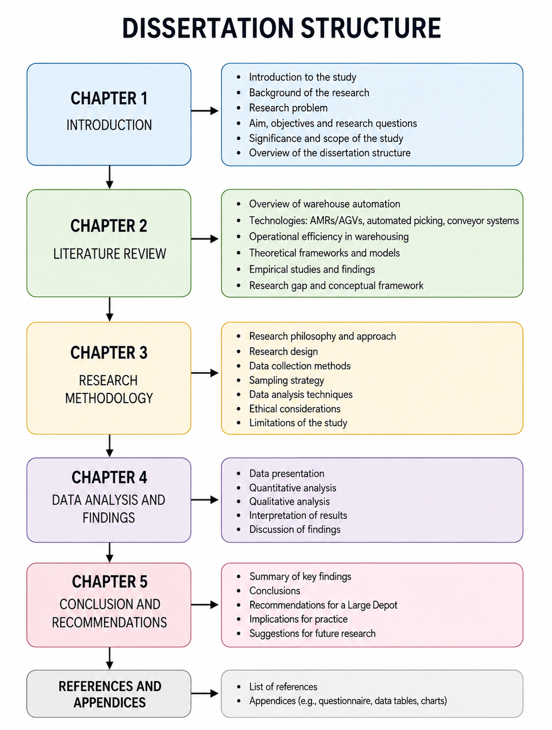
Source: Self-made

Chapter 2: Literature Review

2.1 Introduction

Automating warehouses is a hot topic these days in the world of logistics and supply chain management as these sectors keep demanding more efficient, accurate, and timely operations. In fact, companies today are pouring money into the most advanced technologies to make their warehouses run better and keep up with their competitors in the ever-changing world of business. Autonomous Moving Robots (AMRs), roll-guided vehicles (AGVs), robotized picking systems, conveyor belts, etc., are just some of the ways technology is revolutionizing the manual labor-dependent methods of warehousing and allowing companies to increase their outputs substantially (Christopher, 2016; Richards, 2020).

2.2 Overview of Warehouse Automation in Modern Logistics

Warehouse automation is the use of new technologies, software systems, robots, and intelligent equipment to carry out warehouse activities with the least possible human intervention. Modern logistics companies have taken to automating their warehouses as a means of increasing their efficiency, cutting down their cost of operations, and usually providing better services to their customers. The large number of online orders being placed and the increasingly stringent requirements of customers with regard to delivery time have pushed companies to embrace warehouse automation at a very rapid pace (Rushton, Croucher and Baker, 2022).
In the past, human workers were the main force behind warehouse operations such as stocking the inventory, ordering retrieval, transporting the goods, and carrying out the orders. However, as operations have become more and more complicated, companies have been looking into how they can allow machines to do these tasks more accurately, efficiently, and quickly (Bowersox, Closs and Cooper, 2019). Automation technologies are not only used for moving the inventory but also for material handling, order picking, and information processing, thus enabling warehouse operations to be carried out at a much faster pace and with unchanged precision.
Industry 4.0 which represents the fourth industrial revolution, is a game changer in this regard as it brings about a synergy between warehouse operations and digital technologies such as artificial intelligence, machine learning, computing robots, and data analysis (Zhong et al., 2017). In fact, Frank, Dalenogare, and Ayala (2019) have reported that Industry 4.0 allows firms to develop smart and separated operations. Vial (2019), for his part, contends that digital transformation efforts push firms to invest in automation technologies to realise long-term competitive advantages and make operational improvements.
Warehouse automation is and needs to be considered as more than a mere technical conversion of manual operations to machine operations (Ráduly et al., 2020). This is the view that has been taken in recent years and the thought is that it is a combination of technology, human resources and operational processes that really makes the difference (Ivanov, Tsipoulanidis and Schönberger, 2019). As a result, warehouse automation was and will be one of the main arms of modern logistics systems to increase productivity, cultural flexibility, and customer satisfaction.

2.3 Warehouse Automation Technologies

Warehouse automation refers to implementation of various technologies that improve operational performance and alleviate manpower demand. Four of the top technologies are Autonomous Mobile Robots (AMRs), Automated Guided Vehicles (AGVs), automated picking systems, and conveyor systems. Each of these support inventory movement, material handling, order fulfilment, and workflow optimization inside a warehouse facility (Richards, 2020).
AMRs employ AI and high-tech sensors to move around the warehouse without human assistance and also to react to any changes in the operation. Studies demonstrate that AMRs not only reduce the distances the employees need to cover but also enable them to follow more efficient processes (Grover and Ashraf, 2023). In the same way, AGVs carry out material transport tasks autonomously by shifting warehoused goods from one place to another, which has the effect of not only lowering labor but also enhancing reliability (Khan, 2020).
Picking systems have become a key part of the warehouse due to the growth of e-commerce and customer desire for fast delivery. Jaghbeer, Hanson and Johansson (2020) have found from their study that automated picking technologies contribute to order accuracy and at the same time shorten work cycle through the involvement of robots, computer vision and smart software. Conveyor systems help to a large extent in reducing bottlenecks as they enable continuous movement of goods throughout the warehouse (Rushton, Croucher and Baker, 2022).

2.4 Operational Efficiency in Warehouse Operations

Operational efficiency means an organization's capabilities to produce maximum outputs, on the other hand, it minimalises the usage of inputs such as time, labour, costs, and resources. Within warehouse operations, efficiency is very often gauged using productivity, throughput, order accuracy, resource utilisation, and cost performance indicators (Slack, Brandon-Jones and Johnston, 2019). Since customer expectations are continuously rising, logistics companies find themselves under pressure to enhance operational performance while still upholding high service levels.
The widespread acknowledgment of warehouse automation as a major factor behind operational efficiency should not be overlooked. Automated systems are able to significantly cut down on manual operations, increase work flow regularity, and make inventory management better (Christopher, 2016). As per Bowersox, Closs and Cooper (2019), the efficiency of warehouse operations highly affects the whole supply chain results as the reduction of delays and quick reaction to the customer demand are the main characteristics of the effective operations.
Thanks to their ability to sort and dispatch a greater number of orders in the allotted time, automated solutions contribute to the improvement of throughput as well. Besides that, the deployment of AI-driven solutions and automated picking units contributes to the reduction of the error rate, thus leading to increased order accuracy and customer satisfaction (Casella et al., 2023). On the other hand, Richards (2020) seems to be of the opinion that besides the technological features, it is the deployment, training, and support from the organisation that quite a bit influence the effectiveness. Hence, operational efficiency can be seen as a concept with many dimensions which are affected by both technological and human factors.

2.5 Theoretical Frameworks Supporting Warehouse Automation Research

The adoption and consequences of warehouse automation technologies can be better understood through a number of theoretical models. Among the most significant is the Technology, Organisation, Environment (TOE) Framework which states that technology adoption is a result of three factors i.e., technological capability of the organization, its readiness, and the pressure from the environment or industry (Tornatzky and Fleischer, 1990). This framework fits particularly well with warehouse automation because technology and organizational factors run hand in glove when implementing a solution successfully.
Digital Transformation Theory is another one that brings us closer to understanding how enterprises exploit state-of-art technologies not only for operational purposes but also for gaining competitive edges. Vial (2019) posits that digital transformation cannot be just regarded as the acquisition of technologies but should be seen as the series of changes in the organization involved in innovation and efficiency. Theoretically, Industry 4.0 is on the same page with these by highlighting the blending of robots, AI, and big data with productivity areas (Zhong et al., 2017).
The main focus of Operational Excellence Theory is to work on quality, speed, dependability by making constant changes and improvement whereas Change Management Theory alerts about the role that leadership, communication, and engagement of the employees play during the processes of technological transformations (Kotter, 2012). Combined, these theories lay out a very solid platform for evaluating the consequences of warehouse automation on operational efficiency.

2.6 Employee Perspectives on Warehouse Automation

As a matter of fact, employee views matter a great deal in determining the results of warehouse automation projects. Basically, technological enhancement is a means the main end is always improving productivity but at the same time these improvements roll out only if employees are on board, have the right skills and are motivated to accept a different way of working. Hence, it wouldn't be wrong if one states that automation can be successful only if both, human and technological components, receive the right amount of attention (Vial, 2019).
The first one being one's level of acceptance towards automation technologies. Generally, workers tend to become more supportive of automation if they feel through automation working hours can become shorter, the workplace safer and the performance level higher. Due to the fact that collaborative automation puts together human worker and machine, it is not surprising that a good number of workers have appreciated that this new way of working has made them more productive while not causing any physical stress as opposed to earlier times (Papasarikas, De Vries and De Koster, 2023). Similarly, according to Grover and Ashraf (2023), employees who collaborate with AMRs often have more efficient workflows and face less operational pressures.

2.7 Organisational Factors Influencing Automation Success

Many organisational factors that can affect the success of a warehouse automation implementation, ultimately impacting the adoption of technology and the results of operations. Even though cutting-edge technologies could contribute to efficiency, companies need to organise their environment in a way that would enable the effective integration of such technologies into their existing processes. Leadership support, organisational readiness, workforce capabilities, and technology integration are considered by researchers as the key factors that determine the success of automation (Tornatzky and Fleischer, 1990).
It is no secret that leadership backing is essential for driving forward automation projects and helping employees to be conscious of the goals and perks of changes brought about by technology. Kotter (2012) also points out that leadership can significantly contribute not only by lessening resistance but also by rallying people to come on board and participate actively during the implementation phase.
Equally essential is organisational readiness which implies that enterprises should have at hand adequate financial, physical, and human resources to make their automation technology runs smoothly (Ivanov, Tsipoulanidis and Schönberger, 2019).
The integration of technology is still a major issue. Automated systems are supposed to work unobtrusively with the current warehouse management systems, inventory platforms, and operational procedures. Inadequate integration might be the cause for only marginally enhanced performance and even failure of the automation investments to yield the best results (Kache and Seuring, 2017).

2.8 Empirical Review of Previous Studies

Existing empirical research generally supports the positive impact of warehouse automation on operational performance. Studies conducted across various logistics environments indicate that automation technologies contribute to improvements in productivity, throughput, accuracy, and resource utilisation. For instance, Grover and Ashraf (2023) observed that Autonomous Mobile Robots enhanced the efficiency of workflows significantly and increased the level of operational flexibility in warehouse settings aligned to Industry 4.0. On the other hand, Jaghbeer, Hanson and Johansson (2020) found that automated picking systems not only improved order accuracy but also shortened the time taken for order fulfilment.
Casella et al. (2023) also emphasise that automated order-picking technologies are becoming more and more capable of satisfying customer demand and driving up warehouse performance. Likewise, according to Sarker (2022), when artificial intelligence is deployed it results in better decision-making, inventory management, and even overall operational optimisation. Research into human, robot collaboration brought about by automation revealed increased employee productivity and workload reduction as positive effects (Papasarikas, De Vries and De Koster, 2023).
On the contrary, there are authors who suggest that factors internal to the organisation such as the acceptance of employees, backing of leadership, and training of the workforce are what really make automation successful (Vial, 2019; Frank, Dalenogare and Ayala, 2019). These results indicate that investment in technology is not by itself sufficient to bring about operational improvements. Hence both technological and organisational aspects should be taken into account when assessing the effectiveness of warehouse automation.

2.9 Conceptual Framework

The framework concept of this research has been derived from what has been read in the literature and the set research objectives. It serves to visualise how warehouse automation technologies can be causally linked with operational efficiency results, and at the same time it gives acknowledgement to organisational and employee-related factors as influences. Literature has pointed out that while automation technologies can lead to better operational results, their effectiveness is very often determined by organisational factors like readiness, leadership backing, employee acceptance, and technology integration (Tornatzky and Fleischer, 1990; Vial, 2019).
Warehouse automation technologies in this model are the independent variables and they comprise Autonomous Mobile Robots (AMRs), Automated Guided Vehicles (AGVs), automated picking systems, and conveyor systems. Operational efficiency outcomes, namely productivity, throughput, order accuracy, cost efficiency, and employee experience, are the dependent variables to be affected by the technologies (Richards, 2020; Bowersox, Closs and Cooper, 2019).
Employee training, organisational readiness, leadership support, employee acceptance, and technology integration are the playing the role of mediating variables that can either reinforce or diminish the relationship between automation technologies and operational outcomes. Hence, the framework embodies the Technology, Organisation, Environment triad in that it acknowledges that the performance of technology is in a way determined by the extra-organisational conditions (Tornatzky and Fleischer, 1990). This conceptual framework is the basis for the empirical research conducted at large UK logistics depot .

Figure 2.1: Conceptual Framework
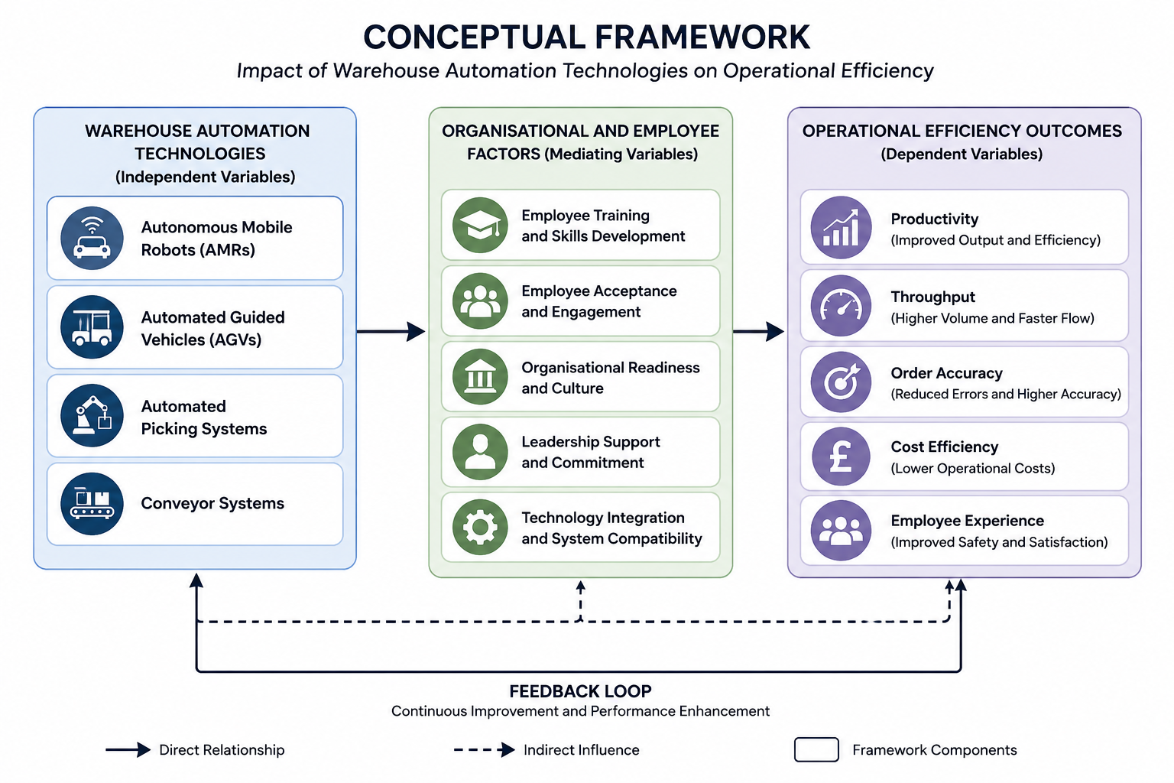
Source: self-made

2.10 Research Gap

While the number of published papers on warehouse automation is increasing, there still are several spaces that remain uncovered. The problem is that research that has been carried out tends only to focus on individual pieces of technology such as AMRs or automated picking systems without examining their combined effect within integrated warehouse settings (Jaghbeer, Hanson and Johansson, 2020). Furthermore, operational performance measurement indicators tend to be given the highest priority by many authors of research papers, whereas employee perspectives and organisational factors aspects are almost neglected (Vial, 2019). There is also a scarce number of publications that are emphasising the UK logistics sector on the whole and individual warehouse facilities too.

Chapter 3: Research Methodology

3.1 Introduction

The aim of this chapter is to explain the research methods I have used to collect and analyze data for the purpose of studying the influence of automation technologies in warehouses on operational efficiency at a large UK logistics depot .
The central focus of this research is to measure the influence of Autonomous Mobile Robots (AMRs), Automated Guided Vehicles (AGVs), automated picking systems, and conveyor systems on operational aspects like productivity, throughput, order accuracy, cost efficiency, and employee experience. This chapter covers the research philosophy, research approach, research strategy, research design, data collection methods, sampling procedures, data analysis techniques, reliability and validity considerations, ethical issues, and research limitations.

3.2 Research Philosophy

Research philosophy is the term used for a set of beliefs and assumptions that guide the process of collecting, interpreting, and analysing research data. It essentially determines the basis on which methodological decisions are taken and also shapes the way researchers perceive the knowledge and reality in the context of a given research study (Saunders, Lewis and Thornhill, 2019). Choosing an appropriate research philosophy is important because it helps to maintain harmony between the research goals, means of data collection, and data processing methods.
It is a reasonable approach to take positivism given that the research aims to measure the influence of automation technologies in the warehouse on their operational efficiency through a set of quantifiable indicators such as productivity, throughput, order accuracy, and employee perceptions. The research consists of the administration of a structured questionnaire containing closed-ended questions that generate numerical data which are amenable to statistical analysis. This is perfectly in line with the positivist notion that knowledge is something that is gained through observation, measurement, and empirical evidence (Bryman, 2016).

3.3 Research Approach

For this research, deductive research approach was chosen. A deductive approach is valid because this research goes through the literature, using already established theories on warehouse automation, operational efficiency, digital transformation, operational excellence, and technology adoption. These perspectives from theory will be the starting point for the investigation of the extent to which automation technologies relate to operational performance of large UK logistics depot (Vial, 2019; Slack, Brandon-Jones and Johnston, 2019).
In the deductive method one first reviews the existing theoretical frameworks and literature, such as the Technology, Organisation, Environment (TOE) Framework, Digital Transformation Theory, Operational Excellence Theory, and Change Management Theory. These papers all indicate that warehouse automation could be a factor in improving operational efficiency given the conditions of the organisation are favourable and employees are engaged (Tornatzky and Fleischer, 1990; Kotter, 2012). Committed to these theoretical propositions, data are gathered to figure out if the anticipated relationships prevail in the case of large UK logistics depot.

3.4 Research Strategy

Choosing a research strategy is mainly about defining how data will be gathered and analysed in a way that directly meets the research aims. Picking the right strategy is crucial since it determines the way research is conducted and the methods through which evidence is collected to answer research questions (Saunders, Lewis and Thornhill, 2019).
The current work chooses case study as research strategy. Case study refers to an intensive examination of an individual unit such as a company, a single event, a certain type of activity, or a specific behaviour in its natural setting (Creswell and Creswell, 2018). This approach is highly relevant when scholars want to have a deep understanding of organizational problems that are so intertwined with their environment, one cannot live without the other.

3.5 Research Design

Research design is the structure of the entire research work that shows the way through which data will be collected, measured and analysed to address the research questions and aims. A thoughtfully planned research frame will ensure that the research stays systematic, reliable and that it aligns with the intended purpose of the study (Creswell and Creswell, 2018). This research work design is a mixed-methods design since it uses quantitative and qualitative methods to study in a comprehensive way the impact of warehouse automation on operational efficiency at a large UK logistics depot .

3.5.1 Mixed-Methods Research Design

Mixed-methods research is the integration of quantitative and qualitative methods in a single research work for obtaining the full picture of a research problem. This approach allows researchers to utilise the strengths of both methods and at the same time reduces the weaknesses associated with each one (Saunders, Lewis and Thornhill, 2019).
Quantitative data in this study comes from a structured questionnaire to be distributed among 50 employees of a large depot in Birmingham. The survey is made up of 15 close-ended questions that address a variety of topics such as perception of employee productivity, order accuracy, work efficiency, training, job satisfaction, and the overall effect of warehouse automation technologies. Quantitative methods are very effective means of gathering measurable data which later on can be subjected to statistical analysis for pattern, trend identification as well as variable relationship (Bryman, 2016).
The secondary sources such as academic publications, books, etc., are used for gathering qualitative data and together with a clear theoretical framework, these data sources provide an understanding of the observations from a different perspective (Richards, 2020; Christopher, 2016).

3.5.2 Justification for Mixed Methods

Choosing a mixed-methods design is backed up by different methodological and practical reasons. Methodological triangulation through the combination of quantitative and qualitative data is the first one. Triangulation is the method of looking at a research problem from different angles to increase the accuracy and validity of conclusions (Saunders, Lewis and Thornhill, 2019).
Technology adoption in a warehouse comes as a result of the interplay of technology, people and organization. Literature points out the successful implementation of automation does not rest only on the performance of technology but also on aspects like leadership support, workforce readiness, employee acceptance and organizational culture (Tornatzky and Fleischer, 1990; Kotter, 2012). The mixed-methods approach facilitates the exploration of these dimensions simultaneously.

3.6 Research Methods

Research methods are the procedures researchers use to collect data and evidence to support a research study. Choosing the right research methods is critical because it greatly affects the quality, trustworthiness, and applicability of the data obtained during the research process (Saunders, Lewis and Thornhill, 2019).

3.6.1 Primary Research

Primary research is original research in which new data are collected directly from the source. It is conducted with the specific purpose of addressing the research objectives (Bryman, 2016). The primary data for the research was collected from the employees working at a large UK logistics depot in through a structured questionnaire that the employees themselves completed. The questionnaire contained 15 objective multiple choice questions which aimed to capture the employees' views on the various types of technologies used in the warehouse such as autonomous mobile robots (AMRs), automated guided vehicles (AGVs), automated picking, and conveyor systems.
The statements in the questionnaire asked the participants to rate their level of agreement from a five-point Likert scale and covered the themes of productivity (how much time is saved), work performance, accuracy of the operations, physical demands and workload of the employees, effectiveness of the training, satisfaction at work, and overall performance of automation. The multiple-choice format was preferred for this survey as it gives the researchers the possibility to have responses in a standardised format which are amenable to quantitative analysis, and also facilitates comparisons of the participants' data (Saunders, Lewis and Thornhill, 2019).

3.6.2 Secondary Research

Secondary research relies on already available data and information that has been collected by other researchers, organisations, or institutions (Saunders, Lewis and Thornhill, 2019).
In relation to this research, the secondary data was drawn from the published literature on the subject in the form of academic journal articles, books, industry reports, conference papers, and professional publications dealing with warehouse automation, operational efficiency, Industry 4.0, digital transformation, and logistics management.
The use of secondary research helped the researchers widen their horizons and gain a better understanding of automation technologies and their potential impacts on organizational performance. Some of the authors consulted for updating the current trends concerning warehouse management and automation practices were Richards (2020), Christopher (2016), Ivanov, Tsipoulanidis and Schönberger (2019), and Rushton, Croucher and Baker (2022) (Grover and Ashraf, 2023; Casella et al., 2023; Papasarikas, De Vries and De Koster, 2023).

3.7 Research Population and Sampling

Sampling refers to the process of selecting a subset of individuals or information sources from a larger population in order to obtain data relevant to the research objectives. Appropriate sampling is important because it influences the representativeness, reliability, and validity of research findings (Bryman, 2016).

3.7.1 Primary Research Sampling

The target population for the primary research consisted of employees working at a large depot in Birmingham who interact directly or indirectly with warehouse automation technologies. This population included warehouse operatives, supervisors, team leaders, and other operational staff involved in warehouse activities where AMRs, AGVs, automated picking systems, and conveyor systems are utilised.
The study adopted a non-probability convenience sampling technique. Convenience sampling is the method of selecting participants for the research who are readily available and willing to participate (Saunders, Lewis and Thornhill, 2019). The study has restricted employee participation due to organisational limitations including employee schedules, and lack of free time.
The total of 50 employees as the sample was selected. The sample size was large enough to give useful statistics data. It was also small enough to stay within the time frames and resources of the study. Employees were chosen for this reason because they have been hands-on with warehouse automation technologies and thus are in a good position to evaluate their performance in terms of efficiency, workload, work output, and satisfaction from their jobs.

3.7.2 Secondary Research Sampling

The component of secondary research employed purposive sampling as a technique to deliberately choose relevant academic and professional sources about warehouse automation and operational efficiency. Purposive sampling is the selection of information sources based on their relevance to the topic under investigation and the objectives of the research (Saunders, Lewis and Thornhill, 2019).
The criteria for inclusion mainly concentrated on sources which cover automation of warehouses, Industry 4.0, improvement of operational efficiency, logistic management, digital transformation, employee viewpoints, and adoption of technology. Preference was given to peer-reviewed journal articles, academic books, conference proceedings, doctoral work, and industry publications that were issued from 2016 to 2024 to guarantee that the content was up-to-date and related to the topic.

3.8 Data Collection Process

The data collection phase is essential in the research journey as it provides the necessary information to address the research objectives and questions. The quality of data collection has a direct impact on the quality and trustworthiness of the research findings (Saunders, Lewis and Thornhill, 2019). In this research, data were collected using primary and secondary methods following the mixed-methods research design.

3.8.1 Primary Data Collection

Primary data were gathered through a structured questionnaire distributed to employees at large UK logistics depot . The questionnaire included 15 closed-ended questions aimed at collecting employees’ views about warehouse automation technologies and their impact on operational performance. The questions revolved around various topics such as productivity, order accuracy, workflow efficiency, employee confidence, training effectiveness, workload, job satisfaction, communication, and overall operational efficiency.
Answers were based on the extent of agreement respondents indicated using Likert scales consisting of 7-point items ranging from "strongly disagree" to "strongly agree." Likert-scale items also served as a means for the researchers to obtain standardized and statistical data suitable for quantitative research (Bryman, 2012). The survey contained four parts of employee characteristics, efficiency improvement of the company, work satisfaction of the employee, and problems caused by automation.
Before collecting the data, the purpose of the study was explained by the researchers, and the anonymity and confidentiality of data of the participants were also made clear. Participants were entitled to quit the study at their own will, even during the data collection. The survey instrument was delivered personally to employees who were selected based on the criteria established for sampling and had agreed voluntarily to give their responses (Creswell and Creswell, 2018).

3.8.2 Secondary Data Collection

To begin with, an in-depth search of literature on warehouse automation, operational efficiency, Industry 4.0, digital transformation, and logistics management was conducted from both academic and professional sources as a source of secondary data. The sources used included peer-reviewed journal articles, academic textbooks, conference papers, doctoral thesis, industry reports, and relevant organisational publications.
To locate relevant literature, academic databases, online libraries, Google Scholar, and institutional repositories were used. "Warehouse automation", "AMRs", "AGVs", "Automated Picking Systems", "Conveyor systems", "Operational efficiency", "Industry 4.0", and "Logistics Automation" were some of the keywords used in the literature search. This enabled the researcher to find both theoretical and empirical studies related to the research topic (Richards, 2020; Ivanov, Tsipoulanidis and Schönberger, 2019).

3.9 Data Analysis Techniques

Data analysis is defined as the method of analyzing, sorting, and explaining information that has been gathered with the aim of finding recurring trends, connections, and relevant insights. In the first place, different analytical methods are important because they allow researchers to turn raw data into solid facts that can answer the research question (Saunders, Lewis and Thornhill, 2019).

3.9.1 Quantitative Data Analysis

The quantitative data collected through the employee questionnaire were analysed using descriptive statistical techniques. Descriptive statistics are frequently relied upon as instruments for summarizing numerical data, and, through that function, revealing the patterns in the participants' answers (Bryman, 2016). That was also the reason why this approach fitted our study because rather than establishing complicated causal relationships between variables the study aims at uncovering employee perceptions in relation to warehouse automation.
The completed questionnaires were reviewed, organised, and coded to facilitate analysis. Responses were then entered into a spreadsheet for processing and interpretation. Statistical measures such as frequencies, percentages, and response distributions were calculated for each questionnaire item. These measures provided an overview of employee attitudes towards warehouse automation technologies and their perceived impact on operational efficiency.
Tables and charts were used to present the quantitative findings in a clear and accessible format. Visual presentation of data assists in identifying trends and enables comparisons across different questionnaire responses (Creswell and Creswell, 2018). The results generated through descriptive analysis were subsequently linked to the research objectives and compared with findings from the literature review.

3.9.2 Qualitative Data Analysis

In the current study, the data from in-depth interviews were analyzed qualitatively using thematic analysis. Thematic analysis is a popular qualitative research technique where patterns or themes from qualitative data are identified through coding of the content. The researcher gets to identify, analyze and draw meaning from patterns or themes within a set of data, thus providing a more comprehensive understanding and explanation of the data at hand. The primary reason why this technique was chosen was that it is both effective and reliable and researchers have found it suitable for working with the large amount of data which could be qualitative in the research process. Moreover, this technique helped us to not only identify the most common themes that emerged from both qualitative and quantitative sources (e.g.
The literature review was done comprehensively to highlight the main themes concerning automated warehouses and operational efficiency. The identified themes from both qualitative and quantitative sources (e.g. product enhancement, operational performance, technological changes, employee motivation, organisational reading, digital transformation, challenges of implementation) remained the same throughout the literature. These were the foundation upon which we categorized and made interpretations of the qualitative evidence (Vial, 2019; Grover and Ashraf, 2023).

3.10 Reliability and Validity

Reliability is the measure of an instrument’s consistency and stability over time and its capacity to produce similar results when used in similar conditions (Bryman, 2016). In this research, reliability was strengthened by employing a structured questionnaire with standardized questions for all participants. The closed-ended Likert-scale questions allowed for consistent data collection and minimized the chance of variations due to different interpretations of the questionnaire
Validity is a measure of the degree to which a research instrument captures the intended target (Saunders, Lewis and Thornhill, 2019). In this research, validity was indicated by the questionnaire items being consistent with the research objectives and theoretical concepts identified in the literature.
Construct validity was improved by basing the questionnaire on concepts that had been discussed in previous studies on technology adoption, operational performance, and digital transformation (Vial, 2019; Richards, 2020). Besides, the mixed-methods design allowed for multiple sources of evidence which also contributed to validity by comparing the results of the employee survey with findings from academic and industry literature. This method of triangulation helped to enhance the accuracy and trustworthiness of the overall research findings (Saunders, Lewis and Thornhill, 2019).

3.11 Ethical Considerations

The first ethical issue was that of informed consent. The respondents read an introductory text before answering the questionnaire which explained the purpose of the study and the type of participation expected from them. Also, the participants were reminded that if for some reason a question was difficult to answer or they felt reluctant in any way, they could simply skip the question and no adverse consequences would follow (Saunders, Lewis and Thornhill, 2019).
Apart from this, there was great care taken to maintain the respondents' anonymity and confidentiality at all stages of the study. When participants filled out the questionnaire their names or any other personal details that would disclose their identity were not a factor since the survey was anonymous. The gathered data were combined, so the result could not reveal an individual's identity or link any data to a person. Anonymity in this context was particularly important as colleagues were sharing their perspectives on the use of technology and their opinions on the functioning of organization practices.
Data protection was another crucial ethical issue. All the data collected during the research were securely stored and used only for academic purposes. Only the researcher had access to the data, and data handling was done in line with relevant data protection regulations. No data were disclosed to third parties or used for purposes other than those specified in the research objectives (Bryman, 2016).

Chapter 4: Data Analysis and Findings

4.1 Introduction

In this chapter, primary research findings derived from a questionnaire are presented and discussed. A questionnaire of 15 closed-ended questions is administered to 50 participants. Demographic questions apart, the rest of the questions were on operational efficiency, employee experience, organisational factors, and overall impact of warehouse automation. The results were interpreted through descriptive statistics like frequency distribution and percentages. The data was visualized with pie charts and bar charts to ease participant comparisons and interpretation.

4.2 Respondent Demographic Profile

The first set of questions was aimed at collecting information of the respondents' demographics to get their background. It helped to get the idea of their roles, experience, and knowledge of warehouse automation technologies that was the basis for the interpretation of other research findings. As a result, 50 staff responses were the survey input that represented various operative roles and experience levels.

4.2.1 Current Job Role

Respondents were invited to share what positions they have held at their organization for question one. According to the data, the largest number of respondents was Warehouse Operatives followed by Supervisors, Managers, and other roles (which accounted for very few respondents). Warehouse operatives being the ones who work most closely with the automation technologies during the daily operations, their replies should be the primary indicator of the operational performance and employee satisfaction. Supervisors and Managers, on behalf of higher-level decision making, also offered a broader strategic viewpoint on the introduction and execution of automation systems at the organizational level.

Figure 4.1: Question 1 Current Job Role
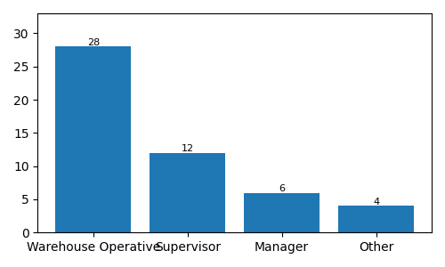

4.2.2 Length of Service

The second question investigated how long a respondent had been employed with the company. According to the survey results employees vary substantially in organizational knowledge and their experience level that the majority of them worked for between one to six years. A small number of respondents have only very limited less than one year working experience, and others have more than six years in the company.
This sample with balanced representation of newly-employed workers and veterans allows one to get different insights on automation from the two groups. The ones who were employed longer are likely to have witnessed many organizational changes especially those related to automation. They probably know the pre- and post-automation work situation better, whereas the more recently employed respondents share a more current view of how automation operates at the company from their perspective.

Figure 4.2: Question 2 Work Duration
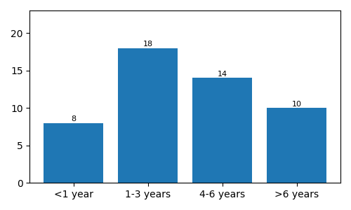

4.2.3 Warehouse Automation Technologies Used

In the final demographic question, participants were asked what automation technologies they use in their work regularly. The technologies covered included Autonomous Mobile Robots (AMRs), Automated Guided Vehicles (AGVs), automated picking systems, conveyor systems, or more than one kind of a technology together.
Interestingly, the largest group among respondents stated that their routine involves multiple automation technologies, which leads us to the conclusion that automation is a cross-functional operational tool and not restricted to specific machines.
In this case, since participants have hands-on experience of working in the environment where various automated facilities are in use, there is no doubt that their replies are accurate and trustworthy.

Figure 4.3: Question 3 What Warehouse Equipment Did You Work with the Most?
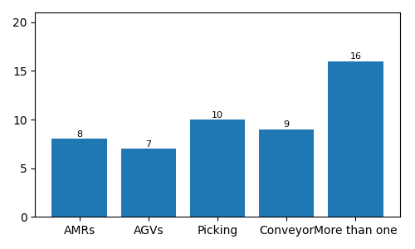

4.3 Findings on the Impact of Warehouse Automation on Operational Efficiency

4.3.1 Productivity Improvement

The fourth questionnaire explored the perception of the respondents about whether warehouse automation has improved productivity of their work environment. The survey response shows that majority respondents were either agree or strongly agree that implementation of automation technologies had led to productivity improvements. It was relatively small number of people who disagreed with the statement. Moreover, only very few respondents did not express any opinion either way, which suggests that employees overall think automation positively contributes to the work performance on a daily basis.

Figure 4.4: Q4 Productivity Improvement
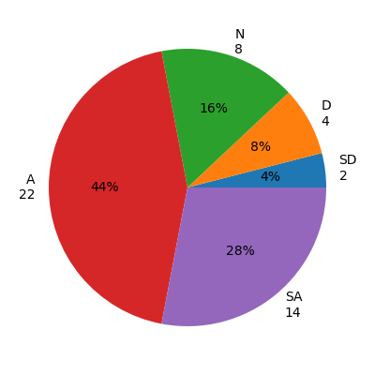

It is clear that automation systems have allowed the staff to be more productive by minimizing their involvement in the manual works and facilitating the warehouse operations. The views that staff hold are in line with the findings of previous research that concluded that using automation technologies increases labour productivity through the elimination of repetitive tasks and by boosting operational output (Christopher, 2016; Grover and Ashraf, 2023). In addition to this, workers' positive reactions also show that they understand how the automated machines could improve the performance of a team.

4.3.2 Speed of Completing Operational Tasks

Respondents were presented with the fifth question asking if, according to the automation of the warehouse, the time it took to complete the operations would get shorter. A great majority of participants chose "Agree" or "Strongly Agree, " indicating that most of them have full confidence in the role of automation systems as tools that can greatly contribute to speeding up the warehouse tasks. Besides that, only one or two of the respondents gave answers of "Disagree" or "Uncertain."

Figure 4.5: Q5 Speed of Completing Operational Tasks
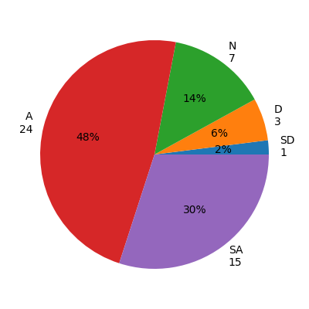

This set of results means that the employees think that the implementation of automation has indeed helped to speed up their day job by minimizing the waiting for the completion of each operation to start the next one, as well as ensuring the goods move smoothly from one warehouse operation to the next one. Automation technology such as picking systems of automatic warehouse, conveyor systems and mobile robots are developed to reduce the processing time of products as well as maintain the consistency of the operation (Jaghbeer, Hanson&Johansson, 2020). The research of Richards (2020) has found a link between the use of automated systems and the increase of warehouse throughput as well as the reduction of handling time.

4.3.3 Reduction in Picking and Order Fulfilment Errors

Question Six asked participants if automation technologies had reduced the occurrence of errors during the picking and order fulfilment processes respectively. Again, the majority of the participants chose the positive answers, which suggests that the staff associates automation with improved accuracy in warehouse operations. Furthermore, very few of the replies pointed to disagreement.

Figure 4.6: Q6 Reduction in Errors
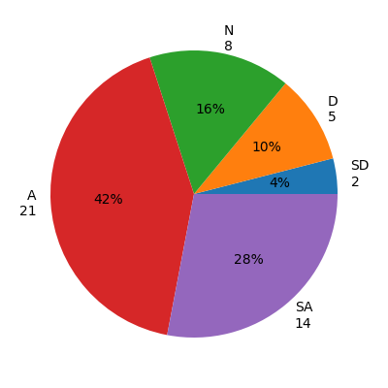
This response pattern illustrates that staff believe automation decreases the level of common errors associated with manual warehouse operations. In the case where the error of order is reduced or eliminated completely the company gains more satisfied customers, lower operating costs and better control of the inventories. Similar to the survey results here a previous study by Casella et al. (2023) shows how picking technologies that are automated have a positive effect of not only lowering human error but also improving the speed and efficiency of fulfilling orders with greater service quality as a result. Moreover, survey respondents' answers further confirm what has already been established about the advantages of adopting a warehouse automation system operationally.

4.3.4 Improvement in Workflow Efficiency

The last operational efficiency question examined the respondents' opinions on whether the automated systems have resulted in a more efficient overall workflow of warehouse operations. Most of the respondents chose either agree or strongly agree that the workflow has become more efficient after the introduction of the automated systems.

Figure 4.7: Q7 Workflow Efficiency
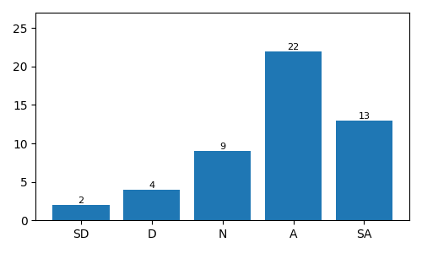

Most of the answers in the survey show that automation can help make working together between different activities much easier while also cutting down on unnecessary interruptions and delays. It seems that the employees themselves acknowledge a better movement of materials, better organisation of tasks, and higher consistency of operations. This point of view is actually backed by Slack, Brandon-Jones and Johnston (2019), who also believe that having efficient workflow is the way to the perfect operation and also that one can make it through the right kind of automation. Furthermore, Ivanov, Tsipoulanidis and Schönberger (2019) suggest that it is precisely by combining different kinds of automation technology that all aspects of warehouse operation are seamlessly linked and that consequently the warehouse as a whole is performing better.

4.4 Findings on Employee Experience

Awareness, training, level of labour intensity, and job satisfaction are the four questions included in the questionnaire regarding employees’ perceptions of how warehouse automation has affected their daily work-life. Earlier studies have pointed out that the success of automation hinges not just on the technological capability but also on employee acceptance and how organisations support their training process (Vial, 2019; Papasarikas, De Vries and De Koster, 2023).

4.4.1 Confidence in Using Warehouse Automation

Participants were questioned whether they were confident when performing operations that involved warehouse automation. In general, the large majority of respondents answered agree or strongly agree which points out that employees mostly feel comfortable working together with automated systems. The results are visualized using two different types of graphs below.

Figure 4.8: Q8 Confidence Using Automation
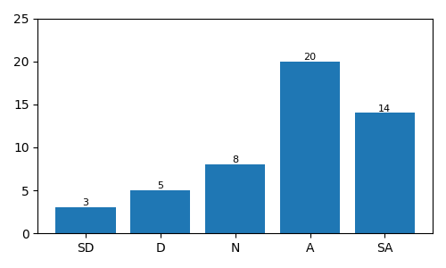
These findings suggest that employees do well with technologies of automation, have learned them to an extent so can perform their tasks without a problem. Worker confidence is considered as a key player for successful technology introduction because people who are confident are willing to adapt their work ways.

4.4.2 Adequacy of Training

To what extent respondents were satisfied with the level of training provided to the employees regarding the use of automated technologies was the focus of question nine. The overwhelming majority agreed, but there was quite a number of neutral and disagreement responses.

Figure 4.9: Q9 Training Adequacy
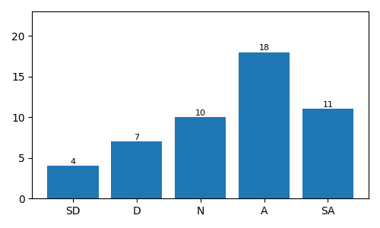
Although training programs were judged to be mostly successful, these results point out that further employee development initiatives would be a nice option to consider. Constant training keeps technology mastery strong, lowers the level of uncertainty, and helps to gain staff support during the period of automation rollout (Kotter, 2012; Saunders, Lewis and Thornhill, 2019).

4.4.3 Reduction in Physical Workload

The respondents were asked whether the introduction of automation had reduced the physical component of the work which they do. Most of the interviewees responded agree or strongly agree and thus showed that automation had significantly lightened the physical effort needed for warehouse activities. The results for the corresponding question in the format of pie chart and bar chart are given below:

Figure 4.10: Q10 Physical Workload
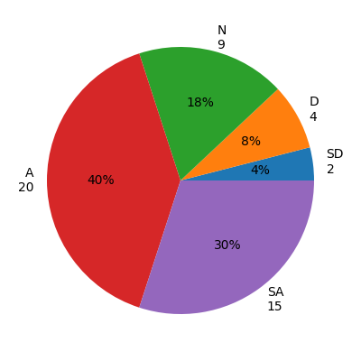
Automation reduces the workload through removing repetitive manual tasks and enabling workplace safety at that same time. Papasarikas, De Vries, and De Koster (2023) also concluded similar results by saying that when collaborative automation is applied then the employees get relief from the workload physically besides getting an uplift in productivity.

4.4.4 Impact on Job Satisfaction

The last question of employees' experience was whether the implementation of automation has resulted in an appreciation of the job satisfaction. Most of the interviewees had positive reactions, but some were left undecided. The following diagrams will illustrate this issue:

Figure 4.11: Question 11 Job Satisfaction
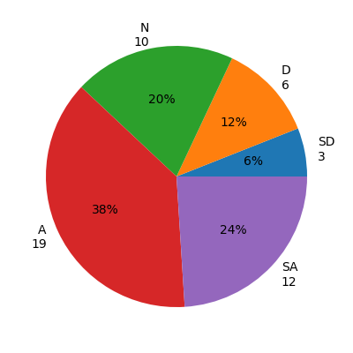
The results reveal that the majority of workers equate their job happiness with the introduction of technology and hence, automation is regarded as a tool to create happier working environment. The reason would be the higher level of efficiency, the less workload, combined with a higher degree of confidence as a result of being able to work side by side with robotic technology. Likewise, previous studies revealed that workers generally feel more motivated with the help of technology which eliminates mechanical operations and thereby opens up a way for them to focus on activities delivering added value (Grover&Ashraf, 2023; Goleman, 2018).

4.5 Findings on Organisational Factors

If organisational factors have any bearing on warehouse automation's success, this section will show you all about it, thanks to the results of the questionnaire which looked into topics such as management support, communication and the resolution of technical problems. These organisational factors have been constantly highlighted as crucial for a successful technology rollout in the literature (Tornatzky and Fleischer, 1990; Kotter, 2012).'

4.5.1 Management Support

More than half of the respondents think management support during the implementation process is up to the level.

Figure 4.12: Q12 Management Support
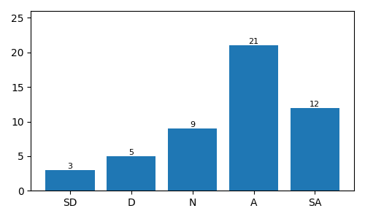
Most employees believe Management Support has been a consistent and valuable factor in technological change. Leadership that inspires confidence is able to drive employees' participation, lower resistance, and ultimately lead to the whole organisation undergoing change smoothly and successfully as per Kotter (2012).

4.5.2 Communication During Automation Implementation

Interviews asked participants whether the communication on automated changes was clear and effective. While a majority gave positive feedbacks, not a few respondents went for a neutral or disagreeing option.

Figure 4.13: Q13 Communication
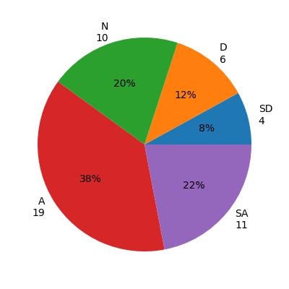
The survey responses are telling us that communication is more a tool than something that can be improved indefinitely, but that said, there are still quite a few ways we can enhance how well it reaches our employees and helps them understand the technological change, which are mostly at the very first stages of a project (Vial, 2019).'
The findings suggest that while communication practices are generally effective, they could be improved to better prepare employees for changes brought about by implementation of the new technology.' Effectiveness of communication is a fundamental characteristic that can ensure the success of any digitally transforming project (Vial, 2019).

4.5.3 Resolution of Technical Issues

The last organisational element studied is the efficiency of resolving technical problems that arise with the automation systems. The respondents in the majority have chosen Agree or Strongly Agree, which is an indication of their trust in organisational technical support.

Figure 4.14: Q14 Technical Issue Resolution
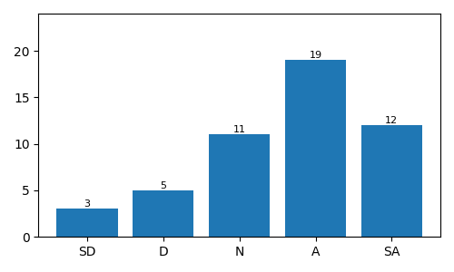
Employees generally think technical problems are fixed quickly. Employees' trust in automation systems is increased due to prompt solving of technical problems. Furthermore, maintaining operational continuity is guaranteed. (Richards, 2020; Ivanov, Tsipoulanidis and Schönberger, 2019). The findings have also pointed out that there is not much need to improve upon technical resolution of issues. (Richards, 2020; Ivanov, Tsipoulanidis and Schönberger, 2019).'
These factors of the organisation are the main reasons that employees have a good attitude towards the change. They were not disappointed when their employers did not help much with the implementation of the new technology, nor did they receive detailed training on the technology. According to the results, it is the combination of the right technology and sound organisational management and effective staff support that makes warehouse automation successful, as argued by the previous works.

4.6 Overall Evaluation of Warehouse Automation

The last section of the survey requested employees' overall assessment on how greatly warehouse automation contributed to the level of operational efficiency. This last question was the best summary of what an employee was thinking, after taking into consideration different factors like productivity, workflow efficiency, the level of comfort and satisfaction with the work, the management support, the flow of information, and how well the technology was working in warehouse operations.
The most common responses were Agree and Strongly Agree which is a sign that, on most occasions, employees consider warehouse automation to have benefited operational efficiency in general. Only small amounts of responses opposed, and several had chosen to stay with neutral attitude.

Figure 4.15: Overall Impact of Warehouse Automation
We are seeing that, at first glance, the main reason for employees to link warehouse automation and better operational performance is that the employees' views of automation were generally positive. For most of the time, positive questionnaire replies were the ones that showed a view of work getting done faster, that people did not get to handle so much physical work anymore, and that they trusted the machines more when doing various tasks with them. The experiences that employees had of technology positively impacted operations are shown by how respondents rated it overall.
Still, there were some responses that were neither negative nor positive. This suggests that the automation rollout does not come with a 'complete solution' at once but needs to be perfected over time as a continuous effort. The organization should not forget that to get the most out of automation technologies, continuous investment is needed in employee training, communication plans, leadership back-up, and technical support.
The data here support conclusions made previously: warehouse automation indeed brings operational efficiency, and this happens when technological investment is backed up by efficient organizational management and employee involvement (Christopher, 2016; Richards, 2020; Grover and Ashraf, 2023). In addition, it is stated by Vial (2019) that only when technological creativity is combined with readiness of organization and acceptance by workers can digital change produce sustainable operational benefits.

4.7 Discussion of Key Findings

Chapter 5: Conclusion and Recommendations

5.1 Introduction

The study explored how warehouse automation technologies affect the operational efficiency of a business from the employees' point of view, with the data being collected through a self-administered questionnaire which gathered about 50 responses. The results shown in Chapter Four were put side by side with theoretical models in the field to see if research goals were accomplished. Besides that, practical suggestions of the author are offered to enable the organizations to better the implementation of warehouse automation. The researcher also briefly explained the limitation of the study as well as the possible direction of future research.

5.2 Summary of Research Findings

The results are such that the respondents have an almost exclusively approving attitude regarding warehouse automation and its benefit regarding operational efficiency. The majority were of the opinion that the implementation of automation has resulted in an increase in productivity, faster operational processes, fewer picking mistakes, as well, a better workflow efficiency. The workers also shared their positive experiences that they feel confident, that automation reduces the workload and, finally, the job satisfaction is higher. On the other hand, training-related queries revealed the need for extra training of employees which could lead to the enhancement of technology usage.
The other findings were about organisational issues such as management support, communication and technical help during the phase when the company was introducing the new technologies. Taking all together, we came in agreement with Richards (2020), Vial (2019), and others that the success of a warehouse automation does not simply depend on the level of sophistication of the technology but also on the quality of leadership and employee involvement as well as organisational preparedness.

5.3 Conclusion

Having carried out the research, it became evident that the study was able to accomplish one of its main goals that is finding out the effect of warehouse automation technologies on the efficiency of the operations. As the result from the employees of automation technologies indicated, they not only feel that it has given the company and the work of the employees more efficiency but as a result they themselves have also benefited. The staffs of the respondents generally liked automation technologies and could see how these things have been very useful in helping them carry out their duties more quickly and precisely.
Through the findings it was clear to us that if automation was introduced, the role of management is as important as the machine itself. Good relationship between management and employees, open channels of communication, effective employee training, and timely provision of technical assistance all lead to employees' positive attitude towards automation and its acceptance. Therefore, based on our study it is confirmed that the literature supporting organisational factor as a necessary support of technological change in fact stands and in the case of warehouse automation technology these factors can make a difference if accompanied by an organisational change management strategy as part of the company's long-term operational strategy.

5.4 Recommendations

The research has generated a number of suggestions. Among others, the first and foremost is that the companies have a continuing commitment to developing employees through training to keep their confidence and competence as well. Secondly, the role play of management is a lot more communication throughout the implementation of a new technology is very important for the employees to grasp what has changed in organisational and operational terms. Again, the maintenance and technical support should be the area under management control not only to avoid the interruptions during operations but also to make sure of the high-performance level of the systems as a whole. As the last point, the organizations should be making use of employees' responses and operational performance indicators so that the performance of automation can not only be tracked but be further used for the identification of new ideas and for the development of the operations efficiency over time.

5.5 Limitations of the Study

Since only 50 people were involved in the study, sampled from the readily accessible population, there is a possibility that the study findings cannot be widely applied. In addition to this, the self-reported questionnaire was used to collect the responses, so there exists the possibility that participants' subjective views may not necessarily reflect the real situation of operations performance. Lastly, the fact that the study was cross-sectional means it only took a snapshot at employee perceptions at one time point whereas, in reality, attitudes towards automation may gradually change with employees experiencing more and more of the latest emerging automated tools.

5.6 Recommendations for Future Research

If future research were to be done then, first of all, the researchers might take very much larger sample sizes from different warehouses to enhance significantly the generalizability of their findings. To be more comprehensive it is also proposed that comparative studies on various logistics organisations should give a better understanding of how warehouse automation takes place in practice.
Furthermore, future scholars might be able to benefit from the adoption of long-term research methodologies which would allow an analysis of the changing employee perception and operational performance after implementation of automation.

REFERENCES

Aboul-Atta, T.A.L. and El-Lebody, Y.M. (2023) ‘Measuring the most important factors affecting the success of different logistic zones’, Journal of Engineering and Applied Science, 70(1).
Akbari, M. (2023) ‘Revolutionizing supply chain and circular economy with edge computing: Systematic review, research themes and future directions’, Management Decision.
Archetti, C. and Bertazzi, L. (2021) ‘Recent challenges in routing and inventory routing: E-commerce and last-mile delivery’, Networks, 77(2), pp. 255–268.
Bowersox, D.J., Closs, D.J. and Cooper, M.B. (2019) Supply Chain Logistics Management. 5th edn. New York: McGraw-Hill Education.
Braun, V. and Clarke, V. (2006) ‘Using thematic analysis in psychology’, Qualitative Research in Psychology, 3(2), pp. 77–101.
Bryman, A. (2016) Social Research Methods. 5th edn. Oxford: Oxford University Press.
Casella, V., Volpi, A., Montanari, R., Tebaldi, E. and Bottani, E. (2023) ‘Trends in order picking: A 2007–2022 review of the literature’, Production&Manufacturing Research, 11(1), 2191115.
Christopher, M. (2016) Logistics and Supply Chain Management. 5th edn. Harlow: Pearson Education.
Cordeau, J.F., Legato, P. and Mazza, R.M. (2024) ‘Integrating storage allocation with manual order picking and replenishment operations in a distribution centre’, International Journal of Production Research, pp. 1–17.
Creswell, J.W. and Creswell, J.D. (2018) Research Design: Qualitative, Quantitative, and Mixed Methods Approaches. 5th edn. London: Sage Publications.
D’Andrea, R. (2021) ‘Human–Robot Collaboration: The Future of Smart Warehousing’, in Disrupting Logistics: Startups, Technologies, and Investors Building Future Supply Chains. pp. 149–162.
Dash, R., McMurtrey, M., Rebman, C. and Kar, U.K. (2019) ‘Application of artificial intelligence in automation of supply chain management’, Journal of Strategic Innovation and Sustainability, 14(3), pp. 43–53.
de Koster, R. (2022) ‘Warehousing 2030: Global Logistics and Supply Chain Strategies for the 2020s’, Vital Skills for the Next Generation, pp. 243–260.
Di Capua, M., Ciaramella, A. and De Prisco, A. (2023) ‘Machine learning and computer vision for the automation of processes in advanced logistics: The integrated logistic platform 4.0’, Procedia Computer Science, 217, pp. 326–338.
Dinh, H. (2020) The Revolution of Warehouse Inventory Management by Using Artificial Intelligence: Case Warehouse of Company X.
Dubey, R., Gunasekaran, A., Childe, S.J., Blome, C. and Papadopoulos, T. (2019) ‘Big data analytics and artificial intelligence pathway to operational performance under the effects of entrepreneurial orientation and environmental dynamism’, Technological Forecasting and Social Change, 145, pp. 271–284.
Frank, A.G., Dalenogare, L.S. and Ayala, N.F. (2019) ‘Industry 4.0 technologies: Implementation patterns in manufacturing companies’, International Journal of Production Economics, 210, pp. 15–26.
Goleman, D. (2018) Emotional Intelligence: Why It Can Matter More Than IQ. 10th anniversary edn. London: Bloomsbury Publishing.
Grover, A.K. and Ashraf, M.H. (2023) ‘Leveraging autonomous mobile robots for Industry 4.0 warehouses: A multiple case study analysis’, The International Journal of Logistics Management.
Huang, Z., Shen, Y., Li, J., Fey, M. and Brecher, C. (2021) ‘A survey on AI-driven digital twins in Industry 4.0: Smart manufacturing and advanced robotic systems’, Sensors, 21(19), 6340.
Ivanov, D., Tsipoulanidis, A. and Schönberger, J. (2019) Global Supply Chain and Operations Management. 2nd edn. Cham: Springer.
Jaghbeer, Y., Hanson, R. and Johansson, M.I. (2020) ‘Automated order picking systems and the links between design and performance: A systematic literature review’, International Journal of Production Research, 58(15), pp. 4489–4505.
Javad, M., Haleem, A., Singh, R.P. and Suman, R. (2022) ‘Artificial intelligence applications for Industry 4.0: A literature-based study’, Journal of Industrial Integration and Management, 7(01), pp. 83–111.
Kache, F. and Seuring, S. (2017) ‘Challenges and opportunities of digital information at the intersection of Big Data Analytics and supply chain management’, International Journal of Operations&Production Management, 37(1), pp. 10–36.
Khan, M.A. (2020) Design and Control of a Robotic System Based on Mobile Robots and Manipulator Arms for Picking in Logistics Warehouses. Doctoral dissertation. Normandie.
Kotter, J.P. (2012) Leading Change. Boston, MA: Harvard Business Review Press.
Kumar, S., Narkhede, B.E. and Jain, K. (2021) ‘Revisiting the warehouse research through an evolutionary lens: A review from 1990 to 2019’, International Journal of Production Research, 59(11), pp. 3470–3492.
Li, K., Wang, J., Wu, X., Peng, X., Chang, R., Deng, X. and Hong, B. (2024) ‘Optimizing automated picking systems in warehouse robotics using machine learning’, arXiv, 2406.16363.
Nasereddin, A. (2024) ‘A comprehensive survey of contemporary supply chain management practices in charting the digital age revolution’, Uncertain Supply Chain Management, 12(2), pp. 1331–1352.
Nguyen, M., Chen, Y., Nguyen, T.H., Habashi, S.S., Quach, S. and Thaichon, P. (2022) ‘Artificial intelligence (AI)-driven services’, in Artificial Intelligence for Marketing Management.
Papasarikas, A., De Vries, J. and De Koster, R. (2023) ‘Assessing the impact of human–robot collaborative order picking systems on warehouse workers’, International Journal of Production Research, 61(22), pp. 7776–7790.
Queiroz, M.M. and Wamba, S.F. (2019) ‘Blockchain adoption challenges in supply chain: An empirical investigation’, International Journal of Information Management, 48, pp. 70–87.
Richards, G. (2020) Warehouse Management: A Complete Guide to Improving Efficiency and Minimising Costs in the Modern Warehouse. 3rd edn. London: Kogan Page.
Rushton, A., Croucher, P. and Baker, P. (2022) The Handbook of Logistics and Distribution Management. 7th edn. London: Kogan Page.
Sarker, I.H. (2022) ‘AI-based modelling: Techniques, applications and research issues towards automation, intelligent and smart systems’, SN Computer Science, 3(2), p. 158.
Saunders, M., Lewis, P. and Thornhill, A. (2019) Research Methods for Business Students. 8th edn. Harlow: Pearson Education.
Slack, N., Brandon-Jones, A. and Johnston, R. (2019) Operations Management. 9th edn. Harlow: Pearson Education.
Soori, M., Arezoo, B. and Dastres, R. (2023) ‘Artificial intelligence, machine learning and deep learning in advanced robotics: A review’, Cognitive Robotics.
Špéfrényi, K., Tamás, P. and Cservenák, Á. (2022) ‘Trends in warehousing and material handling solutions – past, present and future’, Advanced Logistics Systems: Theory and Practice, 16(2), pp. 71–81.
Torchio, F. (2023) Survey on Automated Systems for Smart Warehouses. Doctoral dissertation. Politecnico Torino.
Tornatzky, L.G. and Fleischer, M. (1990) The Processes of Technological Innovation. Lexington, MA: Lexington Books.
Tripathi, S. and Gupta, M. (2020) ‘Transforming towards a smarter supply chain’, International Journal of Logistics Systems and Management, 36(3), pp. 319–342.
Van Gils, T., Namee, K., Caris, A. and De Koster, R.B.M. (2022) ‘Hybrid order picking: A simulation model of a joint manual and autonomous problem’, European Journal of Operational Research, 267(1), pp. 1–15.
Vial, G. (2019) ‘Understanding digital transformation: A review and a research agenda’, The Journal of Strategic Information Systems, 28(2), pp. 118–144.
Waller, M.A. and Fawcett, S.E. (2014) ‘Data science, predictive analytics, and big data: A revolution that will transform supply chain design and management’, Journal of Business Logistics, 34(2), pp. 77–84.
Zhong, R.Y., Xu, X., Klotz, E. and Newman, S.T. (2017) ‘Intelligent manufacturing in the context of Industry 4.0’, Engineering, 3(5), pp. 616–630.

APPENDICES

Appendix 1 – Questionnaire

Assessing the Impact of Warehouse Automation on Operational Efficiency at a large UK logistics depot

Section A: Demographic Information
Q1. What is your current role at the depot?
☐ Warehouse Operative
☐ Supervisor / Team Leader
☐ Manager
☐ Other
Q2. How long have you worked here?
☐ Less than 1 year
☐ 1–3 years
☐ 4–6 years
☐ More than 6 years
Q3. Which warehouse automation technologies do you regularly interact with?
☐ AMRs (Autonomous Mobile Robots)
☐ AGVs (Automated Guided Vehicles)
☐ Automated Picking Systems
☐ Conveyor Systems
☐ More than one of the above

Section B: Impact on Operational Efficiency
Q4. Warehouse automation has improved productivity in my work area.
☐ Strongly Disagree
☐ Disagree
☐ Neutral
☐ Agree
☐ Strongly Agree
Q5. Warehouse automation has increased the speed of completing operational tasks.
☐ Strongly Disagree
☐ Disagree
☐ Neutral
☐ Agree
☐ Strongly Agree
Q6. Automation technologies have reduced errors in picking and order fulfilment processes.
☐ Strongly Disagree
☐ Disagree
☐ Neutral
☐ Agree
☐ Strongly Agree
Q7. Automated systems have improved overall workflow efficiency within the warehouse.
☐ Strongly Disagree
☐ Disagree
☐ Neutral
☐ Agree
☐ Strongly Agree

Section C: Employee Experience
Q8. I feel confident when working with warehouse automation technologies.
☐ Strongly Disagree
☐ Disagree
☐ Neutral
☐ Agree
☐ Strongly Agree
Q9. I have received sufficient training to use automation technologies effectively.
☐ Strongly Disagree
☐ Disagree
☐ Neutral
☐ Agree
☐ Strongly Agree
Q10. Automation has reduced the physical demands of my job.
☐ Strongly Disagree
☐ Disagree
☐ Neutral
☐ Agree
☐ Strongly Agree
Q11. Automation technologies have positively influenced my job satisfaction.
☐ Strongly Disagree
☐ Disagree
☐ Neutral
☐ Agree
☐ Strongly Agree

Section D: Organisational Factors
Q12. Management provides adequate support during the implementation of automation technologies.
☐ Strongly Disagree
☐ Disagree
☐ Neutral
☐ Agree
☐ Strongly Agree
Q13. Communication regarding automation-related changes is clear and effective.
☐ Strongly Disagree
☐ Disagree
☐ Neutral
☐ Agree
☐ Strongly Agree
Q14. Technical issues with automation systems are resolved efficiently when they occur.
☐ Strongly Disagree
☐ Disagree
☐ Neutral
☐ Agree
☐ Strongly Agree

Section E: Overall Evaluation
Q15. Overall, warehouse automation has had a positive impact on operational efficiency at the depot.
☐ Strongly Disagree
☐ Disagree
☐ Neutral
☐ Agree
☐ Strongly Agree
Thank you for participating in this survey. All responses will remain anonymous and will be used solely for academic research purposes.

