

DIGITAL SIKIL
PREPARED BY: SABIR ALI
STUDENT NUMBER :2505769
DATE MAY 28/2026

DIGITAL OPPORTUNITIES FOR CUSTOMER ENGAGMENT AT BRIGHTWAVE C

1. Introduction
In today’s fast-paced food and beverage industry, adopting digital solutions and artificial intelligence is critical for maintaining a competitive edge. For Bright Wave Café, implementing these technologies can streamline operations and deepen customer relationships. This report outlines actionable digital strategies to optimize customer communication and operational efficiency.

Note: I used AI to generate an initial outline and draft sections of this report, which I then carefully edited to ensure an appropriate tone and accurate, café-specific details.
Key Digital Opportunities
1. Social media and Email Marketing
To build community and attract foot traffic, the café should leverage visually driven platforms like Instagram and Facebook. AI-powered social media assistants can help generate content calendars and engaging caption ideas. Furthermore, an email newsletter can keep regular patrons informed about seasonal menu items or weekend promotions. Email marketing platforms like Mailchimp offer built-in AI tools that can optimize send times and segment subscriber lists, ensuring the right message reaches the right customer at the right time.
2. Automated Customer Responses
Managing customer inquiries manually during busy peak hours can result in missed opportunities. Implementing AI-driven automated responses on platforms like WhatsApp or Facebook Messenger allows the café to instantly answer frequently asked questions—such as opening hours, menu availability, or dietary options—even when the store is closed.
3. Digital Menus and Online Ordering
Adopting a digital menu accessible via QR codes or an online ordering system (e.g., Square or Sum-up) provides significant convenience. Digital menus not only speed up the ordering process but also allow Bright Wave Café to easily update items, highlight daily specials, and showcase
4. AI customer service is used in cafe businesses to increase efficiency, reduce labour strain, and boost sales. It acts as an extension of your team, handling routine digital inquiries so human staff can focus entirely on in-store
high-quality images of pastries and beverages. Technology and AI in the Coffee Shop: Innovation That Frees Up Time for Quality
- Demand forecasting and staff scheduling.
- Waste reduction.
- Menu creation.
- Real-time cost control
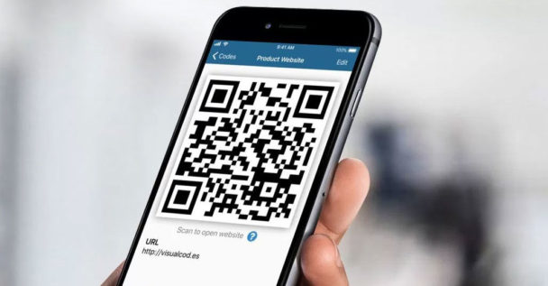
This Photo by Unknown Author is licensed under CC BY-NC

Conclusion
Embracing digital tools and AI does not mean losing the personal, warm touch of a local café. Instead, it automates repetitive backend tasks, allowing staff to focus on delivering excellent in-person hospitality. By implementing these strategic digital solutions, Bright Wave Café will improve its online visibility and customer communication.

Section 2: Ethical / Professional Reflection
When checking the AI-generated content for accuracy, I cross-referenced the suggestions against current industry standards and the specific operational realities of a small café. One major limitation I noticed was that AI sometimes suggested expensive enterprise-level software that is not financially viable or necessary for an independent business. Additionally, AI text occasionally lacked the localized, community-focused voice essential for our neighbourhood café.
In a small business context, responsible use of AI requires recognizing that the AI is a support tool, not an autonomous decision-maker. Because AI can inadvertently generate biased information or hallucinate facts, human judgment is paramount. Human oversight ensures that customer data privacy is respected, brand messaging aligns with local values, and the tone remains authentic. Ultimately, the human editor provides the ethical lens and empathy that an algorithm lacks, ensuring that technology serves both the business and its community responsibly.

References
- Dalla Corte. (2026). AI Tools to Start and Manage a Coffee Shop. Retrieved from Dalla Corte
- Harvard Business School Online. (2025). 5 Ethical Considerations of AI in Business. Retrieved from HBS Online
- Inside. (2025). Digital Marketing Strategy for Coffee Shops. Retrieved from Inside
- Mailchimp. (2025). What is AI Ethics? What it Means for Business. Retrieved from Mailchimp
- Perfect Daily Grind. (2018). 5 Digital Marketing Tools Coffee Professionals Should Use. Retrieved from Perfect Daily Grind
- White ,E.(2026).”Digital menus :Enhancing the customer experience
- Green, R. (2025).; automating customer interactions
- Johanson, L. (2024) AI in customer service: opportunities and challenges

9.Ryan, d . (2020) Understanding digital marketing
10. Martin K. (2022) ethics of date and analytics conceiving

PP

