Student Name: Helen Faye James
Student Number: 2519336
Module Number: ECIE4010
Assignment title: Group video presentation:
Choose one of the ‘wicked problems’ from the module and develop a Pecha Kucha style video pitch presenting a solution to alleviate your chosen problem in an educational context

Link to presentation: Presentation1 Grow & Go.mp4

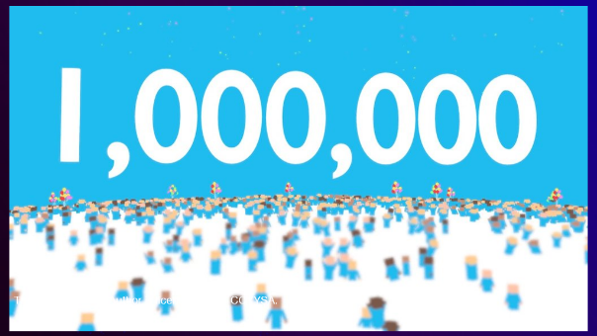
Imagine yourself sitting in class, trying your best to focus and concentrate, but there’s a continuous rumbling coming from your stomach! ​
For many children this a daily reality!!​
Around 820,000 – 1 million children in the UK go to school hungry at least once a week.
(Kellogs.co.uk, 2025)

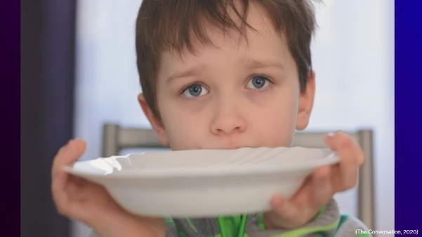
Food poverty is the inability to access or afford sufficient, nutritious food to maintain a healthy diet.​
It's not just about being hungry, it’s about poor diet, skipped meals and the constant uncertainty of – if or when the next meal will be?
(Sustain, 2016)


Hunger can significantly affect a child’s ability to learn. When children are hungry, they often have less energy, leaving them tired and less able to participate fully in lessons. Being hungry can negatively affect concentration, memory skills as well as classroom behavior. (Save the Children UK, 2021)

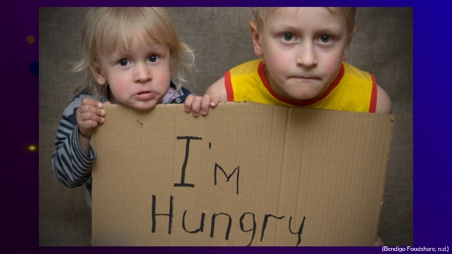
However, hunger doesn’t always carry a sign!​
Research suggests that food insecurity in the UK is often “hidden” and fluctuating rather than constant, meaning children may experience it on some days but not others. Coping strategies, pride and embarrassment can also mask affected children to remain unidentified.
(Hartgen-Walker and Lally, 2023) (Foodfoundation.org.uk, 2022)

Reference list:
Bendigo Foodshare. (n.d.). Home. [online] Available at: https://bendigofoodshare.org.au/.
Foodfoundation.org.uk. (2022). Search Results | Food Foundation. [online] Available at: https://foodfoundation.org.uk/search-results?search=food+insecurity+uk [Accessed 18 Apr. 2026].
Hartgen-Walker, S. and Lally, C. (2023). Child Food Insecurity and Free School Meals. [online] Available at: https://researchbriefings.files.parliament.uk/documents/POST-PN-0704/POST-PN-0704.pdf.
Kellogs.co.uk. (2025). Available at: http://www.kellogs.co.uk [Accessed 18 Apr. 2026].
Save the Children UK. (2021). Poverty and Education in the UK. [online] Available at: https://www.savethechildren.org.uk/what-we-do/global-issues-hub/poverty-and-education-uk.
Shutterstock. (n.d.). Stock Images - Photos, vectors & illustrations for creative projects. [online] Available at: https://www.shutterstock.com/images.
Sustain (2016). What is food poverty? | Sustain. [online] Sustainweb.org. Available at: https://www.sustainweb.org/foodpoverty/whatisfoodpoverty/.
The Conversation (2020). The Conversation: In-depth analysis, research, News and Ideas from Leading Academics and researchers. [online] The Conversation. Available at: https://theconversation.com/uk.

