Finley Clarke
Database Management HND Computing
A Look at the Creation of the Smile Factory Database

CONTENTS

INTRODUCTION: 2
DESIGN PROCESS: 3
- Entity Relationship Diagram (ERD)
- SQL Server
- Table Creation
- Records Creation
- Queries & Indexes
- Fragmentation
CONCLUSION: 9

INTRODUCTION:

This is a look at the design and creation of the Smile Factory database. There will be examinations of the ERD diagram created before the database and how the original design compares and contrasts to the final result. There will be a look into the four table’s designs in SQL server, the types of queries created to test the implemented data in said tables, as well as a look at the SQL code used. Provided with this document will be copies of all of the code used in this project separated into two categories: The code that designs the base structure of the database (Table structure, integrity constraints, check constraints, and tuning enhancements), as well as the SQL that generated the dummy data used in testing and validation queries.
SQL stands for ‘Structured Query Language’ and first came to be around the year of 1974. It is used to manage and structure data in a relational database system or for stream processing purposes. SQL was originally developed by Donald D. Chamberlin and Raymond F. Boyce, both of IBM. Originally titled ‘SEQUEL’ (Structured English Query Language), this was eventually shortened to just ‘SQL’ due to overlapping with copyright law restrictions. SQL since the mid-1970s has seen multiple revisions. The SQL language can be divided into several elements. These being: Clauses, Expressions, Predicates, Statements, Queries, and Statements. SQL has seen several revisions and updates since it’s inception in the mid-1970s. Namely in 1989, 1992, 1996, 1999, 2003, 2006, 2008, 2011 and most recently in 2016.

DESIGN PROCESS:

Entity Relationship Diagram (ERD) -
The first task in this project was to put together a ERD (Entity Relationship Diagram). The ERD helps to paint a picture of how the database will be connected and what it will mainly consist of. This is a much better and assured way of designing a database because less time will be spent trying to figure out specifics when designing the database. One downside can be that it is quite easy to deviate from the established ERD when putting together the database. As new ideas form and the database begins to take shape, it can be rather different from the original design documents that warranted its development.
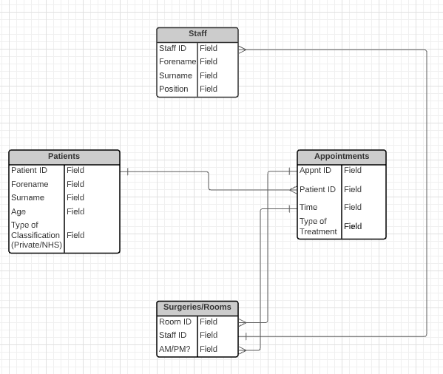

The ERD was developed with Lucidchart, an online diagram tool: https://www.lucidchart.com/pages/

SQL Server (Software used) –
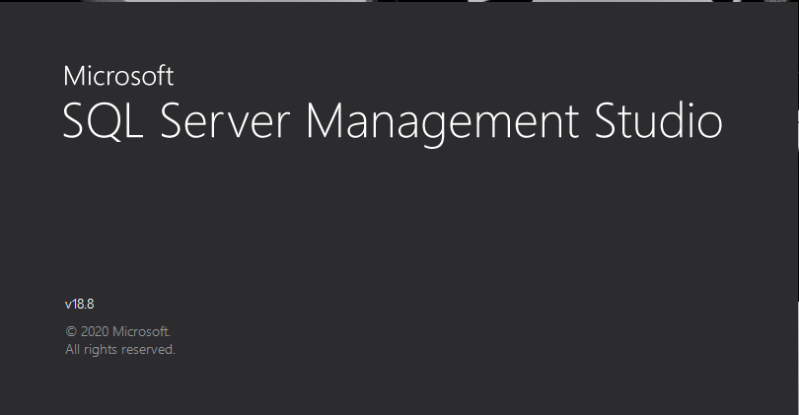
Now known as Microsoft SQL Server Management Studio
The program used to put together the database and run the SQL code was Microsoft’s SQL Server. The program itself was first released in 1989 and is still actively supported today. Microsoft supplies nearly a dozen variations of the software for different applications and needs but the version used for this project was ‘Standard’.

Table Creation –
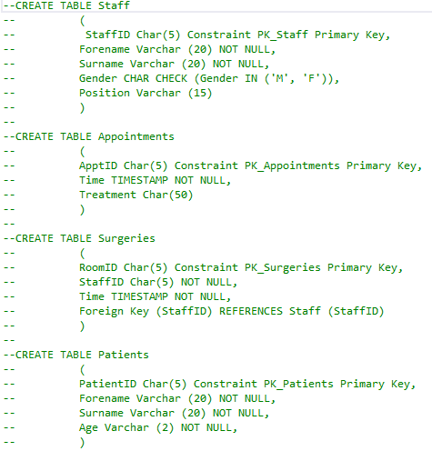

Above is the SQL code for the creation of the tables.
Staff holds all the information for employees at Smile Factory. ‘StaffID’ helps to identify employees quicker then finding them with their names exclusively for instance. Information also included are their positions in the practice and their gender.
Appointments hold data relating to patient’s check-ups and treatments at the practice. Each appointment is given a special ID code for easy tracing, a timeframe is also given alongside the type of treatment being given to the patient.
Surgeries keeps track of the rooms available during the day. Times are assigned to each room. This is where the final database deviates from the ERD slightly because an ‘AM/PM’ option was originally considered but SQL doesn’t provide an easy implementation of this, so a compromise had to be implemented. This meant assigning set times to each surgery room during the day from 08:00:00 onwards (based on a 24-hour clock). A member of staff is assigned to each room (hence their ‘StaffID’ being used as a foreign key), each room has its own unique ‘RoomID’ too.
Patients are each given a unique ID (PatientID) to easily identify them. Their forenames, surnames and age are also included here.

Records Creation –
Staff
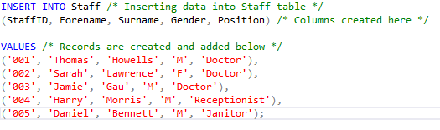
Above, the table that the records will be added to is stated, the columns are then created after that followed by the actual data itself.
Patients
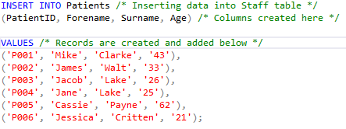
The patient’s data is pretty much the same idea as the Staff records that were created.
Surgeries
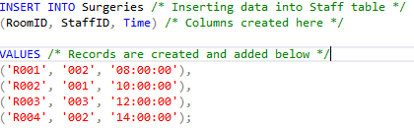
Surgeries again is rather like the above two tables, but different types of records are produced. The Primary key and foreign key (StaffID) from Staff are used here alongside a timeframe to determine whether the room is a morning or afternoon surgery.

Appointments
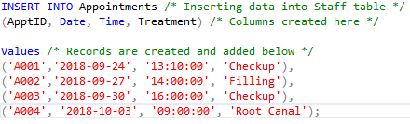
Finally, appointments are just like the prior insert queries. This states the appointment ID (ApptID), the date of the appointment, the timeframe, and the treatment administered.

Queries & Indexes –
Queries
The queries below select specific data from selected tables with variables. The one below selects staff who are classed as female.
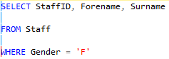

The query above selects patients who are under the age of 30 years.
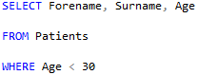

Indexes
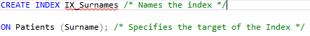
The following are indexes. Indexes are used to boost the performance of the database and make important columns in tables easier and quicker to find.

Fragmentation –
While developing a database, there are three types of fragmentation to keep in mind. Fragmenting is the process of dividing table into a set of smaller tables.
Horizontal
What Horizontal fragmentation does is group the tuples of the tables in accordance to values of one or even multiple fields in said tables. Horizontal fragmentation should conform to re-constructiveness.
Vertical
Vertical fragmentation groups fields and/or columns into individual fragments. Like Horizontal fragmentation, it’s ideal to keep the primary key in all these fragments in order to maintain re-constructiveness between all of them.
Hybrid (Combination of Horizontal and Vertical)
A hybrid is as the name suggests, it combines the two fragmenting techniques. It is considered the most flexible of fragmentation options due to the minimal amount of extraneous information being generated. Reconstructing the original table that the fragments are derived from however can be an extensive and expensive task, however.

CONCLUSION:

SQL as a solution to Database creation has its benefits. It’s generally much faster than using a more tradition GUI-style database management system (like Microsoft’s own Access program). It doesn’t require as extensive an amount of coding knowledge to get to grips with SQL either and a lot of solutions can be searched up through simple internet research. Its portability is also to be commended too. SQL can be run through PCs, Laptops, tablets, and even some mobile phones. That being said, SQL is not GUI-based. Users are typing out code to add to a database will not be seen in its entirety. In order to display and observe data in these databases, select queries need to be made that select the table and then the columns of data that the user wishes to check. For those not fully versed in designing/managing a database, making one through SQL can be a very daunting undertaking indeed and a more user-friendly option such as Access may prove to be the better option in those cases.
In conclusion, the project to design a database for the Smile Factory has been a bit of a disaster. The main problem, it could be argued, is that not enough planning was done prior to the start of the development of the database which caused issues during the production process. The ERD for instance should have been fleshed out further to accommodate for more data (for instance, patient’s DOB’s, contact numbers, addresses, etc) in the tables made. More preparation and research should have been made into the software used in order to better understand it’s features, and functions and better attention should have been spent on the brief of the project that stated the requirements.

