

POPULATION HEALTH AND DIGITAL HEALTH PROMOTION
MSC PUBLIC HEALTH AND SOCIAL CARE IN PRACTICE (LCHS7009)
Digital Health Interventions to Improve Medication Adherence: A Critical Review of Medisafe and the Design of MediCare+
Student name: Mst Rahima Arobe Akhi
Student number: 2524399
Lecturer: Dr Diola Bijlhout

Blog 1
Can Medication Reminder Apps Improve Medication Adherence? A Review of Medisafe
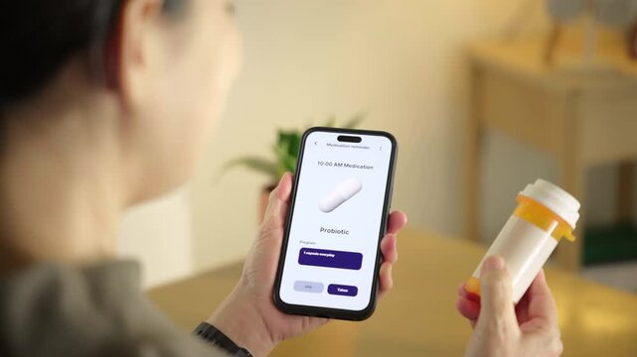
Figure 1: Older adults using a smartphone medication reminder app to support medication management (Adobe Stock, 2026).

The Public Health Burden of Medication Non-Adherence
Many people do not take their medicine as prescribed. Some forget to take them, while others stop taking them because they feel better or experience side effects. This problem is called medication non-adherence (Stewart et al., 2022).
Medication non-adherence can make diseases worse, increase hospital admissions, and reduce people's quality of life. The World Health Organization (2021) reports that about 50% of people with long-term diseases do not take their medicines correctly. As more people are living with chronic diseases improving medication adherence has become more important (WHO, 2021).

About Medisafe
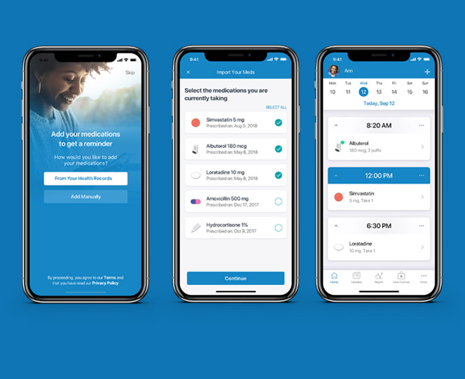
Figure 2: Medisafe smartphone application (Medisafe, 2025).
Medisafe is a smartphone medication reminder application designed to help people take their medicines correctly. Users can schedule reminders, record missed doses, receive refill notifications, and share medication information with caregivers. These features encourage people to take a more active role in managing their own health (Medisafe, 2025).

Promoting Better Health
Digital health technologies help people take a more active role in looking after their health (O'Neil, 2019). Medisafe supports this by reminding people to take their medicines every day. It also helps users build a routine and become more responsible for managing their health. Research has shown that medication reminder apps can improve medication adherence, especially for people with long-term conditions (Lanke et al., 2025).

The Benefits of Medisafe
Research suggests that medication reminder applications can improve adherence, particularly among people with chronic illnesses. Mobile medication apps helped many patients remember to take their medicines more consistently. Better adherence is associated with improved disease control and fewer health complications, supporting the goals of digital health promotion (WHO, 2021).
One of Medisafe's greatest strengths is its simplicity. Timely reminders, refill alerts, medication tracking, and caregiver notifications can help patients establish healthy routines while improving communication between patients, families, and healthcare professionals (Azzopardi-Muscat and Sørensen, 2019).

Limitations of Medisafe
Reminder apps have important limitations. A notification does not guarantee that medication has been taken, so the app measures reminders rather than true adherence (Lanke et al., 2025). Many older adults also struggle due to limited digital skills, poor eyesight or cognitive decline, while people without smartphones or reliable internet face digital exclusion (WHO, 2021). Privacy concerns may further reduce uptake if users are unsure how their health data is protected (Alhammad et al., 2024).

Ways to improve
Medication reminder apps could become more effective by including larger text, voice reminders, and simplified navigation for older users. Short educational videos explaining why each medicine is important could improve health literacy rather than simply reminding users to take medication. Better integration with healthcare services would allow clinicians to identify patients who regularly miss doses and provide timely support. Finally, stronger data encryption, transparent privacy policies, and compliance with UK GDPR would help build user trust (NHS England, 2023).
Overall, Medisafe is a valuable digital health promotion tool that can improve medication adherence, particularly for people with long-term conditions (Medisafe, 2025). However, reminder apps should complement, rather than replace, patient education and healthcare professional support. When combined with person-centred care and equitable digital access, they have the potential to improve health outcomes.

References
Adobe Stock (2026) Medicine reminder application. Available at: https://stock.adobe.com/search?k=medicine+reminder+application
Alhammad, N., Alajlani, M., Abd-alrazaq, A., Epiphaniou, G. and Arvanitis, T. (2024) 'Patients' perspectives on the data confidentiality, privacy, and security of mHealth apps: systematic review', Journal of Medical Internet Research, 26, e50715. Available at: https://www.jmir.org/2024/1/e50715/
Azzopardi-Muscat, N. and Sørensen, K. (2019) 'Towards an equitable digital public health era: Promoting equity through digital health literacy', European Journal of Public Health, 29(Supplement_3), pp. 13–17. Available at: https://academic.oup.com/eurpub/article/29/Supplement_3/13/5628059
Lanke, V., Trimm, K., Habib, B. and Tamblyn, R. (2025) 'Evaluating the effectiveness of mobile apps on medication adherence for chronic conditions: Systematic review and meta-analysis', Journal of Medical Internet Research. Available at: https://pubmed.ncbi.nlm.nih.gov/40743450/
Medisafe (2014) Medisafe Medication Reminder [YouTube video]. Available at: https://www.youtube.com/watch?v=KpTmz9wRb1o
Medisafe (2025) Medication Management Application. Available at: https://www.medisafe.com
NHS England (2023) Inclusive digital healthcare: a framework for NHS action on digital inclusion. Available at: https://www.england.nhs.uk/publication/inclusive-digital-healthcare-a-framework-for-nhs-action-on-digital-inclusion/
O'Neil, I. (2019) Digital Health Promotion: A Critical Introduction. Hoboken, NJ: John Wiley & Sons. Available at: https://www.wiley.com/en-us/Digital+Health+Promotion%3A+A+Critical+Introduction-p-9781509533336
Stewart, S.-J. F., Moon, Z., and Horne, R. (2022). Medication nonadherence: health impact, prevalence, correlates and interventions. Psychology & Health, 38, 726–765. https://doi.org/10.1080/08870446.2022.2144923
World Health Organization (2021) Global Strategy on Digital Health 2020–2025. Geneva: World Health Organization. Available at: https://www.who.int/publications/i/item/9789240020924

Blog 2
MediCare+: A Smarter Digital Companion for Medication Adherence
Moving beyond reminders towards personalised medication support

Figure 1: Illustration of a smartphone medication reminder supporting daily medication management (HealthManagement, 2025)
Medication non-adherence is a major public health problem in the United Kingdom, particularly among older adults with long-term conditions such as heart disease, diabetes and high blood pressure (WHO, 2021). It places a substantial burden on the NHS, with wasted medicines and preventable complications costing hundreds of millions of pounds each year (NHS England, 2023). Preventable medication errors also contribute to thousands of extra hospital admissions and an estimated 1,708 deaths annually in England (Elliott et al., 2021). As the prevalence of chronic illness continues to rise, traditional reminders are no longer sufficient, highlighting the need for innovative, patient-centred digital tools that support safe and consistent medication use (WHO, 2021).

Introducing MediCare+
MediCare+ is a modified version of an existing medication reminder application, designed to overcome the limitations identified in current apps such as Medisafe. Rather than simply reminding users to take their medication, MediCare+ acts as a digital medication companion, providing personalised support throughout the medication journey.

Key features
- 💊 Smart medication reminders
- 📷 QR/barcode scanner to identify medicines
- 🎙 Voice reminders for users with visual impairment
- 👨‍👩‍👧 Caregiver alerts after repeated missed doses
- ⚠ Drug interaction warnings
- 📅 Appointment and prescription refill reminders
- 🏥 Secure sharing of reports with healthcare professionals

Comparison of Medisafe and MediCare+
Feature | Medisafe | MediCare+ (Proposed App)
Medication reminders | ✔ Yes | ✔ Yes
Refill reminders | ✔ Yes | ✔ Yes
QR/Barcode medicine scanner | ✘ No | ✔ Yes
Simple medicine education | Limited | ✔ Included
Voice reminders | Limited | ✔ Yes
Drug interaction warnings | ✘ No | ✔ Yes
Caregiver notifications | ✔ Yes | ✔ Improved alerts
Appointment reminders | ✘ No | ✔ Yes
Weekly adherence reports | Basic | ✔ Detailed reports
Healthcare professional integration | Limited | ✔ Secure report sharing
Accessibility features | Basic | ✔ Large text, voice guidance, multilingual support, offline mode
Table 1. Comparison of the existing Medisafe app and the proposed MediCare+ digital intervention.

How MediCare+ promotes health
MediCare+ promotes health by encouraging self-management, improving medication knowledge, and strengthening communication between patients, caregivers, and healthcare professionals. The app supports behaviour change through reminders, feedback, goal tracking, and educational content, helping users become more confident in managing long-term conditions. These features align with digital health promotion principles that empower individuals, improve health literacy, and encourage preventive care (NHS England, 2023). The app also reflects behaviour change strategies that improve capability, opportunity, and motivation to support regular medication use (Michie et al., 2011).

Critical evaluation
Advantages: Compared with existing reminder applications, MediCare+ offers a more personalised approach. The combination of educational resources, medication verification, caregiver notifications, and professional monitoring may improve adherence more effectively than reminders alone. The app also has the potential to reduce medication errors, enhance patient safety, and strengthen continuity of care through better communication between patients and healthcare providers (Santo et al., 2022).
Disadvantages: Despite these advantages, challenges remain. Developing and maintaining the platform requires significant investment and regular updates. Some older adults may struggle due to limited digital literacy, cognitive impairment or poor internet access. Storing personal health data also raises concerns about privacy, cybersecurity, informed consent and compliance with data protection regulations (Azzopardi-Muscat and Sørensen, 2019; NHS England, 2023).

Addressing the challenges
These limitations can be reduced through large-font displays, voice navigation, multilingual support and offline mode to improve accessibility. Strong data security can be ensured via regular cybersecurity updates, end-to-end encryption and UK GDPR compliance. Community digital skills training and involvement of healthcare professionals can further boost user confidence and long-term engagement (NHS England, 2023; WHO, 2021).
MediCare+ shows how adapting an existing digital tool can create a more patient-centred intervention. By combining medication management, education and professional support, it has the potential to improve adherence, promote healthier behaviours and enhance quality of life (Michie et al., 2011).

References
Azzopardi-Muscat, N. and Sørensen, K. (2019) 'Towards an equitable digital public health era: Promoting equity through digital health literacy', European Journal of Public Health, 29(Supplement_3), pp. 13–17. Available at: https://academic.oup.com/eurpub/article/29/Supplement_3/13/5628059
Elliott, R.A., Camacho, E., Jankovic, D., Sculpher, M.J. and Faria, R. (2021) ‘Economic analysis of the prevalence and clinical and economic burden of medication error in England’, BMJ Quality & Safety, 30(2), pp. 96–105. Available at: https://doi.org/10.1136/bmjqs-2019-010206
HealthManagement.org (2025) 'Pill reminders to support daily medication routines', HealthManagement.org. Available at: https://healthmanagement.org/c/hospital/News/pill-reminders-to-support-daily-medication-routines
Michie, S., van Stralen, M.M. and West, R. (2011) 'The behaviour change wheel: A new method for characterising and designing behaviour change interventions', Implementation Science, 6(42). Available at: https://implementationscience.biomedcentral.com/articles/10.1186/1748-5908-6-42
NHS England (2023) Inclusive digital healthcare: A framework for NHS action on digital inclusion. Available at: https://www.england.nhs.uk/publication/inclusive-digital-healthcare-a-framework-for-nhs-action-on-digital-inclusion/
Santo, K., Richtering, S.S., Chalmers, J., Thiagalingam, A., Chow, C.K. and Redfern, J. (2022) 'Mobile phone apps to improve medication adherence: A systematic review', npj Digital Medicine, 5, 109. Available at: https://www.nature.com/articles/s41746-022-00625-6
World Health Organization (2021) Global Strategy on Digital Health 2020–2025. Geneva: World Health Organization. Available at: https://www.who.int/publications/i/item/9789240020924

