Student Name: Greta Stanelyte

Student Number: 1919216

Lecture’s name: Yajesh Kumar

Assignment Title: Problem Solving and Decision Making

Module title: Problem Solving and Decision Making (BMSW4004)

Table of Contents
1. Introduction 3
2. Identification of Complex Problems in Philips UK 4
3. Problem-solving tools and techniques 5
Cause effect analysis 5
Force field analysis 5
Curt Lewin’s Model of change management 6
4. Finding solutions to the complex problems 7
5. Alternate Solution Generations 7
6. Evaluation of best alternatives 8
7. Implementation 8
8. Monitoring and Control 9
9. Communication to the stakeholders 9
10. Recommendations 10
11. Conclusion 10
References 11

1. Introduction
In the recent few years, Philips UK has been facing different changes in their operations. Skills and motivation among the employees of Philips UK are very much higher. The problem has also been intensified because of the changed supply chain management level. Employees of Philips UK are really skilled and they have effective team dynamics available. Recently, Philips UK is failed to accomplish all the workloads with the changed operational layout and declined employee morale. To make changes on the operations of Philips UK, the first step will need to include the unfrozen step. At the end, Philips UK will have to freeze their operations changes.

2. Identification of Complex Problems in Philips UK
Due to the covid-19, employee skills and motivation have been a very big matter. Philips UK has been facing the challenges on because of the regular covid-19 operations. Skills and motivation among the employees of Philips UK are very much higher. On the other side, the problem has also been intensified because of the changed supply chain management level. On the other side, 15% of the jobs were laid off due to the covid-19 operation. As the result, it had been very challenging for Philips UK to accomplish all the workloads with the changed operational layout and declined employee morale (Nielsen and Minda, 2019). These are complex problems that are being faced by Philips UK. On the other side, tasks that are being given to the employees of Philips UK are also very tough because of the changed supply chain processes.

3. Problem-solving tools and techniques

3.1 Cause effect analysis
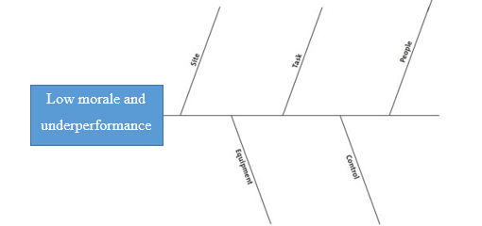
Figure: Cause effect analysis (TAHIRI et al., 2020)
Cause effect analysis is one of the leading tool which helps to understand the effects of every problems. In Philips UK, it has been found that peoples are the first problem. It has been very much visible that morale and number of the employees are lower. On the other side, tasks that are being given to the employees of Philips UK are also very tough because of the changed supply chain processes. Control of the tasks is also not well organized because it was seen that the number of employees are lower (TAHIRI et al., 2020). Because of having lower size of workforce, the performance of Philips UK had gone lower than earlier. These are the key causes of the problems that are being faced by Philips UK.

3.2 Force field analysis
There will be two types of forces which are making impact on the operations. These are:
Driving forces: Changing market situation is the first driving force for Philips UK. After that, social factors are also important to be considered (Pathak et al., 2021). Market demand and customers’ views have started to drive the changes.
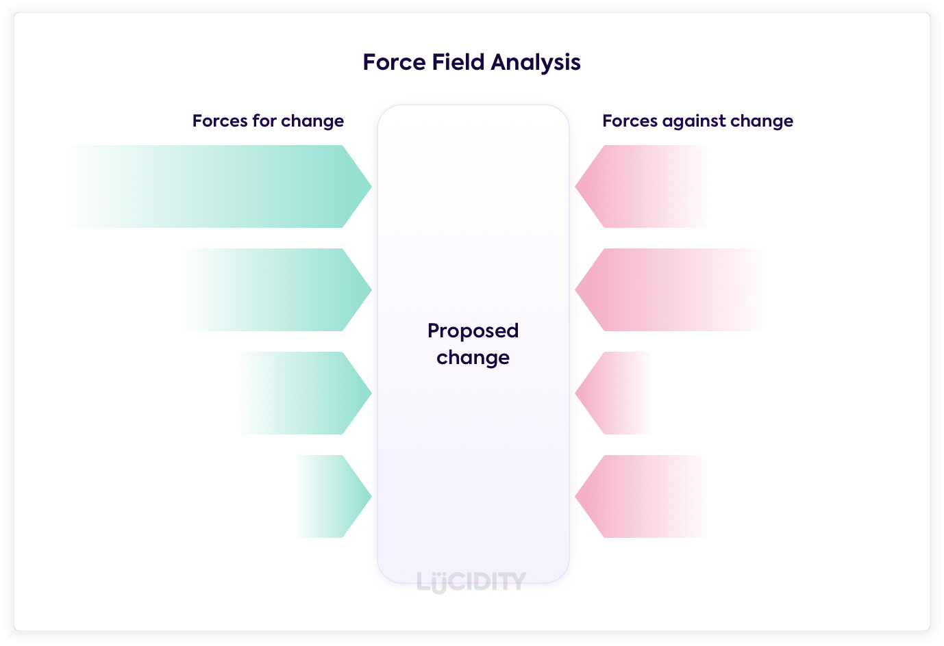
Figure: Force field analysis (Pathak et al., 2021)
Restraining forces: Philips UK has lesser employees than earlier and it has been acting as a restraining force. On the other side, employees’ morale is also lower and it had been causing trouble for Philips UK (Cruz et al., 2020). Leadership style of Philips UK is also not effectively aligning with the objectives of change.

3.3 Curt Lewin’s Model of change management
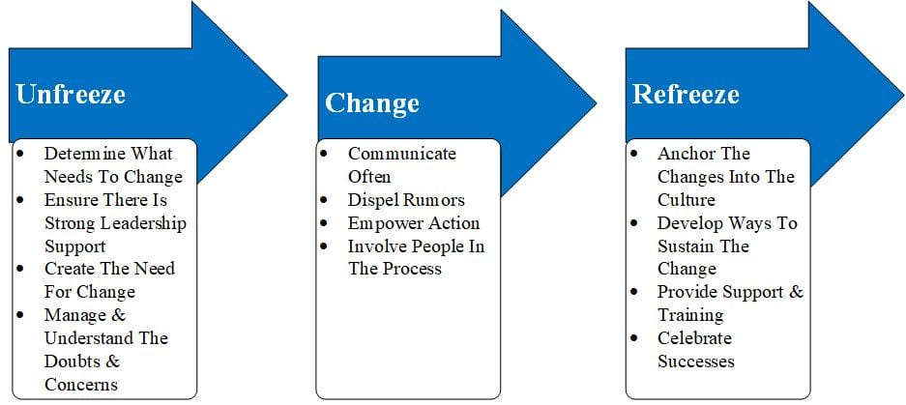
Figure: Kurt Lewin’s change model (Pal and Poyen, 2017)
Kurt Lewin’s change model has three steps and these can support to carry any kind of change. So, to make changes on the operations of Philips UK, the first step will need to include the unfrozen step. In this step, Philips UK is required to determine the changes that are required. So, they will need to make sure that their employees are well trained and skilled (Pal and Poyen, 2017). On the other side, they will also need to make sure that their resources are well managed. After unfreezing, Philips UK will need to change and this change will have to be carried on the operations with proper leadership. At the end, Philips UK will have to freeze their operations changes. In this way, problems can be solve din Philips UK.

4. Finding solutions to the complex problems
Changes are always universal and organizations will need to deal with the changes on regular procedures. In this place, Philips UK will require to create a proper sense of urgency for the employees. When they will be feeling the urgency of the changes, they will also be interested to make changes on the leadership conditions. If the sense of urgency, leaders of Philips UK will be successful at motivating their employees. This sense of urgency will also bring changes on the cultural system (Minda, 2020). This cultural system will help to provide a push to the employees. As the result, this push will be important and effective for assuring and ensuring the effective performance.
Changes on the culture will help to make development on the order delivery process. Creating sense of urgency with effective leadership systems will support to reduce the backlogs of the order delivery system. In the same way, it is also necessary for making and committing changes on the supply chain process. Overall, it will be able to reduce the cost of the organizational operations (Flinn, 2019). It will be making sure that the operational costs of an organisation are well arranged and managed. This is why, creating sense of urgency with effective leadership systems will be the best solution to solve any kind of complex problems.

5. Alternate Solution Generations
Solution 2: The main reason behind the problems of Philips UK is the underperformances of the employees. So, Philips UK can actually go for hiring new employees and it will be able to bring new blood to the organizational positions. On the other side, it has also been found that the new employees can effectively make changes on the present conditions of Philips UK. They can also provide with a sense of competition to the other employees (Osman, 2017). In this way, Philips UK can actually get better and effective results.
Solution 3: Because of the underperformance of the employees of Philips UK, the costs are getting increased. All of these costs can significantly bring problems on the operations of Philips UK. This is why, Philips UK can actually try by investing more to make the operations easier (Roberts, 2019). By the support of this investment, Philips UK will actually be able to make changes on the investment rate and level. So, this can be the second solution for the problems that are being faced by Philips UK.

6. Evaluation of best alternatives
In order to evaluate the best alternative, PMI technique can be used in this place. So, the PMI technique is being used on the following:
Steps | Plus | Minus | Interesting
Creating sense of urgency with effective leadership systems | It will save the cost,  It will motivate employees,  It will bring effective leadership. | It will take more time. | N/a
Hiring new employees | It will bring new skills and competencies,  It will motivate employees. | It will need a huge investment,  It will need new leadership,  It may create chaos. | N/a
Investing more to make the operations | It will help to bring new infrastructures.  It will increase the present capabilities. | It will take more time. | It will bring changes on the total distribution system.

So, by analysing the points, it can be said that creating sense of urgency with effective leadership systems has more pluses than minuses.

7. Implementation
In order to implement the total operations, some changes will have to be brought. In this place, to create sense of urgency with effective leadership, several steps will have to be brought. These are:
Step 1restructuring and cost-cutting: At the first step, Philips UK will need to make sure that their operational procedures are being restructured (Millerand Poston, 2020). They will need to make sure that the resources are being allocated based on the merit of the user. On the other side, the cost of Philips UK will have to be cut during this phase too.
Step 2 creating a movement for change: Philips UK will also require to make a movement for causing the change. In this movement, they will have to make sure that all the changes are being well put. By keeping the changes on well put, better movement can be possible depending on the leadership qualities.
Step 3 implementing change: At the end, Philips UK will need to implement the change as expected. They will have to go for creating and presenting the required changes (Haendlerand Frysak, 2018). In this way, Philips UK will be able to carry out the whole change process.

8. Monitoring and Control
In order to monitor and control the process, a handful of steps will have to be carried and fulfilled. As the result, some big movements on the operations of Philips UK will be necessary. These movements will need to be compared with the standard plan. In the change related conditions, there are various types of standard plans. These standard plans are important for Philips UK to compare with the actual performance. So, in this place, Philips UK is required to compare their standard performance with the actual performance (Proctor, 2018). In this way, several gaps on the actual performance will be seen. All these gaps are needed to be closed and Philips UK will need to make sure that.
Depending on the gaps, Philips UK will be trying to devise new strategies. These strategies will be important for the purpose of monitoring and controlling roles. In this way, Philips UK will make sure that the qualities of their operations are being well fulfilled.

9. Communication to the stakeholders
In order to understand the communication roles, a communication register will be kept. On that communication register, all the stakeholders and modes of communications will be presented (Osman, 2017). These are:
Name | Frequency | Mode | Audience | Communicator
External stakeholders press release | Rare | By using press release | External stakeholders | Manager of the project
Board meeting | Frequent | Face to face, email, and other modes | Board of directors | Manager of the project
Project manager meeting | Frequent | Face to face, email, and other modes | Project manager | Project team members

So, these are the ways in which the communication chain will be established.

10. Recommendations
As recommendations, it can be said that the processes are needed to be introduced on each of the functions of the organization. In each function, a proper sense of urgency will have to be created. If the sense of urgency, leaders of Philips UK will be successful at motivating their employees. After creating the sense of urgency, employees will be well informed about the necessary changes. On the other side, creating sense of urgency with effective leadership systems will support to reduce the backlogs of the order delivery system (Millerand Poston, 2020). In the same way, it will be making sure that the operational costs of an organisation are well arranged and managed. So, it is the most necessary step which will have to be carried by Philips UK.

11. Conclusion
In Philips UK, it has been found that peoples are the first problem. Because of having lower size of workforce, the performance of Philips UK had gone lower than earlier. On the other side, employees’ morale is also lower and it had been causing trouble for Philips UK. Changes on the culture will help to make development on the order delivery process.

References
Cruz, N., Desai, S. C., Dewitt, S., Hahn, U., Lagnado, D., and Tešić, M. (2020). Widening access to Bayesian problem solving. Frontiers in psychology, 11, 660.
Flinn, P. (2019). Decision‐Making and Problem Solving.
Haendler, T., and Frysak, J. (2018). Deconstructing the Refactoring Process from a Problem-solving and Decision-making Perspective. In ICSOFT (pp. 397-406).
Miller, C., and Poston, M. (2020). Problem Solving and Decision Making in Groups. Exploring Communication in the Real World.
Minda, J. P. (2020). The psychology of thinking: Reasoning, decision-making and problem-solving. Sage.
Nielsen, E. G., and Minda, J. P. (2019). Problem Solving and decision making.
Osman, M. (2017). Problem solving: Understanding complexity as uncertainty.
Pal, A., and Poyen, E. F. B. (2017). Problem solving approach. International Journal of Advanced Engineering Research and Science, 4(5), 237180.
Pathak, S., Dewangan, R. L., and Mohanty, S. N. (2021). Decision Making Under Uncertainty and Problem Solving. Decision Making And Problem Solving: A Practical Guide For Applied Research, 1-12.
Proctor, T. (2018). Creative problem solving for managers: developing skills for decision making and innovation. Routledge.
Roberts, H. (2019). 8. Problem-solving and decision-making. In Community Development (pp. 138-152). University of Toronto Press.
TAHIRI, A., KOVAÇI, I., and SHABANI, P. C. S. H. (2020). Planning, Problem Solving and Decision Making Process-Case Study in Small and Medium Enterprises in Kosovo.

