

Assessment 2

Programme:BA Business Management
Module : Managing People
Module code : LCCB5004
Module Lecturer: Dr. Terry Walcott
Student : Zamsa Dan ( 2028094 )

Table of Content 2
Introduction 3
CIPD Profession Map 3
(a) Importance of CIPD Profession Map for the effective working of HR professionals in the UK 3
(b) Application of CIPD professional map on a global scale to HR professionals working 5
Unemployment in the United Kingdom 7
(a) Reason of public sector is facing skills shortages in the UK despite the high unemployment rate 7
(b) Long-term labor market developments to address the skills shortages in healthcare sector professions in the UK 8
Conclusion 9
References 10

Introduction
The purpose of this study is to give a detailed discussion on the CIPD Profession Map that will help every professional personnel to understand their job role and responsibilities. It is particularly an interactive set of guidance for the Human Resource Manager in any workplace all over the world in order to improve and develop the working environment in workplaces. This CIPD Profession Map effectively covers each and every level of HR professionals. It consists of eight behaviors and ten professional areas. It has been set out of almost four brands of competence. This study highlights a discussion on the ways of implementing or using this CIPD Profession Map in an organization. It plays an important role in making an organization work better. It also talks about the shortage of skills in the business organizations although a high unemployment rate has been observed in the UK. This study sheds light on the CIPD Profession Map to provide a detailed discussion on the core knowledge, core behavior and special knowledge.

CIPD Profession Map

(a) Importance of CIPD Profession Map for the effective working of HR professionals in the UK
CIPD Profession Map is an effective way of creating value in a workplace focusing on the behavior of the HR professionals. Considering the importance of the CIPD profession Map on the behavior of HR professionals specifically in the healthcare sectors it can be said that it is part of the Core Behavior in the CIPD Profession Map. The aspects included in the Core Behavior are: ethical practices, professional influence and courage, working inclusively, valuing people, commercial drive, insights focused, passion for learning and situational decision making (Peopleprofession, 2022).
Ethical practices
HR professionals need to possess knowledge regarding ethical practices that can help them in building moral compass so they can be able to make decisions regarding their life and career. Those HR professionals who work in the healthcare sectors need to be very particular about their decisions because it is essential to implement effective and correct decisions in healthcare sectors so they can provide a better environment to their workers and patients.
Professional influence and courage
It is necessary to convey such behavior that can be influential for others and encourage others to take difficult and crucial decisions. This behavior is mandatory everyday in every organization in the United Kingdom so they can motivate their employees to show their positive attitude and accomplish their responsibility well (Harrison et al., 2021). It is particularly necessary in healthcare sectors because it helps the staff and nurses of healthcare sectors to show their good behavior so the patients can also get proper treatment and care from them.
Working inclusively
It refers to the working ability with a diverse team or in collaboration with other people. It is important to be collaborative and understanding towards each other only then they can help in increasing productivity. Listening to someone properly while working with them and showing a friendly approach towards them helps in creating a peaceful environment. In the healthcare sector patients relied on caregivers for their needs. Caregivers need to pay their attention towards the patients and listen to them carefully only then better care can be provided.
Valuing people
In this behavior approach people are at the center and it helps in balancing consideration, fairness and compassion, and supporting people to do the same. It is necessary to value every person that will help to encourage a culture of trust, make everyone able to do their best in their work and people's wellbeing and development (Beatty and Queen's, 2019). Customers or people are the core of any organization in the UK.
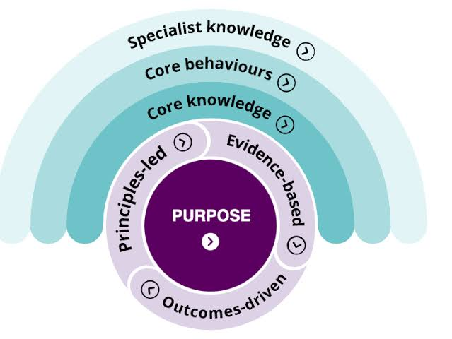
Figure 1: CIPD Profession Map
Source: (Beatty and Queen's, 2019)

(b) Application of CIPD professional map on a global scale to HR professionals working
The roles and responsibilities of HR professionals are equally important in every workplace. CIPD Profession Map can be applied on a global scale that covers all the HR scope and can be applicable in all types of organization irrespective of its scope and size. The CIPD Profession Map is mainly constructed of three aspects: Specialist knowledge, Core behavior and Core knowledge. Following these three aspects can help in applying the map on HR professionals on a global scale.
Specialist knowledge
Specialist knowledge includes many aspects that give a detailed account on the basic points about what types of information and knowledge an HR professional needs to possess. The aspects are: Employee experience deals with the experience and knowledge that an employee has already possessed within him. A HR can overcome all the situations and difficulties successfully and meet all the goals and targets if he is experienced enough of the situations. Employee relations play an important role as the relationship between present members can be harmonious and peaceful only when they have knowledge of the ways of making good and healthy relationships with others in the workplace (Nautinst, 2022). Rewards help in motivation as it with this reward employees get motivated to work hard and improve their performance in their workplace. Talent management helps in managing the talent of HR so they can better implement their talent in their workplace and come up with innovative and effective decision making. Along with this other aspects are Inclusion and diversity, Learning and development, Organization design and development, Resourcing and People analytics.
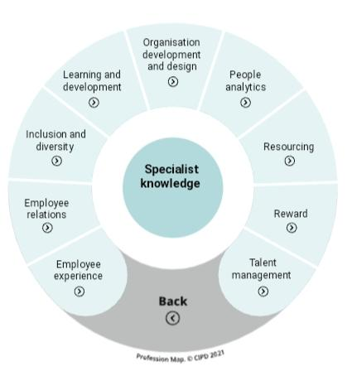
Figure 2: Specialist knowledge
Source: (Nautinst, 2022).
Core behavior
Core behavior influences the behavior of HR professionals in his workplace and it is equally helpful on a global scale. The aspects that are included in the Core Behavior are: Ethical practice focuses on the moral values that HR needs to promote.
Professional influence and courage helps in Influencing other members and encouraging them in their work (CIPD, 2022). Valuing people means to pay attention to people and their needs so their trust can be gained. Other aspects included in this group are Commercial drive, Situational decision-making, Passion for learning and Insights focused.
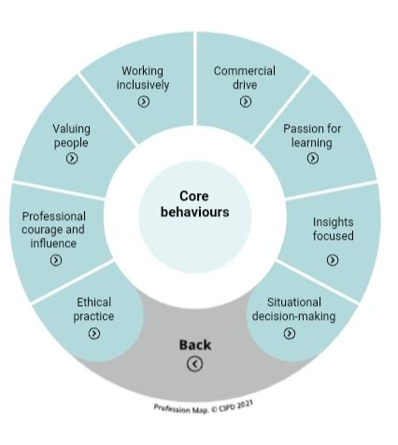
Figure 3: Core Behavior
Source: (CIPD, 2022)
Core Knowledge
It highlights the fact that as a HR it is necessary to possess some effective knowledge that will help in serving oneself as an expert. The important components that will help in making a HR expert are: People practice, to be an effective professional one needs to understand the scope of human practice. Culture and behavior is to understand human behavior and to create a proper organization culture. Business acumen means to understand one's organization, context of their business and wide world of work (Hunter-Hill, 2019). Evidence-based practice refers to the use of data and evidence to solve problems, generate insights, measure impact and develop ideas. People and Technology focuses on the importance of technology in every workplace all over the world and the impact of technology on people.
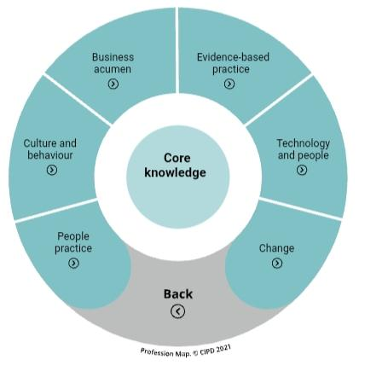
Figure 4: Core knowledge
Source: (Hunter-Hill, 2019).

Unemployment in the United Kingdom

(a) Reason of public sector is facing skills shortages in the UK despite the high unemployment rate
It has been observed that despite the high unemployment rate in the United Kingdom the public sectors are facing a skills shortage. The main reason for facing this shortage is the irresponsibility of people. Their ignorance of their faults make them unable to develop their skills and the shortage of skills are not helpful for the business organizations. As a result of which public sectors are not willing to engage those employees who lack skills. Focusing on the reason of this shortage of skill some of the relevant reasons are:
Lack of sufficient experience
At present employees lack sufficient experience and knowledge. Without sufficient experience and knowledge it is not possible for an employee to handle every situation or difficulties or changes properly (Researchergate, 2022). At present almost every sector demands for experienced employees but without giving opportunities to the freshers how one can become experienced.
Shortage of qualified applicants
It has been observed that there are many students who are in search of jobs but they are facing the crisis of unemployment. People think that the reason of this unemployment is lack of vacancies in public sectors but the fact is that there are many vacancies available in the public sectors but they cannot find out qualified applicants as a result of the shortage in qualification they have shortage in skills also and employees with shortage of skills are useless and burde for the public sectors (Brunello and Wruuck, 2019).
Lack of technical ability
Technology becomes an integral part in the public as well as private sectors. In this age of digitalization every sector is transforming their organization into digital sectors and as everything is transforming into technology there is a need for those employees with technical knowledge and ability but there are not enough employees with technical ability. It can be said that technical ability has become mandatory criteria for applicants in the public sectors.
Wake of Brexit
Along with all the problems and issues that are responsible for the shortage of skills in the wake of Brexit is another reason. During this wake of Brexit the United Kingdom has undergone a serious shortage of labor skills. It has shrunk the pool of easily available EU workers (Wordsworth et al., 2016).

(b) Long-term labor market developments to address the skills shortages in healthcare sector professions in the UK
The issues regarding the skills shortage in the healthcare sector professionally creates problems for the sector and these issues need to be mitigated so they can be able to provide better services to their customers or patients. Healthcare sectors are responsible for the betterment and wellbeing of people and patience for this reason the healthcare staff and employees need to possess effective skills. Some of the long term labor market developments are:
Training and development program
In every healthcare sectors in the United Kingdom they need to take initiative to make their staff and nurses skillful so they can provide more effective care and treatment to their patients. To make them skillful healthcare sectors in the United Kingdom can arrange for the training and development program which might be mandatory for the members so they can develop more knowledge and skill from these training and improve their skills (Amarneh and Muthuveloo, 2020). They can also train how to take care of which sort of patients and make a strong bonding with their patients so they can feel valued and cared by the caregivers.
Government intervention
Government intervention is one of the most important initiative because it is only wth the help of government everyone will show their interest and respect towards the initiatives. The government of the United Kingdom can impose more policies or can arrange for social campaign and support the healthcare sectors for their betterment. Health and safety is the common right of every human being and the government of the UK must be concerned and careful about it. The main challenges that the government of the UK needs to address in their policies are: skill level upgrade, improvement in quality apprenticeships, raising demand of skills within employers and skills training (Hill et al., 2019).
Academic learning
Academic learning is the base of the skill development of an employee. Students while persuing their education in health care stream it is the responsibility of the academic institutions to provide proper knowledge and education to them and pay attention on their skills development. Along with the institutional teachers it is the responsibility of the students also to concentrate properly to their study and attend every calss regularly so they cannot miss any information or knowledge and prepare themselves with effective skills. For example it can be said that Covid 19 is a situation similar to which they can face in near future but if they are skillful enough then they can face such situations easily (Dewart et al., 2020).

Conclusion
From yeh above discussion it has been observed that HR professionals can develop their skills and knowledge with the help of a CIPD professional map and this map not only helps in developing the personality of HR in the United Kingdom but all over the world. This CIPD Profession Map consists of three aspects that helps a HR person to make a clear understanding of their roles and responsibilities in an organization. This study also helps in developing an understanding on the reason for shortage of skills in public sectors despite the unemployment in the United Kingdom. The provided reasons are justified and convincing enough. To mitigate this issue some important solutions are also provided in this study.

References
Amarneh, S. and Muthuveloo, R., 2020. Human resource management practices and person-organization fit towards nurses’ job satisfaction. Management Science Letters, 10(14), pp.3197-3206.
Beatty, C.A. and Queen’s, I.R.C., 2019. From HR practitioner to HR leader: Competencies required. Queen’s University Industrial Relations Centre (IRC).
Brunello, G. and Wruuck, P., 2019. Skill shortages and skill mismatch in Europe: A review of the literature.
CIPD. (2022). CIPD Profession Map. Available at. https://www.cipd.co.uk/cipd-hr-profession/cipd-hr-profession-map/default.html (Accessed 20 January 2022).
Dewart, G., Corcoran, L., Thirsk, L. and Petrovic, K., 2020. Nursing education in a pandemic: Academic challenges in response to COVID-19. Nurse education today, 92, p.104471.
Harrison, P., Tosey, P., Anderson, V. and Elliott, C., 2021. HRD professional education provision in the UK: past, present and future. Human Resource Development International, 24(2), pp.200-218.
Hill, M.A., Overton, T.L., Thompson, C.D., Kitson, R.R. and Coppo, P., 2019. Undergraduate recognition of curriculum-related skill development and the skills employers are seeking. Chemistry Education Research and Practice, 20(1), pp.68-84.
Hunter-Hill, M., 2019. Strategies to Develop Core Behaviours through Psychometrics & Coaching: A Profession Mapping Exercise.: Professional Development Workshop (PDW).
Nautinst. (2022). Global professional standards for HR - The Nautical Institute. Available at. https://www.nautinst.org/resources-page/global-professional-standards-for-hr.html (Accessed 20 January 2022).
Peopleprofession. (2022). The profession map. Available at. https://peopleprofession.cipd.org/Images/full-standards-june-2022-v3_tcm29-109853.pdf (Accessed 20 January 2022).
Researchergate. (2022). What Is a Skill Shortage? Available at. https://www.researchgate.net/publication/254416775_What_Is_a_Skill_Shortage (Accessed 20 January 2022).
Wadsworth, J., Dhingra, S., Ottaviano, G. and Van Reenen, J., 2016. Brexit and the Impact of Immigration on the UK. CEP Brexit Analysis, 5, pp.34-53.

