Following the publication of Dylan Wiliam’s ‘Inside the black box’ in 1998, Assessment for Learning (AFL) became a national priority in the education sector (Christodoulou 2017). Three main issues have been raised surrounding AFL in the classroom; 1) the assessment methods that teachers use are not effective in promoting good learning, 2) grading practices tend to emphasise competition rather than personal improvement, and 3) assessment feedback often has a negative impact, particularly on low-achieving students, who are led to believe that they lack “ability” and so are not able to learn (Black, et al., 2004 p 9). Decades of research has shown that giving effective feedback to pupils dramatically improves their progress (Christodoulou 2017). Despite these findings, AFL has not been the success it once was; the majority of feedback tends to focus on what is deficient about pupil’s work rather than what the learners can do to improve their learning and make progress. This report will focus on the latter and critically evaluate the strategies that School X’s Modern Foreign Language Department is adopting to achieve excellent progress, outcomes, standards and attitudes to learning for all pupils. This report will review the role of strategic planning in bringing about reform in schools followed by a discussion of School X’s Departmental Improvement plan (DIP), and School Improvement Plan (SIP). The report will critically evaluate one of the key methods of assessment for learning; feedback, and discuss strategies suggested in academic writing and literature which support and challenge the Department’s plans to improve pupil progress through effective feedback.

Strategic planning has been adopted by many educational institutions and is now a vital process within the education sector in terms of school improvement. The Minister for Education and Skills has set out a challenging and ambitious framework for educational reform in Wales to raise standards of education and improve learner outcomes. Estyn’s annual report for 2012–13 concluded that self-evaluation and planning for development could be improved in just over a quarter of those schools in Wales inspected (Welsh Gov 2014 p 2). As a result, the school development plan in Wales, finalised in 2014 aims to support schools in embedding a robust strategic planning procedure, which in turn should deliver improvements in learner outcomes. (beta.gov.wales). Literature defines strategic planning as a commitment to both short- and long-term goals, enabling schools to envision their future (Davies, 2004). In the past, school development plans comprised in short-term goals based on meeting the immediate needs of the school. However currently, strategic planning involves implementing long term, analytical and visionary goals (Davies et al 2010). The vision and purpose for school improvement in Wales is to create a self-improving education system where all elements of the system, regional and national are involved (Welsh Gov. 2015). The national model is based on a vision of regional school improvement consortia working on behalf of local authorities to lead, orchestrate and co-ordinate the improvement in the performance of schools and education of young people.(Welsh gov 2015 p5). Due to the changes the Welsh education system is undergoing in acceptance of Donaldson’s successful futures, the national model for school improvement is changing. In coincidence with this new curriculum, the National model for school improvement states that Wales needs an educational system that helps produce young people who are clever, skilled, happy and healthy. Therefore, student outcomes are central to strategic planning within the education sector.
According to the Welsh Government, a school development plan must include how it will address the national priorities of education; implementing literacy and numeracy and reducing the impact of poverty on educational attainment. Estyn has identified that a school with an effective strategic plan improves it’s learners outcomes and experiences. With this in mind, it is necessary to illustrate that an effective strategic plan must show that: it has an impact on learner outcomes regardless of their background, it involves all stakeholders in identifying strengths and areas for improvement, it is informed by a self-evaluation of school provision, performance and contextual data and is presented as a ‘live document’ that is made available to all staff (Welsh GOV 2015) The latter has had an effect on implementing change in schools. The Welsh Government states that a successful plan needs to have a clear purpose that is shared and understood by all. Smith et al. (1997) found that schools that struggled with implementing significant change were generally those in which teachers lacked a sufficient understanding of the change process. Regulation 9 (Welsh Gov.) states that in preparing a School development plan (SDP), the governing body must consult with the headteacher, school staff, learners, parents and others involved in the life and work of the school, e.g. local authority, regional consortia challenge adviser, other schools, community, etc. Moreover, Slavin (2017) argues that successful reform depends on the school’s readiness and has categorised schools into three types; seed, sand and brick. Within a seed school, all stakeholders and school partners are cohesive and unafraid of change. Within a brick school, leaders are positive toward change but don't have the necessary resources to implement the change. Finally, sand schools do not work as a cohesive whole and may have been unsuccessful previously. This emphasises the collaborative nature of strategic planning as involving all partners is essential in ensuring that everyone has a commitment to the school’s improvement agenda (Welsh Gov 2014).
In fostering a motivational and achievable vision, the school’s context must be considered and investigated. (Welsh Gov). Bryson (1995 quoted in Rutherford 2009 p 3) states that this context of change must include an assessment of the external political, economic, and social forces and trends that influence the manner in which the organisation runs as well as the internal resources and limitations that are present. Furthermore, from O’Brien’s (1991) perspective, strategic planning involves developing strategies and plans to align resources with environmental opportunities and threats. Therefore, it is important that a SDP is tailored to the school itself.
Following investigating the context of the school, Estyn (Welsh Gov, 2014) emphasis the SDP should be informed by regular self-evaluations of the inner workings of the school. Self-evaluation allows schools to identify how well they performing, their strengths, what needs to be improved and what actions to take to move forward. Estyn (Welsh Gov, 2014) has recognised a strong correlation between school self-evaluation that focuses on impact and outcomes, and improvements in educational outcomes and experiences for learners.

Before proceeding to examine School X’s strategy for development, it is important to discuss the context of the School. School X is an English-medium mixed 11 to 18 school maintained by
Cardiff local authority. There are currently 1,721 pupils on roll, including 344 in the
sixth form, compared to 1,440 pupils, including 254 in the sixth form, at the time of the last inspection. The school serves a catchment area in which there are high levels of social and economic disadvantage. The proportion of pupils eligible for free school meals is 28.6%, which is considerably higher than the national average of 17.4%. Around 60% of pupils live in the 20% most deprived areas of Wales. Around 35% of pupils have a special educational need, which is above the national average of 25.1% and 2% of pupils have a statement of special educational need, which is lower than the 2.5% average in Wales. Approximately 70% of pupils come from a minority ethnic background and speak English as an additional language. (Estyn, 2017)

In its Estyn inspection in 2017, School X received ‘excellent’ for its current performance and its prospects for improvement. The school was classed as ‘green’ according to the National School Categorisation System. A ‘green’ support category means that School X is a highly effective school which is well run, has strong leadership and is clear about its priorities for improvement (Welsh Gov 2018). These schools have a track record in raising the standards that pupils achieve and have the capacity to support other schools to do better. Following this categorisation, the school were given two recommendations for further improvement:
- to improve standards in very few subjects so that they match the excellent overall outcomes achieved by pupils.
- to strengthen a few aspects of self-evaluation and improvement planning in order to increase the proportion of excellent teaching.
In response to these recommendations, School X’s SIP outlines four priorities to raise standards of achievement: To achieve excellent progress, outcomes, standards and attitudes to learning for all pupils, to develop excellent teaching and learning and outstanding provision, to maximise opportunities for staff development and professional learning and to develop leadership throughout the school. This report will focus on School X’s aim to achieve excellent progress, outcomes, standards and attitudes to learning for all pupils. The SIP has broken this target down into four sub-sections: Improving pupils’ attitudes to learning, Improve progress and outcomes for all pupils in KS3, KS4 and KS5, improve pupil progress through effective feedback and to raise standards of pupil wellbeing. This report will focus on the sub-section of improving pupil progress through feedback. The whole school plans to achieve this aim by conducting termly group work scrutinies which involve all staff and pupils, by improving the quality of departmental monitoring procedures that impact on marking and feedback and sharing three DIRT activities with staff to be used throughout the year. The school hopes that this strategy will have the following impact on the school: 80% of feedback will be good or better, departmental reviews will demonstrate that all departments have embedded processes that enable accurate and relevant feedback where progress can be made in learning, that pupil voice will demonstrate that useful formative feedback enables progress in learning and that AFL is embedded into all lessons in preparation for the new curriculum for Wales. In order for the school to achieve these goals, school X must develop a shared understanding of AFL at every level so that teachers can work collaboratively across the school to develop their practice (University College London).

The Modern Foreign Languages Department (MFL) aims to make progress in line with the school improvement plan by focusing on the same four priorities. As demonstrated in the whole school improvement plan, the Modern Foreign Languages department has broken individual priorities down into three sub-categories: plans to bring about improvement, key actions required and success criteria. This report will focus on the DIP’s aim to ‘expose pupils to a range of questioning strategies in feedback to deepen thinking’. This relates to the wider school target of ‘improving pupil progress through effective feedback’. The following actions are required to bring about improvement within the Department:
- A new KS3 marking policy to be created to improve quality of pupil response to feedback in class
- Individual class teachers to record feedback videos for levels 5-7 once per topic. Each video must include numerous WWW’s, EBI’s in the form of a question and a choice of DIRT tasks. It must also include an example piece of work. This video will be attached to a QR code and stuck in pupil books.
- this strategy will be fed back at Central South Consortium Regional Meeting.

The plan requires at least 3 examples of QR code feedback to be evident in each KS3 class’ books by May 2019.

The development of feedback in improving pupil progress was highlighted by Estyn in the 2017 report. They found that ‘nearly all teachers provide pupils with regular written feedback. In the majority of cases, teachers provide pupils with useful advice on how to improve their work. However, only a minority of teachers ensure that pupils consistently improve their work when asked to do so’.

Before discussing in more detail how School X is responding to Estyn’s recommendations, it is necessary to evaluate what key researchers say about the topic of marking and feedback within Assessment for Learning (AFL). School X is not alone in its aim to improve its AFL strategies; ‘promoting children’s learning is a principal aim of schools. Assessment lies at the heart of this process’ (TGAT, 1988).
It is important to recognise the difference between assessment for learning and assessment of learning. Assessment of learning has preoccupied the minds of the teaching profession for many years in an effort to meet the pressures of external examinations and awarding bodies (Jones, 2005). Assessment of learning can detract from effective classroom practice as assessment decisions are not shared with students therefore they cannot act on their mistakes (Jones, 2005). Assessment for learning has been closely associated with formative assessment because its principal practises; questioning and feedback, help ‘form’ or shape student learning (Cambridge).

Although teachers are realising the gains of formative assessment, according to the Annual report of the Chief inspector for Wales (1995-96 quoted in The Assessment Reform Group 1999 p3) the implementation of assessment information in determining the next steps in learning was unsatisfactory in a substantial minority of secondary schools. The Welsh Government has realised gaps in its assessment framework and identified that assessment for learning procedures are not well embedded in schools. Welsh Government (2014). The Educational Improvement Plan for Wales recognises the need to provide high-quality feedback through means of formative assessment – assessment for the purpose of informing the next steps in teaching and learning by identifying whether children and young people are progressing as intended – if the achievements of children and young people in Wales are to improve (Donaldson 2015 p 73).
In 2014, the OECD report on Welsh education recognised Wales’ need to ‘ensure that student assessments support learning for all and align to national objectives’ (OECD 2014 p 8). Furthermore, the HMCI annual report for 2012–2013 demonstrated that the most common recommendation in inspection reports concerned the need to improve teacher assessment, with nearly 40 percent of schools inspected having this as a significant area for improvement (estyn.gov p26).

Research identifies the main factors that inhibit the improvement of learning through assessment. They have identified that a greater attention has been given to marking and grading, much of which is damaging pupil’s self esteem instead of providing advice for moving forward. Moreover, teachers feedback to pupils often serves social and managerial purposes rather than responding to their needs (Black & Wiliam,1998). The following characteristics promote progress and learning: targets are shared with pupils, pupils practise self-assessment, feedback allows pupils to recognise their next steps and how to take them and both teacher and students are involved. The latter was discussed by Royce Sadler (1989 in James, 1998), he explained that feedback is a principal element of formative assessment and requires two key participants; teacher and learner. He wanted to transition from teacher-led feedback to student-led in which pupils monitor themselves and reflect on their own performance. Like Sadler, Wiliam supports the idea of ‘metacognition’, in other words ‘thinking about thinking’ (Cambridge International Education). Both researches promote self-assessment, a key characteristic of successful AFL. The new Welsh curriculum leader states that ‘If children and young people are to develop the capacity to learn throughout life, they need to be able to reflect and diagnose their own progress and further learning needs. (Donaldson 2015 p 80). The new curriculum in Wales aims to develop ambitious and capable learners who ‘set themselves high standards, seek and enjoy challenge, problem solving and are building up a body of knowledge which they can apply in different contexts (Donaldson 2015). It could be argued that without promoting these ‘metacognitive’ skills, teachers will be unlikely to foster Donaldson’s vision of creating life-long learners. Sadler (1989) formerly evaluated that formative assessment, grounded in a constructivist theory of learning, will need to be become the professional practice of most teachers if it is to satisfy the demands of education in the twenty first century.

A common misconception about feedback is that ‘work should always be given a grade or mark’ (Cambridge). However, an experiment by Butler compared feedback by giving marks and comments and feedback with only comments (Black et al. 2003) The research showed that learning gains were greatest when students received only comments. This research was carried out following teachers findings that students rarely read their comments when combined with grades. This type of feedback described by William, D as ‘ego-involving feedback’ focused students on their status in the class rather the work in hand and how it could be improved, and damaged the self-esteem of lower attainers. He argues that we should teach learners that ability is not fixed and instead focus should be put on effort (Cambridge International Education). Dweck argues that it is important to instil a growth mindset in all learners. According to Dweck (2006), when learners were praised for effort rather than their grades, 90% of them wanted the challenging new task that they could learn from. The study by Butler showed that students realised comments helped them complete future work more effectively and parents no longer had to second guess grades (Black et al. 2003).
As previously stated, one recommendation by Donaldson is that both self-assessment and peer-assessment should be developed as ways of encouraging children and young people to take greater responsibility for their own learning. Comments created a culture where learners worked on understanding the teacher’s written feedback, thus preparing them to begin judging their own learning and set their own goals (Black et al. 2003).

Although this idea appears to have solved a lot of problems in terms of well-being, this form of feedback could be problematic due to lack of time. Due to increasing pressure on teachers, The National Union of Teachers is campaigning to reduce teacher workload. The government has provided advice on eliminating unnecessary workload around marking. The NEU workload survey (2018) found that 81% of teachers considered leaving the profession in the last year because of workload pressures.
Marking is a vital element of teaching, but when it is ineffective it can be demoralising and a waste of time for teachers and pupils. It has been observed that teachers provide extensive written comments on every piece of work without evidence that this improves pupils progress in the long term (NUE 2018). Estyn does not stipulate how teachers should mark but judges the impact of marking or feedback on how well pupils understand what they need to improve (estyn.gov). They state that teachers should not provide excessive written feedback to pupils as this can become a disincentive for pupils to accept challenges and take responsibility their own improvement. They add however that teachers should regularly evaluate their policy to ensure consistency and worthwhile impact on pupil progress.

School X’s MFL Department has introduced a technology-enhanced form of feedback for KS3 with the intention of overcoming the challenges of marking in large-classes, as well as improving quality of pupil response to feedback in class. Donaldson’s digital competency framework requires learners to use digital technologies creatively to communicate, find and analyse information. In response to this, School X is providing the learners with QR code feedback. The code links to a video of the teacher marking a model piece of work, identical to that which the students are currently doing, commenting on targets for improvement. Sadler (1989 in James 1998) has commented on this style of marking, stating that it gives learners a ‘direct authentic evaluative experience’, that is to say, giving the students the opportunity to play the role of the teacher and self-assess their work recognising their own targets. This further emphasising the role of a ‘metacognitive’ approach to learning. He argues that using exemplar material to gain an understanding of standards can fulfil the same role for learners as it does for teachers. However, this technique could be seen as problematic; in instances where learners don't have a real understanding, they could disengage and simply mimic the teachers feedback (James,1998). Jones (2005) adds that teachers should model how to act on feedback appropriately as self-assessment is a skill that does not happen incidentally. Self-assessment and reflection can inform future learning therefore, it could be suggested that teachers need to take the time to make self-assessment an explicit skill.
Hattie (2011 quoted in Cambridge International Education) ranked feedback strategies 10th out of 150 factors that bring about significant improvements in learner outcomes and found that this was particularly true if the feedback involved strategies about the learners own work. This opposes School X’s strategy as teachers don’t give direct individual feedback. However, teachers giving feedback can have a negative effect on learners. If feedback is provided solely by the teacher, learners rely on the teacher to give the right answer and therefore lack independence (Cambridge International Education).
(Wiliam in Christodolou 2017 p141) argues that when provided, teacher feedback should be ‘task-focused’; “it is not enough to clarify the learner’s current state and goal state but to design a series of activities to help them arrive at goal state”. Research data by Hattie showed that that the most effective forms of feedback provide cues or reinforcement to learners; are in the form of video-, audio-, or computer-assisted instructional feedback; and/or relate to goals. The study compared students receiving feedback about a task and how to do it more effectively and feedback with praise and rewards. Feedback on a specific task had the highest effect sizes (Hattie 2007).

These findings support the strategy that School X is adopting. The DIP states that each feedback video must include numerous What Went Well comments, Even Better If comments and a choice of DIRT tasks; Dedicated Improvement Reflective Time. These DIRT tasks allow students to reflect on their targets and select a task that would help them practise the target. This could be to practise verb endings, spelling gender etc. This approach supports Wiliam’s theory that ‘good feedback causes thinking’ (Cambridge International Education). Christodoulou (2017) adds that progression models need to be tailored to the student, and need to break complex skills down into smaller tasks.

Due to School X’s policy, learners do not receive homework or take their books home. This means that time would be taken out of class for students to listen to the feedback, set targets and complete the DIRT task. This type of feedback is recorded once per class topic. Carless (2016) deems end of year marking unproductive and adds that teachers should include more in-class dialogic activities which encourage students to develop evaluative capacities, spending less time on one-way transmission of comments after a course is completed.
School X’s current strategy requires teachers to give a list of targets for students to choose from. If students are to become self-assessors, it could be argued that they should be given opportunities to set their own targets and tasks. As mentioned above, a flaw in this idea may be students lack of skills to carry out this task, therefore students should be involved in this process on a regular basis. James (1998) discussed the idea of letting the students ‘into the secrets’ of the teacher. This would mean engineering tasks which encourage learners to internalise the process of assessment. Teachers could involve students in activities where they mark a piece of work bases on success criteria and standards. Some teachers could argue that curriculum coverage could suffer as this addition would take considerable time (Teacher Toolkit 2019). Although involving the students in the process of assessment and marking may require learning to be slowed down in order to secure the skill, James (1998 p177) argues that there is little to be gained by achieving only partial, surface learning. With regards to School X, if students are to benefit from self-assessment, more time needs to be invested in ensuring learners understand the purpose of targets being set. Black and Wiliam's research showed that teachers wait less than a second to give students a chance to answer a question in class. In reality, a teacher need to allow three to five seconds to increase the thoughtfulness of students and to increase achievement (Cambridge International Education). This notion could be applied to School X’s new strategy, investing time in ensuring learners understand the purpose of targets being set if they are to benefit from feedback.

This idea of pupil participation can be seen in Estyn’s effective practise stories. School Y reviewed the quality of marking and feedback in their school and identified room for development. The school council reviewed the marking and assessment system in the school. Pupil’s views and conclusions on the effectiveness of the current marking and assessment policy were collected and presented to the senior leadership team. These recommendations were fed back to faculty leaders and pupils reviewed the school development plan. As a result, marking and assessment are more consistent across the school and pupils have a very thorough understanding of the assessment policy (Estyn 2015). This idea could be adopted in school X. Learners could be invited to give their views on the new marking policy, gaining a deeper understanding of AFL and the role of feedback. Nicol (2010) argues that often feedback focuses on the teachers viewpoint rather than on students interests or needs. One strategy suggested by Nicol (2010) to overcome this is to allow students to state those aspects on which they would most like to receive feedback, encouraging them to reflect on their work and start to develop a dialogue surrounding assessment and marking with the teacher. As well as giving learners ownership for the learning, this would save teacher marking time and add a focus to comments.
In order for feedback to have an impact on pupil progress, the whole school must develop effective practice in AFL. There should be a structured approach on sharing good practice. As mentioned in the SIP, the school aims to ensure that all departments are embedding processes that impact on pupil progress. One suggestion for moving forward could be to give all members of staff updated on progress being made in the implementation of AFL across the school with examples of good practise being shared. This would ensure a collaborative approach to the implementation of AFL and ensure consistency across the school so that pupils become accustomed to feedback processes.

In conclusion, it is clear that pupil progress depends on the nature of feedback that is given to pupils. Key research has shown that self-assessment and task focused feedback plays an important role in pupil achievement. School X’s new marking policy supports the findings of key researchers in promoting the use of self-assessment through technology-enhanced feedback but in order for self-assessment to be beneficial for students, teachers need to invest time into giving the learners the necessary skills and understanding of self-assessment. A combination of task-focused feedback and self-assessment will create the independent learners that the new curriculum hopes to achieve. Furthermore, involving pupils in the marking process, giving them access to success criteria and allowing them to set their own targets will set them up to judge their own work in future and take informed action of feedback.

Reference list
Christodoulou, D (2017) Making Good Progress?: The Future of Assessment for Learning Oxford University Press

Black, P., Harrison, C., Lee, C., Marshall, B., & Wiliam, D. (2004). Working inside the Black Box: Assessment for Learning in the Classroom. Phi Delta Kappan, 86(1), 8–21

Wiliam, D (2011) Embedded formative assessment Solution Tree Press

University College London Practical strategies to support the whole-school development of Afl with APP (Primary) Available at : https://dera.ioe.ac.uk/774/1/pri_ws_dev_afl_app0034310.pdf

Estyn 2017 https://www.estyn.gov.wales/sites/default/files/documents/Fitzalan%20High%20School.pdf

The Welsh Government (2015) school development plans. Available at: https://beta.gov.wales/sites/default/files/publications/2018-03/school-development-plans.pdf

The Welsh Government (2015) The National Model for regional working. Available at: https://beta.gov.wales/sites/default/files/publications/2018-03/the-national-model-for-regional-working.pdf

Donaldson G (2015) Successful futures Available at: https://gov.wales/docs/dcells/publications/150225-successful-futures-en.pdf

Davies B (2004) Developing the strategically focused school. School Leadership and Management 24(1): 11–27.

Davies B and Davies BJ (2010) The nature and dimensions of strategic leadership. International Studies in Educational Administration 38(1): 1–21

Rutherford, C., 2009. Planning to change: Strategic planning and comprehensive school reform. Educational Planning, 18(1), pp.1-10. Available online at: http://isep.info/wp-content/uploads/2015/03/18-1reduced.pdf#page=7

Smith, L., Maxwell, S., Lowther, D., Hacker, D., Bol, L., & Nunnery, J. (1997). Activities in schools and programs experiencing the most, and least, early implementation successes. School Effectiveness and School Improvement, 8(2), 125-150

Slavin (2015) Seeds, Bricks, and Sand: Stages of School-Reform Readiness https://www.huffingtonpost.com/robert-e-slavin/seeds-bricks-and-sand-sta_b_6477740.html?guccounter=1

Bryson, J. (1995). Strategic Planning for Public and Non-profit Organizations. San Francisco: JosseyBass

OBrien, P. (1991). Strategic planning and management for organization. In R. Carlson and G. Awkerman (Ed.), Educational Planning: Concepts, Strategies, Practices. New York: Longman.

The assessment reform group (1999) Assessment for learning: beyond the black box The Nuffield foundation Cambridge

Jones, Cheryl A (2005) assessment for learning London Learning and Skills Development Agency

James, Mary (1998) Using assessment for school improvement Heinemann Educational
Dweck, C (2006) Mindset: Changing the way you think to fulfil your potential New York The Random House Publishing group

Cambridge International Education Getting started with assessment for learning Available at https://cambridge-community.org.uk/professional-development/gswafl/index.html

Black, Paul Harrisson, Christine, Lee Clare, Marshal Bethan and William Dylan (2003) Assessment for Learning: Putting it into practice England Open University Press

The National Education Union Teachers and Workload Available at - https://www.teachers.org.uk/pay-pensions-conditions/workload

Estyn Reducing workload A Guide for Teachers and Headteachers Available at:www.estyn.gov.wales

Teacher Toolkit (2019) Live Marking:Feedback in Lessons Available at: https://www.teachertoolkit.co.uk/2016/10/20/live-feedback/

Hattie (2007) The Power of Feedback John Hattie and Helen Timperley University of Auckland Review of Educational Research March 2007, Vol. 77, No. 1, pp. 81–112

David Carless (2016) Feedback as Dialogue University of Hong Kong Springer Science+Business Media Singapore

Nicol, D. (2010). From monologue to dialogue: Improving written feedback processes in mass higher education. Assessment and Evaluation in Higher Education, 35(5), 501–517

OECD (2014) Improving Schools in Wales:An OECD Perspective Available at: http://www.oecd.org/education/Improving-schools-in-Wales.pdf

Welsh Government (2014) Qualified for life: An education improvement plan for 3 to 19-year-olds in Wales Welsh Government
The National school categorisaton The Welsh Government Available at: https://beta.gov.wales/sites/default/files/publications/2018-03/parents-and-carers-guide-national-school-categorisation-system.pdf

Black, P.J and Wiliam, D (1998) ‘Assessment and Classroom Learning’, Assessment in Education, 5(1), 7-74.

Estyn Effective classroom practice Improving marking and assessment through pupil participation Available at: https://www.estyn.gov.wales/effective-practice/improving-marking-and-assessment-through-pupil-participation

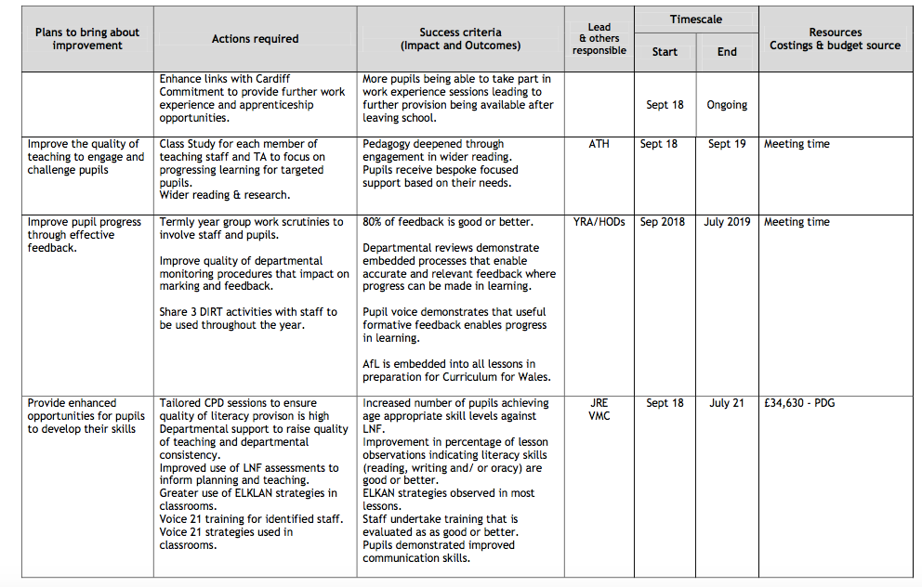
SIP
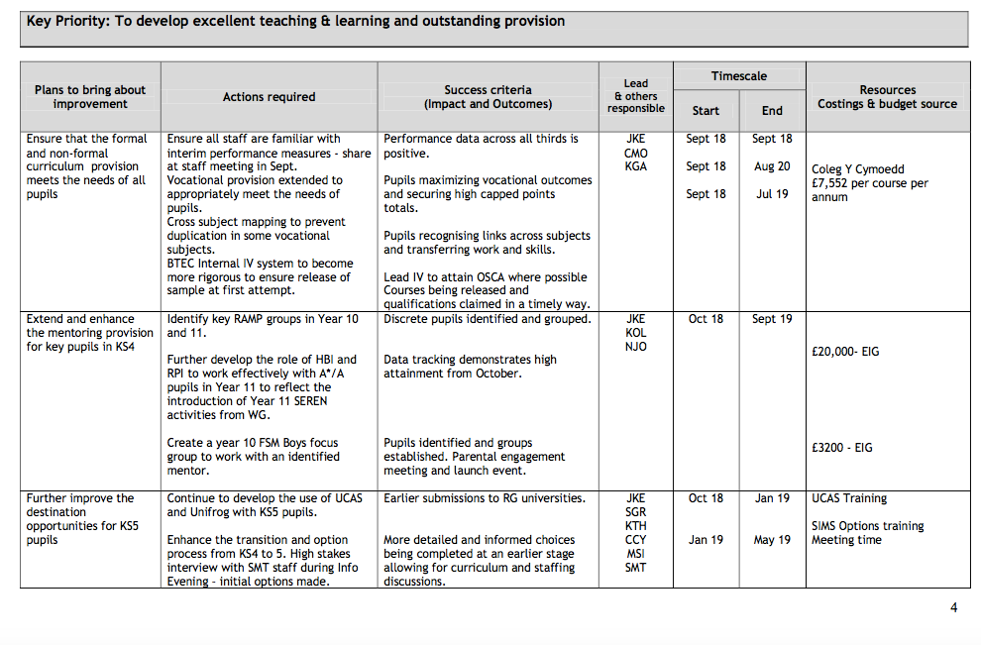
Department Improvement Plan



