Certificate in Higher
Education in Skills for the Workplace

Name: Ana-Maria Paveliuc
Student no: 1711207
Module Title: Digital skills and research methods
Module code: BMSK4003
Assigment title: Smart Tehnology in the workplace
Lecturer Name: Balendran Kandasamy

Smart Technology in the Workplace
The purpose of this assignment is to talk about the smart technology at the workplace. I choose to talk about web conferencing, web based email, tablets and smartphones.
When a new technology is introduced in the society, it is generally framed both as something that will save the world and as something that is intrusive and threatening. Technology provide the basis conversation in social and personal relationships.
(… ) Web Conferencing is a online sevice where people can hold meetings, conferencing, presentations and trainings through the internet. They can connect to the conference by telephone or using computers speakers and microphone through a VoIP connection. (3CX, 2016).
Web conferencing usually allows real time point-to-point communication as well as multi task communications from one sender to many receivers in separate locations. Depending on the service, either on application is downloaded and installed or a web-based application is launched in the browser.
The web conferencing platforms are accessible through a web browser, but you may need to download and install the application, in order to take advantages of all latest updates, such as voice and video conferencing and content sharing. (techtarget, 2017)
There are many platforms of web conferencing this day , but I choose to talk about skype and team viewer, because everyone knows them and they are the oldest.
What are the advantages of web conferencing? It allows peoples to combine the advantages of o normal phone conversation with a live camera. During the web conferencing you can also send messages, that mean you can communicate verbal and type messages on the same time.Even if you do not have a internet connection, you can still access your files right from the computer desktop and share them during the web conferencing.
Web conferencing reduces the need for travel, that is all what business need in this days. Personal or face to face meetings can be held through web, with peoples dialing from different locations around the word. Therefore, this help business on save money and time, and will no longer be reasons or excuses for staff to miss out meetings and conferences. For example, if a staff is ill and he can come to important meetings, web conferencing allows him to work from home.
There are some disadvantages of using web, one of them it is that is not free, and the software that is free is limited in capability. Depending on the speed of the internet, web conferencing can reduce the visibility and function. It is more informal than a face to face meeting and there are same cost associated with the updates.
“Skype is the first web conference platform and it has been launched a long time ago and is still popular. Skype is an instant messaging application that provides online texting and video chat services. It allows for the transmission of files online, such as text documents or digital attachments (video clips or images). The video conferencing platform makes it one of the best web conferencing platforms ever.” (eztalks, 2018)
Team viewer is one of the oldest and free web conferencing platforms. This application can be accessed from anywhere in the world. The unique remote solution of accessing one is screen by another is designed to get you working in the least possible time. It is very safe and secured as the one providing with access still controls the conferencing with just a click.
Smartphones do not all the time connect with other people or provide you with information, music and video. We view smartphones as relational technologies to accentuate the relational functions and implications of their use in society and workplace. There are symbolically connected with to lifestyles,or media personalities.
Smartphones are phone devices that are used to brows, run applications and navigate. They are consider as compact personal computers which are use for making phone call and there do not always connect with people or provide us the informations, music and video.(Maund, 2017)
Smartphones are changing how people communicate and form relationship with others, as well as established goals and norms. This devices position people as being constanty connected and available to others, even with the workplace and the colleagues.
Tablets are fully functioning standal one computers the size of a thin LCD monitor that use the screen itself for control and data input. Both of these devices may be categorized based on the mobile operating system that they use.
Tablets are something between smartphones and laptops. They have a bigger screen than smartphones and are mainly able to do everything that a smartphone can, except making calls and sending SMS. There are also some applications that only run in tablets and not in smartphones. Tablets are built to provide a rich multimedia experience and allow a user to have more computational capabilities.
The advantages of using tablets or smartphone is that they have the same operating system, such Apple’s ,Ios and Google’s Android.
The major difference between smartphones and tablets is about their connectivity, which means that they are able to connect through a Wi-Fi signal to the internet and are able to send SMS, send and download data and also call. Another difference between this to is tat smartphones are able to make phone calls and it is easy to take with you everwhere compare with tablets which is bigger. Tablets, on the other side, are famous for their larger screens and easier web surfing, social networking and video watching capabilities. (Research gate, 2018)
Smartphones have a navigational device with features of GPS, A-GPS, EDGE, and GPRS. They have the ability to store a large amount of information and media files, are able to download and upload files at great speeds on the internet, either thru 3G or Wi-Fi. They can be used to surf the net, take pictures, shoot videos, chat live with friends, social networking. Also have twin cameras for video chatting and video calling. Both smartphones and tablets are close to full computers. Due to the introduction of dual core processors and operating systems, they have the ability to do most of everything that desktops and laptops can. Their computing abilities are only restricted by a smaller display and their inability to play a CD or DVD.
Web based email are web-based email accounts. These are usually free email accounts that are operated from a website. Examples include Hotmail, GMail and Yahoo Mail.
Webmail allows the users to access their emails as long as they have access to an Internet connection and a web browser, this also means that the user cannot read an old email or draft a new email offline. Although it is easy to use, the usage of email can have plenty of and also disadvantages.
The most important advantage: it is free to use: once you are online , you do not have any other expenses; easy to reference: send, receive emails and attachments are stored safely, organize and more easy to find; easy to use: your data storage and contacts can easily be accessed from anywhere at any time
Disadvantages of using email can be the emotional response, to much information overloaded, misunderstandings because people who do not take the time to read what they write before send it.
Gmail makes the top of the best email accounts and it is Google's free email service that is really nice and modern, and there are numerous shortcuts you can use to make it even easier to work with. There are different themes you can apply to Gmail's interface to customize how it appears, tons of advanced settings, and the ability to create labels and filters, import email in from other email accounts, use a chat client, and, among other features, install gadgets (add-ons) to extend Gmail's functionality. You can even view your Gmail messages without an internet connection if you install Gmail Offline. ( Balance everyday, 2017)
Outlook.com (Outlook Mail) is Microsoft's free email service that, like Gmail, has a solid interface that's easy to work with. Email rules are supported with Outlook.com, which means you can set new messages to automatically move to a specified folder, be categorized, flagged or even forwarded if certain conditions are met. In addition to regular mail features, you can also connect to Skype, Facebook and a couple other messaging services so you can stay connected without having to leave Outlook.com.
Yahoo Mail is the free email account offered by Yahoo. The compose window when making new emails is a bit similar to Gmail, but one useful difference is that it's easy to switch between inline image attachments and normal file attachments. This means you can switch a file attachment to be embedded in the email and just as easily reverse it to make it a file attachment. Several awesome themes are available with Yahoo Mail that changes the entire background and color scheme of the website, which makes for a pretty unique design. Yahoo Mail lets you import contacts from a file on your computer as well as from your Facebook, Google or Outlook.com account. This makes it easy to transfer contacts from a different email provider to Yahoo Mail.
Yahoo Mail also gives you access to an online calendar and an instant messaging service. You can even connect external email accounts to Yahoo Mail so you can use one interface to manage all your mail, even from services like Gmail and Outlook Mail
Conclusion
I am working in retail, so for me using smart technology is really important and it is help a lot. Every week we have web conferencing with others members of the stores where we discuss changes and important things for the week, which is really helpful because everyone is participating and we do not need to be meet, be on the same place. Thru the smartphones, we are connected on the same group where we talk with each other and leave comments about the work, even when a member a staff is not at work, they will know the latest news.
Social media are computer-mediated technologies that facilitate the creation and sharing of information, ideas, career interests and other forms of expression Thru virtual communities and networks. The most website pages which I use are facebook and linkedln. I choose facebook because it is easy to use and I am keeping in touch with my friend, I discover new commercials and jobs. Linkedln I used to search for new and interesting jobs.
Facebook is an American online social media and social networking service. Facebook can be accessed from a large range of devices with Internet connectivity, such as desktop computers, laptops and tablet computers, and smartphones.
https://www.facebook.com/ana.paveliuc.1?viewas=100000686899395&returnto=profile&privacy_source=viewas_chrome_bar
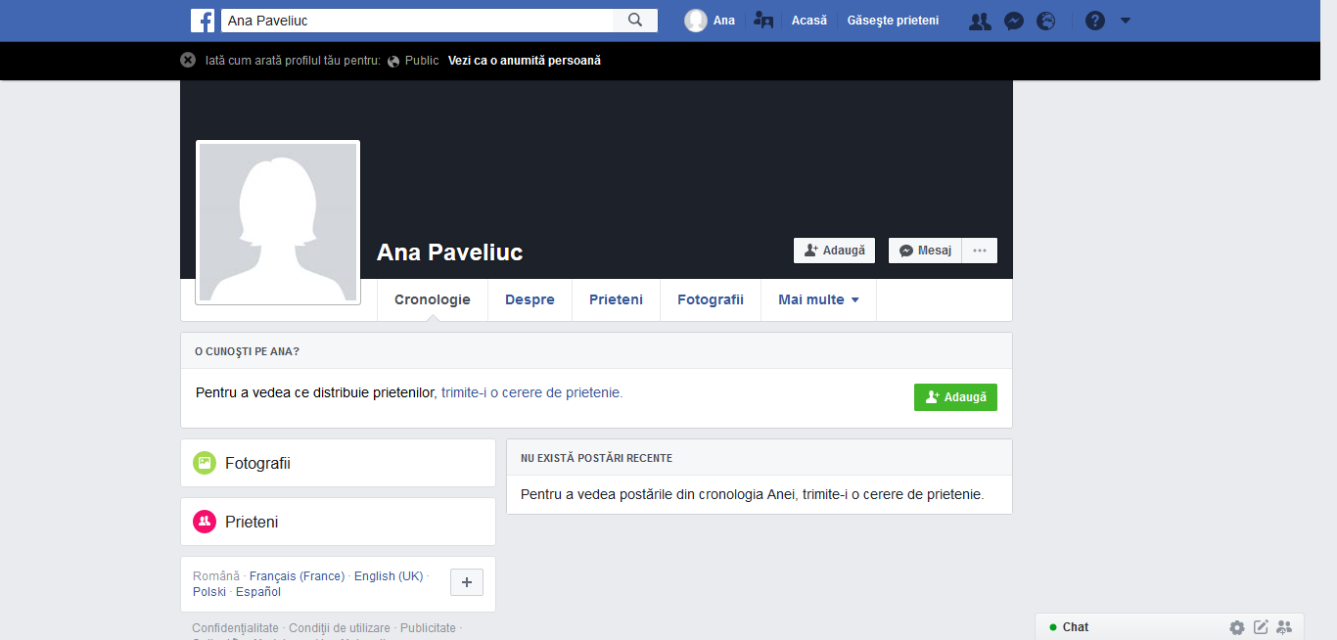

Linkedln is a business and employment-oriented service that operates via websites and mobile apps. Down is my linkedln account : https://www.linkedin.com/in/ana-maria-a5323915b/
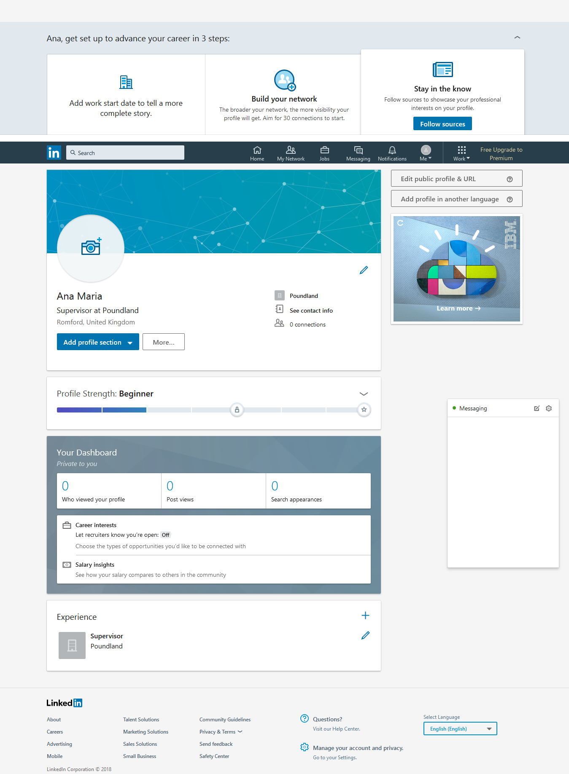

References
Maund, A,. Schriek, M. and Tinkler, P. (2017) Certificate in Higher Education: Skills for the Workplace Student Yearbook, Sage Publications
( Online ) Available from :
https://www.3cx.com/pbx/web-conferencing/ ( accessed on 20 april 2018)
( Online ) Available from: https://searchunifiedcommunications.techtarget.com/definition/Web-conferencing (accessed on 15/04/2018)
( Online ) Available from: https://www.eztalks.com/video-conference/web-conferencing-platforms.html ( accessed on 20/04/2018)
( Online ) Availale at: https://www.researchgate.net/publication/234121858_Smartphones_tablets_and_mobile_applications_for_radiology ( accesed on 02/05/2018 )
( Online ) Available at: https://www.thebalanceeveryday.com/best-free-email-accounts-1356641

