
Faculty of Architecture and Construction
Material Science and Building Services
Lecturer: Allan Nantel

Lighting Layout and Sound Index calculation

AUTHOR: KELENE FREDERICK
PROFESSION: QUANTITY SURVEYOR

SUBMISSION DATE: 4/4/22

WORD COUNT: 759

Table of Contents
1. Task A1 ………………………………………………………………….3
1.2. The Utilization Factor………………………………………………….4
1.3. The number of lamps required…………………………………………5
1.4. The Smax Value ……………………………………………………….5
2. Task A2 ………………………………………………………………….6
2.1 The Plan Layout for the best fit luminaire installation…………………6
3. Task B1…………………………………………………………………..8
3.1. The Implications of the Factors of frequency and Wavelength………..9
3.1.1. Building fabric resonance……………………………………………9
3.1.2. Partition wall construction technique………………………………..10
3.1.3. The Insulation material choice………………………………………10
4. References……………………………………………………………….11

FIGURE LIST
Figure Number | Page
Figure 1 Calculations for the Room Index | 1
Figure 2 The utilization factor | 4
Figure 3 Calculations for the number of lamps | 5
Figure 4 Smax value | 4
Figure 5 The Plan Layout for the best fit luminaire installation | 6
Figure 6 calculations for the luminaire installation | 7
Figure 7 Calculations of the sound reduction index for the entire wall | 8
Figure 8 Calculations of the sound reduction index for the entire wall | 9

1. TASK A1
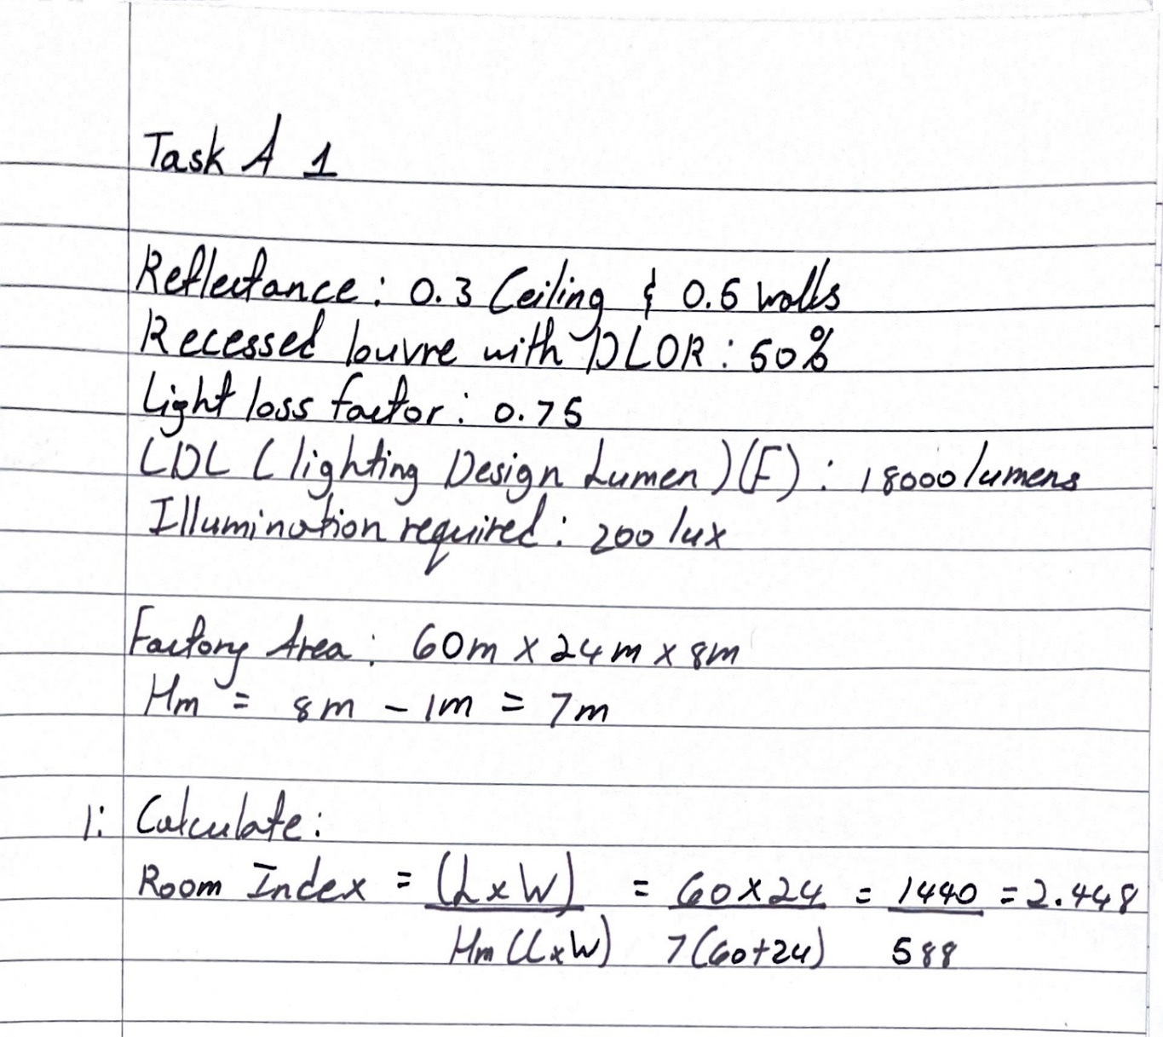
Figure1 showing calculations for the Room Index by Frederick K, (2022).

1.2 The Utilization Factor
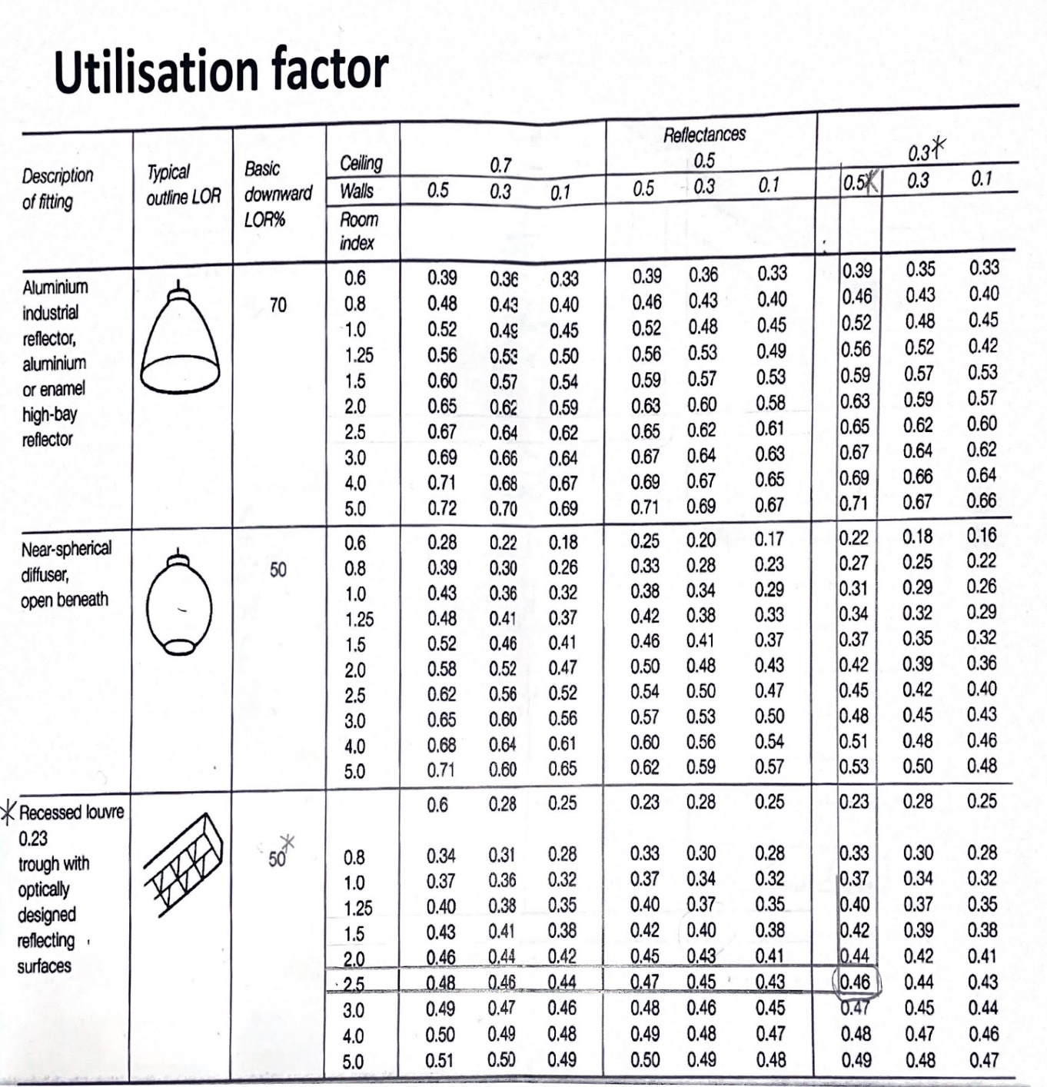
Figure2 showing the utilization factor (0.46) by Frederick K, (2022).
To find the utilization factor one must take note of the ceiling and wall value provided, in this case they were both 0.3m² and 0.5m² respectively. These figures were used to find the reflectance’s of the recessed louvre on the utilization factor table found above. The downward light output ratio (DLOR) given was 50%, this figure was used to identify the basic downward LOR found on the table above. Once the room index is found, the number that was derived (in this case 2.448) is used to help identify the room index value on the utilization factor table. The closest number to 2.448 is 2.5. Along the section of the recessed louvre a line is then traced from 2.5 at the room index and from the 0.5 at the wall, giving us a value of 0.46.
1.3 The number of lamps required
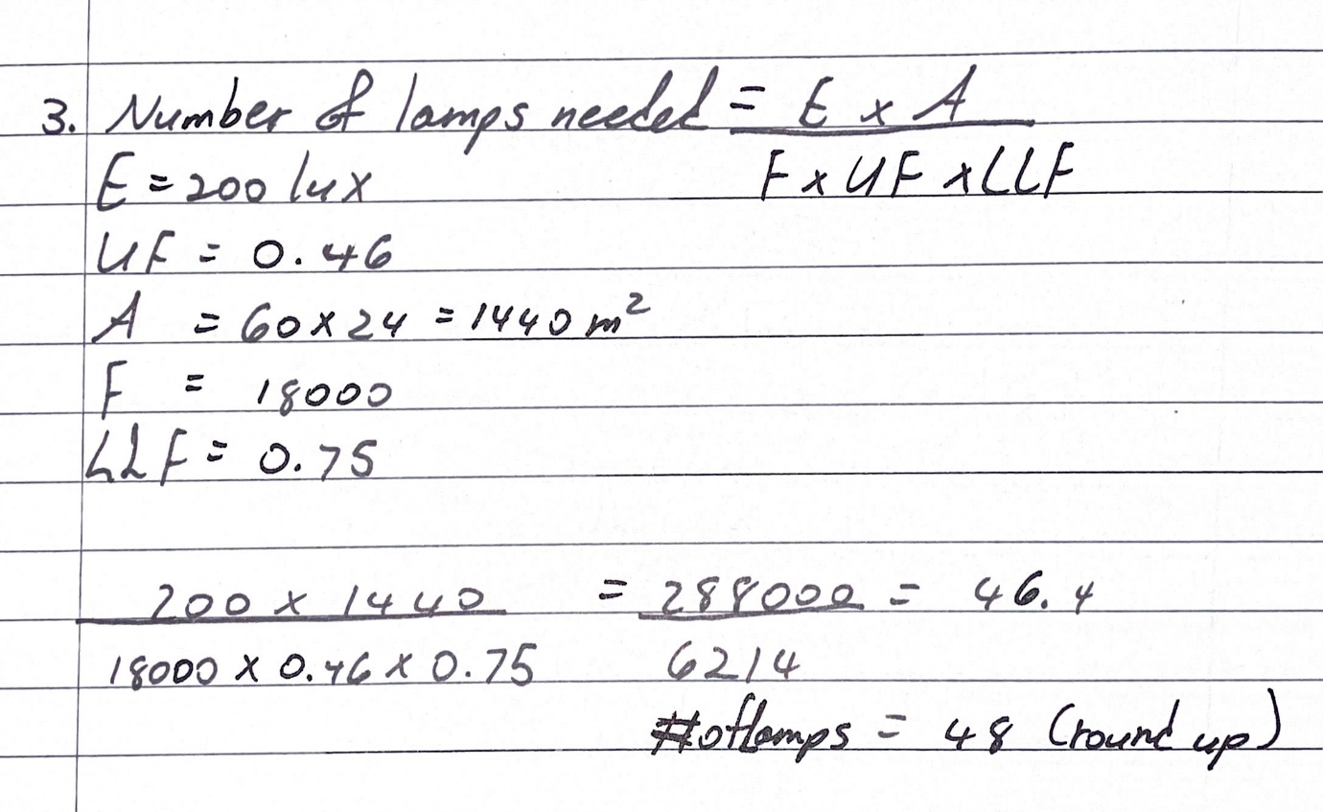
Figure3 showing the calculations for the number of lamps required by Frederick K, (2022).

1.4 The Smax Value
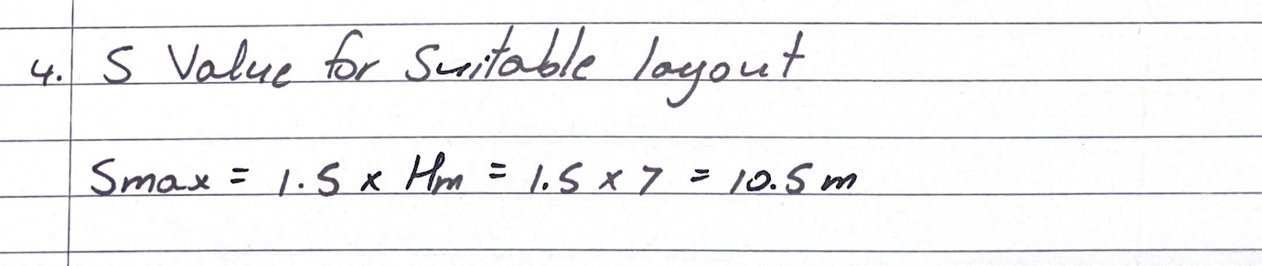
Figure 4 showing the Smax value by Frederick K, (2022).
The Smax value is the maximum spacing between fittings​. Meanwhile Hm is the height of the luminaire measured from the working plane. The Smax equation is used for fluorescent tubes in diffusing luminaires.

2. TASK A2
2.1 The Plan Layout for the best fit luminaire installation
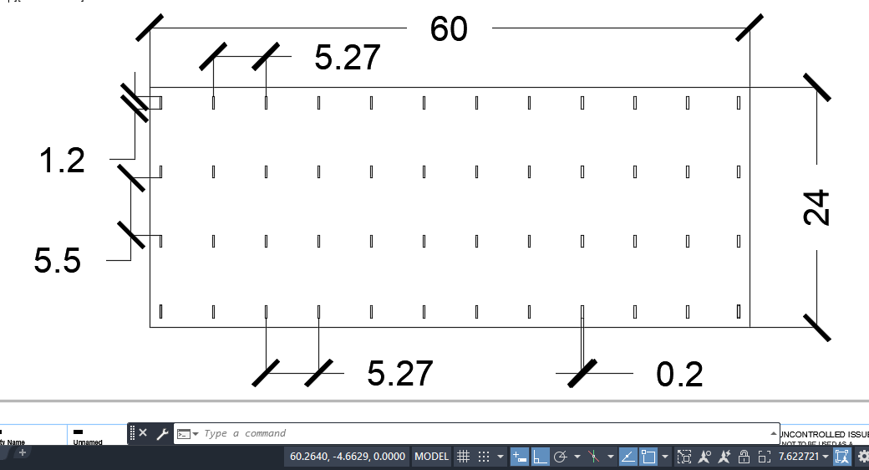
Figure 5 showing The Plan Layout for the best fit luminaire installation by Frederick K, (2022).

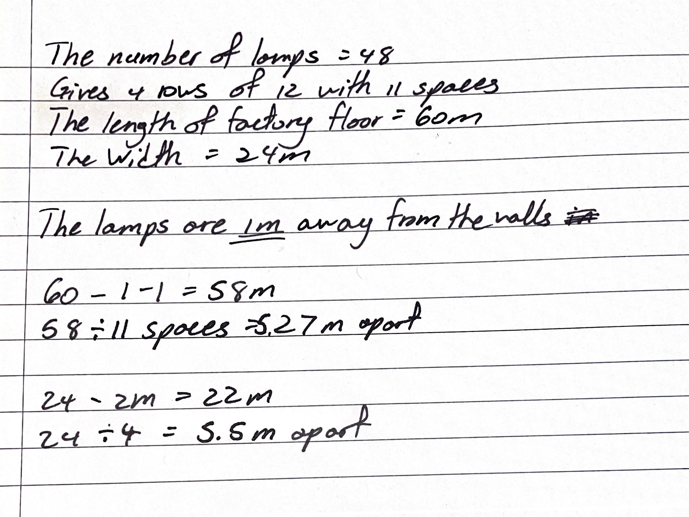
Figure 6 showing the calculations for the luminaire installation by Frederick K, (2022).

3. TASK B1
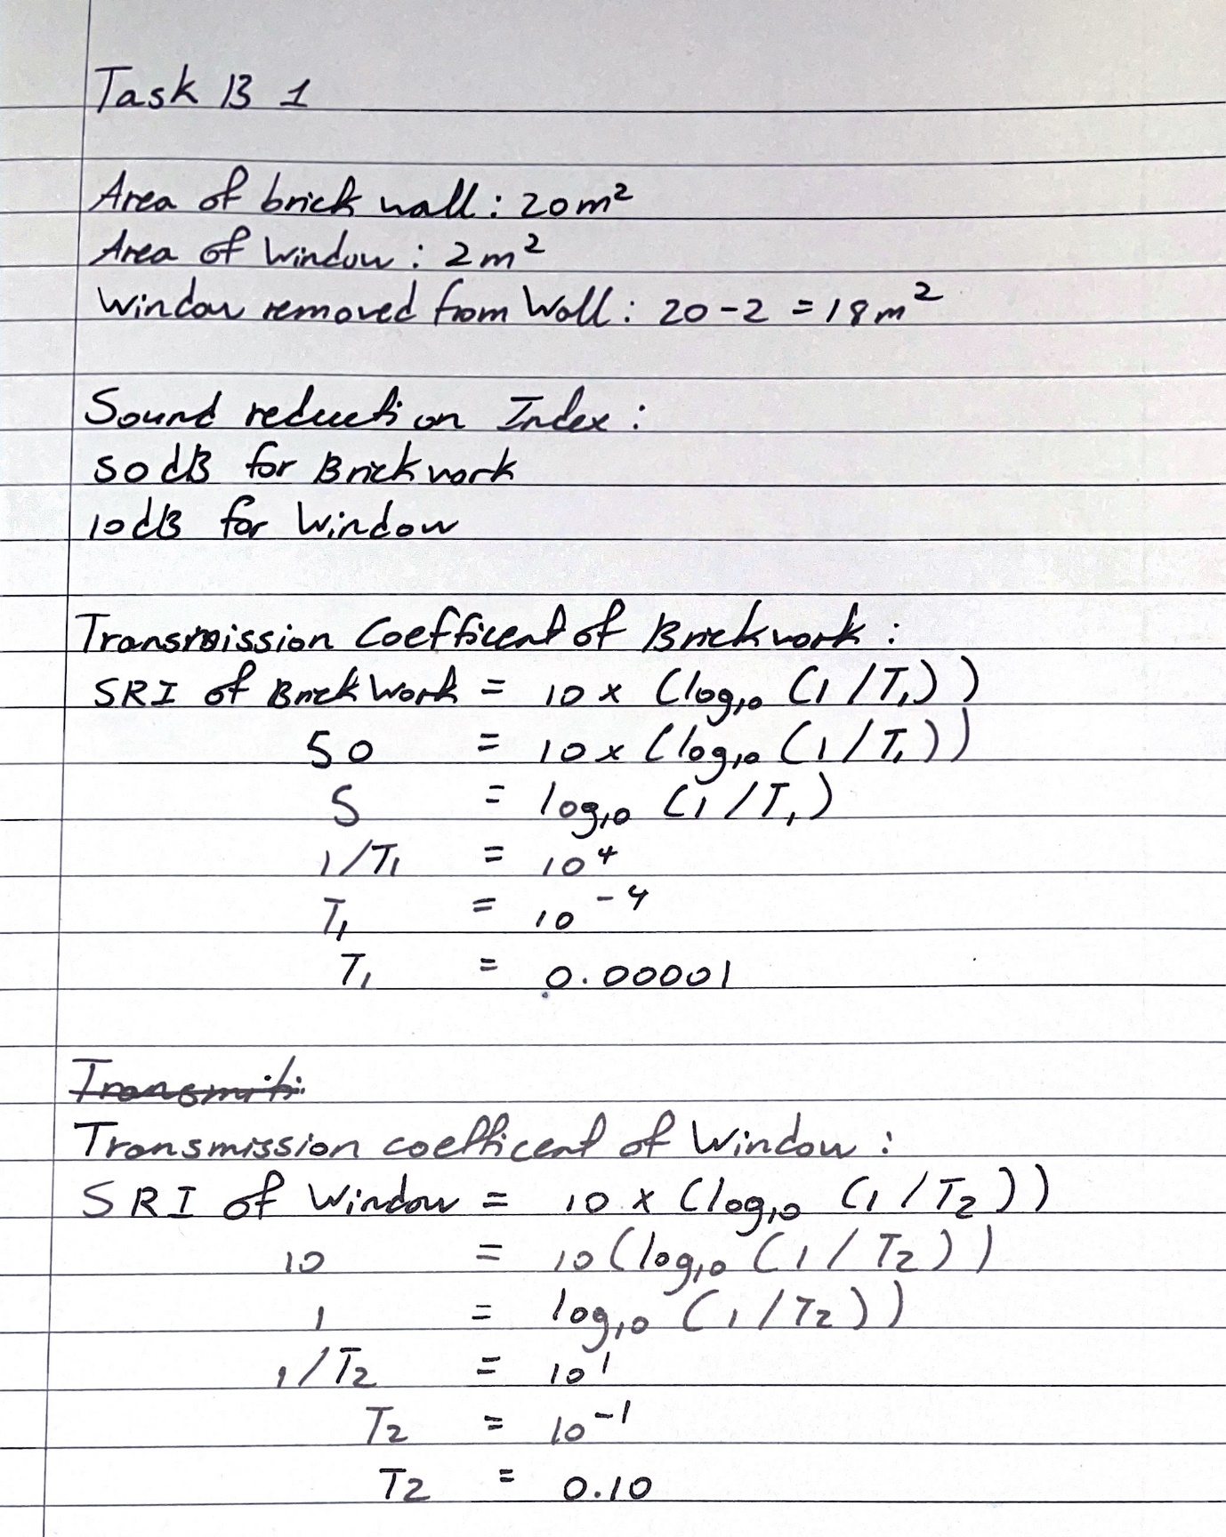
Figure 7 showing calculations of the sound reduction index for the entire wall by Frederick K, (2022).

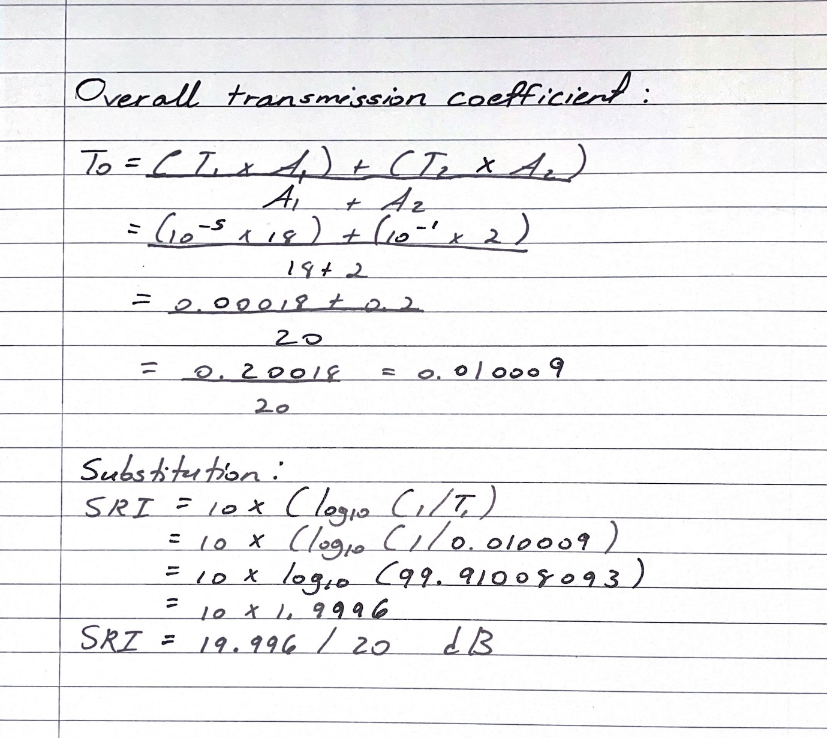
Figure 8 showing calculations of the sound reduction index for the entire wall by Frederick K, (2022).

3.1 The implications of the factors of frequency and wavelength
3.1.1. Building fabric resonance
As stated by Wren (2007), resonance can be defined as the condition of a structure in which an excessively large vibration is created in response to environmental stimuli, which occurs when the stimulus frequency is the same as, or almost the same as, the system's natural vibration frequency. The vibration of a system is the frequency at which it would oscillate if no damping forces were present. Resonance is the phenomenon of operating a system at a frequency equal to its natural frequency, and a system that is operated at its natural frequency is said to resonate, according to (OpenStax, 2022). The system in this case would represent the building’s material. Based on its shape and composition different elements of the building will have their own resonance. The resonance of a building would be affected based on the wavelengths and frequencies acting upon its structural elements. Monahan (2019) defines wavelengths as the distance between identical spots on a wave for one wave cycle is denoted as the wavelength. The distance between the crests of two consecutive waves is commonly used to determine wavelength. Monahan (2019) also defines frequency as The number of waves that travel through a particular spot in a given length of time is known as frequency. Hertz is the unit of frequency measurement. In relation to wavelengths, when the length of a vibrating system is increased, the wavelength grows and the natural frequency lowers. A reduction in the length of a vibrating system, on the other hand, reduces the wavelength and raises the resonance frequency according to (The Physics Classroom, 2019).

3.1.2. Partition wall construction technique
As a result of specific wavelengths and noise frequencies that can affect the comfort within the internal environment of a building, partition walls are constructed uniquely to drown out excessive noise. In order to combat this, the walls are engineered with a cavity and also fitted with insulation. A simple example of this explained by Soundproof Cow (2020) would be the use of Acoustic room dividers, where a soundproof partition sound-absorbing wall is constructed of materials such as cotton or polyester that can be moved around is placed between workers in an office. Instead of bouncing back into the room, sound waves are converted into tiny quantities of heat energy by sound-absorbing materials like polyester. They dampen the sound's effect and make it less perceptible. This shows that the type of material used within the partition wall has a large impact on the wavelengths and frequencies within the environment. It is seen that having a double leafed partition aids in the reduction of noise transmission. A double leafed partition is defined as a partition is a structure that consists of two leaves separated by an air gap or cavity that dynamically connects the two leaves stated by (ASSAF, 2015). Fahy (2001) states that in actuality, it is common for structures to require not only a low weight but also a high transmission loss for example tall building partition walls, and single-leaf dividers cannot meet this expectation. Therefore, constructions consist of two parallel leaves separated by an air gap.
3.1.3. The Insulation material choice
The type of insulation plays an important role in the reduction of vibrational systems. The composition of the insulation type acts on the frequencies and wavelengths in order to reduce them. For example, according to P.S. Liu (2014) the sound insulation function of polymer foams works in two ways: (1) the porous body absorbs sound wave energy to stop sound waves from bouncing and transferring; (2) the porous body removes resonance and reduces noise. When a sound wave hits the cell wall of a pore in polymer foams, it strikes the pore and compresses the gas within. As a result of this pause, the sound wave's impact energy diminishes. Don (2012) states that placing batt or blanket insulation between studs or joists during construction or remodelling is an efficient and economical approach to increase the soundproofing performance of walls and ceilings. He continues to say that the reduces sound that would easily flow through the wall framing's air spaces, 3 1/2-inch-thick fibreglass or rock wool batts made exclusively for this use. They're both great at absorbing sound that would be transmitted via the air. According to Better Sound Proofing (2019) other good soundproofing insulation material includes blown-in cellulose, foam board and spray foam insulation.

4. REFERENCES
ASSAF, R. (2015). Noise and vibration pollution: analytical analysis of double-leaf partition. 292 rue Saint-Martin, 75141 Paris Cedex 03: Elsevier Ltd, p.1.
Better Sound Proofing (2019). Best Soundproofing Insulation for Noise Reduction - Better Soundproofing. [online] Better Soundproofing. Available at: https://bettersoundproofing.com/best-soundproofing-insulation/ [Accessed 4 May 2022].
Don, V. (2012). Soundproofing Walls & Ceilings. [online] HomeTips. Available at: https://www.hometips.com/diy-how-to/soundproofing-insulation-walls-ceilings.html [Accessed 4 May 2022].
Downlights (2020). How do I Comply with the Building Regulations? [online] Downlights.co.uk. Available at: https://www.downlights.co.uk/faq-how-do-i-comply-with-the-building-regulations-.html#:~:text=To%20comply%20with%20Part%20L2 [Accessed 3 May 2022].
Frederick, K. (2022). CALCULATIONS.
Gov.uk (2010). The Building Regulations 2010. [online] Legislation.gov.uk. Available at: https://www.legislation.gov.uk/uksi/2010/2214/schedule/1/made [Accessed 4 May 2022].
Monahan, C. (2019). Wavelength and Frequency — Definition & Overview. [online] expii. Available at: https://www.expii.com/t/wavelength-and-frequency-definition-overview-11057 [Accessed 4 May 2022].
OpenStax (2022). 14.4 Sound Interference and Resonance - Physics | OpenStax. [online] openstax.org. Available at: https://openstax.org/books/physics/pages/14-4-sound-interference-and-resonance [Accessed 4 May 2022].
P.S. Liu (2014). Sound Insulation - an overview | ScienceDirect Topics. [online] Sciencedirect.com. Available at: https://www.sciencedirect.com/topics/engineering/sound-insulation [Accessed 4 May 2022].
Sounds Proof Cow (2020). Acoustic Partitions. [online] soundproof Cow.com. Available at: https://www.soundproofcow.com/product-category/sound-absorption-materials/acoustic-partitions/ [Accessed 4 May 2022].
The Physics Classroom (2019). Resonance. [online] Physicsclassroom.com. Available at: https://www.physicsclassroom.com/class/sound/Lesson-5/Resonance [Accessed 4 May 2022].
Wren, J. (2007). What Is Resonance? Prosig Noise & Vibration Blog. Available at: https://blog.prosig.com/2007/05/23/what-is-resonance/ [Accessed 4 May 2022].

