
Module Assignment Submission
Student Name: | Emma Louise Stevens
Student Number: | 2025270
Module Code: | BMSK6006
Module Title: | Developing Emotional Intelligence for the Workplace

Statement of Confirmation of Authenticity
By the act of making this submission, the student declares that this is the work of the student named above. The work has not, in whole or in part, been knowingly presented elsewhere for assessment, or where assessment has been built on a previous assessment, this has been identified. Where materials have been used from other sources it has been properly acknowledged. If this statement is untrue, the student acknowledges that an assessment offence has been committed.
Attention is drawn to the plagiarism and unfair practice policies of the University.

Contents
Introduction 2
Critically evaluate theories of emotional intelligence and their relevance to workforce development and business performance. 2
What is Emotional Intelligence (EI)? 2
How does EI effect workplace development? 3
How does EI effect workplace performance? 4
Blooms Taxonomy 5
Use theories of emotional intelligence and mindfulness to review the effect of emotions on your own workplace performance. 6
How can my emotions effect my workplace performance? 7
Mindfulness in the workplace 8
Conclusion 12
References 14
Bibliography 17
Appendix 1 19
Appendix 2 21

Introduction

Developing emotional intelligence in the workplace is nothing new in the 21st century, by being self-aware of your own emotions and others’ emotions, self-regulating yourself, being internally motivated, empathetic, and having a good set of social skills all come under the emotional intelligence umbrella. Mental health is crucial to society and how we function in our personal and professional lives, nowadays and even more so within businesses to ensure their staffs wellbeing is priority. Businesses now train management and partner with outside wellbeing companies to ensure the wellbeing of their employees is paramount. There are many concepts of emotional intelligence and its relevance to the workplace, the most important concept being mindfulness and how we achieve and maintain mindfulness in the workplace.

Critically evaluate theories of emotional intelligence and their relevance to workforce development and business performance.

There are many theorists and theories to research on emotional intelligence (EI), this is because over the past 20 years management styles, technology and employee development and performance has had a massive focus on it on how business owners and their employees can become more emotionally aware on how to behave around their employees and how to understand how their employees are feeling.

What is Emotional Intelligence (EI)?

According to Goleman (1995) Emotional intelligence (EI) is the ability to perceive, interpret, demonstrate, control, evaluate, and use emotions to communicate with and relate to others effectively and constructively. Goleman (1995) was one of the first people to suggest that emotional intelligence is more important than IQ for a successful life and career.
Goleman (1995) breaks EI into five components. These are self-awareness, self-regulation, internal motivation, empathy, and social skills. Goleman (1995) believes that with using these five components together you will not only be a good manager but a good leader. By embracing these five components while leading a team you will become a people person and build stronger relationships with your colleagues/employees.
This is why EI is widely discussed and practiced within most workplaces. Without businesses taking the time to invest into their employees’ emotions and lives there will be no bond, therefore no strong relationship can be made. Heaphy and Dutton (2008) suggest that when employees experience positive relationships, the body’s ability to build, maintain, and repair itself is improved both in and out of the workplace. Having a high EI will help improve your job performance and manage your employees well. This will in turn mean your employees feel valued and their work performance will improve or increase as they will feel job satisfaction. Lopes, Salovey, and Straus (2003).
Being emotionally intelligent and stable instils positivity in individuals and inspires others to achieve emotional stability. There are even courses designed for individuals to study independently or within the workplace. These courses will teach you how to master the art of self-management and become emotionally intelligent. Learn about the principles of neuro-linguistic programming, important communication skills, tips to improve business practices, anger, and conflict management and how to impact the workplace.

In conclusion having a high EI will mean you are better equipped to effectively manage conflicts and, in turn, sustain relationships out with and within the workplace when compared to those with low to moderate levels of EI.

How does EI effect workplace development?

Workplace development is crucial within any workforce, the development of employees will allow room for employees to ‘climb the ladder’, try something new and/or become more competent in there current role. By giving employees the change to further their development and learn new skills shows willingness from the company to invest into there staff and show them they are valued. There are many benefits to developing your employees some of these are, increased job satisfaction, lower turnover rate, increased operational efficiency, improved productivity, enhancements in innovative thinking and proactive problem solving. By developing your employees this will give the employee ownership and make them feel empowered. An empowered workforce is one which feels like an asset to their employer. This gives the company and management team an opportunity to communicate with their employees about best practice, what training works and what doesn’t, to share feedback and how they can move forward in the industry together. When an employee feels they are not being given the chance to develop by the company or their management this is when employee retention could become low, and the employee may feel neglected or ignored therefore not valued by the company. MyWorkChoice (2019).
It may initially cost the company money to send employees on courses and training and then have to increase wages however with the employee’s new skillset or job role they will help the company make profit. For example within TSB Bank once an employee has achieved and maintained their individual lending qualification the employees annual salary will increase by £1500, so they company will initially take a loss, however once that employee starts to see frequent lending appointments the bank will earn their money back in interest from the overdraft, credit card, loan or mortgage that customer takes.
Therefore, by the company and/or management using their emotional intelligence they will be able to understand, communicate and help their employees succeed in there development.

How does EI effect workplace performance?

According to Dufat (2018) your performance in the workplace is a measure of your achievements that have contributed to the growth of the company you work for. It is a measure of whether you are able to do your job well and meet the targets that your company or management has set for you. Your manager and the company as a whole evaluate your performance from time to time to ensure that you are on track and that you are able to deliver to the highest possible standard expected from you. These targets and personal career goals would be discussed, set and tracked through regular one to ones throughout the year. Each company is different and may conduct one to one’s monthly, quarterly, or even annually.
The employee’s performance targets and/or personal career goals will give them the motivation to do their best to excel in their job role and stand out in the workplace. It goes without saying there are a lot of factors that directly influence how the employee will perform in their job role. So, the performance of the employee is an outcome of the actions of several factors including their own individual behaviours, efforts, decisions, and the company’s systems and technologies that support the employee to do their job well and accomplish their set objectives.
When a company or management are able to be emotionally intelligent this is when they will find they have a higher employee retention rate, they will not need to recruit unless employees have had promotions, they will make significant profit and staff will regularly be meeting targets/goals and customer satisfaction will also be high.
For example, if an employee was to come into work with a negative attitude towards the other employees this would bring the moral of the workplace down, this would then mean all employees have a negative attitude towards their work and would not be productive. Emotional intelligence is being aware of these negatives attitudes by recognising the body language of the employee, the tone of voice used by the employee and/or any facial expressions they may make. This is when management would need to step in and speak to the employee to understand how they are feeling before the whole team possibly becomes negative. This negativity within the employee would mean they would not be performing to the best they can and would affect the business performance.
Covey (1989) discusses his theory of Circle of Concern this is whereby the circle is split into 3 categories. The outer circle is named circle of concern, this is where there are longer term goals and ambitions we aim for. The middle circle is named circle of influence whereby you may set shorter goals or medium-term activities that influence the longer-term goals and that you have some influence over. The inner circle is named circle of control. These are the immediate tasks that we can do now to create inertia and energy. By using this module in the workplace companies and management are able to help employees create a personal development plan and a personal performance record. (Appendix one).
Therefore, emotional intelligence plays a huge part in keeping a business running competently, becoming successful, making profit, and maintaining a good reputation.

Blooms Taxonomy

According to Bloom, Englehart, Furst, Hill, and Krathwohl (1956) the Blooms Taxonomy framework consists of six major categories: Knowledge, Comprehension, Application, Analysis, Synthesis, and Evaluation. Blooms Taxonomy definition of knowledge involves the recall of specifics and universals, the recall of methods and processes, or the recall of a pattern, structure, or setting. Blooms Taxonomy definition of comprehension refers to a type of understanding or apprehension such that the individual knows what is being communicated and can make use of the material or idea being communicated without necessarily relating it to other material or seeing its fullest implications. Blooms Taxonomy definition of application refers to the use of abstractions in particular and concrete situations. Blooms Taxonomy definition of analysis represents the breakdown of a communication into its constituent elements or parts such that the relative hierarchy of ideas is made clear and/or the relations between ideas expressed are made explicit. Blooms Taxonomy definition of synthesis involves the putting together of elements and parts so as to form a whole. Blooms Taxonomy definition of evaluation engenders judgments about the value of material and methods for given purposes. Taxonomy of Educational Objectives (Handbook One, pp. 201-207)
Many teachers use the Blooms Taxonomy framework in collages to encourage their students to think about their learning goals and also help teachers in the way they thought about the questioning process within the classroom. The taxonomy was originally structured as a way of helping teachers think about the different types of test items that could be used to measure student academic growth. Blooms Taxology framework has evolved into new meanings for the 21st century. These still consist of 6 categories: Remember: is ability to recall facts and basic concepts. Understand: To be able to explain ideas or concepts. Apply useful information in new situations. Analyze: Drew connections among ideas. Evaluate: Justify a stand or decision and to create or produce new or original work.
Blooms Taxonomy framework applies to emotional intelligence within the workplace as it is all about understanding the individual and helping the employee to develop. The employer would even be able to use Blooms Taxology framework with the employee to show and guide them through development or training. All of the above categories contribute to the way an individual or an employer would be able to be emotionally aware of the employee they are dealing with at the time.

Many businesses now have training and courses in place for management and leaders to go on or study before becoming a manager in that particular industry. For example, as part of TSB Banks manager training there are sections throughout on how to deal with volatile, vulnerable and dependant customers and employees. Blooms Taxonomy framework gives tools to the teacher/employer/management/business on how to help that employee either in their career within the industry or in their personal goals. Being this emotionally aware of how to help your employees will great a good working relationship and as previously discussed with reflect well on the business in terms of staff retention, staff sickness rates, staff motivation and performance in the overall team/network.

Use theories of emotional intelligence and mindfulness to review the effect of emotions on your own workplace performance.

“Transactional Analysis (TA) is a psychoanalytic theory and method of therapy developed by Eric Berne during the 1950s. Transactions refer to the communication exchanges between people” Murry (2023).
Transactional analysis is the method used to analyse this process of transactions in communication with others. It requires us to be aware of how we feel, think, and behave during interactions with others.
Transaction analysis means that the human brain recognises that the human personality is made up of three “ego states”; each of which is an entire system of thought, feeling, and behaviour from which we interact with each other. According to Berne (1976) the Parent, Adult, and Child ego states and the interaction between them form the foundation of transactional analysis theory.
Firstly, the parent state is shown or displayed to be behaviours, thoughts and feelings copied from parents and/or parent figures. It is believed our experiences during our first five years of life contributed to the parent ego state. The parent ego state is also said to have two states one being controlling and one being nurturing. These two states and how your upbringing was as a child will affect how emotionally intelligent you are within your adult life.
Secondly, the adult state is known to be the behaviours, thoughts and feelings that you directly respond to there and then. This state is more open, more rational, and less quick to make harsh judgments on a situation or person. When communication occurs in the adult state, you are more likely to be respectful, make compromises, listen fully to others, and have more healthy social interactions. Meaning you will have a good social awareness and therefore be more emotionally intelligent.
Lasty is the child state this is known to be when behaviours, thoughts and feelings are replayed from childhood and the individual may come across as child like or immature. When an individual is in the child state they will have no emotional intelligence or awareness of what is happening around them. (Appendix 2).

How can my emotions effect my workplace performance?

It is crucial within a business that the management have an understanding of their employees emotional health on an individual bases as this will impact on productivity and performance within the workplace. It is important to harness the teams’ emotions and use then to do better work.
As an employee with TSB Bank I can confirm that emotions and high tension can and does effect the whole performance of the team. For example, if one employee is unhappy with a process, a customer, the way they have been spoken to this will effect their moral for the day. There moral and motivation to do the job to a high standard will be deflated and they will not feel valued as an individual. This could then cause a ‘domino effect’ in the sense of another employee may then start to have low moral as they are working in the same team and/or alongside this employee. This then means you have one or more members of your team not feeling satisfied in there job role and not completed their workload to the highest or even expected standard. This could lead to targets not being made and the business not making profit, loosing customers, or even loosing staff to sickness if they feel they are then not in the right mental state to be working.
There are many factors that of course go into this scenario and it depends on how the management have approached the individual and if they have been emotionally intelligent when approaching and speaking to them. This being said alternatively if an employee is in a positive mood and achieving set goals this would/could set an explain for the rest of the team and employees may also begin to feel more positive and able.
In conclusions the way in which we present ourselves in our workplaces has a deeper, more meaningful, and detailed meaning than we first may think. It is important to be aware and recognise that some colleagues may latch onto the emotions you either bring into work or display throughout the day. It is equally as important for the management team to approach an individual in a respectful and professional manner to ask if the employee is ok and if they are able to assist or help in anyway.
This leads me onto mindfulness, whereby this is a growing empire of learning about mental health and what we can do to help or maintain or mental health through mindfulness.

Mindfulness in the workplace

According to the NHS (2022) mindfulness is where we pay attention to what is going on inside and outside of ourselves, moment by moment. It is important to stop/pause to reconnect with our bodies and senses as we experience them. By paying attention to the sights, sounds, smells and tastes of the present moment will give you mindfulness. It is also important to have an awareness of our thoughts and feelings as they happen moment by moment and how these may affect those around you at that time.
Mindfulness was first discussed in America by Jon Kabat-Zinn in (1979) and since then has been rolled out globally through meditation, yoga, sound therapy etc.
Businesses are now more than ever are paying attention to the wellbeing and mindfulness of their employees for example TSB Bank have partnered up with the brand Unmind. Unmind is a mental health app which offers tools and training for use in the workplace. Unmind can be used on the mobile app and/or has desktop options. Unmind uses simple, understand language to help guide you. The app covers a range of mental health subjects, including sleep, stress, productivity, and your ability to support others during a difficult time. These are all delivered through through audio, video, and interactive content. This is just one way TSB Bank are striving to help their employees with mindfulness. The bank also have a wellbeing representative in each branch, the wellbeing representative role has been designed for employees to feel able and comfortable speaking to this staff member about worries or stresses or simply for the wellbeing representative to point them in the right direction whereby the can gain professional help through Unmind or Validium.

“Validium is a mental health and wellbeing consultancy that works in partnership with HR professionals, business leaders and service users in a range of environments, to prevent and overcome the stress, trauma and absence issues that can limit people from performing.” Validium (2021)

These are the two external companies that TSB Bank use to help support and help their employees. That being said as previously discussed TSB Bank management training has extensive on how to ‘deal’ with people and how to not only manage them but understand each employees personal ways of communicating and learning. This means all management should be able to recognise and know their employees well enough to know when something isn’t quite right or for an employee to feel comfortable speaking to either management or the wellbeing representative in a time of need.

The wellbeing representatives have monthly calls whereby the share employees experiences, worries and stresses anonymously and with the employees permission. This gives all the wellbeing representatives in the South Wales area a chance to share how they delt with the situation, how the help or what they could do next time/going forward. With each representative giving examples this shows a unity and working together to make things better spirit.
These factors show that TSB Bank want and are actively looking after their employees by putting these facilities in place. The Unmind app is free for all employees and the bank will pay for five free sessions with Validium. TSB Bank (2023).
Through research I have found that many big and well-known businesses work with Unmind such as: Sainsburys, Uber, Nationwide bank, Wework, Virgin Media, O2, British Airways, John Lewis, Ogilvy, Mediacom, Standard Chartered and even the NHS.
Through personal experience I can an able to confirm that the Unmind app is accessible, easy to use and understand and does help in a time of need. The section that I used Unmind for was to help me sleep. The audio helped me to relax and the yoga sessions before bed helped me to unwind and put the day’s work behind me. The Unmind app helped me and guided me to a place where I no longer needed to use it as I had trained my mind on how to relax before bed. This is just one example, there are thousands more stories and appreciation posts on the Unmind website. Unmind data shows that 71% of employees felt reductions in stress after using Unmind courses, and 62% said they felt less anxious. According to UK research if you have 4997 employees working for your business (average employees at TSB Bank), 833 of these employees are struggling with some form of mental health issue. This means that 21491 days could be lost per year due to work-related stress depression, and anxiety. This could then cost the business £6,496,105 annually for ill-mental health in the workplace. (Figures taken from Unmind Calculator, 2023). (Appendix 2).

Lack of mindfulness and emotional intelligence can look like or come across as if the person has difficulty recognizing and understanding their emotions and those of others. People with low emotional intelligence may also have poor emotion regulation and find it difficult to use their emotions to attain personal goals. Other traits that may show lack of emotional intelligence include always having to be ‘right’, they don’t and can not acknowledge other people’s feelings, they may behave insensitively, they blame other for their problems, poor coping skills, they may have emotional outbursts, struggle making and maintaining relationships and turn conversations towards themselves.
Research shows that you are actually more likely to further your social goals by setting other thoughts aside and focusing on the interaction itself and being present in the moment. By following the flow of another person's emotional responses is a give-and-take process that requires you to also pay attention to the changes in your own emotional experience and by paying attention to others doesn't diminish your own self-awareness, but by investing the time and effort to really pay attention to others, you'll actually gain insight into your own emotional state as well as your values and beliefs. For example, if you feel discomfort hearing others express certain views, you'll have learned something important about yourself. Segal et al (2019).
According to Whitener (2022) to improve your emotional intelligence you need to follow the five main components of self-perception, self-expression, interpersonal skills, decision making and stress management.
It is common for people to have an uneven level of emotional intelligence in these categories and some of your emotional intelligence levels could be higher than others. If you are seeking to improve your emotional intelligence you should consider what your strengths and weaknesses are and what you can improve most. When going through your working day try to make a conscious effort to improve your development and add to your personal development plan to track your progress. There are several steps you can take to improve your emotional intelligence.
These consist of firstly understanding you own emotions and the trigger being a certain emotion. By working on this and knowing your triggers you can reduce the number and intensity of your impulsive responses and decrease your regrets after the situation has passed.
Then being able to label your feelings and emotions and determain the root cause of these emotions to identify their locations in your body. By labelling them and identifying where they have came from within your body you can help pinpoint exactly what you feel and identify which emotion you are feeling. You should pay attention to how often you experience the same feeling/emotion as there may be a trigger.
You will need to increase your self-awareness to the point in which you can observe your relationships with your thoughts, feelings, and emotions.
You should feel free and able to express your feelings and emotions. By talking about or doing something about your feelings and emotions can be healthy. The key is not to bottle them up or keep a detail from someone who would benefit from knowing. You need to own your voice by having healthy assertive communication style formed of your needs, wants, beliefs, values, all while remaining respectful.
Lastly you must have to ability to regulate your emotional responses so that you have time to choose among alternative actions during or before the situation occurs. You can do this by pausing, counting to five in your head, exploring other perspectives, meditating, taking part in a new hobby or most importantly asking for help. You should never feel like you cannot ask for help.

Through carrying out an emotional intelligence questionnaire using Mindtools, I have been able to determine how emotionally intelligent I am. After answering 15 questions my score was shown as 60. This results 56-75 mean that I am an emotionally intelligent person, I have good relationships and that people may find it easy to approach me for advice. The script also details that people who are emotionally intelligent often have great leadership potential. (Appendix 2).

In conclusion mindfulness and emotional intelligence go hand in hand. To be mindful is to be aware of your surroundings, including the people around you. By being mindful of people’s feelings and how they may think is peak emotional intelligence. Being able to read a person’s body language, tone of voice, stance and facial expressions and know how to engage in the correct way will help you build and maintain relationships either in the workplace, professionally or in personal relationships, outside the workplace.

Conclusion

In conclusion to my findings Emotional intelligence is crucial to the success in both personal and professional relationships. It is made up of five key components, which are, self-awareness, self-regulation, motivation, empathy, and social skills. By improving your emotional intelligence, you can become more self-aware of your surroundings, better regulate your emotions, achieve your goals, understand others' perspectives, opinions, and views, and communicate efficiently and respectfully. By having a high emotional intelligence is having a skill that can be learned and developed, and it is essential for achieving success in both personal and professional lives.
Finally, to build social awareness, you need to recognize the importance of mindfulness in the social process. While many of us pride ourselves on an ability to multitask, this means that you'll miss the subtle emotional shifts taking place in other people that help you fully understand them. If you are unable to read nonverbal cues you are more than likely in your own head, thinking about other things, or zoning out. Social awareness requires your full attention and to be completely in the moment and this is the golden ticket to be successful in attaining and maintaining a high emotional intelligence. By improving emotional intelligence in the workplace can inspire you and your team and promote a positive work environment for everyone. The five key steps to do this are to identify your weaknesses, review your history of emotions, receive, and take onboard feedback, ask for help and practice emotional intelligence daily. If you or your employer/business, follow Goleman (1995) theory on emotional intelligence this will help the business as a unit to achieve the goals set out and to maintain a healthy workplace.

References

Armstrong, P. (2010). Bloom’s Taxonomy. Vanderbilt University Center for Teaching; Vanderbilt University. https://cft.vanderbilt.edu/guides-sub-pages/blooms-taxonomy/
Barbara. (2019, May 2). How to know if you are wasting your precious energy. Return Wellness®. https://returntowellness.co.uk/2019/05/02/are-you-wasting-your-precious-energy/
Dufat, J. M. (2018, August 31). What is Performance in the Workplace? Www.linkedin.com. https://www.linkedin.com/pulse/what-performance-workplace-jean-marc-dufat
Dutton, J. (2020, August 4). JANE DUTTON HIGH QUALITY CONNECTIONS. Www.youtube.com. https://www.youtube.com/watch?v=3TMGeSCdlFA
Dutton, J., & Heaphy, E. (2003). The Power of High Quality Connections Adult Education of Professionals View project Consulting firm WLB View project.
Houston, E. (2019, August). The Importance of Emotional Intelligence (Including EI Quotes). PositivePsychology.com. https://positivepsychology.com/importance-of-emotional-intelligence/
Lopes, P. N., Salovey, P., & Straus, R. (2003). Emotional intelligence, personality, and the perceived quality of social relationships. Reader.elsevier.com. https://reader.elsevier.com/reader/sd/pii/S0191886902002428?token=50A247BB9DA1FC5C74A156415BF3E910DE1F32D741396E4A34D96DED32A45B7C18FB076058CCA1B773C0F451B62D305A&originRegion=eu-west-1&originCreation=20230214203813
Marchant, J. (2015, October 6). » The Parent-Adult-Child model: the basics. Emotionalintelligenceatwork.com. http://www.emotionalintelligenceatwork.com/resources/parent-adult-child-model-basics/
Mind Tools Content Team. (2022). MindTools | Home. Www.mindtools.com. https://www.mindtools.com/aybbu19/five-ways-to-show-emotional-intelligence-infographic
Morgan, J. (2021, November 18). 5 Components of Emotional Intelligence by Daniel Goleman. Jacob Morgan. https://thefutureorganization.com/5-components-of-emotional-intelligence/#:~:text=5%20Components%20of%20Emotional%20Intelligence%201%20Self-awareness%20This
MyWorkChoice. (2019, December 2). What is Workforce Development? Benefits, Examples & Best Practices. MyWorkChoice. https://myworkchoice.com/blog/workforce-development/?utm_source=bing.com
NHS. (2018, November 20). Mindfulness. Nhs.uk. https://www.nhs.uk/mental-health/self-help/tips-and-support/mindfulness/
Quinonez, N. (2014). Udemy Blog. Udemy Blog. https://blog.udemy.com/domains-of-learning/
Segal, J., Smith, M., Robinson, L., & Shubin, J. (2019). Improving Emotional Intelligence (EQ). HelpGuide. https://www.helpguide.org/articles/mental-health/emotional-intelligence-eq.htm
Singh, I. (2022, February 28). Who Invented Mindfulness? 2022 HelpToStudy.com 2023. https://www.helptostudy.com/who-invented-mindfulness/?utm_content=cmp-true
Thomas, L. J. (2019). Bloom’s taxonomy | education. In Encyclopædia Britannica. https://www.britannica.com/topic/Blooms-taxonomy
Unmind. (2022). Unmind | Mental wellbeing. Done well. | Workplace. Unmind.com. https://unmind.com/
Validium. (2021, June 16). About - Validium. Validium. https://validium.com/about/
Whitener, S. (2022, December 30). Council Post: Why Is Emotional Intelligence Important? Forbes. https://www.forbes.com/sites/forbescoachescouncil/2022/12/30/why-is-emotional-intelligence-important/?sh=46a270913289
Goleman, D. (1999). Working with Emotional Intelligence. London: Bloomsbury.
Goleman, D. (1996). Emotional Intelligence: Why It Can Matter More than IQ. London: Bloomsbury.
Goleman, D., Boyzatis, R and McKee, (2004) A. Primal Leadership: Learning to Lend with Emotional Intelligence, Boston: Harvard Business School Press.
TSB Bank. (2023). Personal Banking | Life Made More | TSB Bank. Www.tsb.co.uk. https://www.tsb.co.uk/

Bibliography

Armstrong, P. (2010). Bloom’s Taxonomy. Vanderbilt University Center for Teaching; Vanderbilt University. https://cft.vanderbilt.edu/guides-sub-pages/blooms-taxonomy/
Armstrong, P. (2010). Bloom’s Taxonomy. Vanderbilt University Center for Teaching; Vanderbilt University. https://cft.vanderbilt.edu/guides-sub-pages/blooms-taxonomy/
Marchant, J. (2015, October 6). » The Parent-Adult-Child model: the basics. Emotionalintelligenceatwork.com. http://www.emotionalintelligenceatwork.com/resources/parent-adult-child-model-basics/
MyWorkChoice. (2019, December 2). What is Workforce Development? Benefits, Examples & Best Practices. MyWorkChoice. https://myworkchoice.com/blog/workforce-development/?utm_source=bing.com
Quinonez, N. (2014). Udemy Blog. Udemy Blog. https://blog.udemy.com/domains-olearning/
Thomas, L. J. (2019). Bloom’s taxonomy | education. In Encyclopædia Britannica. https://www.britannica.com/topic/Blooms-taxonomy
Covey, S. (2004) The 7 Habits of Highly Effective People: Powerful Lesson in Personal Change, New York: Free Press.
Chaskalson, M. (2011) The Mindful Workplace: Developing Resilient Individuals and Resonant Organisations with MBSR, Chichester: Wiley-Blackwell.
Chaskalson, M. (2011) The Mindful Workplace: Developing Resilient Individuals and Resonant Organisations with MBSR (Online) Malden, MA : Wiley.http://www.tsd.ac.uk/en/lrc/onlineresources/e-books/
Cherniss, C. and Goleman, D. (2001). The Emotionally Intelligent Workplace, San Francisco: Jossey Bass.
Chemiss, C and Goleman D. (2001) The emotionally intelligent workplace. (Online) San Francisco : Jossey-Bass. http://www.tsd.ac.uk/en/lrc/onlineresources/e-books/
University of South Florida. (2013) Emotional Intelligence in the Workplace, Available from, http://www.woodassociates.net/FAP/Newsletters/Search/PDF/FAP%20August%202013%207_23_13.pdf.
MindTools. How emotionally intelligent are you? Available from, http://www.mindtools.com/pages/article/ei-quiz.htm.
Goleman, D. (1999). Working with Emotional Intelligence. London: Bloomsbury.
Goleman, D. (1996). Emotional Intelligence: Why It Can Matter More than IQ. London: Bloomsbury.
Goleman, D., Boyzatis, R and McKee, (2004) A. Primal Leadership: Learning to Lend with Emotional Intelligence, Boston: Harvard Business School Press.
Segal, J. The Language of Emotional Intelligence: The Five Essential Tools for Building Powerful and Effective Relationships, London: McGraw-Hill, 2008.

Appendix 1

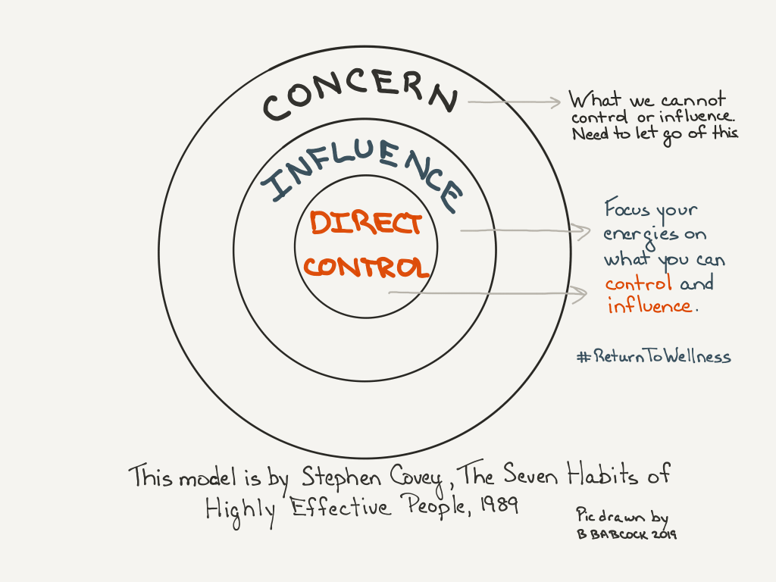
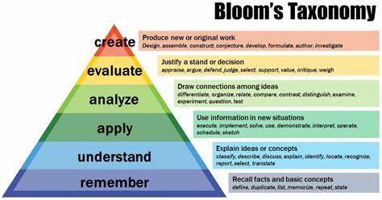
Armstrong (2010)

Appendix 2
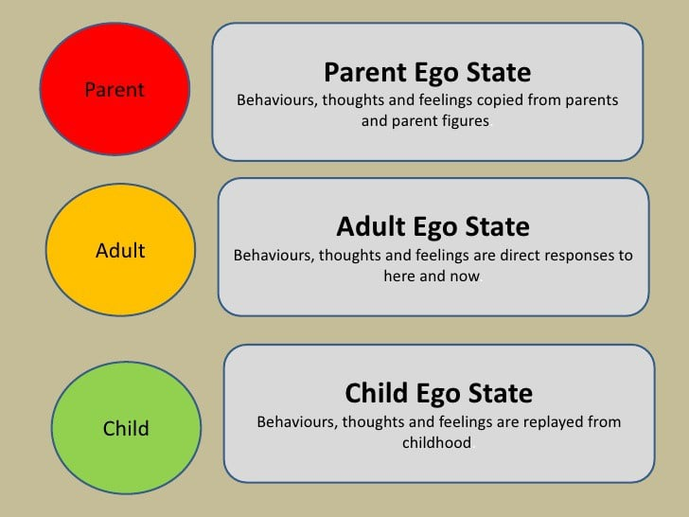
Berne (1976)
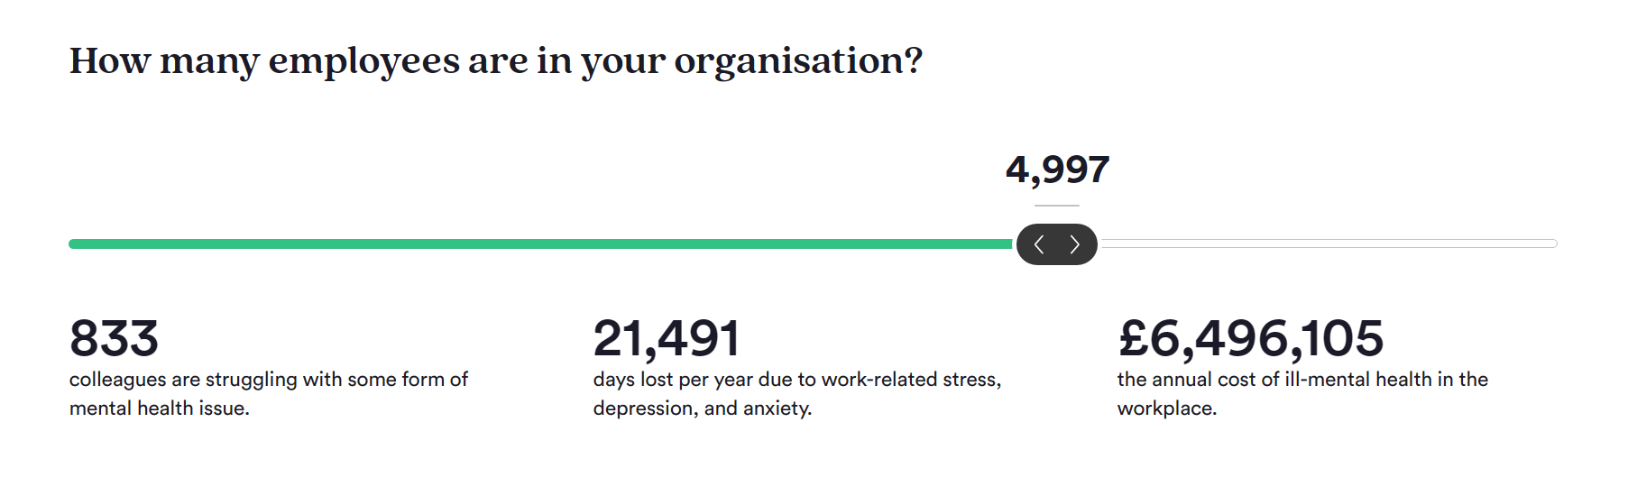
Unmind (2023)
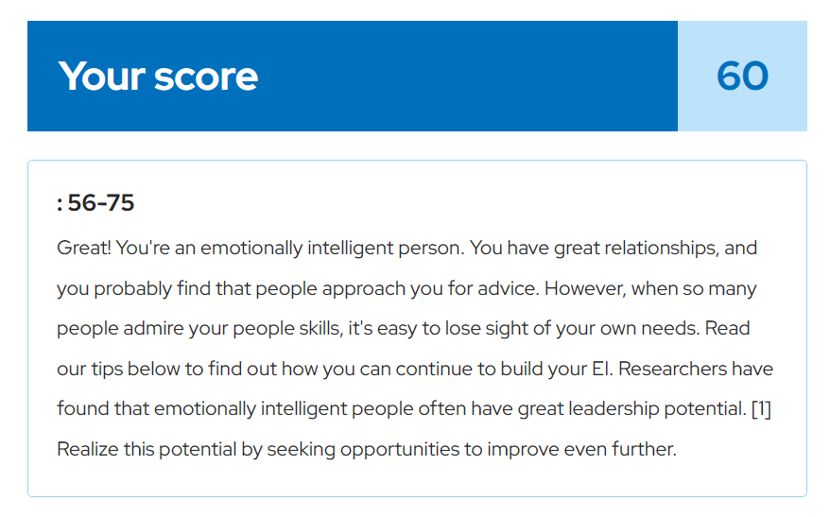
Mindtools (2023).

